Managing Enterprise in the 21st century
BMSK4006
Assessment-2
Name: Gias Ahmed
ID: 1709681

Table of Contents
Introduction 3
Description of the findings 4
Description 4
Feelings 5
Evaluation 6
Conclusion 8
Action plan: 9
Conclusion 10
References 11

Introduction
At present managing business in the 21st century is a challenging job. The business environment is much more competitive rather than the previous time. To manage a business in this modern era a business person has to follow several legal issues and environmental regulation. Basically, management has a couple of liability to run the business in an efficient way. Business creates a massive opportunity for the young generation for contributing to the growing world (Curtin, 2011). There are three friends including me and another two friends are starting a new cafe. The aim of our business is to make people comfortable with providing coffee for their refreshment. The name of our business plan was Heavenly Handmade. We learned time management, conflict management, and different pricing strategy from our business plan. To conduct our plan, we prepared a couple of activities like first of all conducted market segmentation, differentiation, promotional activities, financial activities and also cash flow statement. Finally, Gibbs model helps me to share my experience effective way.

Description of the findings
Our business plan was inspired by a coffee shop in Brixton Rd. The name of the coffee shop was parroted coffee. We have made a plan to establish our coffee shop which name was Heavenly Handmade. We have experienced a real-life business plan development experience while developing the plan. It has enabled us to understand the business challenges with opportunities. To describe my experience in a structured way, I have used ‘Gibbs Reflective Cycle' developed by Gibb G. (1988). The main discussion using Gibbs framework is given below:
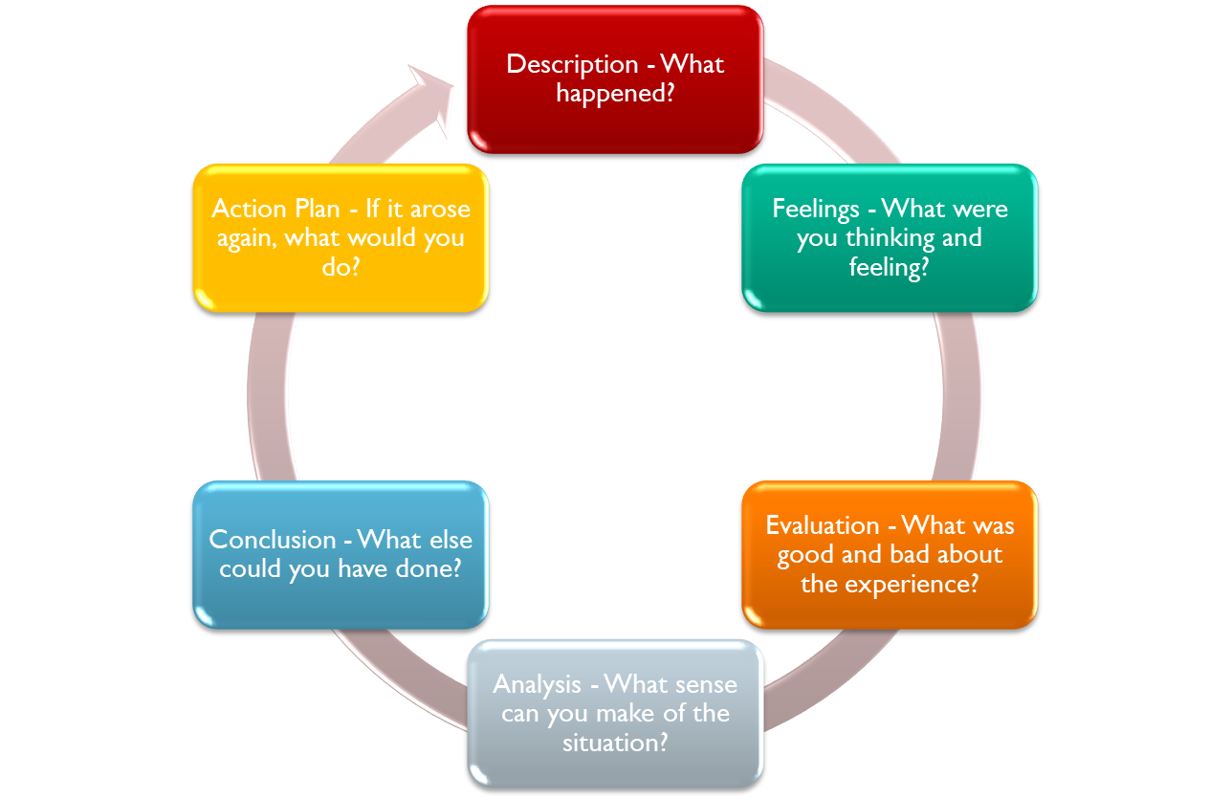
Figure: Gibbs model (Ray, 2018)
Description
A first we had to look for a suitable place for our coffee shop. we decided to open a new coffee shop business in Brixton. As a team leader, I divided our tasks among all the group members. I used the Belbin team role to cover all nine essential team roles within our group to accomplish our business plan. We knew that we had to face a few challenges to start our business, but I thought conducting proper plan helps us to effectively run the business in an effective way. The plan was decorated with market segmentation strategy which included we targeted middle-income people and their preference. I also focused on physiological and skimming pricing to set the price for the middle-income people. We maintained health and hygienic factors for producing our products. Besides, I also followed various legal issues of the business and environmental issues for producing quality products. I decorated a financial plan and cash flow statement for running the business in an efficient way. Later I identified my potentiality of the business plan. I knew the strength and weakness of my business and training process of the employee as well. I also learned the negotiation process and built the network with business professionals. I also knew the social, political, economic and legal issues of the business. Later I determined our mission and vision align with the customer demand. For the first time, our journey had started as a young entrepreneur with a huge challenge and enthusiasm.
Feelings
It was a great feeling for me after preparing my business plan using theoretical knowledge. Before starting the business, my feeling was general like I didn’t have any idea of doing a business plan. But I thought that it helped me a lot to enhance my ability to work under pressure as well. I had the ability to take a calculated risk after forming my business plan in an efficient way. I was introduced with many new aspects of a business plan like market segmentation, target market, pricing strategy, mission, vision and time management skills. I was excited after introducing this topic. I knew about promote any issues like personal branding, product branding which generally helped me to expand my skills and abilities for the removing of 21st-century challenge. I had to incorporate technological and changing environmental issues while developing the plan and this section was very much practical and challenging as well. I think this activity reflected my critical thinking ability and problem-solving ability. I was curious about any new issues from my childhood and I was very much delighted with my business plan. I learned a course in my academic life regarding entrepreneurial development where I learned about a business plan. It was a matter of pleasure that I applied my theoretical knowledge by making this business plan.

Evaluation
Every plan and initiative give a person a more innovative idea. It may have a negative and positive side (Bridge, 2012). The positive impact in my life was I gathered interpersonal skill, critical thinking skills, and conflict management skills, time management skills, collaboration skills, team building skill from the business plan. There had a positive impact on learning different skills from my business plan. My communication skill has improved from that business plan. I gathered policy and legal requirement for business also. It enhanced my critical thinking ability. I developed my technological skills during the making of my business plan. The projections of financial issues with the application of different financial statements were full of critical thinking, challenges, time management, etc. We think that there are a couple of benefits in having own business rather doing any traditional job as well.
The fund is considered as the lifeblood of any business to implement the plan in an efficient way (G, T. 2017). We are looking for an investor to give us half of our budgeted investment. This the first time we made a business plan with a group. In the perspective of my business plan, there were several issues do not conduct properly. We had some conflicts regarding taking a decision and with the conflicts, we developed a strong relationship between us. We faced challenges regarding the efficient distribution of task among the team members with the absence of proper financial projection and business environment related skills. Actually, these challenges have mainly come from our personal limitation rather than the business plan itself.
. Analysis
The analysis gives a person in understanding the real scenario of the plan and activity and enhances a person problem-solving ability (Trompenaars, 2016). I had the ability to understand financial management projection, work under pressure, and to estimate the scenario of business in a different changing business environment.
I observed the political environment of that place, the requirement of business strategy and policy of the business environment and the employment law to conduct the business in a vast perspective. The financial projection helps me to know about the financial management and balance sheet approach. Preparation of income statement, cash flow statement, and the statement of financial position help us to interrelate every single task with our financial position. We have successfully able to identify the material portion of our income and expenses. Thus we have controlled as well as managed the variable in these financial statements compiling the required accounting and reporting standard. We know the application of that problem and know the way to solve that problem.
I have experienced different strategies that were implemented and from that, I learned strategic management issues including proper time management and critical thinking.
From the business plan I had experienced about the different products pricing strategy which helped me to utilize my skills in the strategic area to control cost items. I have also introduced some smart technological innovations that help me to run my next business plan in an effective and efficient way. I also learned the different economic, legal, political, social, environmental issues that are considered as the secret of success nowadays in case of any businesses.
According to Gupta (2015), a business plan is essential for everyone with analyzing the market properly. He also said that before conducting any business it is necessary to set the vision, mission and proper market analysis of that business. It was very crucial for us to develop proper concrete objectives for our business plan to attract the customer for a very long term. In this regard, our mission to offer a superior quality product was the screaming of the markets because people always look for something new and special.
According to Wankel (2012), marketing skill is very essential to reach the potential targeted customers in an efficient way. Marketing enhances problem-solving ability that helps for the survival of critical situation in the vast perspective of view. Besides, the effectiveness of a plan depends on the target customer loyalty and pricing strategy in an effective manner. We have also considered these aspects while developing our business plan and priced our products in line with the market demand.
We have also used different financial techniques and principles to allocate our initial capital of £50,000 into different required segments. Among the total funds, 25,000 are used for various purposes like the cost of goods sold, deposit for the shop, marketing and administration, and others. After the first year, our revenue for sale was £70,000 and cost of goods sold £20000 and £19200. We have determined the profit before tax is £44800 and finally, net profit of £40600. Completing these projections, I have learned proper utilization of fund in case of my personal life and professional life
We have also used SWOT analysis to understand the strengths, weakness, threats, and opportunities of our business plan in an efficient way. It helped us to find out the real scenario of the business environment also. Our strength is the positioning of our cafe in a busy area with high-quality products. Besides, Wi-Fi free zone will also help to attract to the customer in an efficient way. Our weakness is regarding the introduction of businesses in the new market place with a small size coffee shop. On the other hand, we just need to phase some threats like the high range of electricity bill and rent. However, there is a possibility to expand our business and growing coffee shop business in the marketplace by doing advertising activities properly. Proper identification of the strength, weakness and threat and opportunities helps us to make the corrective decision on a continuous basis.
We have also used PESTLE analysis to manage our business in line with the external environment properly. We have determined the tax policy and employment laws and considered the Brexit issues in an effective way. We also evaluated the local economic environment and consumer preference. We have included environmental rules and regulation to conduct my plan in an efficient way.
Conclusion
It seems to me that I could have done numerous things from my business plan. I had the opportunity to further improve my team working skill, communication skill, time management, financial projection, critical thinking, build positive attitudes, problem-solving skill, etc. From experiencing the business plan, it is not easy to start a new business. Besides this, I had found that I had an opportunity to realize the importance of networking skill because it is considered as the core section to reach mass customers in an efficient way. However, as we have developed a business plan for the very first time that is why I have a little bit of lack of knowledge about market segmentation and differentiation strategy. I don't have the proper technical skill and a little bit knowledge about the financial projection and preparing statements. In fact, I had to enhance my negotiation skill, improve cultural knowledge, and enhance skill regarding customer behavior.
Action plan:
When I observed my lacking’s regarding communication skills, I decided that I had to develop it at any cost. For this, I will focus on four core part of communication in the area of listening, speaking, reading and writing. I have planned to improve it by watching tutorials and attended any training session regarding the communication course.
Later I will focus on improving my networking skills. I have set a plan to improve my networking skill. The duration was 6 months. Within six months, I will try to improve my networking skills with different business personnel, friends of friend, professionals, etc.
I will also focus on my marketing skill regarding the development of my knowledge about market segmentation and pricing strategy. I will try to learn this strategy from different books, visiting the market, and by meeting with experienced business professionals. I also need to work with my critical thinking abilities.
Finally, I will also focus on learning of different software applications which are related to the business plan. I will try to learn this from a training institution in an efficient way. Besides this, I had to gather financial data to improve my skills by reading the preparation of financial strategies statements.

Conclusion
To manage the business in the current situation is a challenge for everyone. An individual has to gather different rules and regulations of the business for managing the business in an efficient way (G, T. 2017). I have developed the creative thinking ability from the plan. I have experienced the way of behavior in a critical situation and the requirement of business, legal issues, policies, etc. I have also learned the total process of starting a new business. I have developed my networking skills, financial projection, team working, problem-solving skill, conflict management skills, time management skill, and interpersonal skills from my business plan. I will apply this knowledge in my personal life and for a future business plan to be self-employed.

References
Bridge, G., Butler, T., and Lees, L. (2012). Mixed communities.
Curtin, L. (2011). Nursing into the 21st century. Springhouse, Pa.: Springhouse Corp.
Firstenberg, P. (2016). The 21st century nonprofit. New York: Foundation Center.
G, T. (2017). Managing the Menopause - 21st Century solutions. The Obstetrician & Gynaecologist, 18(1), 75-75. doi: 10.1111/tog.12276
Idea Group Pub. (2017). Intelligent enterprises of the 21st century. Hershey, PA.
Gupta, J. (2015). Intelligent enterprises of the 21st century. Hershey, PA: Idea Group
Lazar, J. (2017). Managing IT/community partnerships in the 21st century. Hershey, PA: Idea Group Publ.
Stankosky, M., & Baldanza, (2017) C. 21 for 21.
Technology, D. (2019). DXC TechTalk: Reprocessing the Enterprise and the 21st Century Organization. (Video Online) Available at- <https://www.youtube.com/watch?v=mDIi00t_FFI&t=453s> Accessed 29th April, 2019
Trompenaars, A., & Hampden-Turner, C. (2015). 21 leaders for the 21st century. New York: McGraw-Hill.
Wankel, C. (2012). 21st-century management. Los Angeles: SAGE.

