1. An interest in classical art and reflections in an era where new artistic thinking is gradually fading.

2. Salvador Dalí and Marcel Duchamp,

Two Case Studies:
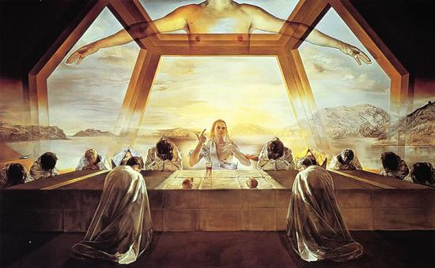
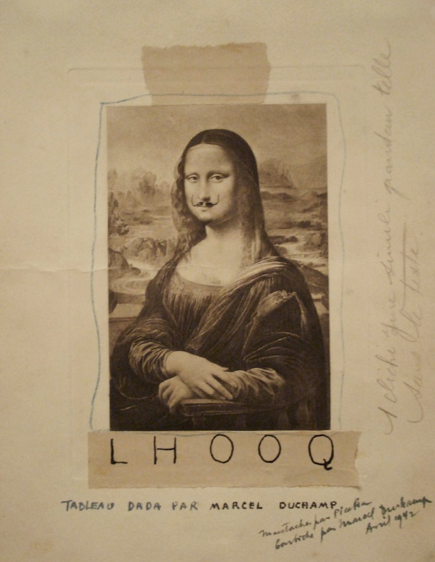
Both artists chose classic oil paintings by Leonardo da Vinci, a master of classical oil painting, and adapted them to varying degrees using traditional painting techniques. Dalí adapted da Vinci's classic work, *The Last Supper*, maintaining the original classic composition but modifying other elements. Dalí's work expressed a mysticism combining traditional religion and science in an era of rapid technological advancement. Duchamp's work appears somewhat casual; he chose a postcard of the Mona Lisa as his base, adding two humorous mustaches to the Mona Lisa, expressing his homage to classical art and satirizing the blind following of classical works by his contemporaries.

3. As artists in the AI ​​era, using AI to adapt traditional classical oil paintings is a trend of the times and a necessary means to decentralize and popularize artistic creation. From these adaptations of traditional art using traditional methods, we can see that these artists not only preserved the important, classic elements of the paintings but also used their own new language to make the content more easily understood. Therefore, my influence lies in adapting these paintings in conjunction with contemporary life. A successful adaptation is one that retains the original artist's understanding and creative intention while also adding new interpretations and creations.

4.
The Work of Art in the Age of Mechanical Reproduction, 1935.This is a book about understanding the "decentralization of art." Benjamin pointed out that traditional original works possess a sacred "aura," but mechanical reproduction (such as photography and printing) destroys this uniqueness, making art accessible to the masses.It supports my view on the "decentralization of artistic creation." In the AI ​​era, art is no longer the privilege of a few elites; any ordinary person without traditional creative abilities can engage in simple artistic creation. This "disappearance of aura" is precisely the premise for the birth of new art forms.

In *The Death of the Author* (1967), Barthes argues that the meaning of a work should not be determined by the original author, but rather by the reader (or adapter) during the reading process. Each reader's involvement is a reconstruction. This provides theoretical support for every ordinary person who adds a new understanding. When adapting Leonardo da Vinci with AI, our role is not that of a "plagiarist," but rather a "new author" who breathes new life into the work.

In *Cultural Software* (2013), Manovich, a new media theorist, discusses how software reshapes culture. He believes that contemporary creation is essentially "meta-creativity"—the re-editing and algorithmic generation of existing media elements.It is a textbook for understanding AI creation and new media creation. AI's pixel-level processing of classical paintings is essentially a "software-based" art practice, a process of reprogramming classics as data streams.

