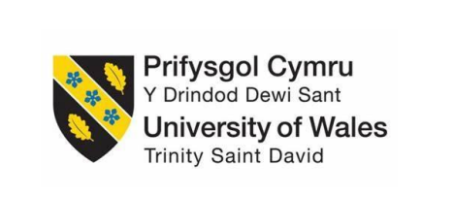

Assessment Component 1
Case study - Supporting Paper

Student name: Bozica Katic
Student ID: 2008115
Module name: Children, Young People and Families
Module code: (BMHP5004_LON)
Lecturer name: Bianca Sanfilippo
Submission Date: 11 April 2022
Word count: 1079

Presentation of case study

The study case presented a family, with a parental mental health problem, a single mother with three children, who lived in Portsmouth in the UK. They lived in rent apartment and under the pressure of eviction. She had anxiety, no motivation to work so the family faced financial problems and lived in poverty. She had a hard time coping with her daily responsibilities. The family was familiar with social services and was concerned that the mother would be able to meet the needs of the children. The children did not go to school and nursery and the eldest daughter took on the role of mother, taking care of the younger children.

The risk factors of vulnerability

This family differs from other families due to specific vulnerability factors that affect the quality of life of its members. Children were vulnerable and in need. To be vulnerable means to be able easily mentally or physically injured, attacked or influenced (Cambridge Dictionary, 2022). Not all children are ¨ in need¨. According to the Children Act 1989, a child is in need if it is not possible to provide the child with a good quality of life without the intervention of social service. Mother cannot ensure a quality life for herself and her children. She needed support and she was opened to cooperation with social worker. Anxiety is a long-lasting, uncomfortable feeling of fear or worry that can get serious affect an individual’s social, cognitive, or emotional abilities (NHS, 2021). The consequences of the mother's mental health were reflected on the children's health and well-being in different ways depending on the personality and age of the child, and its stage of development. If a parent has serious mental health problems, this can affect the child’s cognitive, emotional, social, and psychological development (Karimzadeh et al ,2017).

The impact of these factors on the children’s
health and wellbeing

Due to the mother's condition, the children were neglected. The eldest daughter had to take on the role of mother and became a young carer, taking care of the siblings and her mother. Occupied with that role left her less time to devote to herself and her self-care needs. She did not attend school and she neglected her social life. It reflected on her emotional and mental well-being as a child. Usually, young carer does not know their rights, but they do so to help their family although they could be exhausted from this role that can’t ask for help. The Children Act (1989) and the Children and Families Act (2014) emphasize that there is a duty to inform the young caregiver of his or her rights (GOV.UK, 2014). Statistically, 1 in 3 young caregivers has a repressed mental health problem (Medic Alert, 2021). The prolonged life of developing children under such conditions can damage brain structure and, probably sooner or later in life, cause mental disorders (Harvard University, 2022).
In this case study, the problem of parental mental health is not the only problem in this family. The family faces other vulnerability factors like unemployment, financial problems, poor housing, poverty, and lack of social support which makes their lives even more difficult. Children live in poverty, so their basic physiological needs for healthy development are not met. According to Maslow's Hierarchy of Needs, this can harm children's development at all levels (Cherry, 2022). In this case study, the situation is extremely difficult because it is a single parent with a mental health problem who needs to take care of three children and herself.

The process of intervention by relevant health and
social care agencies

Due to the mother's anxiety and fear of being separated from the children, they did not attend school and the youngest did not attend nursery. According to the United Nations Convention on the Rights of the Child (UNCRC), Article 19, the Government has to protect children from any kind of abuse. The Health and Social Care Agency made an assessment framework based on the HM Government Policy Working Together to Safeguard Children (2018), which includes more agencies working together to safeguard and promote the welfare of children. Based on this, the social worker made a plan for the best possible support for the family. The common assessment framework (CAF) for child protection is a process used to identify unmet children’s needs and support children (Learning ladders, 2021). The assessment framework included assessments of different aspects of the family: parental capacity, children's developmental needs and family environmental factors.

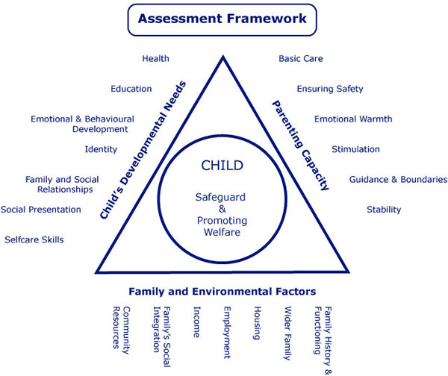
(Londoncp, n.y.)

The plan was made by the following laws: The Children Act 2004 which stipulates those agencies should work together to protect children; The Children Act 1989 justifies keeping children in families where possible; Equality Act 2010, stipulates that all children have equal rights to care and protection.
The planned intervention of the social service was based on establishing a good relationship between the social worker and the mother (mother confidence). This is the most important strategy to help the family in this case study. According to Bronfenbrenner's (1977) ecological systems theory that the state importance of their good relationship is to keep the family open to the support of a social worker and thus positively influence child development (Simply Psychology, 2020). The social worker scheduled health appointments for the mother to get rid of anxiety; enrolled the children in a school and nursery closer to home; initially, accompanied the mother to a new school and nursery to cope with the change more easily. She helped the mother to be able to meet the physiological needs of the children. According to Maslow’s hierarchy of Needs (1954), these are the basic need that needs to be satisfied for the motivation and healthy development of children.
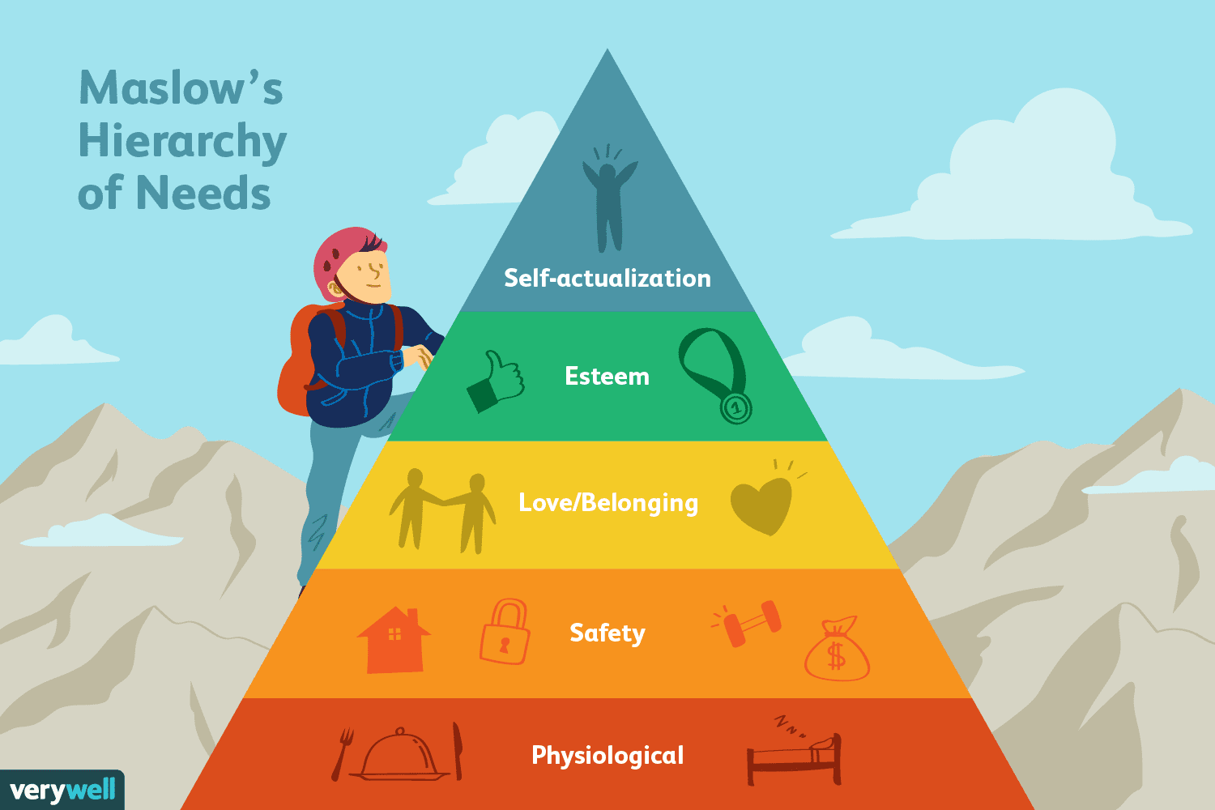
The impact of the intervention on the children and the mother has been successful. The children attended school 100%, the youngest attended the nursery, the eldest daughter is no longer a young caregiver, the mother continued with health care, she began volunteering for easier employment, took control of finances. Social services are no longer concerned about her parenting.
In my opinion, there is a lot of ambiguity in resolving this case. The case was resolved by the action of social agency, which interact with health agency for mother appointment and school and nursery for children attendance to school and nursery. It remains unclear how the financial and housing issue (safety issue), or family poverty has been resolved, given that the mother started volunteering and not working.

References:

Cambridge Dictionary, (2022). Vulnerable, Cambridge University Press. Available at: https://dictionary.cambridge.org/dictionary/english/vulnerable, (Accessed: 21 March 2022).
Cherry, K., (2022). Maslow's Hierarchy of Needs. (Online). Available at: https://www.verywellmind.com/what-is-maslows-hierarchy-of-needs-4136760 (Accessed: 29 March 2022).
Children and Families Act 2014, (Online). Available at: https://www.legislation.gov.uk/ukpga/2014/6/contents/enacted (Accessed: 29 March 2022).
Harvard University, (2022), Early Childhood Mental Health, Available at: https://developingchild.harvard.edu/science/deep-dives/mental-health, (Accessed: 28 March 2022)
Karimzadeh, M., et al, (2017), The association between parental mental health and behavioural disorders in pre-school children, Electron physician, 9(6), p.p.4497-4502
Learning ladders, (2021). What is the Common Assessment Framework? Explained for 2021. (Online). Available at: https://www.learningladders.info/news/common-assessment-framework (Accessed: 29 March 2022)
Londoncp, (n.y.). Assessment Framework Triangle. (online). Available at: https://www.londoncp.co.uk/appendix_4.html (Accessed: 29 March 2022)
Medic Alert, (2021), Supporting Young Carers, Available at: https://www.medicalert.org.uk/news/2021/05/17/supporting-young-carers?gclid=CjwKCAjwloCSBhAeEiwA3hVo_eo8SbugMq3IYDoLxFqVtHyNfnZazxCmdZAfoGDicFV7i1jalW3buBoCxcgQAvD_BwE, (Accessed: 28 March 2022)
NHS, (2021), Overview - Generalised anxiety disorder in adults, Available at: https://www.nhs.uk/mental-health/conditions/generalised-anxiety-disorder/overview/, (Accessed: 21 March 2022)
Simply Psychology, (2020). Bronfenbrenner's Ecological Systems Theory. (Online). Available at: https://www.simplypsychology.org/Bronfenbrenner.html (Accessed: 29 March 2022)

Appendix: Power Point Presentation for debate WEEK 9



