

Stress and FEA
  - Engine connecting rods
Jack Hazlewood | Motorsport Engineering | 27/01/2019
Contents
Introduction 2
Aims 2
Methodology 3
Creating the model parts 3
Assembly 9
Motion simulation 10
Stress calculations 12
Results 15
Results 19
References 20
One Drive Link 20

Introduction
The project is to look at a vital part of an assembly and to use solidworks to create the product to the correct specifications and to create a realistic motion study on the part to then find the amount of deflection that has been exerted on the part designed. This project looks at a ford four cylinder engine, with the crank, piston, gudgeon pin and conrod are all drawn to scale and a block created to allow everything to align in the correct manner. The stress calculations will be done on the conrod of the part to see how much pressure can be exerted onto the top of the piston before the conrod bends too much and allows it to break causing engine failure.
During the project, there will be changes in forces to the top of the piston to simulate an increase in boost pressure on the engine, change the designs of the conrod to try to decrease the weight which will have a good effect due to the reduction of weight within rotating parts. Also change the material of the conrod to see how that will affect the strength of the conrod, which should allow more boost to put through the engine.
The main materials that are used for a connecting rod are usually made of steel alloys such as: 42CrMo4, 43CrMo4, EN-8D and SAE1141. Other materials that are usually used are aluminum and titanium in performance vehicles and race vehicles as they are lighter weight and can take more force, this means the engine can be tuned to a higher level without failure. (Industries, 2014) Forging a conrod is quite common practice in modern motoring with manufacturers such as BMW, Honda, Mitsubishi and Nissan. The ford conrod that is being used in this application is constructed using forged steel. This is then connected to a cast iron crankshaft meaning the weakest link of the engine is the connecting rod. (Gunnell, 2015)

Aims
- Create a realistic model of the internals of a ford 1.6 Eco boost engine.
- Create an engine block to surround the internals of the engine.
- Run a realistic motion simulation using gravity and engine forces being pushed down on the engine.
- Import the motion simulation into the conrod that has been selected and run an FEA on the rod using the forces that have been imported from the motion simulation
- Create relevant improvements to the part and do a retest on the model .

Methodology

Creating the model parts
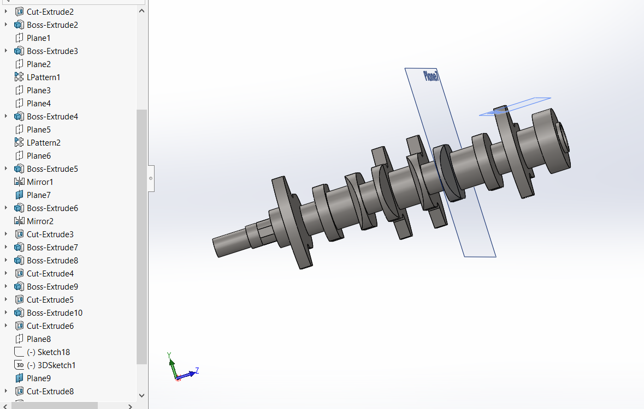
The first part of the model that was created was a crank of the engine. This was measured accurately to the crank that has come out of the 1.6 litre Eco boost engine. Each of the gaps that were created for the conrod to connect to were made to the correct sizing, using the correct diameter and width. All of the fixing points for the crank are created to the correct size and accurately measured. The offset parts of the crank the connecting rod connects to was offset to the correct distance to get the correct stroke of the eco boost engine. All of the parts that are used to balance the crankshaft were all made to the correct specifications with the cut outs of the crank all being present.
To create the products there were an array of tools that have been used which go along the lines of a simple boss extrude and cut extrude to using the 3D sketch tool to get the cut out to the correct size. The 3D sketch was used instead of using a chamfer as the chamfer wouldn’t commute while going around a semi-circle. Therefore, a 3D sketch was used to orientate the plane in the correct way to allow the extrude cut to create the correct shape. These cuts were then mirrored about a plane in the center of all the contact points.
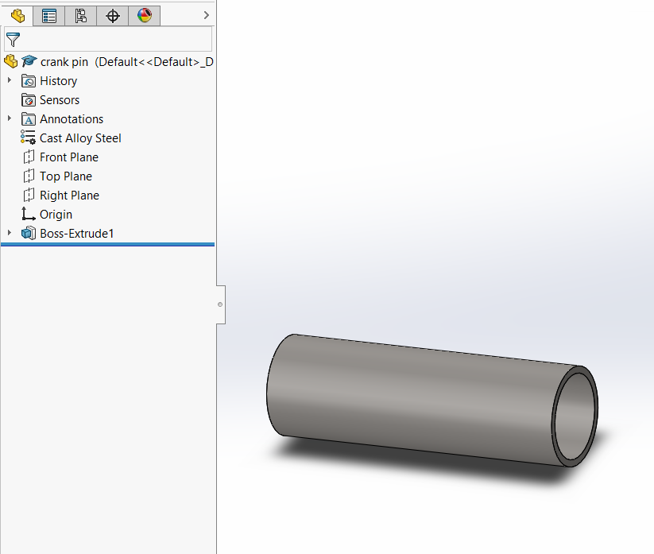
The gudgeon pin was created using a simple boss extrude of two circle that were measured to the correct size to fit perfectly within the piston and conrod and to the same thickness of the genuine ford part. The length was also measured to the correct ford specifications. The gudgeon pin is usually constructed of alloy steel with name AISI 4130 chromoly.
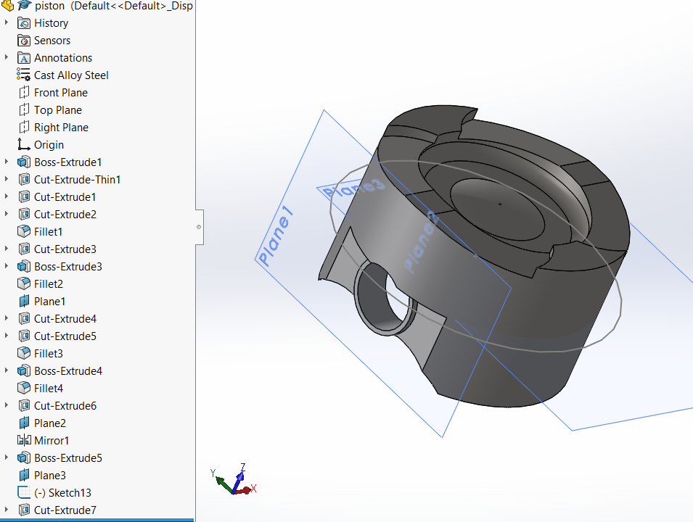
The piston started as a cylinder that was made to the correct bore and measured to the highest point, all the walls of the skirts were made to the correct thickness for the piston to exert the force in the correct way. The squared of part of either side of the piston was cut to the correct distance by measuring each side and deducting the correct amount from the diameter of the piston. The cut for the gudgeon pin was the created throughout the piston matching the diameter of the gudgeon pin. An extruded surface was created to the gudgeon pin and created right through the piston with the middle being cut out inside the piston for the conrod to connect around. The top of the piston was carved out using cut extrudes, boss extrudes and adding fillets and chamfers to create the smooth area rather than having sharp edges that will cause high stress force on the edges. There are cut outs for valve clearances to ensure there are no interferences during the combustion process.
The piton was created using a circle that was extruded to be a cylinder, the sides were then cut down the piston to create the squared off effect. Now the general shape has been made of the piston a cut was made at the bottom of the piton to hollow the piston to allow room for the conrod to move freely as it rotates about the crank. A cut and fillet was made to the bottom of the piston and fillet added to smooth it off. The cuts along the top were created using extrude cuts along a plane that was added to the tangent of the piston, it was then mirrored about a centre line to create the same shape on the other side of the piston The centre of the piston was extruded up and then a fillet added around the outer edge to create the dome effect that is on top of the piston.
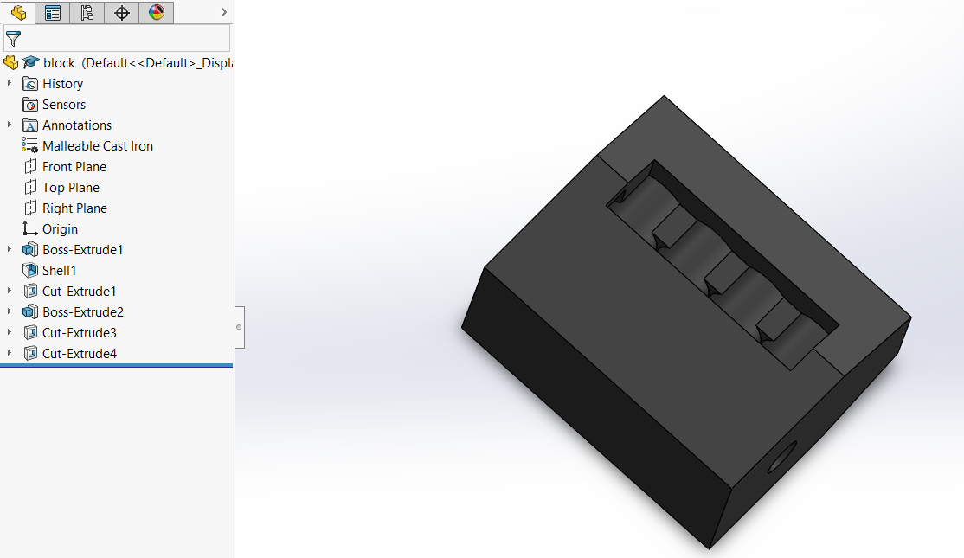
The block is a simple representation of a block and has no significant design added to it, however each of the piston holes were measured to line up with the centre of each of the conrod attachments on the crank.
The block is made of simple extrusions and cuts with the use of a shell in the bottom section of the head to allow room for the crank to rotate freely. A cutout was added to the side of the engine block to allow the user to see exactly what is happening during the motion simulation without having to hide the block.
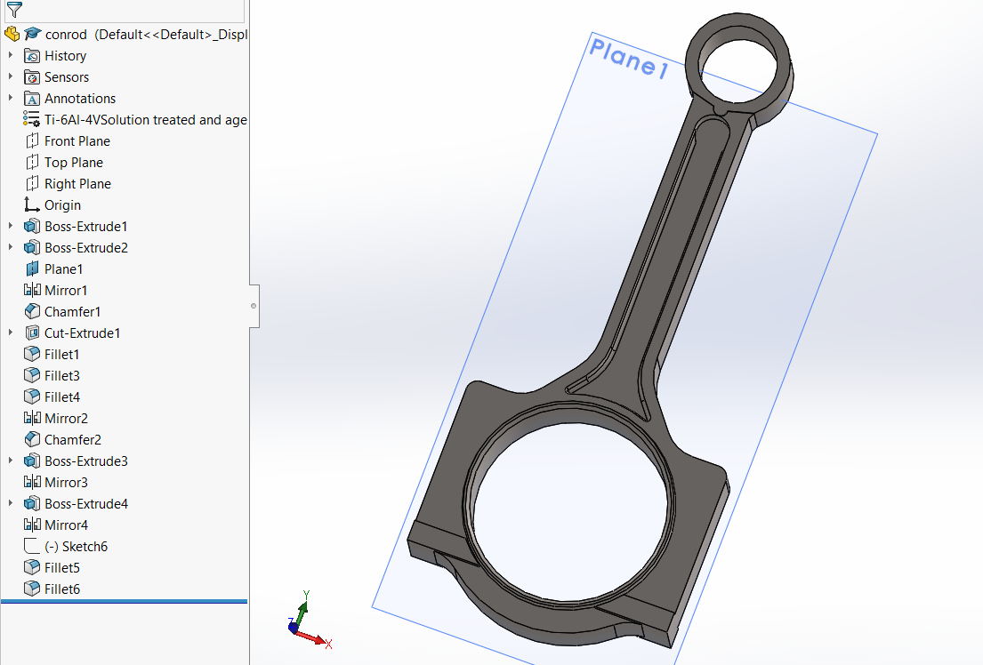
All of the dimensions of the conrod was made to the specifications that ford had originally intended, the indentation in the centre of the conrod was made to the right depth, the conrod hole was made to the right size to be able to use bearing shells in between the conrod and crank and the top hole was made to the outer diameter of the gudgeon pin for the pin to fit correctly. All of the sharp edges were taken away and smoothed out in a similar way to the actual conrod. As the ford conrods are snapped at the bottom of the conrod rather than machined, there are no cuts to represent them being fully tightened and squeezed together.
The conrod was drawn using lines and circles to get the shape of the conrod on one half and the other half was mirrored onto the other side of the conrod to get a complete conrod., this was then extruded to the correct depth. Fillets and chamfers were used to eliminate all of the sharp edges to smooth them off in a similar way to the ford conrod and also eliminates any high stress points that can cause cracks. The cuts were then made in the conrod using cut extrude tool and the mirroring about plane 1 which is the centre of the extrude of the conrod.
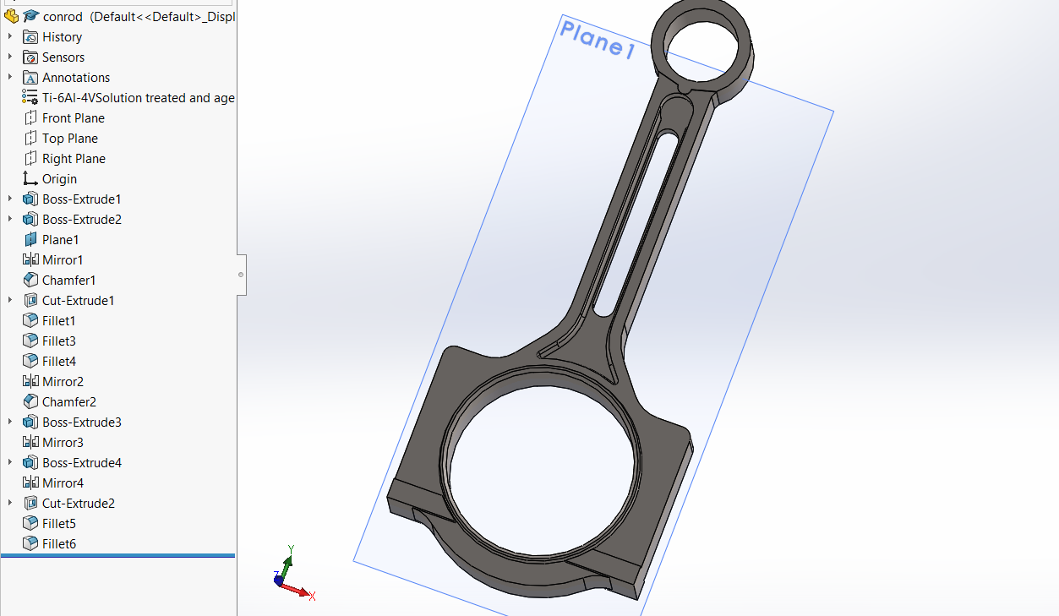
As an adaptation a cut was made in the conrod to see the effects it will have during its cycle. The cut was done using two circles that were smart dimensioned from the end of the cut that is already in place on the conrod. Two lines then joined the furthest point of the circle and the rest of the circle was deleted using the trim tool. The sketch was then cut using cut extrude.

Assembly
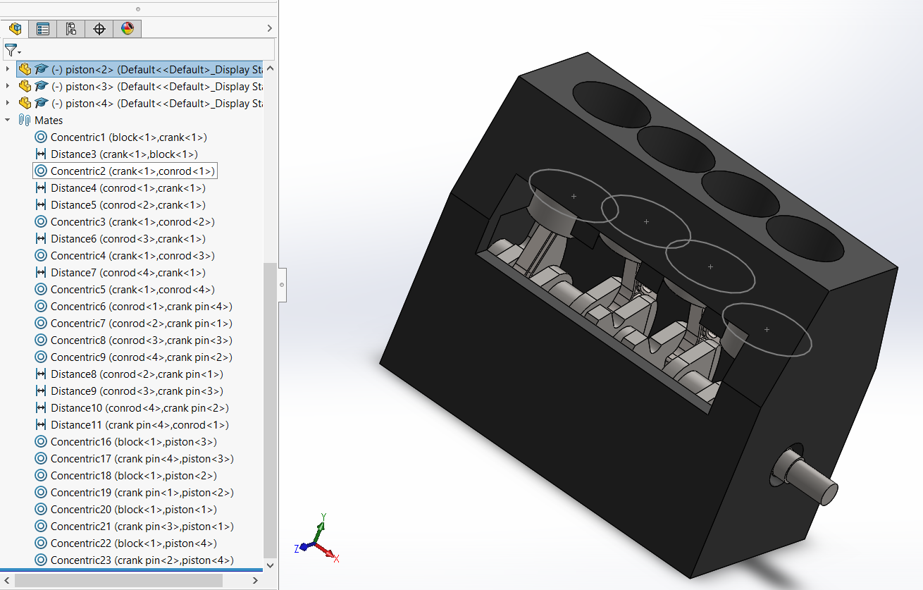
The first parts to be added to the assembly were the block and crank, they were mated concentrically, and a distance mate added to ensure the crank is aligned to the centre of the piston holes. The conrods are all added and are mated concentrically to the crank to ensure they move when the crank spins around. Distance mates are added between the con rod and the sides of the crank balancers to ensure they are centralized and that the piston goes through the block in the correct way. The gudgeon pins were then added into the model and mated concentrically to conrod and then distance mated to ensure there is equal amount of gudgeon pin sticking out of each side. The pistons were then included in the model and were mated concentrically using a ring that was added in a sketch of the piston to the sleeve of the block, this means they cannot spin around and go up and down in the sleeve of the block and allow the conrod to move aback and fourth. The piston is then concentrically mated to the gudgeon pin and aligns perfectly due to the distance mates that were added to the gudgeon pin and conrod when that was being assembled. Spinning the crank as a test then shows that the model aligns correctly and has the motion an engine would normally have with no weird glitches.

.

Motion simulation
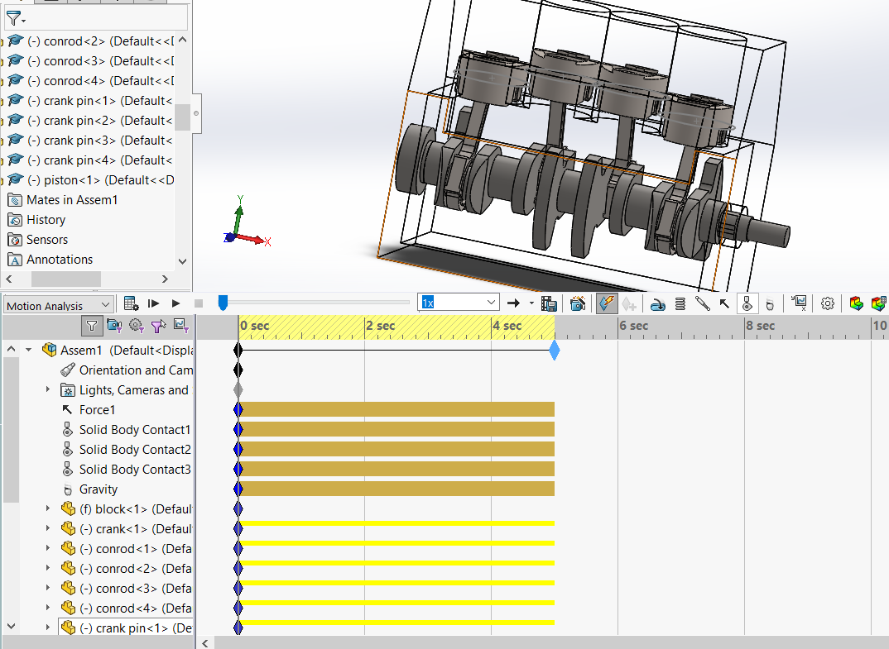
The motion simulation was made 5 seconds long of a variable force being added to the top of piston one pushing it down allowing the crank to spin and moving all of the pistons up and down in a motion that is similar to the ford engine. Solid body contacts were added between all the relevant parts that were being analyzed in this case there was a contact between the piston and gudgeon pin, the gudgeon pin and con rod and the conrod and the crank to represent the contact between each part. Gravity was also added to the parts as an additional force as this would be in effect during the combustion cycle of an internal combustion engine.
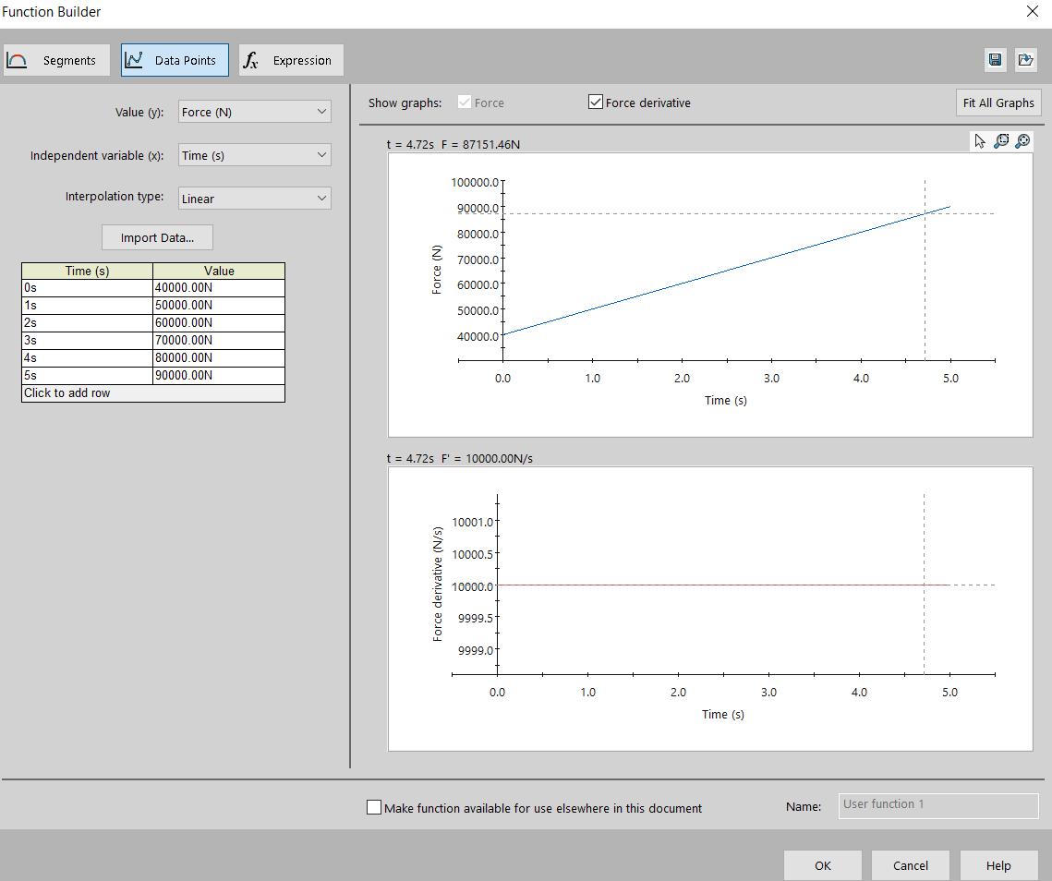
The force was added in stages to the piston rather than have one big bang to the top of the piston it allows it to be a gradual increase in pressure to represent the increase in pressure during a combustion cycle. The pressures were changed during models using a peak pressure of 45000N which is roughly the pressure that the 1.6 Eco boost engine is subjected too and at 90,000N to represent the engine when it is under a higher load. This may be due to the boost being turned up on the engine and therefore causing more force to be pushing down on the piston. Each of the numbers within the table are halved when the peak power is at 45000N to try and keep a similar pattern when the pressures are changed so it is subjected to a similar line and a similar pressure increase.
The run can then be setup choosing which data points you would like it to focus on and the run can be initialized, ensuring the run is doing as you want it to when its being calculated and not glitching out in a way that it is not supposed to be. Once the run is complete this can be imported to the part.

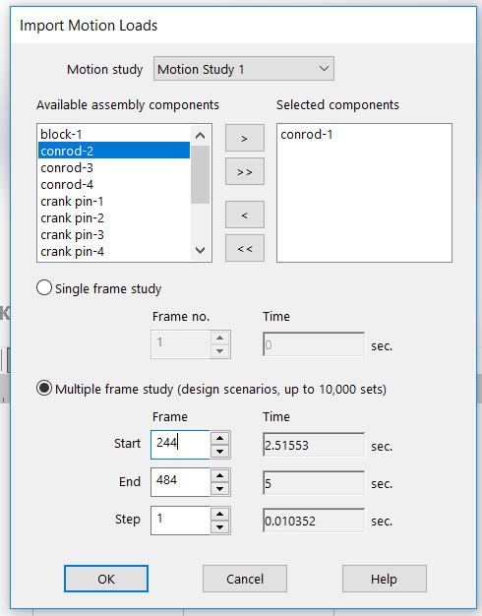
The motion load can then be imported on that part allowing those forces and to be applied to the conrod in the correct way and not just at the top, this will then allow you to run a stress analysis on the conrod to see where the breaking point is and how much the part deflects. Simply select the part you would like to import the forces of and select multiple frame studies and select at which points you would like to import of the study. In this instance the last half of the study was chosen as this is when the conrod sees the higher forces and these are the more relevant points of the study.

Stress calculations
Next open the part that you have imported the motion study forces too. In this case it is the conrod.
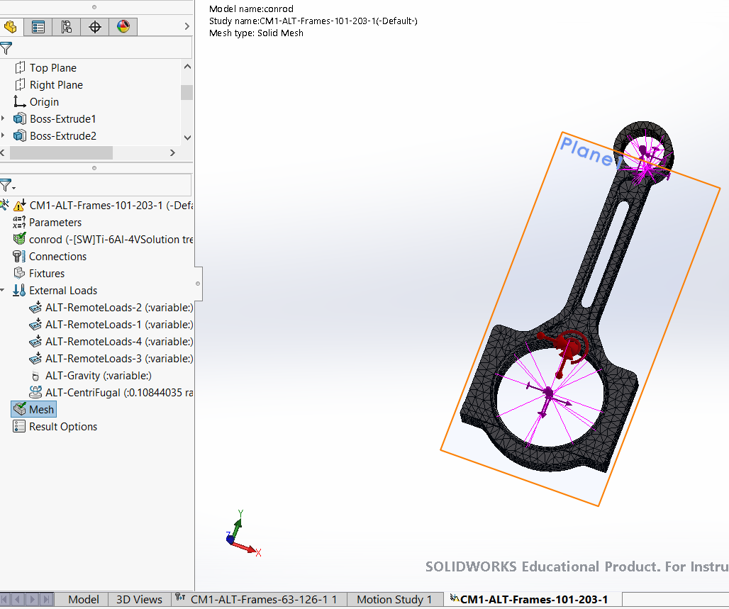
The part will then have two extra tabs at the bottom of the screen which were imported from the motion study. Select the one that has the fixtures indicated onto it and the stress setup along the left-hand side of the screen.
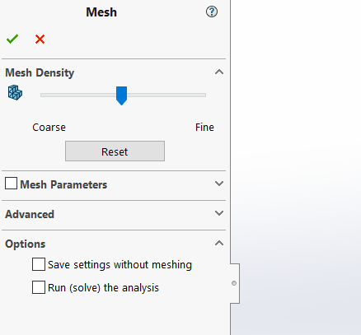
Setup a mesh for the part to allow the stress analysis to run, the finer the mesh the more accurate the stress analysis will be however the longer it will take to solve the problem. Ensure that the mesh is set the same for each scenario to ensure a constant result. Click the tick and wait for the part to mesh.

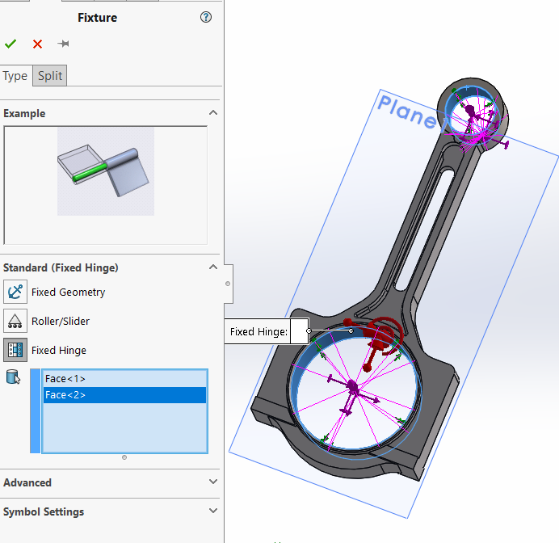
Add a hinged fixture onto the inner surface of where the crank and gudgeon pin would be connected too, this will allow the program to solve the problem in the correct way and stop it from failing.
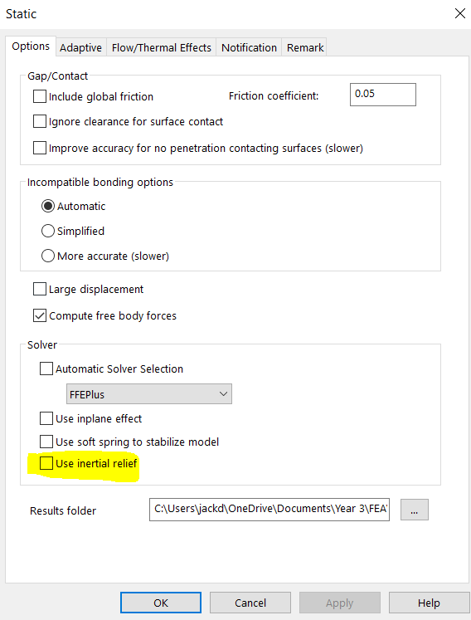
Right click on the run property and scroll down to properties, this will bring up the screen shown to the left. Untick the highlighted selection to allow the previous fixtures to work in the correct way. Having this ticked still will mean it is calculated incorrectly or the simulation will fail.

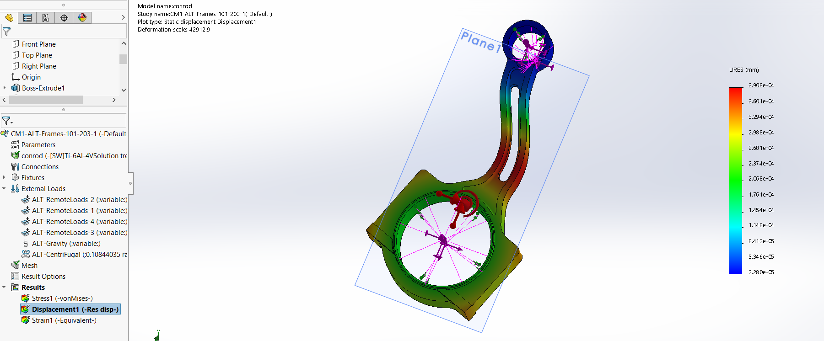
Run the analysis and double click displacement tab under the results to show how much the conrod has bent and deformed. The main part to look at is the scale to the right-hand side of the model, this is the indicator of how much the rod has been bent.

Results
To compare results the displacement will be used for each this will give an indication of the deformation and a large number of deformation will mean the conrod has failed and the engine will no longer work.
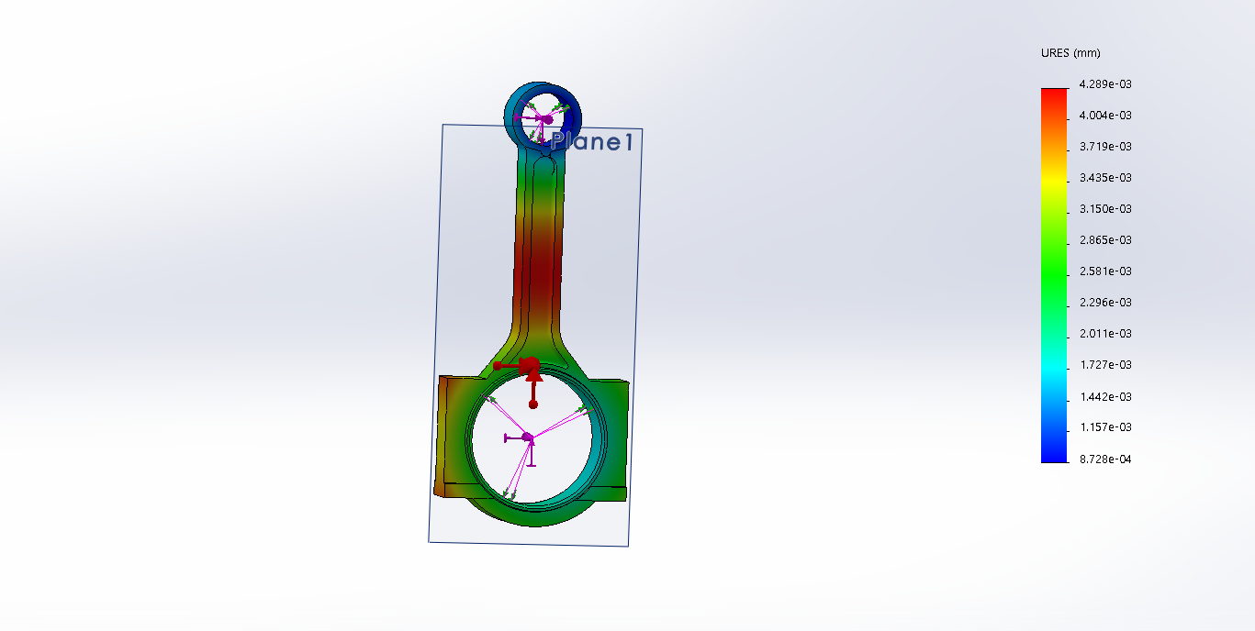
The first basic stress analysis on the original conrod at 45,000N being applied to the top of the piston. As shown by the results the amount of movement is very small and there is minimal effects being taken place on the con rod. It is more than adequate to take this amount of force. The maximum amount of movement within the conrod is a maximum of 0.2mm of deflection.
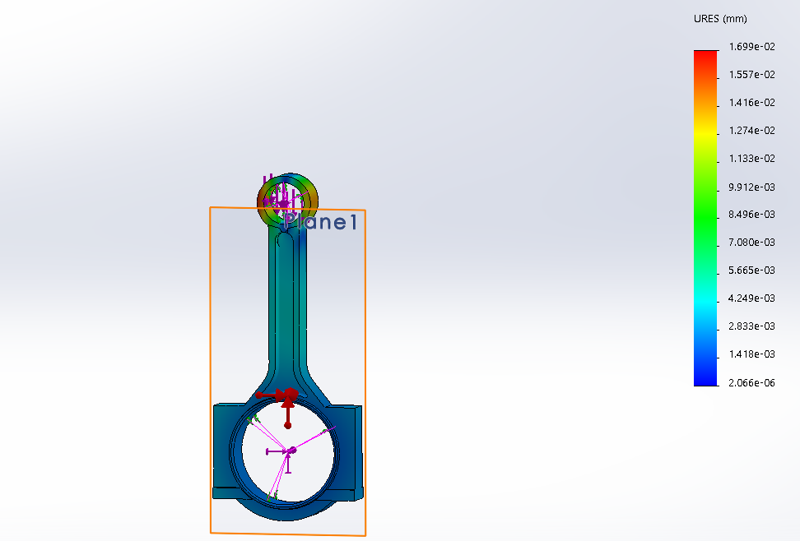
To modify the next scenario more boost was added to the engine meaning the forces that have been exerted on the top of the piston is at 90,000N. This would see more deflection in the section as before however solidworks has calculated it as a higher resistance, this may be due to several reasons such as material not being assigned correctly.
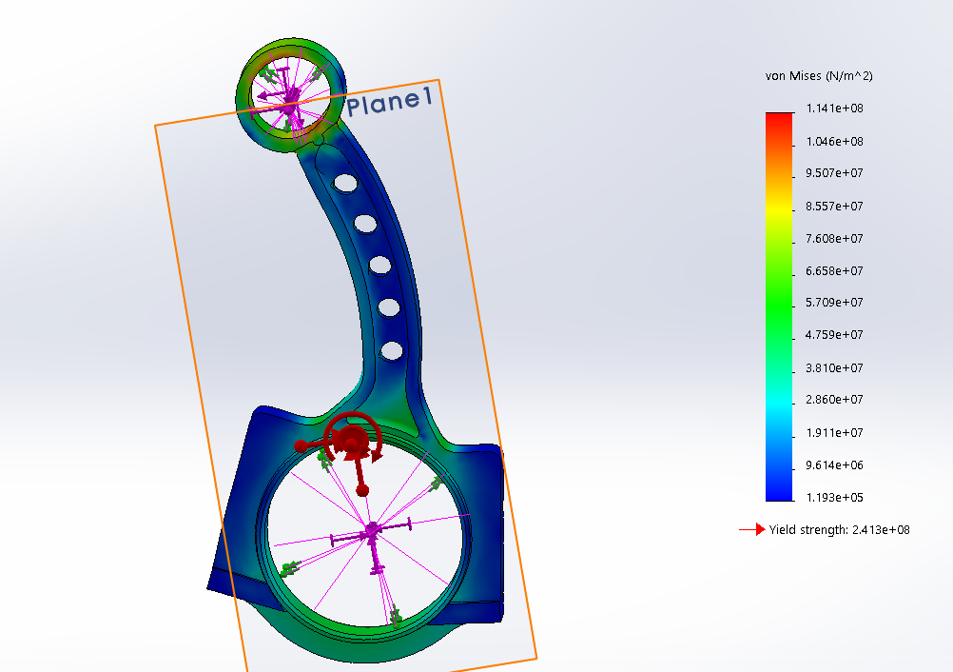
This is with a modification to the conrod where there are holes drilled through the centre to try and reduce weight, however due to user error this was calculated using the stress factors however as this shows there isn’t too much stress being exerted through the centre where the cuts have been applied, this may be due to the fact there are no sharp edges present meaning there isn’t an obvious point of cracking.

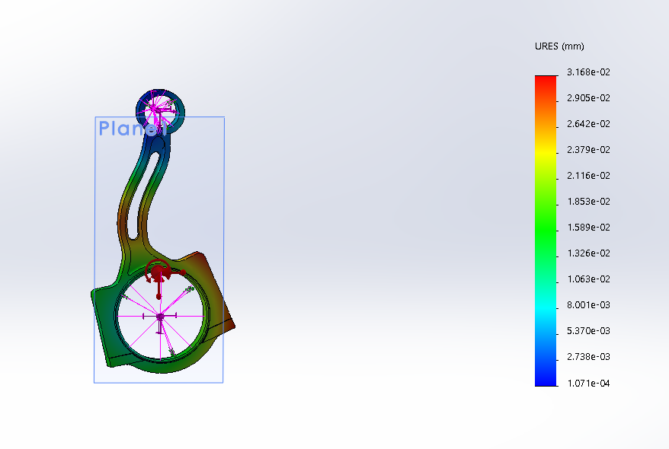
As the holes in the centre didn’t make too much difference to the conrod, more of the centre was taken out but sticking with curved edges where there are less likely areas for cracking. A force of 45000N was added to the top of the piston. This material was a factory steel along with the previous runs. As shown the deflection on the conrod has increased as expected but isn’t quite at its breaking point. The part however will fatigue quicker and fail sooner than the factory product. The results show that there is a maximum deflection of 0.427mm
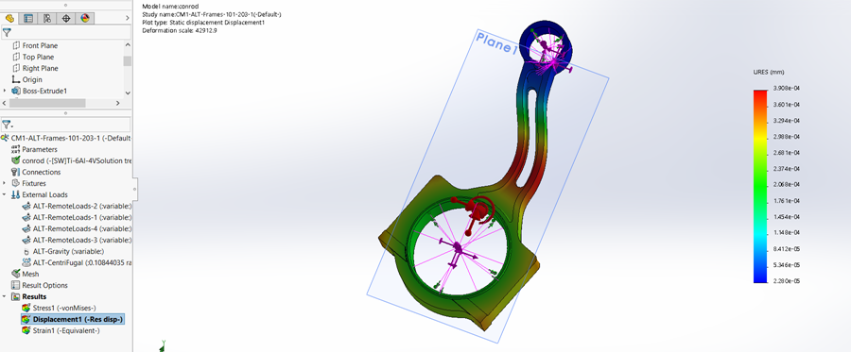
This run the material of the conrod was changed to titanium rather than. The titanium has the name of TI-6AI-4V. (Kirkham-Jones, 2019) Which is a common material used on conrods that have been made from titanium. A force of 45,000N was added to the top of the piston. The max amount of deflection that’s occurred was 0.0715mm.
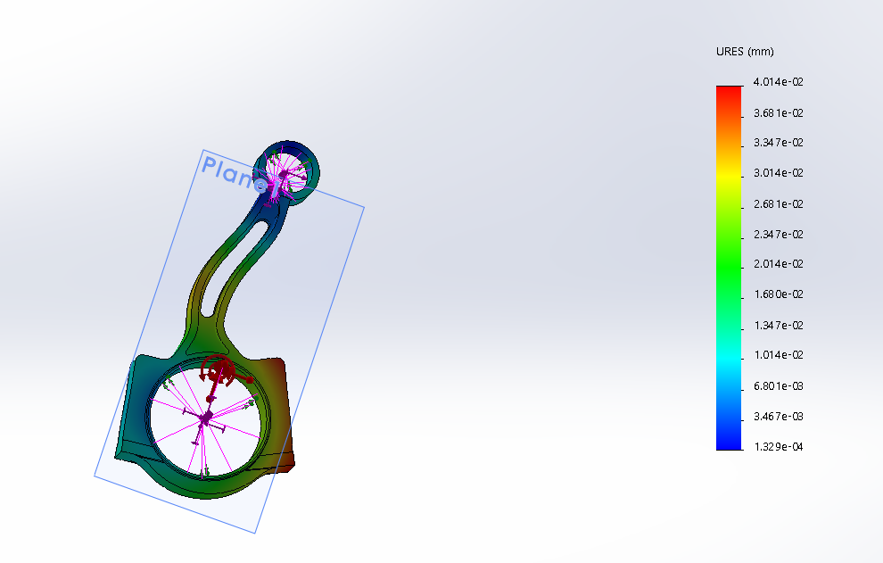
This material was still titanium, however there was a force of 90,000N being applied to the top of the piston to represent the car running more boost pressure. The maximum amount of deflection that occurs during this run is 0.542mm.

Results
The results show that the conrod is more than adequate for the job that it has to be used for. The amount of force that is being added to the top of the piston (45,000N) is accurate to the amount of force that is added to the topo of the piston within the real engine. This was calculated during an assignment that was given out by Malcom in an engine design assignment, this was then used within the simulations as an accurate representation. The addition force is then added, during a possible remap of the vehicle to see how the conrod will take the extra amount of boost and it shows that it shouldn’t have too much problem with the extra amount of boost added in the engine. The results then show that adding cut outs into the simulation make the conrod weaker and therefore effect the end safety limits, however it does show that there shouldn’t be any kind of breakages during the combustion cycle just a less durable engine part. However, in a race application this may be a suitable modification to make as there is less rotational inertia meaning a freer revving engine and a race engine is quite often rebuilt so durability and cost aren’t a bit issue.
The titanium rod makes the rod a lot stronger than the steel rod. In fact, the results show that a cut titanium rod is the strongest scenario with the least amount of deflection, therefore if the cost isn’t an issue it is the conrod to choose allowing the user to tune the engine to a much higher level with less amounts of deflection and therefore a more durable part.

References
Gunnell, J., 2015. Chicago Auto Show Display takes 1.0L EcoBoost Apart. [Online]
Available at: https://l.facebook.com/l.php?u=https%3A%2F%2Fwww.enginebuildermag.com%2F2015%2F06%2Fchicago-auto-show-display-takes-1-0l-ecoboost-apart%2F%3Ffbclid%3DIwAR0YJb6xIqLzI0i8bOSnS_jkRGubnlQ9iDgE4mJnrXhZaBis6DNVXuSl610&h=AT2lSR0NO9Zh-WdaqBMUJHWANr1hBi_eEQjhokMPu
[Accessed January 2019].
Industries, P., 2014. Materials Used in Manufacturing of Connecting Rod. [Online]
Available at: www.preciousind.com/connectingrod-manufacturing-materials.php
[Accessed 01 2019].
Kirkham-Jones, M., 2019. Conrod Materials [Interview] (January 2019).

One Drive Link
https://uowtsd-my.sharepoint.com/:f:/g/personal/jhazlewood_146235_student_uwtsd_ac_uk/EsINinO9BN9CmAQpLAZFzpUB2iVUp1ivf3FwiPq05gUQwg?e=AXestB

