Student Name: Elena Trasnea
Student Number:2332284
Changemakers: Building your Personal Brand for Sustainable Employment (BMHP5015_BIRM)
Tsiwani Khumalo
Component 2: Assignment (Report)

1. Introduction
Healthcare Assistants play a vital role in supporting patient wellbeing and assisting healthcare professionals in delivering safe and effective care within the NHS (NHS England, 2019). Healthcare Assistants support nurses and other healthcare professionals in delivering high-quality patient care within hospitals, care homes, and community settings. This report focuses on the Healthcare Assistant role within the National Health Service (NHS), analysing the employability skills required for the position and evaluating my own current skills in relation to these requirements. The report will also develop an action plan outlining how I can improve my professional skills and progress towards achieving this career goal. In addition, the report will explore how building a strong personal brand, developing a professional identity, and creating a professional network can support successful employment in the health and social care sector. Healthcare Assistants play a vital role in supporting patient wellbeing, assisting with daily care activities, and ensuring that healthcare services operate efficiently (Health Careers, 2024).
2. Job Description and Person Specification
Healthcare Assistants work closely with nurses, doctors, and other healthcare professionals to provide direct support to patients. Typical responsibilities include helping patients with personal care, monitoring vital signs, assisting with mobility, supporting patients with eating and drinking, and maintaining accurate patient records (NHS Health Careers, 2024). In many NHS settings, Healthcare Assistants also help maintain a safe and clean environment for patients and support communication between patients and the healthcare team.
According to NHS job descriptions, key skills required for Healthcare Assistants include communication skills, teamwork, empathy, patience, and attention to detail. Healthcare Assistants must also demonstrate compassion and a strong commitment to patient-centred care, which is a core value of the NHS (NHS England, 2023). Employers often require candidates to have relevant health and social care training, practical experience in caring roles, and the ability to work effectively in a multidisciplinary healthcare team.
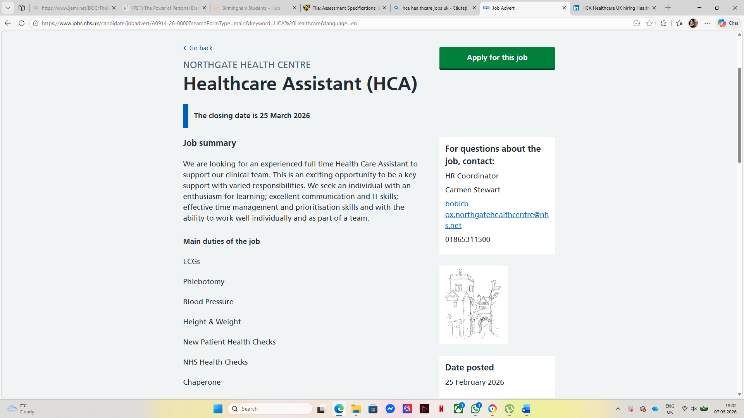
Current NHS job advertisements highlight that Healthcare Assistants are responsible for supporting clinical teams and performing tasks such as monitoring blood pressure, conducting ECGs, and assisting with patient health checks (NHS Jobs, 2026).
3. Analysis of Employability Skills Required for the Healthcare Assistant Role
Healthcare Assistants require a range of employability skills in order to provide safe and effective patient care within health and social care settings. One of the most important skills is communication. Healthcare Assistants must communicate clearly with patients, families, and members of the healthcare team to ensure that patient needs are understood and appropriate care is delivered. Effective communication also helps to build trust and improve patient experience (Skills for Health, 2023).
Another essential skill is teamwork. Healthcare Assistants work closely with nurses, doctors, and other healthcare professionals as part of a multidisciplinary team. The ability to collaborate effectively with colleagues ensures that patient care is coordinated and delivered efficiently (NHS Health Careers, 2024). Teamwork is particularly important in busy healthcare environments where staff must support one another to maintain high standards of care.
Empathy and compassion are also key employability skills for Healthcare Assistants. Patients may experience pain, anxiety, or vulnerability while receiving care, and healthcare staff must be able to demonstrate understanding and emotional support. Compassionate care is considered a core value within the NHS and plays a vital role in improving patient wellbeing (NHS England, 2023). Strong collaboration and communication between healthcare staff are essential for maintaining high standards of patient care and improving healthcare outcomes (Health Foundation, 2023).
Evaluation of My Own Skills Against the Healthcare Assistant Role
Evaluating my current skills in relation to the Healthcare Assistant role is important in understanding how prepared I am for this position and identifying areas where I need further development. Healthcare Assistants are expected to demonstrate strong communication, teamwork, compassion, and organisational skills in order to provide effective patient care (NHS Health Careers, 2024). One of my key strengths is communication. Through my studies in health and social care and my experience working with people, I have developed the ability to communicate clearly and respectfully with others. Effective communication is essential in healthcare environments because it ensures that patients feel supported and that important information is shared accurately with healthcare professionals (Skills for Health, 2023). Another strength I have developed is empathy and compassion. Working in health and social care requires an understanding of the emotional and physical needs of patients. I believe that showing kindness, patience, and respect can help patients feel more comfortable and supported during difficult situations. Compassion is recognised as a core value within the NHS and plays an important role in delivering high-quality care (NHS England, 2023). However, there are also areas where I would like to improve. For example, I would like to develop stronger clinical skills and practical healthcare experience, such as monitoring vital signs and supporting patients with different care needs. Gaining additional training, volunteering opportunities, and practical experience will help me develop these skills further and prepare me for working effectively as a Healthcare Assistant.
Health and Social Care Experience and Qualifications
Developing relevant experience and qualifications is essential for preparing for a role as a Healthcare Assistant. Employers within the NHS often seek candidates who have completed relevant health and social care training and have experience working with people in supportive or caring environments (NHS Health Careers, 2024). These experiences demonstrate that candidates understand the responsibilities involved in providing patient care and supporting healthcare professionals. Through my studies in health and social care, I have developed a strong foundation of knowledge regarding patient care, safeguarding, and professional practice. Studying this subject has helped me understand the importance of patient-centred care, effective communication, and maintaining professional standards when working in healthcare environments. Education and training play an important role in preparing individuals for healthcare roles because they provide both theoretical knowledge and practical skills that are essential for safe and effective care (Health Education England, 2023). In addition to academic learning, practical experience is extremely valuable when developing employability within the healthcare sector. Volunteering or working in care settings allows individuals to develop confidence when interacting with patients and healthcare professionals. It also helps develop important interpersonal skills such as empathy, patience, and teamwork. Continuous professional development is important within healthcare professions because the healthcare workforce must continually update its knowledge and skills to respond to changing healthcare needs (World Health Organization, 2022).
Building My Personal Brand and Professional Identity
Building a strong personal brand is increasingly important for individuals seeking employment within the health and social care sector. A personal brand reflects an individual’s professional values, skills, and reputation, and it helps potential employers understand what a candidate can contribute to an organisation (Pawar and Gandhi, 2016). For someone pursuing a career as a Healthcare Assistant, developing a professional identity based on compassion, professionalism, and reliability can significantly improve employability. One way to build a personal brand is by demonstrating professionalism through education, training, and practical experience. Healthcare employers value individuals who are committed to continuous learning and who demonstrate a strong understanding of patient-centred care. Developing professional behaviours such as effective communication, empathy, and teamwork can strengthen a person’s professional identity within healthcare environments (NHS England, 2023).
Another important element of personal branding is maintaining a professional online presence. Platforms such as LinkedIn allow individuals to highlight their qualifications, training, and experience while also connecting with healthcare professionals and organisations. Networking with professionals within the healthcare sector can provide valuable opportunities for learning, mentorship, and career development.
Additionally, volunteering, attending training courses, and engaging with healthcare communities can further strengthen an individual’s personal brand. These activities demonstrate commitment, motivation, and a willingness to develop professionally. By building a strong personal brand and professional identity, individuals can improve their chances of securing employment within the healthcare sector and progressing in their careers.
Value I Can Add to the Healthcare Assistant Role
When applying for a Healthcare Assistant role, it is important to consider the value that an individual can bring to the organisation. Employers within the healthcare sector often seek candidates who not only meet the required qualifications but also demonstrate personal qualities that support high standards of patient care. My personal strengths and professional values could allow me to contribute positively to this role. One of the key strengths I can bring to the Healthcare Assistant role is my commitment to compassionate and patient-centred care. Patients often experience vulnerability, discomfort, or anxiety while receiving healthcare services. Demonstrating empathy, kindness, and patience can help patients feel supported and respected. Compassionate care is recognised as one of the core values of the NHS and is essential in delivering high-quality healthcare services (NHS England, 2023).
Another value I can add to this role is my strong motivation to learn and develop professionally. The healthcare sector is constantly evolving, and healthcare professionals are expected to continuously improve their knowledge and skills. Being open to learning and participating in training opportunities can help improve patient care and support professional development (Health Education England, 2023).
In addition, I believe that my communication and teamwork skills can contribute positively to healthcare environments. Healthcare Assistants work closely with nurses, doctors, and other professionals, and effective collaboration is essential for ensuring safe and coordinated patient care. Overall, my willingness to learn, compassionate approach to patient care, and ability to work collaboratively with others represent my unique contribution to the Healthcare Assistant role.
Action Plan and Timeline for Developing Skills
Developing the necessary skills to become a Healthcare Assistant requires a structured action plan and a clear timeline. Setting realistic goals over a number of years can help ensure that individuals gradually develop the knowledge, experience, and professional skills required for employment within the healthcare sector. Career planning is an important process because it allows individuals to identify the steps required to achieve their professional goals and improve their employability (Cottrell, 2019).
In the short term, my focus will be on completing my current health and social care studies and continuing to develop essential employability skills such as communication, teamwork, and empathy. These skills are fundamental within healthcare environments because they support effective collaboration between healthcare professionals and improve the quality of patient care (NHS Health Careers, 2024).
Within the next two to three years, I plan to gain additional practical experience through volunteering, training opportunities, and entry-level healthcare roles. Practical experience is extremely valuable because it allows individuals to apply theoretical knowledge in real healthcare settings and develop confidence when working with patients.
Over the longer term, I intend to continue developing my professional skills through further training and continuous professional development. Healthcare professionals are expected to update their knowledge regularly in order to maintain high standards of care and respond to changes within the healthcare system (Health Education England, 2023).
By following this action plan and timeline, I will be able to gradually develop the skills, knowledge, and experience required to successfully pursue a career as a Healthcare Assistant.
Resources Needed to Develop My Skills
Achieving my career goal will require access to various resources that support learning and professional development. Education and training are among the most important resources for developing the knowledge and competencies required for healthcare roles. Participating in health and social care courses, workshops, and training programmes can help individuals develop both theoretical understanding and practical skills.
Another valuable resource is practical experience within healthcare environments. Volunteering opportunities and work placements provide individuals with the chance to develop interpersonal skills, build confidence when interacting with patients, and gain a better understanding of how healthcare organisations operate. These experiences can also help individuals build professional networks that may support future employment opportunities.
Mentorship and guidance from experienced healthcare professionals can also be an important resource. Learning from professionals who already work within healthcare settings can provide valuable insights into the expectations and responsibilities of healthcare roles. Mentors can also provide advice on career progression, professional development, and the skills required for success within the sector.
Finally, digital platforms such as professional networking websites, healthcare career resources, and training platforms can help individuals access information about career opportunities and professional development. Using these resources effectively can support career progression and help individuals achieve their employment goals.
Communicating My Skills to Potential Employers
Effectively communicating professional skills to potential employers is an important part of gaining employment within the healthcare sector. Employers need to clearly understand a candidate’s qualifications, experience, and personal qualities in order to assess their suitability for a particular role. One of the most common ways to present professional skills is through a well-structured curriculum vitae (CV) and a tailored cover letter. These documents allow candidates to highlight their education, training, and relevant experience in a clear and professional manner (Cottrell, 2019).
In addition to written applications, digital platforms such as LinkedIn can also be used to present professional skills and develop a professional network. Maintaining a professional online profile allows individuals to share their achievements, qualifications, and career interests while connecting with healthcare professionals and organisations. Networking through professional platforms can increase visibility and create opportunities for employment within the healthcare sector. Another important way to communicate skills to employers is through interviews and professional interactions. During interviews, candidates can demonstrate their communication skills, professionalism, and motivation for working in healthcare.
Overall, clearly communicating professional skills through CVs, online profiles, and interviews can significantly improve employment opportunities within the health and social care sector.
Conclusion
This report has explored the role of a Healthcare Assistant within the UK health and social care sector and analysed the employability skills required for this position. The report evaluated my current skills in relation to the requirements of the role and identified areas for further development. It also examined how relevant education, training, and practical experience can support career progression within healthcare.
In addition, the report highlighted the importance of developing a strong personal brand, building professional networks, and effectively communicating professional skills to potential employers. Creating an action plan and identifying the resources needed for professional development are essential steps in preparing for future employment.
References
Cottrell, S. (2019) Skills for Success: Personal Development and Employability. London: Palgrave Macmillan. Available at: https://study.sagepub.com/skillsforsuccess5e (Accessed: 7 March 2026).
Health Education England (2023) Education and training for the NHS workforce. Available at: https://www.hee.nhs.uk/our-work/education-training (Accessed: 20 March 2026).
Health Foundation (2023) The healthcare workforce in the UK. Available at: https://www.health.org.uk/news-and-comment/charts-and-infographics/the-health-care-workforce-in-the-uk (Accessed: 20 March 2026).
Health Careers (2024) Healthcare Assistant. Available at: https://www.healthcareers.nhs.uk/explore-roles/healthcare-support-worker/roles-healthcare-support-worker/healthcare-assistant (Accessed: 20 March 2026).
NHS England (2019) The NHS Long Term Plan. Available at: https://www.longtermplan.nhs.uk (Accessed: 20 March 2026).
NHS England (2023) The NHS Long Term Workforce Plan. Available at: https://www.england.nhs.uk/long-read/nhs-long-term-workforce-plan/ (Accessed: 17 March 2026).
NHS Jobs (2026) Healthcare Assistant (HCA) – Northgate Health Centre. Available at: https://www.jobs.nhs.uk/candidate/jobadvert/A0914-26-0000 (Accessed: 15 March 2026).
Pawar, A. and Gandhi, R. (2016) ‘The Power of Personal Branding’, International Journal of Engineering and Management Research, 6(1), pp. 840–847. Available at: https://www.ijemr.net/DOC/ThePowerOfPersonalBranding(840-847).pdf (Accessed: 17 March 2026).
Skills for Health (2023) Core Skills for Healthcare Support Workers. Available at: https://www.skillsforhealth.org.uk/resources/healthcare-support-worker/ (Accessed: 17 March 2026).
World Health Organization (2022) Health workforce. Available at: https://www.who.int/health-topics/health-workforce (Accessed: 20 March 2026).

