UNIVERSITY OF WALES
SAINT TRINITY DAVIS
NAME:MARIA DANIELA ENACHE
STUDENT NUMBER:1916676
PRROGRAME:BA BUSINESS MANAGEMENT
LEVEL 4/TERM 1/GROUP 3
MODULE:COMMUNITY ENGAGEMENT
ASSIGNMENT PART B:REFLECTIVE EVALUATION
TITLE ASSIGNMENT:REFLECTIVE EVALUATION FOR LIDl
LECTURER: MOLLY JACK

REFLECTIVE EVALUATION FOR LIDL

Executive summary
At the end of this part of the raport,i can say that i have tried to do my best within the allocated time.In the report ,i have used the Reflection CYCLE OF Gibbs to describe my feelings,evaluate myself and to prepare an action plan if i have to do the same work again.I can say that improvement of self-management skills,communication and interpersonal skills is needed.The effort would have been better from my end if i were allowed more time to analyse the competitors and their training plan.I could say that the training plan i have prepared earlier would be more detailed if were able to collect more information.At last ,i have concluded on the whole reflection of my work.

Table of Contents
Part B…………………………………………………………………………………………………5
- Introduction……………………………..………………………………………………….5
- Reflection…………………………………………………………………………………….5
  - Description………………………………………..……………………………….5
  - Feelings………………………………………………………………………………6
  - Evaluation………………………………………………………………………….7
  - Analysis………………………………………………………………………………7
  - Conclusion………………………………………………………………………….8
  - Action plan…………………………………………………………………………8
- Conclusion……………………………………………………………………………….…10
Reference list……………………………………………………………………………………11
Appendices…………………….………………………………………………………………..12

Part B
1.0 Introduction
The first part of this report was based on the external analysis of the Lidl supermarket chain with the help of PESTLE Analysis. It also considered the importance of training and development in the betterment of the employees. The role of store manager in Lidl, its requirements and training process was also described. Lidl was familiar to me as I have been working here in the management role now. I will reflect on the communication, self-management and interpersonal skills which I have developed from the experience. I will use the reflective framework of Gibbs to describe the development of these skills and to relate the theoretical knowledge to practice. Later, a conclusion will also be given at the end of this report.
2.0 Reflection
Gibbs reflective cycle is developed on the basis of the triangular model of Boud, and it would be used to evaluate my performance while working on Lidl. The components of the Gibbs Reflective cycle are used in the study in the following manner:
2.1 Description
I made an analysis of the external environment of Lidl in the UK market. The analysis was done to understand the competitive position of the organisation in the supermarket industry. I further looked into the importance of training and development. I chose the role of the store manager in Lidl to understand the criteria and essential training. I prepared some recommendations too regarding the training requirements in Lidl.
It happened when I was working on the external environment analysis of Lidl. When I undertook the job, I looked at the value, vision and the mission statement of the organisation. The organisation has the mission to achieve shared success by offering the customers the best value for their money and to offer the best possible quality goods. So, it happened in the organisation when I gathered information from Lidl. (semanticscholar.org, 2017)
While collecting the information, I was only to collect information there. When I collected the data, the employees and the store manager helped me with the necessary information. Therefore, the employees and the store manager were present among the organisational persons. Except me, none was present when I collected information from the website.
I did the collection of the necessary information regarding the role of store manager. The employees also helped me to know why the organisation has performed so well and what they do for Lidl. So, they supplied me the information, and I collected those for analysis.
The outcome of the situation when I asked the store manager and the employees was the curiosity among the employees. When they came to my objective, they helped me as far as possible, and the outcome was positive.
I was there as a part of the organisation and to collect the necessary information about the store manager role and employee perception.
I wanted to analyse the role of these employees and the store manager. I wanted the manager and the employee to provide me with the information which happened.
2.2 Feelings
I felt encouraged while I was collecting data from the store. The employees and the store manager helped me in every possible way with the information. So, I felt delighted as I was able to gather the information.
I was feeling encouraged to get the opportunity to look at the vast area of research within the supermarket chain and to analyse training and development needs. After the collection of information, I felt satisfied.
The other people, the store manager and the employees felt hesitant to share the information as they did not know about my intention. Therefore, they were feeling hesitant and curious about sharing the information as far as I have understood from the situation. (semanticscholar.org, 2017)
After knowing my intention, the other people are eager to share their views and their personal opinion of the job role. When they came to know my objective of knowing their role in the development of Lidl, they felt encouraged as they are highly motivated to work in Lidl.
I was thinking about the collection of the necessary information as much as possible. I was thinking to collect the information about what the store manager was to do and what training he was provided with. I was also thinking to know about the perception of the employees about Lidl and their job role.
Now, I think the situation has been handled well. The employees were not comfortable in the sharing of their perception and information about their role (Dong et al. 2018). The situation was a little demanding for me to convince them about my objective. The situation now I think is ideal for running the necessary evaluation about training importance.
2.3 Evaluation
The experience of the research of the external environment of Lidl and the importance of training for the role of store manager was new to me. It was a good experience for me to look at the vast environment and to analyse the competitive scenario of Lidl. It was an excellent experience that all the employees helped me with the information. The only bad thing about the experience was that the employees were not able to give me enough time as they were very busy with the day to day activities. I have already mentioned that the employees and the store manager have to manage the busy stores daily, and they were able to give me enough time. (brookes.ac.uk, 2020)
The collection of information from the employees and the store manager went very well. I made an external analysis on the basis of the available data of the organisation's external environment and the status of the other competitors of Lidl. The political, economic and the other scenario of the supermarket industry in the UK, especially after the recession period, was analysed through PESTLE (Mencl et al. 2016). I feel the best part of the work was this analysis. The analysis of the training and development for store managers also went well, and the requirements are also well presented.
I feel the training requirements were not prepared so well. To do this, the analysis of the training provided by the other supermarket operators was also necessary. Therefore, this part did not go that well as per my expectation.
I have contributed to the external analysis positively as per the situation. While considering the complicated situation at the store, the employees also contributed positively.
2.4 Analysis
The analysis of the external environment and employee perception went well because of my communication and interpersonal skills as far as I can understand. I communicated with the store employees very well, and they were convinced through soft-skills. I communicated them with empathy so that they feel relaxed enough to share their views and training experiences with me. Besides, I consider my self-management skills as satisfactory as I have regulated my behaviour and communication process well.
The training requirements were not done very well. As I have already stated, the comparative evaluation of the training provided by other organisations against the store manager role was also required. I did not have that time to contact the store managers of the other organisations (So et al. 2018). Besides, their active participation is also highly doubtful. Therefore, I think the preparation of the training recommendation and the schedule was not very well and detailed. (brookes.ac.uk, 2020)
From this situation, I can make sense that the situation was handled quite satisfactorily, and I can make sense that it required some more time. To understand and prepare a training program for the role of a store manager, the availability of the information was also outstanding. Therefore, comparison with other organisations is also needed. I can further sense that the company will attract more customers if the price remains competitive and if the products are excellent. So far, Lidl has performed very well amidst the budget customers.
The understanding of the economic situation in the UK, where Lidl mainly operates is necessary. Therefore, the knowledge of the supermarket industry and the economic situation of the UK is necessary as it would help to understand the situation.
2.5 Conclusion
I learnt the techniques of communication and interpersonal skills while interacting with the members of the organisation and with the store manager. Besides, the knowledge of analysing the business environment and the organisational situation, the implementation of business strategy tools were necessary. Therefore, I learnt the proper application of PESTLE. Above all, the skills of self-management were the most important while assessing the results of the analysis, controlling emotions and to efficiently interpret the available results. I learnt all these skills while working in this report (Caldwell and Spinks, 2005).
The situation would have been favourable for every employee, the store manager and for me if I had more time to complete the assignment. If the interaction with the employee was possible for some more time, I would have more ease in collecting necessary information. Besides, a personalised interview in a separate place would have made it easier to share the information with me. Besides, if the collection of training information from the other organisation was possible, it would have been easier to prepare a more compact training plan (So et al. 2018).
The skills of interpersonal development and communication are to be developed with the course of time. With a developed interpersonal communication skill, it would be easier to handle this type of situation in the future. With better skills, the interaction in these types of situations would be more natural for me.
I could have done a more detailed analysis of the training plan of the store manager in Lidl. Besides, the collection of information from the employees of Lidl stores would have been more comfortable if they were given a separate place to conduct a personal interview with the employees. Besides, the analysis of the external environment could have been better if I had the time for compact competitor analysis.
2.6 Action plan
If I have to do the same work for the next time, I will develop my interpersonal and communication skills first. I would like to take the personal interview with the store manager and the employees in a separate place. I would do a different analysis of the strength of the other operators in this industry. For that, I would consider the market share of the other operators like Tesco, Cooperative, Aldi and others to determine the external environment of my organisation Lidl (Caldwell and Spinks, 2005). I would also do an interview with the store managers of other organisations to know about the training experience they were provided. On the basis of the collected information from them, I would prepare a more compact and proper training development plan with milestones and evaluation scale.
I would develop the communication and self-management skills to carry on effective communication with the employees of our organisation. The development of this skill will help me to improve my communication skills. First, the resistance to stress should be built by me for carrying on the job. Secondly, developing problem-solving capability would be my second goal. Thirdly, the communication skills would also be practised by me through cognitive behaviour theory (Nguyen-Truong et al. 2018). Time management would be my fourth step in developing self-management skills. According to the Social learning theory, the amalgamation of environmental and cognitive determinants can increase self-management capacity. The process should be followed by me to improve my skill. [Referred to Appendix 1]
To make sure I act differently at the next time, I would prepare a plan showing what I have done and what could have been done better. I would also do the self-evaluation about doing the job more effectively. Thus, I can make sure that the results would be used to activate the next time differently.
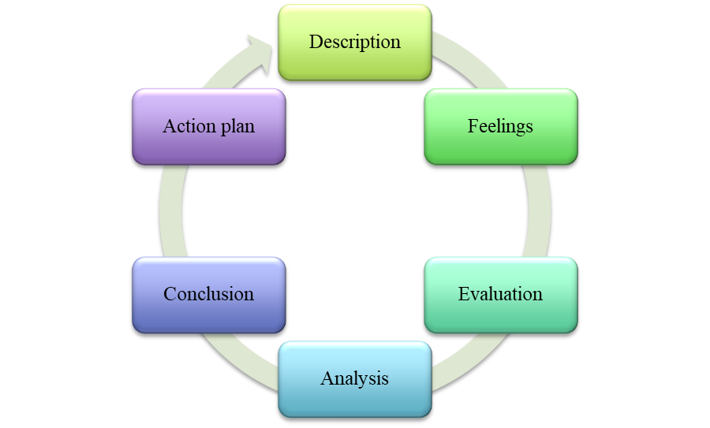
Figure 1: Gibbs reflective Cycle
(Source: Self-created)

3.0 Conclusion
At the end of the report, it can be concluded that I would prepare an evaluation of what I do and what I would do at the next time. I have thoroughly reflected on what I have done, who was present with me, and what my experience was. I have also evaluated myself with a critical perspective. To do things better, I need to improve my self-management skills, communication skills and interpersonal skills. The need for time and further research was felt during the conduct of the study. I felt that additional time was needed to interview the managers of the other organisations to come to know about their training plan. I would have prepared the training plan more accurately with details if the time was enough.

Appendices
Appendix 1: How to develop interpersonal skills


