Drawing on one of the establishments visited, how is both material (‘tangible heritage’) and non-material (‘non-tangible heritage’) aspects of Welsh life represented and how might it develop such representations in the future?

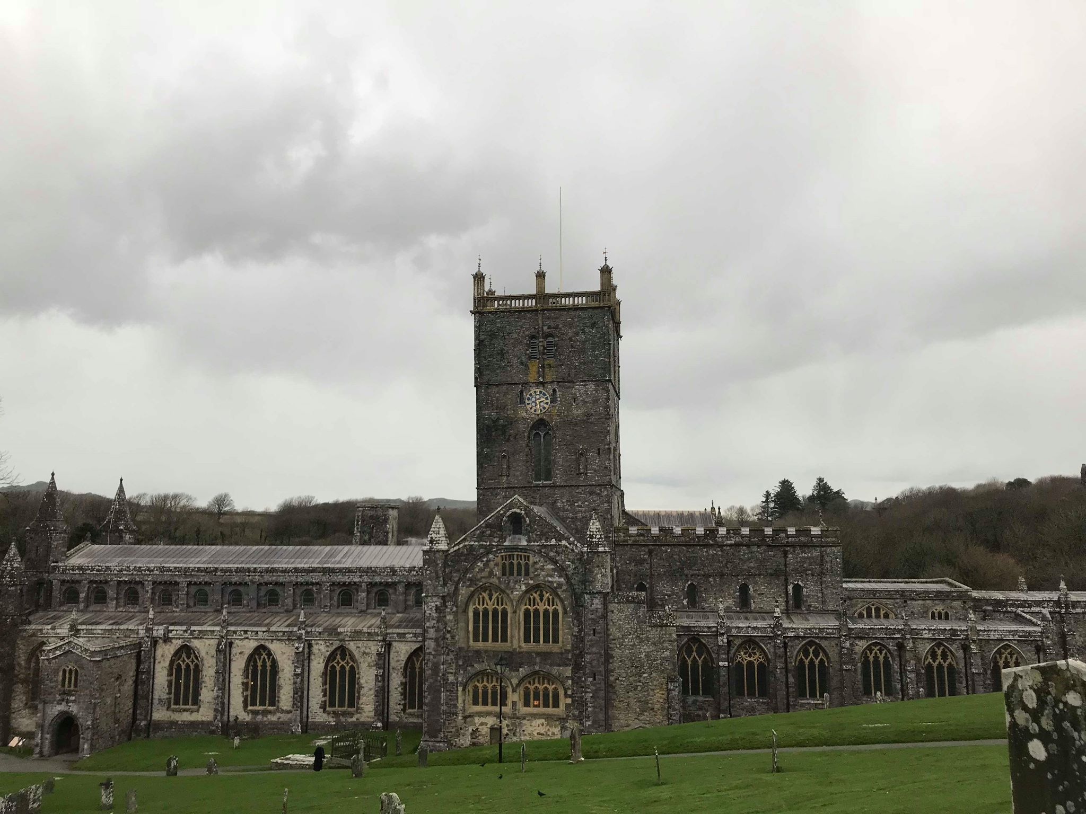
(Picture taken by Ben Andrews 04/12/18)

St David’s, the smallest city in the United Kingdom is located in Pembrokeshire in South West Wales. It is a site which represents both the intangible and tangible heritage of Wales illustrating the Welsh way of life. The city of St David’s itself today is orientated towards tourism to the site. This is evident from the various services that can be found around the city. For example, there is a fishing service, ice cream parlours and many different restaurants around the city. It has embraced and continued to develop its setting of natural beauty with many nearby campsites. Like much of Pembrokeshire, it shows how the economy here has driven the Welsh life towards a more tourism orientated climate. The cathedral and other aspects of St. David’s are all unique in their representation of the Welsh heritage. The cathedral has undergone many changes throughout its existence. For instance, the roof of the church was stripped bare in 1648 by troops of parliament who caused further damages to the cathedral (St Davids Cathedral, n.d.). Today, it plays a major role in the tourism of Wales, and the city of St. Davids attract visitors from all around the world.

Figure 1: City of St. Davids

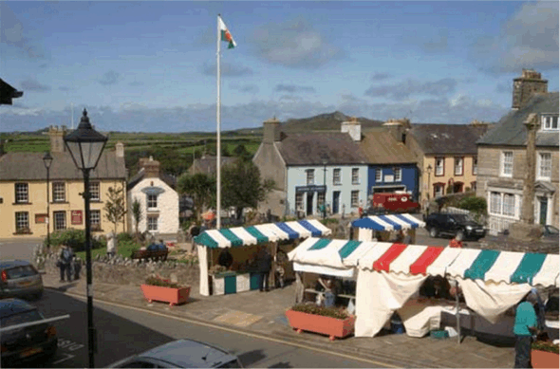
(http://stdavidsinfo.org.uk/st-davids-city/)

Until recently, heritage as a discipline tended to focus more on the tangible aspect of cultural heritage. Tangible heritage is a monument or an artefact that can be held or visited, while intangible culture heritage refers to the non material aspects of heritage.
It was during the 20th century that the intangible culture came into focus, which represented the living culture of human communities, their evolution and the continuing development of these communities (Lenzerini, 2011: 102). As West & Ansall (2010: 12) stated, ‘the history of Wales is written on its landscape’. Symbols such as the daffodil, the red dragon and ancient castles are deeply embedded in the Welsh culture and identity. Monuments such as the castles and cathedrals belong to the tangible heritage of Wales, whilst oral stories such as that of the red dragon and religion with its elements are part of its intangible heritage. All of these are seen in the small city of St. David’s which will be the focus of this report.
St. David’s Cathedral, founded in 589 A.D by St. David, provides an insight into how the Welsh heritage, both tangible and intangible is deeply rooted in religion which has played a significant role in shaping the history of Wales. In the 12th century, Pope Calixtus II declared that two pilgrimages were equivalent to one pilgrimage to Rome (St Davids Cathedral, n.d) thus highlighting the significance of the cathedral as a religious site. However, as a result of its high stature, it made the cathedral a high valued target throughout its life. It has been looted at least ten times by Viking raiders alone (Evans & Wooding, 2007: 274). Moreover, the reliquary at St. David’s was also stripped of the precious metals that adorned it in 1094 (Evans & Wooding, 2007: 270) which meant that the cathedral has suffered a loss of its tangible heritage through the succession of raids and damages caused by it. Bishop Barlow intended to bring an end to the cult of St. David as well as the cathedral that once housed them (Evans & Wooding, 2007).
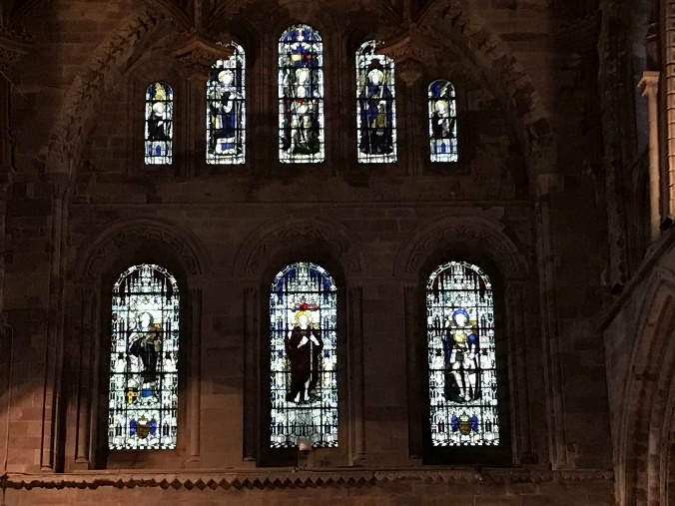
Upon entering the cathedral, visitors are met with large grandiose architecture with a high celling decorated with stain glass windows (left) and is found throughout the cathedral. Similar to the ones shown here, after entering through the north entrance, visitors are met by a local guide who provide a small map and gives information about an app that is available about the site. From this, it is evident that the Welsh culture is being kept alive, as it is being propagated into the modern world through technology.

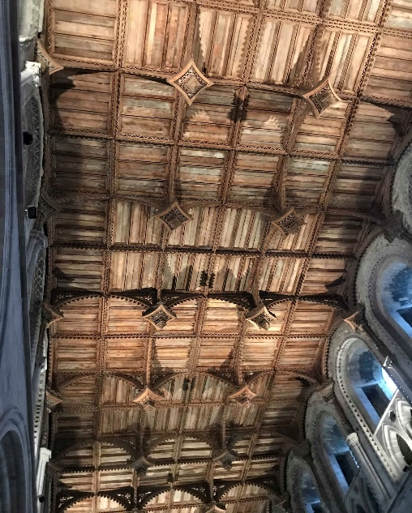
Figure 1: stain glass window (Ben Andrews 04/12/18)

Figure 2: Ceiling at St David (Ben Andrews 04/12/18)

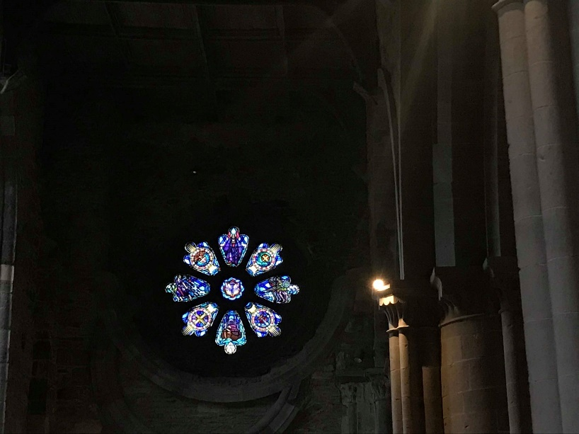
There are many aspects of tangible heritage of Wales found throughout the cathedral. The stain glass window pictured on the right shows different saints. Located within the cathedral is a small museum as shown opposite. The museum has a chronological feel to it, and is extremely compact but nonetheless, has sufficient amounts of tangible heritage displayed. Such artefacts hold significance to the cathedral and the Welsh culture and heritage. To develop their representation further, it may be more potent to spread them around the cathedral with information boards next to them. By doing so, it would encourage the visitors to wander around the cathedral in its entirety rather than creating a hot spot towards the middle. As visitors continue to progress, they encounter different altars around the cathedral (bottom right), and near the centre of the cathedral adoring the walls are recently discovered paintings. The significance of the altar is apparent as they were abundant throughout the cathedral, and poses both intangible and tangible qualities. Subsequently, the religious aspect in association with the altar can be regarded as intangible heritage, as it demonstrated the significance of religion in Welsh culture.
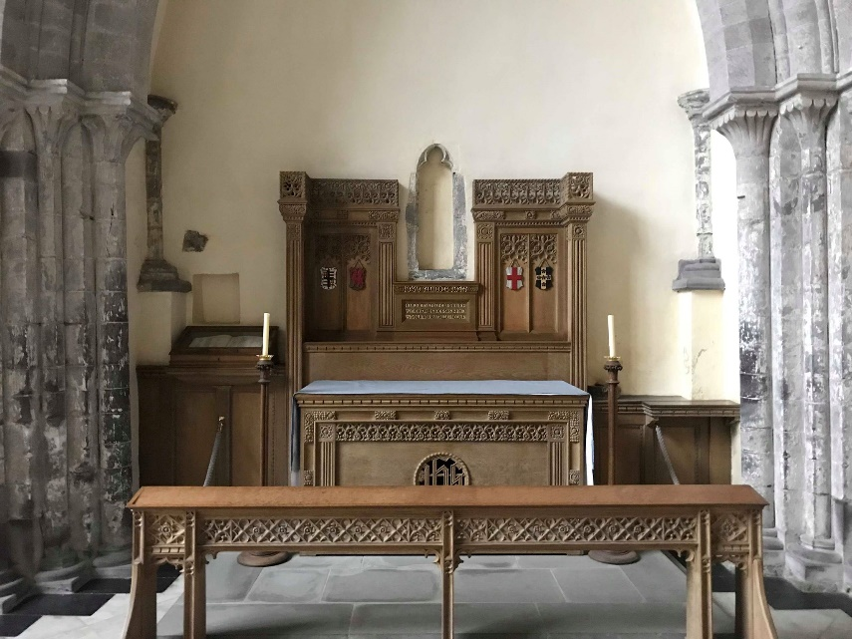
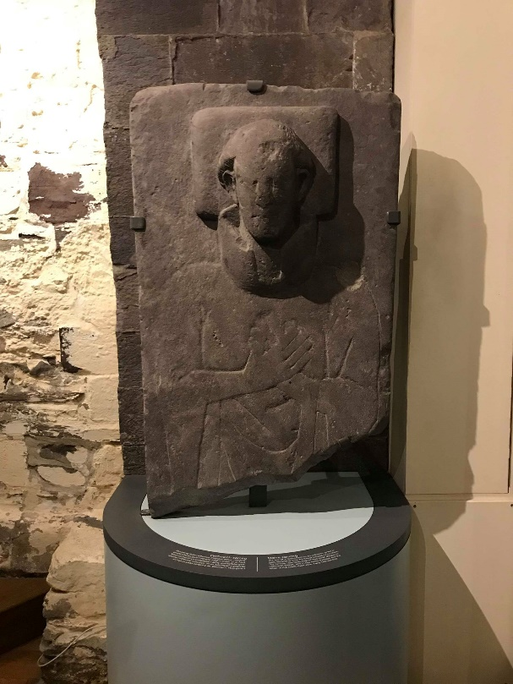

(Figure 4 Alter at St David cathedral (Ben Andrews 04/12/18)

Figure 5 Artifact from museum (Ben Andrews 04/12/18)

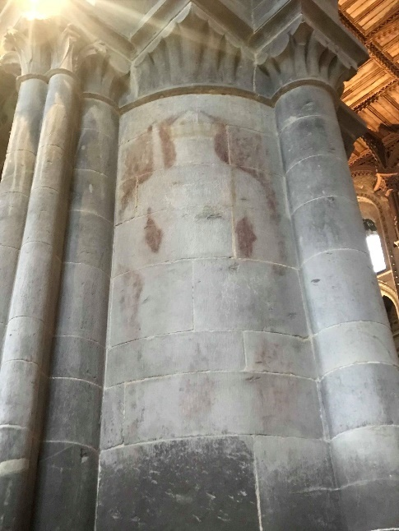
Figure 6 St Davids wall painting and information (Ben Andrews 4/12/18)
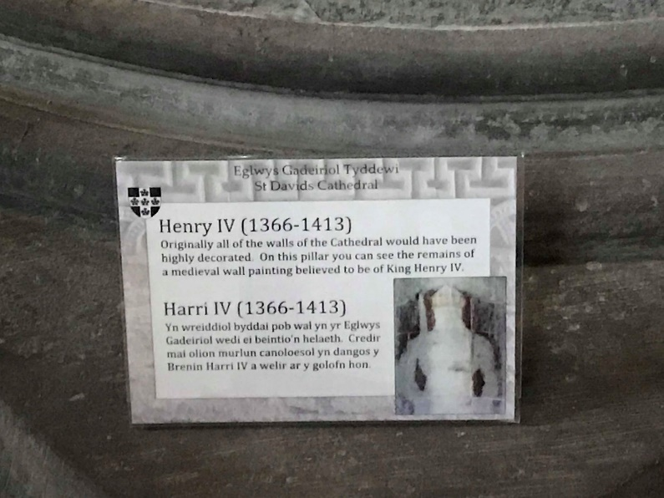

Figure 7 Unknown artwork (Ben Andrews 4/12/18)

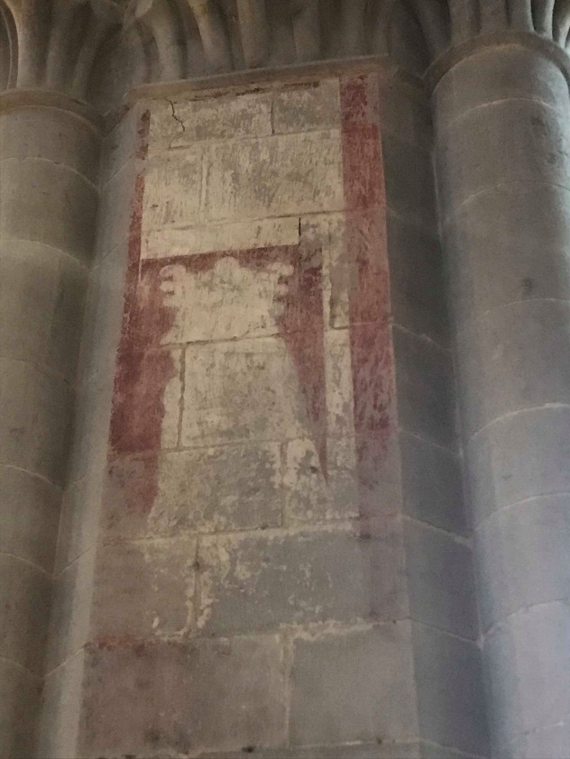
The paintings (above and to the left) depict an
aspect of Welsh life which is not only religious, but also political in its nature due to England conquering Wales in the 14th century. Moreover, the association between the King and his representation within a holy place reinforces the idea of the divine right of kings (Collins Dictionary, n.d.). As such, the artwork is tangible and intangible in a sense that it is clearly visible to us, but the meaning is not clear due to the what it may once have symbolised in Welsh history. Today, the cathedral suffers from poor representation of these iconographic pieces, with the information on them being extremely limited. For instance, the second depiction (left) had no information that was visible to accompany it. Moreover, the signage by the painting paled in comparison to the information given by the local guide present who was able to demonstrate a more in depth description about them. He explained how the paintings were discovered during a recent renovation of the cathedral. The lack of information on the boards provide evidence to the fact that not much research had been done on this recent discovery. In order to develop and maintain such representations, it is important that they are documented immediately to be studied and researched.

There are a number of tombs around the cathedral as displayed below. These tombs represent the cathedral’s long history. Some of them are the only surviving examples left. Moreover, as shown in Figure 7, some of the tombs at the cathedral are positioned in an awkward manner to make it convenient for its regular worshippers. A number of them had little to no documentation as to who is buried there (below) or their lives prior to their deaths, which is further enhanced by their awkward positioning. Although the cathedral is still being used as an active place of worship, the positioning of these tombs must be taken into consideration as it shows respect to the dead and the Welsh ancestors. The tombs are examples of how the Welsh way of life interpreted the treatment of the dead by burying those who were held in high esteem such as St David. However, when Edward I came to visit the Cathedral in 1284 (Evans & Wooding, 2007: 278), he took the head of St. David and other remains at the site and brought them back to England to be put on display.

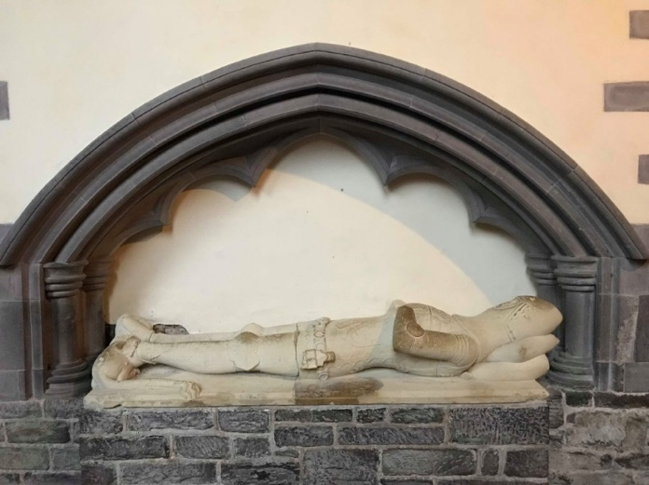
Figure 8 Tomb at Cathedral (Ben Andrews 04/12/18)
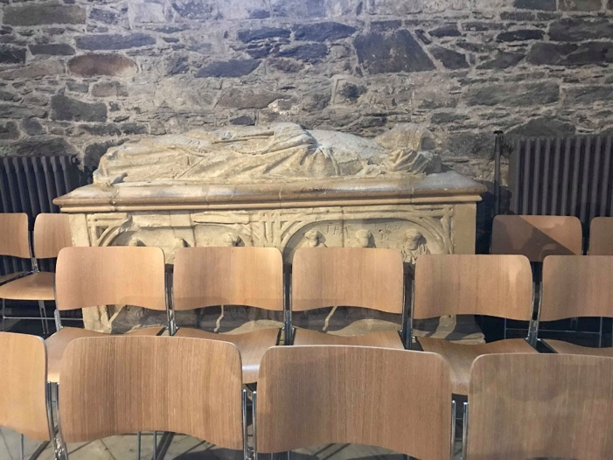
Figure 9 tomb at St Davids (Ben Andrews 04/12/18)

It was described as the English taking the Welsh glory and pride (Burry, 1283). The loss of such a significant aspect of Welsh life makes it harder to be developed in the future due to the speculation now as to where the remains whereabouts now. These also represent another issue with Welsh life from this time around the cult of St. David (Evan & Wooding,
2007) due to the damage done to the cathedral by William Barlow. He served as the Bishop from 1536-47 AD (Evans & Wooding, 2007:22) and was determined to see the cathedral be de-established as his views on St. David and the Welsh were very negative (Evans & Wooding, 2007:23). Moreover, he did not see the potential for Wales within Protestantism.
Furthermore, in 1538 he stripped the jewels from the shrine and confiscated other relics in order to counter act superstition (St Davids Cathedral, n.d.). Subsequently the damage done to the shrine at St. Davids signifies another loss of tangible heritage although the shrine has since been restored as shown below in before and after images.
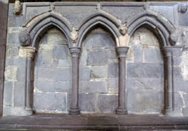
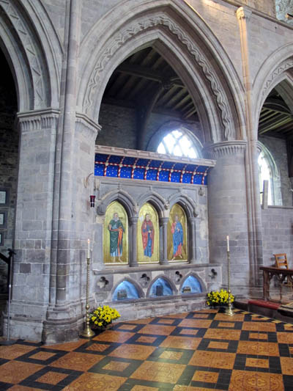
(St David Cathedral)

Due to the restoration effort that was undertaken in 2012 (St Davids Cathedral, n.d), it has allowed a small part of the cathedral to regain a lost aspect of the church. It is a prime example of the work that could be undertaken for future representations. Alongside this, work has also been done in an attempt to preserve a neighbouring site that is also linked with the figure of St David which is his mother. St Non.


The Chapel of St Nons (left) today pales in comparison to the cathedral. As pictured above, the chapel is now baron and shares a field with livestock. It represents a unique aspect of Welsh life here because the location is so removed from the city of St. David coupled with the different architecture of the chapel. The building is north-south facing as opposed to the other chapels at the time (St. Nons Retreat, n.d.). It is also situated near the spring where St. Non allegedly gave birth to St. David, (St Nons Retreat, n.d.) thus its location represents an aspect of Welsh folklore. There is little information around the site of St. Nons, however, few documents such as poetry have been written in Welsh about St. Nons which highlights the rich intangible heritage of Wales. As a result of the chapel being so far from the town, it is difficult to ascertain how it might be preserved for the future as there is already existing measures in place such as the fence as seen in the image above. More could be done in the city of St. David to promote the site which is at risk of being lost through time and it would be a loss of both tangible and intangible heritage. Furthermore, there is another chapel which was built in 1934 nearby with stain glass windows (St. Nons Retreat, n.d.) that features other saints that are associated with things such as bountiful harvests demonstrating some of the core aspects of Welsh life in this area. The chapel has been under the protection of Cadw. Therefore, it is evident that work is being done at St Nons to conserve the site.

In conclusion, the city of St. David with its cathedral, St. Nons and the city itself, each represent key aspects of Welsh heritage, both tangible and intangible. This has been embraced by the local community to promote the national heritage of Wales, which
attracts a large numbers of tourists that are able to visit the cathedral and St Nons to gain a better perspective on Welsh history, culture and heritage. The cathedral represents the significance of religion in Welsh history, and the impact that St David had on Welsh life. Throughout the years, the cathedral has undergone significant change through the loss of tangible heritage. Moreover, as the cathedral has had to undergo renovation while still being an active cathedral, it kept the Welsh culture alive as religion was deeply embedded in its culture. Furthermore, to engage visitors and spark their interest in Welsh history and heritage with the use of information boards will help develop the representations of Welsh culture. Without a doubt, the city of St. David and its elements represent both the intangible and tangible heritage of Wales and must be preserved and developed for the future.

Bibliography

Cannon, J. ; Hargreaves, A.( 2009) The Kings and Queens of Britain(Oxford university press)

Chronical of Burry st Edmund , ed gransden, 85, and no .2; waverly Annals s.a. 1283, ed, laurd Annals monestatic, vol. 2, 401.

Collins Dictionary. (n.d.). Divine right of kings definition and meaning | Collins English Dictionary. [online] Available at: https://www.collinsdictionary.com/dictionary/english/divine-right-of-kings [Accessed 30 Dec. 2018].

D. Morgan, (2009) Calvinism in Wales: c.1590-1909, ( Welsh Journal of Religious History), Vol. 4, p22-36

White, E (2011) Key Census Statistics for Wales [web site article]: https://www.ons.gov.uk/peoplepopulationandcommunity/populationandmigration/populationestimates/bulletins/2011censuskeystatisticsforwales/2012-12-11#tab---Religion [DOA:06/12/18]

Evans, J. and Wooding, J. (2007). St David of Wales. Cambridge: Cambridge University Press.
http://www.stnonsretreat.org.uk/history.html [Accessed 29 Jan. 2018].

Lenzerini, F (2011). Intangible Cultural Heritage: The Living Culture of Peoples. European Journal of International Law, Volume 22, Issue 1. Pp 101-120.

Smith, L. (2006) Uses of heritage (New York, Routledge)

St Nons: https://cadw.gov.wales/daysout/stnonschapel/?lang=en [DOA 1/1/18]

St. David’s Cathedral (n.d). 1869. The Sunday at home : a family magazine for Sabbath reading, (804), pp. 613-616#
Stdavidscathedral.org.uk. (n.d.). St Davids Cathedral: The Gatehouse. [online] Available at: http://www.stdavidscathedral.org.uk/index.php?id=723 [Accessed 27 Dec. 2018

Stephen, N. (1960) Anglicanism (Oxford Penguin)
West, S and J. Ansell (2010) ‘A History of Heritage’ in Understanding Heritage in Practice (Understanding Global Heritage) S. West (ed.). Manchester: Manchester University Press.

