Course Code: Module BMPO 7005
Assignment: Leadership & the individual
Submitted: 3rd May 2022
Word Count: 5326

Programme: MSc Policing (Operational and Strategic leadership)
Submitted by: Justin Evans
Student number: 2016153
- Contents
- Abstract
- Introduction
- Reflective Practice
- Leadership through the Covid Pandemic
- Reflections on leadership through the Covid Pandemic
  - Feelings
  - Evaluation
  - Analysis
  - Conclusion
  - Action Plan

- Management and Leadership

- Blake and Mouton Managerial Grid

- Tannenbaum-Schmidt Leadership Continuum

- Action Centered Leadership

- Situational Leadership

- Goleman’s six leadership styles and Emotional Intelligence
- Motivation & Transformational Leadership

- Leadership power

- Needs

- Communication and Trust

- Conclusion and Final Reflections

2. Abstract

This work aims to set out elements of my leadership approach – reflecting critically upon my experiences and challenges within the context of my police leadership role. This reflective report aims to review, assess and consider my own performance whilst taking into consideration empirical evidence relating to relevant styles and theories of leadership and management, employee needs, motivation, power, and how I can combine these elements in my leadership moving forward.

3. Introduction
I am a Chief Inspector within South Wales Police with 27 years police experience. I have held a number of leadership roles across the force for over twenty years and have managed both police officers and staff across teams of varying size, experience and competency.

4. Reflective Practice
In his seminal work of 2006, Wagner emphasised the importance of reflective practice in experiential learning, describing how the ability to reflect upon events is critical to successful personal and professional development. It is important to state that to learn from experience is more than just spending ‘time in the saddle’ and Folkman and Zenger (2020, p. 33) highlighted this important point in that improvement requires more than simple experience of a role or task, and must include detailed consideration of the benefits and drawbacks of the activity and relevant approach taken.Several other academics have further articulated the benefits of reflection and how this impacts on future performance (Cottrell, 2015; Rushmer, et al., 2004). The practice of reflection has evolved over time, with a number of theories developed. As one of the earliest reflective practitioners, Borton pioneered a 3 stage model posing the 3 questions of what? So What? Now What

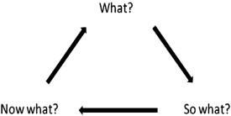
Fig 1.
Borton’s reflective model
(Borton 1970, cited in Rolfe, 2014)
It could be said that Borton’s model is straightforward and easy to recall. It is arguably best suited to a longer term performance or activity over a period of time as opposed to a specific incident or event. Notwithstanding this, it is the view of the author that the model could oversimplify the reflective process and lead to important factors not being considered. In expanding the elements within the reflective process, Gibbs’ reflective cycle identifies 6 separate factors, which when sequentially followed will allow for more detailed reflection. It is the author’s view that Gibbs’ approach facilitates a far more in depth analysis and subsequent opportunity to learn from experience.
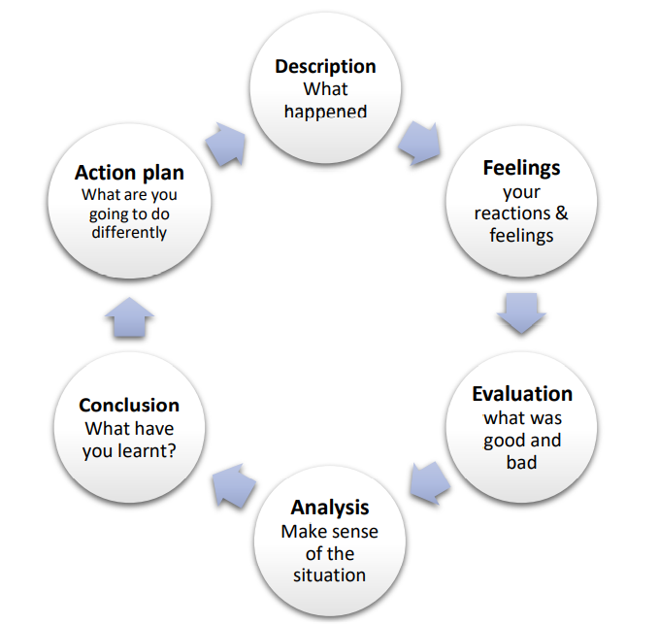

Fig 2.
Gibbs reflective cycle
(Gibbs, 1988 cited in University of Cumbria, 2020)

5. Leadership through the Covid pandemic
I am currently the head of operational delivery within learning & development and have responsibility for a broad range of activity and staff across multiple locations. I commenced this role in February 2020 – shortly before the Covid 19 pandemic. This type of organisational leadership role was very new to me. I had volunteered to take the role and expose myself to new areas of the business, but to that point – my service had always been in operational policing. In March 2020 I was nominated as the learning & development lead in response to the Covid 19 pandemic and oversaw a programme to ensure the maintenance of training provision. Due to government restrictions this period saw the force move to a more remote management structure than had been the case. My Covid recovery responsibility extended across the whole of training including areas over which I had no direct leadership authority and this period coincided with the most aggressive Police recruitment programme in a generation. The Government announcement of 20,000 new police officers over a 3 year period translated to recruitment of over 1000 new starters into the organisation between 2019 – 2023. It is critical to the communities of south Wales that these levels are achieved and maintained. I established a work programme – utilising the wider team in a regime of activities – which included directing them to make best use of technology and quickly facilitate remote learning and maintain activity in line with Covid 19 legislation. This would complement face to face training where necessary. Whilst some embraced this change, this created pushback from several areas of the unit who were not ready to quickly change approach. I in turn pushed back against this robustly – articulating the severity of the challenge; however, they remained staunchly resistant. There was also resistance to face to face training due to the risks of infection and transmission. This had a significant impact on the outcome in that some areas successfully transitioned to remote delivery whilst many didn’t. Some areas maintained in person delivery whereas others didn’t – therefore impacting the capability and capacity of the force to deliver.

6. Reflections
The following section will follow the elements of Gibbs reflective cycle (Gibbs, 1988).

6.1 Feelings
In simple terms I was extremely angry at what I perceived to be a staunch refusal to dynamically engage with the processes required. This was compounded at almost every meeting whereby certain staff would go to great lengths to articulate the reasons as to why this was inappropriate or unachievable. I considered this to be a challenge to my authority and I found this to be extremely frustrating.

6.2 Evaluation
Some managers grasped the initiative and drove forward improvement activities, whilst others did not. I recognised that this aligned to the areas over which I had direct management responsibility, and those that I didn’t. My own direct staff did engage in new processes whist others refused.

6.3 Analysis
In questioning why some areas had engaged while others had not, I considered my leadership approach. My leadership approach at this time was transactional – subsequently providing senior managers with little autonomy. As the senior police officer within my department, I felt that my position provided sufficient authority by which to mandate a response from my staff. I felt this was appropriate at the time, but on reflection I realise that for many managers – this was their first experience of me. Whilst I had built appropriate relationships with my direct reporters, I hadn’t done the same with others. They didn’t know me – so how could they trust me? or have confidence in my decision making or care for them as a leader? This absence of trust or previous knowledge was a critical factor.

6.4 Conclusion
I ask – what gave me the authority to lead this team? In this case, my authority came from my position and presumption that this would translate to compliance. Whilst this holds true to a degree for police officers who are subject to orders and instructions – this is not the case for police staff to the same degree. I clearly failed to consider or understand their own needs or the best way in which to engage them. Another factor was that people were scared. I hadn’t considered their requirements or what would motivate them to perform. Media activity focussed on the death rate and this period saw a series of local and national lockdowns and restrictions aimed at curbing the spread of a deadly virus. People did not understand how the virus would impact on them or their friends and family. My transactional approach was effective for some of the team (mainly police officers), but not all (mainly police staff).

6.5 Action Plan
I needed to form a better understanding of motivation and the needs of staff when selecting and implementing leadership approach. I also needed to better test decisions and behaviours against values whilst being clear as to what success looks like. As a more senior leader it is critical that I develop trust with peers and subordinates in order to appropriately apply leadership power.

In reaching these conclusions I have reviewed, considered, and applied the empirical evidence surrounding leadership and management. Despite the notion that leadership and management are entirely separate concepts it is necessary for modern managers to demonstrate characteristics of leadership to be as effective as possible (Zaleznik, 2004). Often misunderstood – whilst both areas serve different functions – they are essentially interrelated. Management is a series of convoluted undertakings that include organising resources, setting budgets and strategic planning to allow organisations to consistently achieve success (Kotter, 1998). Leadership concerns itself more with behaviours which motivate, inspire, and empower people and teams to achieve goals and deliver success (Helmold & Samara, 2019; Fatma & Aini, 2015). Effective leadership is one of the most significant factors in shaping employee activity and subsequently delivering results (Lamprakis & Samanta, 2018). The leader must clearly impact on motivation, but what are the skills and competencies that I need to deliver against these areas?

- Management and Leadership
The review of leadership undertaken by the College of Policing (2015) essentially reimagined policing into a profession as opposed to a vocation. This identified further need for leadership and management development. (Ramshaw, et al., 2019). Contemporary managers must assess and address organisational challenges – sometimes through impactive programmes of change whilst acknowledging and controlling their emotions and positively impacting on those of their staff (Wethersby, 1999) . The empirical evidence identifies a number of leadership approaches and whilst this work cannot reflect them all – it will set out those that I feel are most relevant to my leadership.

- Blake and Mouton Managerial Grid

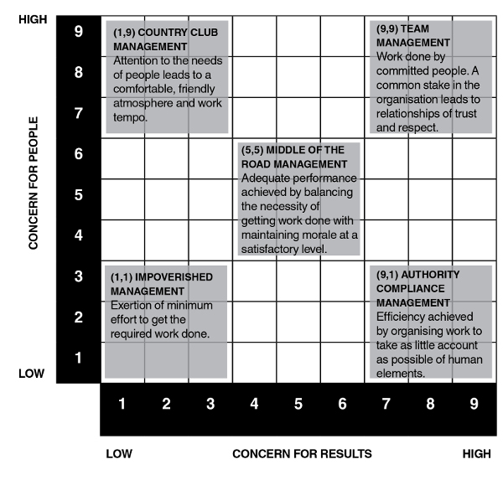
Fig 3.
Blake and Mouton Managerial Grid
(Blake & Mouton, 1964)
Blake and Mouton identified 5 unique leadership styles dependant on the attitude, personality, behaviour and feelings of the manager.
- 1,1. Impoverished. Little or no concern for either results or individuals. A manager whom is primarily concerned with their own position, with little or no tolerance of errors within the workplace.
- 1,9. Country club. Little or no concern for results, but with higher concern for people. Hopes that leadership interaction will automatically correspond to levels of performance. This environment may be enjoyable – but not necessarily productive.
- 9,1. Authority compliance. The opposite to country club management, focussing predominantly on results with little or no concern for individuals. Arguably appropriate in a critical or dynamic incident but could contribute to poor motivation, turnover and high cost if maintained over extended periods.
- 5,5. Middle of the road. The manager seeks to balance focus on results and people. This can be successful over short periods – though results can also be that neither individual nor production needs are adequately and consistently met.
- 9,9. Team. Manager invests significant time and effort in both production and individuals, actively promoting teamwork and engagement. According to Blake and Mouton’s model, this is identified this as the optimum style.

On review, it can be argued that the 2 axes identification of ‘best way’ is overly simple – though Blake and Mouton insist that the axes reflect attitudes, personality, feelings and behaviours, thereby representing a comprehensive assessment. (Molloy, 1998). I feel the model fails to consider a critical factor – the follower. The model focusses almost exclusively on the manager. When I reflect on the leadership incident above – I submit that my approach was both ‘team’ and ‘authority compliance’ management. What I failed to consider was whether the team were able to follow my approach. Leadership theory has evolved since publication of the Blake and Moulton approach and unsurprisingly, the model has undergone further review since publication which sees team considerations added and how these deliver against organisational objectives (Helmold, 2021).

- Tannenbaum-Schmidt Leadership Continuum

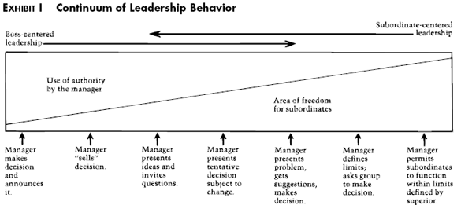
Fig 4.
Continuum of Leadership Behaviour
(Tannenbaum & Schmidt, 1973 cited in Harvard Business Review, 1973)
The Tannenbaum-Schmidt continuum also considers leader’s imposition of authority – contextualised through the level of freedom allowed to teams and individuals (Tannenbaum & Schmidt, 1973). This theory identified how approach lands at any point on the continuum at any given time dependant on action taken. At one extreme, leaders simply instruct subordinates, whilst at the other allow almost complete autonomy within predefined parameters. As one moves across the continuum and the level of independence increases, the levels of direction decrease (Tannenbaum & Schmidt, 1973) .
- Tells. Simply tells individuals what to do and expects it done. Arguably most suited to crisis situations, but detrimental to long term employee engagement.
- Sells. This leader takes time to explain the rationale behind the decision. The leader uses explanation to demonstrate respect for subordinates but won’t seek input into the decision.
- Suggests. This leader puts forward the proposed course of action and invites questions, responding as appropriate. This assists subordinates in better understanding the action.
- Consults. The leader consults with subordinates before deciding. This can be a positive intrinsic motivator when individuals gain satisfaction from contribution to the decision; however, can be problematic where teams are inexperienced or have limited knowledge.
- Joins. Leaders take a collaborative approach to problem solving or decision making. Allowing teams to offer solutions maximises engagement, motivation, and productivity.
- Delegates. This leader sets boundaries or limits of exploitation – handing decision making to the team whilst maintaining accountability. Whilst this is a powerful motivator, any lack of trust in the relationship could undermine the quality of the process
- Abdicates. Requires subordinates to identify issues and problem solve. The team are expected to act on the problem and achieve resolution. This can be extremely motivating. Care must be taken as results could be sub optimal unless blessed with extremely engaged, skilled and knowledgeable teams.
Like other leadership theory, the continuum provides sufficient flexibility to adopt different leadership styles in different circumstances. In this context, the continuum is one of several approaches that recognise how no one single style is appropriate to all circumstances (Helmold, 2020). I feel that the leadership continuum reinforces several of the areas identified by Blake & Moulton – perhaps in a little more detail in identifying 7 approaches. The continuum also introduces (albeit limited) consideration of skills and knowledge alongside trust as relevant factors.

- Action Centred Leadership
In his influential work, Adair (1973 as cited in Adair, 2006) presented action centred leadership. I submit that this formally overlayed the additional team variable onto the approaches set out by Tannenbaum & Schmidt, and Blake and Moulton.
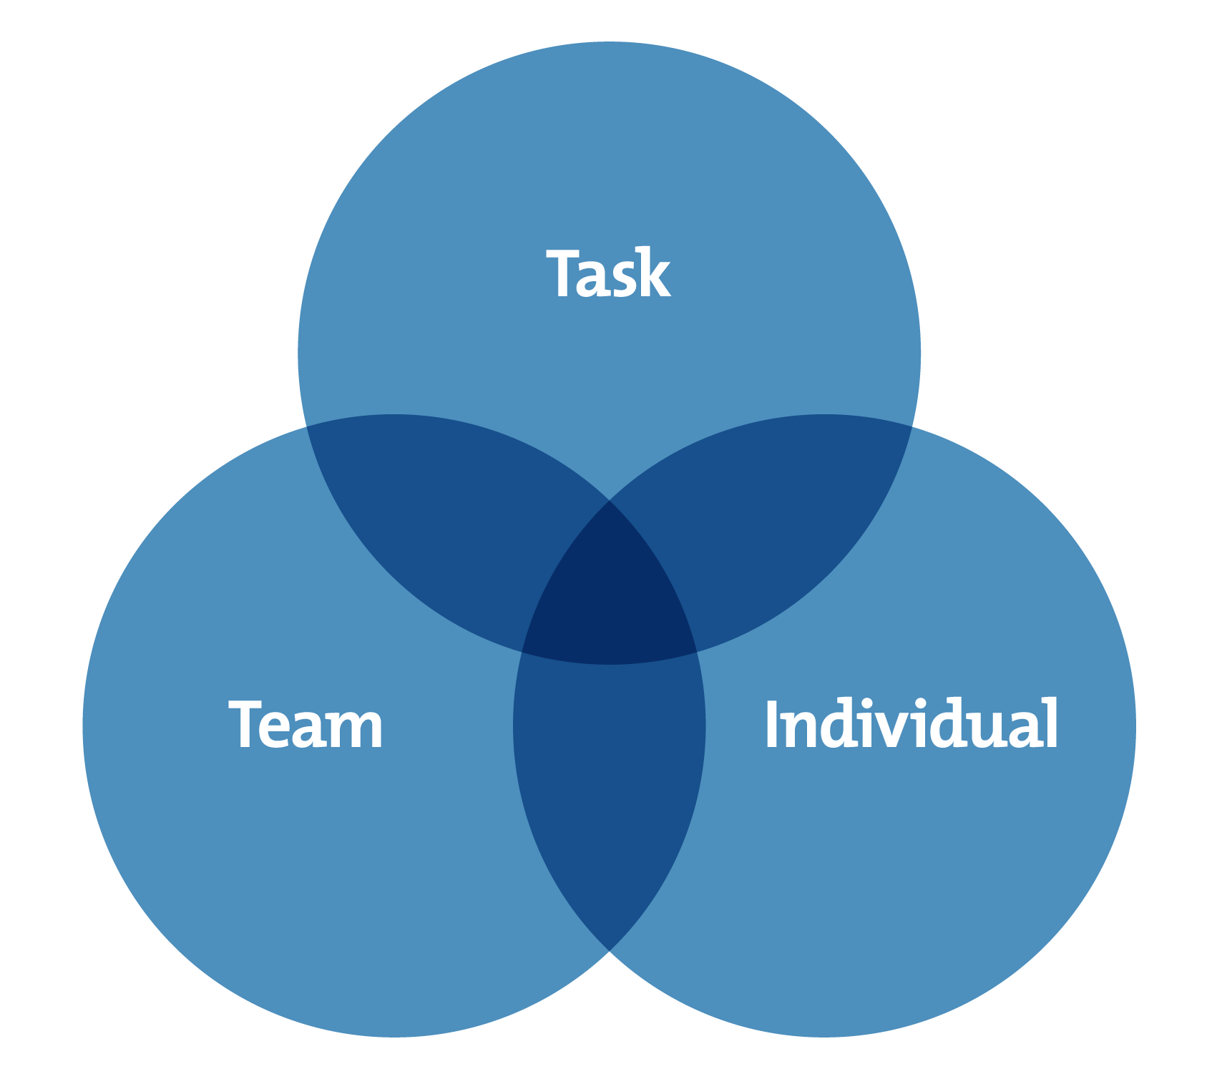
Fig 5.
Action Centred Leadership
(Adair, 1973 cited in Mindtools.com, 2020)
A popular theory, which considers the interaction between task, individual and the team. The darker area at the centre of the interlocking circles provides a visual representation of the interdependence and interaction between the areas. Central to Adair’s position is the theory that leaders should pay sufficient attention to all 3 areas so as to keep them balanced. I feel that there is some risk of oversimplification, and Adair later signposted quality, functionality and situation as important considerations (Adair, 2006). I feel that effective leadership will consider Adair’s 3 variables; however, equal balance isn’t always appropriate – particularly in dynamic or fast moving circumstances. In applying this theory to my example, I was clearly too focussed on the task at the expense of individuals and by association the team. I didn’t consider needs of the wider team, nor the impact of other factors on their motivation. My leadership was ineffective in these circumstances, notwithstanding there are occasions where it’s entirely appropriate to emphasise task over other areas and vice versa. Subsequent research recognised that the emphasis should indeed vary over time dependant on specific circumstances (BRAUN, et al., 2012; Schulze & Pinkow, 2020). Why was my leadership style ineffective? For me, the absence of trust is an important factor - which cannot be overstated. Self awareness is a critical factor in leadership and in focussing on the criticality of the task, I’d unintentionally failed to consider other relevant factors including the needs of my team. The critical factor in this case was that my failure to maintain balance in Adair’s terms was done subconsciously. Had this been intentional – I could have shifted focus appropriately in order to maintain balance over time. I maintain that unintentionally prioritising an area over another is creating troubles for time to come.

- Situational Leadership
Hersey and Blanchard (1977) developed the situational leadership (SLT) model and identified that the best leaders amend their approach based on both the circumstances at hand and the readiness of subordinates. There is no specific optimal leadership style.

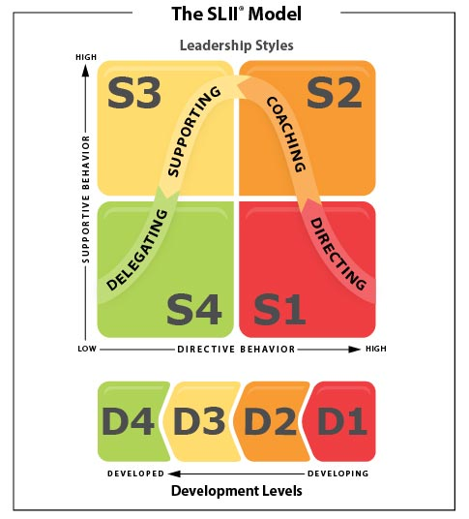
Fig 6.
Situational Leadership Model
(Blanchard, 2021)
To deploy the SLT model, leaders must understand the motivation, requirements, and competency of their subordinates. This ranges from enthusiastic beginners (D1) to self-reliant achievers (D4) and applying the correct approach from directing (S1) to delegating (S4) as appropriate.
In considering SLT within my leadership this does set out a logical and intuitive approach, and I consider it entirely appropriate to delegate decision making to appropriate individuals. However, I don’t believe that self-reliant high achievers at D4 require minimal interaction with leaders, and the model oversimplifies determination of style as confirmed by Meirovich & Gu (2015). In reviewing SLT - Cairns et al (1998) confirmed that whilst leadership activity can indeed be matched to those of low and moderate follower readiness, higher follower readiness is irregular and their requirements surpass those inferred by SLT modelling and require substantial leader interaction. How does this translate into my own leadership activity? In my experience highly motivated high performers require a more bespoke and nuanced approach more aligned to mentorship than management – a view reinforced by Bush (2017) who identified that highly motivated millennials are more intrinsically driven and require strong support and guidance to maximise their performance and engagement and develop them for future leadership roles.

- Goleman’s six leadership styles and Emotional Intelligence
Emotional intelligence in leadership has been the subject of much study and its relevance is well established (Kim & Kim, 2017: Lam & O’Higgins, 2012).
Emotional intelligence is the ability to perceive emotions, to access and generate emotions so as to assist thought, to understand emotions and emotional knowledge, and to reflectively regulate emotions so as to promote emotional and intellectual growth
(Salovey, et al., 1997, p. 197)
Emotional intelligence (Goleman, 1998) has an acute impact on employee engagement and satisfaction (Mojgan & Bagheri, 2013; Mohammad, et al., 2014; Kassim, et al., 2016). Emotionally intelligent leaders are more successful professionally (Gardner & Stough, 2002). In considering how this impacts on me – I am an extroverted character. I have completed testing to confirm this. This brings many benefits – enthusiasm, energy and a willingness to make decisions. There are also drawbacks to this personality type – a potential to overpower people, and so I temper this appropriately. Self-awareness is critical to my leadership and is a critical factor of emotional intelligence (BRATTON, et al., 2011). Goleman (2002) set out six leadership styles as set out below.
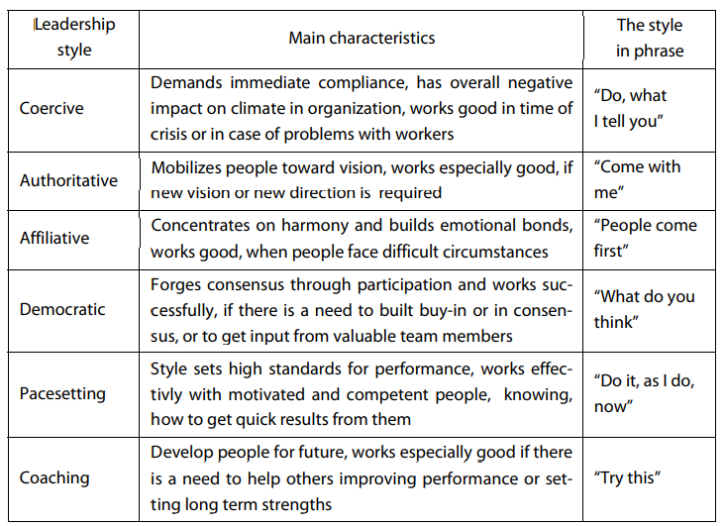
Fig 7.
Goleman’s six leadership styles
Goleman (2002)
In my example above I clearly adopted a coercive approach; however, on reflection could have taken a more democratic approach. Goleman articulated how effective leaders switch between style based on circumstances (Goleman, 1998) and it is my submission that Goleman’s definition follows many of the theories already in existence. This ‘repetition’ serves to reinforce the relevant principles of leadership across the empirical evidence which essentially amounts to situational leadership whereby leadership approach changes depending on the numerous variables or factors. Saxena et al, (2017) identified that more senior leaders are most comfortable in changing styles – I agree and recognise the importance of this as I haved moved into more senior leadership positions. In considering the outer extremity of the optimal hands off approach articulated by many of the leadership theories referred to above – I ask myself - how do I create the environment in which individuals are sufficiently motivated so as to deliver positive outcomes for the unit or organisation?

- Motivation & Transformational Leadership
Review of the literature identifies that a great many of the earlier motivation theories concerned themselves with outcome – or ‘the ends’, and are based on a system of sanction or reward depending on outcome of tasks or transaction aligned to the expectancy theory first introduced by Vroom (1964). Expectancy theory established the view that employees are motivated by reward, and where that reward is attractive – will lead to enhanced effort. Increasing motivation through expectancy theory requires several criterion to be suitable for the individual. The employee needs the skills and competencies to complete the task. This has a training implication. The employee presupposes expectation that reward will be forthcoming and that the reward will be attractive. Conversely, Bass (1990) championed the benefits of a very different approach – one that taps more deeply into intrinsic motivations in securing outcomes. Featuring significantly in numerous contemporary leadership reviews, the aim of ‘transformational leadership’ is to inspire individuals to draw satisfaction from the results and actions of the team. This has a powerful motivational effect and requires leaders to demonstrate several core principles including positive role modelling, consideration of the individual, challenging and intellectual stimulation, and engendering confidence in credible leaders. Transformational leadership has been subject of much research and firmly empirically established as an effective approach – providing that transactional approaches are retained and implemented where required alongside transformational leadership (Bass & Aviolo, 1990). This presents an interesting challenge for me – are the team motivated by intrinsic or extrinsic factors? How do I manoeuvre individuals to the point of seeing beyond themselves? People must be suitably motivated to do this and several theories or approaches exist with regards to human motivation, including the biological and physical underpinnings. Early behavioural analysis (Watson, 1917) established the view that external factors shaped human response and therefore one should focus on those elements – akin to Vroom’s expectancy theory whereby employees expect to be suitably rewarded by the manager for good performance. This view endured throughout the early 20th century and Skinner (1953) also dismissed internal human workings as irrelevant to the functional view of behaviours. Psychological, physiological, and neurological explanations for human behaviour were eschewed in favour of external factors . Motivational theory continued to evolve throughout the period and the current empirical evidence no longer supports this view. Motivational science is now very much concerned with what’s going on internally, with many of the major frameworks focussing on the impacts of expectation, goal setting and self-efficacy alongside biological, cognitive and emotional mechanisms that underpin behaviours (Ryan, 2019). Several additional motivational theories exist. Bandura’s (1986) social cognitive theory spotlighted the concept of self-efficacy – describing how a person’s belief in their ability to execute actions contributes to a level of performance. Further reinforced by several academics it is taken that self-efficacy has an important impact on individual behaviour. Higher self-efficacy is associated with positive outcomes such as physical and mental health (Bandura, 1997), academic performance (Robbins, et al., 2004) , and job satisfaction (Judge & Bobo, 2001). In their study of the impact of self-efficacy on employee (rather than academic) performance, Cherian and Jacob (2013) identified how scepticism from professionals impacts on colleagues, particularly those charged with complex tasks or problem solving. It is therefore suggested that managers display positivity and can further improve performance by detailing the task, recognising the technical detail required to resolve the task, and also removing physical distractions and barriers.
Motivation theory applies equally to the leader as the follower, and is a factor which helps inform leadership power.

- Leadership Power
French et al, (1959) identified 6 types of leadership power as briefly described and set out in the table below.
- Legitimate power is brought about by position or title. In my example above – I considered my position sufficient to draw a leadership response form my staff.
- Reward power is derived from the ability to offer an enhancement for good performance – aligned to Vroom’s expectancy theory.
- Coercive power is in many ways the opposite to reward power and involves the imposition of sanction when poor performance is present.
- Informational power is that held by those privy to relevant information.
- Expert power is that held by subject matter experts that operate as experts in their field.
- Referent power is that achieved through respect or admiration.
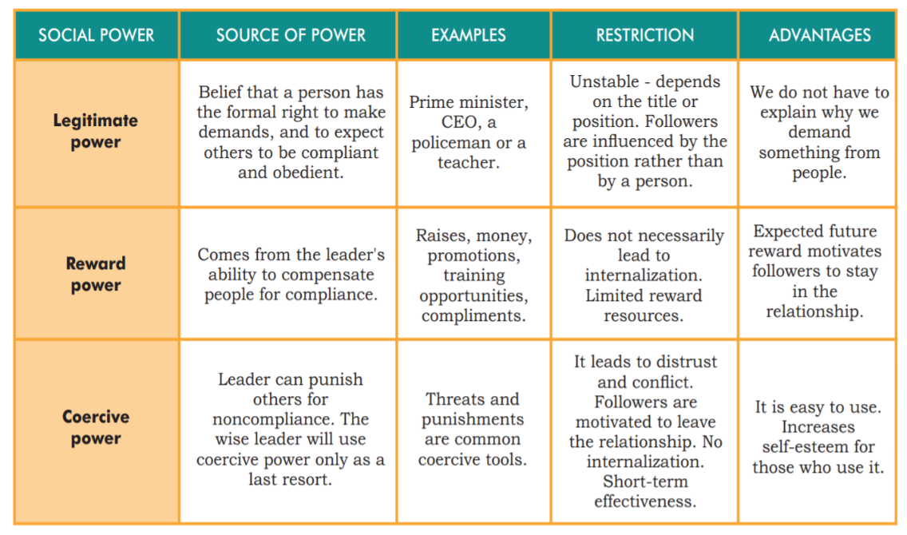
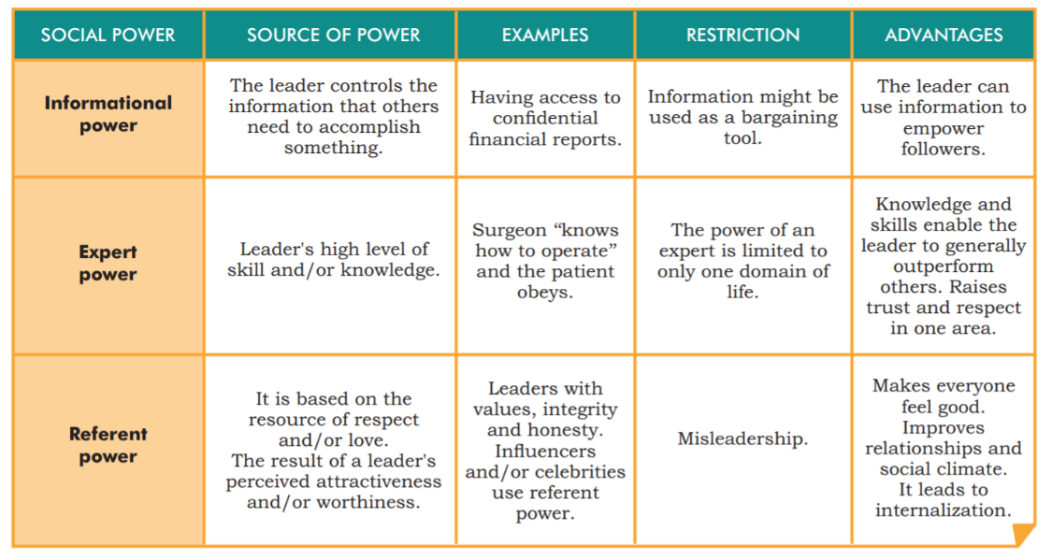
Fig 8.

6 sources of social power in leadership.
(Joyful Leader.com)

In reflecting on my leadership example above – my power was derived from my position and yet this was ineffective. In considering sources of power – I had access to relevant information that I could have shared in order to wield informational power and being an experienced leader I could have demonstrated expert power too. It is my submission that some staff did not recognise my legitimate power as a leader – potentially as I did not have direct leadership authority and therefore did not suitably motivate them to perform.

- Needs
A review of the academic evidence identifies several ‘needs based’ motivational theories. Maslow’s (1943; 1987) hierarchy is a model based on the fulfilment of needs (5, later updated to 7 as below) to achieve good performance.
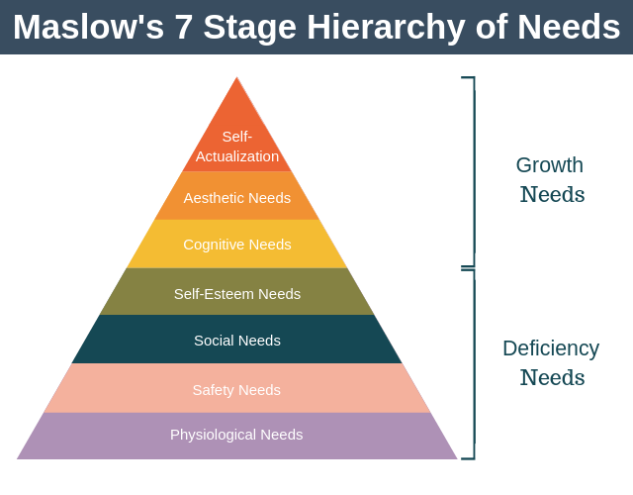
Fig 9.
Maslow’s 7 stage hierarchy of needs.
(Expert Programme Management, 2019)
Starting with basic survival – moving hierarchically up to self-fulfilment, the theory concerns itself with the concept that humans require these ‘deficiency needs’ and ‘growth needs’ to be met to perform to optimum levels. To use a very straightforward example, a hungry or exhausted student would find concentration difficult (Mcleod, 2018). Maslow’s theory is well known, particularly in the UK and provides a logical framework for leaders in considering needs. It’s accuracy has however been questioned by academics – particularly Maslow’s assertion that each need must be met before considering the next. Alderfer (1972) reworked Maslow’s theory to identify three groups of needs broadly aligned to Maslow’s namely, existence, relatedness, and growth. Alderfer also identified how several needs can exist simultaneously, and that where a higher need is suppressed – the individual will seek greater fulfilment of lower-level needs in order to perform. Several other needs-based theories exist (Herzberg, et al., 1959; McClelland, 1961) In considering this and applying to my example above – I simply didn’t consider the elements that contributed to the motivation of my staff. it is my assertion that whilst several needs-based theories exist – they share the same characteristics with regards to practical application in that one must know enough about an individual in order to motivate in the best way. Maslow’s hierarchy is relevant in my example as the physiological and safety needs weren’t met and proved an impenetrable barrier to progress. Employee motivation has never been something I’ve considered in detail and my considerations have never extended beyond competence and performance. My review and analysis of motivational theory now allows me to consider motivation and serves to highlight the criticality of knowing my people and importance of relationships.

- Communication and Trust
Trust and communication are critical elements of motivation and of the connection between the leader and the individual (Blanchard, 2013). The empirical evidence shows that trust enhancing behaviours are the bedrock of successful teams (Burke, et al., 2007; Braun, et al., 2013; Stevenson, et al., 2020), and help create highly motivated individuals who establish high performing teams. Trust is critical in the way in which leaders are afforded their power and the CMI (2014, p. 1) describes trust as 'the glue that holds relationships together'. It is those in leadership positions that are critical in establishing trust on a pan organisation level to deliver success. Notwithstanding this, Blanchard (2013) identified how only 1 in 5 individuals trust their employer – and only 11% their direct manager. The ABCD trust model (Blanchard, 2013) sets out a simple framework by which to understand, assess and build trust.
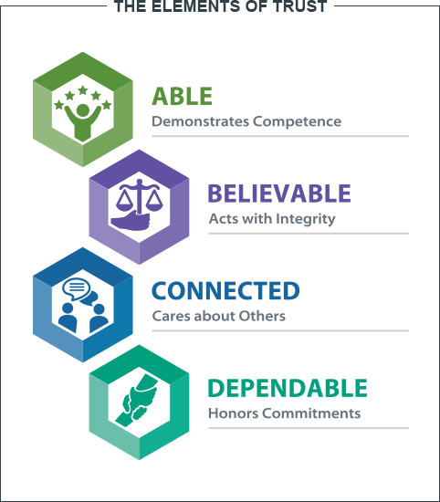

Fig 10.
ABCD Trust Model
(Blanchard, 2021)

- Able. Leaders are expected to operate with expertise which engenders confidence. Lack of competence results in lack of confidence. Equally, subordinates that demonstrate competence are better trusted by management.
- Believable. Leaders demonstrate integrity through honesty and aligned with the values of the organisation. The standards of public life or ‘Nolan’ principles are particularly relevant within the public sector.
- Connected. Leaders show care for others. This improves cohesion and significantly impacts on motivation.
- Dependable. Reliability earns respect. Closely aligned to motivational theory – in that leaders must deliver on promises as agreed or expected.

In applying this theory to my leadership example – I clearly failed in building the right connection and demonstrating care for others. Blanchard’s view is reinforced by much of the leadership theory (Lok & Crawford, 2004; Schein, 2010; Kargas & Varoutas, 2015; Vrdoljak & Borovac, 2017), and he provides a compelling (2010) example of aligning decisions against company values to uphold trust. His business was heavily impacted by the 9/11 terrorist attack, losing $1.5 million dollars monthly. One proposal by executive leadership was to reduce employee numbers by 10% companywide . This was legal and would deliver against objectives of cost reduction – but how did this stand against the company values of relationships, learning, success and ethical behaviour? It didn’t. The company successfully maximised the skills, knowledge and experience of its staff to minimise cost and maximise revenue.

- Conclusion & Final Reflections
In reflecting, I have carefully considered my leadership through the covid period and the variables that have impacted during this time. Aligned with many leadership academics, I consider self-awareness to be the start of effective leadership through emotional intelligence. Much of the theory around leadership and motivation has progressed through time – frequently developing work undertaken by others, and it is my submission that the application of leadership is no different in that it translates to learning from and building upon previous experiences – be they lived or learned. Policing is unique, with expectations changing significantly over my 27 years Police service (Desroches, et al., 2018). As a truly 24/7 function, policing has moved to fill the space unavoidably vacated by other services such as mental health following the government austerity programme in 2011; However, the dynamic and operational nature of policing will always demand a leadership response, and it is critical that leaders adapt to circumstances. It is also critical that police leadership understands where power is derived – the fact that policing is a disciplined service does not always translate into legitimate power, both within the service and externally. There are many studies that demonstrate different needs across generations which generate different leadership responses – for example the millennial generation are far more intrinsically motivated than those before them - though that is beyond the scope of this particular work. I will always be well suited to the fast-moving world that is operational policing. My default style is transactional, but through experience, reflection, and feedback I better consider the human elements of leadership. My default style will remain; however, I have been able to mitigate leadership ‘weaknesses’. I am most effective when consciously adapting my leadership approach to the particular circumstance, but recognise the challenge associated with this in maintaining self-awareness – to know when transactional leadership is appropriate at a dynamic operational incident, or when to focus more on the individual or take a democratic or transformational approach when approaching a longer term piece of work or endeavour. It is vital to know how leadership power is derived and acted upon in determining the optimum approach.. The mission, vision and values of my organisation are also a critical consideration, and I ensure to align decisions and behaviours against those. The public sector is not business – there are preferred outcomes, but no shareholder profit by which to measure leadership success. It’s hard to prove when leadership is effective, but this only further highlights the importance of reflective practice within policing – as is the norm within other areas such as education and healthcare. Further to my own reflection, I’ve sought feedback from colleagues which demonstrates my improved performance with regards to motivating and developing both my peers and staff. Such is my attention and focus in this area –this has now become a natural reaction. I consider it also relevant that I oversee a large department with comparatively low levels of grievance, of complaints, and of sickness absence. These are all areas that I term pseudo measures of leadership performance. I have no doubt that setting the style of contemporary policing will remain a challenge – and one that needs effective leadership (Ramshaw, et al., 2019). This is a challenge that I remain prepared to meet, and I recognise that leadership power provided by my rank and role will only ever take me so far. My study of motivation and needs has been invaluable in recognising this.

Bibliography
Adair, J., (1973). Action centred leadership. s.l.:s.n.
Adair, J., (2006). Leadership and Motivation. London: Kogan Page Ltd.
Alderfer, C. P., (1972). Existence, relatedness, and growth: Human needs in organizational settings.. s.l.:s.n.
Bandura, A., (1986). Social foundations of thought and action: A social cognitive theory.. Englewood Cliffs: s.n.
Bandura, A., (1997). Self-Efficacy: The Exercise of Control. New York: W.H. Freeman.
Bass, B., (1990). From transactional to transformational leadership: Learning to share the vision. Organizational Dynamics, 18(3), pp. 19-32.
Bass, B. & Aviolo, B., (1990). Developing the transformational leadership: 1992 and beyond. Journal of European Industrial Training, 14(5), pp. 21-27.
Blake, R. R. & Mouton, J., (1964). The Managerial Grid. Houston: Gulf.
Blanchard, K., 2010. Leading at a higher level. Blanchard on leadership and creating high performing organisations. s.l.:s.n.
Blanchard, K., (2013). Trust. Training journal, pp. 55-58.
Blanchard, K., (2021). Building Trust. [Online]
Available at: https://www.kenblanchard.com/Products-Services/Building-Trust
[Accessed 23 April 2022].
Blanchard, K., (2021). SLII. Powering Inspired Leaders. [Online]
Available at: https://www.kenblanchard.com/Products-Services/SLII
[Accessed 23 April 2022].
BRATTON, V., DODD, N. & BROWN, F., (2011). The impact of emotional intelligence on accuracy of self-awareness and leadership performance.. Leadership & Organization Development Journal, 32(2), pp. 127-149.
BRAUN, F., MICHEL, A. & MARTZ, B., (2012). Action-centered team leadership influences more than performance. Team performance management, 18(3), pp. 176-195.
Braun, S., Peus, C., Weisweler, S. & Frey, D., (2013). Transformational leadership, job satisfaction, and team performance: A multilevel mediation model of trust. The Leadership Quarterly, 24(1), pp. 270-283.
Bright Hub Project Management, (2020). Global ethics and how various cultures face decision making.. [Online]
Available at: https://www.brighthubpm.com/methods-strategies/120248-global-ethics-and-how-various-cultures-face-decision-making/
[Accessed 9 April 2022].
Bush, C., (2017). Leading and Motivating Generation Y Employees. Radiology Management, 39(2), pp. 19-23.
Cairns, T., Hollenback, J., Preziosi, R. & Snow, W., (1998). Technical note: a study of Hersey and Blanchard's situational leadership theory.. Leadership & Organization Development Journal, 19(2), pp. 113-116.
Chartered Management Institute, (2014). Developing Trust Checklist. [Online]
Available at: https://www.managers.org.uk/~/media/Files/Campus%20CMI/Checklists%20PDP/Developing%20trust.ashx
[Accessed 3 April 2022].
Cherian, J. & Jacob, J., (2013). Impact of Self Efficacy on Motivation and Performance of Employees. International Journal of Business and Management;, 8(14), pp. 80-88.
College of Policing, (2015). Estimating Demand on the Police Service. [Online]
Available at: https://paas-s3-broker-prod-lon-6453d964-1d1a-432a-9260-5e0ba7d2fc51.s3.eu-west-2.amazonaws.com/s3fs-public/2021-03/demand-on-policing-report.pdf
[Accessed 28 April 2022].
College of Policing, (2015). Leadership Review. [Online]
Available at: https://www.college.police.uk/about/leadership-review
[Accessed 19 April 2022].
Cottrell, S., (2015). Skills for Success : Personal Development and Employability. 3 ed. London: Macmillan Education UK.
de Vries, E., Bakker-Pieper, A. & Oostenveld, W., 2010. Leadership = Communication? The Relations of Leaders' Communication Styles with Leadership Styles, Knowledge Sharing and Leadership Outcomes. Journal of business & psychology, 25(3), pp. 367-380.
Derue, D., Narghang, J., Wellman, N. & Humphrey, S., (2011). TRAIT AND BEHAVIORAL THEORIES OF LEADERSHIP: AN INTEGRATION AND META-ANALYTIC TEST OF THEIR RELATIVE VALIDITY.. Personnel Psychology, 64(1), pp. 7-52.
Desroches, C., Hadjpavlou, S. & Redgrave, H., (2018). Rethinking police demand: A review of drivers, capability and capacity in partnership with the Dawes. [Online]
Available at: https://static.wixstatic.com/ugd/b9cf6c_2e5f620f265a42b2a7c385c68308b68b.pdf
[Accessed 29 April 2022]
Expert Programme Management, (2019). Maslow's heirarchy of needs. [Online]
Available at: https://expertprogrammanagement.com/2019/06/maslows-hierarchy-of-needs/
[Accessed 12 April 2022].
Fatma, N. & Aini, Y., (2015). The Impact of Transformational Leadership Style on Employee Job Performance.. International Journal of Science and Research., 5(6), pp. 499-503.
Folkman, J. & Zenger, H., (2020). A broader view of developing strengths. Leader to Leader, 2020(95), pp. 32-36.
French, J., Raven, B. & Cartwright, D., 1959. The bases of social power. Classics of organisation theory, pp. 311-320.
Gardner, L. & Stough, C., (2002). Examining the relationship between leadership and intelligence in senior level managers.. Leadership & Organization Development Journal, 23(2), pp. 698-78.
Gibbs, G., (1988). Learning by doing: A guide to teaching and learning methods.. Oxford: Oxford Bridges.
Goleman, D., (1998). Working with Emotional Intelligence. s.l.:Bloomsbury.
Goleman, D., Boyatzis, R. & Mckee, A., (2002). The New Leaders. Transforming the art of leadership into the science of results. London: Sphere.
GÖRGENS-EKERMANS, G. & ROUX, C., (2021). Revisiting the emotional intelligence and transformational leadership debate: (How) does emotional intelligence matter to effective leadership?. SA Journal of Human Resource Management, , Volume 19, pp. 1-13.
Helmold, M., (2020). Leadership and empowerment. In: Lean Management and Kaizen. s.l.:Springer, pp. 57-64.
Helmold, M., (2021). Transformational Leadership in New Work Organizations. In: New Work, Transformational and Virtual Leadership. Management for Professionals. s.l.:Springer, pp. 67-77.
Helmold, M. & Samara, W., (2019). Progress in performance management: Industry insights and case studies on principles, application tools, and practice. Springer.. Berlin: Springer.
Hersey, H. & Blanchard, K. H., (1977). Management of organizational behavior: Utilizing human resources. 3 ed. NJ: Englewodd Cliffs.
Herzberg, F. I., Mausner, B. & Snyderman, B., (1959). The motivation to work. 2 ed. New York: John Wiley.
Joyful Leader, n.d. 6 sources of social power in leadership. [Online]
Available at: https://joyful-leader.com/6-sources-of-power-in-leadership/
[Accessed 17 April 2022].
Judge, T. & Bobo, J., (2001). Relationship of core self-evaluations traits - self esteem, generalized self-efficacy, locus of control, and emotional stability with job satisfaction and job performance: A meta analysis.. Journal of Applied Psychology, 86(1), pp. 80-92.
Kargas, A. & Varoutas, D., (2015). On the relation between organizational culture and leadership: An empirical analysis. Cogent Business & Management, 2(1), pp. 1-18.
Kassim, S., Bambale, A. & Jakada, B., (2016). Emotional Intelligence and Job Satisfaction Among Lecturers of Universities in Kano State: Empirical Evidence. Journal of Education and Practice, 7(10), pp. 53-59.
Kim, H. & Kim, T., (2017). Emotional intelligence and transformational leadership: A review of empirical studies.. Human Resource Development Review, 16(4), pp. 377-393.
Kotter, J., (1998). The Leadership Factor. New York: The Free Press.
Lam, C. S. & O’Higgins, E. R., (2012). Enhancing employee outcomes: The interrelated influences of managers’ emotional intelligence and leadership style.. Leadership and Organization Development Journal, 33(2), pp. 149-174.
Lamprakis, A. & Samanta, I., (2018). MODERN LEADERSHIP TYPES AND OUTCOMES: The case of Greek public sector. Management : Journal of Contemporary Management Issues, 23(1), pp. 173-191.
LAN, H. & TRINH, D., (2021). The Effects of Emotional Intelligence on Job Satisfaction: A Study of a Vietnamese Electronics Company.. IUP Journal of Organizational Behavior, , 20(1), pp. 7-24.
Lipnack, S. & Stamps, J., (2000). Virtual teams. People working across boundaries with technology.. s.l.:s.n.
Lok, P. & Crawford, J., (2004). The effect of organisational culture and leadership style on job satisfaction and organisational commitment: A cross‐national comparison. The Journal of Management Development, 23(4), pp. 321-338.
Maslow, A. H., (1943). A theory of human motivation. Psychological Review,. Psychological Review, 50(4), pp. 370-396.
Maslow, A. H., (1987). Motivation and personality. 3 ed. Delhi: Prabhat.
McClelland, D., (1961). Acheiving Society. Simon & Schuster ed. s.l.:Simon & Schuster.
Mcleod, S., (2018). Maslows Hierarchy of Needs. [Online]
Available at: https://www.simplypsychology.org/maslow.html
[Accessed 6 April 2022].
Meirovich, G. & Gu, J., (2015). Empirical and Theoretical Validity of Hersey-Blanchard's Contingency Model: A Critical Analysis.. Journal of Applied Management and Entrepreneurship, , 20(3), pp. 56-74.
Mindtools, n.d. Action Centered Leadership. [Online]
Available at: https://www.mindtools.com/pages/article/newLDR_48.htm
[Accessed 5 April 2022].
Mohammad, F. N., Chai, L., Aun, L. & Migin, M., (2014). Emotional Intelligence and Turnover Intention. International Journal of Academic Research, , 6(4), pp. 211-220.
Mojgan, E. & Bagheri, N., (2013). The Relation Between Emotional Intelligence and Job Satisfaction. European Journal of Experimental Biology, 3(1), pp. 554-558.
Molloy, P., 1998. A Review of the Managerial Grid Model of Leadership , s.l.: Aquarius Consulting.
Nickerson, C., (2016). Herzberg’s Motivation Two-Factor Theory.. [Online]
Available at: www.simplypsychology.org/herzbergs-two-factor-theory.html
[Accessed 26 April 2022].
Obama Foundation, (2020). Highlights from the first Reimagining Policing workshop: Police Accountability and Reforms, Washington: s.n.
Penn State University, (2016). Situational Leadership and Phil Jackson. [Online]
Available at: https://sites.psu.edu/leadership/2016/07/02/situational-leadership-and-phil-jackson-a-situational-leader/
[Accessed 26 April 2022].
Ramshaw, P., Simpson, M. & Silvestri, M., (2019). Police Leadership : Changing Landscapes. Cham: Palgrave Macmillian.
Robbins, S. et al., (2004). Do Psychosocial and Study Skill Factors Predict College Outcomes? A Meta-Analysis.. Psychological Bulletin, Volume 130, pp. 261-288.
Rolfe, G., (2014). Reach touch and teach: Terry Borton. Nurse Education Today, 34(4), pp. 488-489.
Rushmer, R. et al., (2004). Introducing the Learning Practice – III. Leadership, empowerment, protected time and reflective practice as core contextual conditions. Journal of Evaluation of Clincal Practice, 10(3), pp. 399-405.
Ryan, R. M., (2019). Inside the Black Box: Motivational Science in the 21st Century. In: R. M. Ryan, ed. The Oxford Handbook of Human Motivation. s.l.:Oxford University Press, pp. 2-11.
Salovey, P., Mayer, J. & Caruso, D., (1997). Emotional intelligence. Theory, findings and implications. Phscological Inquiry, 15(3), pp. 197-215.
Saxena, A., Desanghere, L., Stobart, K. & Walker, K., (2017). Golemans Leadership styles at different hierarchical levels in medical education. BMC Medical Education, Volume 17.
Schein, E., (2010). Organisational culture and leadership defined. San Fransisco: Jossey-Bass.
Schulze, J. & Pinkow, F., (2020). Leadership for Organisational Adaptability: How Enabling Leaders Create Adaptive Space.. Administrative Sciences., 10(3).
Shawn Burke, C., Sims, D., Lazzara, E. & Salas, E., (2007). Trust in leadership: A multi-level review and integration. The Leadership Quarterly, 18(6), pp. 606-632.
Skinner, B. F., (1953). Science and Human Behaviour. New York: Macmillian.
Stevenson, R., Neubert, E., Burnell, D. & Kuratco, D., (2020). Entrepreneurial Hustle: Navigating Uncertainty and Enrolling Venture Stakeholders through Urgent and Unorthodox Action. Journal of management studies, 57(5), pp. 1002-1036.
Tannenbaum, R. & Schmidt, W., (1973). The Tannenbaum-Schmidt Leadership Continuum. Harvard Business Review.
Tarrant, P., (2013). Reflective Practice and Professional Development.. London: SAGE publications.
University of Cumbria, (2020). Gibb's Reflective Cycle. [Online]
Available at: https://my.cumbria.ac.uk/media/MyCumbria/Documents/ReflectiveCycleGibbs.pdf
[Accessed 11 April 2022].
Vrdoljak, R. & Borovac, O., (2017). ORGANIZATIONAL CULTURE AND LEADERSHIP STYLE: KEY FACTORS IN THE ORGANIZATIONAL ADAPTATION PROCESS. Economic Herald, 30(1), pp. 209-219.
Vroom, V., (1964). Vroom Expectancy Theory.. s.l.:s.n.
Wagner, K., (2006). Benefits of Reflective Practice. Leadership, 36(2), pp. 30-32.
Watson, J. B., (1917). Behaviorism. London: Routledge.
Wethersby, G., (1999). Leadership v Management. Management Review, 88(3), p. 5.
Zaleznik, A., (2004). Managers & Leaders: Are they different. Harvard Business Review, 82(1), p. 74.

