Assignment 2 Changemakers
Jacob Davies
2416227
Database Systems

Contents
Introduction 3
Project Management 4
Project Design 6
Enterprise 8
Reflection 12
Conclusion 14
References 15

Introduction

In this report I am going to detail the project scope including the solution to my project idea and the required technologies to achieve this. My project idea is a client and case management system for a solicitors firm. I will create a Gantt chart to create a timeline of when I want to achieve the different objectives of the project like development and testing. I will document and describe some of the design work that went into my idea for my project by using things such as diagrams, flowcharts etc.
I will also document some key considerations from a PEST & SWOT analysis for a tech company including some legal and ethical considerations [9]. I will document a potential tech start up name, logo, business type and a business strategy to get funding to start up.
I will also reflect on my project idea and explain how I intend to use this opportunity to develop new skills. I will also explain how my project could have a positive impact and how it could contribute to the legal sector. Finally I will identify the risks and challenges I may face and how I could reduce or remove them.

Project Management

Project Scope
The aim of the project is to design and implement a secure, user friendly case management system for Clients and Matters and to start this would be aimed at small to medium sized firms. This will streamline the admin of gathering and maintaining clients, efficient document management, searching and tracking of clients and matters, billing all while making sure it follows the legal guidelines for compliance with GDPR [1] and the SRA guidelines [2].

Proposed Solution
A Case management system with cloud based storage that is secured with SSL/TLS encryption [5] and multi factor authentication. It will include automation features and complex search capabilities

Technology and resources
Backend of the system – Python (Django)
Frontend – Python (Django)
Database – MySQL
Hosting – Azure [5]
Security – SSL/TLS encryption [5], Multi factor Authentication
Resources – a team of developers, someone who is qualified in compliance to ensure it follows the guidelines [2], a designer to create the look of the system to make it visually appealing to recognisable to users, testers

Timeline and Schedule
I created the below timeline and converted this into a Gantt chart to keep track of where the project is. As an example this is set around the current date. This would be a long task so would take multiple weeks to set up as defined below.

Project Scope – 1 week
Requirements & Analysis – 1.5 weeks
Design – 2 weeks
Development – 6 weeks
Testing Phase – 2 weeks
Deploy & Training – 1 week
Review – 1 week

Gantt Chart for timeline of project
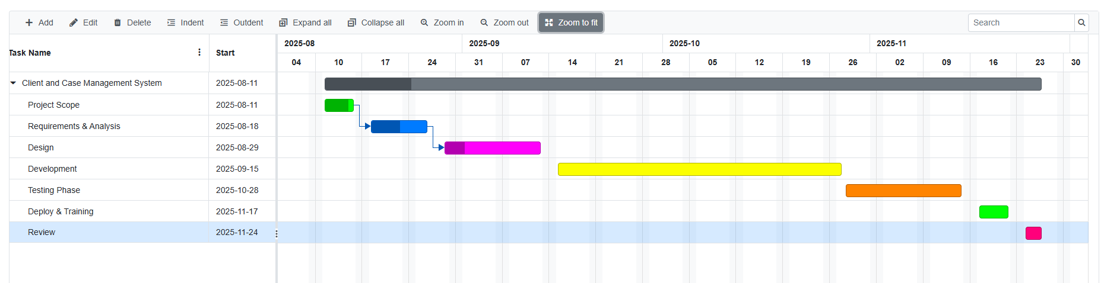

Constraints
This would be costly to design and develop so I would need a budget and a way to get money for it. It would also need to comply with the guidelines so I would need to be cautious about what I do and set up making sure everything follows the guidelines to make it fit for purpose. There will be time constraints as this would need to be created by the time the project is due after is set in the final years of this course.

Project Design
ERD
I created an ERD based off of the knowledge I have from how we use the case management system in my job [7]

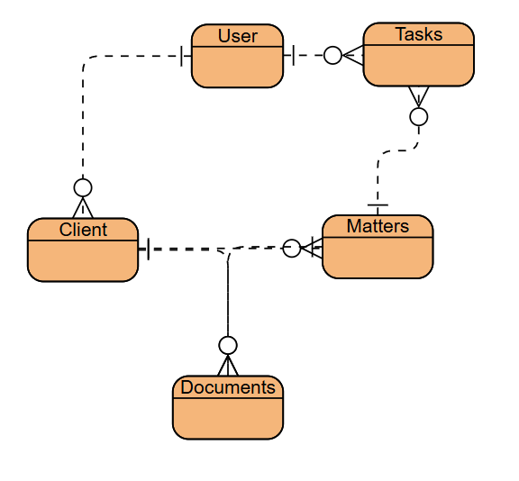

Entities : User, Client, Matters, Documents, Tasks
Relationships:
- A User has many Clients
- A User has many Tasks that belong to them
- A Client has many Matters
- A Client has many Documents
- A Matter has many Documents
- A Matter has many Tasks

WireFrame
I created a wireframe for what the main hub page could look like. [8]
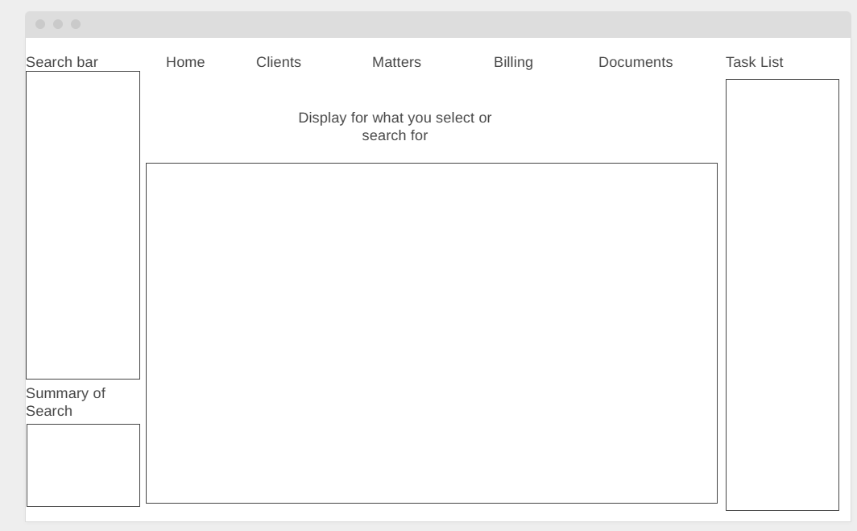
Search bar and Summary - included things like a Search bar which would have a summary to show a snip of information before selecting what you want
Navigation Buttons – I included buttons along the top which will take you to different parts of the system such as Home, Clients, Matters, Billing and Documents
Task List – I included a task list on the right hand side so it will always be visible telling you what needs to be done
Display Box – I included a display box which would show whatever you selected. So if you selected a client or matter then it would show the details of that specific client or matter

Enterprise

I have decided to do a PEST and SWOT analysis for Practice Evolve [9] which is a tech company that have developed a case management system.

Political
- Data Protection – they must comply with GDPR [1]
- Legal Regulations – the software must comply with Solicitors Regulation Authority Rules [2]
- Government digital transformation initiatives – this might create demand for more integrated, paperless legal systems.
Economic
- Budgets – budgeting may delay software investments
- Competition – Competing platforms like LEAP, ALB and ILE could put a pressure on pricing and innovating features [9]
- Growth – the tech market is always expanding offering a lot of opportunities for scaling

Social
- Remote working – after the pandemic the demand for hybrid working increased so this also increases demand for cloud based solutions
- User Adoption – solicitors may be reluctant to change systems as they are likely familiar with the one they use and wouldn’t want change to have an impact on how effectively they can work moving forward
- Expectations from Client – Increased demand for transparency and quicker communication and results with solicitors [10]

Technological
- AI and automation – AI is on the rise and is offering a variety of solutions to problems such as automating admin tasks [10] so users can focus more on their work
- Cybersecurity – Increased risk of phishing and data breaches
- Cloud scalability – the ability to handle large matters and a large client base without a loss in performance [5]

Strengths
- Established brand in legal tech with a client base over multiple countries
- Specialised features such as matter tracking, workflow management and creator, document management and billing
- Customisable to different areas of law
- Focused on compliance with GDPR and other legal standards

Weaknesses
- Learning curve for users transitioning from other case management systems
- Relies on internet connectivity so outages could prevent access to critical data
- Limited brand recognition
- Integration limitations

Opportunities
- Development of AI powered research and searching
- Modular pricing to attract small firms
- Partnerships with associations or schools for use in training

Threats
- Competition from other companies that develop CMS
- Any cybersecurity breaches would lose trust
- Compliance always changing meaning constant changes to the system so it meets the standards and requirements

Legal & Ethical Considerations
- Data privacy and protection – must ensure that there is end to end encryption, secure storage and also limited access to meet the requirements of GDPR to protect client confidentiality [1]
- Ethical use of AI – if predictive analytics or automation are integrated, the algorithms must be free from bias and must be transparent [10]
- Consent – Clients and Firms must be made aware of how their data is stored and shared [1]
- Contracts – must give clarity with clear service agreements to relay uptime guarantees, support times and ownership [3]

For my project I created a tech start up name. I decided to go with LexOrganise, I got this because Lex is derived from latin meaning Law. Organise because the case management system would organise all of the client and matter information as well as documents. I created the below logos for this company. I used a folder as the main point as people recognise file explorer as a way to organise your files and documents so I thought that was fitting. I also included a slogan of Organise, Secure, Succeed to show that it will organise your work whilst also keeping it secure so you can succeed. In the second logo I also included a shield to enforce the meaning behind secure.

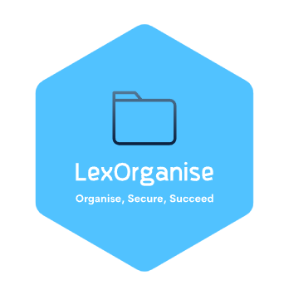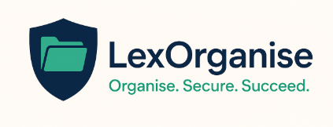

I would create this as a Private Limited Company (Ltd) for it’s limited liability protection, client credibility and the ability to attract investments. It would also be registered in the UK under the Companies Act 2006. [3]

Business Strategy
LexOrganise would aim to become a leading provider of cloud based client and matter management that is secure for the legal sector.
It would automate admin tasks, keep all client and matter data centralised [5] and also comply with all of the GDPR and SRA guidelines
To start I would focus this towards the small to medium firms in the UK to test how the system would cope and after some updates and development when it gets to a point where I think it can move to a larger scale I would then push this outside of the UK and to larger firms. I would try to get more support to be able to maintain the system and preferably some from other countries to ensure there is support for time zones that aren’t the UK
It would have competitive pricing for small to medium firms to try and get people to go with LexOrganise over other options. It would also market customisable workflows so people can control how they do their work. I would ensure there are UK based data centres for legal data sovereignty.

Funding Initiative
- I would try and get government grants by applying for UK innovate grants which target digital transformation in professional services [4]
- Try and get partnerships by going to law schools to see if they would use it for training and possibly allow for co development [10]
- Crowdfunding based options like Crowdcube would be a good way to allow solicitors and early adopters to invest in the product
- Could offer early access to firms that are willing to pay upfront for multi year contracts

Reflection

When looking to create a legal case management system I see myself picking up a lot of new skills as it is a valuable opportunity to strengthen my project management, technical and professional skills.
With the technical side of things I will gain a greater understanding of web application development and skills with SQL for database management. I currently do not have much experience with SQL and web application development softwares so when I start doing a lot of research and progress further on this course I hope to gain the knowledge to be able to have a basic understanding of how to do this. I can then utilise a variety of different sources to broaden my knowledge to hopefully create what I imagine. I will also be looking into Azure to for cloud based hosting [5], at the moment in my job we haven’t moved to cloud based yet but I can already see the benefits it has for if there were any problems such as the services going down, it would allow us to continue working a lot easier so I would like to be able to integrate this into my project. I will also develop various cybersecurity skills whilst looking into encryption and multifactor authentication to ensure the client and matter details that are stored on the CMS are stored securely with less risk of information being leaked or used maliciously. All of the above are critical for creating a CMS so I will need to develop my skills to be able to make an effective project. i will need to understand the compliance side of the legal sector to make sure my CMS complies with the guidelines and policies that are set in place by the SRA for example and the legal ombudsman. I will need to look into GDPR [1] and the SRA standards [2]. If I can do this then I will be able to create a system that meets both the legal and technical requirements.

This idea can have a massive positive effect and has the potential to make a big contribution to society by enhancing the efficiency of legal services. It can be used to streamline, automate and enable solicitors to share documents easily which means that the solicitors and other admin teams can use their time more effectively by advising clients instead of focusing a lot of their time on paperwork. This could lead to matters being resolved quicker to ensure lower costs of the time put in which may lead to more clients as the costs of the work can be a lot more competitive. With data protection being a big focus for this project it will give clients peace of mind that their data is being used safely and managed correctly to reduce the chances of data breaches. This project could also be developed further to allow remote services so solicitors and clients can access their matter information and documents from whereever they are without needing to be in an office. This could be done through conversion to a mobile app that people can download that will require 2 factor authentication. This benefits people living in rural areas of the country as they wont need to travel far to an actual office building to get what they need.

I think the biggest challenges of this project will be Scalability, Data Security and User Adoption. As the firm grows the system will need to handle the increased amount of data and user loads without any effect on performance speed. One way to try and prevent this from happening is to choose a scalable cloud based infrastructure and design the database for expansion from the start even if it isn’t expected. Legal firms deal with a lot of sensitive data making this a target for cyberattacks. To mitigate the risk of cyberattacks I could implement end to end encryption, I could conduct frequent penetration tests and also make sure to follow the ISO/IEC 270001 information security standards. Users might be reluctant to change from the system they are currently using and to try and avoid this, user training would be set up before the go live date to ensure everyone as the opportunity to see how the system works. Demos could also be set up to show off the system and describe the benefits that the system will have in comparison to others on the market.

Conclusion
This report has outlined the scope, design and strategic planning behind the project idea of a case management system. It demonstrates how it can make processes more efficient, follow compliance guidelines and improve efficiency for small to medium legal firms. Through detailed project management and research into PEST and SWOT analysis for a similar company, and the creation of a business strategy for my potential company LexOrganise the concept has been molded into a potential start up opportunity with big potential. The reflection highlighted the technical, professional and compliance skills that I could develop during the project. there are some challenges that could arise in relation to scalability and security, also user adoption but as detailed in the report these can all be mitigated through the strategies I identified. This project idea represents a technical solution for law firms and also a possible step towards transformation and innovation within the legal industry

References

[1] Information Commissioner’s Office (ICO), “Guide to the UK General Data Protection Regulation (UK GDPR),” [Online]. Available: https://ico.org.uk/for-organisations/uk-gdpr-guidance-and-resources/.
[2] Solicitors Regulation Authority (SRA), “SRA Standards and Regulations,” [Online]. Available: https://www.sra.org.uk/solicitors/standards-regulations/.
[3] UK Government, Companies Act 2006, [Online]. Available: https://www.legislation.gov.uk/ukpga/2006/46/contents.
[4] Innovate UK, “Funding for Innovation,” [Online]. Available: https://www.ukri.org/councils/innovate-uk/.
[5] National Cyber Security Centre (NCSC), “Cloud Security Guidance,” [Online]. Available: https://www.ncsc.gov.uk/collection/cloud-security.
[6] British Standards Institution (BSI), “ISO/IEC 27001: Information Security Management,” [Online]. Available: https://www.bsigroup.com/en-GB/iso-27001-information-security/.
[7] Visual Paradigm, “ERD Tool,” [Online]. Available: https://online.visual-paradigm.com/.
[8] Wireframe.cc, “Wireframe Tool,” [Online]. Available: https://wireframe.cc/.
[9] Practice Evolve, “Legal Practice Management Software,” [Online]. Available: https://www.practiceevolve.com/.
[10] The Law Society of England and Wales, “Technology and the Law,” [Online]. Available: https://www.lawsociety.org.uk/topics/research/technology-and-the-law.

