

Managing Enterprise in the 21st Century

Business Plan



Module Title: Enterprise and Entrepreneurship
Module Code: LCLM4006
Assessment 1: Business Plan
Student Name: Stanica-Roxana Dediu
Student Number: 2441417
Lecturer’s Name: Charles Obinwa
Submission Date: 30 March 2026

Table of Contents………………………………………………………………..Page
1. Executive Summary……………………………………………………………….4
2. Business Description………………………………………………………………4
3. Market Analysis………………………………………………………………….…5
4. Marketing Approach……………………………………………………………….6
5. Operations plan………………………………………………………………….…7
6. Management and Organisation…………………………………………………..8
7. Financial Plan………………………………………………………………………9
8. Conclusion…………………………………………………………………………10
9. Reference List……………………………………………………………………..11

List of Appendices
Appendix A: PESTEL Analysis……………………………………………………..13
Appendix B: Porter’s Five Forces Analysis………………………………….…….14
Appendix C: SWOT Analysis………………………………………………………..15
Appendix D: Organisational Structure………………………………………..….…16
Appendix E: Financial Details……………………………………………………….17

1. Executive Summary
Funfinity Kids Play & Events is a London-based start-up offering indoor play and event services for children aged 2–12. The business provides safe, engaging play areas alongside party hosting and group booking services. Revenue will be generated through entry fees, memberships, and event packages, with the aim of meeting growing demand for children’s leisure activities and achieving profitability within the first year.

2. Business Description
The business will operate under the name Funfinity Kids Play & Events, chosen to reflect its focus on children’s entertainment and event services. A search of the UK Companies House database confirmed that no identical name exists within the same market, ensuring the brand is distinctive. (Companies House, 2026).
Funfinity Kids Play & Events is a children’s entertainment centre that combines indoor play facilities with organised event services. The business aims to provide a safe, structured, and engaging environment where children can participate in both free play and organised activities, while parents benefit from convenience and reliability.
The core services include supervised play areas, structured physical and social activities, birthday party hosting, group bookings, and optional catering services. By combining play and events within one venue, the business offers a comprehensive solution that increases customer value and creates multiple revenue streams.
The business will be located in London, targeting families, schools, and community groups. This location provides access to a large customer base; however, it also involves high competition and operating costs. Therefore, the business must focus on high service quality, safety standards, and customer satisfaction to remain competitive.
Funfinity will operate as a private limited company (Ltd), providing limited liability and supporting future growth and investment opportunities.

SMART Objectives:
- Achieve break-even within the first 12 months
- Attract at least 200 customers per month
- Build brand awareness through digital marketing
- Expand services within 2 years
These objectives provide clear direction for the business and are achievable with effective management and marketing strategies.

3. Market Analysis
The UK children’s entertainment industry is a growing sector, driven by increasing awareness of children’s physical activity, social development, and demand for structured leisure activities. Research shows that families are increasingly spending on services that combine entertainment with developmental benefits, making this market attractive for new businesses.
Target Market:
- Parents aged 25–45 with children aged 2–12
- Families living in London
- Schools and community groups
This target market is large and consistent, particularly in urban areas such as London where population density is high. However, competition is also strong, meaning the business must clearly differentiate itself.
Customer Needs:
- Safe and clean environments
- Engaging and educational activities
- Convenient booking systems
- Affordable pricing
Industry trends indicate a shift towards indoor play centres, especially in cities where outdoor space is limited. These centres benefit from year-round demand, as they are not affected by weather conditions.
However, the market is highly competitive. Competitors include soft play centres, trampoline parks, and digital entertainment. The rise of home-based entertainment, such as video games and streaming services, presents a strong substitute, which may reduce demand for physical activities.
In addition, consumer behaviour is influenced by convenience, price, and perceived value. Parents are more likely to choose services that offer both entertainment and developmental benefits. Economic conditions may also affect demand, as leisure spending can decrease during financial uncertainty.
A full external analysis is provided in Appendix A (PESTEL) and Appendix B (Porter’s Five Forces). A summary of internal and external factors is also included in Appendix C (SWOT Analysis). Overall, the market offers strong opportunities, but success will depend on differentiation, service quality, and effective marketing.

4. Marketing Approach
Funfinity Kids Play & Events will adopt a marketing strategy based on segmentation, targeting, and positioning (STP), which helps businesses effectively reach and engage their customers.
Segmentation and Targeting:
The business focuses on families with children aged 2–12, particularly parents aged 25–45 living in London. This group is selected due to its consistent demand for children’s activities and willingness to spend on safe and engaging experiences. However, strong competition means the business must clearly communicate its value.
Positioning:
Funfinity will be positioned as a safe, high-quality, and engaging children’s play and event centre. This positioning highlights key factors influencing customer decisions, particularly safety, convenience, and overall experience.
Marketing Channels:
- Social media platforms (Instagram and Facebook)
- A website with an online booking system
- Partnerships with schools and nurseries
- Promotions such as discounts and party packages
Digital marketing provides a cost-effective way to reach a large audience, while local partnerships help build trust and credibility within the community.
Customer Engagement:
The business will focus on building long-term relationships through customer satisfaction and loyalty. Positive experiences are likely to encourage repeat visits and word-of-mouth promotion.
In addition, marketing performance will be monitored using indicators such as engagement and booking rates. This allows the business to adapt its strategy and remain competitive in a changing market.
Overall, the marketing approach is suitable for a start-up, although its success depends on consistent execution and maintaining high service quality.

5. Operations Plan
The operations of Funfinity Kids Play & Events will focus on delivering a safe, efficient, and high-quality service for both children and parents. As a service-based business, operational performance is directly linked to customer satisfaction and overall success.
Key activities include supervising play areas to ensure safety, organising birthday parties and events, managing bookings and customer service, and maintaining high standards of cleanliness and hygiene.
The business will operate from a rented facility in London, chosen for its accessibility and proximity to target customers. However, high rental costs represent a significant financial commitment, meaning the business must maintain consistent customer demand.
Equipment and supplies will be sourced from multiple suppliers to ensure reliability and cost efficiency. While this reduces supply risks, it requires effective coordination.
Technology will play an important role, including an online booking system and social media platforms, which improve efficiency and customer convenience.
Staff will be trained in child supervision, safety procedures, and customer service to ensure a positive experience.
Efficient management of peak periods, such as weekends and school holidays, will be essential. Poor organisation during busy times could negatively affect service quality and customer satisfaction. Overall, effective operations management is critical to business success.

6. Management and Organisation
Funfinity Kids Play & Events will adopt a simple organisational structure suitable for a start-up business. This structure ensures clear responsibilities while maintaining flexibility during the early stages of development.
The organisation will include:
- Founder/CEO
- Operations Manager
- Marketing & Sales Manager
- Finance & Administration Manager
- Supporting staff
The Founder/CEO will be responsible for overall decision-making, strategy, and business development. The Operations Manager will oversee daily activities and ensure that services are delivered efficiently and safely.
The Marketing & Sales Manager will focus on promoting the business and attracting customers, while the Finance & Administration Manager will manage budgeting and financial records.
Supporting staff will assist with supervising children and delivering services, playing a key role in customer experience.
In the early stages, some roles may be combined to reduce costs. However, as the business grows, additional staff may be required to improve efficiency and support expansion.
Full organisational chart is available in Appendix D.

7. Financial Plan
The financial plan outlines the expected costs, revenues, and profitability of Funfinity Kids Play & Events. Careful financial planning is essential to ensure the business remains sustainable and achieves its objectives.
Start-up Costs:
The estimated start-up costs range between £29,500 and £57,000. These include expenses such as rent deposits, equipment, renovation, licensing, insurance, and initial marketing. Although these costs are significant, they are necessary to create a safe and attractive environment.
Operational Costs:
Monthly operating costs are estimated between £8,400 and £15,300. These include rent, staff wages, utilities, maintenance, and marketing. A large proportion of these costs are fixed, meaning they must be paid regardless of customer numbers.
Revenue Streams:
The business will generate income from multiple sources, including entry fees, birthday party bookings, membership packages, and catering services. This diversification reduces financial risk.
Revenue and Profitability:
Estimated monthly revenue ranges from £12,000 to £22,000, with a potential profit of approximately £5,000. Break-even is expected within the first year, depending on customer demand and cost control.
Financial performance may be affected by seasonal demand and unexpected costs. Therefore, regular monitoring and careful budgeting are essential to ensure long-term sustainability.
Full financial details are provided in Appendix E.

8. Conclusion
Funfinity Kids Play & Events represents a strong business opportunity within the growing children’s entertainment market in London. The business meets key customer needs by providing a safe, engaging, and convenient environment for children, while offering added value through combined play and event services.
Although the market is competitive, the business can achieve success through clear differentiation, high service quality, and effective marketing strategies. The operations and management structure support efficient service delivery and customer satisfaction.
Financial projections indicate that the business is viable, with the potential to achieve profitability within the first year. However, success will depend on maintaining consistent demand and controlling costs.
Overall, with effective management and continuous improvement, Funfinity has the potential to become a successful and sustainable business.

9. Reference List
Chambers, D. (2012) A Sociology of Family Life: Change and Diversity in Intimate Relations. Cambridge: Polity Press.
Companies House (2026) Find and update company information. Available at: https://www.gov.uk/get-information-about-a-company (Accessed: 28 March 2026).
Furnham, A. and Gunter, B. (2008) Children as Consumers: A Psychological Analysis of the Young People’s Market. London: Routledge.
Mackelprang, A.W., Habermann, R.C. and Swartz, M. (2012) ‘The role of service quality in customer satisfaction’, Journal of Service Management, 23(4), pp. 456–472.
Mogaji, E. (2025) Introduction to Marketing: Principles and Practice. London: Sage.
Mullan, K. (2019) ‘A child’s day: Trends in time use in the UK’, British Journal of Sociology, 70(3), pp. 997–1024.
Rajagopal, R. and Davila, A. (2020) ‘Entrepreneurial growth and organisational structure’, Journal of Business Venturing, 35(2), pp. 1–15.
Scriven, J., et al. (2015) Marketing and Promotion in the Leisure Industry. London: Routledge.
Sintha, L. (2020) ‘Break-even analysis for business decision-making’, Journal of Economics and Business, 3(1), pp. 45–52.
Statista (2024) Children’s leisure market in the UK. Available at: https://www.statista.com (Accessed: 28 March 2026).
UK Government (2023) Health and safety regulations for businesses. Available at: https://www.gov.uk (Accessed: 28 March 2026).
Ofsted (2023) Childcare and child safety guidelines. Available at: https://www.gov.uk/government/organisations/ofsted (Accessed: 28 March 2026).
NHS (2022) Physical activity guidelines for children. Available at: https://www.nhs.uk (Accessed: 28 March 2026).
Mintel (2024) UK leisure and entertainment market report. Available at: https://www.mintel.com (Accessed: 28 March 2026).

Appendix A: PESTEL Analysis

Factor | Analysis
Political | - Must comply with UK health, safety, and child protection regulations  - Local council policies may affect licensing and operating conditions
Economic | - Cost of living may reduce spending on leisure activities  - Economic conditions can influence pricing and demand
Social | - Growing demand for safe and structured children’s activities  - Busy lifestyles increase demand for convenient services
Technological | - Online booking systems improve efficiency and customer experience  - Social media supports marketing and customer engagement
Environmental | - Increasing focus on eco-friendly and sustainable practices  - Need to manage waste and energy use responsibly
Legal | - Must meet legal requirements for insurance and safety standards  - Staff must follow safeguarding rules and DBS checks

Appendix B: Porter’s Five Forces Analysis

Force | Level | Explanation | Impact on Business
Threats of New Entrants | Medium | Moderate start-up costs and regulations create some barriers, but new businesses can still enter the market | The business must build strong branding and customer loyalty to compete with new entrants
Bargain Power of Suppliers | Low - Medium | Multiple suppliers are available for equipment and services, reducing dependency | The business can negotiate prices and manage costs effectively
Bargain Power of Buyers | High |  | The business must offer high quality and competitive pricing to attract and retain customers
  Customers have many alternative entertainment options and can easily switch
Threat of Substitutes | High | Alternatives such as digital entertainment and outdoor activities are widely available | The business must provide unique and engaging experiences to stand out
Competitive Rivalry | High | There is strong competition from existing play centres and leisure venues | The business must differentiate through service quality, safety, and customer experience

Appendix C: SWOT Analysis
 | Favourable | Unfavourable
Internal | Strengths  - Combination of play and event services increases customer value  - Safe and engaging environment attracts families | Weaknesses  - High start-up costs due to equipment and location  - Limited brand recognition as a new business
External | Opportunities  - Growing demand for children’s entertainment services  - Partnerships with schools and nurseries | Threats  - Strong competition in the children’s leisure market  - Economic conditions may reduce customer spending

Appendix D: Organisational Structure
As a start-up business, some roles may initially be combined or managed by the founder to reduce costs. As the business grows, additional staff will be recruited to support expansion.
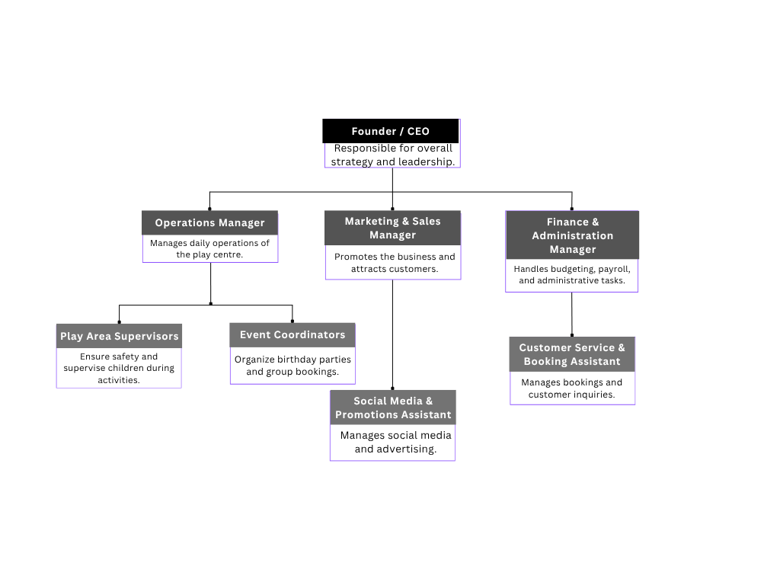

Appendix E: Financial Details

Table 1: Start-up Costs
Item | Estimated Cost (£)
Facility rent deposit & lease | 5,000 – 10,000
Renovation & interior design | 5,000 – 12,000
Play equipment & installations | 10,000 – 20,000
Furniture & fixtures | 1,000 – 5,000
Licensing & legal fees | 500 – 1,500
Insurance | 1,000 – 2,000
Website & booking system | 1,000 – 2,000
Initial marketing & promotion | 1,000 – 4,000
Total Estimated Cost | £29,500 – £57,000

Table 2: Monthly Operational Costs
Item | Estimated Monthly Cost (£)
Rent | 2,000 – 4,000
Staff wages | 5,000 – 8,000
Utilities | 500 – 1,000
Maintenance & Cleaning | 300 – 800
Marketing & Advertising | 300 – 700
Insurance | 100 – 300
Supplies | 200 – 500
Total Monthly Costs | £8,400 – £15,300

Table 3: Monthly Revenue Estimate
Source of Income | Estimated Monthly Revenue (£)
Entry fees | 6,000 – 10,000
Birthday party bookings | 3,000 – 6,000
Membership packages | 2,000 – 4,000
Catering services | 1,000 – 2,000
Total Revenue | £12,000 – £22,000

Table 4: Break-even Estimate
Description
  Amount (£)
Average Monthly Costs | 10,000
Average Monthly Revenue | 15,000
Estimated Monthly Profit | 5,000

