

Programme: Master of Business Administration
Module: Strategic Management
Module CODE: LCMB7003
Assessment Component: Individual Report
Word count: 5246

Student name: Kazi Mahmud Ul Islam
Student ID: 2510576
Lecturer’s Name: Hoang Nguyen

Submission Deadline: 1st May 2026 by 2pm

Title: A Report on Analysing Strategic Management of Google in the UK

How to acknowledge your use of AI

Updated: February 2026
This guidance is for students to support the integration of AI tools in assessment.
Every assessment specification identifies the allowable use of AI in that assessment. You should be able to see a version of the following table:

RESEARCH | For this assessment, you can use Generative AI to  support you in research, including searching for bibliography, using tools to summarise, compare and interrogate materials. | Yes ☐No ☐
STRUCTURE | For this assessment, you can use Generative AI to  support you in structuring your submission, including creating a draft argument structure, identifying parts and headings, etc. | Yes ☐No ☐
PROOFREADING | For this assessment, you can use Generative AI to  check your own text/creation for grammatical and syntactical mistakes, including rephrasing of your own work within specific standards. | Yes ☐No ☐
WRITING | For this assessment, you can use Generative AI to  create text for submission. | Yes ☐No ☐
CREATIVE | For this assessment, you can use Generative AI to  create creative materials, such as images. | Yes ☐No ☐
PROGRAMING | For this assessment, you can use Generative AI to  create and check code. | Yes ☐No ☐
NONE | For this assessment, you are not allowed to use any  type of Generative AI support. This includes research support, structure support, writing/proofreading support and creative support. | Yes ☐No ☐

Basic Acknowledgement format of AI tool use

I acknowledge the use of Grammarly (https://www.grammarly.com/) on 1st May 2026 to check my work using the prompt(s):

I confirm that I have not presented any AI generated text as my own work. I confirm I have copies of my drafts, notes, and other resources I used before, and after the use of AI tools which I may be asked to provide in evidence.

Table of Contents
Basic Acknowledgement format of AI tool use 3
Section 1: Report 5
1. Organisational Context and Overview 5
2. External and Internal Environment Analysis 7
PESTLE Analysis 7
CSFs and Strategic Challenges faced by Google 9
Internal Environment of Google 10
VRIO analysis 11
Contribution of internal strengthen in competitive advantage of Google 13
3. CSR and Sustainability objectives 14
4. Comprehensive and holistic view of the organisation 16
Financial 16
Customers 17
Internal Business Processes 17
Learning and Growth 18
5. Strategic Choices and Implementation 18
Business level strategies 18
Corporate level Strategies 19
Recommendation for Google 21
Managing this change and its impact 21
6. Strategic Evaluation and Recommendations 22
SWOT analysis 22
Ansoff Matrix 23
Recommendations 24
Section 2: Reflective Practice 25
References 29

Section 1: Report

1. Organisational Context and Overview
Alphabet Inc, the parent company of Google has been represented as the most influential firms in the global digital ecosystem operating at the intersection of artificial intelligence or AI, digital advertising and cloud computing. It was founded in 1998 by Sergey Brin and Larry Page, Google has initially emerged as the search engine aims to organise the information of the world (Google, 2025). Originally Google was named “BackRub” in 1996 and was rebranded as Google which is a play on the term “Googol” and incorporated in a California garage. Google was introduced in 2004, in 2006 it acquired YouTube and later it became a subsidiary of Alphabet Inc in 2015 (Cyfuture Cloud, 2025). At present the services of Google have expanded aggressively into food computing, AI, and Quantum technology. The mission of Google is to organise the information of the world and market it universally useful and accessible.
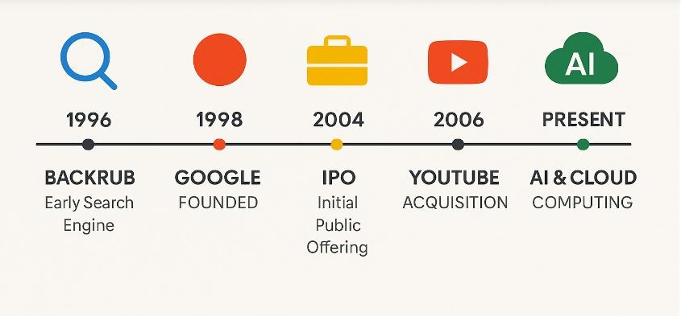
Figure 01: Historical significance of Google Inc.
(Source: Cyfuture Cloud, 2025)

This mission continuously underpins the strategic trajectory of the brand although the operational scope of Google is significantly diversified (Singh et al. 2023). The vision of Google is to offer access to the world's information with one click emphasizing access, innovation and simplicity.
The creation of Alphabet has been marketed as the structural shift offering strategic clarity separating core businesses like Google Cloud and Google Services from the experimental ventures like “Other Bets”. Alphabet has invested more than USD 200 billion in Research and Development in the past five years to offer deliberate transition in the AI-first business model (Sec Gov, 2025). The business model of Google remains functional, and advertising driven as the revenue is mostly generated through YouTube, Search Engine and network advertising complemented by acceleration on AI-driven enterprise solutions and cloud services. In 2014, Google generated USD 348.16 billion (Statista, 2024). Google operated within a highly competitive digital platform and global technology industry. The sector is characterised by network effects, rapid innovation and regulatory scrutiny. The core competitors of Google are Microsoft which offers AI and cloud services, Meta platforms which offers digital advertising ecosystem and Amazon which offers digital and cloud infrastructure services (Harrington, 2021). Despite intensified competition, Google maintains a dominant market position specifically in search where it processes trillions of queries annually.

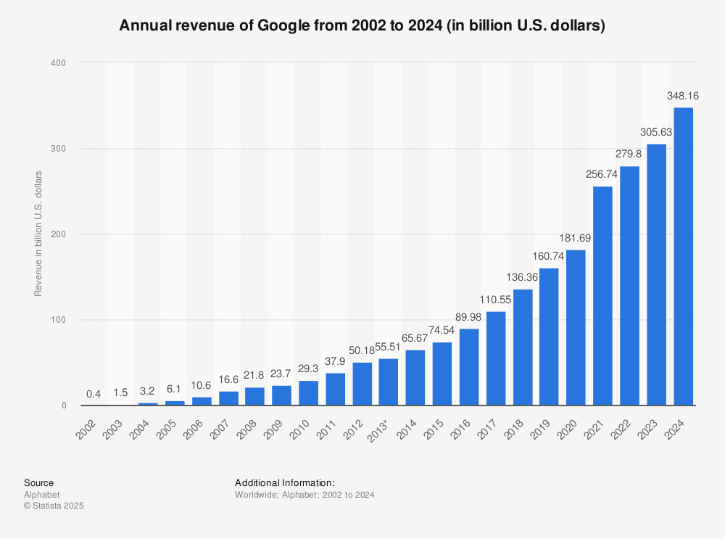
Figure 02: Global Revenue across the Globe
(Source: ‌Statista, 2024)

However, structural imbalances have posed challenges against the strategic market position of Google as it is facing tension between global energy demands and sustainability commitments simultaneously. Google faces challenges to reduce emission rate from its data centres despite the sustainability and computational needs (Google Data Centers, 2024). Therefore, the case
of Google will offer an opportunity to explore strategic paradoxes in its market leadership, analysing the competitive disruption, regulatory pressures and environmental issues.

2. External and Internal Environment Analysis

PESTLE Analysis
Political: The operations of Google in the UK are shaped by active regulatory oversight. The CMA or Competition and Market Authority has intensified the regulatory scrutiny over the dominance of digital advertising. On the other hand, the Digital Market Unit UK has proposed “strategic market status" rules to target the firms like Google (GOV UK, 2025). Post-Brexit industrial policy has also emphasised sovereign AI capability that influenced the investment in governance, transparency policy and compliance strategy of Google in the UK to mitigate antitrust risks.
Economic: The digital economy of the UK has generated USD 281.03 billion in 2023 from the revenue stream of Google (Statista, 2023). However, the microeconomic pressure like reduced ad spending and high inflation and reduced spending in addition has affected the growth. Advertising remains the primary income source of Google making it sensitive to economic cycles of the UK and marketing expenditure fluctuations in SMEs.
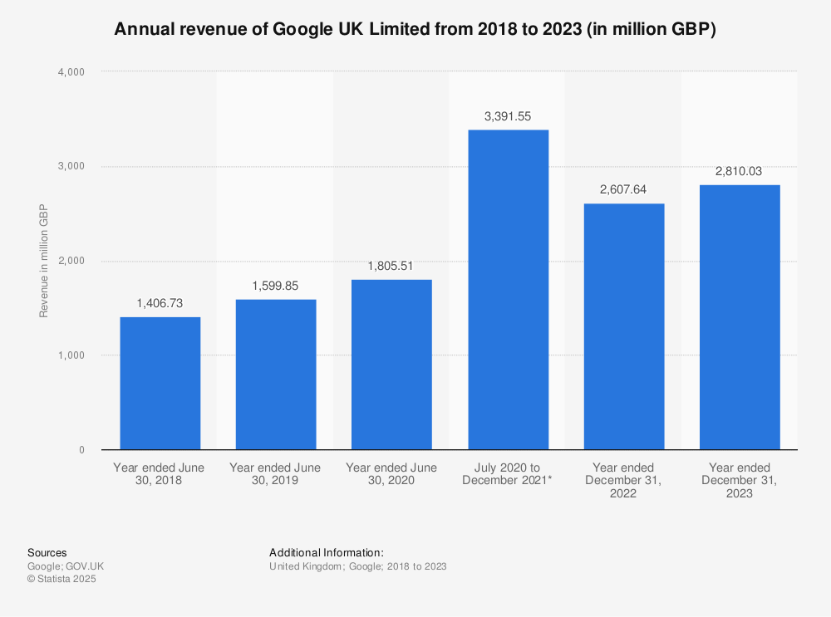
Figure 03: Revenue of Google in the UK
(Source: Statista, 2023)
Social: The high internet penetration rate in the UK and mobile-first behaviour had reinforced the ecosystem dominance of Google. Due to its android dominance, this search giant is ordered to pay USD 5.1 for abusing the dominant position of Android in the smartphone industry (Statista, 2016). However, the data privacy issue and societal concerns over misinformation and AI ethics are rising. Google has clearly demonstrated the use of ethical AI to maintain transparency with its stakeholders.

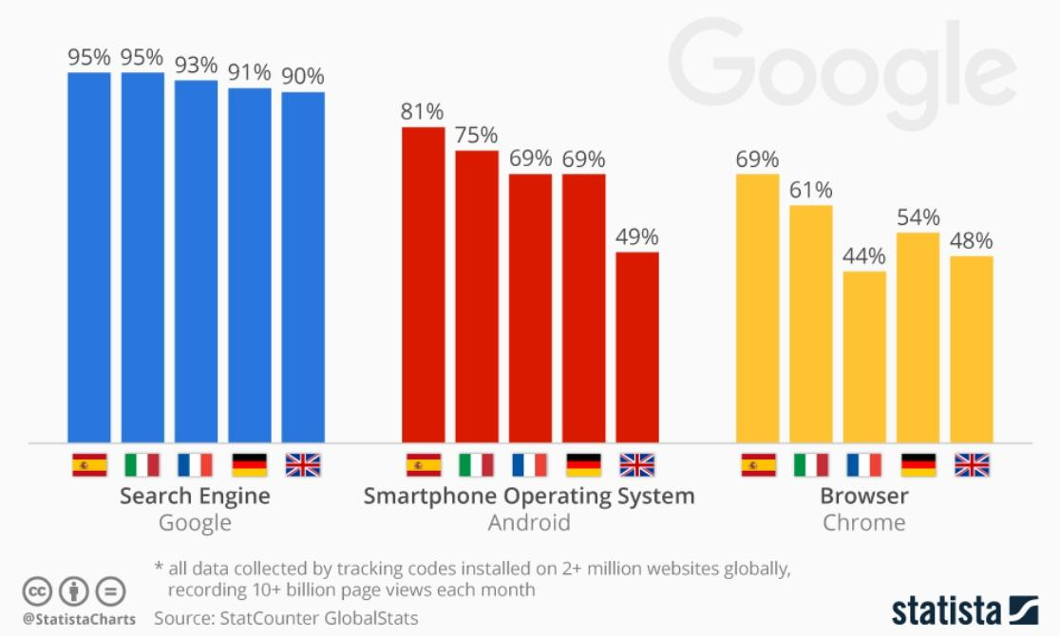
Figure 04: Dominance of Google in European countries
(Source: Statista, 2016)

Technological: The UK is the key hub for cloud and AI adoption supporting the Cloud computing service expansion in Google. The government supported the AI partnerships and strategies with the universities has strengthened the innovation ecosystems. The USD 15 billion investment of Google in AI infrastructure and efficiency to improve the performance of data centres has enhanced its competitive advantage (Kurian, 2025). This Strategic decision has delivered significantly high computational outputs per energy unit.
Legal: Google needs to comply with the strict UK-based regulations and the Data Protection Act 2018 (Miller, Lukic and Skiera, 2025). Ongoing potential enforcement according to Digital Markets, Consumer Bills and competition and antitrust investigation has created legal uncertainty for Google. These legal consequences have directly influenced data practices of Google and obligations in platform governance within the UK market.
Environmental: The operations in Google have increasingly influenced the net-zero target by 2050. The global sustainability strategy like progress towards 24/7 carbon-free energy and 100% renewable energy provision has intersected to the climate policy of the UK (Sustainability, 2020). However, the increasing AI-based energy demands has presented a structural tension between environmental commitments and operational expansion in the UK market.

CSFs and Strategic Challenges faced by Google
Critical Success Factors: The sustained competitive advantage of Google in external involvement is underpinned by three interrelated success domains.
- Firstly, its AI capability leadership is supported by the USD 200 billion investment in R&D enabling product integration and continuous innovation across Cloud computing, YouTube and Search.
- Secondly, the data-driven network effects have reinforced the market dominance of Google specifically in digital advertising and search where the scale of Google has enhanced user lock-in and algorithmic precision (Martens, 2023).
- Thirdly, infrastructural efficiency including the highly optimised data centres have delivered significantly greater computational outputs per energy units which has strengthened the scalability and cost leadership.
Strategic Challenges: Google is facing structural challenges which have intensified its operational complexities in the global market.
- Regulatory pressure specifically in antitrust intervention globally and in the UK has threatened its advertisement-centric model which may enforce its structural separation.
- AI-driven energy consumption has presented a critical paradox as the scaling computational capability conflicts with carbon-free ambitions despite progress towards emission reduction targets.
- In addition, competitive convergence from the firms like Amazon and Microsoft has eroded differentiation in the AI and cloud markets (Sklenarz et al. 2024). These procedures have collectively necessitated the strategic recalibration balancing compliance, innovation and sustainability within an increasingly constrained external environment.

Internal Environment of Google
Key resources: The internal strength of Google is anchored in a highly sophisticated resource base that combines the intangible and tangible assets. Financially, sustained cash flows from the advertising platforms enabled larger share in revenue generation of nearly USD 400 billion in the UK (The Business Standard, 2026). Technologically, the proprietary infrastructure involving the customer Tensor Processing Units and global data centres has supported the scalable deployment of AI. Intangible resources include the vast dataset defined from billions of users alongside the platform ecosystem involving YouTube, Search and Android and powerful brand equity. Human capital is equally critical, and Alphabet has 183,029 full time employees including the elite AI engineers and researchers who drive innovation (Statista, 2024). Collectively, these resources reflect high rarity and values forming the foundation for the strategic positioning of Google.

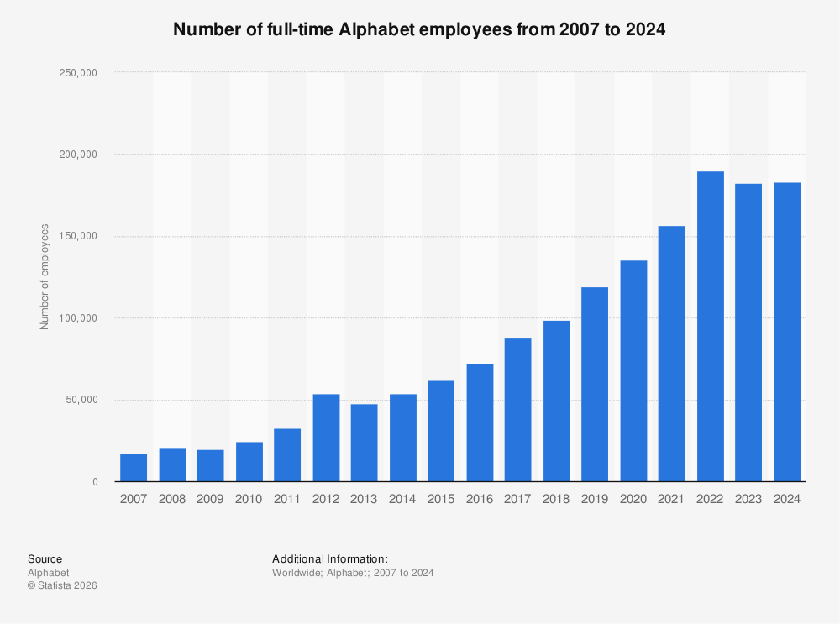
Figure 05: Full time human resources in Alphabet Inc.
(Source: Statista, 2024)

Capabilities: The capability of Google lies in its ability to leverage and integrate the resources dynamically across the markets and products. The capability of AI integration enables continuous embedding of machine learning across its services exchanging monetisation and user experience (‌Chtinis, 2025). Operationally, Google has demonstrated superior infrastructure optimisation and data processing achieving significantly higher computational outcomes per energy units. In addition, its platform orchestration ability has allowed seamless interaction between Ads, Search and Cloud reinforcing the ecosystem synergy (Kodali, 2025). These capabilities are aligned to dynamic capability theory reflecting the capacity to sense the technological shift and seize opportunities like Generative AI and reconfigure the resource efficiency within volatile environments.

Core Competencies: The core competencies of Google emerged from. The strategic integration of capabilities and resources. Foremost is the algorithmic and search intelligence which underpins the dominance in the targeted advertising and information retrievals (Rezaei, 2025). Secondly, its data analytics and AI competencies have enabled personalised services and predictive insights at scale differentiating it from its core competitors. Thirdly, the ecosystem integration that links products like YouTube, Search and Cloud has created strong user lock-in and network effects (Morley, Widdicks and Hazas, 2018). These competencies are difficult to imitate due to scale, path dependency and technological complexities. Therefore, sustaining long-term competitive benefits which aligned to criteria of VRIO framework to sustained superiority.

VRIO analysis
Valuable: Value creation is evident in the advertising-based ecosystem like YouTube and Google properties of Google has accounted for most of its revenue which is 77.8% of total revenue of Google (Statista, 2024). This reflects the economic significance of the data-driven monetisation capabilities and data-driven targeting. In addition, its AI-driven infrastructure will enhance the scalability and efficiency aligning with operational performance with strategic value creation.
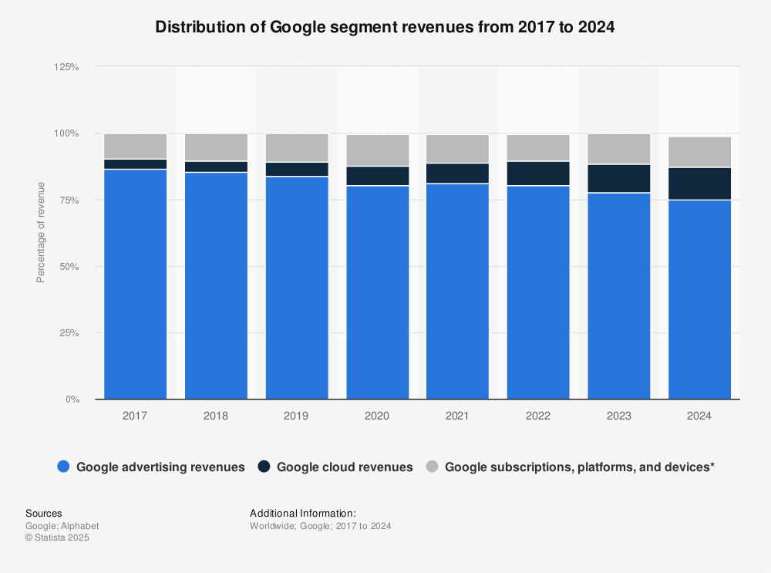
Figure 06: Revenue Distribution of Google by segments
(Source: ‌Statista, 2024)

Rare: In Rarity perspectives, the integrated ecosystem of Google combining the YouTube, Search Engine and Cloud Computing remains relatively unique. Its competitors like Amazon and Microsoft have possessed strong individual capability (Rashid and Kausik, 2024). The cross-platform data integration of Google along with its global user base has created distinctive competitive configurations which cannot be replicated at scale.
Inimitable: Despite the advantages in high capital intensity, path dependency and volume of data, global accessibility to Gen AI has reduced entry barriers for its competitive firms (Mariani and Dwivedi, 2024). Its core competitors are further engaging and have replicated and further advanced the AI functionalities which had reduced durability of sustainable competitive benefits. However, accessing the reach, infrastructure and scale of Google is not easily possible due to its complexity and resource intensively.
Organised: Alphabet supports the strategic flexibility of Google through decentralised innovation culture. A competitiveness is achieved by Google as it is rapidly evolving its AI-based products and services through aggressive innovation (Hall, 2024). This is evidenced by the rapid innovation cycles and investing resources across its business units.

Strategic capabilities | Valuable | Rare | Inimitable | Organised
Data and Advertising monetisation | ✓ | ✓ | ∆ | ✓
AI capabilities and infrastructure | ✓ | ✓ | ∆ | ✓
Platform Ecosystem with YouTube and Search | ✓ | ✓ | × | ✓
Global User Base and Brand | ✓ | ✓ | × | ✓
AI services and Cloud competencies | ✓ | × | ∆ | ✓
Keys: ✓=Strong presence, × = Difficult to imitate and ∆ = Moderately imitable

Contribution of internal strengthen in competitive advantage of Google

The internal strengths of Google have translated into the competitive advantage of Google through reinforcing structural scalability and dominance. The search capability of Google in Mobile has commanded 95.5% market share and I. Desktop 79% in the key markets suppressing its competitors (Statista, 2023). It has created powerful network effects enhancing the algorithmic precision and data accumulation. This has been complemented by the continuous R&D investment and AI infrastructure enabling product integration and rapid innovation. In addition, the highly efficient operations across the data centre have improved cost leadership while supporting the expansion (Ma et al. 2025). However, this advantage is contingent on sustaining technological differentiation and managing regulatory constraints in the intensified AI-driven competitive advantage.
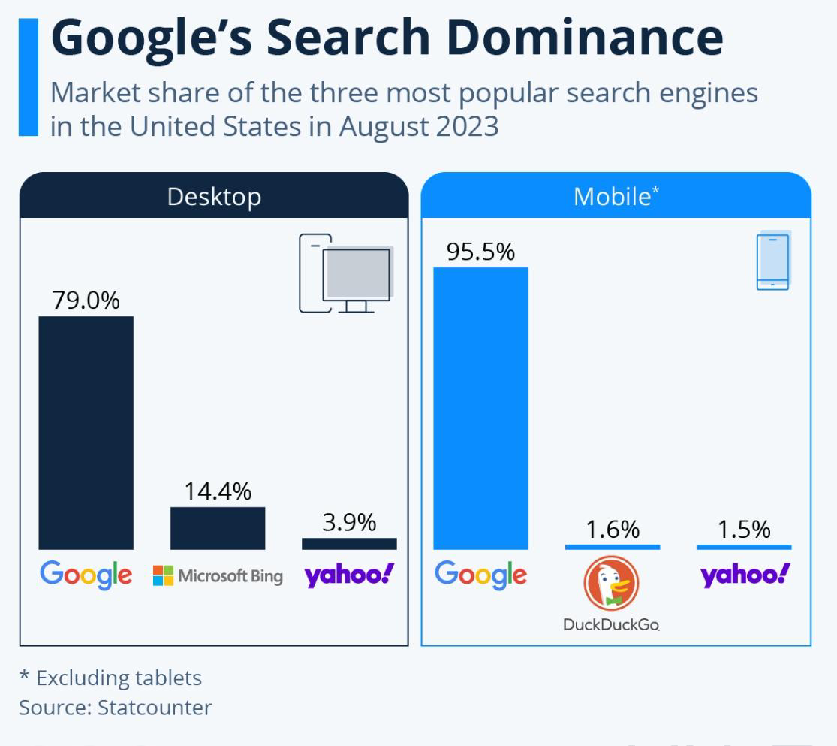
Figure 07: Competitive advantage of Google in Search Engine
(Source: Statista, 2023)

3. CSR and Sustainability objectives
The CSR strategy of Google is evaluated through the Triple Bottomline model which reflects the profit, people and plant perspectives.
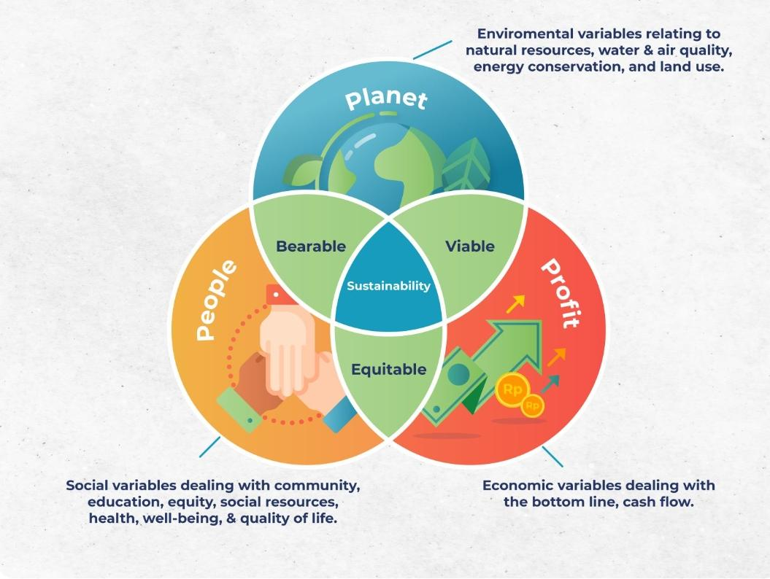
Figure 08: Three Dimensions of Triple Bottomline
(Source: Bahraini, 2021)
Profit: The digital economy of the UK has achieved over USD 281.03 billion in 2023 from the revenue stream of Google (Statista, 2023). Moreover, the search engine has grabbed 92% of the market becoming the most visited sites across the globe whereas Bing of Microsoft has only 3% share reflecting its scale (Bryce, 2024). The data centres in Google have achieved substantial optimisation of energy with advanced AI infrastructure delivering higher computational outcomes per unit of electricity which has directly reduced the operational costs supporting scalability.

Planet: Although, in sustainability reports, Google has claimed that it has achieved measurable progress with 12% reductions in energy emissions across the data centres despite a 27% increase in electricity demand. It has procured 8 GW of cleaner energy (Google Sustainability, 2025). However, reports by Bryce (2024) identified CO2 emission in Google has increased four-fold since 2017 as the company recorded 14.3 million tons emission in 2023. These contrasting claims between corporate disclosure and third-party reports indicating possible greenwashing issue

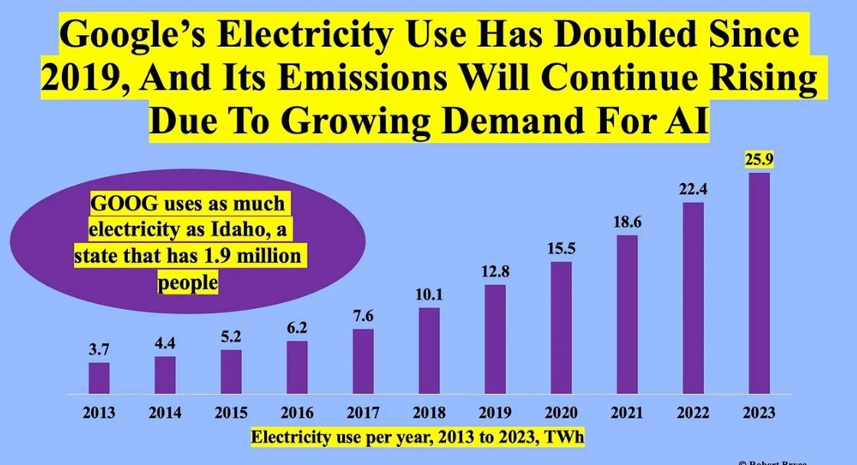
Figure 09: Continuous increase of Emission and Electricity Usage in Google
(Source: Bryce, 2024)

People: The investment of Google in AI-driven disaster prediction for the wildfire and flood forecasting has enhanced public resilience and safety. The CSR of Google is extended to digital inclusion and responsible AI deployment which has enhanced trust of stakeholders. The products and services enabled 26 million metric tonnes reduction of CO2e in 2024 through its tools like smart traffic systems and fuel-efficient routing demonstrating wider value creation for society (Sustainability, 2024). However, persistent concerns in misinformation, data privacy and market dominance have challenged trust of stakeholders.

4. Comprehensive and holistic view of the organisation
The balanced scorecard proposed by Kaplan and Norton (1992) has enabled multidimensional analysis of strategy of Google integrating the non-financial and financial performance aligned to its mission of organising global information and evolving AI-driven innovations. The scorecard of Google demonstrates a data-driven and platform-based business model which is increasingly shaped by sustainability constraints and AI scalability.

Financial
The financial objective of Google is to sustain revenue growth by diversifying the services beyond advertisement services. The key performance indicators in such a financial goal are revenue growth in Cloud, market share of advertising and operational margin in Google (Untaylored, 2026). Google aims to reduce dependency on advertisement services which is currently the most dominant revenge stream and expansion of cloud profitability. Google is investing in AI-driven products and enterprise-based Cloud computing solutions. The financial strategy of Google remains anchored in its advertising services which have contributed revenue majority reinforcing the profitability. Google Limited in the UK has generated net profit of GBP 373.86 million in 2023 and during COVID-19 period it was highest with GBP 896.08 billion (Statista, 2023). The strategic shift towards AI services and Google Cloud reflects deliberate diversification efforts as it is continuously investing in R&D that supports long-term revenue growth. This indicates tradition from monetisation efficiency to innovation driven growth aligning strategic positioning with financial outcomes.
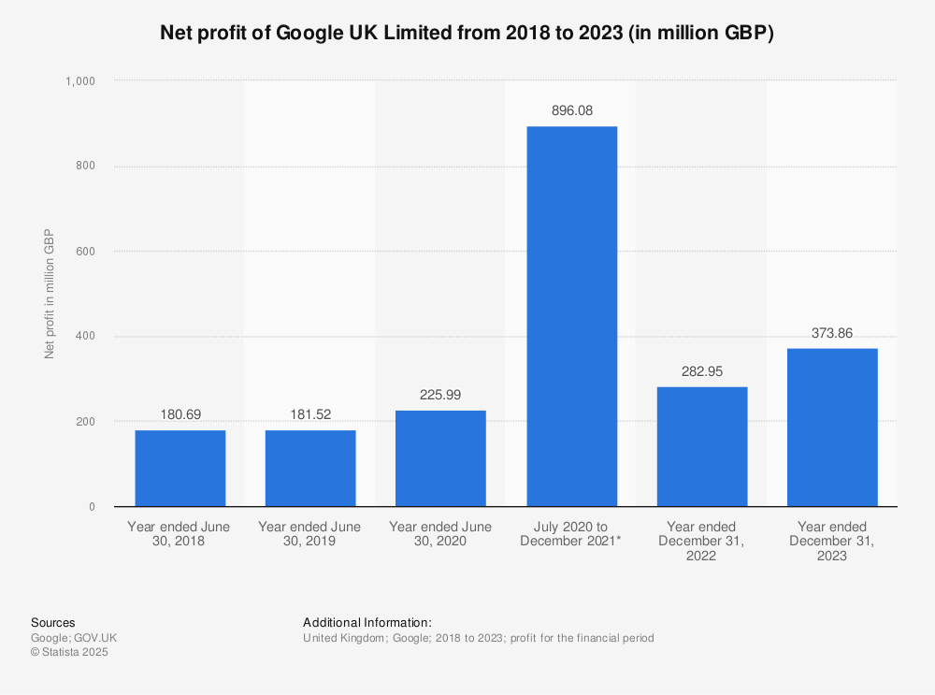
Figure 10: Net Profit of Google in the UK
(Source: Statista, 2023)

Customers
The objectives for customer retention and loyalty are to enhance trust, user engagement and ecosystem retention. The KPIs are the user engagement rate in Google Search and YouTube, market share of its search engine and adoption rate of enterprise Cloud (Dwivedi et al. 2021). The target of Google is to maintain dominant search share and its enterprise client base. Google has taken initiatives like AI integration through Generative search, product personalisation and privacy controls. The competitive advantage of Google is deeply rooted in habitual usage and user trust. The ability of Google to process trillions of searches yearly reflects the unparalleled engagement (Dzreke, 2025). However, increasing scrutiny over misinformation and data privacy has necessitated the strategic emphasis on transparency and responsible AI. Therefore, customer value is shifting towards trust-based differentiation from functional efficiency.

Internal Business Processes
The key objective is to optimise the sustainable infrastructure and operational efficiency. Google observes its progress in internal business operation through efficiency of Data centres calculating energy usage per computation, performance of AI models and emission data. Google targets increased usage of carbon-free energy and reduced operational emission. To achieve these targets Google has taken initiatives like advanced AI optimisation, decarbonisation of supply chain and clean energy procurement (Google Sustainability, 2025). The internal processes in Google are characterised by industry leading infrastructure efficiency. The data centres are delivering high computational outputs per unit of electricity consumption which is supporting high sustainability and cost efficiency (Google Data Centers, 2023). However, rapid expansion of AI has increased energy demands which create tensions between environmental commitments and operational scaling. This reflects a shift towards efficiency-constrained growth where sustainability has become a core operational variable.

Learning and Growth
The core objectives of Google in learning and growth factor are to sustain innovation leadership through technology, creating AI-driven jobs through training and development and retaining human capital. The KPIs which reflect the progress of Google in learning and growth are AI model advancements, R&D expenditure, patent outcomes and employee expertise. Google targets to maintain the leadership of Google in AI deployment and research and continuous capability enhancement. To achieve these initiatives Google has heavily invested in AI deployment and research of priorities technologies like TPUs and talent acquisition. The long-term competitiveness of Google is driven by the learning capability specifically in AI. Significant investment in R&D and continuous development of proprietary technologies has enabled rapid innovation cycles. Google has pledged GBP 5 billion investment in the UK to create AI-driven jobs (Katanich, 2025). This matches dynamic capability theory where organisational learning has supported the adoption of volatile environments. However, intensified competition for experts in AI and increasing learning costs has posed economic pressures.

5. Strategic Choices and Implementation

Business level strategies
Cost leadership: Cost leadership focuses on achieving lower operational costs to offer competitive prices for its target audiences (Khan, Khan and Knight, 2025). This scale has lowered the marginal costs and maintains superior monetisation efficiency. However, increasing challenges in AI infrastructure costs has challenged this advantage. Google has captured nearly 60% of the global search advertising revenue that has generated more than USD 160 billion from search engines alone (Statista, 2025). The cost leadership strategy of Google is evident through energy-efficient automation and data centres which sustains profitability managing increasing computational expenditure.
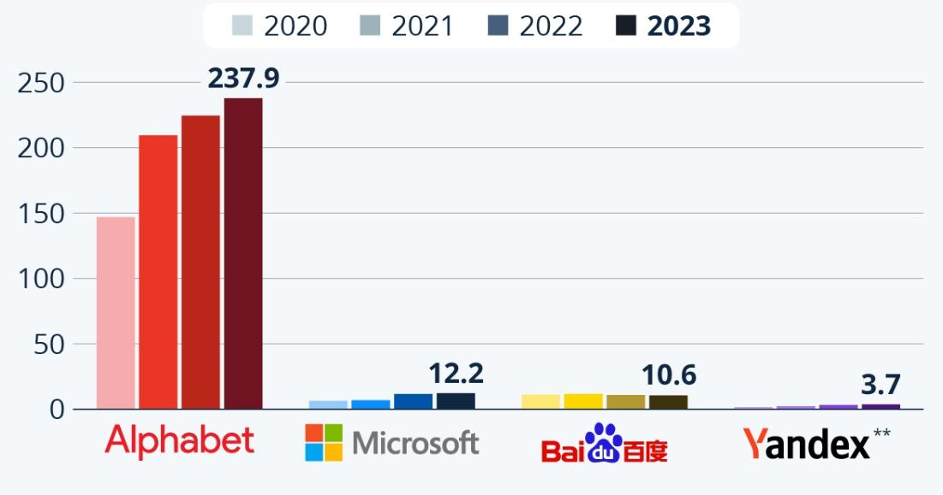
Figure 11: Competitors of Google in Ad Revenue
(Source: ‌Statista, 2025)
Differentiation: Differentiation strategy reinforces creating unique cake through superior user experience and rapid innovation (Jerab and Mabrouk, 2023). Google has created differentiation through personalisation in services by AI integration and rapid innovations like Google Gemini. These advanced AI tools have enhanced functionality and personalisation. Its dominance in search engines is managing more than 90.82% of all devices which generate operating revenue of USD 45.4 billion (Statista, 2025). However, AI competitors like Microsoft and Amazon are redefining the search paradigm which may erode the uniqueness of Google.

Corporate level Strategies
Diversification: Diversification reduces dependence of a brand on a single revenue stream expanding new related or unrelated products and services (Andreasson et al. 2024). Diversification is the centre of reducing the reliance of Google over advertising expanding into the AI services, Google Cloud and hardware which reflects related diversification Strategy leavening the existing competencies. Diversification Strategy reduces the concentration risks of revenue but increases the strategic complexities and capital intensity (Chen, 2026). Google has embedded diversification through the structure of Alphabet which enables its focus on innovation, maintaining synergies across the business units through shared AI capabilities.
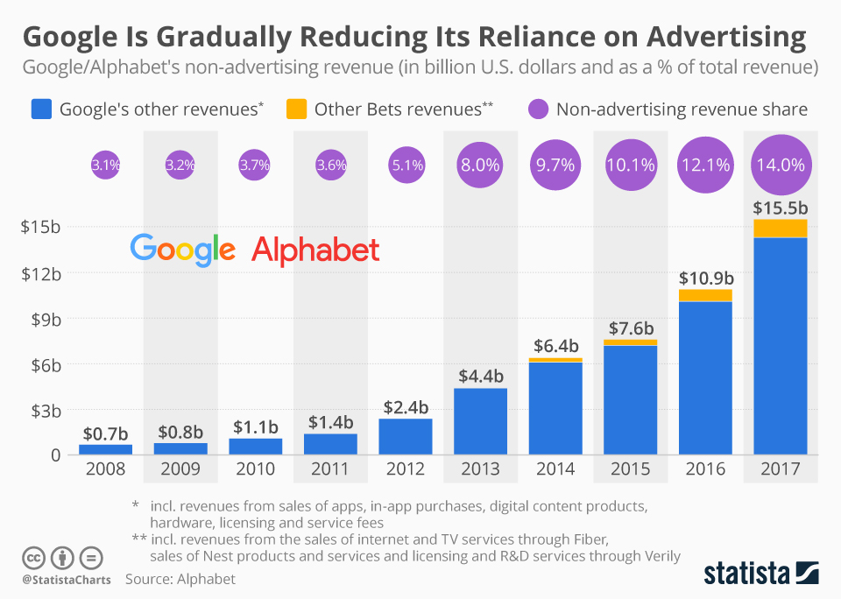
Figure 12: Diversification Approach of Google
(Source: Statista, 2018)
International expansion: International expansion strategy enabled global scaling advantage and market growth. Google has embedded urs international strategy with billions of users globally and 85 billion monthly visits in Google.com. In India 93.99% people use Google as a search engine followed by 89.11% in Brazil (Branka, 2023). This has enhanced the advertising effectiveness and data accumulation. However, international expansion has exposed this brand to geopolitical constraints and regulatory fragmentation (Zhang and Tian, 2025). Google embeds this approach through compliance adoption, localisation and infrastructure investment balancing region-specific regulatory requirements and global standardisation.
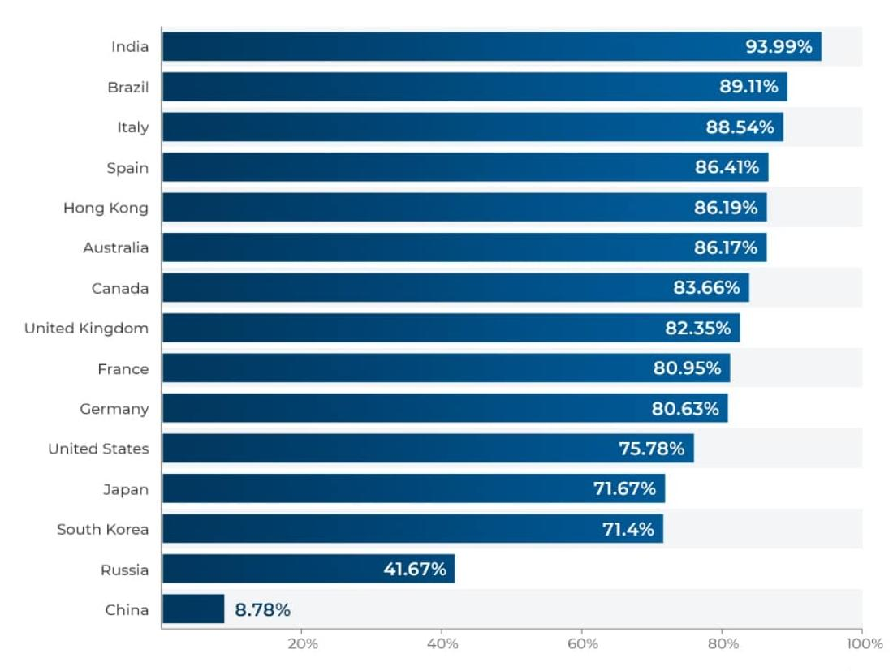
Figure 13: International Expansion of Google
(Source: Branka, 2023)

Recommendation for Google
A hybrid strategy of differentiation and diversification strategy will be appropriate for further growth of Google. Differentiation will sustain the competitive advantage of the brand through AI-driven innovation whereas diversification will mitigate overreliance in advertising revenues (Dzreke, 2025). A structural shift towards AI-driven cloud markets and search engines will prioritise the AI-enabled entries Google to strengthen long-term resilience.

Managing this change and its impact
Google will effectively manage the large-scale strategic change specifically transitioning to AI-driven organisation and addressing the resistance across the organisation. The management team may follow Lewin's change model to successfully adopt the change (Priya et al. 2025). The change leaders will unfreeze or stop the ongoing strategies creating a change awareness through discussion over generative AI competition. Then they will integrate AI access to their products and services in a change phase. The change process will be sustained in refreeze stage through robust transformation of operations through training and development.
The change management process will enable rapid AI integration enhancing ecosystem cohesion and product innovation. However, the increasing sustainability constraints and regulatory scrutiny may complicate the execution (Ye et al. 2025). In addition, shifts in search behaviour will be driven by AI tools to alter the traditional monetisation model in Google.

6. Strategic Evaluation and Recommendations

SWOT analysis
Strengths | Weaknesses
- Dominant search ecosystem in Google with large global market share and high economies of scale (Si, Si and Ye, 2022).  - Premium service quality through algorithmic precision and data accumulation.  - Global digital infrastructure including proprietary hardware and data centres.  - Ecosystem integration and brand equity has created user lock-in (Haftor, Climent and Kallmuenzer, 2025).  - Sustainability leadership in Google including the procurement of renewable energy and reduction of emission. | - Overdependence on advertising revenue in Google has exposed the firm to macroeconomic cycles (Özturan, Deleersnyder and Özsomer, 2023).  - Rising cost centres in data centre expansions and AI infrastructure has challenged cost efficiency.  - Strategic interest in core search engine and AI-driven conversational search has threatened traditional search monetisation.  - Increasing AI-driven energy consumption has conflicted with carbon free ambition.
Opportunities | Threats
- Expansion of generative AI and AI-driven services present a significant growth potential.  - Growth in the cloud computing market offers diversification potential (Kushchov and Dudka, 2023).  - Sustainability innovation through AI-driven emission reduction tools can position Google as the leader of green technology. | - Intensified competition in cloud computing and AI sector from Amazon and Microsoft.  - Regulatory exposures due to ongoing data privacy regulations and antitrust policies (Loertscher and Marx, 2020).  - Technological disruption from Generative AI may redefine the search behaviour reducing advertising revenue and traffic.

The SWOT analysis reveals that Google is structurally strong although strategically vulnerable currently. Although the AI capabilities, scale and ecosystem integration of Google has sustained competitive advantage, the strengths are constrained by environmental regularity and technological disruption. The heavy reliance of the firm in advertising has amplified the exposure of Google to externs, should. Therefore, the strategy of Google needs to transit from scale-based dominance to adaptive resilience balancing sustainability pressure and regulatory adherence with innovation.

Ansoff Matrix
Market penetration: Market penetration strategy focuses on increasing market share of a brand within its existing operational market. Google has achieved huge market share through continuous innovation and optimisation in AI competence, advertising effectiveness and search algorithm that reinforces advertising value and user engagement (Tanabe, 2023). Its dominant search position has reflected successful penetration within the operational market. However, saturation of the brand influences its growth potential that requires innovation to sustain monetisation and user engagement within mature digital advertising markets.
Product development: Product development strategy reinforces introducing new offerings through products and services into existing markets. Google has embedded this strategy through AI-driven innovation like advanced Gemini, cloud services and generative research. These have enhanced user experience through personalisation and expanded the functionality (Shukla, 2023). However, the rapid AI commodification may reduce differentiation within the highly competitive market. Therefore, continuous R&D investment is essential for sustaining such competitive advantage.
Market Development: Market development targets new demographic or geographical markets to expand the business. The global expansion strategy of Google shows its reach to billions of users. Infrastructural investment and strategic localisation have enabled penetration of emerging markets like India, Japan and Brazil (Lee et al. 2021). However, geopolitical constraints and regulatory fragmentation have limited the scalability.
Diversification: Diversification strategy introduces new products into new markets. The expansion of Google into hardware, cloud computing and AI services demonstrates related diversification reducing dependence on advertising revenue. Although diversification enhances resilience, it increases strategic complexities (Nguyen and Nguyen, 2024). Strategic alignment of the structure of Alphabet has supported coordination although success is dependent on effective integration of diverse business units.
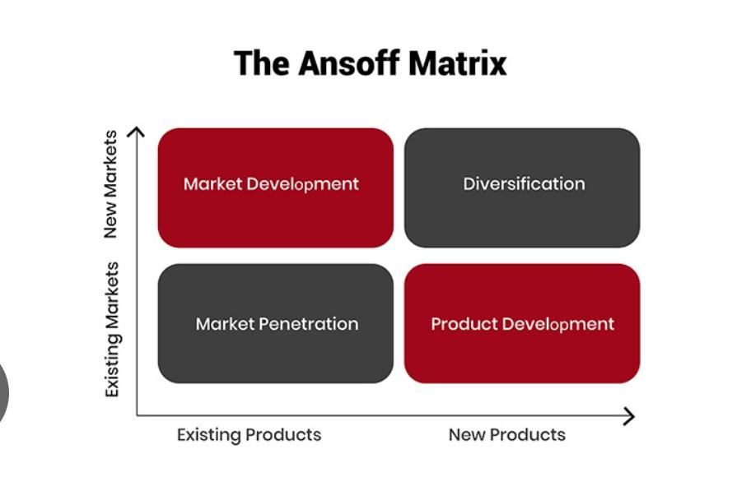
Figure 14: Ansoff Matrix Strategy
(Source: The Strategy Institute, 2024)

Recommendations
- Firstly, Google needs to accelerate its transition towards AI-native search models integrating the generative AI redefining the monetisation mechanisms. It enhances dynamic capability theory which enables adoption of technological disruption.
- Google needs to invest in next generation clean energy solutions to address the AI-sustainability paradox (Chouksey et al. 2026). It will ensure the alignment and I ESG expectations maintaining operational scalability.
- Expansion of Google Cloud and enterprise AI service will reduce dependence on advertising, and this strategy is consistent by diversification strategy.

Section 2: Reflective Practice
Gibbs Reflective cycle will be used to create reflective accounts on the experience of developing this strategic analysis report on Google.
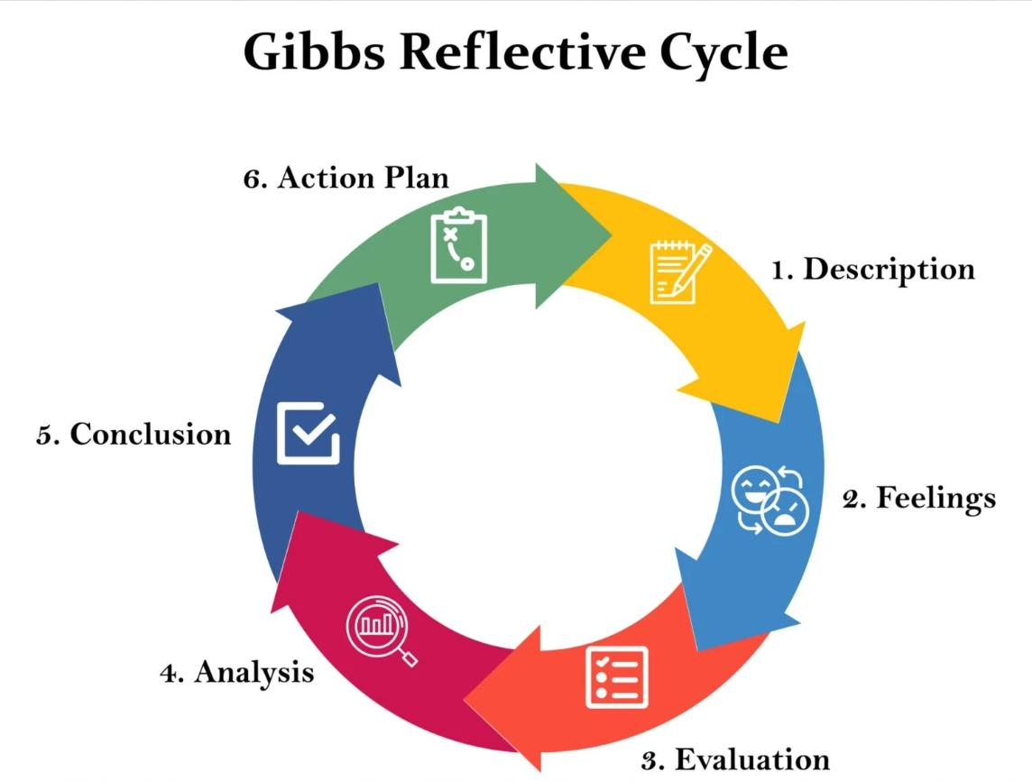
Figure 15: Gibbs Reflective Cycle
(Source: McLeod, 2025)
Description
This project was proposed to identify the skills and knowledge in effective strategic management theories, frameworks and concepts in analysing a real-world business. Therefore, this project required extensive research and strategic analysis applying the tools and concepts learned in weekly sessions. To make this project real-world based, I have accessed the sustainability reports, annual disclosures, newspaper reports and industry data regarding sustainability commitments, firm performance and organisational approaches. These data have helped me in backing the strategic analysis models complementing each statement to ensure the relevance to organisational competencies. I have applied the strategic analysis tools like PESTLE, SWOT, Balanced Scorecard, VRIO and Ansoff Matrix according to brief requirements. I tried to make each statement evidence based and ensure critical interpretation to create in-depth analysis. The analysis of strategic positioning of Google has involved critical engagement with Google Inc. I have gone through the weekly learning and tried to solve confusion in each concept from my peers and as a result I successfully attempted applying these tools to generate deeper insights with theoretical analysis and empirical data. I have drafted the report involving multiple revisions as I aim to reduce descriptive content and strengthen analytical depth (Bengtsson, 2026). I have selected the scholarly literature in establishing arguments on market data and verifiable corporate disclosures.
Feelings
Initially I felt extremely nervous as this paper required extensive analysis and in-depth discussion. I was confused in applying the strategic analysis tools in the appropriate position too. For example, when the brief required choosing Ansoff matrix or BCG matrix, I first felt confused about suitability of these frameworks and finally decided to apply Ansoff matrix although later I felt BCG was also suitable. However, I am not fully satisfied with the application and analysis of Google’s strategic position through Ansoff Matrix due to the volume of datasets and the expectations of the assignment brief for high-level critical analysis. I further faced uncertainty in balancing real-world evidence in theoretical models so that the writing does not seem descriptive and boring to the reader. However, as I progressed, I gathered confidence through repeated engagement with clear understanding of tools and models. At the same time, maintaining originality adhering to strict academic standards has created pressure for me.
Evaluation
The strength of developing this strategic report is the proposed utilisation of credible data sources along with visual representation of data and evidence with bar graphs and charts available on different credible sources. This evidential analysis has enhanced the validity of this assessment. The evidence from corporate disclosures has ensured the arguments are based in the real organisational practices of Google. In addition, integrating multiple models has allowed me to create a more holistic approach in analysing Google’s strengths and areas of improvement aligning emphasis of the module in synthesis (Herrera et al. 2026). However, there were several limitations in the report structuring as I thought more critical interpretation could have enhanced the report section. Initially, the analysis looked descriptive and genetic when integrating the VRIO and PESTLE models which lacked critical depth too. Later, I deliberately refined these parts incorporating critical analysis with data and evidence. This demonstrates my ability in research and critical thinking (Ayala, Fuertes and Jarrin, 2024). Managing time for this large report was also a significant constraint as critical thinking required multiple revisions. Although I have improved the linkage of theory and practical evidence, the scope has strengthened the originality developing nuanced arguments.

Analysis
My reflective journey highlighted my tradition from surface-level understanding of different strategic management models and tools as taught in class to critical synthesis ability through their proper application in the real-world case of Google. I have understood that reflective learning and deeper learning occurs when individuals move beyond descriptive writing to critical synthesis and interpretation (Chan and Lee, 2021). This was significantly evident as I have progressed from identifying the strategic factors to analysing their interdependencies. For instance, while I have linked the external pressure identified in the PESTLE tool with international capabilities identified in the VRIO tool, it has allowed me to create a more comprehensive analysis on the competitive advantage of Google. This also has enhanced the linkage between external and internal factors which interdependently create a strategic position for firms within a market. This has reinforced my understanding of the strategic management models. Furthermore, this process has highlighted the relevance with dynamic capability concept specifically in understanding how firms adopt technological and environmental changes to retain its market value, customer base and competitiveness (Zhou et al. 2018). Applying this perspective has enabled me to create more critical assessment in strategic resilience and flexibility.
Conclusion
This reflective process has enhanced my knowledge in strategic analysis models and tools as the critical and integrative discipline is maintained throughout the report. I have developed competence in application of theoretical models and real-world contents to maintain the analytical depth alongside academic integrity. However, this expression has revealed my urgent requirement to continuously improve my structuring arguments and strengthen originality. The transition from descriptive analysis to critical writing has remained my ongoing developmental area.
Action plan
Areas of improvement | Action steps | Expected outcomes | Timeline
Critical evaluation | Practicing analytical discussion in strategic analysis reports using questioning techniques like “why” and “so what” | Competency in critical argument and interpretation | Ongoing through weekly practice sessions
Integration of modelled | Developing mind maps linking different strategic models before crafting | Improved coherence and synthesis | Next assignment cycle
Academic theory integration | Engagement with peer-reviewed journals for deeper conceptual understanding (Balacuit, Nabua and Saludares, 2025). | More theoretical grounded assessment | 2-3 hours per week
Avoiding descriptive analysis | Creating a structured outline of each part before drafting arguments will help me avoiding descriptive analysis | Data-driven and evidence-based arguments | Ongoing
Time management | Allocating dedicated time for reviewing, drafting and refining (Jamesespinosa, 2023) | High quality outcomes with reduced last-minute pressure. | From next assignments

References
Andreasson, M., Karabag, S. F. Simonsson, J. and Agarwal, G. (2024). Dynamics of related and unrelated digital diversification in established firms: Strategies, programs, process, and outcomes. Technological Forecasting and Social Change, [online] 202, pp.123300–123300. doi:https://doi.org/10.1016/j.techfore.2024.123300.‌
Ayala, E., Fuertes, W. and Jarrin, F. (2024). Critical Thinking Skills in Research Process, a Literature Review. An Input to Propose a New Measurement Instrument to Gauge Critical Thinking. International journal of religion, 5(11), pp.1–14. doi:https://doi.org/10.61707/pwy5df19.‌
Bahraini, A. (2021). The Triple Bottom Line of Sustainability in Waste Management. [online] Waste4Change. Available at: https://waste4change.com/blog/the-triple-bottom-line-of-sustainability-in-waste-management/.
Bengtsson, M. (2016). How to Plan and Perform a Qualitative Study Using Content Analysis. NursingPlus Open, [online] 2(2), pp.8–14. doi:https://doi.org/10.1016/j.npls.2016.01.001.
Branka (2023). How Many People Use Google in 2021 - Facts & Stats. [online] TrueList. Available at: https://truelist.co/blog/how-many-people-use-google/.
Bryce, R. (2024). Google’s Net Zero Plans Are Going Up In Smoke. [online] Substack.com. Available at: https://robertbryce.substack.com/p/googles-net-zero-plans-are-going-up-in-smoke.‌
Chan, C. and Lee, K. (2021). Reflection literacy: A multilevel perspective on the challenges of using reflections in higher education through a comprehensive literature review. Educational Research Review, 32(100376), p.100376. doi:https://doi.org/10.1016/j.edurev.2020.100376.
Chen, G.C. (2026). Diversification strategies and risk: Does ownership structure matter? Evidence from the Chinese non–life insurance industry. International Review of Economics & Finance, [online] 106, p.104903. doi:https://doi.org/10.1016/j.iref.2026.104903.‌
Chouksey, A., Rajan, A.K., Gurjar, V., Tiwari, R. and Mishra, P.K. (2026). The green paradox: The climate, environmental, and sustainability implications of artificial intelligence. Global Environmental Change Advances, 6, p.100029. doi:https://doi.org/10.1016/j.gecadv.2025.100029.
‌Chtinis, A. (2025). Embedding AI and Machine Learning into Modern Data Architectures: Innovations in Scalable Analytics and Intelligent Automation. Journal of Artificial Intelligence General science (JAIGS) ISSN:3006-4023, 8(1), pp.208–218. doi:https://doi.org/10.60087/jaigs.v8i1.367.
Cyfuture Cloud (2025). Google: The Technology Giant Shaping the Digital Era. [online] Cyfuture.cloud. Available at: https://cyfuture.cloud/kb/general/google.
Dwivedi, Y.K., Ismagilova, E., Hughes, D.L. and Carlson, J. (2021). Setting the future of digital and social media marketing research: Perspectives and research propositions. International Journal of Information Management, [online] 59(1), pp.1–37. doi:https://doi.org/10.1016/j.ijinfomgt.2020.102168.‌
Dzreke, S. (2025). The Competitive Advantage of AI in Business: A Strategic Imperative. International Journal For Multidisciplinary Research, 7(4). doi:https://doi.org/10.36948/ijfmr.2025.v07i04.50400.‌
Google (2025). How we started and where we are today - Google. [online] About Google. Available at: https://about.google/company-info/our-story/.‌
Google Data Centers. (2023). Power usage effectiveness – Google Data Centers. [online] Available at: https://datacenters.google/efficiency.‌
Google Data Centers. (2024). Operating sustainably – Google Data Centers. [online] Available at: https://datacenters.google/operating-sustainably.
Google Sustainability. (2025). Sustainability Reports & Case Studies - Google Sustainability. [online] Available at: https://sustainability.google/google-2025-environmental-report/
GOV UK (2025). CMA confirms Apple and Google have strategic market status in mobile platforms. [online] Available at: https://www.gov.uk/government/news/cma-confirms-apple-and-google-have-stratgic-market-status-in-mobile-platforms.
Hall, B. (2024). 101 real-world gen AI use cases from the world’s leading organizations. [online] Google Cloud Blog. Available at: https://cloud.google.com/transform/101-real-world-generative-ai-use-cases-from-industry-leaders.
Harrington, K. (2021). Comparison of Leading Cloud Providers AWS vs Azure vs Google Cloud. [online] ResearchGate. Available at: https://www.researchgate.net/publication/392103528_Comparison_of_Leading_Cloud_Providers_AWS_vs_Azure_vs_Google_Cloud.‌
Haftor, D.M., Climent, R.C. and Kallmuenzer, A. (2025). Business ecosystems as a way to activate lock-in in business models: a theoretical integration. International Entrepreneurship and Management Journal, 21(1). doi:https://doi.org/10.1007/s11365-025-01078-5.
Herrera, A., Velandia, P., Jose, M., Sanchez, M. and Villalobos, J. (2026). Integrating business strategies into business models: benefits of a structured and visual approach. Journal of Business Strategy, 47(2), pp.305–320. doi:https://doi.org/10.1108/jbs-08-2024-0142.‌
Jamesespinosa (2023). Effective Time Management in Proposal Writing: Meeting Deadlines. [online] Medium. Available at: https://medium.com/@jamesespinosa926/effective-time-management-in-proposal-writing-meeting-deadlines-aaf373eb1b9e.
Jerab, D.A. and Mabrouk, T. (2023). Strategic Excellence: Achieving Competitive Advantage through Differentiation Strategy. [online] ResearchGate. Available at: https://www.researchgate.net/publication/373999782_Strategic_Excellence_Achieving_Competitive_Advantage_through_Differentiation_Strategy.‌
Katanich, D. (2025). Google pledges £5bn investment in the UK, creating AI-driven jobs. [online] euronews. Available at: https://www.euronews.com/business/2025/09/16/google-pledges-5bn-investment-in-the-uk-creating-ai-driven-jobs.‌
Khan, H., Khan, Z. and Knight, G. (2025). International marketing agility and cost leadership strategies of frontier emerging market exporters in advanced economy markets. International Business Review, 34(3), pp.102422–102422. doi:https://doi.org/10.1016/j.ibusrev.2025.102422.‌
Kodali, P. (2025). Intelligent Automation Ecosystems: AI and Cloud Computing Synergies in E-Commerce Platform Engineering. International Journal of Engineering and Advanced Technology Studies, 13(2), pp.36–46. doi:https://doi.org/10.37745/ijeats.13/vol13n23646.‌
Kurian, T. (2025). Our First AI Hub in India, Powered by a $15 Billion Investment. [online] Google. Available at: https://blog.google/intl/en-in/company-news/our-first-ai-hub-in-india-powered-by-a-15-billion-investment/.
Kushchov, O. and Dudka, O. (2023). GLOBAL TRENDS IN THE DEVELOPMENT OF CLOUD SOLUTIONS AND TECHNOLOGIES. Collection of scientific papers ‘ΛΌГOΣ’, [online] (December 22, 2023; Boston, USA), pp.213–217. doi:https://doi.org/10.36074/logos-22.12.2023.056.
Lee, J., Kim, J., Kim, J. and Choi, S. (2021). Why Localization Is Necessary as a Business Strategy in Emerging Markets: The Case Comparison of Hyundai and Volkswagen. Journal of Open Innovation: Technology, Market, and Complexity, [online] 7(3), p.190. doi:https://doi.org/10.3390/joitmc7030190.
Loertscher, S. and Marx, L.M. (2020). Digital monopolies: Privacy protection or price regulation? International Journal of Industrial Organization, [online] 71, p.102623. doi:https://doi.org/10.1016/j.ijindorg.2020.102623.
‌Ma, Y., Zhang, W., Ma, C., Ai, Y. and Hu, J. (2025). Artificial intelligence, data elements, digital economy, and corporate innovation performance. International Review of Economics & Finance, [online] 103, p.104560. doi:https://doi.org/10.1016/j.iref.2025.104560.
Mariani, M. and Dwivedi, Y.K. (2024). Generative artificial intelligence in innovation management: A preview of future research developments. Journal of Business Research, 175, p.114542. doi:https://doi.org/10.1016/j.jbusres.2024.114542.‌
Martens, B. (2023). What Should Be Done About Google’s Quasi-Monopoly in Search? Mandatory Data Sharing Versus AI-Driven Technological Competition. Social Science Research Network. doi:https://doi.org/10.2139/ssrn.4550753.‌
Miller, K.M., Lukic, K. and Skiera, B. (2025). The impact of the General Data Protection Regulation (GDPR) on online tracking. International Journal of Research in Marketing. doi:https://doi.org/10.1016/j.ijresmar.2025.03.002.
McLeod, S. (2025). Gibbs Reflective Cycle. [online] Simply Psychology. Available at: https://www.simplypsychology.org/gibbs-reflective-cycle.html.‌
Morley, J., Widdicks, K. and Hazas, M. (2018). Digitalisation, energy and data demand: The impact of Internet traffic on overall and peak electricity consumption. Energy Research & Social Science, 38, pp.128–137. doi:https://doi.org/10.1016/j.erss.2018.01.018.‌
Nguyen, T.B.C. and Nguyen, Q.N. (2024). Strategic resilience: Exploring diversification’s impact on R&D investment during economic crises. Heliyon, 10(23), p.e40582. doi:https://doi.org/10.1016/j.heliyon.2024.e40582.
‌Özturan, P., Deleersnyder, B. and Özsomer, A. (2023). Brand advertising competition across economic cycles. International Journal of Research in Marketing, [online] 41(2). doi:https://doi.org/10.1016/j.ijresmar.2023.11.001.
P. Balacuit, I.C., B. Nabua, E. and G. Saludares, J.R. (2025). Examining Conceptual Understanding and Engagement in Mathematics Students. Indonesian Journal of Mathematics Education, [online] 8(1), pp.1–17. doi:https://doi.org/10.31002/ijome.v8i1.2535.
Rashid, A.B. and Kausik, A.K. (2024). AI Revolutionizing Industries Worldwide: a Comprehensive Overview of Its Diverse Applications. Hybrid Advances, 7(100277), pp.100277–100277. doi:https://doi.org/10.1016/j.hybadv.2024.100277.‌
Rezaei, M. (2025). Artificial intelligence in knowledge management: Identifying and addressing the key implementation challenges. Technological Forecasting and Social Change, 217, p.124183. doi:https://doi.org/10.1016/j.techfore.2025.124183.
S. Priya, Varghese, G.R., Sharma, S.K., Vaidya, V. and Yadav, H.S. (2025). Change Management in Organizations: Strategies for Successful Implementation and Resistance Mitigation. Cuestiones de Fisioterapia, [online] 54(3), pp.4788–4797. doi:https://doi.org/10.48047/dgp89662.‌
Sec Gov. (2025). goog-20251231. [online] Available at: https://www.sec.gov/Archives/edgar/data/1652044/000165204426000018/goog-20251231.htm.
Shukla, K. (2023). The Role of UI/UX Design in Enhancing User Experience. [online] Medium. Available at: https://medium.com/@kshitij8795/the-role-of-ui-ux-design-in-enhancing-user-experience-8adc86477e5d.
Si, M., Si, Z. and Ye, Y. (2022). The Analysis of Google’s Monopoly in The Search Engine Industry. [online] www.atlantis-press.com. doi:https://doi.org/10.2991/aebmr.k.220307.356.‌
Sklenarz, F. A. Edeling, A., Himme, A. and Julian R.K. Wichmann (2024). Does Bigger Still Mean Better? How Digital Transformation Affects the Market Share-Profitability Relationship. International Journal of Research in Marketing, 41(4). doi:https://doi.org/10.1016/j.ijresmar.2024.01.004.
Singh, A., Lim, W.M., Jha, S., Kumar, S. and Ciasullo, M.V. (2023). The State of the Art of Strategic Leadership. Journal of Business Research, 158(1), p.113676. doi:https://doi.org/10.1016/j.jbusres.2023.113676.‌
Statista. (2016). Google’s European Dominance. [online] Statista Daily Data. Available at: https://www.statista.com/chart/amp/4694/googles-dominance-in-europe/ [Accessed 28 Mar. 2026].
Statista. (2018). Google is Adopting a Diversifying Approach to Minimize the Rely on Advertisement Only Business Model. [online] Digital Information World. Available at: https://www.digitalinformationworld.com/2018/10/infographic-google-is-gradually-reducing-its-reliance-on-advertising.html [Accessed 28 Mar. 2026].‌
Statista. (2023). Google UK Limited: revenue in the UK 2023| Statista. [online] Available at: https://www.statista.com/statistics/1221489/google-uk-limited-annual-revenue-uk/?srsltid=AfmBOoq6fSZmoPnIyO1lyOt_FKw_nM7-M_AmokOWNw6k4cNXK2B5Srbw [Accessed 28 Mar. 2026].
Statista. (2023). Google UK Limited: net profit in the UK 2023| Statista. [online] Available at: https://www.statista.com/statistics/1222107/google-uk-limited-net-profit-uk/?srsltid=AfmBOooDT5O74kfPraAZT39l8NrxVuOskP9ffgn7AbZ0L6Bg1YlFx2Yz [Accessed 28 Mar. 2026].‌
Statista. (2023). Infographic: Google’s Search Dominance. [online] Statista Daily Data. Available at: https://www.statista.com/chart/23250/search-market-share-in-the-united-states/?srsltid=AfmBOopkvQ9-7wskSLHzWODyF-TdGvwplvEapCBYjG-XVLwQRpn4VRXN [Accessed 28 Mar. 2026].
‌Statista. (2024). Google revenue 2002-2024| Statista. [online] Available at: https://www.statista.com/statistics/266206/googles-annual-global-revenue/?srsltid=AfmBOop8qfh-A00YTQ-ePUl_qAkWpUAFFmB00bKlzNF9JNJiXNUjyNdg [Accessed 28 Mar. 2026].
‌Statista. (2024). Google: distribution of revenue by segment 2024| Statista. [online] Available at: https://www.statista.com/statistics/1093781/distribution-of-googles-revenues-by-segment/?srsltid=AfmBOorQsyx3K7sU87MaEcbBUbYoK2w0US3jezdygmtyAShUjsgAWQez [Accessed 28 Mar. 2026].
Statista. (2024). Alphabet: number of employees 2024| Statista. [online] Available at: https://www.statista.com/statistics/273744/number-of-full-time-google-employees/?srsltid=AfmBOorX4-vR4_Jy14qBIEj9fMGKB7gFTm14q9OfBPoEdlW6WYm6g7LD [Accessed 30 Mar. 2026].‌
‌Statista. (2025). Google online advertising online search Daily Data. [online] Available at: https://www.statista.com/chartoftheday/google%20online%20advertising%20online%20search/?srsltid=AfmBOopHFG3fpmh2bXyBKJlY9yf263wfQesqtcaCyvfjq0p8QCqKJTZJ [Accessed 28 Mar. 2026].
Statista. (2025). Topic: Google. [online] Available at: https://www.statista.com/topics/1001/google/ [Accessed 30 Mar. 2026].‌
Sustainability. (2020). Sustainable Innovation & Technology - Google Sustainability. [online] Available at: https://sustainability.google/reports/247-carbon-free-energy/.
Sustainability. (2024). Sustainable Innovation & Technology - Google Sustainability. [online] Available at: https://sustainability.google/products/.
The Business Standard. (2026). Google’s annual revenue tops $400b for first time, AI investments rise. [online] Available at: https://www.tbsnews.net/tech/googles-annual-revenue-tops-400-bn-first-time-ai-investments-rise-1352386 [Accessed 30 Mar. 2026].
‌Tanabe, S. (2023). The Marketing Strategy of Google. Journal of Education, Humanities and Social Sciences, [online] 23, pp.416–421. doi:https://doi.org/10.54097/ehss.v23i.12927.
The Strategy Institute (2024). The Ansoff Matrix: a Powerful Tool for Business Strategy and Growth. [online] The Strategy Institute. Available at: https://www.thestrategyinstitute.org/insights/the-ansoff-matrix-a-powerful-tool-for-business-strategy-and-growth.
Untaylored. (2026). How Does Google Make Money? The Business Model and Revenue Streams Explained. [online] Available at: https://www.untaylored.com/post/how-google-makes-money-business-model-explained.‌
Ye, D., Yuan, R., Luo, J., Liu, M.J. and Yannopoulou, N. (2025). Responsible artificial intelligence (AI) for responsible innovation in Chinese manufacturing: From the affordance–actualization theory. Technological Forecasting and Social Change, [online] 221, p.124349. doi:https://doi.org/10.1016/j.techfore.2025.124349.‌
Zhang, H. and Tian, L. (2025). Risk hedging: How geopolitical risks affect enterprises’ overseas merger and acquisition? International Review of Economics & Finance, pp.104296–104296. doi:https://doi.org/10.1016/j.iref.2025.104296.
‌Zhou, Y., Hong, J., Zhu, K., Yang, Y. and Zhao, D. (2018). Dynamic capability matters: Uncovering its fundamental role in decision making of environmental innovation. Journal of Cleaner Production, 177, pp.516–526. doi:https://doi.org/10.1016/j.jclepro.2017.12.208.
‌

