
Name: Samuel Jones
Student number: 2024633
Module number: ACCA4023

Introduction to Web and Database Concepts
Database Analysis and Design

Table of contents

Database
A database is a digitalised information storage system, allowing backend users to search, update, select and store information. Databases are used worldwide and are commonly used for activities such as collecting user information, stock update and holding historic information. These uses are beyond helpful, where old times of keeping notes on a notebook is replaced by the digitalised era where all information can be stored on to a database.
Case Study
In this case study, I’m tasked with creating a database and an environment for a catering business that have expanded to 3 new locations. It begins with creating a data flow diagram, a context diagram, and an entity relationship diagram. All 3 of these are important to creating a database system for the business.
Context Diagram
Context diagrams, also known as Level 0 data-flow diagram, are created to define and outline the high-level process of the database. In simpler terms, it describes how the data flows between the system and its external entities.

Fig. 1 context diagram level 0
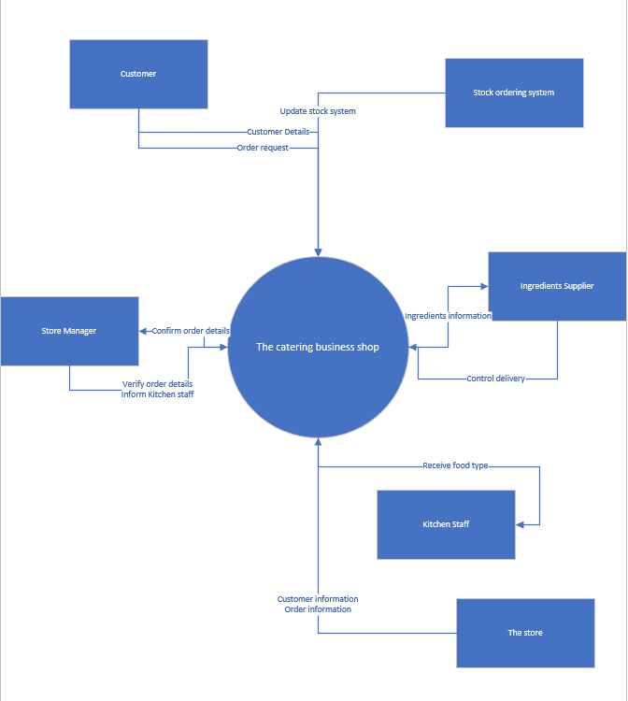

This Level 0 diagram clearly illustrates how the database system will travel information between themselves.
I’ve introduced the system and included the case study where the store manager controls the majority when a customer creates an order process. The store manager confirms the order details and then returns the details and informs the kitchen staff of the order.

Entity Diagram Relationship
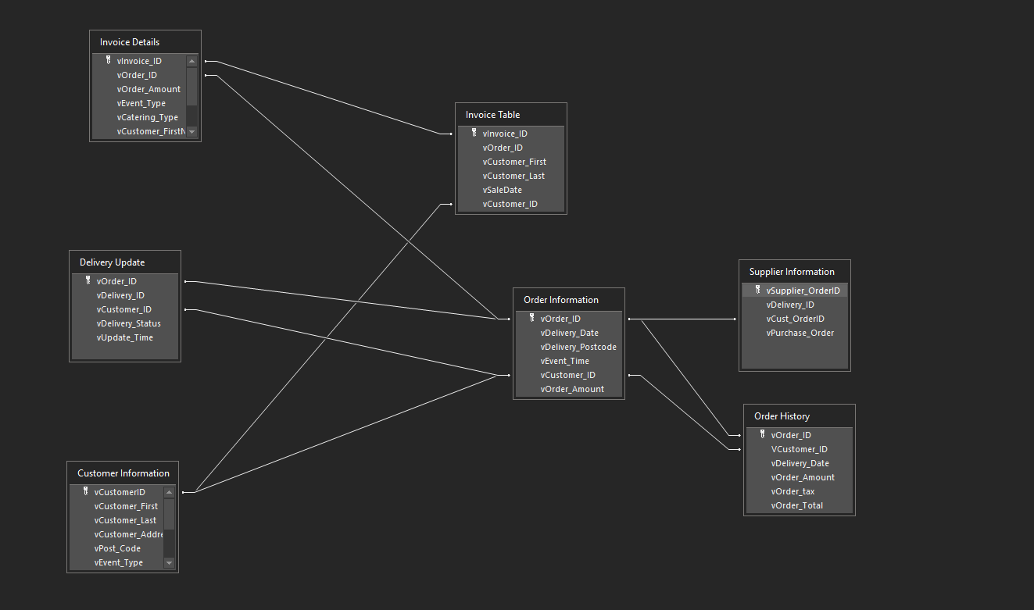

Entities
An entity is an object that exists, and typically these objects are typically the focus of a single table. In database administration, an entity can be an object, person, or location. Data can be stored about such entities.
In database development, only those things about which data will be captured or stored is considered an entity. The purpose of having an entity is to capture data about said information, otherwise it would be pointless creating the entity.
Our entities in these relationships are as declared:
- Customer Information
- Order Information
- Supplier Information

Relationships
Tables:
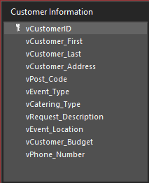
Customer information – Relationships:
- Invoice table
- Order Information

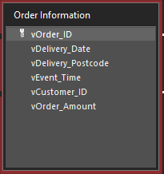
Order information – Relationships:
- Supplier information
- Order history
- Customer information
- Delivery update
- Invoice Details
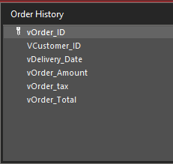
Order history – Relationships
- Order information
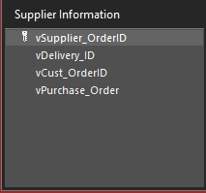
Supplier information – Relationships
- Order history
- Order information
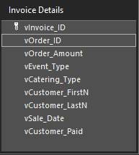
Invoice details - relationships
- Order information
- Invoice table

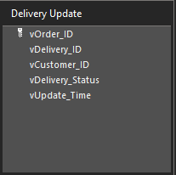
Delivery update - relationships:
- Order information

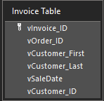
Invoice table – relationships
- Invoice details
- Customer information

Degree of Relationships
Membership Class
Annotated descriptions for each relationship

Documentation

