Good afternoon, today we will be talking about Marks and Spencer.
Marks and Spenser has been famous high street name for last century.

Mark and Spencer were formed in 1884 by a polish refugee, selling cloth in the market stall.

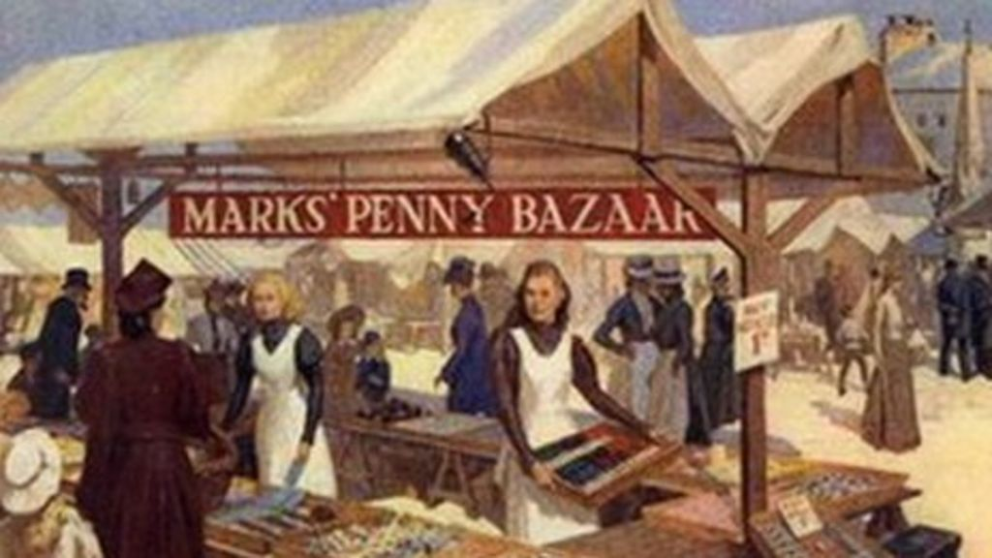

They opened their first shop in 1904 n Leeds and became public limited company in 1926.
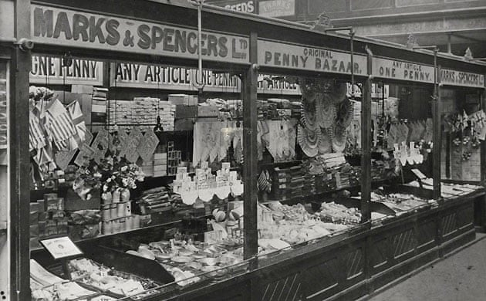

M&S had all their cloth made in UK, and build up close relationship with their suppliers.
Over the years M&S has been adding new products to their range, from foods to financial products.

In the 1970’s food sale accounts for almost 60% of the M&S’s of their business.



(Marks in time)

Marks and Spencer’s Aim & Objectives

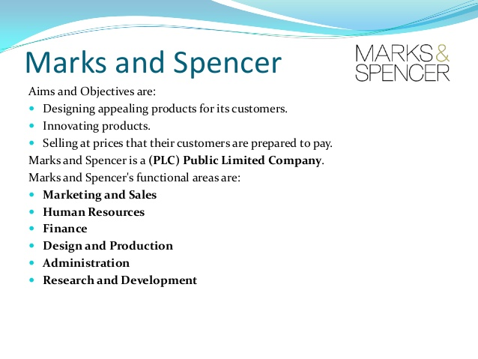(Slideshare.net)

Definitions of Customer relationship Manager (CRM)
Now I will go through Customer Relationship Manager (CRM) and how Marks and Spencer is implementing CRM.
Firstly to help broaden the understanding of CRM. A British Author Adrian Payne from Cranfield School of Management explore definition aspect of CRM, the author has identified three alternative of CRM.
- The need for cross function (meaning different functional expertise working towards common goal, from finance to marketing)
- Process Oriented (meaning protocols are followed and actively in good rankings)
- Strategic level of CRM (Strategic planning, making decisions on allocating its resources)
(Payne, 2005, p167-176)

And secondly, Customer relationship Manager is a term that refers to practices strategies and technology, the organisation use in order to acquire and analyze customer behaviour,
( so for example which products customer buy, how often they buy, was it online or direct from the store etc. By collecting customer data the aim is to act on their need to retain customer and increase growth in the organisation.
Using latest technology to consolidate customer information
The organisation may use many different channels to connect and stay in touch with their customers, such as live chart, social media and telephone marketing. With the advance in latest technology the customer data than managed to consolidated in to single CRM database, which will help monitor customer activity.
(Rouse, 2018)

Marks and Spencer’s Customer Relationship Manager (CRM)



M & S CRM has joint up with tech company Siebel’s software to deal with M & S drop in productivity.
M & S has rolled out Siebel’s eRetail call centre application at their head-office.
M & S customer service has suffered because they were unable to cope with large number of enquiries, Spoke man for M & S said, and I quote “ Tracking customer inquiries and responding to them more quickly and effectively is now easier, thanks to the new software”
PECA
So M&S is clearly trying to use PECA.
Paying attention to their customer- Have Empathy when dealing with customer-Clarify-and Act, take action
Database is used to developed new products and service by M&S
To assist with research and developing new products and service M&S CRM is using Siebel database. This helps the organisation to pick up on trends and quality issues to improve the products.
(Thomas, 2002)

Daniel. T (2002) M&S reviews CRM system after drop in productivity
https://www.computerweekly.com/news/2240044628/MS-reviews-CRM-system-after-drop-in-productivity
Accessed 20th February 2019

Marks in time
https://marksintime.marksandspencer.com/ms-history/timeline
Accessed: 20th February 2019

Payne,A (2005) Journal of Marketing, Vol. 69, No.4.

Rouse. M (2018)
www.searchcrm.techtarget.com
Accessed 13th February 2019

slideshare.net
https://www.slideshare.net/jackrichards96/case-study-33797384
Accessed: 20th February 2019

