Business Issues and the Contexts of HR

Name: Julie Folland

CIPD Membership Number: 22525553

Date: 17.01.2018

I declare that this assignment is my own work and that any information obtained from books and other sources have been appropriately referenced.

Signed.....................J. Folland...................... Date.....17.01.2018.........................

Contents

1. Introduction 3
2. Key Forces that Shape the HR Agenda 3
3. Analysing the Business Environment 6
4. Factors Affecting the Organisation’s Business and it’s HR Function 13
4.1 External Factors 13
4.1.1 Labour Markets 13
4.1.2 Government Legislation/Brexit 13
4.2 Internal Factors 14
4.2.1 Internal Policies and Procedures 14
4.1.2. HR Systems 14
5. Key Stages of Strategy Formulation and the Role of HR 15
6. Business Ethics 18
7. Evaluating Business Performance 19
8. Sources of Data and how Data can be used for Planning Purposes 22
8.2 Correlation and causation 23
9. Conclusion 25
10. References 27

Introduction
Established in 1996 following local Government reorganisation, Neath Port Talbot County Borough Council is one of 22 unitary authorities in Wales, and is a single tier council responsible for the provision of functions normally carried out by local authorities such as education, highways, social services and environmental services i.e. refuse collection, etc.
Employing approximately 6000 staff NPTCBC has 5 directorates: Chief Executives; Finance; Education, Leisure & Lifelong Learning; Social Services and Environment.
As a local government organisation, NPTCBC must fulfil certain social/legal obligations e.g. education and social services. To do this it must ensure that staff are fully qualified and trained in the most up to date methods to deal with situations they come across during their career i.e. child protection, etc. These services are regulated and inspected by CSSIW (social services) and ESTYN (Education Sector). Should NPTCBC fail in their duties, will they be heavily fined and bring negative publicity to the organisation which would be damaging.
NPTCBC needs to be able to respond to the political, economic, social and technological changes if they are to survive the current financial climate.
This paper has been written as part of the delegate pack titled ‘The Evolving Role of HR in the Contemporary Business World,’ and highlights the forces affecting different organisations, the impact this has on HR, how organisational and HR strategies and practices are being shaped and developed, and how to identify and respond to changes in the business environment.

Key Forces that Shape the HR Agenda

(Dieleman, M.895 cited in Mullins, Laurie J, 2001, p.748) states ‘since the late 90’s the business environment has radically changed. Companies are under great pressure to find new strategies to cope with a rapidly changing business environment. When the rate and quality of change exceed a certain threshold, the need for talented people to run the business will become a more critical success factor. Organisations have come to realise that they must invest in their human resources to release true value...... the competitive edge comes as much from people as from the product. As trends in the business environment reshape organisational life, HR practitioners must respond with new strategies, competencies and practices.’
There are three types of organisations operating in the UK today, those that produce goods and services with the aim of making a profit, the public sector that supply goods and services that cannot be supplied at a profit, public goods, where everyone in the society benefit from a service such as public heath, and some natural monopolies, and the voluntary sector that meets the needs of its members e.g. clubs, mutual organisations or professions, and its clients i.e. charities, or campaigns on issues (Kew & Stredwick, 2005).
The organisation is the background in which the HR function works and understanding the nature of the organisation is the main goal for HRM as the nature of the organisation impacts on the way that people are managed. There are several functional areas of business management as shown in figure 1:
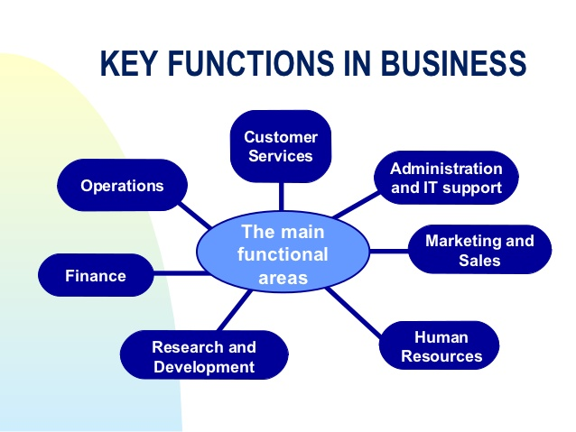
(Figure 1: ‘Functional Aspect of Managing’. Source: Slideshare.net, 2015)
The role of management within the organisation is to accomplish goals and objectives through planning, organising, staffing, leading and directing, controlling and monitoring, and motivating. The role of manager is being able to use available resources efficiently and effectively to meet the roles and objectives of the organisation. Henri Fayol defines four functions of management below:
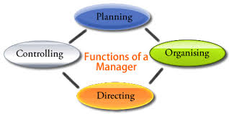
(Figure 2: ‘Four Functions of Management’. Source: Papermasters.com)
The function of HR is to enable the organisation to achieve its objectives by taking initiatives and providing guidance and support on matters relating to its’ employees. The aim is to ensure that management deals effectively with everything concerning the employment and development of people, and the relationships that exist between management and the workforce. HR provides the ability ‘to aid the creation of an environment that enables people to make best use of their capacities and to realise their potential to the benefit of the organisation and themselves’ (Armstrong, M, 2003).
According to Ulrich (1998) cited in Armstrong, M. 2003 p. 38, ‘the activities of HR appear to be and often are disconnected from the real work of the organisation’, and believes that HR ‘should not be defined by what it does but by what it delivers’. Ulrich’s emphasises four key roles that HR need to adopt:
- Strategic partners
- Administrative experts (shared services)
- Employee champions
- Change agents

‘With focus on a business-focussed approach, then the emphasis upon customer focus, cost efficiencies, innovation and the ability to respond quickly to changes is highly important’ (Ulrich, D, cited in Rees and French, Leading, Managing and Developing People, 2013, p.26).

Larger organisations are more likely to adopt the Ulrich model, also known as the ‘three-legged stool’, and include three functional areas of HR:

- Shared services handling transactions e.g. absence monitoring and payroll, with low-cost and effective HR administration
- Centres of excellence - small teams of HR experts with specialised knowledge of HR functions with advantage being sought through HR innovations, e.g. reward, learning, engagement and talent management
- Strategic business partners who work with business leaders to influence strategy formulation and implementation with activities that include organisational and people capability building, resource and talent planning, etc (ibid).
The ‘Baldridge Criteria for Performance Excellence’ model was implemented by the US government and identifies seven key areas that determine an organisation’s business results:
Leadership
Strategic planning
Customer and market focus
Measurement, analysis and knowledge management
Human resource focus
Process management
Excellence levels and trends
(Table 1. Source: Watson and Gallagher, 2005)
The ‘Harvard framework’ is based on the notion that the problems of historical personnel management can only be solved ‘when general managers develop a viewpoint of how they wish to see employees involved in and developed by the enterprise, and what HR policies and practices may achieve these goals’. General managers provide the organisation’s aims and objectives while the HR function ‘remain independent with its own practice tradition’ (Armstrong, M., 2003).
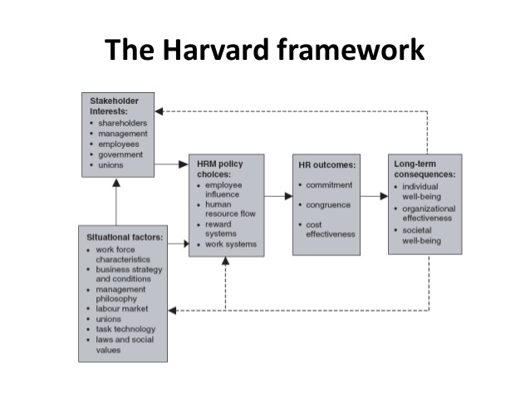
(Figure 3: The Harvard Model. Source: Slideshare.net, 2015)

Analysing the Business Environment

According to Johnson, Scholes and Williamson, op cit, he mission and objectives of the organisation are constrained by four main factors:
Corporate governance | External constraints on the organisation, set by company law, reports of investigations such as the Cadbury Report on non-executive directors or the Greenbury Report on directors’ pay; regulatory bodies such as the Financial Services Authority, and targets and controls imposed by the Government on public bodies (i.e. Best Value for local authorities)
Stakeholders | Stakeholders can influence the organisation’s strategic direction through their power and/or their interest
Business ethics | Ethics impact on organisations at three levels: general ethical policy; how the organisation interprets its corporate social responsibility when it formulates its’ strategy; and the ethical behaviour of individuals within the organisation.  Ethics is about values, particularly those of senior management
Culture | Culture in organisations operates at three levels:  - Values, often written down as part of the mission statement  - More specific beliefs, often expressed as policies  - Taken for granted assumptions – the organisational paradigm – the ‘way things are done here’. At grass roots level, these may often be in conflict with the values and beliefs officially expressed at a higher level e.g. the police force in the UK is committed to eradicating ‘institutional racism’, but at the level of ‘canteen culture’ there are still racist PC’s.
(Table 2. Source: Kew and Stredwick, 2005)
Kew and Stredwick (2005) state that ‘the analysis of strategic management is simple, and consists of getting answers to the following questions:
- Where are we?
- Where do we want to get?
- How can we get there?
- What do we have to do to get there?’
Strategic analysis relates to the strategic position of the organisation, the key characteristics and changes occurring in the environment that will have a bearing on the organisation and its activities. Analysis is used to determine the key influences on the organisation at present and for the future, and determines the expectations of stakeholders, as well as the organisation’s culture, vision and values.
According to the CIPD (2017) ‘a ‘PESTLE’ can be used as a framework to analyse the key factors influencing an organisation from the outside’. HR professionals and senior managers are able to use the results of the analysis to determine strategic decision making. There are six elements to a PESTLE analysis as shown below:
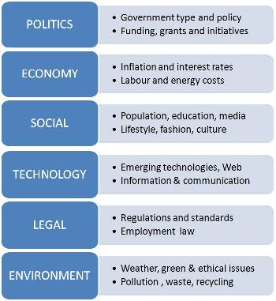
(Figure 3: PESTLE analysis. Source: Consultants Online, n.d.)
A further E has recently been addition to the framework and stands for ‘ethical’ issues that are of concern to the organisation for social responsibility and business ethics.
Farnham (2005) describes political factors that affect the organisation as ‘public policies and legislation at local, national and European levels and the distribution of political power at each of the levels’. Economic factors ‘include market competition, energy and communication costs, consumer spending, government spending, interest rates, currency fluctuations, exchange rates policy, inflation and investment spending’. Social issues ‘affect demand for goods or services and its labour supply include education, health, demography, attitudes to work and leisure, and general social trends. Technological factors include the impact of IT on working life, rates of technological change and levels of research, and development spending in an organisation’ (ibid). Environmental factors ‘cover pollution, resource conservation, the ‘social costs’ of given policies and other ‘green’ issues. Ethical factors relate to the impact of business decisions on organisational stakeholders (ibid).
The following table highlights the advantages and disadvantages of using the PESTLE framework:

Advantages: | Disadvantages:
- It’s a simple framework. | - Some users (of a PESTLE analysis) oversimplify the amount of data used for decisions – it’s easy to use a limited selection of data.
- It facilitates an understanding of the wider business environment. | - The risk of capturing too much data may lead to ‘paralysis by analysis’.
- It encourages the development of external and strategic thinking. | - The process needs to be undertaken on a regular basis to be effective.
- It can enable an organisation to anticipate future business threats and take action to avoid or minimise their impact. | - The pace of change makes it increasingly difficult to anticipate developments that may affect an organisation in the future.
- It can enable an organisation to spot business opportunities and exploit them fully. | - The data used may be based on assumptions that subsequently prove to be unfounded.
(Table 3: Advantages and Disadvantages of PESTLE analysis. Source: CIPD, 2017)
An example of a PESTLE analysis can be found in Appendix A.
Another framework analysis commonly used is ‘SWOT’ and focuses on strengths, weaknesses, opportunities and threats that face organisations (figure 4). This analysis enables an organisation to form a basis to make decisions and problem-solving, however ‘care must be taken that the process does not lead to an over-simplified and misleading analysis’ (Mullins, 2005).

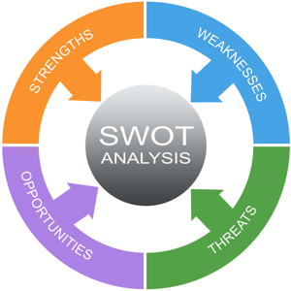
(Figure 4: SWOT analysis. Source: projectsmart.co.uk, 2018.)
Strengths and Weaknesses are inward-looking and concerned with the resources of the organisation. Opportunities and threats are outward-looking and involve the analysis of environmental factors. The organisation should ensure that its Strengths (or core competencies) are appropriate ones to exploit Opportunities or to counter Threats (Kew and Stredwick, 2005).
Table 4 highlights the advantages and disadvantages of using the SWOT framework:
Advantages: | Disadvantages:
- It is a simple four box framework. | - Some users over-simplify the amount of data used for decisions – it is easy to use scant data.
- It facilitates an understanding of the strengths and weaknesses of the organisation. | - To be effective this process needs to be undertaken on a regular basis.
- It encourages the development of strategic thinking. | - The best reviews require different people being involved, each having a different perspective.
- It enables a management team to focus on strengths and build opportunities. | - Access to quality internal data sources can be time consuming and politically difficult (especially in more complex organisations – parent company, etc).
- It can enable an organisation to anticipate future business threats and take action to avoid or minimise their impact. | - The pace of change makes it increasingly difficult to anticipate developments that may affect an organisation in the future.
- It can enable an organisation to spot business opportunities and exploit them fully. | - The risk of capturing too much data is that it may make it difficult to see the wood for the trees and lead to ‘paralysis by analysis’.
- It is flexible. | - The data used in the analysis may be based on assumptions that subsequently prove to be unfounded (good and bad).
 | - It lacks detailed structure, so key elements may get missed.

(Table 4: Advantages and Disadvantages of SWOT analysis. Source: CIPD, 2015)
An example of a SWOT analysis can be found in Appendix B.
Another analysis model used is Michael Porter’s Five Forces of competitive rivalry:
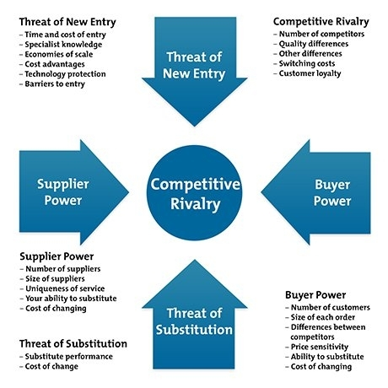
(Figure 5: Porter’s Five Forces. Source: researchpaperswot,com, 2017.
‘Each of the forces is determined by a number of factors. When the five forces are completely analysed, this determines how attractive the industry is to firms within it, and those who might wish to enter it’ (Kew and Stredwick, 2005).
Howeve,r some key points to remember when using this model:
- Porters Five Forces model was developed in an environment different to the one organisations operate in today and
- To consider the following:
• The pace of change today is faster.
• Market structures were perceived to be relatively static.
• The model provides only a ‘snapshot ‘of your environment.
• It can be difficult to define the industry
• The model does not consider non-market forces
• It is more suited to analysis simple market structures
• The model is based on the idea of competition.

(Source: free-management-ebooks.com, n.d.)

Factors Affecting the Organisation’s Business and it’s HR Function

External Factors

Labour Markets

‘Organisations seek employees, and individuals offer their availability to organisations and this impacts on what people resources are available to the organisation to be able to achieve its’ aims and objectives. The internal labour market is able to promote, train and redeploy to meet the organisation’s future needs’ (Armstrong, M, 2003), however the external labour market is not subject to the organisation’s control, and can create uncertainty for HR Management. The aims of HR would therefore be:

To attract and retain the number of people required with the appropriate skills, expertise and competencies
Anticipate the problems of potential surpluses or deficits of people
Develop a well trained and flexible workforce, thus contributing to the organisation’s ability to adapt to an uncertain and changing environment
Reduces dependence on external recruitment when key skills are in short supply by formulating retention, as well as employee development strategies
Improve the utilisation of people by introducing more flexible systems of work’
(Table 5: Aims of HR. Source: Armstrong, M. 2003)

Government Legislation/Brexit

The decision of the UK to leave the EU (Brexit) has caused a period of uncertainty as well as a long period of adjustment for organisations, having a massive impact on both organisations and its’ HR function. There will ‘be significant transitional work as EU responsibilities move back to the UK’ including changes to employment law and employment regulations as well as costs incurred from the resulting changes.
EU nationals are currently able to live and work in the UK without restrictions, however the government will need to change the migration policy, and organisations having to change their talent policies, impacting on organisations who currently employ EU nationals. EU funded projects will also cease leading to job losses.

Internal Factors

Internal Policies and Procedures

Kammar, S. n.d. states ‘internal policies are the guide maps in the organisation. Policies direct the manner in which the objectives of the organisation are to be achieved. Objectives show the destination, but the route towards that destination is shown by policies. Policies offer standard answers to recurring questions and specify the steps to be taken in making decision. Policies also:
- Provide safe working conditions for employees
- Encourage employees to achieve as much of their potential as possible
- Provide such compensation to employees that encourages high levels of performance
- Provide promotional avenues to employees’ (Source: yourarticlelibrary.com)
Armstrong, 2003 states, ‘the advantage of explicit policies in terms of consistency and understanding may appear to be obvious, but there are disadvantages: written policies can be inflexible, constrictive, platitudinous or all three. To a degree, policies have often to be expressed in abstract terms... but managers do prefer to know where they stand – people like structure – and formalised HR policies can provide the guidelines they need’.

4.2.2. HR Systems

Another factor that impacts on an organisation and its HR function is HR Systems. Kammar S. n.d. states, ‘The survival, development and performance of an organisation depends on the quality of its’ personnel. Organisations today are creating HRD departments, introducing participative management and quality circles, providing free flow of upward communication and enhancing the status of the employees. These changes are not the end but the beginning to the status of the HR function in the years ahead. It can be said that the study of environment enables HR experts to become proactive in their approach to personnel aspects’.

Kummar suggests that HRM consider the following points:
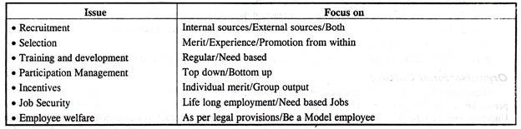
(Figure 6: Designing HR Subsystems. Source: yourarticlelibrary.com, n.d.)

5. Key Stages of Strategy Formulation and the Role of HR

Strategy formulation refers to ‘the process of choosing the most appropriate course of action for the realisation of organisational goals and objectives and thereby achieving the organisational vision’ (Mintzberg et al, 1988,cited in Armstrong, M, 2003) states that ‘strategy can have a number of meanings:
- A plan, or something equivalent – a direction, a guide, a course of action
- A pattern, that is , consistency in behaviour over time
- A perspective, an organisation’s fundamental way of doing things
- A ploy – a specific ‘manoeuvre’ intended to outwit an opponent or a competitor’
Mintzberg believes that ‘strategy formulation is a systematic process: first we think, then we act, we formulate and then we implement. But we also ‘act in order to think’. In practice, ‘a realised strategy can emerge in response to an evolving situation’ and the strategic planner is often ‘a pattern organiser’ who manages a process in which strategies and visions can emerge as well as be deliberately conceived’.
HR’s contribution to strategy includes performance appraisals, staffing, training and development, environmental scanning and competitive intelligence, and the implementation of resource allocation.
The process of strategy formulation basically involves six main steps.

- Setting Organizations’ objectives - The key component of any strategy statement is to set the long-term objectives of the organisation. It is known that strategy is generally a medium for realisation of organizational objectives. Objectives stress the state of being there whereas Strategy stresses upon the process of reaching there. Strategy includes both the fixation of objectives as well as the medium to be used to realise those objectives. Thus, strategy is a wider term which believes in the manner of deployment of resources so as to achieve the objectives.
While fixing the organisational objectives, it is essential that the factors which influence the selection of objectives must be analysed before the selection of objectives. Once the objectives and the factors influencing strategic decisions have been determined, it is easy to take strategic decisions.
- Evaluating the Organisational Environment - The next step is to evaluate the general economic and industrial environment in which the organisation operates. This includes a review of the organisations competitive position. It is essential to conduct a qualitative and quantitative review of an organisations existing product line. The purpose of such a review is to make sure that the factors important for competitive success in the market can be discovered so that the management can identify their own strengths and weaknesses as well as their competitors’ strengths and weaknesses.
After identifying its strengths and weaknesses, an organisation must keep a track of competitors’ moves and actions so as to discover probable opportunities of threats to its market or supply sources.
- Setting Quantitative Targets - In this step, an organisation must practically fix the quantitative target values for some of the organisational objectives. The idea behind this is to compare with long term customers, so as to evaluate the contribution that might be made by various product zones or operating departments.
- Aiming in context with the divisional plans - In this step, the contributions made by each department or division or product category within the organisation is identified and accordingly strategic planning is done for each sub-unit. This requires a careful analysis of macroeconomic trends.
- Performance Analysis - Performance analysis includes discovering and analyzing the gap between the planned or desired performance. A critical evaluation of the organisations past performance, present condition and the desired future conditions must be done by the organisation. This critical evaluation identifies the degree of gap that persists between the actual reality and the long-term aspirations of the organization. An attempt is made by the organisation to estimate its probable future condition if the current trends persist.
- Choice of Strategy - This is the ultimate step in Strategy Formulation. The best course of action is actually chosen after considering organisational goals, organisational strengths, potential and limitations as well as the external opportunities.
(Table 6: The Process of Strategy Formulation. Source: Management Study Guide, n.d)

Table 6 sets out the main differences between Strategy Formulation and Strategy Implementation-
Strategy Formulation | Strategy Implementation
Strategy Formulation includes planning and decision-making involved in developing organisation’s strategic goals and plans. | Strategy Implementation involves all those means related to executing the strategic plans.
In short, Strategy Formulation is placing the Forces before the action. | In short, Strategy Implementation is managing forces during the action.
Strategy Formulation is an Entrepreneurial Activity based on strategic decision-making. | Strategic Implementation is mainly an Administrative Task based on strategic and operational decisions.
Strategy Formulation emphasizes on effectiveness. | Strategy Implementation emphasizes on efficiency.
Strategy Formulation is a rational process. | Strategy Implementation is basically an operational process.
Strategy Formulation requires co-ordination among few individuals. | Strategy Implementation requires co-ordination among many individuals.
Strategy Formulation requires a great deal of initiative and logical skills. | Strategy Implementation requires specific motivational and leadership traits.
Strategic Formulation precedes Strategy Implementation. | Strategy Implementation follows Strategy Formulation.
(Table 7: Source: Management Study Guide, n.d)
The following are the main steps in implementing a strategy:
Developing an organisation having potential of carrying out strategy successfully.
Disbursement of abundant resources to strategy-essential activities.
Creating strategy-encouraging policies.
Employing best policies and programs for constant improvement.
Linking reward structure to accomplishment of results.
Making use of strategic leadership.
(Table 8: Steps in Implementing a Strategy. Source: Management Study Guide, n.d)

6. Business Ethics

Schwartz, 2001 (cited in Kew and Stredwick, 2005), defines a code of ethics as ‘a written, distinct, formal document, which consists of moral standards which help guide employee or corporate behaviour’. Codes of ethics should recognise the importance of relationships with internal and external stakeholders and involve them in their preparation. They should be clearly communicated to all stakeholders, and ensure they are understood and effective’ (Kew and Stredwick, 2005). Poor codes of ethics tend to be inward looking, ignore external stakeholders, and tend to be regulatory and over-detailed. These companies do not make their codes of ethics available to their stakeholders, and some do not make them easily available to their employees.
Mullins, 2005, states ‘anything done by an organisation can be done ethically or unethically’. The following list describes the nature of ethics in business:
- ‘Behaviours towards customers, suppliers, distributors, and competitors e.g. marketing and selling, fair competition, intelligence gathering, inducements and incentives
- Treatment of employees e.g. recruitment, rewards, training, promotion, dismissal, employee and employer rights and duties
- Treatment of other stakeholder groups e.g. local communities, governments, interest groups
- Effect on the natural environment e.g. pollution, recycling, sustainability
- Conduct on international operations e.g. use of power respect for human rights, ‘delocalisation’ of operations to lower-cost environments’ (ibid)
Codes can be of three different types (Brinkmann and Ims 2003, p266, cited in Kew and Stredwick, 2005):
- Educational – aimed at increasing moral awarement and behaviour within the organisation
- Regulatory – detailed rules for behaviour, which recognise moral conflicts and help with resolving them
- Aspirational – laying down general values, and communicating ideals to individuals within the organisation.
(Table 9: Types of Code. Source: Kew and Stredwick, 2005)

According to Taylor, S. 2014, the main implications from a HR perspective are:
The need to build ethical criteria into person specification, and hence into employee selection decisions
The need to stress the importance of ethical and professional conduct at induction and through training interventions and other forms of employee communication
A need for codes of conduct and disciplinary polices to be written depicting intolerance of unethical behaviour of its employees
The need to include ethics into all types of talent management activities, so that an appreciation of their importance works its way up the organisation as well as down
The need to set an example in the way that the HR function operates, treating staff equitably at all times
(Table 10: Implications of Code of Ethics from a HR perspective. Source: Taylor, S., 2014)

Evaluating Business Performance

There are several methods used to evaluate businesses. Mullins, Laurie J. states ‘benchmarking can vary from an informal or casual look at how other companies are performing, gathering information about other company’s best practices, to an in-depth investigation of a company’s performance compared to that of its’ major competitors’. Benchmarking in large organisations can also be carried out internally, comparing different sections, locations etc.
Barnes P., 1999 (cited in Armstrong, M. 2003) states that ‘although external benchmarking has a role to play in raising business performance, it should be used with care, and only after considering the circumstances and contingencies in the organisation involved.’
According to Modena, M. 2003 (cited in Armstrong, M. 2003), ‘benchmarking is one of the key tools for learning and enables forward-looking organisations to measure their performance against the best in the business. It should cover a balanced portfolio of practices and capabilities to bring about both short- and long-term success.’
The European Foundation for Quality Management (EFQM) model (figure 7) is a framework used to evaluate business performance. Customer satisfaction, employee satisfaction, and impact to society are factors in the model. This drives policy and strategy, people management, resources and processes leading to excellence in business results and can be used as a basis for measuring individuals as well as organisational performance.
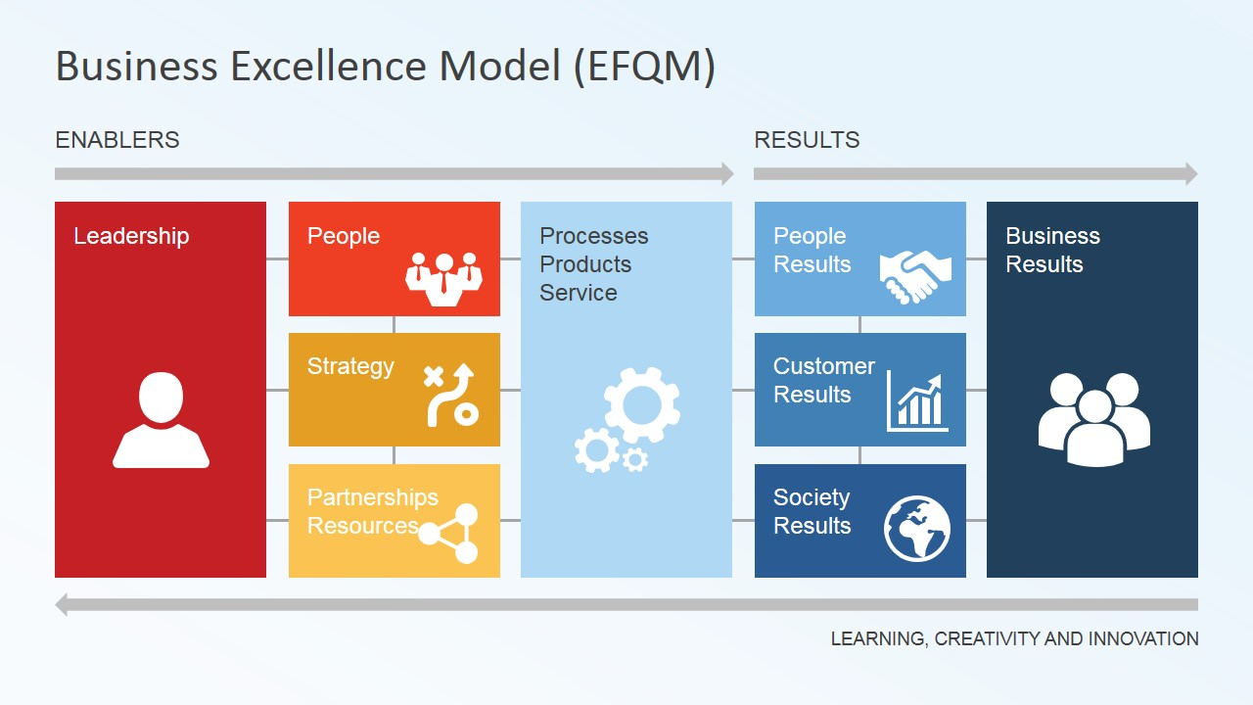
(Figure 7: The EFQM Model. Source: slidemodel.com)
Another method used to assessment to assess the HR’s function’s contribution is the ‘balanced scorecard’. The model assumes planned and effective communication (internally and externally) as a key factor, however this questions as to what level HR can become involved in developing and measuring the balanced scorecard (Rees and French, 2013). There are four elements that require targets and measure taken:
Learning and growth | relating to how we sustain our ability to change and improve
Customer | how we should appear to our customer
Financial | how we should appear to our shareholders
Internal business processes | to satisfy shareholders and customers, what  business processes must we excel at?
(Table 11: Balanced Scorecard. Source: Rees and French, 2013)

Armstrong, M. (2005) states ‘human resource planning should be an integral part of business planning. It identifies the core competencies the organisation needs to achieve its goals and therefore, skill requirements. HR planning interprets them in terms of people requirements, but may influence the business strategy by drawing attention to ways in which people could be developed and deployed more effectively to further the achievement of business goals as well as focussing on any problems that might have to be resolved in order to ensure that the people required will be available and capable of making the necessary contribution’. Quinn Mills, 1983 (cited in Armstrong, M., 2005) indicates that ‘human resource planning is ‘a decision-making process that combines three key activities:
  - Identifying and acquiring the right number of people with the proper skills
  - Motivating them to achieve high performance
  - Creating interactive links between business objectives and people planning activities.
Where clear business strategies do not exist, human resource planning may rely more on making assumptions about the need for people in the future, based on some form of scenario planning (ibid).
Human resource planning takes place within the context of organisation. The extent to which it is used, and the approach adopted, will depend on the extent to which management recognises that success depends on forecasting future people requirements, and implementing plans to satisfy those requirements.
HR has a major role to play in facilitating change. Ulrcih, 1997 (cited in Armstrong, M. 2005) states that ‘one of the key roles of HR professionals is to act as change agents, delivering organisational transformation and culture change’.
The importance of the human resources in achieving change has been emphasised by Johnson and Scholes, 1993 (cited in Armstrong, M., 2005):
‘Organisations which successfully manage change are those which have integrated their human resource management policies with their strategies and the strategic change process... training, employee relations, compensation packages, and so on are not merely operational issues for the personnel department; they are crucially concerned with the way in which employees relate to the nature and direction of the firm and as such they can both block strategic change and be significant facilitators of strategic change’.
As well as being involved in initiating change, HR practitioners can act as a stabilising force in situations where change would be damaging. Mohrmon and Lawler, 1998 (cited in Armstrong, M., 2005) state ‘the human resources function can help the organisation develop the capability to weather the changes that will continue to be part of the organisational landscape. It can help with the ongoing learning processes required to assess the impact of change and enable the organisation to make corrections and enhancements to the changes. It can help the organisation develop a new psychological contract and ways to give employees a stake in the changes that are occurring and in the performance of the organisation.’
Ulrich (1998) states that ‘HR professionals are not comfortable or compatible in the role of change agent, however HR practitioners are in a good position to understand possible points of resistance to change, and help facilitate the information flow and understanding required to overcome that resistance.’
HR’s contribution to change management includes implementing the right tasks, structures, processes and systems to support change (Armstrong, M., 2005). Six steps to implement change whilst building a self-reinforcing cycle of commitment, co-ordination and competence are:
- Mobilise commitment to change through the joint analysis of problems
- Develop a shared vision of how to organise and manage to achieve goals such as competitiveness
- Foster consensus for the new vision, competence to enact it, and cohesion to move it along
- Spread revitalisation to all departments without pushing it from the top – do not force the issuer, let each department find its own way to the new organisation
- Institutionalise revitalisation through formal policies, systems and structures
- Monitor and adjust strategies in response to problems in the revitalisation process (ibid)

Sources of Data and how Data can be used for Planning Purposes

Data is used to convert into useful information that provided the basis for decision making and the quality of the decisions made. According to the CIPD (2017) data comes in many forms, and may be quantitative or qualitative.
Quantitative data is measured through numbers. Qualitative data cant be measured and more often refers to individual’s views.
Quantitative data | Qualitative data
Objective | Subjective
How many? How much? | What? Why?
Facts are value-free/unbiased | Facts are value-laden and biased
Measurable | Interpretive
Report statistical analysis. Basic element of analysis is numbers | Report rich narrative, individual; interpretation. Basic element of analysis is words/ideas
‘Counts the beans’ | Provides information as to ‘which beans are worth counting’
Examples: number of employees, remuneration rates, productivity | Examples: employee opinion survey feedback, appraisals and performance reviews, learning and development outcomes
Table 12
Quantitative data can be obtained through the collection of sickness absence statistics. When employees are not healthy, increased absenteeism and decreased performance reduces productivity in the organisation. Monitoring and managing sickness absence can assist in business planning by ensuring policies and procedures follow best practice and that they are fit for purpose. Analysing staff turnover statistics can help determine future staffing and recruitment needs, and reviewing policies and promoting flexible working where possible can reduce pressure on employee, therefore increasing productivity, reducing costs and improving organisation effectiveness.
Qualitative data can be obtained by carrying out exit interviews. Exit interviews can reveal patterns into the reasons why staff leave and can raise issues or problems in the organisation. High staff turnover is costly due to the recruitment and training of new staff. Addressing and improving issues raised in exit interviews and discovering valuable insights into the organisation can inform organisation strategy and workforce planning , reduce costs and increase productivity of not having vacancies in the organisation.

8.2 Correlation and causation

HR analytics helps to identify cause and effect relationships, by determining the relationship between two sets of data to be investigated, and deciding whether the relationship is correlation or causal.
CIPD, 2017, states ‘correlation is when two or more things or events happen around the same time which might be associated with each other, but they aren’t necessarily related in a cause-effect relationship. It implies a mathematical relationship between two things which are measured, and is often described numerically with a value between 0 and 1, where 0 is no relationship and 1 is a fully predictive relationship’.
Causation is when one event or thing happens and as a result of it happening, another event or thing happens. If the first event did not happen, then the second does not happen. There is not a mathematical/probalistic relationship between the two but instead a time-based cause-effect relationship.
Just because two things correlate, it doesn’t necessarily mean there’s a causal (or cause-effect) relationship between them. For example, an increase in sales in a team which also has high engagement does not necessarily mean that engagement causes more sales. Other factors, such as improved training, or increase in customer-facing staff, may also be causing an increase in sales. Therefore, it is important to analyse as much data as possible before drawing conclusion (CIPD, 2017).
Data gathered in relation to recruitment and retention can inform recruitment advertising decisions. If the organisation is able to see where candidates are coming from,it can determine where to advertise and stop using underperforming advertising sources. Advertising in the right forum can reduce costs of re-advertising by getting the right candidates the first time.
Recruitment data allows you to recognise seasonal trends, e.g. a sudden increase in applications at particular times of the year and identifying quieter times of the year will allow recruiters to manage their activities accordingly. Being able to identify how candidates apply for posts can determine if it is worth investing in particular areas e.g. if a large amount of candidates apply using a mobile device, it may be worth investing in a mobile recruitment strategy.
Identifying trends in recruitment e.g. if more candidates apply on certain days of the week the organisation can ensure adverts are live the previous night, and recognising trends in how the longest serving employees applied for posts will allow the organisation to continue investing in that source.
Retention can be improved by gathering data on existing employees by asking them to undertake regular surveys to rank certain areas of the organisation e.g. the culture of the organisation, development prospects etc. The information gathered would allow the organisation to improve on these areas.
Demographic data can have a major impact on business planning. An ageing population means that people will live and work longer. The pensionable age has been increased with the aim of keeping people in work longer therefore reducing the strain on state benefits. A larger proportion of older workers in future workforces will affect recruitment, training, occupational health, employee benefits etc. It may also lead to conflict in the workplace as older people being seen to be blocking career progression for younger workers.
Generation ‘Y’ or the millennials have higher expectations from their employers and are keen to strike a positive work-life balance. Attracting and retaining younger workers may be more challenging as they will expect more opportunities for training and progression. Otherwise staff turnover could increase massively.
A globalised workforce means that populations are moving more freely around the world increasing cultural diversity. Challenges may come in the form of equality and inclusion with HR professionals required to be more culturally aware. Migration impacts on the size and composition of talent pools, with more graduates from different countries entering the global workforce.
The population of the authority will also have an impact on planning, as an increase in population may put more financial pressure on the authority as demand for services become higher, whereas a decrease in population may result in less demand for services resulting in job losses. Birth rate also has an impact meaning the authority can plan how many school staff will be required in future years.

Conclusion

HR needs to react to new technology, increasing globalisation, and employees’ changing expectation, in a rapidly changing business world. The future of work will be unrecognisable from work today.
Coombes, R., 2014 states that there will be 10 business trends that will radically reshape HR in the next five years:
The rise of the extended workforce | Companies will be increasingly composed of an ever-shifting, global network of contractors, business partners and outsourcing providers. As talent stretches beyond the confines of the company, HR teams may have to pay as much attention to people outside of the organisation as to those inside.
Managing individuals | Instead of managing a workforce with a one-size-fits-all approach, HR will treat each employee as a “workforce of one” with unique needs and preferences, and will customise employee incentives accordingly.
Technology advances radically disrupt HR | Technology will integrate talent management into the fabric of everyday business. HR IT will become a vital component of an organisation characterised by social media, cloud computing, mobility, and Big Data.
The global talent map loses its borders | With a mismatch between areas of supply and demand of jobs globally, companies will be composed of highly diverse workforces. HR will need to adopt new recruitment strategies to effectively match talent with task across the world.
HR drives the agile organisation | The world is becoming increasingly unpredictable and organisations that can adapt to changing business conditions will outperform the competition. HR will fundamentally reshape itself to enable new organisations designed around nimble and responsive talent.
Talent management meets the science of human behaviour | As new discoveries into brain science and human behaviour are emerging – and companies are using analytics to achieve improved results – HR will begin to arm itself with the tools and insights of a scientist to achieve better performances from their workforces.
Social media drives the democratisation of work | Social media is pervading the workplace and making it easier for employees to exchange information and ideas online. HR will need to play a vital role in helping build effective organisational cultures that support this, as well as incentives and processes for knowledge sharing, innovation and engagement.
HR must navigate risk and privacy in a more complex world | As the internet continues to break down information barriers, HR will adopt risk management strategies covering everything from protecting confidential information and data, to risks associated with weak hiring or turnover of talent.
HR expands its reach to deliver seamless employee experiences | HR will evolve from being a clearly defined, stand-alone function to one that collaborates closely with other parts of the business, such as IT, strategy and marketing, to deliver well-rounded HR and talent management processes.
Tapping skills anywhere, anytime | Skills gaps are widening and HR will be increasingly hard pressed to ensure their organisations have the right people. HR will need to develop initiatives to be able to quickly tap skills when and where they are needed.
(Table 13: Ten trends that will reshape the future of HR. Source: Coombes, R., 2014)
Trends are changing now and impact significantly on HR. New HR practices and those that are better suited to the changing workforce will be needed.

HR practices that respond to change that will have a better opportunity to help organisations and people become leaders in the new world of work. For those companies that don’t respond will risk the relevance of HR (Coombs, R., 2014).

10. References

Armstrong, M., 2003. Human Resource Management Practice. 9th ed. London: Kogan Page Limited.
CIPD, 2015. SWOT analysis. [Online]
Available at: https://www.cipd.co.uk/knowledge/strategy/organisational-development/swot-analysis-factsheet
[Accessed 10 January 2018].
CIPD, 2017. HR Analytics. [Online]
Available at: https://www.cipd.co.uk/knowledge/strategy/analytics/factsheet#7742
[Accessed 14 January 2018].
CIPD, 2017. PESTLE analysis. [Online]
Available at: https://www.cipd.co.uk/knowledge/strategy/organisational-development/pestle-analysis-factsheet#7990
[Accessed 07 January 2018].
Consultant online, n.d.. External Environment - PESTLE. [Online]
Available at: http://www.consultants-on-line.com/default.asp?contentID=23
[Accessed 07 January 2018].
Coombs, R., 2014. Ten trends that will reshape the future of HR. [Online]
Available at: http://www.hrmagazine.co.uk/article-details/ten-trends-that-will-reshape-the-future-of-hr
[Accessed 16 January 2018].
Farnham, D., 2005. Managing in a Strategic Business Context. 1st ed. London: CIPD.
free management ebooks, n.d.. Advantages and Disadvantages. [Online]
Available at: http://www.free-management-ebooks.com/faqst/porter-07.htm
[Accessed 10 January 2018].
Haughey, D., 2018. SWOT Analysis. [Online]
Available at: https://www.projectsmart.co.uk/swot-analysis.php
[Accessed 09 January 2018].
Joy, M. M., 2015. slideshare.net. [Online]
Available at: https://www.slideshare.net/manumelwin/the-harvard-framework-human-resource-management-manu-melwin-joy
[Accessed 07 January 2018].
Kammar, S., n.d.. Internal Factors Affecting Human Resources. [Online]
Available at: http://www.yourarticlelibrary.com/essay/human-resource-management/internal-factors-affecting-human-resources/75330
[Accessed 13 January 2018].
Kew, J. & Stedwick, J., 2005. Business Environment: Managing in a Strategic Context. 1st ed. London: CIPD.
Lav, N., 2012. slideshare.net. [Online]
Available at: https://www.slideshare.net/lavnigam/functional-aspect-of-management
[Accessed 06 January 2018].
Management Study Guide, n.d.. Steps in Strategy Formulation Process. [Online]
Available at: http://www.managementstudyguide.com/strategy-formulation-process.htm
[Accessed 14 January 2018].
Mullins, L. J., 2005. Management and Organisational Behaviour. 7th ed. Essex: Financial Times / Prentice Hall.
Papermasters, n.d.. Papermasters.com. [Online]
Available at: https://www.papermasters.com/four-functions-management.html
[Accessed 06 January 2018].
Rees, G. & French, R., 2013. Leading, Managing and Developing People. 4th ed. London: CIPD.
researchpaperspot.com, 2017. Porter's Five Forces - Strategy Skills Training From Mindtools with Porter's Five Forces Template. [Online]
Available at: http://www.researchpaperspot.com/porters-five-forces-template/porters-five-forces-strategy-skills-training-from-mindtools-with-porters-five-forces-template/
[Accessed 09 January 2018].
Slidemodel.com, n.d.. EFQM Business Excellence Model Diagram. [Online]
Available at: https://slidemodel.com/templates/business-excellence-model-efqm/efqm-business-excellence-model-diagram/
[Accessed 14 January 2018].
Taylor, S., 2014. Resourcing and Talent Management. 6th ed. London: CIPD.
Watson, G. & Gallagher, K., 2005. Managing for Results. 2nd ed. London: CIPD.

