Analysis of Results – 4.0

Introduction – 4.1
The aim for this section is to analyse the results that have been gathered from the questionnaire which was sent out to 10 current serving members of Gwent Police throughout different ranks on 4th January 2022. The questionnaire was sent to Gwent Police serving officers through a link via Survey Monkey which is an online platform that allows the recording of data through the various questions. This ascertained a total of ten responses to the ten questions asked within the questionnaire.
The research that was targeted, as previously highlighted within the methodology to develop an understanding of how the communities throughout England and Wales could be affected by an increase in drug crimes and will highlight how police have managed to deal with these drug crimes. The further aims of the research were to highlight the growth of drug use by identifying how often officers believe drug use has occurred when dealing with policing incidents. The research was also targeted at officers to identify the current methods used by police as well as potentially highlighting new preventative methods to drug use. These aims that were laid out within the methodology and questionnaire were to show information about the effects of drugs on the community and police due to the gap of literature which was highlighted within the literature review.
The results that were gathered from the questionnaire may pose a hindrance to the data that the dissertation was originally aiming for. This is due to the fact that the questionnaire was sent to currently employed officers of Gwent Police meaning that the data that has been received will be restricted to Gwent Police area only, meaning that any questions based around policies may differ from other police forces within England and Wales. The results are exhibited within the graphs displayed below. As there was only a total of 10 participants for this questionnaire, each participant equates to 10%.

Survey: question one – 4.2
Q.1
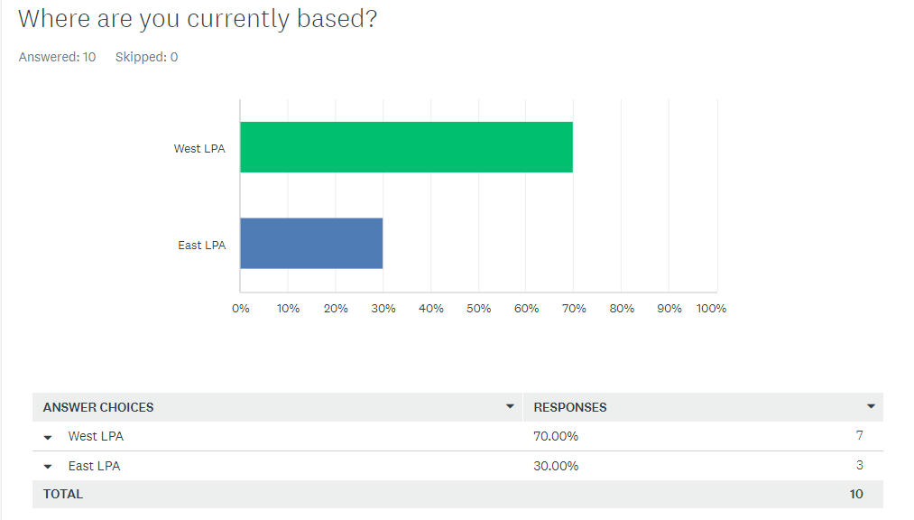
The results within this graph highlight that of the ten responses received from current serving Gwent Police Officers, 7 officers fall under working within the West LPA as 70% and 3 officers working within the East LPA as 30%.

Survey: question two – 4.2.1
Q.2
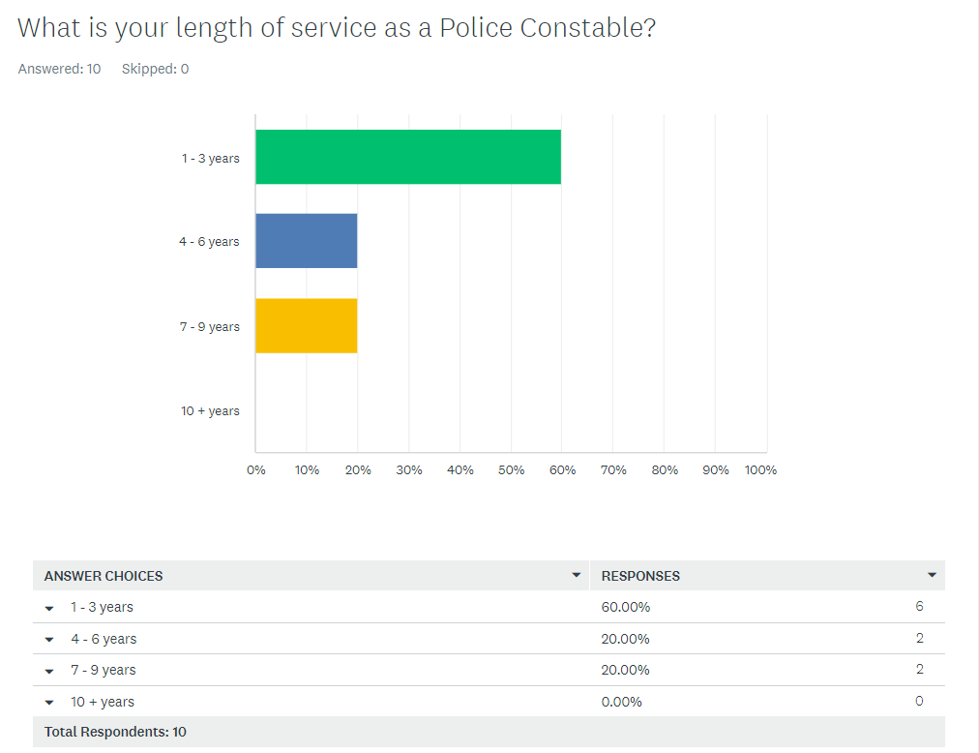
The results within this graph display that 60% of responses received have served as a Police constable for ‘1 – 3 years’. The remaining 40% of current serving officers is divided by two showing that 20% fall within the ‘4 – 6 years’ category and the remaining 20% falling within the ‘7 – 9 years’ category. None of the participants selected the ’10 + years’ option.

Survey: question three – 4.2.2
Q.3
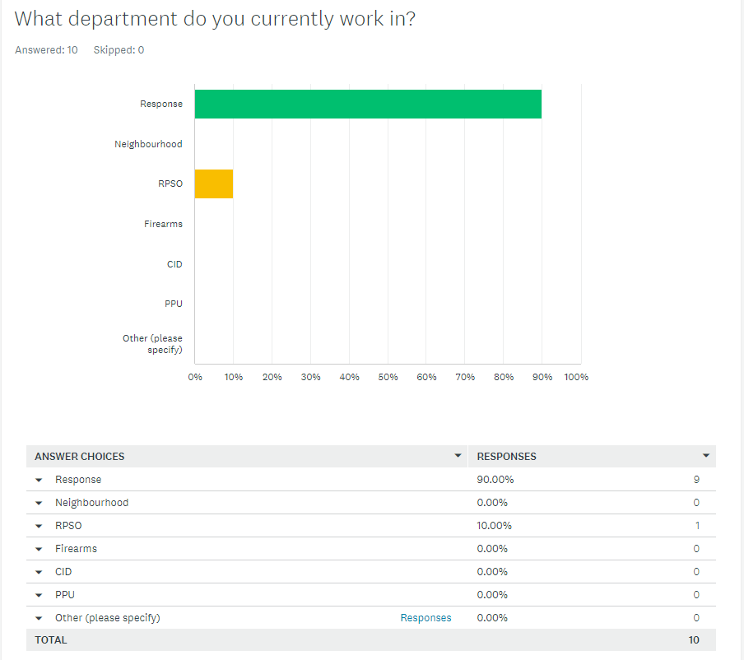
This graph displays an array of multiple choice answers relating to a vast amount of different roles within Gwent Police however only two options have been selected. 90% of the respondents answered that they are currently still working within a response policing role and the remaining 10% which equated to one officer working within Roads Policing Specialist Operations (RPSO). This questionnaire was disseminated to different departments within Gwent Police however no responses were received from Neighbourhood, Firearms, CID, and PPU. The ‘Other’ option was also not selected.

Survey: question four – 4.2.3
Q.4
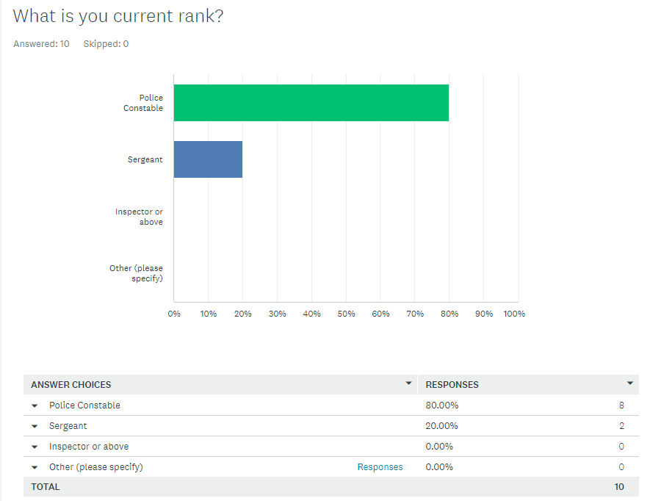
The results displayed within this graph show that 80% of the participants stated that they are Police constables and the remaining 20% of participants selected that they are Police Sergeants. There were no participants within this questionnaire that were ranked ‘Inspector or above’ or ‘Other’.

Survey: question five – 4.2.4
Q.5
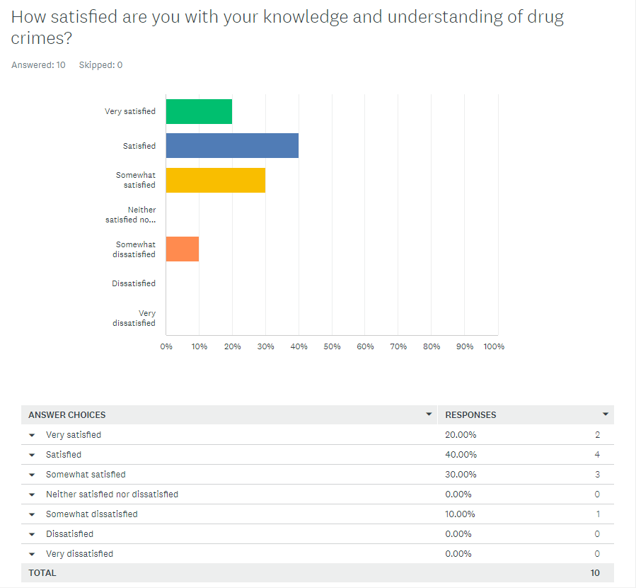
The results in this graph vary and show that 20% of respondents selected that they are ‘Very satisfied’ with their knowledge and understanding of drug crimes. The most selected option shown in this graph is ‘Satisfied’ which was selected by 40% of the participants. 30% of the participants selected that they are ‘Somewhat satisfied’ with their knowledge and understanding of drug crimes. The remaining 10% selected that they are ‘Somewhat dissatisfied’ with their knowledge of drug crimes. There were three options shown within this graph that were not selected by any of the participants which were ‘Neither satisfied nor dissatisfied’, ‘Dissatisfied’ and ‘Very dissatisfied’.

Survey: question six – 4.2.5
Q.6
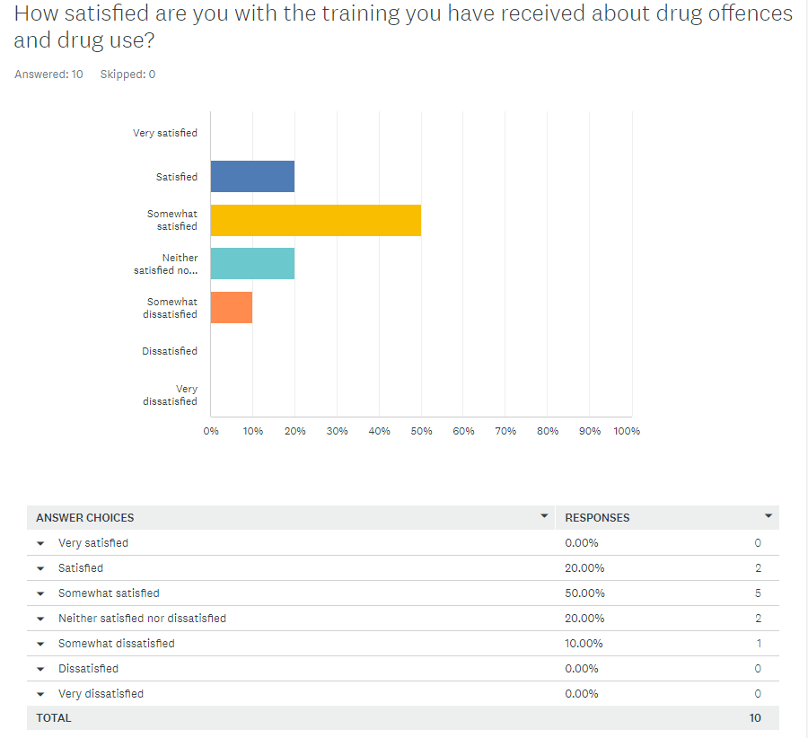
The results in this graph show that 50% of respondents have selected that they are ‘Somewhat satisfied’ with the training they have received about drug offences and drug use. 20% of respondents fall into the ‘Satisfied’ category along with another 20% falling into the ‘Neither satisfied nor dissatisfied’ category. The remaining 10% of participants selected that they are ‘Somewhat dissatisfied’. No participants had selected the ‘Very satisfied’, ‘dissatisfied’ and ‘Very dissatisfied’ category.

Survey: question seven – 4.2.6
Q.7
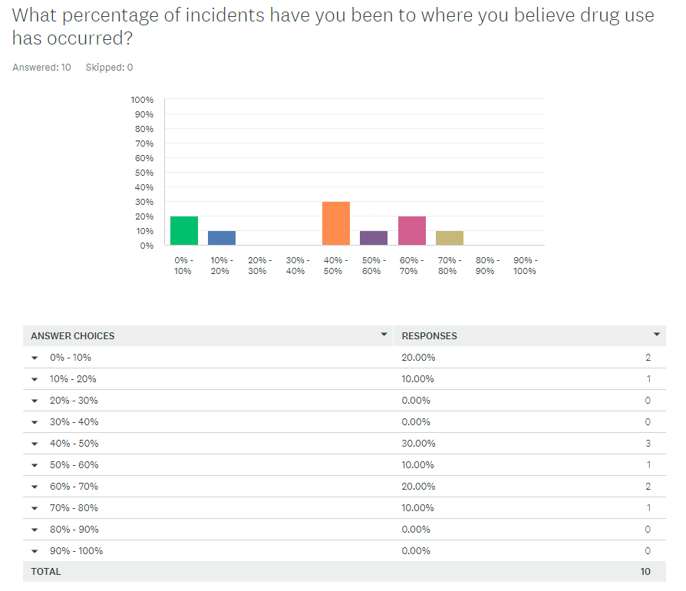
The results displayed in this graph vary with the highest selected category being ‘40% - 50%’. This was selected by 30% of the participants whereby they believe that 40% - 50% of the incidents they have been to, drug use has occurred. 20% of respondents stated that they believe that drug use has occurred in only ‘0% - 10%’ of the incidents they have dealt with. A further 20% of participants selected ‘60% - 70%’. The remaining 30% of participants have been divided by three with the categories they have selected with 10% selecting ‘70% - 80%’, a further 10% selecting ‘50% - 60%’ and the remaining 10% of participants selecting ‘10% - 20%’. There were multiple categories left unselected being ‘20% - 30%’, ‘30% - 40%’, ‘80% - 90%’ and ‘90% - 100%’.

Survey: question eight – 4.2.7
Q.8
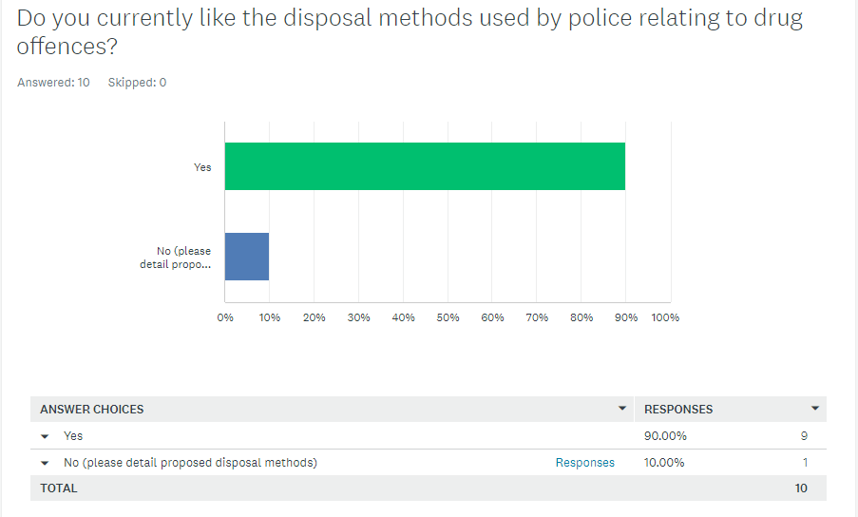
The results shown in this graph detail that 90% of participants have selected ‘Yes’ meaning that they currently like the disposal methods that are used by police relating to drug offences. The remaining 10% which equals to one respondent has selected ‘No’ and had to detail what potential disposals they would like. The respondent detailed their reasoning as, “I believe the cannabis warnings should come back for the times a small amount of cannabis is found on a person. Does not seem worth the courts or police’s time and money for someone to get a conditional caution”.

Survey: question nine – 4.2.8
Q.9
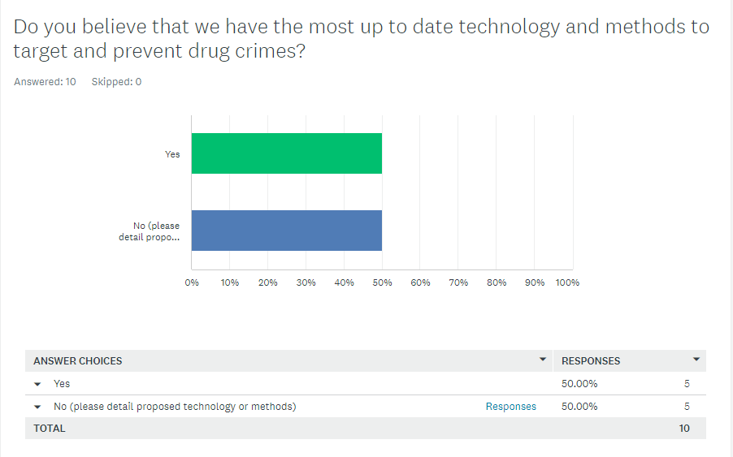
The results that are displayed within this graph show that 50% of the participants selected ‘Yes’ meaning they believe that we as police currently have the most up to date technology and methods to target and prevent drug crimes. The only other option being ‘No’ means that the remaining 50% of participants selected this option along with providing details of proposed methods that the police could use. The participants comments are detailed below:

Response 5:
“I would like to see more officers trained in testing drugs as well as trained in use of drug wipes”.

Response 4:
“Although I am trained in drug wipes. I believe that a lot more officers should be trained in this as it would be a much more effective way of managing drug crimes”.
Response 3:
“While I believe I understand the justification behind having EDIT trained officers required to identify cannabis, I feel that this could add an unnecessary extra step to simple possession 'jobs' where experienced officers could identify it themselves. Obviously, this does open up the possibility of less experienced officers attempting to identify cannabis, perhaps incorrectly, but I believe with appropriate management and support by sergeants this can be mostly avoided”.

Response 2:
“Drug wipes are an easy way of testing drug drivers and hardly any officers are trained in it. Also limited number of cops can ID which is silly as it slows things down”.

Response 1:
“It would be great if front line officers could have access and training for drug wipes so these can be used on a regular basis”.

A common theme within these responses provided by the participants is that officers are trained to ‘drug wipe’. This is seen within response 1,2,4 and 5. Another theme identified within the responses is that officers are trained to ‘identify’ drugs. This is detailed in response 2 and 3.

Survey: question ten – 4.2.9
Q.10


This question was an open based question asking the respondents to provide details of their opinion on the impact they believe drugs have on the community so the results will be displayed as text, and these are presented as follows:

Response 10:
“Large impact on the community because drugs often relate to other offences such as theft as the person will often result to this to fund their habit for drug use. This is a huge concern because it will affect shops as well as the public who will likely be the victims to the thefts”.

Response 9:
“Huge impact in regard to how much money it costs for police and other public services to deal with drug issues. I believe it also leads to a lot of ASB and other offences such as theft, criminal damage and assaults”.

Response 8:
“Has a huge effect on officer as well as a huge effect on funds for the public services having to manage it. I believe it relates to a lot of other offences such as theft to fund the drugs and ASB”.

Response 7:
“Drugs have a pervasive impact wherever they are present. Sometimes this is in the acquisitive crime used to fund habits, and sometimes in the family impact from those present with drug users. Drug use can also have significant physical and mental health impacts, sometimes exacerbating already significant issues people face”.

Response 6:
“Negative”.

Response 5:
“A big one, shop thefts, rtc, damage, ASB”.

Response 4:
“Negative impact”.

Response 3:
“The impact currently is that issues surrounding drugs is taking front line officers from their main duties, this has an impact on the rest of the community as a whole in responding to calls. Drugs is also having an impact on mental health services and the health care system”.

Response 2:
“A negative one - when a persons use of drugs makes others either connected or not connected with the user feel Alarmed or Distressed. The further impact on our support services (Police/ Ambulance etc) means that others who are in need are getting a less effective service”.

Response 1:
“Large impact in regard to the amount of money public services are spending to prevent and manage drug use”.

There are many common themes within the responses provided by the participants for question 10. One common theme is that drugs are stated to have an impact on ‘public services such as police and health care’ meaning ‘money is being spent’ and making ‘public service’s less effective’. This theme is seen in response 1, 2, 3, 8 and 9.
Another theme seen throughout the responses is linking the impact of drugs to ‘thefts’. This theme is detailed in responses 5, 7, 8, 9 and 10.
ASB (Anti-social behaviour) is another impact detailed to have an affect on the community from drugs therefore creating another theme seen within responses 5, 8 and 9.
‘Criminal damage’ is a further theme highlighted within responses 5 and 9.
An additional theme that is displayed throughout all responses is the affect drugs will have on the community will be ‘negative’. All respondents have detailed negative affects of drugs to the community.
Other impacts that have been detailed by participants with no themes seen within the responses are ‘assault’ and impact on ‘family’ members.

Analysis of results: Conclusion – 4.3
To conclude the analysis of results, it has been identified that a vast majority of current serving officers within Gwent Police believe that drug use is apparent in 40 to 80% of the incidents we manage, with a small amount of officers detailing that they believe 0 to 20% of the incidents we manage has involved drug use. These results may vary due to the varying number of years each officer has had within their active role.
In addition to this, 90% of the officers selected that they are ‘somewhat satisfied’, ‘satisfied’ and ‘very satisfied’ with their knowledge in regard to drug offences which would in turn identify that officers have had sufficient training in regard to drug offences.
Half of the responding officers have also detailed that they would like more officers trained to carry out a drugs procedure via drug wipes as well as highlighting that more officers should be trained to identify drugs. The remaining half of respondents are currently satisfied with the current technology and methods used by police.
A vast majority of police officers totalling 90% within Gwent Police are satisfied with the current disposal methods that are used relating to drugs.
The respondents all share a similar view in regard to the affect drugs have on the community detailing that it has a ‘negative impact’ as it often relates to ‘ASB’, ‘theft’, ‘criminal damage’ and ‘public services’ wasting time and money making them ‘less effective’.
The following chapter will go into further detail identifying themes and patterns from the current research obtained from the questionnaire and will also compare the current data with any historic data displayed within the literature review.

Word Count: 1632

