

Name: Kemisha Bryan
Student ID: 2335173

Module code: Protecting and Supporting Families in Health and Care (BMHP5021)

Digital Mental Health Support App for Frontline Health and Social Care Workers

Table of Contents
Title and Innovation Overview 3
The Issue / Gaps in Health and Social Care 4
Target Audience and Impact 5
Implementation 6
Timeline 7
Development and Regulations 8
Technology Integration 9
Dissemination 10
Conclusion 11
Introduction and Rationale 12
2. The Case for Innovation in Workforce Wellbeing 13
3. Value Creation and Impact 14
4. Feasibility and Practical Implementation 15
5. Conclusion 16
References 17

Title and Innovation Overview

This poster proposes a digital mental health support app designed to improve the wellbeing of frontline health and social care workers in the UK. Workforce wellbeing is a recognised national priority due to its influence on staff retention, service sustainability, and quality of care (NHS England, 2020). The innovation is a confidential, mobile-based platform offering accessible mental health support, including self-guided cognitive behavioural therapy (CBT) tools, stress management exercises, mood tracking, and signposting to professional services.
The app is innovative because it provides preventative and stigma-free support that can be accessed flexibly around shift work. By reducing barriers such as time pressures and fear of judgement, the app encourages early intervention and supports safer care delivery (World Health Organization, 2020).

The Issue / Gaps in Health and Social Care

Frontline health and social care workers experience high levels of stress, emotional exhaustion, and burnout due to staff shortages, increasing demand, long working hours, and emotional labour. These pressures affect both NHS and social care staff and have intensified in recent years.
Poor staff wellbeing is associated with increased sickness absence, staff turnover, and reduced quality of care. The Care Quality Commission has identified workforce pressures as a key factor affecting safety and service quality (Care Quality Commission, 2021). NHS England has also highlighted the importance of staff wellbeing in delivering safe and effective care (NHS England, 2020).
Despite this recognition, access to timely mental health support remains inconsistent, particularly in social care settings. Barriers such as stigma, limited time, and lack of occupational health provision often prevent early help-seeking, creating a clear gap in current support systems.

Target Audience and Impact

The main target audience for this innovation is frontline health and social care workers, including carers, support workers, healthcare assistants, nurses, and social care staff working in residential, domiciliary, and community settings. These roles often involve high emotional demands, responsibility for vulnerable individuals, and limited recovery time between shifts, which places workers at increased risk of stress and burnout.
Within many care environments, staff are expected to prioritise the needs of service users, often leaving little time or space to focus on their own mental wellbeing. In practice, this can result in workers delaying support until difficulties become unmanageable. Research has shown that carers and healthcare staff are particularly vulnerable to emotional exhaustion due to workload pressures and the relational nature of care work (Maslach and Leiter, 2016). Digital wellbeing tools offer a more flexible form of support, allowing workers to engage privately and at times that fit around shift patterns (CIPD, 2022).
The impact of this innovation extends beyond individual staff members. Improved mental wellbeing is associated with higher job satisfaction, reduced sickness absence, and improved staff retention, all of which are critical for maintaining continuity of care. Workforce stability is particularly important in social care, where high turnover can negatively affect service quality and relationships with service users (Skills for Care, 2023). In terms of the common good, supporting the mental health of carers and healthcare staff contributes to more equitable, compassionate, and sustainable health and social care services.

Implementation

The app would be implemented across NHS and social care settings, including hospitals, care homes, and community services. Collaboration between NHS organisations, local authorities, and independent providers would ensure consistent access across sectors. Staff wellbeing initiatives are most effective when embedded into everyday practice rather than treated as optional extras (NHS England, 2020).
Employers could introduce the app during staff induction and promote its use through wellbeing initiatives. In social care settings where occupational health support is limited, the app provides a practical way to extend mental health support to carers and support workers (Skills for Care, 2023).
The app would be developed using a co-production approach involving frontline staff and mental health professionals, increasing relevance and long-term engagement (OECD, 2021).

Timeline
Table 1: Development and Implementation Timeline for the Digital Mental Health Support App
Phase | Key Activities | Timeframe
Phase 1: Design & Development | Co-production with frontline staff and carers; development of app features; creation of mental health content | 0–3 months
Phase 2: Pilot Testing | Trial of the app in selected NHS and social care settings; collection of staff feedback; usability testing | 4–6 months
Phase 3: Evaluation & Rollout | Review of pilot data; refinement of the app; wider rollout across NHS trusts and social care providers | 7–12 months

Development and Regulations
The digital mental health support app must follow UK data protection laws, including UK GDPR and the Data Protection Act 2018, to ensure confidentiality and secure handling of sensitive mental health information. Clear information about data use and the option for anonymous access are important to encourage staff to engage with the app.
The innovation supports health and social care responsibilities under the Care Act 2014 by promoting staff wellbeing and workforce sustainability. It also aligns with professional standards such as the Nursing and Midwifery Council Code, which emphasises safe practice and self-care. Ethical considerations include built-in safeguarding measures and ensuring the app complements, rather than replaces, existing mental health services.

Technology Integration
The app integrates mobile health technology into everyday practice, allowing staff to access wellbeing support via smartphones or tablets. Features such as stress management tools, mood tracking, and confidential signposting encourage early recognition of stress.
Digital approaches reduce barriers such as stigma and long waiting times, improving engagement with mental health support (World Health Organization, 2020). Secure access and data protection measures support trust and confidentiality (NHS England, 2020).
Figure 1: How the Digital Mental Health Support App Supports Frontline Health and Social Care Workers
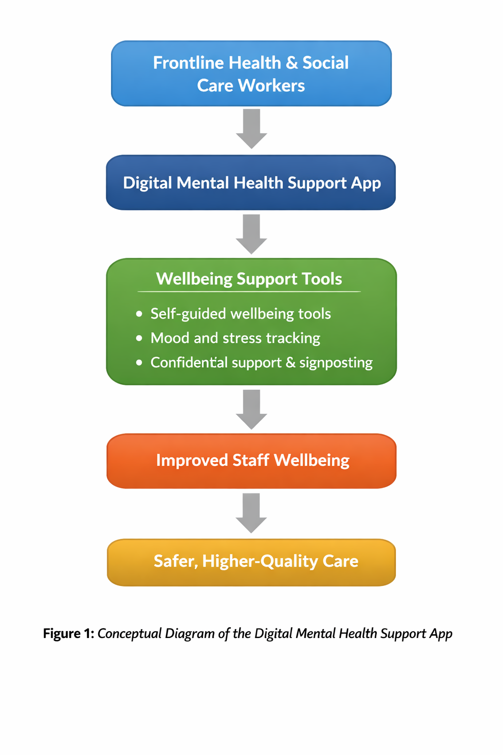

Dissemination

The app would be promoted through organisational communication channels such as staff induction, internal newsletters, wellbeing campaigns, and team briefings. Using established communication routes supports awareness and engagement (NHS England, 2020).
Workforce organisations could support dissemination through professional networks and development platforms. Clear messaging that emphasises confidentiality and ease of use may reduce stigma and increase uptake (Skills for Care, 2023).

Conclusion

This poster has proposed a digital mental health support app to address workforce wellbeing challenges in UK health and social care. By offering accessible and confidential support, innovation addresses gaps in existing provision.
Supporting staff wellbeing aligns with the Care Act 2014 and contributes to workforce sustainability. A resilient workforce is better able to deliver safe and compassionate care, supporting the common good (Department of Health and Social Care, 2014).

Introduction and Rationale

The wellbeing of frontline health and social care workers has become an increasingly urgent concern within the UK. Persistent workforce pressures, including staff shortages, rising service demand, and the emotional intensity of care work, have contributed to high levels of stress and burnout among carers and healthcare professionals. These challenges affect not only staff wellbeing, but also the quality, safety, and sustainability of health and social care services.
National policy recognises that staff wellbeing is central to effective service delivery. The NHS Long Term Plan highlights the need to better support the mental health of the workforce to improve retention and maintain high standards of care (NHS England, 2019). Despite this recognition, access to timely and appropriate mental health support remains uneven, particularly within the social care sector. Barriers such as stigma, limited time, and restricted access to occupational health services often prevent early help-seeking.
This pitch proposes the adoption of a digital mental health support app designed specifically for frontline health and social care workers. The innovation offers flexible, confidential, and preventative support that can be accessed around shift work and caring responsibilities, addressing gaps in current provision and creating value for individuals, organisations, and the wider system.

2. The Case for Innovation in Workforce Wellbeing

Traditional approaches to staff mental health support have often focused on reactive interventions, such as counselling accessed once difficulties have become severe. While valuable, these services are frequently limited by long waiting times and low uptake due to time pressures and stigma. For many carers and frontline staff, accessing face-to-face support is not always practical.
Research into burnout highlights that prolonged exposure to high emotional demands without adequate support can lead to emotional exhaustion and disengagement (Maslach and Leiter, 2016). Preventative approaches that support early recognition and management of stress are therefore essential.
Digital innovation provides a practical response to these challenges. Mobile wellbeing tools allow staff to engage with support privately and flexibly, reducing barriers such as scheduling difficulties and stigma. Evidence suggests that digital mental health interventions can improve access and encourage earlier help-seeking among working populations (World Health Organization, 2020). From an organisational perspective, digital solutions are also scalable and cost-effective, supporting workforce wellbeing at scale.

3. Value Creation and Impact

The proposed digital mental health support app creates value at multiple levels. At an individual level, the app supports frontline workers to manage stress, build resilience, and access support in a way that fits around demanding work patterns. Early engagement with wellbeing support is particularly important for carers and healthcare staff who may otherwise delay seeking help.
At an organisational level, improved staff wellbeing is linked to reduced sickness absence, improved job satisfaction, and higher staff retention. Workforce instability remains a significant challenge across NHS and social care services, with high turnover disrupting continuity of care (CIPD, 2022; Skills for Care, 2023).
At a system level, supporting staff wellbeing contributes to safer, more compassionate care and aligns with policy priorities that recognise the workforce as central to service quality and sustainability (NHS England, 2019). The innovation also contributes to the common good by promoting equity, dignity, and ethical workforce support.

4. Feasibility and Practical Implementation

The proposed app is feasible to implement across NHS and social care settings through collaboration between NHS organisations, local authorities, and independent providers. Embedding the app within existing wellbeing strategies and staff induction programmes would support uptake and normalise its use.
Co-production with frontline staff and mental health professionals would guide development, ensuring the app reflects real workplace pressures. Co-produced innovations are more likely to be accepted and sustained in practice (OECD, 2021). Potential risks, such as low engagement, can be mitigated through clear communication, confidentiality assurances, and ongoing evaluation.

5. Conclusion

This pitch has outlined the rationale for adopting a digital mental health support app to address workforce wellbeing challenges in UK health and social care. By offering accessible, confidential, and preventative support, the innovation addresses gaps in current provision and supports early intervention.
Investing in staff wellbeing aligns with national policy priorities and supports workforce sustainability. A supported and resilient workforce is better positioned to deliver safe, high-quality, and person-centred care. Overall, the proposed innovation represents a practical and ethical approach to strengthening health and social care services and promoting the common good.

References

Care Act 2014. London: The Stationery Office.
Care Quality Commission (2021) The state of health care and adult social care in England 2020/21. Newcastle upon Tyne: CQC.
Chartered Institute of Personnel and Development (CIPD) (2022) Health and wellbeing at work survey. London: CIPD.
Data Protection Act 2018. London: The Stationery Office.
Department of Health and Social Care (2014) Care Act 2014: Statutory guidance. London: DHSC.
Maslach, C. and Leiter, M.P. (2016) ‘Understanding the burnout experience: recent research and its implications’, World Psychiatry, 15(2), pp. 103–111.
NHS England (2019) The NHS Long Term Plan. London: NHS England.
NHS England (2020) We Are the NHS: People Plan 2020/21. London: NHS England.
Nursing and Midwifery Council (2018) The Code: Professional standards of practice and behaviour for nurses, midwives and nursing associates. London: NMC.
Organisation for Economic Co-operation and Development (OECD) (2021) Innovation in public service delivery. Paris: OECD.
Skills for Care (2023) The state of the adult social care sector and workforce in England. Leeds: Skills for Care.
UK General Data Protection Regulation (UK GDPR) (2018).
World Health Organization (2020) Mental health and psychosocial considerations during the COVID-19 outbreak. Geneva: WHO.

