

Communication Channels in Private High Rise Residential Buildings: Facilities Managers need to Talk the Talk and not just Walk the Walk

MSc Property and Facilities Management

Researcher : Bradley Wood
Researcher Student Number : 20144427
Date : 3rd February, 2022
Supervisor: Trevor Francis, MSc, MRICS, MCIOB, MCABE,
P.G Diploma Architectural Conservation

Authors Declaration
I declare that the work in this dissertation was carried out in accordance with the regulations of the University of Wales Trinity Saint David. The work is original except were indicated by special reference in the text and no part of the dissertation has been submitted for any other degree.
The views expressed in the dissertation are those of the researcher and in no ways represent those of the University of Wales Trinity Saint David.
The dissertation has not been presented to any other University for examination in either the United Kingdom or overseas.
I hereby give permission for my work, if accepted, to be available for photocopying and inter-library loan, and for the title and the summary to be made available to outside organisations.

Signed _______________________________________(Candidate)
Date : 3rd, February 2022

This work has not previously been accepted in substance for any degree and is not being currently submitted in candidature for any degree.

Signed _______________________________________(Candidate)
Date : 3rd, February 2022

STATEMENT 1
This dissertation is the result of my own investigations, except where otherwise stated. Where correction services have been used, the extent and nature of the correction is clearly marked in a footnote(s). Other sources are acknowledged by footnotes giving explicit references. A bibliography is appended.

Signed _______________________________________(Candidate)
Date : 3rd February, 2022

STATEMENT 2
I hereby give consent for my dissertation, if accepted, to be available for photocopying and for interlibrary loan, and for the title and summary to be made available to outside organisations

Signed _______________________________________(Candidate)
Date : 3rd February, 2022

Abstract
The focus of Facilities Management (FM) has traditionally been that of a cost and maintenance driven sector with an emphasis on hard FM services, yet the need for soft skills, such as communication are becoming increasingly important.
FM of high-rise residential buildings (HRRB’s) is receiving attention, primarily because of the Grenfell Tower fire, the Hackitt report and the UK Building Safety Bill. Recommendations of the Hackitt report indicated residents of HRRB’s should be given a voice where safety issues are concerned, regardless of tenure. From empirical observations in private high rise residential buildings (PHRRB’s), communication channels between residents and Facilities Managers (FM’s) are a product of their past, failing to recognise changing ethnographies, demographics, disabilities, or language barriers. Such channels have not kept pace with new technologies and innovations in hard FM, such as Building Information Modelling, Computer Aided Facilities Management or Building Energy Management.
There has been significant growth in the private rented sector and build to rent sectors in recent years, particularly in PHRRB’s. Such sectors are dependent upon residents occupying short term tenancies, yet they are largely overlooked in the whole FM process. When considering communication with residents in PHRRB’s, there is a need to be innovative. This can be achieved through a better understanding of individuals and their social needs. FM of PHRRB’s must recognise their customers, and their social and environmental objectives if they are to achieve residents satisfaction and be accepted as a knowledge-based sector.
A literature review failed to identify studies into communication strategies in PHRRB’s or resident satisfaction of soft FM services in such buildings. The focus of this research study were residents living in two large PHRRB’s, in Swansea and Barnsley, and the FM’s of those buildings. The data collection assumed a philosophical approach, from a constructivist viewpoint, with a mixed method approach adopted. Data was collected in the form of a residents questionnaire and semi-structured, face to face interviews with each FM.
This study revealed residents do have preferred channels of communication, and the majority would engage with the FM team if their preferred channels were adopted. However, FM’s consider cost as a driver in residential FM, and due to a lack of time, resource, and staff: the social needs, or understanding of what is important to residents of all tenures are often overlooked. There is no recognition of resident satisfaction, which is a necessity for effective FM, nor demographics and ethnographies of residents. This is of particular concern, given the role of FM in such buildings is ensuring the safety and comfort of residents.

Acknowledgments
Throughout the last 18 months, from undertaking each module to the completion of this dissertation, I have received a great deal of help, advice, support, and encouragement. This academic journey at the University of Wales Trinity Saint David has been a great opportunity, in such challenging times, not just for myself but also for my lecturers, who, given the challenge of lecturing online have still managed to make lectures informative, enjoyable, and providing a platform where discussions of subjects and ideas could take place. Thank you.
A huge thanks to my supervisor, Trevor Francis. Though we spent many hours discussing Swansea City FC, his knowledge and guidance during lectures, as well as his ideas for my dissertation provided me with additional skills, knowledge and understanding which I used in my research, and which I can take forward into my new employment role. I would also like to thank Associate Professor Chris House, not just for accepting me onto this MSc course, but who helped me strip away my massive dissertation idea, to reveal the essence of what I was trying to research.
Thank you also to Emily Howell from the library team who provided me with the tools to get the most out of the library resources.
I would like to thank all participants at the two study sites, particularly the Facilities Managers, who took the time out to allow me to interview them about my research topics.
It is not often you can thank your family in print, so I would like to thank all my family. To my in-laws Jan and Peter who are always there, and for their continued love and care towards my wonderful family. To my mother, Liz, for everything you have done for me and my family. Through your own hardships, you have been a tower of strength to all, but your love, support, and compassion for everything I have done throughout my life has made me the person I am today.
To my own family, thank you; for ‘forgiving’ me for lost nights, weekends and even lost days on our summer holidays. My children Ceris and Alis; Mami and I could not be any prouder of you, and though you are only starting out in your young lives, your attitude towards education will take you far in life, but your kindness and thoughtfulness will take you further.
Lastly, to my wonderful wife, Dr Sian Wood. Your love and support over the last 20+ years are always treasured. Where my education is concerned, your enduring support, especially in my early months ensured I continued with this course, for which I will always be grateful. Your careful proof reading and your suggestions for improvement ensured I was able to submit this dissertation, which I am considerably proud of; I could not have done it without you but am thoroughly disappointed you didn’t get to spend many weekends in a caravan, which I know you craved!

Contents
Authors Declaration i
Abstract ii
Acknowledgments iii
Table of Figures ix
Table of Tables x
Abbreviations xii
1 Introduction 1
1.1 Communication and Facilities Management 1
1.1.1 Communication 1
1.1.2 High Rise Residential Buildings (HRRB’s) 1
1.1.3 Defining Facilities Management 2
1.2 Research Focus: Measuring Communication Methods and Customer Satisfaction in PHRRB’s 3
2 Literature Review 5
2.1 Facilities Management in UK HRRB’s 5
2.1.1 Growth of HRRB’s and PHRRB’s in the UK: An Opportunity for FM 5
2.1.2 Future Growth of the Private Rented Sector (PRS) and Build to Rent Sector (BTRS) 6
2.2 The Driver of the FM Process in PHRRB’s: It’s Residents 7
2.2.1 Customer Satisfaction: A Necessity for Effective FM 7
2.2.2 A Requirement for Effective Communication in PHRRB’s 8
2.2.3 A Marketing Approach to Identifying and Managing Residents Communication Needs in PHRRB’s 8
2.2.4 Recognising Tenants as Internal Customers in PHRRB’s 9
2.3 Facilities Managers 10
2.3.1 Recognising the Competencies of Facilities Managers 10
2.3.2 The Need to Develop Soft FM Skills 10
2.3.3 Forward Planning: The Opportunity to Improve FM 10
2.4 Future Challenges for FM in PHRRB’s 11
2.4.1 Fire Safety in HRRB’s: The Grenfell Tragedy 12
2.4.2 The Hackitt Review: A Need for Effective Communication 13
2.4.3 Covid-19 and FM 14
2.5 Communication 14
2.5.1 Communication Methods 14
2.5.2 The Problem of Miss-Communication 15
2.6 Public Communication 16
2.6.1 A Contrast in Public Perception: The SARS Outbreak 16
2.6.2 Learning Lessons from Poor Communication 17
2.7 The Changing Face of Communication 17
2.7.1 Technological Advances in Communication 18
2.8 Use of Technology in FM 19
2.8.1 Smart Buildings 19
2.9 Technology and Innovation to Support Communication Channels between FM’s and Residents in PHRRB’s 20
2.9.1 Harnessing the Potential of New Technologies to Meet Social Needs of Residents 21
2.9.2 Can Technology Help Create Communities in a PHRRB? 21
2.10 Summary 22
3 Research Methodology 23
3.1 Introduction 23
3.2 Research Rationale 23
3.3 Hypotheses 23
3.4 Research Philosophy 24
3.5 Research Approach 25
3.6 Research Strategy 25
3.7 Research Methods 27
3.7.1 Study Sample 27
3.7.2 Meridian Quay, Swansea 27
3.7.3 Gateway Plaza, Barnsley 28
3.7.4 Questionnaire: Pilot Study. Reliability and Validity 29
3.8 Research Instruments 30
3.8.1 Questionnaire Design 30
3.8.2 Questionnaire Distribution 31
3.8.3 Qualitative, Semi-Structured, Face-to-Face Interviews 31
3.8.4 Planning the Interview 33
3.8.5 Location of Interviews 33
3.9 Research Data Analysis 33
3.10 Ethical Considerations 34
3.11 Limitations 35
3.11.1 Questionnaire Limitations 35
3.11.2 Interview Limitations 35
3.12 Summary 36
4 Results and Discussion 38
4.1 Introduction 38
4.2 Completed Questionnaires 38
4.2.1 Method of Questionnaire Completion 39
4.3 Demographics & Ethnographies 39
4.3.1 Nationalities and Languages 39
4.3.2 Residential Status 41
4.3.3 Employment Status 42
4.3.4 Age Groups / Gender 42
4.4 Communication Channels of FM’s and Residents 43
4.4.1 FM’s Work Communication Channels 43
4.4.2 FM’s Communication with Colleagues during the Covid-19 Lockdown 44
4.4.3 FM’s Communication with Residents during the Covid-19 Lockdown 44
4.4.4 FM’s Regular Communication Channels with Residents 46
4.4.5 Residents PCC with Family and Friends (FF) 47
4.5 Is Quick and Effective Communication with the FM team Important to Residents? 48
4.6 Establishing Residents PCC 56
4.6.1 Residents Use of Smart Phone Apps 56
4.6.2 Residents PCC with FM’s 57
4.6.3 Residents PCC with FM’s: Traditional and Changing Technologies 60
4.6.4 Would Residents Engage More with the FM if their PCC was Adopted 62
4.7 Measuring Residents Importance of Soft FM Services 64
4.7.1 Residents Understanding of the FM Service 64
4.7.2 How do FM’s Measure Satisfaction of Residents? 65
4.7.3 Identifying the Importance of Soft FM Services 66
4.8 The Importance of Establishing a Vulnerable or Risk Register 69
4.8.1 Do FM’s Create Vulnerable or Risk Registers 70
4.8.2 Is Legislation a Requirement to Create Vulnerable or Risk Registers? 71
4.9 FM in PHRRB’s and the UK Building Safety Bill 72
5 Conclusion and Recommendations 75
6 References 79
7 Appendixes 87
7.1 Appendix 1: Questionnaire 87
7.2 Appendix 2: Letter to Barnsley residents who did not receive a paper copy of the questionnaire 100
7.3 Appendix 3: Consent form to interviewee participants 101
7.4 Appendix 4: Question cards introduced at interviews 103
7.5 Appendix 5: Questions used by researcher during interviews 107
7.6 Appendix 6: Transcripts of interviews 114
7.6.1 Interview with Swansea FM 114
7.6.2 Interview with Barnsley FM 128
7.7 Appendix 7: Interviews compared and coded 150

Table of Figures
Figure 1: How the Grenfell Tower Evacuation Happened. Number of people who were left in the building over the course of the night. Source: BBC, 2019. 13
Figure 2: Addressed Letter Volumes (millions). Source: Ofcom. 18
Figure 3: Meridian Quay, Swansea (Wood, 2021a). 28
Figure 4: Gateway Plaza, Barnsley (Wood, 2021b). 29
Figure 5: Method of questionnaire completion at both study sites. 39
Figure 6: Nationalities of respondents returning questionnaires. 40
Figure 7: Residential status of respondents returning questionnaires. 41
Figure 8: Employment Status of respondents returning questionnaires. 42
Figure 9: Age groups of respondents returning questionnaires. 42
Figure 10: Respondents top two communication channels used with friends and family. 47
Figure 11: Friend and Family, PCC of respondents aged 55-64 and 65+. 48
Figure 12: Age demographics of respondents choosing Text/WhatsApp as a PCC with FF. 48
Figure 13: Respondents Classification of Importance of Communication between Residents and FM’s. 49
Figure 14: Residents ratings of communication channels at Barnsley / Swansea. 51
Figure 15: Respondents RQ’s use of Smart Phone Apps. 56
Figure 16: Respondents Rankings of PCC. 57
Figure 17: Respondents replies when asked if they would engage more if their preferred channel of communication was implemented. 63
Figure 18: The Understanding of the Role of the FM / MA of Respondents Returning Questionnaires. 64
Figure 19: Respondents Measurement of Importance, of 8 ‘soft FM’ Services Provided by the FM / MA at their Building. 67
Figure 20: Respondents response. Have you ever been asked to be added to a vulnerable or risk register? 70

Table of Tables
Table 1: Four Worldviews. Adapted from (Cresswell, 2009). 24
Table 2: The Deductive approach in Quantitative Research and the Inductive approach in Qualitative Research – Adapted from (Cresswell, 2009). 25
Table 3: Distinctions to choosing a Qualitative, Quantitative, and Mixed Methods Approach – Adapted from (Cresswell, 2009). 26
Table 4: Resident feedback to pilot questionnaire. 30
Table 5: Options, advantages, and limitations of gathering information from interviews – Adapted from (Creswell, 2009). 32
Table 6: Interview types and considerations. 32
Table 7: Questionnaire delivery method and responses. 38
Table 8: Respondents understanding of spoken and written English. 40
Table 9: How FM’s deal with language barriers with residents. 41
Table 10: Response of FM’s regarding communication channels used at their work. 43
Table 11: FM’s communication channels with colleagues during the COVID-19 countrywide lockdown. 44
Table 12: FM’s responses on how they communicated with residents at their sites during the UK Covid-19 lockdown. 45
Table 13: FM’s responses to how they communicate with residents at their buildings and its effectiveness. 46
Table 14: Interviewees and residents response: Rank the Importance of Communication between Residents and FM’s. 49
Table 15: Respondents who have had communication with the FM team since moving into their property. 50
Table 16: A Swansea respondents use of ‘free text’ box in the questionnaire, to express an opinion about communication at their buildings, which was rated as ‘other.’ 51
Table 17: A Barnsley respondents use of ‘free text’ box in the questionnaire, to express an opinion about communication at their building, which was rated ‘very poor.’ 52
Table 18: Respondents use of ‘free text’ box in the questionnaire, at both study sites, to express an opinion about communication at their building, which was rated ‘poor.’ 53
Table 19: A Swansea respondents use of ‘free text’ box in the questionnaire, to express an opinion about communication at their building, which was rated ‘very good’. 54
Table 20: Respondents use of ‘free text’ box in the questionnaire, at both study sites, to express an opinion about communication at their building, which was rated ‘average.’ 55
Table 21: FM’s prediction of residents PCC at their site following Question Card 5. 58
Table 22: FM responses to whether their organisation encourages FM’s to implement ideas through practice led innovations. 59
Table 23: Barnsley respondents ‘free text’ box comments on the FM’s channel of communication: Email. 61
Table 24: Comments from Swansea respondents who used the ‘free text’ box to comment on communication with the FM team. 62
Table 25: FM’s comments on how service and satisfaction was measured by respondents at the study sites. 65
Table 26: FM’s Predictions of Respondents Most Important Soft Services Provided at the Site. 68
Table 27: FM’s responses when asked “do they ask residents whether they wish to be added to a risk register”. 70
Table 28: FM’s responses when asked whether this could be addressed by legislation or via letting agents. 71
Table 29: Responses of FM’s when asked how they are preparing or adjusting to the Hackitt Report / UK Building Safety Bill. 72

Abbreviations

APP / APPS | Application
ARLA | Association of Residential Letting Agents
AST's | Assured Shorthold Tenancy Agreements
BEM | Building Energy Management
BIFM | British Institute of Facilities Management (Now known as IWFM)
BIM  BREEAM | Building Information Modelling  Building Research Establishment Environmental Assessment Method
BTRS | Build to Rent Sector
CAFM | Computer Aided Facilities Management
CDC | Centre for Disease Control
ECOM | Effective Communication in Outbreak Management
FF | Friends and Family
FM | Facilities Management
FM's | Facilities Managers
HRRB's | High Rise Residential Building
ICT | Information Communication Technology
ISO | International Organisation for Standardisation
IFMA | International Facility Management Association
IWFM | Institute of Workplace Facilities Managers
MA | Managing Agent
ONS | Office for National Statistics
OVDC | Online Video Digital Channels
PCC | Preferred Channel of Communication
PHRRB's | Private High Rise Residential Buildings
PRS | Private Rental Sector
QR | Quick Response Codes
RICS | Royal Institute of Chartered Surveyors
RQ's | Returned Questionnaires
SMS | Short Messaging Service
SARS | Severe Acute Respiratory Syndrome
UK | United Kingdom
US | United States of America

Introduction

Communication and Facilities Management

Communication
The ability to communicate with others is one of the most important human social functions (Greenaway et al., 2015). Parker et al (1998), suggest the process of communication is a process of intentionally transmitting messages between a communicator and a receiver, through a channel, and which a target group can be drawn to. Ivancevich & Matteson (2002, quoted in Spaho, 2010), suggest the necessity exists for the “receiver to not just understand the meaning of the message, but to show the sender, through expected reactions.”
Communication is recognised as an important aspect of all industries and sectors. In the Facilities Management (FM) sector, people skills are at the very heart of the discipline. The International Organisation for Standardisation (ISO) 41011:2017 view of facilities management vocabulary defines FM:
“An organisational function which integrates people, place and process within the built environment with the purpose of improving the quality of life of people and the productivity of the core business” (ISO, 2017).

High Rise Residential Buildings (HRRB’s)
In 2018, The United Nations reported 55% of the world’s population live in urban areas and predicted by 2050 this will have increased to 68% (United Nations, 2018). The construction of HRRB’s is a popular strategy for accommodating population rise in cities, with increasing numbers of people living in HRRB’s globally. In the United Kingdom (UK) a HRRB has many definitions, but The Building Safety Bill, defines a HRRB as one which is 18 metres in height (Building Safety Bill, 2021). HRRB’s are characterised by multiple owner / occupiers, the involvement of companies for management of the property, and accompanying services and facilities.
FM of private high rise residential buildings (PHRRB’s) is unique, as facilities are largely paid for by leaseholders and maintained by a FM team or managing agent (MA). These facilities and services need to be managed and maintained efficiently to meet residents expectations. Effective communication and relationship building skills are essential in multi-unit residential facilities due to large numbers of people living in proximity to one another.

Defining Facilities Management
When several professionals and academics were asked to list their favourite definition of FM out of a list of pre-described definitions, the most frequently selected was: “FM being the total management of property, plant and human resources to improve service quality, reduce operating costs and increase business value to provide competitive advantage” (Price, 2003; cited in Theo van der Voordt, 2017).
FM services ensure a facility runs efficiently, remains compliant with the law, with such services seen from a ‘hard’ or ‘soft’ perspective. Hard FM services are often required by law to ensure safety and refer to physical structures within a building such as, but not limited to, lighting, heating, and air conditioning. Whereas soft FM services are people driven services, such as ground maintenance, cleaning services or concierge and reception. Typically, soft FM services make a building more pleasant and comfortable for residents, but both services are essential in ensuring effective management of buildings and delivering occupant satisfaction.
FM is a profession which emerged from the integration of three main roles: property management, property operations, and maintenance and office administration (Pitt, Tucker, 2008). This explains FM being perceived in the main as an engineering and cost-driven discipline (Lepkova, 2012), and provides a reason for research in the sector focussing on hard FM, such as maintenance management, space management and performance management (Campbell, 2017). Therefore, the focus on hard FM research is to be expected, given the likelihood of a more immediate impact on the built environment, or driven by legal or economic requirements, which may explain soft FM services being under researched (Campbell, 2017).
Predicting the future of FM has been the focus of a wealth of studies since the early 1980’s (Bröchner, Haugen & Lindkvist, 2019), and when analysing the trends in FM development, Meng (2015) interviewed 30 experts, with 47 per cent of interviewees citing changes in Government legislation or policies having been the second most significant change within FM.
FM should be considered a services management discipline, with soft FM services more emphasised. Atkin and Bildsten (2017) suggested, “FM is not just a cost to be borne, but where the asset is to satisfy a social need, the benefits might be rather intangible, but they are no less important than more tangible, quantifiable benefits”. This suggests social needs of residents in PHRRB’s are of equal importance, which encompass engagement and communication, and are therefore key factors for customer satisfaction (Sanderson, 2019). However, it is acknowledged hard FM services work in passive ways, but residents are made aware of on-going changes, such as environmental conditions, maintenance issues and routine maintenance work (CHE-ANI et al., 2009), which is achieved by soft FM. This offers a suggestion why communication is listed the number one competency by IFMA (International Facilities Managers Association), and a level 2 mandatory competency by the RICS (Royal Institute of Chartered Surveyors) (Tucker, Roper, 2015), demonstrating the capacity to communicate is a critical requirement of FM.
Although FM is often described as an invisible service, globally it is an industry which claims to manage over 78 billion square feet of built assets, delivering $1.12 trillion to the global economy (IFMA), 2020). In the UK, the FM industry is now a defined sector, with an annual turnover of roughly £115 billion and employing 3% of the national workforce (Atkin, Bildsten, 2017), albeit 6.6% of the national workforce is employed in the construction sector (Rhodes, 2019), which is a subject of FM.

Research Focus: Measuring Communication Methods and Customer Satisfaction in PHRRB’s
Measuring communication methods between FM and residents in PHRRB’s, to establish a preferred channel of communication (PCC) and engagement to improve resident satisfaction.
Research Aims
- Identify current communication channels between residents and Facilities Manager’s (FM’s) in PHRRB’s and determine residents’ perception of current communication channels, and the importance of communication with FM’s at their building.
- Establish residents PCC with FM’s and determine whether employing a PCC would encourage residents to engage more with FM’s.
- Assess FM’s understanding of what is important to residents when considering Soft FM services.
- Determine are residents asked whether they ought to be added to a risk or vulnerable register and what lengths FM’s go to collect this information.
- Identify how FM’s are planning for the Building Safety Bill, and whether they believe residents will want to engage should the bill be passed.

Literature Review
The literature review aims to identify communication channels between FM’s and residents in UK PHRRB’s. It seeks to establish examples of poor communication and its consequences, explore how other sectors learn from poor communication and understand whether changing technologies can play a part to identify and consider how FM’s in PHRRB’s can learn from other industries, sectors, and settings to improve communication and satisfaction amongst all its stakeholders.

Facilities Management in UK HRRB’s
One example where the FM profession and communication is essential, is HRRB’s. Appropriate FM of HRRB’s is required to serve, ensure the safety and comfort of numerous residents and to address maintenance of shared common parts. This is notable given the increasing numbers of people living in urban areas and the rise in construction of HRRB’s.
The increase in urban populations (United Nations, 2018) is also evident in the UK, where London has increasing numbers of HRRB’s either under construction or in the planning pipeline (White, 2018). Yet the pace of HRRB development in the UK lags behind global ‘skyscraper’ cities, such as Hong Kong, Singapore, or New York, where Central Park Tower is located, the tallest residential building in the world at 1550 feet (Guinness World Records, 2021).
In recent times, many developed societies have favoured urban, high rise, intensification policies to ensure more sustainable development patterns, with many cities seeing large population influxes’ into central areas, and significant demographic and social changes (Howley, 2009), highlighting the challenges for effective FM of HRRB’s.

Growth of HRRB’s and PHRRB’s in the UK: An Opportunity for FM
Over the last two decades, the UK new-build housing market has seen many apartments being built, contributing 20%+ of all new build completions (HM Ministry of Housing, Communities & Local Government, 2020). Increasing confidence in the UK residential high-rise sector, was documented when the Tall Buildings Conference advised there were around 500 buildings, proposed and approved for construction, of which 70% were PHRRB’s, many incorporating leisure facilities and concierge services (Tall Buildings Conference, 2019), which are important aspects of soft FM.
In England alone, it is reported the housing deficit stands at four million homes (Ambrose, 2019), with estimates putting the number of new homes needed at 345,000 per year (Barton and Wilson, 2021). This suggests an urgent need for a massive increase in development of properties, which could potentially be met with further development of HRRB’s and PHRRB’s to attempt to answer the housing crisis, and reflecting on international marketplaces ,such as Singapore where 85% of its residents live in HRRB’s (Wong, 2004).
When considering tenures of PHRRB’s, research from as far back as 2007 found in four study locations outside London, that most residents generally renting flats in city centres were private tenants, with socio-economic evidence indicating rises in social status, especially in PHRRB’s (Bromley, Tallon & Roberts, 2007). The Office for National Statistics (ONS), reported in 2007, the number of households in the UK private rented sector stood at 2.8 million, but 10 years later this had risen to 4.5 million; an increase of 1.7 million (63%) households (ONS, 2018), suggesting FM’s of PHRRB’s need to communicate not just with internal stakeholders but with external stakeholders, such as tenants and recognising the social changes taking place.

Future Growth of the Private Rented Sector (PRS) and Build to Rent Sector (BTRS)
On a global scale, it is anticipated by 2030, the number of people living in cities with more than 1 million residents will jump from 3.1 billion to 3.8 billion, a rise of 22% (Tauber et al., 2019). In the UK, such migration has led to significant growth of PHRRB’s and is an area where the BTRS) is expanding.
In 2020, the UK BTRS accounted for over 157,000 new homes completed, under construction or in the planning process, with developments located in urban areas such as London, Manchester, Birmingham, and Leeds. As of 2020, this equated to 2% of the total UK housing stock, but the number of developers in this sector had increased by double digits in the preceding 12 months, as well as the number of people renting properties (MarketLine (Firm), 2020).
In 2019, the RICS recommended Local Authorities include the BTRS in their strategic planning, especially in areas of high rental need (Hooper, 2019). Such a suggestion may have resulted in the highest number of BTRS schemes gaining full planning permission in the first quarter of 2021, largely driven by UK core cities. This resulted in 25 developments for 7,000 homes (Savills, 2021), with commercial property agents, Knight Frank, advising by 2026 the BTRS will equate to 6.3% of total UK rental stock (Babacic, 2019). It is acknowledged the BTRS and PRS does not just involve HRRB’s but does provide future opportunities and challenges for the FM sector. In June 2021, the RICS and ARLA (Association of Residential Letting Agents) reported demand from private renters is at an all-time high (Propertymark 2021, RICS, 2021). Knight Frank expect this growth to continue with an additional 560,000 households predicted to be living in the PRS, taking the proportion to 22% by 2023 (Babacic, 2019).
Such growth in the PRS and BTRS demands an increase in the facilities needed for urban living and highlights the need for those working in FM to critically consider the effectiveness of its communication channels, as the structures and functions of the facilities become more complex. If communication between FM’s and residents of PHRRB’s is to improve, then FM of PHRRB’s must move away from the perception of FM members as an engineering and cost-driven discipline (Lepkova, 2012) and realise the managed asset is there to satisfy the social needs as well (Atkin, Bildsten, 2017).

The Driver of the FM Process in PHRRB’s: It’s Residents
Property can be viewed in three ways: An asset, a liability, and a resource, with the most important resource being its people (Balch, 1994). Balch suggested it is important those working in FM consider how they view the facility, with Alexander (1993) suggesting FM teams have a need to develop better customer care policies, identify their customer and ensure they are involved in consultations. Similarly, Nutt (2000) outlined his four competing futures for FM: Business, property, people, and information all featured, demonstrating, particularly in the case of PHRRB’s, the most important resource, are its residents.
Though it is reported many FM organisations fail to realise the customer drives the whole FM process (Teicholz, 2001, p. 21), a recent four-year study by Sanderson (2019) recognised the importance of residents in this process, demonstrated by their perception of the property management service they receive.
At the beginning of 2020, Facilitate Magazine published an article outlining how FM trends were changing, and where innovation, sustainability and diversity were initiatives being vigorously pursued (Grewal, 2020). Fast forward 18 months, and the same publisher reported at a recent Institute of Workplace Facilities Managers (IWFM) webinar, the FM industry’s focus on people would become even more pronounced over the ensuing 12 to 36 months (Keen, 2021).

Customer Satisfaction: A Necessity for Effective FM
Customer satisfaction is determined not only by technical performance, but by “an intricate set of exchange processes” such as effective communication and management of expectations (Campbell and Finch, 2004). This must be acknowledged by FM of PHRRB’s, as such services involve understanding customers’ needs and expectations, taking action to meet those needs, and following up to determine if the customer was satisfied with the outcome. This becomes a continuous process of communication, action, and follow-up, always striving to meet and exceed customer expectations while operating effectively and efficiently (Teicholz, 2001, p. 21).
With increasing demands on the FM industry, studies demonstrated the importance of customer satisfaction in FM and how the services management aspect of the profession is viewed (Campbell and Finch 2004, Lepkova, 2012). Lepkova (2012) reported the importance of relationship management in FM because customers evaluate the quality of service and quality of the entire relationship of an FM provider.

A Requirement for Effective Communication in PHRRB’s
Though the built environment is relatively stable, when considering FM and those working in FM, it must be recognised people change. Management attitudes of FM are subject to trends, increasing educational levels and changing cultural issues (Bröchner, Haugen & Lindkvist, 2019). It is noteworthy some people struggle to communicate with others from different cultures, different genders, or different age groups (Greenaway et al., 2015), which is important in PHHRB’s as such struggles affect those managing and those living at the facility. Greenaway et al,. (2015) suggest a sense of shared identity between partners is a key determinant of effective communication, therefore recognising PCC between residents and FM’s is an essential requirement of effective FM.
Partners in PHRRB’s include many stakeholders, such as head leaseholders, leaseholders, FM’s/MA, and leaseholders committees. Though effective communication in PHRRB’s involves all these stakeholders, it rarely involves tenants who are renting properties, on contractual agreements. These contracts are known as Assured Shorthold Tenancy Agreements (AST), which is a contractual agreement to let a property, naming the landlord, tenant and agreed price per calendar month to be paid by the tenant. If successful communication is to be achieved with residents of all tenures, recognising current cultures in FM of PHRRB’s must be observed, whilst acknowledging proposed legislation and global developments, which are fundamentally necessary to ensure change happens.

A Marketing Approach to Identifying and Managing Residents Communication Needs in PHRRB’s
Insanity is often described as doing the same thing repeatedly, but expecting different results, and, until people share common frameworks for communicating with each other, do not expect much beyond blind men describing an elephant (Lefebvre, 2009). Such a description is often accepted by the marketing profession, whose mindset is based on the concept an organisations survival depends on its customers, and therefore by its very nature, is innovative.
There are 7 principles of marketing, defined as the 7P’s: Product, Place, Price, Promotion, People, Physical Environment and Process. This process is widely taught today, due to its logic and ability to adapt to include changes in communication (Market Business News, 2021). Lefebvre (2009) suggested when using these principles an organisation can achieve success by satisfying consumer wants and needs, which echoes Nutt’s (1999) suggestion, that FM needs to innovate, with Alexander (1993) earlier suggesting though ‘innovation is not necessary for a business to grow bigger it is necessary for it to grow constantly better and often through the creation of a new want’.
In FM, when considering communication with residents in PHRRB’s, there is a need to be innovative, through a better understanding of individual and social changes, which are often shaped by activities of those individuals. Recognising who these individuals are, and what role they play, is vitally important. Alexander (1993) suggested, though marketing is conventionally thought of as concerning relationships with external customers, the FM department will have mainly internal customers. Though this may be true, the documented growth in the UK PRS (Babacic, 2019; Propertymark, 2021; RICS, 2021) and the BTRS (Babacic, 2019; Savills, 2021) particularly within PHRRB’s, demonstrates the need to consider relationships of FM’s managing PHRRB’s and external customers, namely tenants of occupied properties, whose importance cannot be understated.

Recognising Tenants as Internal Customers in PHRRB’s
Leaseholders of PHRRB’s are key stakeholders and considered internal customers in the context of marketing. They drive the FM process through payment of service charge demands from the FM/MA. The significance of such is leaseholders who become landlords in the PRS, may be reliant on rental payments from tenants to meet service charge payments. Vacant properties in the PRS incur costs to landlords, and whilst tenants may not renew leases for several reasons, they are more likely to renew if they are satisfied with their accommodation, their landlord and management of their property (Gibler, Tyvimaa & Kananen, 2014). If leaseholders/landlords are considered the driver for FM, it is suggested they too must recognise tenants as a fundamental part of the FM process, and ensuring their satisfaction is essential.
Though landlords in the PRS can control the satisfaction of accommodation, they cannot control satisfaction of the management of the building and estate. Therefore, such findings by Gibler et al., (2014), highlight the value of tenants to leaseholders, and clarifies tenants as an integral part of the FM process.
If tenants evaluate the quality of the service and relationship of the FM provider (Lepkova, 2012), it demonstrates landlords must recognise they are dependent upon the relationship between FM’s and tenants. Residents satisfaction is an equally important aspect of FM, demonstrated in Sanderson’s research into winning tenants loyalty in the PRS. Sanderson (2019) found, communication and relationship management in the top 5 causes of dissatisfaction of residents in this sector, which are core competencies of BIFM (British Institute of Facilities Management {now known as IWFM}), IFMA and the RICS (Tucker, Roper, 2015).
If the 7 marketing principles are applied where FM of PHRRB’s is concerned there must be recognition of internal and external customers, if organisational success, and wants and needs of landlords and tenants are to be met. In the context of communication in PHRRB’s, consideration of its effectiveness will not only provide opportunities to improve communication, through innovation, but it will encourage and support behavioural change between residents of PHRRB’s and FM’s.

Facilities Managers

Recognising the Competencies of Facilities Managers
Roper (2017) assessed competencies across three FM professional associations, BIFM {IWFM}, IFMA & RICS and found whilst compliance & standards, and contracts & procurement were recognised across all three frameworks, maintenance & operations were dominated by members of IFMA (Roper, 2017). If the FM role developed from being a maintenance and operations role, and if members are predominantly from technical backgrounds in maintenance and operations, it offers a suggestion, historically those working in FM are more likely to see FM as a maintenance profession rather than one focused upon customer service, with communication and engagement with residents not recognised as an intrinsic part of the role of FM of HRRB’s.

The Need to Develop Soft FM Skills
In an executive perception study, Robles (2012) identified communication, courtesy, responsibility, flexibility, and social skills amongst the top 10 soft skills perceived as being important by business executives. However, Roper (2017) suggests “too often FM’s take a ‘heads down’ approach to getting work accomplished, but do not ‘look up’ to learn from research and innovate their own practice.” If such soft skills suggested by Robles (2012) are overlooked, because of the necessity to get the job done, then needs of customers will be overlooked and dictated as Nutt (1999) suggested, by secondary demands such as global or political developments, rather than FM’s proactively addressing new needs.
It is acknowledged FM’s play an important role in the functioning and maintenance of plant within any managed facility, often driven by a requirement to comply with relevant legislation, as well as satisfying budgetary requirements of key stakeholders. It is acknowledged, competition for contracts will always dominate a facility, which is fundamentally driven by cost, yet its customers’ needs are often overlooked (Roper, 2017).

Forward Planning: The Opportunity to Improve FM
In an article ‘Linking FM Practice and Research’, Nutt (1999) stated significant growth in FM over the preceding 10 years, but emphasised research had not kept pace. Nutt suggested, FM needed to innovate; highlighting operational, problem, personal and contextual origins need researching, through practice-led innovations, personal ideas or triggered by global and political developments. This is reiterated by Alexander who suggested “FM must define its contribution in three main areas; knowledge-based economy, sustainable growth and employment, and social and environmental objectives” (Alexander, 2009, p6).
Education in FM is highly significant, and there must be recognition for FM’s and researchers to contribute ideas, experiences, and knowledge. Alexander advocated the FM profession, and FM’s, must “understand the importance of future studies, of effective scenario planning and the need to develop skills and competencies to contribute to the forward planning in organisations” (Alexander, 2009, p7). If FM research is primarily focused on hard FM (Campbell, 2017), it is suggested FM services will always be perceived as a cost factor, rather than a sector that adds value by enhancing users well-being (Per Anker Jensen et al., 2012) through customer satisfaction, and which must be addressed.
Writing in 2017, Roper recognised 18 years after Nutt (1999); research into FM had increased but not significantly in the preceding 10 years, indicating if resources, staff shortages and long hours are the norm, time-consuming changes that normally accompany innovation and improvements often stall in implementation. If this remains the case, it is suggested future research will continue to be driven by cost factors, rather than social objectives which enhance user well-being and improve satisfaction, with researchers continuing to be preoccupied with what’s gone before, rather than trying to understand the changes that are coming (Atkin, Bildsten, 2017).
For FM’s, understanding residents perceptions of their building must not be assumed, and Gifford (2007) suggests progress cannot be made toward understanding the effects of living in HRRB’s unless research is undertaken. This supports the concept that if Alexander’s (2009) and Nutt’s (1999) recommendations had been followed, the future trends now advocated by IWFM (Keen, 2021) may not be because of social objectives or political developments, but an obligation to recognise its most important resource, which Balch (1994) suggested, is people.

Future Challenges for FM in PHRRB’s
Though FM is largely budget and maintenance focused, its fundamentally a strategic driven discipline. There are many new challenges facing FM in UK PHRRB’s, such as Covid-19 and future pandemics, as well as the UK Building Safety Bill. Additionally, with increasing numbers now residing in the PRS, there is a need to recognise changing ethnicities, social demographics, and language barriers.
The attention of research and trends in FM have largely centred on hard FM, “defined by its ability to meet demands and solve problems of people in an organisational setting” (Campbell, 2017). However, FM is a support service that covers hard and soft FM, and as priorities shift and business circumstances change, FM services must be selected to meet changing needs, future challenges, and expectations of the facility and all stakeholders, which require soft skills and which FM needs to develop.

Fire Safety in HRRB’s: The Grenfell Tragedy
The Grenfell Tower tragedy, a 23-storey tower block in North Kensington, West London, saw one of the worst modern disasters in the UK. 72 people lost their lives due to a fatal fire, on the 14th of June, 2017. Fifteen of the 72 fatalities were registered as vulnerable individuals.
In the event of fire, Grenfell Tower had a ‘stay put’ fire safety policy in place, as was the norm within many similar buildings throughout the UK. A ‘stay put’ policy is a recommendation to residents, that if they are not directly affected by the fire, they should remain in their flat, with windows and doors closed, until they are advised to move by fire and rescue (National Fire Chief Council, 2021).

A short timeline of critical moments during the Grenfell fire:
- 00:54 the first call was received by emergency services of a fire on the 4th floor.
- 01:09 – 01:14 fire was no longer contained to one flat.
- 01:23 Dr Barbara Lane, a fire engineer appointed by the Grenfell Tower inquiry, stated the stay-put policy had failed (Booth, 2018).
- 01:26 Thirty-two minutes after the first 999 call, the fire had reached floor 23 on east side.
- 01:42 the fire had reached the North side.
- 01:52 it had reached the South side (BBC, 2019).
- 02:06 London fire brigade declared the fire a major incident.
- 02.47 Figure 1 highlights the time stay put policy was abandoned and changed to an evacuation. At this time, 107 people were still inside, only 36 got out after this point (BBC, 2019).
- 04:14, 3 hours and 20 minutes after the first 999 call was received, the Metropolitan Police addressed the onlooking crowd, by shouting “Listen to me ... listen ... if you know people inside, tell them to self-evacuate ... do not wait for the fire brigade. If you get a phone call, tell them, you tell them, to get out now” (Whinnett & Miranda, 2017), illustrating the seriousness of the situation and perhaps the ineffectiveness of communication in HRRB’s.

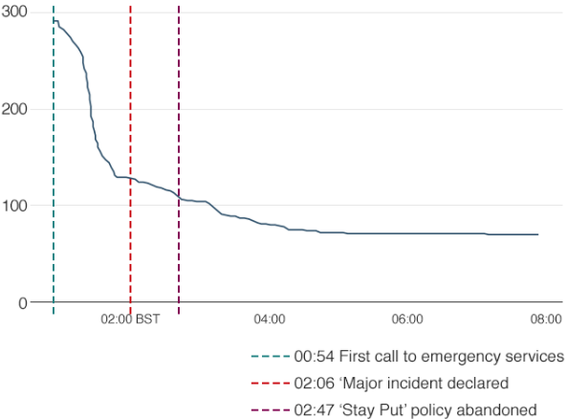
Figure 1: How the Grenfell Tower Evacuation Happened. Number of people who were left in the building over the course of the night. Source: BBC, 2019.

The Hackitt Review: A Need for Effective Communication
Following the Grenfell Tower fire, the UK Government commissioned the Independent Review of Building Regulations and Fire Safety led by Dame Judith Hackitt. Among the findings of the ‘Hackitt report’, residents of HRRB’s reported their frustrations of the intermittent and partial nature of information available on safety, and the lack of consultation when addressing safety (Hackitt, 2018). Residents consistently raised the need for: greater transparency, better consultation, and involvement in decision-making processes. The report identified the need for residents to feel informed on matters of safety, and recommended a resident engagement strategy must be developed, supporting the principles of transparency of information with residents, but it did not go as far as to advise on the means of engagement.
Following the Building a Safer Future consultation response, the draft Building Safety Bill was the Government’s commitment to fundamental reform of the building safety system, which intends to implement the recommendations laid out by Dame Judith Hackitt’s review. The Bill’s objective is to learn lessons from the Grenfell Tower fire and improve the whole regulatory system for building safety, with greater accountability and responsibility for fire and structural safety issues throughout the lifecycle of buildings (Building Safety Bill, 2021). Though the Building Safety Bill outlines residents will be at the heart of new communication strategies, it remains to be seen whether those working in FM are planning for this or watching and waiting.

Covid-19 and FM
COVID-19 put a spotlight on FM services, with a focus on cleaning, disinfecting, and sanitisation, with FM adapting to new challenges through differentiated services (Shanbang, 2020). In response to the COVID-19 crisis, IWFM published comprehensive guidance measures to manage the impacts of the pandemic (IWFM, 2020). IWFM specified the importance of “a variety of appropriate channels: email updates; intranet/internet information pages with Q&As; video conferencing if possible; and, where appropriate, posters in buildings and public areas”, and specifically addressed the need for effective and trusted ways of communication to ensure people are aware of decisions made and actions to take (IWFM, 2020).

Communication
The Cambridge English Dictionary describes communication as “the process by which messages or information is sent from one place or person to another, or the message itself” (Cambridge Dictionary, 2021a).
If efficient communication is to take place, then Ivancevich & Matteson (2002, quoted in Spaho, 2010), suggest the necessity exists for the “receiver to not just understand the meaning of the message, but to show the sender, through expected reactions.” This is acknowledged as a necessity in FM, if not always required, but often the receiver of such information, may need to contact the sender to confirm, respond or acknowledge a message, or, to contact the FM regarding any given matter. Whether such communication is verbal, non-verbal, written, or visual, it must be considered good, co-ordinated, informative, accurate, confirmative, and timely.
In all industries and sectors, communication is a key component and considered an essential dynamic to ensuring collaboration and effective teamworking. However, it is widely recognised, poor communication can lead to errors, disasters, and a complete lack of trust.

Communication Methods
The UK has a multi-ethnic population, and consideration must be given to such diversity. For FM’s there is an obligation to be familiar with all available methods and to select the right communication channel, to ensure effective communication takes place which can result in greater collaboration between all parties and improve satisfaction amongst residents. Therefore, this study must consider different methods of communication and establish whether alternative communication channels would encourage residents in PHRRB’s to communicate more with FM’s on a regular basis.

- Verbal Communication
It is inconceivable to think FM’s can communicate verbally with all residents in any PHRRB. Verbal communication can be used as a channel to construct common meanings for residents, or demonstrate an array of messages, such as how maintenance tasks will be performed, and describing its effect to residents. Consideration must be given to the process of verbal communication, which may require planning, reflection, and resources.
- Written Communication
Written communication is described as asynchronous, unlike verbal communication which can be carried on in real time. Unlike verbal communication, it can be read by many people: providing it is understood. Letters, short messaging services (SMS) and emails are a ‘read-by-many’ form of communication, and utilised for most communication channels, to convey facts, and allowing for more considered choices built on messages conveyed.
- Non-verbal communication
Though verbal communication is vitally important, often what is not said, can be equally important. Non-verbal clues, such as facial expressions or shrugs can provide additional information. However, in an FM setting, one would question the level of requirement for this form of communication.
- Visual communication
Visual communication can include verbal, non-verbal, and written communication channels, and is growing in popularity. For example, YouTube is an online video digital channel (OVDC), where over a billion hours of videos are uploaded and watched daily, with OVDC marketing expenditure forecasted to increase to $37 billion by 2025, reaching 4.5 million global users (Duffett, 2020). OVDC’s provide opportunities for FM’s as they are easy to implement but require careful consideration as to which communication methods, such as verbal or non-verbal, to be used.

The Problem of Miss-Communication
Miss-communication leads to many major disasters and continues to be problematic within many industries. The Challenger Space Craft exploded due to communication issues between engineers and contractors (Neuffield and McDonald and Hansen, 2010), and miscommunication between structural engineers and steel fabricators at the Hyatt Regency Hotel Kansas, led to 113 people losing their lives when two walkways collapsed (Autotec, 2016). Though these examples demonstrate poor communication between different industries, miss-communication is problematic within same sectors.
In 2016, the United States (US) aviation industry reported three recent aircraft crashes were caused by breakdowns in verbal communication (Wilson, 2016). Additionally, the US healthcare sector saw the joint commission cite inadequate communication as a top contributor to medical errors, finding communication lapses in 70% of reviewed sentinel events (Feinman, 2020). Though these examples illustrate poor communication in aviation and healthcare sectors, they demonstrate all sectors must critically evaluate communication methods, and not rely on past methods used.
When considering PHRRB’s, miss-communication between FM’s and residents is likely unless there is a recognition of socio-demographics and ethnographies of residents within the facility. Consideration must be given to such miscommunication, which can easily lead to poor satisfaction amongst residents, which impacts on the whole FM process.

Public Communication

A Contrast in Public Perception: The SARS Outbreak
When the 2003 severe acute respiratory syndrome (SARS) outbreak occurred, the Hong Kong government faced a major crisis. Residents and media accused the government of being impotent in its handling of the crisis through its communication, with government officials considered too inconsistent with their comments and behaviour (Lee, 2009). Such criticism of Hong Kong’s Government was in stark contrast to the Singapore Governments response to the SARS outbreak. The Singapore Governments key instruments in managing public fear and panic, were transparency and trust, which did not come easy, yet every conceivable communication channel was used (Menon, Goh, 2005).
These two islands are similar in size, have high population densities per square kilometre (The World Bank, 2021), and have many residents living in HRRB’s (Wong, 2004; Yow, 2021). Yet when faced with the SARS outbreak, the perception of how communication was handled by both Governments was remarkably different, but demonstrated, in Singapore’s case, how good communication provided people with the tools to make informed decisions (Menon, Goh, 2005).
Many PHRRB’s are similar in their needs, especially where maintenance is concerned, but also in their needs for effective communication. It is suggested, FM’s can learn from the Singapore Governments handling of SARS, by recognising alternative communication channels, providing less likelihood of miss communication, thereby presenting an opportunity to establish greater trust and satisfaction amongst residents.

Learning Lessons from Poor Communication
In 2009, the H1N1 ‘swine flu’ pandemic led to widespread death and destruction with estimated deaths between 151,000 and 575,400 (Centre for Disease Control {CDC}, 2019). Failure to prepare by many governments around the world led to the establishment of the Effective Communication in Outbreak Management (ECOM) project, to identify lessons from the H1N1 ‘swine flu’ pandemic, and make recommendations for future pandemics (ECOM, 2015). An objective of the project was to identify deficiencies of health authorities to communicate the need for large-scale measures, recognising effective behavioural and communication strategies require integration of social, behavioural, communication and media sciences. Further research into the ECOM project provided an opportunity to establish how different countries’ health authorities responded to the emerging threat. A surprising finding was none of the three case study countries conducted any audience research to inform the content, design, tone, emotional appeal or targeting of the communications provided to the public (Crosier, McVey & French, 2015).
Crosier et al (2015) established communications were characterised by a ‘one size fits all’ and a top down’, expert-led response, with little effort to evaluate the impact of communications. A key aspect of good communication should include audience research, understanding the needs and motivations of different groups; which is an objective of this study, and essential to understanding whether residents behaviours would change if they were consulted more.
If behavioural change is required, then communication is a vital element to encourage this. Learning from such pandemics as the H1N1 ‘swine flu’ pandemic, is perhaps best illustrated though efforts to stop the spread of the Ebola virus in West Africa (USAID, 2018). This successful campaign used multiple communication channels to deliver informational messages to targeted audiences, through face-to face communication, mass media and community-level activities. The campaign demonstrated there was no ‘one-cap fits all’ approach where communication is concerned, and combining different channels increased the likelihood of effectiveness of communication between communicators and receivers. FM must recognise this and acknowledge communication methods are not just a channel to establish transparency and trust but can be used as tools to measure satisfaction amongst residents.

The Changing Face of Communication
From cave paintings to smoke signals and carrier pigeons, methods and channels of communication have evolved over centuries, but over the last few decades, such channels have progressed exponentially.

Technological Advances in Communication
Technology has revolutionised the world and industry, with communication taking place in a matter of seconds. Today, the internet has provided a luxury and convenience to people’s lives and learning never seen before, with mobile phones allowing access to information via the internet, anytime and anywhere, empowering people to search for information when it is needed.
In 1994, Radiolinja became the first network service provider to carry out person-to-person text messaging, and in the same year, web surf engine Yahoo was born, signifying the start of the popularity in emailing (Munoz, 2018). In the 25 years since, their growth and widespread use has been phenomenal. In 2018, SMS’s accounted for 9 trillion global messages (Munoz, 2018), and in 2019, 293.6 billion email messages were sent worldwide, predicted to rise to 376.4 billion by 2025 (Johnson, 2021). Both forms are available instantly and easily accessible from mobile phones, smart tablets, and personal computers.
From empirical observations, the most widely used method of communication between FM’s and residents of PHRRB’s is letters or notice boards, but if reactions are required, neither facilitates this, as they are asynchronous. The rise in SMS and email suggests these channels are here to stay, but if FM is to be a contributor to a knowledge-based economy with social and environmental objectives (Alexander, 2009, p6), then is sending letters effective FM, and do existing communication channels meet social and environmental aims outlined by Alexander (2009).
As other industry sectors embrace alternative communication methods, letter sending is in decline (Figure 2), with Royal Mail seeing continual year-on-year falls, in all delivered mail (Ofcom, 2020).
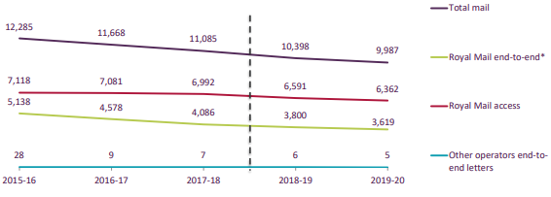
Figure 2: Addressed Letter Volumes (millions). Source: Ofcom.
Today’s use of smartphone Apps (Applications) enable users to shop, make travel plans, order food or access bank accounts, quickly, efficiently, and effectively with many Apps offering two-way communication. Additionally, social media channels allow users to communicate within seconds, demonstrating whilst commerce has exploited new technologies to meet operational goals, FM of PHRRB’s is perhaps relying on products of its past where communication is concerned
If FM of PHRRB’s is to define its contribution to the economy, it must recognise an opportunity to consider alternative channels of communication, embrace new technologies and lessen its environmental impact by reducing its use of natural resources.

Use of Technology in FM
To ascertain the use of technology in the FM role as a means of enhancing communication and engagement, the researcher conducted a review of literature published from 2000-2020 to identify communication and engagement strategies between FM and residents of HRRB’s. Exploring peer-reviewed journals, ‘Journal of Facilities’, ‘Facilities’, ‘Communication and the Public’ and ‘Communication Studies’ did not reveal any evidence of advancements in communication technology being utilised in this way.
As far back as 2003, Alexander set out a strategy for FM, highlighting a requirement for FM’s to harness the potential of new technologies, and understand people’s needs. The rapid advancements in technology were a clear driver for Alexander, but the relevance of his points appears to have been lost within FM research, with a few researchers preoccupied with what’s gone, rather than trying to understand the change that is coming, and how it will impact the facility (Atkin & Bildsten, 2017).
This is not suggesting FM is ignoring new technologies, as new technology is becoming part of the built environment. A study exploring the evolution of information communication technology (ICT) in FM described ICT in FM includes the use of email, Maintenance Management software, Computer Aided Facilities Management (CAFM), Building Energy Management (BEM), Agile software and the more recent technology Building Information Modelling (BIM) (Aziz et al., 2016). In recent years, BIFM {Now IWFM} called on the FM profession to engage with the BIM agenda (Meng, 2015), which can only aid the FM industry, by ensuring innovations are brought to, and widely used by members.
However, it is notable the use of ICT in the FM sector is established more so in the office/business environment, with reference to the use of technologies for communication with residents of HRRB’s lacking.

Smart Buildings
‘Smart’ buildings are developing areas where technology is being adopted in soft FM services, with buildings viewed as “ones that provide a productive and cost-effective environment through optimisation of four basic components: structure, system, service and management and the interrelationship between them” (Reffat, 2010). Though the benefits of using technology to strengthen relationships in an office setting have been demonstrated, with office users being able to control temperatures and gain access to their building (DePass, 2016), such evidence in PHRRB’s is rarely witnessed. This suggests in office environments, those managing or designing facilities have realised the potential to improve environments, reduce costs and resources, as well as improving satisfaction amongst occupiers, thereby providing an opportunity to use technology as a source of communication.

A Commercial Smart Building: The Edge, Amsterdam
According to British rating agency Building Research Establishment Environmental Assessment Method (BREEAM), The Edge building in Amsterdam is not just the greenest building in the world, but the smartest (Randall, 2015). The Edge was completed in 2014 and is considered the building of the future, where an App has been developed that starts from the moment you wake, checking your daily schedule, directing you to a parking space, finding you a desk, knowing your light and temperature preferences, selecting a lunchtime meal, ordering fresh groceries for delivery at the end of a working day and booking the gym and keeping track of your progress.
Though Alexander (2009, p6), suggested FM must define its contribution in three main areas, “knowledge-based economy, sustainable growth and employment, and social and environmental objectives”, it is the designers of The Edge who designed a building which meets such objectives, where participation of users is utilised to improve productivity of those managing the facility.

Technology and Innovation to Support Communication Channels between FM’s and Residents in PHRRB’s
A literature review is important but is nevertheless based on second-hand information. From empirical observations, communication channels between FM’s and residents of PHRRB’s are a product of their past, and have not evolved to consider new, quicker forms of direct communication.
Nearly 20 years ago, Alexander suggested a key issue for FM was assimilating the potential for new technologies and ensuring full use of diminishing resources, while minimising environmental impact (Alexander, 2003), later advocating “things that were not possible five years ago, are now mainstream, for example mobile phone technology, web 2.0, blogs, social networking websites” (Alexander, 2009, p10). Although advancements in technology are now recognised, FM must justify its use by demonstrating it adds value, directly or indirectly, and is not just a cost to be borne, which is of particular importance to key stakeholders in PHRRB’s. However, the culture of FM of PHRRB’s appears not to recognise its limited resources, staff shortages and long hours, which stalls and prevents innovation due to a “heads down” approach, to get the job done (Roper 2017), and therefore the challenge for FM’s in PHRRB’s is to learn from buildings like The Edge, and, in the case of communication channels, consider whether existing channels need innovating to meet changing social and environmental objectives, which can be achieved through education and research.

Harnessing the Potential of New Technologies to Meet Social Needs of Residents
Engagement and communication are recognised important factors for customer satisfaction in the PRS (Sanderson, 2019), highlighting social needs of residents in PHRRB’s are vitally important. FM’s in PHRRB’s and leaseholders must acknowledge the potential of new technologies and assess whether existing forms of communication meet the choices and expectations of residents in PHRRB’s, as well as addressing environmental issues of existing methods. Such considerations are likely to involve cost resources, nonetheless, when considering costs, FM’s and leaseholders must recognise “where the facility is to satisfy a social need, the benefits might be less tangible, but are no less important than the more tangible, quantifiable benefits” (Atkin, Bildsten, 2017).
Such expectations are intensified through global factors and political motivations, such as COVID-19 and the UK Building Safety Bill, which presents FM’s in PHRRB’s with an opportunity to explore technologies as alternative channels of communication. Nutt (1999) suggested such innovations are likely to be practice-led, largely driven by “those with direct knowledge and experience of current operations and procedures, to find ways in which existing best practice might be modified or superseded by better working processes, methods and technology.” If such changes are based on personal insight and ideas, it validates support of those working in FM, who are the best resource to consult to satisfy social needs of residents of PHRRB’s, but who must also recognise the importance of audience research, by understanding needs and motivations of different groups (Crosier, McVey & French, 2015); in this case, residents.

Can Technology Help Create Communities in a PHRRB?
Alexander (2003) argued changes take place in response to new business needs in the FM sector, but the literature review did not reveal how residents needs were considered, such as safety, security, maintenance, or cleaning, which would affect such business needs. It is suggested, if residents are encouraged to play an active role through a PCC, it has the capability to benefit not just the facility, but stakeholders at the facility.
Interesting research by Sanderson (2019) focused on almost 5,000 interviews with PRS tenants, with a single landlord over a 4-year period, where many interviewees commented on the importance of the community and the way the landlord can enhance it. Sanderson suggested “Institutional Landlords who own some or all of an estate are able to engage in community building in a way individual, small-scale private landlords are not”, yet enhancing the built environment is not lost on some high end PHRRB’s where gym’s and concierge facilities are regular features. This is also the case for purpose-built, student and later living accommodation, which often incorporate gym facilities, communal spaces, small cinema’s as well as the organisation of community events, such as communal barbeques. These benefits can enhance the quality of service, and the relationship management between tenants and FM’s which was advocated by Lepkova (2012), through the creation of a community.
In all levels of society, state-of-the-science communication devices have seen significant developments. Smart Apps, Facebook, or WhatsApp group chats, are widely used to promote and support positive change. If Sanderson’s study demonstrates the importance of community building as integral to retaining tenant loyalty, it is suggested alternative communication channels, which embrace new technologies, should be considered as alternative methods of communication between FM’s and residents of PHRRB’s. FM’s and leaseholders at PHRRB’s must recognise the advantages, and not focus only on cost, especially where such advances can deliver social and environmental benefits (Alexander, 2009, p6; Atkin, Bildsten, 2017).
Recommendations of the Hackitt review highlight a need for residents of all tenures to be given a residents voice (Hackitt, 2018), providing an opportunity for all residents to create communities within a PHRRB. It remains to be seen whether the FM sector in PHRRB’s is watching and waiting for the UK Building Safety Bill to be implemented, or will communication with residents be implemented through a consultation with residents, or an approach advocated by the FM industry. It cannot be assumed residents of PHRRB’s want to engage with each other, or the FM team, but rather than relying on methods of the past, perhaps further audience research, and understanding the needs and motivations (Crosier, McVey & French, 2015) of different residents, may reveal more favourable preferences, especially where communication is concerned.

Summary
The attention of this research centres on the necessity for effective communication in PHRRB’s and how satisfaction of residents can be measured. It seeks to determine whether tenants of properties in PHRRB’s are considered part of the FM process, or whether they are considered as an external customer, whose role is not fully appreciated by those working in FM.
Though the literature review provided evidence of historic research when measuring satisfaction of residents, this centred previously on hard FM services (Campbell, 2017), but a gap in literature was identified when considering effective communication between FM and residents of PHRRB’s. Furthermore, the literature review found no measure of establishing resident satisfaction of soft FM services in PHRRB’s.

Research Methodology

Introduction
The literature review identified a need for research to establish whether residents at two PHRRB’s consider existing channels of communication between FM’s and themselves effective, and to understand the views of FM’s on current communication channels at their sites.
This chapter seeks to summarise the philosophical approach taken, the methodology approach implemented, and instruments and methods used to evaluate data collection methods used. It ends with how data is analysed, the limitations in collecting data, and ethical considerations of the research study.

Research Rationale
A review of literature highlighted a gap in communication between residents in PHRRB’s and FM’s. The rise of the PRS, BTRS and PHRRB’s was established, recognising communication as an important component to achieving satisfaction of tenants within such sectors, and signifying the importance and opportunity available to FM. Furthermore, it revealed a lack of communication and miss-communication can lead to disasters, but demonstrated good communication is an opportunity to provide people with the tools needed to make informed decisions. Lastly, it highlighted advances in technology and communication channels such as SMS, emails and Smart apps which are widely used in all industries and sectors, but not FM of PHRRB’s.
When evaluating a strategy for the empirical research undertaken, it was important to the researcher to recognise where the research journey started. The researcher worked as an Estate Manager at a PHRRB, where major fire protection defects were identified, prior to the Grenfell Tower fire of 2017, but the gap in literature relating to communication between residents and FM’s, and a lack of measurement of resident satisfaction of ‘soft FM services’, led the researcher to consider a need to adopt an early exploratory research approach.

Hypotheses
It was considered any theory driven hypothesis could not be derived or tested where residents were concerned, given the literature review did not provide an opportunity to formulate any hypotheses to establish an extent to which new technologies could be considered as alternative channels of communication between residents within PHRRB’s and FM’s who manage those buildings. From empirical observations in an FM role, the researcher formulated three hypotheses, which aimed to assist with meeting the aims of the research.

- Hypothesis 1
Communication channels between residents and FM’s of PHRRB’s are implemented by FM’s rather than understanding needs or expectations of residents in PHRRB’s.
- Hypothesis 2
The importance of creating a vulnerable or ‘at-risk register’ for residents in PHRRB’s is not lost on many working in FM, yet there is no generally adopted method of ensuing this is updated regularly.
- Hypothesis 3
If FM’s consider the FM sector to be a cost and maintenance driven industry, rather than a strategic discipline that encompasses the needs of residents and users of PHRRB’s, then the necessity to recognise the importance of soft FM services are lost on those working in FM.

Research Philosophy
Creswell (p.6 2009) uses the term ‘worldview’ as meaning “a basic set of beliefs that guide action”, but highlights others use the terms, paradigms, epistemologies, and ontologies. Table 1 defines these world views.
Four Worldviews
Post positivism  - Determination  - Reductionism  - Empirical observation and measurement  - Theory verification | Constructivism  - Understanding  - Multiple participant meanings  - Social and historical construction  - Theory generation
Advocacy / Participatory  - Political  - Empowerment Issue-oriented  - Collaborative  - Change-oriented | Pragmatism  - Consequence of actions  - Problem-centred  - Pluralistic  - Real-world practice oriented

Table 1: Four Worldviews. Adapted from (Cresswell, 2009).
Communication is a social and human problem, therefore experiences and understanding of residents at the study sites are critical to meeting the research aims. The research aims to assess communication strategies in PHRRB’s and comparing responses of data collected from FM’s and residents was required. The reliance on participants views requires an understanding of current communication channels at two study sites, but seeks resident’s perspectives regarding these channels, to establish PCC’s, but which must be substantiated by research if any future theories are to be explored.
The philosophical approach adopted is a constructivist viewpoint, rather than positivists, largely due to the research being dependent on the viewpoint of residents of PHRRB’s, and FM’s of the situation being studied, rather than the researchers own experiences.

Research Approach
There are two common methods of a research approach, inductive and deductive. Cresswell (2009 p.55-63) states an inductive process builds on data collected from participants to form a theory, whereas a deductive process begins with a theory, with the objective of testing or verifying that theory, rather than developing it and reflecting on its confirmation or disconfirmation. Table 2 demonstrates the logic for adopting either approach.

 | Deductive Logic |  | Inductive Logic
 | Researchers tests or verifies a theory |  | Researcher measures or observes variables using an instrument to obtain scores
 | Researchers tests hypotheses or research questions from the theory |  | Researcher looks for broad patterns, generalisations, or theories from themes or categories
 | Researcher defines and operationalises variables derived from the theory |  | Researcher analyses data to form themes or categories
 | Researcher measures or observes variables using an instrument to obtain scores |  | Researcher analysis data to form themes or categories
Researcher gathers information
(e.g., interviews, observations)

Table 2: The Deductive approach in Quantitative Research and the Inductive approach in Qualitative Research – Adapted from (Cresswell, 2009).
If information gathering, data collection, and reporting of results seeks to lead to changes in social process and relationships, then Creswell (2009 p.66) states a mixed method theory could be considered. The researcher considered how the research aims could guide empirical data collection to establish indicative or testable hypotheses for future research, which could contribute to knowledge within FM. Therefore, a mixed method approach was selected.

Research Strategy
Creswell (2009, p.17) creates distinctions when choosing a qualitative, quantitative, or mixed method approach (Table 3).

Qualitative, Quantitative, and Mixed Methods Approaches
Tend to or typically… | Qualitative Approaches | Quantitative Approaches | Mixed Method Approaches
Use these philosophical assumptions | Constructivist / advocacy / participatory knowledge claims | Post-positivist knowledge claims | Pragmatic knowledge claims
Employ these strategies of enquiry | Phenomenology, grounded theory, ethnography, case study, and narrative | Surveys and experiments | Sequential, concurrent, and transformative
Employ these methods | Open-ended questions, emerging approaches, text, or image data | Closed ended questions, predetermined approaches, numeric data | Both open- and closed-ended questions, both emerging and predetermined approaches, and both quantitative and qualitative data analysis
Use these practices of research as the researcher | - Positions him- or herself  - Collects participants meanings  - Focuses on a single concept or phenomenon  - Brings personal values into the study  - Studies in the context or settings of participants  - Validates the accuracy of findings  - Makes interpretations of the data  - Creates an agenda for changes or reform  - Collaborates with the participants | - Tests or verifies theories or explanations  - Identifies variables to study  - Relates variables in questions or hypotheses  - Uses standards of validity and reliability  - Observes and measures information numerically  - Uses unbiased approaches  - Employs statistical procedures | - Collects both qualitative and quantitative data  - Develops a rationale for mixing  - Integrates the data at different stages of the enquiry  - Presents visual pictures of the procedures in the study  - Employs the practices of both qualitative and quantitative research

Table 3: Distinctions to choosing a Qualitative, Quantitative, and Mixed Methods Approach – Adapted from (Cresswell, 2009).
Typical methods used for data collection are qualitative and quantitative, but communication is a social and human science, and a mixed method strategy was chosen. The data collection instruments used in the research were questionnaire surveys to residents and interviews with FM’s.
A quantitative questionnaire, with close-ended questions aimed to identify variables, allowing the researcher to generalise or make claims about a sample population. Additionally, a qualitative interview, with FM’s was considered necessary to understand their views on current communication channels.
Given the time restraints, data was collected concurrently with neither priority given to qualitative or quantitative data collection, with the researcher merging two data sets to present when analysing.

Research Methods

Study Sample
Research participants for this study were residents of two PHRRBs in the UK, and FM’s at the sites. The study sites selected both have serious fire installation defects due to poor installation during construction, requiring external and internal fire-reinstatement work. This has necessitated for more frequent communication between residents, and FM’s at those buildings.

Meridian Quay, Swansea
Meridian Quay (Figure 3; Wood, 2021a) is an award-winning development in Swansea, Wales, constructed in March 2010, by Carillion Plc (liquidated). There are seven buildings, separated by a highway, ranging from 6 to 29 storeys, with the Meridian Tower standing at 107m (305ft) making it the tallest building in Wales. There are 291 apartments, housing on average 600 residents. The development encompasses 1950m² of commercial and retail space, incorporating a top floor restaurant in the Meridian Tower.
The researcher was previously employed as the Estate Manager at Meridian Quay, and from empirical observations, there are many international students residing there, allowing the researcher to consider how different ethnographies engaged with the research instrument.
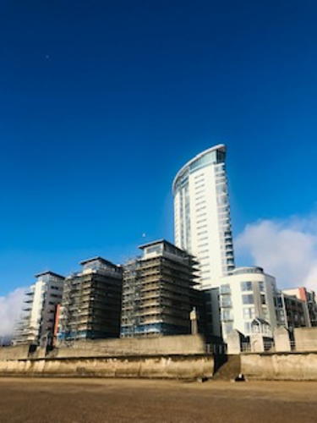 | 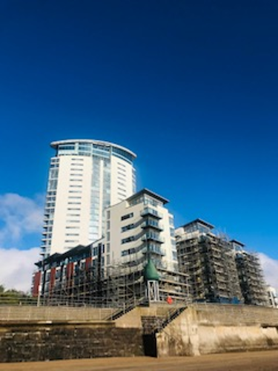
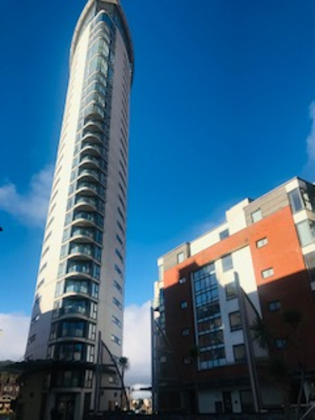 | 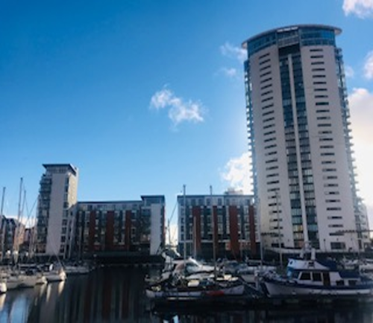
Figure 3: Meridian Quay, Swansea (Wood, 2021a).

Gateway Plaza, Barnsley
Gateway Plaza, pictured (Figure 4; Wood, 2021b), is a mixed-use development in Barnsley, England, constructed in 2011 by Browns Construction Ltd (liquidated). There are 188 apartments housing on average, 300 residents. The building ranges from 4 to 15 storeys, reaching 35 metres in height. There is 96,000 sq. ft of office space, a Premier Inn Hotel, Restaurant & Bar, and state-of-the-art medical centre.
Nothing was known of the demographics or ethnographies at the development by the researcher.
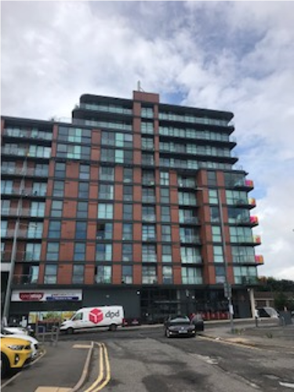 | 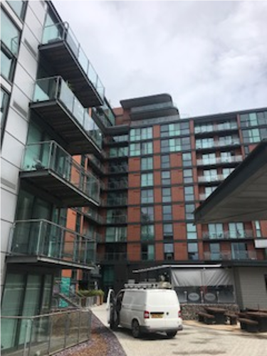
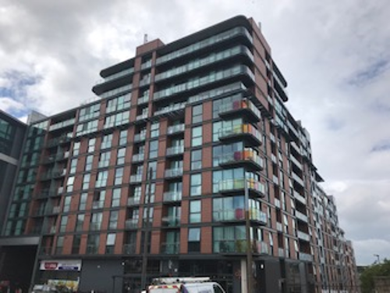 | 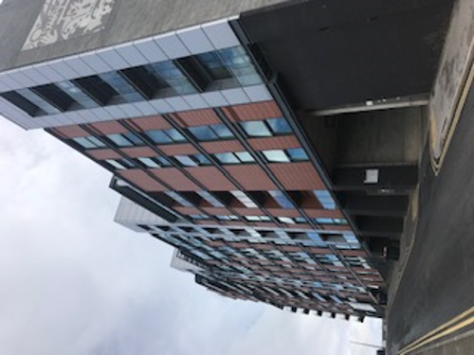
Figure 4: Gateway Plaza, Barnsley (Wood, 2021b).

Questionnaire: Pilot Study. Reliability and Validity
Respondents in pilot studies should be similar as possible to the main inquiry (Oppenheim, 1992 p.29). The questionnaire was drafted following unstructured discussions around the subject, with several residents of different tenures at Meridian Quay.
A basic questionnaire was produced using Microsoft Word and distributed to three residents. Each were asked to complete and provide feedback relating to their understanding of the questionnaire, its length, time to complete, and understanding of questions. The outcome of the pilot questionnaire led to the following suggestions (Table 4), and an average completion time of 6 minutes 20 seconds.

Respondent | Comment
UK Resident, Male, aged 45-54, owner occupier. | “The understanding of the research project was clear, yet the explanation of the role of FM teams needed to be shorter.”
International PhD student, female, aged 26-34, renting the property. | “The questions were considered straightforward and unbiased, but suggest minor adjustments need to be made to the grammar”
International undergraduate student, male, aged 18-25, renting the property. | “I would suggest advising people that additional copies can be obtained, if more than one resident was residing in an apartment.”

Table 4: Resident feedback to pilot questionnaire.

Research Instruments

Questionnaire Design
“A questionnaire is not just a list of questions or a form to be filled out but is a scientific instrument for measurement and for collections of particular kinds of data” (Oppenheim, 1966). When sufficient information is known, a questionnaire offers an objective means to collecting information about peoples knowledge, beliefs, attitudes, opinions, experiences, predictions, and behaviour. Yet they often lack rigour and lead to poor quality data, misleading conclusions, and unclear recommendations (Boynton and Greenhalgh, 2004; Rowley 2014).
It is essential to ask what the aims are, what is trying to be found out and what are the specific research questions (Gillham, 2000, p.15). Questions posed must measure what they are supposed to measure to ensure their validity, and not leave too many ambiguities in their conclusions, to obtain clear answers to meaningful problems (Oppenheim, 1996, p.70). Though only two study sites were selected, if another study site was added to the research study, it was important the same variables could be measured and ensure the aims of the research could be met.
When considering planning the questionnaire, the changing ethnographies, and demographics of residents in PHRRB’s was identified from the literature review. It was important data collected would generate a profile of characteristics from the sample population, particularly age, nationality, gender, and residential tenure to establish whether a relationship between these variables would offer predictions about future events and patterns or allow variables to be tested in future research. No personal information was sought from residents revealing identities.
The questionnaire explained to the respondent its purpose and the FM role, to ensure data collected could be validated. The questionnaire was designed to obtain relevant data to answer the research aims, to analyse different variables and to draw conclusions from data collected to help obtain clear answers to the research aims.
Ensuring the questionnaire was easy to understand and complete would retain respondents interest. A short questionnaire, with closed questions was considered appropriate, to result in more valid useable data, allowing aggregated data to be produced quicker. Careful consideration was given to a requirement for a free text box at the end of the questionnaire, allowing residents to reveal other important facets of information, but it was acknowledged adequate time was needed to analyse responses (Boynton, Greenhalgh, 2004).
The questionnaires were designed using the Microsoft Office 365 Forms package (Appendix 1).

Questionnaire Distribution
Completion of questionnaires offered an insight on how respondents engaged with the material, which allowed respondents to complete in 3 ways.
- A paper copy - Hand delivered to all apartment letterboxes, regardless of tenure and returned to reception.
- Scanning a QR code and completing on a mobile phone or smart tablet.
- Requesting a web link to complete on a personal computer, mobile phone, or a smart tablet.
One box of questionnaires didn’t arrive at Barnsley, due to the courier losing them in transit. A letter was drafted explaining the research, which asked residents to complete a questionnaire by scanning the QR code or contacting the researcher to request a paper copy or weblink to be emailed (Appendix 2).
The researcher recognised the opportunity of their previous Estate Manager position, and their relationship with residents and local Qatari and Kuwaiti student societies. An SMS request was made to residents and both student societies asking residents at Meridian Quay to complete the questionnaire.

Qualitative, Semi-Structured, Face-to-Face Interviews
Many people identify a research interview, as an appropriate technique for collecting opinions and information, which can be employed to find out things which cannot be clearly witnessed (Hannabuss, 1996; Beer 1997). An interview was considered appropriate and would provide an understanding how FM’s view FM of PHRRB’s, but also to extract FM’s beliefs and opinions on complicated or delicate matters, such as the UK Building Safety Bill.
Creswell (2009, p.179) sets out options, advantages, and limitations of gathering information from interviews, which is demonstrated in Table 5.
Data Collection Type | Options Within | Advantages | Limitations
Interviews | - Face-to-face – one-on-one, in-person interview  - Telephone – researcher interviews by phone  - Focus group – researcher interviews participants in group  - Email internet interview | - Useful when participants cannot be directly observed  - Participants can provide historical information  - Allows researcher control over the line of questioning | - Provides indirect information filtered through the views of the interviewees  - Provides information in a designated place rather than the natural field setting  - Researcher’s presence may bias responses  - Not all people are equally articulate and perceptive

Table 5: Options, advantages, and limitations of gathering information from interviews – Adapted from (Creswell, 2009).
Interviewees are the subject, and face-to-face interviews are considered the dominant technique in the field of qualitative research (Opdenakker, 2006). The researcher felt this technique was more appropriate due to its ability to give social clues, such as voice, body language and intonation to verbal answers given, with answers more likely to be spontaneous, rather than reflected or considered. Table 6, outlines three types of interviews, allowing the researcher to identify a semi-structured interview as the most appropriate type, to satisfy the research aims.
Interview type | Considerations
Structured | Inappropriate, as it is too inflexible and too rigid for the research. More likely to be used in large sample research
Unstructured Interview | The main concern was to minimise bias when interviewing. An informal unstructured interview is considered inappropriate, given the researchers need to identify themes and provoke more detailed responses.
Semi-structured | Qu and Dumay (2011) suggest semi structured interviews allow an opportunity to get closer to the truth and to disclose hidden facets of human and organisational behaviour. The researcher considers this important as it allows interviewees personalities to come through, affording the opportunity to understand how FM’s and their organisations see communication, as well as how they see their world and problems within FM, such as the UK Building Safety bill or Covid-19.

Table 6: Interview types and considerations.

Planning the Interview
Qu and Dumay (2011) suggest there is no ‘one right way’ of interviewing, or appropriate format, and no single way of wording questions, but its validity is often the most queried aspect of qualitative research (Thomson, 2010). However, conducting semi-structured interviews still requires a great deal of care and planning before and after, to get the best possible responses. It is difficult to make a judgement regarding reliability of data, because “different interviewers will evoke different responses from the same interviewee given the way questions are answered and probed” (Qu, Dumay, 2011), and it is accepted any question can lead to an undetermined number of answers.
Rowley (2012) suggests there can be varying numbers of questions, and degrees of adaptation, but for a novice researcher, the interview schedule should consist of 6 to 12 well-chosen questions, with some flexibility to allow 2 to 4 sub questions or prompts. Topics of discussion were identified during the literature review, allowing for preparation of questions, which were planned at the same time as the questionnaire distribution. Additionally, question cards were introduced that mirrored questions asked of respondents of the questionnaires (Appendix 4).
An hour of recorded interview takes 5 to 6 hours to transcribe (Bryman, cited in Opdenakker 2006), and Hannabuss (1996) warns how easy it is to let a research interview degenerate into a conversation or chat. The approach adopted ensured the main questions could be asked, but allow for different sub questions to be explored, depending on the answers. The interview was planned to take 40-50 minutes. Appendix 5 illustrates the questions posed, the recordings were transcribed and measured for accuracy, from the researchers viewpoint, illustrated in Appendix 6.

Location of Interviews
Both interviewees were advised their personal and organisation details would remain anonymous and agreed interviews could be recorded. The interview with the Swansea FM took place at the study site, and the Barnsley FM’s at their Manchester head office.

Research Data Analysis
The research approach is from a constructivists viewpoint, using mixed methods qualitative and quantitative data collection.
Software packages, such as SPSS, were considered to create codes and themes, but the researcher recognised their time constraints learning this software, but also whether it was a requirement, as there were only two interviews to compare. Therefore, following the transcribing, the researcher compared interviewees responses side by side, and coded such themes that were considered relevant, to compare against the quantitative data from the questionnaires (Appendix 7).
Microsoft Forms allows the researcher to see a full breakdown of different questionnaire answers, and how each respondent answered, allowing answers to be cross compared. The software also provides a dashboard with analytics of submitted data, but data was downloaded into Microsoft Excel allowing several variables to be considered.

Communicating results is as important as the research itself, and as this is a concurrent mixed methods study, results from the quantitative questionnaires were integrated with comments and interpretations of the qualitative interviews, to measure relationships, which the researcher considers better to understand the research problem.

The researcher recognises data sets are descriptive statistics and describe answers of a sample population. The presentation of results describes characteristics of responses, or relationship between two variables, which is presented with tables, bar charts and pie graphs.

Ethical Considerations
When collecting data, researchers must respect participants and the site of the research study, as well as not putting participants at risk (Creswell, 2009 p. 89).
To ensure compliance with information given to the university ethics committee, each questionnaire described its relevance and length, provided contact details of the researcher, and outlined the importance of the FM / MA at their building, which was annotated to the questionnaire (Appendix 1). Care was taken when constructing the questions, not just to prevent bias from the researcher but to ensure questions used language respondents understood.
Anonymity of respondents was respected; therefore, names or addresses were not taken. Covid-19 was considered a risk, so adding a QR code to allow respondents to complete questionnaires was provided.
Seeking consent from interviewees was obtained by telephone and by email, outlining the research purpose, with care being taken not to mislead participants of their purpose to the study. Following the agreement to interview, a consent form was sent to each participant (Appendix 3), following advice set out by Creswell (2009 p. 89). At no point was there any conflict with any participant during the research.

Limitations

Questionnaire Limitations
The researchers previous position, and relationship with residents could have influenced higher response rates from residents at the Swansea site. A poor response rate from residents at the Barnsley study site may suggest residents were not concerned with communication strategies at their building, or they were entirely satisfied. This led the researcher to reflect on whether it was appropriate to explore other issues which could be of interest to the FM industry, or whether a reduction in the number of questions would have resulted in a higher return rate.
The Grenfell Tower tragedy wasn’t explicitly explained, but further reflection considered if its relevance was applied to the rationale of the questionnaire, would returns have been greater? However, the researcher introduced this line of question into the interviews, which Hannabuss (1996) suggested, is “a good ways of eliciting opinions on complex and sensitive issues”.
Though the questionnaire was drafted following unstructured discussions around the subject, the finality of its design was solely that of the researcher. Every effort was made by the researcher to explain the context of the research and role of the FM/MA, but each respondent will answer questions entirely from their viewpoint. Additionally, knowing who completed the questionnaire is impossible to answer, but the researcher acknowledges responses do not suggest solutions to meeting the research aims but can offer an opportunity to understand residents perspectives where communication and FM is concerned, which can only be built from the view of the researcher.
The researcher considered the planned fire remediation works, could impact on data collected from residents due to uncertainty of such works, but also because of negative press identified in Swansea (Price, 2021; Lees, 2021).

Interview Limitations
Sample sizes of the interviews provided many hours of contemplation, and Bowen (2008) suggests, particularly for novice researchers, there are few, if any, definitive rules for determining saturation with guidelines almost non-existent in literature for qualitative methods. It was determined, increasing sample sizes would not impact on data collected, given the structure of the interview, which centred on obtaining information about interviewees attitudes, beliefs, behaviours, and experiences and how the researcher would compare responses provided by respondents to questionnaires at the study sites.

Summary
The research methodology in this chapter explained the necessity for research, and the constructivists philosophy which builds the research. Explanations regarding deductive and inductive logic approach, the mixed method strategy and instruments used to capture and analyse the data have been provided.
The ensuing chapter will present the results and discussion, its limitations before a conclusion and recommendations are offered.

Results and Discussion

Introduction
Chapter 3 outlined the research methodology, highlighting the research as a concurrent mixed methods approach, with quantitative questionnaires and qualitative interviews. In this chapter, the descriptive statistics of returned questionnaires (RQ’s) of the sample population are presented, alongside the researchers interpretations of the interviews with tables, bar charts and pie graphs used.

The research approach was from a constructivist viewpoint, where interpretations of interviewees responses are based on the researchers understanding of the responses, considering what was said to determine the facts of the interview. Though such interpretations are subjective, the researcher recognises interviewees are equally reflecting on their own experience and interpretations of the situation and questions asked, but it was for the researcher to assess what was said, to determine the real facts of the interview.

Completed Questionnaires
Questionnaires were delivered mid-July, 2021.
Questionnaire Completions: Average Completion time 11 minutes 35 seconds
 | Swansea | Barnsley
Delivery Method | 291 paper copies hand delivered. | 188 copies couriered. 1 box lost in transit (78 copies). 110 were hand delivered.  78 letters (Appendix 3) were emailed, and hand delivered.
Follow up | Request made by SMS to Qatari and Kuwaiti student societies asking them to encourage residents at study site to complete. | 188 letters emailed, and hand delivered, advising return deadline was extended.
Responses | 89 | 14

Table 7: Questionnaire delivery method and responses.
It is suggested the reason for a greater number of RQ’s from Swansea is due to the researcher knowing several residents and having a relationship with the Qatari and Kuwaiti student societies. It is recognised by the researcher, had this relationship not existed, returns may have been comparable to Barnsley. It is worth considering whether this relationship influenced RQ’s or was the subject of the questionnaire the motivation for residents to complete.

Method of Questionnaire Completion

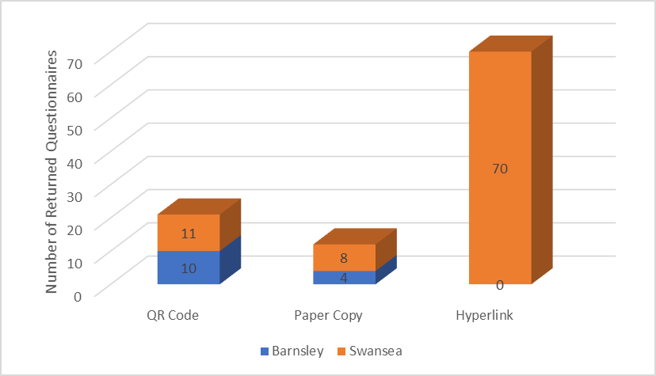
Figure 5: Method of questionnaire completion at both study sites.
The method of completion is considered interesting, given 20% (21/103) completed using a QR code and 68% (70/103) completed using a hyperlink which involved no cost to the researcher. Paper copy RQ’S accounted for 12% (12/103), which therefore cost an average of £25 for printing and delivery for each RQ.

Demographics & Ethnographies
Data for demographics and ethnographies were collected to establish if any independent variables could be identified, affecting dependent variables. The interviews established neither FM had any measure of this, and assumptions were made entirely from empirical observations.

Nationalities and Languages
To verify the questionnaire and understanding of questions, the researcher asked respondents their understanding of the English language (Table 8). It is considered international students are likely to understand written English, but it must be recognised 18% of respondents said they only had a ‘good understanding of written English’, suggesting FM’s must consider other languages when selecting communication channels.

Choice | Response
I can speak and read English | 84 (82%)
I can speak English and have a good understanding of written English | 19 (18%)
I cannot speak English. Someone helped me to complete the questionnaire | 0

Table 8: Respondents understanding of spoken and written English.
Eight respondents did not select a nationality. Though British nationalities dominated RQ’s accounting for 37% (38/103), 15 other nationalities were identified, equating to 55% (57/104) of RQ’S (Figure 6).
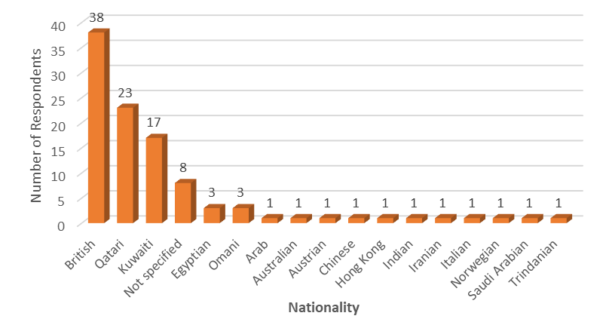
Figure 6: Nationalities of respondents returning questionnaires.
The importance of recognising ethnographies and different languages of residents within HRRB’s and PHRRB’s, is perhaps best demonstrated by recognising 19 different nationalities died in the Grenfell Tower fire tragedy (Rice-Oxley, 2018). There is a need for effective communication, especially where safety or fire safety is concerned, or being recognised for a vulnerable or risk register, which is something FM must acknowledge in PHRRB’s.
Early returns of questionnaires provided the research with an opportunity to ask FM’s how they deal with language issues (Table 9).

How do the FM’S deal with language barriers | Response
Swansea FM | “We have printed tenant regulations, and have also printed these in Arabic and Mandarin”  – It was established the FM’s had delivered these tenant regulations a while ago; not recently
Barnsley FM | language barriers were a ‘big thing for them at the moment…and there could be 50 versions of that.”  They encourage residents to download Google translate.

Table 9: How FM’s deal with language barriers with residents.
It is considered neither FM are really engaged with the necessity to recognise different nationalities, or languages, and it is considered neither will there be, unless legislation makes it a mandatory requirement. Additionally, while the Barnsley FM stated they encourage residents to download ‘Google Translate’, it is worth considering, will this really happen?

Residential Status
Figure 7 highlights those renting property account for 67% (69/103), with ‘living with parents or friend’ a further 8% (8/103), collectively, 75% (77/103) of respondents RQ’s are viewed as renting a property. The importance of private tenants, residing in PHRRB’s, must be recognised in the whole FM process, particularly those in the PRS or BTRS. It is suggested FM’s and leaseholders must recognise this, given Sanderson’s (2017) study found 12 causes of dissatisfaction of tenants, and highlighted four of the top five causes to be maintenance, responsiveness, communication and relationship management, accounting for 51% of all causes of dissatisfaction. These causes are in the control of the FM, not individual leaseholders, and therefore effective communication with these groups is critical.
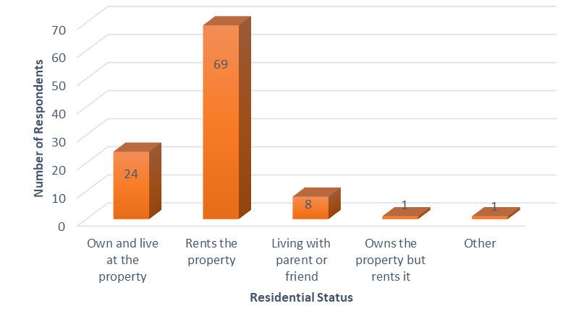
Figure 7: Residential status of respondents returning questionnaires.

Employment Status
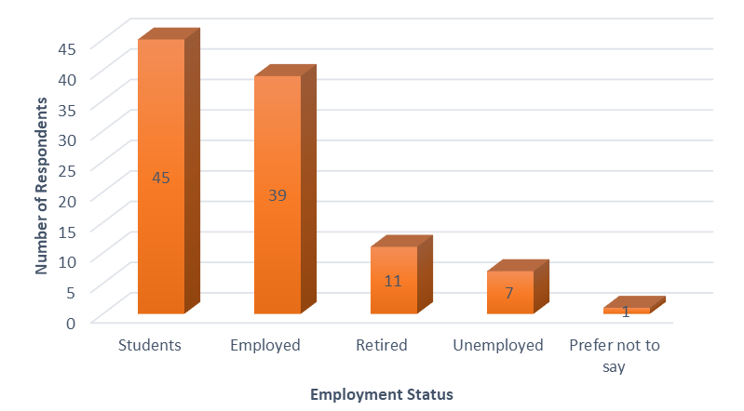
Figure 8: Employment Status of respondents returning questionnaires.
There are nearly half a million international students studying in the UK (Study in UK, 2021). Figure 8 is considered of interest, as neither study sites are purpose-built student accommodation blocks, yet the majority of RQ’s were from students, demonstrating not just the importance of recognising demographics when developing customer care policies, but the employment status offers an insight into PCC by international students.

Age Groups / Gender
The majority of RQ’s were from males 68%, although this maybe a reflection of the male to female ratio of residents at the sites. Figure 9 highlights 51 (49%) of RQ’s were completed by the 18-25 age group, which was heavily weighted by students.
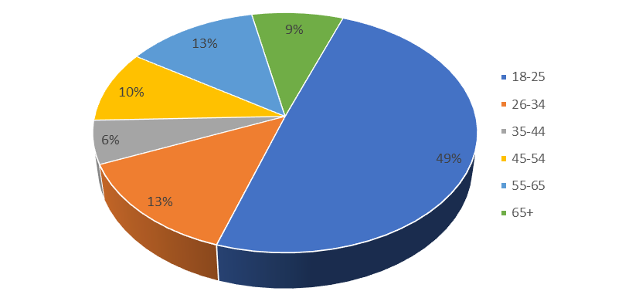
Figure 9: Age groups of respondents returning questionnaires.

Communication Channels of FM’s and Residents
This section of the results seeks to address aim one and hypothesis one.
- Aim 1: Identify current communication channels between residents and FM’s of PHRRB’s and determine residents’ perception of current communication channels, and the importance of communication with FM’s at their building.
- Hypothesis 1: Communication channels between residents and FM’s are implemented by FM’s rather than understanding needs or expectations of residents in PHRRB’s.
Recognising communication channels and understanding the importance of communication for residents in PHRRB’s were key aims of the research. The literature review could not identify research investigating this, but identified the importance of good communication and the problems with miss-communication, resulting in a lack of trust which is a key requirement of FM.
To begin, the researcher wanted to understand channels used by FM’s in a work setting, and how they communicated with friend and family (FF).

FM’s Work Communication Channels
The researcher wanted to explore FM’s changing communication channels at work (Table 10) and would this lead to a recognition of alternative communication channels available with residents.
Question | Swansea FM | Barnsley FM
What communication channels were used when starting work? | “Letter and Fax. Emails were just coming onto the scene”. | “Letters and faxes and sometimes emails”.
What channels do you use at work today? | “Letters and phone calls, but mainly email”. | “Telephone, we use emails, we use chats, and we use message boards that we’ve got in within developments, which are really effective…and notices on desks”.  “What we found…you get deluged with emails, you get so many, you don’t know whats important”.  “a text message…people tend to take a bit more notice…its novel...it’s a text message, do I need to deal with it”

Table 10: Response of FM’s regarding communication channels used at their work.
The interviewees gave clear recognition of how communication channels changed at work during their career. The literature review highlighted Covid-19 or future pandemics as challenges for FM, and the researcher wanted to understand if the UK lockdown had led to FM’s adopting different channels of communication with colleagues, and were these channels considered effective.

FM’s Communication with Colleagues during the Covid-19 Lockdown
The researcher recognises working from home was a necessity of the Covid-19 lockdown, but a shared identity between employees still exists, which is essential for effective communication (Greenaway et al., 2015). Table 11 illustrates the comments made by FM’s when this subject was explored.
Question | Swansea FM | Barnsley FM
How did you communicate with colleagues when working from home? | Email and phone.  “We started using a lot more video conferencing , so Teams, which we hadn’t really ever used as a business before”. | “Email communication was strong, but it was always followed up by phone calls”.  Using Microsoft Teams  “You can see people’s faces, if you think someone needs a conversation aside, cos they look a bit worried, you pick up from the facial expressions”
Did this make it more effective? | “In an office, you talk face-to-face…When you are trying to communicate that over email that might be 10-20 emails, rather than you know a 2-minute conversation” | “For me as a leader, it wasn’t just paint everyone with the same brush. As a business it works”.

Table 11: FM’s communication channels with colleagues during the COVID-19 countrywide lockdown.
The interviews demonstrated the use of alternative communication channels were utilised during lockdown, but not without difficulties or new challenges. It was considered of particular interest the Swansea FM stated, “trying to communicate on email may take 10-20 emails” and the Barnsley FM stating “you can’t paint everyone with the same brush…you pick up facial expressions…” If communication was difficult between those with shared identities, FM’s must recognise you cannot paint residents with the same brush, especially where languages, ethnography and demographics of residents are concerned; supporting Roper (2017), who stated the needs of customers are overlooked, which is an essential requirement of effective FM.

FM’s Communication with Residents during the Covid-19 Lockdown
The change in communication channels offered the researcher an opportunity to explore how FM’s communicated with residents during the lockdown (Table 12), to establish if changes in communication at work, would lead to a consideration to change communication channels with residents.
Question | Swansea FM | Barnsley FM
How did they communicate with residents during lockdown? | They put up notices  Sent letters encouraging contact by email or phone | “All on email at the moment”  “We did a bi-weekly, whole mass email to customers stating what they were doing to keep them safe…really well received, I think”
Did the way they communicate at work lead to consideration to change channels with residents? | “Probably not. Because we don’t have access to like who they are, what their email address is, how long they are here for. And because it’s such a moving feast, as well, so we would be relying on the owners to tell us”
Cleaning during Covid | “Our focus would be really on more of the cleaning. So, cleaning frequently touched areas” | “Cleanliness is massively important, given whats going on in the world right now”

Table 12: FM’s responses on how they communicated with residents at their sites during the UK Covid-19 lockdown.
The comments from both FM’s (Tables 10 & 11) suggested communicating by email is ineffective, yet both FM’s encouraged residents to communicate this way during the Covid-19 lockdown (Table 12). The Barnsley FM stated, “emails were well received”, but there was no measure of evaluating this. It is further considered, if FM’s find the use of emails difficult, which “take longer” and “you get deluged with emails, you don’t know what’s important,” then is it effective to encourage residents to communicate this way?

Will Communication Channels with Residents Change, as a Result of Covid-19?
When asked whether communication channels with all residents would be changed (Table 12), the Swansea FM stated, “they don’t have access to who they are, what their email address is, how long they are there for…unless it was completely automated”. There is a clear recognition from the FM, that technology could be a driver for change, but which also supports Roper (2017) who stated, “FM’s need to get the job done and adopt a head down approach.” Therefore, it is suggested the culture of FM must recognise its limited resources, staff shortages and long hours and recognise the opportunity to use technology to get better.
Both FM’s believed FM is driven by cost, allowing the researcher to consider, if improving communication channels is likely to result in further costs and losing FM contracts, is this the reason why it is not explored.
However, FM must also satisfy a social need and the researcher suggests FM’s in PHRRB’s must recognise important studies, such as Sanderson (2019), and realise the importance of residents, whose perception of property management services received is particularly important to their internal stakeholders, such as leaseholders in the PRS.

FM’s Regular Communication Channels with Residents
The Cambridge dictionary defines ‘effective’ as “successful or achieving the results you want.” (Cambridge Dictionary, 2021b). Interviewees were asked how they communicated with residents, and whether it was effective (Table 13).
Question | Swansea FM | Barnsley FM
How do you communicate with residents? | To the occupiers, always by letter.  “We don’t necessarily have any relationship with those occupiers at all. We don’t know their name, you know….we need to make them aware, we would send a circular distribution or notice out to the building” | Emails. Personal contact on site  “We’ve got kind of message boards that we’ve got within developments,”  “Where there is an elder, so we switch up to letters”.
Is it effective? | “I think for the purpose of the way we need to communicate with the occupiers, it is effective” | Message boards  “Which are really effective in terms of, like a digital display outside of the lifts which is your kind of point of contact to the customers”

Table 13: FM’s responses to how they communicate with residents at their buildings and its effectiveness.
From the FM’s point, the use of letters and digital boards are asynchronous and can be considered effective to deliver their messages, but are they effective if they fail to address the needs of intended targets?
It was established the digital message boards at Barnsley allowed messages to be transmitted in English only, but do not allow for OVDC’s, which is an increasing channel of communication (Duffet, 2020). Message boards are a good example of FM using new technologies, but its capabilities could be better, if messages could be transmitted in different formats which could address other needs of residents.

Residents PCC with Family and Friends (FF)
The research sought to establish how residents communicated with FF and would these same channels be demonstrated in PCC with FM’s. Question eight of the questionnaire (Appendix 1) asked residents to select two channels, from a list of six, how they frequently communicated with FF, 202 choices were selected from the 103 RQ’s (Figure 10). No respondent selected ‘other’ as a choice.
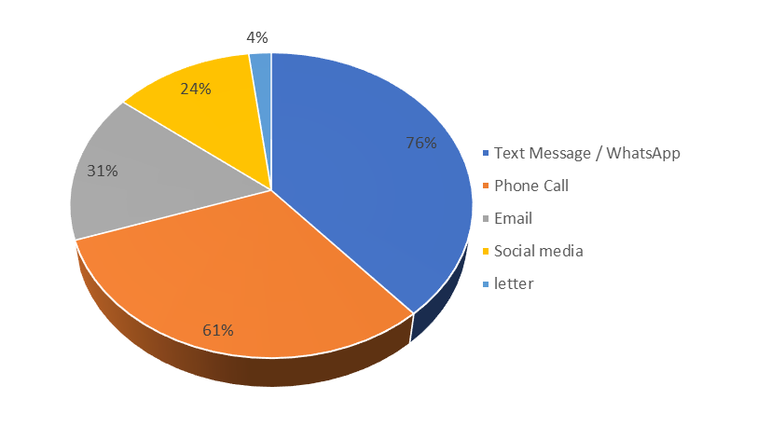
Figure 10: Respondents top two communication channels used with friends and family.
PCC with FF is shown in Figure 10. Text/WhatsApp was selected as a PCC more than any other option, with 76% of respondents (78/103) selecting it as one of their PCC, which is not surprising given the reported rises in use of this channel (Munoz, 2018). This is followed by phone call, selected by 61% of respondents. Social media was selected by 24% (25/103) of respondents as a PCC with FF, which is not unexpected given there are 4.5 billion users worldwide (We are Social, 2021).
Neither FM or researcher has offered any definition of an elder, but it is considered a very general and ageist statement from the Barnsley FM (Table 13), that they “switch up to letters where they know there is an elder”, implying that ‘elders’ wouldn’t want to communicate via technological channels. However, as shown in Figure 11, Text/WhatsApp was the PCC selected most by the 55-64 age group (35% of respondents) and by the 65+ age group, in combination with email (33% of respondents), whilst only three respondents in this age group selected letter as a PCC with FF.
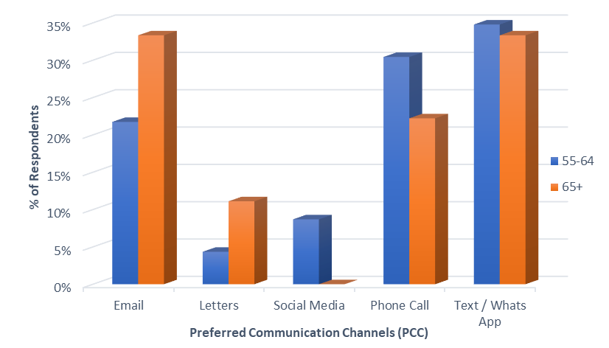
Figure 11: Friend and Family, PCC of respondents aged 55-64 and 65+.
Text/WhatsApp is the most popular of all communication channels between FF. Figure 12 demonstrates total RQ’s in each age group, and the number of respondents who included Text/WhatsApp in PCC with FF. Such findings suggest using letters when ”switching up to elders” is largely an assumption this is what ‘elders’ will want, rather than understanding needs and preferences of residents, which was advocated by Alexander (2003).
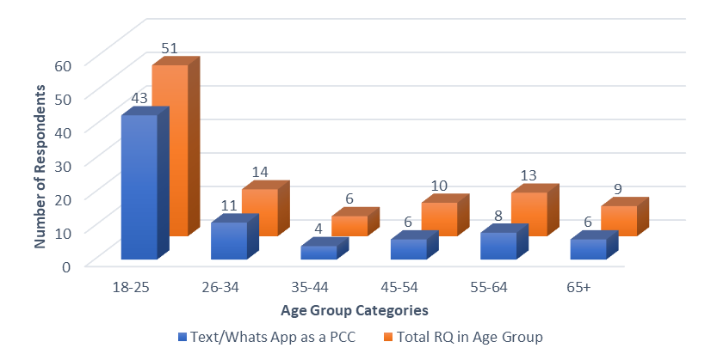
Figure 12: Age demographics of respondents choosing Text/WhatsApp as a PCC with FF.

Is Quick and Effective Communication with the FM team Important to Residents?
Communication is of particular importance in community building (Sanderson, 2019) and determining whether better communication channels would encourage residents to engage more is necessary, as the benefits can enhance the quality of service, and the relationship management between tenants and FM’s (Lepkova ,2012).
Question 10 of the questionnaire (Appendix 1) asked residents how important it was to have quick and effective communication with their FM/MA (Figure 13).
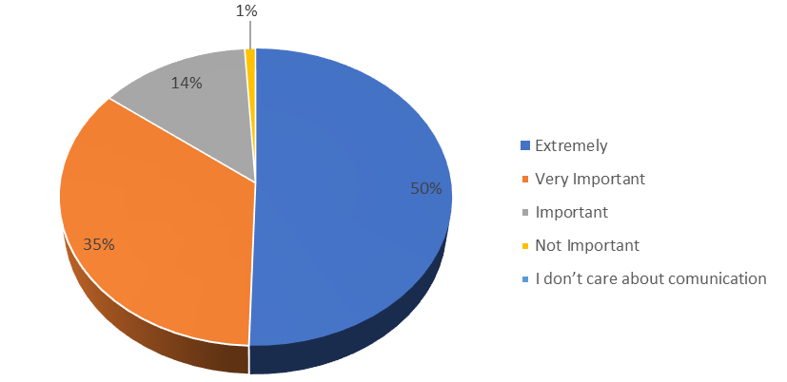
Figure 13: Respondents Classification of Importance of Communication between Residents and FM’s.
It is significant 50% of respondents (52/103) stated communication is ‘extremely important’ and 35% (26/103) stated ‘very important’. The researcher considers, if FM’s understood the needs of residents, they would understand the importance of communication between themselves and residents.
Question card 3 (Appendix 4) asked interviewees how they thought residents would answer the same question and were asked to rank the most chosen answer at the top and the least chosen at the bottom (Table 14).
Swansea FM Predicted Ranking | Swansea; No. of Residents Selecting | Swansea Residents Ranking Order | Barnsley FM Predicted Ranking | Barnsley; No. of Residents Selecting | Barnsley Residents Ranking Order
1st - Important | 13 | 3rd | 1st - Very Important | 2 | 2nd
2nd - Very Important | 34 | 2nd | 2nd - Important | 1 | 3rd
3rd - I don’t care about communication | 0 | 5th | 3rd - Not Important | 0
4th - Not Important | 1 | 4th | 4th - I don’t care about communication | 0
5th - Extremely Important | 41 | 1st | 5th - Extremely Important | 11 | 1st

Table 14: Interviewees and residents response: Rank the Importance of Communication between Residents and FM’s.
It is concerning both FM’s selected ‘extremely important’ as the least likely answer of residents, yet it received the highest response ranking at both study sites, suggesting there is neither recognition for resident’s needs, nor its importance. If FM of PHRRB fails to recognise the importance of communication to residents of all tenures, how can FM’s develop customer care policies that were advocated by Alexander (1993), or ensure residents are involved in future consultations, which is a recommendation of the UK Building Safety Bill (Building Safety Bill, 2021).
81% (29/36) of RQ’s who chose ‘very important’ were residents on AST’s, which particularly important in the PRS and BTRS, supporting Lepkova (2012), who suggested customers evaluate the quality of service and quality of the relationship of the FM provider. If there is little recognition of the importance of communication to residents from FM’s, it must be recognised by landlords, as Gibler et al (2014) advised, tenants are more likely to renew their lease if they are satisfied with their accommodation, their landlord and the management of their property.
Communication is a social and human problem, and buildings have an obligation to satisfy social needs of residents. It is suggested FM of PHRRB’s must recognise this, and demonstrate to landlords that delivering soft FM services, which encompass communication, are equally as important as costs associated of the FM service.

Residents Perceptions of Existing Communication Channels with FM’s
To begin to understand residents perceptions of communication with the FM’s, question three of the questionnaire (Appendix 1) asked respondents if they have regular communication with FM’s at their building. The results are included in Table 15, but the researcher recognises occupation of a property can commence on any given date.
Have you had regular communication with the FM / MA since moving into your property?
Yes | 71 | 68.9%
Only when I moved in | 12 | 11.7%
No | 16 | 15.5%
Never | 4 | 3.9%

Table 15: Respondents who have had communication with the FM team since moving into their property.
Though 81% of respondents (83/103) have had some form of communication with the FM team, it was fascinating nearly 19% (20/103) had not. The researcher acknowledges had the questionnaire asked residents how long they had lived at the property, results could have been better quantified. Nevertheless, responses to the importance of communication to residents (Figure 13) coupled with perceptions of both FM’s of how they believed residents consider communication, gave meaning to question seven of the questionnaire (Appendix 1), which asked residents to rate existing communication channels with the FM. The ‘free text box’ on the questionnaire, also offered some interesting comments which are presented in the following sections.

Respondents Opinions of Communication at their Building
Residents opinions of communication in PHRRB’s is highlighted in (Figure 14). 48% of residents consider existing communication channels to be excellent or very good, which is in contrast with 13% who consider it poor or very poor, with the remaining 39% (54/103) rating it average. It is suggested, if FM in PHRRB’s is to be recognised as a multi service strategic discipline, then FM’s must acknowledge a need to be better than average, and engage more with all residents, as the benefits can enhance the quality of service.
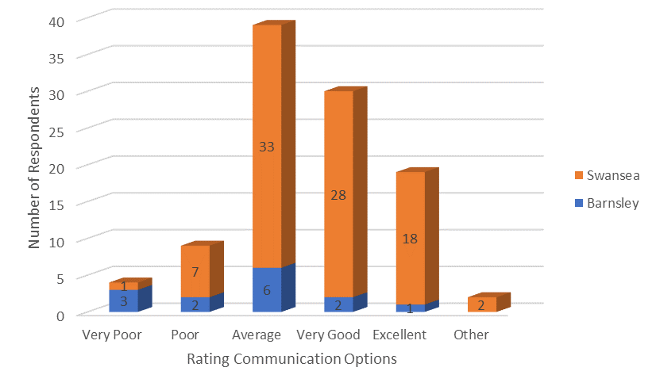
Figure 14: Residents ratings of communication channels at Barnsley / Swansea.

Residents Opinions about Communication: Other

Site | ‘Other ‘comment
Swansea  Male  55-65  Owner  Ext. Important | “Levels and frequency of communication need significant improvement - residents had to point out that information on the website was four years out of date. I’m sure the managing agent will claim that they communicate regularly via the website, but they fail to ask whether the communication is what residents actually want and require”

Table 16: A Swansea respondents use of ‘free text’ box in the questionnaire, to express an opinion about communication at their buildings, which was rated as ‘other.’
This comment supports Crosier et al (2015) who suggested a key aspect of good communication should include audience research. Additionally, if FM’s consider satisfaction of leaseholders is measured by cost, then this owners comment suggests owners care as much about communication.

Residents Opinions about Communication: Very Poor

Site | ‘Very Poor ‘comment
Barnsley  Male  65+  Owner  Ext. Important | “In 11 Yrs. living here the current management team are the worst ever. No contact only by email. you cannot speak to anyone. They don’t visit site and have no-one on site. They are a disgrace.”

Table 17: A Barnsley respondents use of ‘free text’ box in the questionnaire, to express an opinion about communication at their building, which was rated ‘very poor.’
Almost 30 years ago, Alexander (1993) suggested FM teams must develop better customer care policies and identify their customer, and though the Barnsley FM embraced new technologies, advocated by Alexander (2003), there is little evidence the use of new technologies, or the needs of residents have resulted in this resident being satisfied with the FM team. It is also important to note, three of the four respondents who considered existing communication to be ‘very poor’ were also residents at the Barnsley site, given the Barnsley FM highlighted their use of technological to implement communication channels with residents.

Residents Opinions about Communication: Poor
Site | ‘Poor ‘comment
Swansea (Respondent 1)  Male  55-64  Renting  Very Important | “I think they should be a lot more open regarding their communication with residents.”
Swansea (Respondent 2)  Male  55-64  Owner  Ext. Important | “Communication is a two-way activity which is a concept lost on the current Board and Managing Agent. Information is provided as and when they see fit and there is little or no opportunity to discuss issues. When questions are asked, you feel you have offended them personally. This has led to many residents having given up in trying to engage.”
Barnsley  (Respondent 3)  Male  55-64  Renting  Ext. Important | “I have been in this apartment for over one month and do not even know what the Facilities team are - or indeed the boundaries of their responsibilities. Is there a difference between the managing agents and the facilities team? I have simply guessed who, is who, and further guessed their responsibilities. I asked various questions on beginning my tenancy to find answers: very little was offered without my asking. I had to read and signed an 8 (single lined) page document about legal requirements of myself as tenant and my connection with the landlord whose legal obligation were never included in the document. I asked if there was any paperwork required which was for the terms and conditions for tenant and Facilities team / managing agents - there were none! I did all the talking - very little was offered. After that initial introduction nothing has been said!”
Barnsley (Respondent 4)  Female  26-34  Renting  Very Important | “At least a reply to an email is really helpful”

Table 18: Respondents use of ‘free text’ box in the questionnaire, at both study sites, to express an opinion about communication at their building, which was rated ‘poor.’
Respondent 2 is an owner occupier who commented, “Communication is a two-way concept”, which supports Ivancevich & Matteson (2002, quoted in Spaho, 2010), but further demonstrates, FM is not seen by owners as just a cost service. ‘Respondent 4’ gives significance to the previous comments made by the Barnsley FM (Table 10), when suggesting “you get deluged down with emails…you don’t know whats important,” which considers whether the communication channels at Barnsley, are only ever meant to be asynchronous.
The comments from respondent 1, 3 & 4, reveals tenants as external customers in the FM process, but perhaps supports Sanderson (2019), who suggested residents of all tenures are an important part of the process. This must be recognised by FM’s as it is considered, these residents are making perceptions, and rating the property management service they receive, which is often beyond the control of the landlord, yet is a critical factor when tenants decide to renew their lease (Gibler, Tyvimaa & Kananen, 2014; Sanderson, 2019).

Residents Opinions about Communication: Very Good
Site | ‘Very Good ‘comment
Swansea  Male  55-64  Owner  Very Important | “A concierge in the lobby definitely improves communication”

Table 19: A Swansea respondents use of ‘free text’ box in the questionnaire, to express an opinion about communication at their building, which was rated ‘very good’.

The comment from this owner supports Atkin and Bildsten (2017), by recognising the building must satisfy a social need, which is no less important than more tangible, quantifiable benefits. Furthermore, if FM of PHRRB’s is a cost driven service, it must recognise a concierge service is a cost. Therefore, there is an opportunity for FM’s to research, if a PCC could be adopted which encompasses the needs of all residents, then would this result in long term savings by dispensing of a concierge service, which is a cost saving.

Residents Opinions about Communication: Excellent
“Cost is their number one priority” and “efficiency of resolution”, were the interviewees replies to what is the most important factor for property owners. Though this may be true of some, 25 RQ’s indicated they were owners of the property, yet only three rated communications as excellent. This is not to say this will be true for all owners, but encouragingly for some leaseholders in the PRS and BTRS, 16 respondents identifying as renters, considered communication channels to be excellent.

Residents Opinions about Communication: Average
‘Average’ accounted for 38% of respondents (39/103), drawing six comments.
Site | ‘Average ‘comment
Swansea  (Respondent 1)  Male, 65+  Owner  Ext Important | “The importance of communication between management/agents and residents cannot be over emphasised. Failure to do so can give the impression of issues of concern being neglected or overlooked, which in turn has a negative impact on the perception of management by the residents”.
Swansea  (Respondent 2)  Male, 45-54  Owner  Ext Important | “More regular updates on important issues - i.e. monthly updates on fire safety issues, stating what exactly has been done in previous weeks”
Swansea (Respondent 3)  Male, 26-34  Renting  Very Important | “With regard to rental properties, the management only communicates with the landlord and not the tenants who are directly affected by planned maintenance...etc”
Swansea (Respondent 4)  Female, 18-25  Renting  Very Important | “Quicker replies”
Swansea (Respondent 5)  Female, 26-34  Renting  Ext Important | “I think too often if you’re renting then the needs of tenants are overlooked. I’ve rented many apartments and it seems a problem with all developments, yet it is tenants paying”
Swansea (Respondent 6)  Male, 18-25  Renting  Very Important | “Get in touch with every move in residence even they just rent the flat”

Table 20: Respondents use of ‘free text’ box in the questionnaire, at both study sites, to express an opinion about communication at their building, which was rated ‘average.’
Respondents 1 & 2 are both owners and who consider communication as extremely important. Their comments illustrate a necessity to communicate more, plus its importance: demonstrating the role FM of PHRRB’s, is more than just cost. It is further considered, of the 39 respondents, eight were owners and 31 were renting properties. This rating does not offer a suggestion whether those renting property would renew their lease, but gives significance to Gibler et al., (2014), that residents are more likely to renew their lease if they are satisfied with their accommodation, and management of the building and estate, which must be acknowledged by FM’s of PHRRB’s.
There are several comments to consider from renters. The comment from Respondent 3 supports Roper (2017) that customers (tenants) needs are overlooked, and though Respondent 6 has a valid suggestion, it is unlikely to happen given comments made by each FM (Table 13), where they reported their communication channels are effective and they don’t have relationships with those renting. It is suggested, unless FM’s or landlords in the PRS have a legal requirement to notify FM’s when changes in tenancies occur, then this is unlikely to happen.

Establishing Residents PCC
This section addresses aim two of the research.
- Aim 2: Establish residents PCC with FM’s and determine whether employing a PCC would encourage residents to engage more with FM’s.
The literature review highlighted rises in new technologies to communicate (Munoz, 2018; Duffett, 2020; Johnson, 2021) but writing 20 years ago Nutt (1999) and Alexander (2003) had already advocated FM needed to innovate, to make it better and create new wants.
Figure 10 established residents PCC with FF, and question nine of the questionnaire (Appendix 1) asked residents what smart phone Apps they used their mobile phone for. The purpose was to establish whether their use of, and familiarity with, smart phones Apps influenced their choice of PCC with FM’s, which question 11 of the questionnaires then asked.

Residents Use of Smart Phone Apps
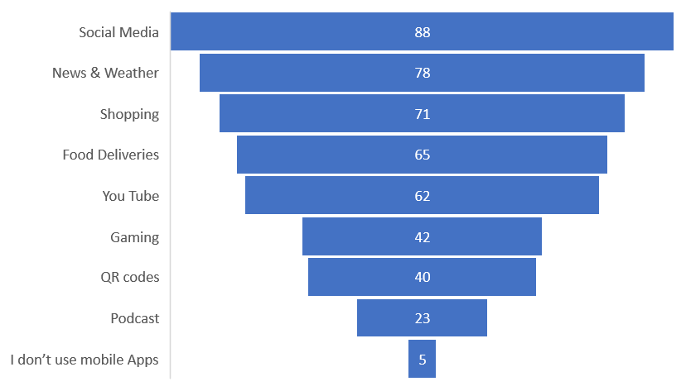
Figure 15: Respondents RQ’s use of Smart Phone Apps.
It is clear to see mobile smart apps are widely used for social means, supporting the findings of the literature review. Five RQ’s stated they did not use mobile phone apps when communicating with FF, choosing to use letters, phone calls or emails, except for one, who did use ‘Text/WhatsApp’, which can be considered a Smart App.

Residents PCC with FM’s
To establish residents PCC with FM’s, Question 11 of the questionnaire (Appendix 1) asked residents to rank their PCC, the outcome of which is presented in Figure 16. For comparison, question card 5 (Appendix 4) in the interview, asked the FM’s to predict how they believed the residents would rank PCC with the FM team (Table 21).
To compare resident and interviewees responses, the researcher adopted a score system, with 9 given to interviewees first answer and 1 to their last answer.
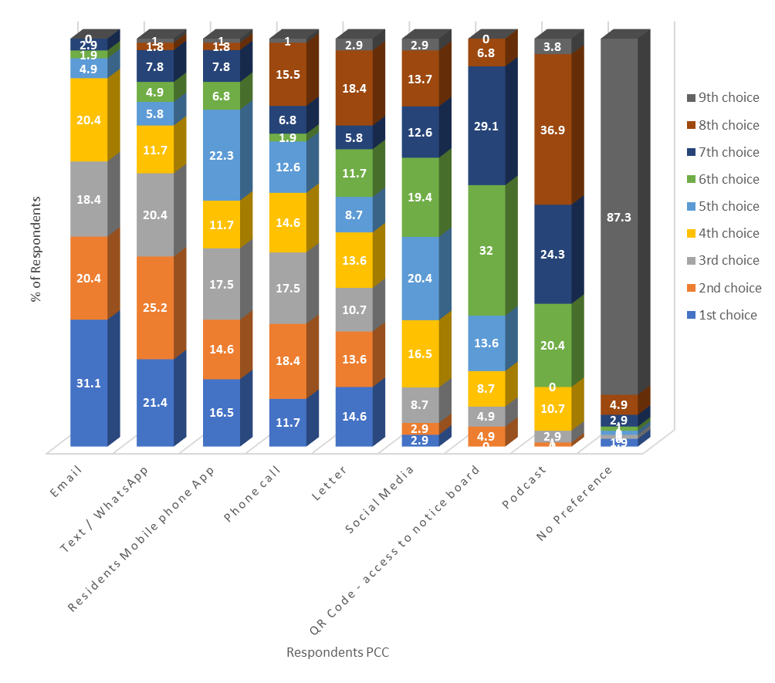
Figure 16: Respondents Rankings of PCC.

 | Swansea FM | Barnsley FM | Combined
1st choice | Text Message / WhatsApp - 9 | Residents Mobile Phone App - 9 | Residents Mobile Phone App
2nd choice | Residents Mobile Phone App - 8 | Email - 8 | Email
3rd choice | Email - 7 | Text Message / WhatsApp - 7 | Text Message / WhatsApp
4th choice | Phone Call - 6 | Letter - 6 | Phone Call
5th choice | QR code - access to notice board - 5 | Phone Call - 5 | Letter
6th choice | No preference - 4 | Social Media - 4 | QR code - access to notice board
7th choice | Letter - 3 | QR code - access to notice board - 3 | Social Media
8th choice | Social Media - 2 | Residents Podcast - 2 | No preference
9th choice | Residents Podcast - 1 | No preference - 1 | Residents Podcast

Table 21: FM’s prediction of residents PCC at their site following Question Card 5.
Reflecting on Figure 13 , 85% (88/103) of respondents considered communication with FM’s to be very important or extremely important. The researcher does not consider it surprising to see 98% (101/103) of respondents having a PCC and only 2% (2/103) of residents selecting they have no PCC, which the Swansea FM considered would be the 6th choice of residents.
It is interesting neither FM expected the communication channel they currently use with residents to be selected as the 1st choice PCC by residents. It is recognised both FM’s top three choice predictions were in line with residents choices of PCC (email, text/whats app & residents mobile phone app), and as both FM’s had stated FM is a cost driven discipline, it is worth noting two of these communication channels cost nothing and could easily be implemented.

The Barriers Preventing Research and Innovation of Communication Channels
Both FM’s recognised residents would have a PCC, largely based on technology and innovation. Though this is recognised by both FM’s, it provides an opportunity for further studies, and supports Roper (2017), that many FM’S “adopt a head-down approach to get the work accomplished efficiently but have not looked up to learn from research and innovate their own practice,” and that “soft FM is under researched with soft FM communication areas not keeping pace with the other areas of ICT, such as CAFM, BEM or BIM” Campbell (2017).
The researcher considered FM’s rankings of PCC, and their responses to interview Question Card 4 (Table 21) reflecting on Nutt’s suggestion that “such areas of research must be encouraged through practice-led innovations and personal ideas.” Therefore the researcher asked both interviewees whether such a practice was encouraged (Table 22).
Does your organisation actively encourage FM’s to implement personal ideas through practice led innovations?
Swansea FM | FM - “…innovations are generally sort of quite I.T led …Within our organisation there isn’t really that opportunity to…for individuals to be particularly innovative…” “it has to be a more global package for the whole business.”  Researcher - if the building manager said “well I think this would be better, but it’s going to cost us more” how do you think that gets dealt with by your organisation?  FM - “That’s a tricky one…is it something we could apply across the board… then I think it then comes down to a question of cost.”
Barnsley FM | FM - “the building managers all know this, if there are things which are quick wins, get them done”… “and it’s for the benefit of the building so it’s only going to be a good thing.”  Researcher – Their ideas, are decisions based on whether it is going to be a cost on a particular development, or a cost across the organisation.”  FM - “if it’s something we need to implement across the whole organisation clearly its time and the process that needs to be followed on that one, um if its cost on the development and it’s below a certain threshold and it will notify the client that we are doing it, we will just crack on and do it. If there is budget left in the pot for it, and it’s going to save them money by doing it, it’s a no brainer.”

Table 22: FM responses to whether their organisation encourages FM’s to implement ideas through practice led innovations.
Such replies support Per Anker Jansen et al (2012), that FM services are perceived as cost factors rather than a sector which adds value by enhancing users well-being, with the needs of residents overlooked (Roper, 2017). Alexander (2009, p.7) advocated, FM’s must “understand the importance of future studies, of effective scenario planning and the need to develop skills and competencies to contribute to the forward planning in organisations,” which is overlooked by FM’s, and which the researcher suggests is down to cost and competition for contracts, which will always dominate each facility.
These responses allowed the researcher to reflect and recognise communication by letters and email are not just efficient means of communication with residents, but cost-effective ones. Roper (2017) suggested, we cannot keep using the same software for decades despite our comfort with it, therefore without soft FM research into communication, FM of PHRRB will continue to ignore changing demographics, ethnographies, and will never understand the needs or wants of residents, which could impact leaseholders in the PRS as well as those managing facilities on behalf of the BTRS.

Residents PCC with FM’s: Traditional and Changing Technologies
The researcher considered traditional channels to be telephone and phone call; and changing technologies as social media, QR Codes, Podcasts, Mobile Phone Apps, Text/WhatsApp, and email.

Traditional Channels: Letters & Phones calls
The questionnaire results were not established when the interview with the Swansea FM took place, and the researcher considered it a missed opportunity to delve further into why the Swansea FM thought letters would only be the 7th most popular answer, when it was the communication channel used at their site.

Changing Technologies as PCC
There was nothing of significance to report for trends when considering communication through social media. QR codes and podcasts are asynchronous and may not encourage residents to engage, yet 20% (21/103) RQ’s used a QR code, yet no respondent selected this as a PCC. This is not to say these channels of communication should be dismissed, because they offer opportunities to communicate with residents who struggle to communicate because of hidden disabilities, or disabilities such as poor eyesight.
Figure 15 demonstrated 85% (88/103) of respondents used at least one mobile phone App. Surprisingly, 16.5% (17/103) selected a ‘residents mobile phone app, allowing two-way communication with the FM team’, as their PCC, and which was the combined number one choice of FM’s (Table 21).
Although 76% (78/103) respondents communicate with FF using Text/WhatsApp, only 21.4% (22/103) selected this as their 1st choice PCC with FM’s, and 46.6% when taking into account 1st and 2nd choice PCC. This suggests although people communicate with FF by a particular channel or use mobile phone App’s in several aspects of their lives, it cannot be assumed they want to engage with FM’s in the same way. Nonetheless, almost half (46.6%) of respondents did choose Text/WhatsApp as their 1st or 2nd choice PCC, only surpassed by email which was a 1st or 2nd choice selected by 51.5% of respondents.
Both FM’s stated the use of email at work was the main form of communication, and its popularity as a PCC was also apparent, accounting for 31% (32/103) of respondents selecting as their 1st choice PCC. This suggests the Barnsley FM team are on the right track, yet the ‘free text’ box (Table 23) was used by two of the 14 RQ’s from Barnsley, suggesting its ineffectiveness. This supports the comment of the Barnsley FM that “you can’t paint everyone with the same brush” (Table 11), highlighting residents frustrations.
Respondents Information | Respondents Comment in Free Text Box
Barnsley  (Respondent 1)  Male, Age 65+  Renting  Rates Communication now – Very Poor  Is communication important - Very important | “In 11 Yrs. living here the current management team are the worst ever. No contact only by email. you cannot speak to anyone.”
Barnsley  (Respondent 2)  Female, Age 26-34  Renting  Rates Communication now – Poor  Is communication important – Very important | “At least a reply to an email is really helpful.”

Table 23: Barnsley respondents ‘free text’ box comments on the FM’s channel of communication: Email.
Respondent 1 says much about their satisfaction of the FM team and communication channels, suggesting needs and expectations of this resident are overlooked, yet Teicholz (2001, p.21), stated many FM organisations fail to realise the customer drives the whole FM process, which demonstrates the value of Sanderson’s (2019) study, that engagement and communication are important factors of customer satisfaction, which must be recognised by FM’s of PHRRB’s who believe the measure of satisfaction where owners are concerned, is ‘cost’ or ‘what residents see’, for those renting.

The Swansea FM stated for leaseholders, cost is the most important thing. Table 24 illustrates comments made by Swansea leaseholders, addressing communication, demonstrating FM is more than just cost.
Preferred channel of communication:  Email | Respondents response
Respondent 1  Owner – Age 65+  Opinion of current communication channels – Average  Would you communicate if adopted - Yes | “The importance of communication between management/agents and residents cannot be over emphasised.”
Respondent 2  Owner – Age 55-64+  Opinion of current communication channels – Poor  Would you communicate if adopted - Maybe | “Communication is a two-way activity which is a concept lost on the current Board and Managing Agent. Information is provided as and when they see fit and there is little or no opportunity to discuss issues. When questions are asked, you feel you have offended them personally. This has led to many residents having given up in trying to engage.”
Resident 3  Owner – Age 45-54  Opinion of current communication channels – Average  Would you communicate if adopted - Maybe | “More regular updates on important issues…We are kept in the dark”
Resident 4  Owner – Age 55-64  Opinion of current communication channels – too sporadic  Would you communicate if adopted - Yes | “Levels and frequency of communication need significant improvement - residents had to point out that information on the website was four years out of date.”

Table 24: Comments from Swansea respondents who used the ‘free text’ box to comment on communication with the FM team.
These comments underline the importance and frequencies of communication, and the need for it to improve and become a two-way process. Perhaps the most alarming comment was from respondent 2, who stated ‘many residents have given up trying to engage,’ which is noteworthy, given Sanderson’s suggestion (2019) of the importance of community building, to winning tenant loyalty.

Would Residents Engage More with the FM if their PCC was Adopted
FM is a multi service, strategic discipline and FM’s in PHRRB’s must engage with all residents, as the benefits can enhance the quality of service. Therefore, FM of PHRRB’s must not just be focused on cost, especially when it can deliver social and environmental benefits (Alexander 2009 p.6; Atkin and Bildsten, 2017).

The importance of communication to residents was revealed in Figure 13, with 50% and 35% considering it extremely, or very, important respectively. Question 12 of the questionnaire (Appendix 1) sought to identify if a residents PCC was adopted, would it encourage them to engage more. Only 4% of respondents reported it would not encourage engagement, in contrast to 74% (76/103) of respondents who reported it would encourage them to engage more, and 22% (23/100) of respondents who may encourage them to engage more (Figure 17), both of which the researcher considers significant to FM of PHRRB’s.
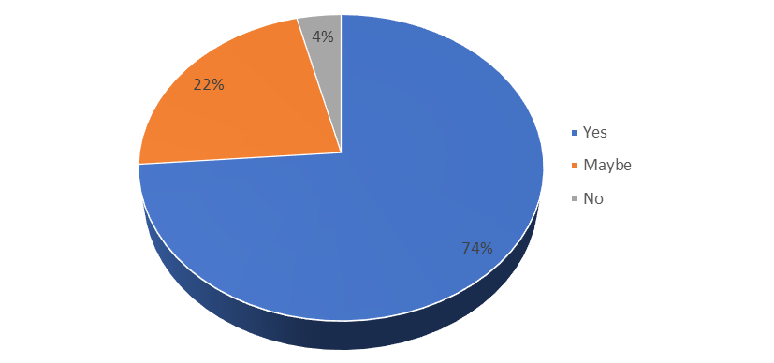
Figure 17: Respondents replies when asked if they would engage more if their preferred channel of communication was implemented.
Of the 76 (74%) respondents who said they would communicate more if their PCC was adopted, 78% (59/76) were in the PRS. It noteworthy 47% (28/59) of those, rated current communication channels to be poor, very poor or average. If engagement and communication are recognised important factors for customer satisfaction (Sanderson, 2019), and if tenants evaluate the quality of the FM service and quality of the relationship (Lepkova, 2012), then recognising residents are likely to engage is important to the BTRS, PRS, and FM’s managing PHRRB’s.
Question card five (Appendix 4) allowed the researcher to ask both FM’s whether they thought residents would engage more if a PCC was adopted.
- The Swansea FM said, “maybe”
- The Barnsley FM said, “yes”
The response from the Barnsley FM may be an acknowledgement of PCC, but the researcher considered it a missed opportunity to follow up and ask, if they did think residents would engage, why aren’t they encouraging it. When reflecting on this section, it provided the researcher with an opportunity to consider the importance of Soft FM services.

Measuring Residents Importance of Soft FM Services
This section looks to explore Aim 3, and Hypothesis 4
- Aim 3: Assess FM’s understanding of what is important to residents when considering soft FM services.
- If FM’s consider the FM sector to be a cost and maintenance driven industry, rather than a strategic discipline that encompasses the needs of residents and users of PHRRB’s, then the necessity to recognise the importance of soft FM services are lost on those working in FM.

Residents Understanding of the FM Service
Question one of the questionnaires (Appendix 1) asked residents whether they understood the role of the FM/MA. Figure 18 demonstrates 81% (83/103) said they do. It is considered important, 70% (58/83) identified as residents renting property, which is an important indicator that residents of all tenures, should be recognised by FM as internal customers, particularly given rises in the PRS and BTRS where residents satisfaction is a key component to retaining tenant loyalty (Gibler, Tyvimaa & Kananen, 2014; Sanderson, 2019).
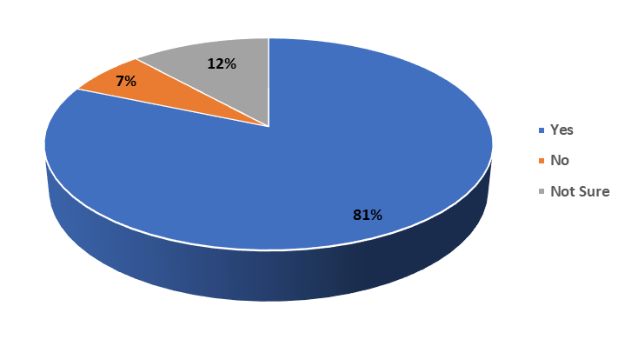
Figure 18: The Understanding of the Role of the FM / MA of Respondents Returning Questionnaires.
For this aim to be met, Question 5 of the questionnaires (Appendix 1) sought to establish frequencies of communication between FM’s and Residents on five soft FM services. When analysing the results, the researcher recognised an occupancy of a property can commence on any given date, and acknowledged some residents, particularly those in Swansea were from international students who may have returned to their country because of COVID-19, during the previous 12 months to continue studies online. Therefore, it was concluded the figures presented could not be accurately analysed.
However, the researcher recognised how important quick and effective communication is between residents and FM’s: whether it is to deal with a leak which is affecting neighbouring property, or other important reasons, which are considered in aim four.

How do FM’s Measure Satisfaction of Residents?
Both FM’s perceived FM to be a cost driven service, and in PHRRB’s such costs are collected through annual service charge demands. Such demands are leaseholders responsibility, unlike most commercial premises, where service charges are often paid by tenants or occupiers.
The interviews allowed the researcher to ask FM’s what they think is important to residents in terms of FM services provided, and how satisfaction is measured. Table 25 outlines responses, but neither FM offered a measure of how satisfaction is obtained or its importance to residents.
Respondent | Comment
Swansea | “Owners, I think it is definitely cost is their number one priority.”  The researcher reminded the FM, the questions was asked from a residents perspective, to which the reply was  “What they see and what they notice more...its cosmetic I think.”
Barnsley | “I think it’s, um, speed of resolution for renters…and efficiency of resolution for landlords.”  Researcher - I assume with leaseholders, if their budget has gone up, they’re not happy, if their budget comes down, they’re happy?  FM response - “That’s it.”  Researcher – But in terms of the residents that actually live in those buildings, how do you….  FM Response - “So, it’s the quality of the building is the kind of, whats happening in the corridors are they all painted, are they clean”

Table 25: FM’s comments on how service and satisfaction was measured by respondents at the study sites.
Unsurprisingly, given the competition for contracts, responses centred on cost. Though the Swansea FM’s first response was answered from a leaseholders perspective, it is noteworthy 73% (65/89) of RQ’s at Swansea were residents on AST’s, who do not pay service charges. It is suggested such tenants measure their satisfaction on the rental cost of property and services provided by FM’s at the building, which is important as it is leaseholders who must pay service charges, as tenants are likely to renew leases if they are satisfied with their accommodation, their landlord and management of their property (Gibler, Tyvimaa & Kananen, 2014).

Identifying the Importance of Soft FM Services
The literature identified the importance and perception of the property management service that residents receive (Sanderson, 2019), and question four of the questionnaire (Appendix 1) asked residents to rank the most important service provided by the FM at their building (Figure 19).
Question card one (Appendix 4) also asked FM’s to rank how they considered residents would rank these. To compare, the researcher awarded 8 points to the FM’s first answer, 7 for their second answer and so on. The scores were combined to produce a ranking, to compare answers against respondents choices (Table 26).

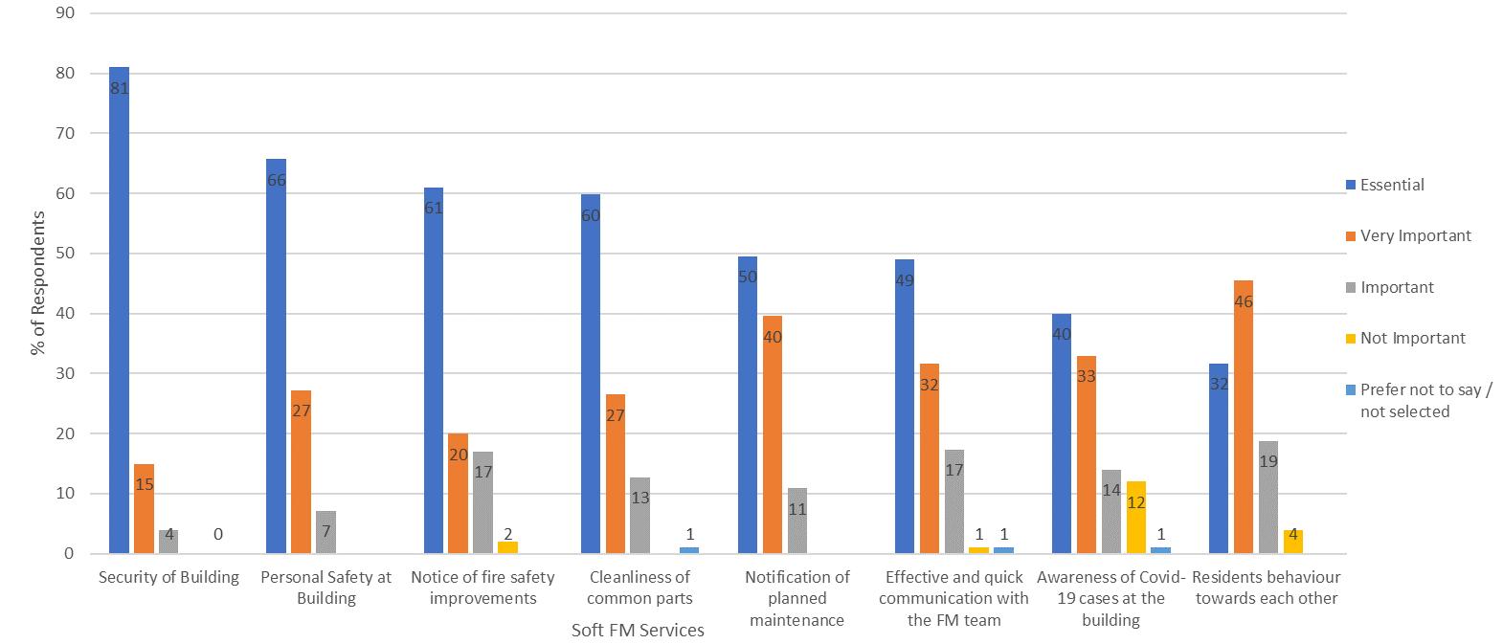

Figure 19: Respondents Measurement of Importance, of 8 ‘soft FM’ Services Provided by the FM / MA at their Building.

 | FM's were asked to rank what they thought most residents returning questionnaires would select as the most important service provided
Rank | Soft Service | Swansea Ranked |  | Barnsley Ranked |  | Total Points
1 | Cleanliness of common areas | 1st - 8 points | essential | 1st - 8 points | essential | 16 points
2 | Security of the building | 2nd - 7 points | very important | 2nd - 7 points | very important | 14 points
3 | Notice of fire safety improvements at the building | 5th - 4 points | important | 4th - 5 points | very important | 9 points
3 | Personal safety at the building | 3rd - 6 points | important | 6th - 3 points | very important | 9 points
3 | Effective and quick communication with the FM Team | 6th - 3 points | important | 3rd - 6 points | important | 9 points
6 | Notification of planned maintenance works at the building | 4th - 5 points | very important | 7th - 2 points | important | 7 points
7 | Awareness of Covid-19 cases at the building | 7th - 2 points | important | 5th - 4 points | very important | 6 points
8 | Residents behaviours towards each other | 8th - 1 point | important | 8th - 1 point | important | 2 points

Table 26: FM’s Predictions of Respondents Most Important Soft Services Provided at the Site.

It is suggested these eight examples can be classed as meeting social or environmental objectives of residents in PHRRB’s, which supports Atkin and Bildsten (2017), who highlighted “where the asset is to satisfy a social need, the benefits might be rather intangible, but they are no less important than more tangible, quantifiable benefits.”
Though the literature review did not reveal residents measurement of satisfaction or the importance of safety, security, maintenance, or cleaning needs, the comparisons of answers between RQ’s and FM’s were contrasting, but equally important.
Given the responses by the FM’s (Table 25), the researcher does not consider it surprising to see both FM’s consider ‘cleanliness of the common areas’ as the most important service from a residents perspective and an essential service. What is considered surprising, is this was the only service both FM’s considered residents would rank as essential. The researcher suggests such a contrast supports Balch (1994) who stated it is important to understand how those working in FM view the facility, but who may still fail to realise it’s the customer drives the whole FM process (Teicholz, 2001, p,21). As stated by Lepkova (2012), relationship management in FM cannot be understated, because customers evaluate the quality of the service and quality of the entire relationship of the FM provider. This is of particular importance, not just to FM’s, but to leaseholders in the BTRS and PRS, as the service provided by FM’s is a critical component to retaining tenant loyalty.

The Importance of Establishing a Vulnerable or Risk Register
This section is to consider Aim four and hypothesis two of the research:
- Aim 4: Determine are residents asked whether they ought to be added to a risk or vulnerable register and what lengths FM’s go to collect this information.
- The importance of creating a vulnerable or ‘at-risk register’ for residents in PHRRB’S is not lost on many working in FM, yet there is no generally adopted method of ensuing this is updated regularly.
The Oxford Reference definition of vulnerability is “a position of relative disadvantage, which requires a person to trust and depend upon others” (Oxford Reference, 2021), with the ISO (2017) definition of FM as “an organisational function which integrates people, place and process within the built environment with the purpose of improving the quality of life of people and the productivity of the core business”.
The importance of a literature review established 15 of the 72 Grenfell fire fatalities were registered as vulnerable individuals at the building yet collecting such data concerning vulnerability in PHRRB’s is still not a legal requirement.

Do FM’s Create Vulnerable or Risk Registers
It is worth noting the demographics and ethnographies in section 4.3. It was established during the interviews the FM’s could not accurately assess these, nor recognise and acknowledge the importance of residents languages. The study sites were selected, largely due to both undergoing major fire re-instatement works, and the interview provided an opportunity to test the findings from the literature review and ask FM’s if they collected such data as resident vulnerability (Table 27).
Question | Swansea FM | Barnsley FM
Do you ever ask residents do they wish to be added to a vulnerable or risk register? | “We have sent out that questionnaire, I think, 3 or 4 times now, and out of 123 apartments, we have had about 12 responses. It’s been really low” | “Once or twice a year, we’ll send out a mail shot to everyone, just say, “look, contact the local authority or let us know to register yourself on this system”

Table 27: FM’s responses when asked “do they ask residents whether they wish to be added to a risk register”.
Question six of the questionnaire (Appendix 1) asked residents whether they had ever been asked to be added to a risk or vulnerable register (Figure 20).
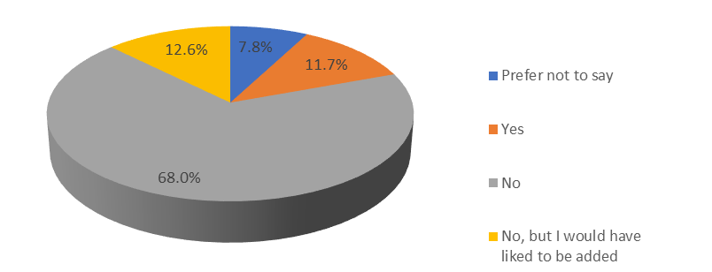
Figure 20: Respondents response. Have you ever been asked to be added to a vulnerable or risk register?
The researcher later recognised residents can move into a property on any given day, and tragedies like Grenfell can also occur on any given day. This may be recognised but not acknowledged by FM of PHRRB’s, particularly at Barnsley where 86% (12/14) of respondents said they have not been asked, despite the FM stating during the interview “everyone gets asked.”
The importance of the literature review reported Dr Barbara Lane stating at the Grenfell Tower enquiry, the stay put policy failed within 29 minutes of the first 999 call (Booth, 2018) and the fire had reached floor 23 within 32 minutes (BBC, 2019), demonstrating perhaps that FM’s of buildings with a stay put policy has a duty to ask all residents if they are vulnerable or at risk.
It is suggested the greatest significance is 13% (13/103) of respondents selected “No but would have liked to have been asked.” The demographics and ethnography did not reveal anything of significance within these 13, but it is considered, what are the consequences if just one of those 13 needed assistances in any future incident, such as the Grenfell Tower tragedy.
Card 3 (Appendix 4) was introduced asking FM’s how they thought most residents would answer.
- Barnsley FM said, yes.
- Swansea FM said, “I’m going to say no, just judging on the poor response.

The responses to the questionnaire, together with the responses of the FM during the interview suggest this ‘task’ must be addressed, and supports Lefebrve (2009), who described insanity as “doing the same thing repeatedly and expecting the different results.” The researcher asked the Swansea FM, whether sending a questionnaire three of four times is ineffective, which the FM acknowledged “I think that would be true.”

Is Legislation a Requirement to Create Vulnerable or Risk Registers?
Meng’s (2015) study demonstrated 47% cent of FM interviewees citied changes in Government legislation or policies as the second most significant change within FM. The researcher considered the interview an opportunity to ask interviewees, whether collecting all residents data should be a legal requirement, or something lettings agents should have to do (Table 28).
Swansea FM | Barnsley FM
Addressing legislation - “Yes, I think it should. For that, I think occupiers should almost have to self-identify whether that’s with a requirement to do that with the fire brigade directly, or for their letting agent to let the building managers know…there has to be some personal responsibility in it” | Addressing letting agents - “No. It’s not a thing they do, because it’s an extra piece of work and sometimes they don’t know who the managing agent is, they’re renting the properties out, on behalf of a landlord, landlord pays a service charge, it’s not a relationship they have”.

Table 28: FM’s responses when asked whether this could be addressed by legislation or via letting agents.
Though the Swansea FM recognises a requirement for residents to self-identify, the Barnsley FM does not think this is something that letting agents will do. In Wales, all landlords in the PRS must identify and register themselves on the Rent Smart Wales website (The Housing (Wales) Act 2014). If this process is already in place, it is suggested in Wales at least, ensuring residents self-identify, seems like a logical process to adopt.

FM in PHRRB’s and the UK Building Safety Bill
The final section seeks to address the final aim, 5.
- Aim 5: Identify how FM’s are planning for the Building Safety Bill, and whether they believe residents will want to engage should the bill be passed.

Atkin and Bildsten (2017) suggested “a few researchers are preoccupied with what’s gone, rather than trying to understand the change that is coming, and how it will impact the facility.” The Hackitt review recommended residents of all tenures must be given a voice on safety (Hackitt, 2018), which the current draft of the Building Safety Bill is looking to implement (Building Safety Bill, 2021), and it must be recognised by FM of PHRRB’s, that residents on AST’s should be regarded as internal customers, and stakeholders in the FM process of PHRRB’s. But Roper (2017) suggests, FM fails to recognise its limited resources, staff shortages and long hours, so the interview allowed the researcher to identify what FM’s are planning to do if all residents want to engage with the FM team regarding safety issues (Table 29).
Q – How are you preparing or adjusting for the Hackitt report recommendations that the residents, will have a voice?
Swansea FM | Barnsley FM
“we’re waiting to see what the legislation will finally be…our current understanding at the moment or the way perceive things at the moment is that residents and occupiers aren’t actually that interested.” | “For us it’s going to be putting on residents shoes. It’s got to be easy to do and quick to access. So, both of them tick boxes, so for me it ends up in a portal where they can access it 24/7 whenever they need it. Um, and if they then want a physical copy sending out, we can organise for that.”

Table 29: Responses of FM’s when asked how they are preparing or adjusting to the Hackitt Report / UK Building Safety Bill.
Over 10 years ago, Alexander (2009, p.7) advocated the FM profession should have effective scenario planning. In December 2017, the draft Hackitt report was released, with the published report released in May, 2018 (Hackitt, 2018), yet both FM’s seem to support Roper’s (2017) suggestion, due to limited resources, effective scenario planning has not taken place to recognise the change that is coming. It is again suggested, the needs of customers are overlooked, with FM’s in PHRRB’s watching and waiting to see what the legislation delivers, which supports Nutt (1999) and Meng (2015) that such changes are usually because of secondary demands.
Nevertheless, the researcher considers this an opportunity to learn from Crosier et al (2015), and rather than adopting a ‘one size fits all’ led from the ‘top down’, it should involve audience research to understand the needs and motivations of different residents, which considers diversities such as changing ethnographies and demographics and which provides a unique opportunity for such research to be led by FM’s of PHRRB’s, and shared by, the FM sector.

Conclusion and Recommendations
The research focus was residents of all tenures living in PHRRB’s. The purpose was to explore five ‘broad aims’ centred on Soft FM services which included measuring the importance of communication, residents opinions of communication, establishing residents satisfaction of soft FM services, the necessity to create vulnerable risk registers, and to establish PCC of residents in PHRRB’s with FM’s of those buildings. The researcher considers the aims of this research have been met, through the quantitative analysis of data collected from the questionnaires, which was assessed alongside the hypotheses and assessment of both qualitative interviews conducted.
This research identified FM’s consider cost as the main driver in FM of PHRRB’s, which is largely down to competition for contracts, but also a lack of resources, staff, and time. This was also identified during the literature review, and which limits soft FM research particularly where resident’s needs are concerned, preferring to focus only on the internal stakeholders, who they believe are largely concerned with cost. It is therefore suggested FM’s in PHRRB’s must regularly read academic journals and important conference papers, such as Alexander (2009) or Sanderson (2019), not just to implement change, but to demonstrate to internal stakeholders, particularly those in the PRS, the perception of property and management services received from FM’s may involve additional cost, but sometimes it’s the intangibles they are investing in.
Aim one and hypothesis one established over 80% of residents have had some form of communication with their FM, but communication channels are implemented by FM’s with no consideration for the needs of residents’, and no recognition of demographics, ethnographies, or languages. This may have resulted in more than 50% of residents rating communication channels as poor, very poor or average, yet it was deemed an essential or very important requirement by 85% of residents. By way of contrast, FM’s considered residents would not rate communication as an essential service (Table 14), demonstrating a huge disparity of opinions.
Aim two established residents did have a PCC with FM’s at their building, and though these varied in channels, residents overwhelmingly stated they would be encouraged to communicate more with the FM team if theirs was adopted. A mobile phone app allowing two-way communication was the 3rd most popular PCC, but the use of smart phones apps was apparent with only five residents stating they did not use them, suggesting this channel of communication would be used, given residents familiarity with smart phone apps. However, implementing new communication channels from the FM’s point are likely to be I.T led, which is by its nature, cost led.
Aim three and hypothesis 3 identified FM’s consider FM of PHRRB’s as a cost and maintenance driven sector, with cost the measure of satisfaction for leaseholders, yet for residents its ‘by what they see.’ However, the top three responses of residents all centred on unseen services: namely security. The researcher recommends FM’s of PHRRB’s recognise there are two drivers in the process; leaseholders who pay the service charges and the residents of all tenures within the facility. The importance of this cannot be underestimated as residents evaluate the quality of service and relationship of FM’s, which must be recognised by leaseholders in the PRS, as resident satisfaction is a key component to retaining tenant loyalty. The researcher recommends advice laid out by academics in the field of FM, and FM’s must develop soft FM skills and better customer care policies, identify their customer and ensure they are involved in consultations through audience research, which can be the first step in the process to ensuring leaseholders and tenants are equally satisfied with the FM service they receive.
Aim four and hypothesis four highlighted the ineffectiveness of data collection methods, and frequency of data collection, regarding vulnerability of residents. The literature review identified the vulnerabilities of those who lost their lives in the Grenfell Fire, and though most respondents stated they had not been asked by the FM team if they wished to be added to a risk register, it is considered highly significant 13 residents reported “they had not been asked but would have liked to have been.” If FM of PHRRB’s is to ensure the safety of residents within, then regardless of limited resources, the researcher considers a risk register as an absolute necessity.
Aim five identified FM’s are watching and waiting for the outcome of the UK Building Safety Bill, rather than taking the opportunity for effective scenario planning. The findings relating to aim four and hypothesis four suggest this is an opportunity for FM organisations to acknowledge problems affecting their industry, and lead and encourage change, rather than being led by any UK Government legislation.
If FM of PHRRB’s is to be considered a knowledge-based economy which meets the ever changing social and environmental objectives of residents of PHRRB’s, then it is proposed, through better collaboration between FM members, issues identified within this research can be explored further by allowing FM’s of PHRRB’s an opportunity to contribute their ideas, their experience, and their knowledge; thereby ensuring they are at the forefront of forward planning within their own organisations but also within FM of PHRRB’s.
The researcher considers research in FM of PHRRB’s, on subjects identified within this research project have been minimal, if any. This has led to a huge gap in what FM of PHRRB’s consider is important to residents of all tenures living in PHRRB’s, with the researcher also suggesting the observations and interpretations of responses in the interview are likely not to be limited to the two study sites, but should be considered illustrative of FM of PHHRB’s, largely due to competition for contracts and lack of resources.
The researcher suggests, the qualitative and quantitative research results have demonstrated there is an opportunity for further research, given the huge disparity between several key soft FM services. This is particularly important where communication between residents and FM’s of PHRRB’s is concerned, given how residents rate the importance of soft FM services and which contrasted greatly with how FM’s consider residents rate the service they receive. It is considered a failure of FM of PHRRB’s, not recognising residents on AST’s as internal customers in the management of PHRRB’s, which must be challenged and changed. Such a change in the way FM’s view their facility must involve leaseholders, particularly those in the PRS, who need to understand the way residents view a facility, can dictate whether residents renew their leases, which significantly impacts them.
It is considered, this research has demonstrated further research in many areas could and should be researched by FM’s of PHRRB’s, but further research will be more credible with better collaboration and data sharing between FM’s of PHRRB’s. Such areas of future research are considered:
- Familiarity with the use of mobile phone smart apps was evident with 85% of residents regularly using them. Though the development of such an app would involve cost, residents familiarity with such apps may suggest a smart phone app would be used. If such an app was implemented, it must incorporate demographics, ethnographies, languages, and disabilities, as well as identifying the impact this will have on resident’s needs, as well as measuring their satisfaction of the service they are receiving. It should seek to understand whether an App improves communication channels between residents and FM’s of PHRRB’s or whether, through its use, does it improve resident satisfaction of FM services of PHRRB’s. Additionally, if this was researched, it is suggested while its implementation may involve cost, it must also consider what, if any, cost savings could be harnessed in the long term.
- If residents measure the FM service they receive, this must be conveyed to leaseholders, particularly those in the PRS and BTRS. Future research should involve tenants, leaseholders, and FM’s of PHRRB’s to evaluate these services with a view to implementing suggestions to improve satisfaction and analysing the impact any cost spending has on tenant satisfaction, but also tenant loyalty.
- The research interviews identified FM of PHRRB’s are largely watching and waiting for the recommendations of the Hackitt review and the passing of the Building Safety Bill. The researcher suggested if residents can be encouraged to play an active role, then it has the capability to benefit not just the facility but all stakeholders at the facility. Research could begin by understanding whether residents of all tenures wish to engage on matters of safety, or are they simply not interested and are quite happy to be told when change is happening.
- The literature review revealed 15 of the 72 fatalities at Grenfell Tower tragedy were registered as vulnerable, and despite both interviewees revealing they have asked residents whether they are vulnerable, 68% of residents said they have not been asked, with 13% stating they “had not been asked but would have liked to have been asked.” The researcher recognised limitations in the data collected, given residents can move into and out of a building on any given date, which must also be recognised by FM’s in PHRRB’s. Additionally, the Swansea FM also recognised the ineffectiveness of their own data collection methods, when collecting such data. It is suggested future research could centre on the necessity for tenants to have to self-identify their own vulnerabilities. Such research could establish the best way to collect such data and establish whether such a requirement should be a legislative requirement.
Where such studies are concerned, there is certainly a need to generate greater sample sizes to increase their reliability. This can be achieved by FM of PHRRB’s collaborating, to deliver significant hypothesis which could be tested to prove validity. It is further suggested such research should centre on qualitative methods, such as interviewing FM’s and residents of all tenures, as well as organising focus groups to participate in such research. However, quantitative, or mixed method studies should not be dismissed, as many hypotheses could be developed from such research. It must also be acknowledged, if the perception of FM of PHRRB’s centres on cost, then any future research must also consider the financial impacts on the facility, as well as the consequence of delivering changes and the subsequent performance measurements of FM’s of PHRRB’s.

References
Alexander, K. (1993), "Identifying and managing facilities needs", Facilities, vol. 11, no. 3, pp. 18.
Alexander, K. (2003), "A strategy for facilities management", Facilities, vol. 21, no. 11/12, pp. 269-274.
Alexander, K. & Brown, M. (2006), "Community-based facilities management", Facilities (Bradford, West Yorkshire, England), vol. 24, no. 7, pp. 250-268.
Alexander, Keith. (2009). European Facilities Management: the next generation. Available at: https://www.researchgate.net/publication/264627239_European_Facilities_Management_the_next_generation (Accessed: 19 July, 2021).
Ambrose, J. (2019),"The ongoing housing shortage", Property Journal, , pp. 23.
Atkin, B. & Bildsten, L. (2017), "A future for facility management", Construction Innovation, vol. 17, no. 2, pp. 116-124.
Autotec (2016) 3 Engineering Disasters That Were the Result of Miscommunication Available at: https://news.aucotec.com/3-engineering-disasters-result-miscommunication/ (Accessed: 6 March, 2021).
Aziz, N.D., Nawawi, A.H. & Ariff, N.R.M. (2016) "ICT Evolution in Facilities Management (FM): Building Information Modelling (BIM) as the Latest Technology", Procedia - Social and Behavioral Sciences, vol. 234, pp. 363-371.
Babacic, B. (2019) Knight Frank Multi Housing 2019, PRS Research. Available at: https://content.knightfrank.com/research/707/documents/en/the-uk-tenant-survey-2019-6118.pdf (Accessed 25 July, 2021).
Balch, W.F. (1994) "An integrated approach to property and facilities management", Facilities, vol. 12, no. 1, pp. 17.
Barton, C., Wilson, W. (2021) Tackling the under-supply of housing in England. Available at: https://commonslibrary.parliament.uk/research-briefings/cbp-7671/ (Accessed 25 July, 2021).
BBC (2019) Grenfell Tower: What happened Available at https://www.bbc.co.uk/news/uk-40301289 (Accessed 19 August, 2021).
Beer, D.W. (1997) ‘There's a Certain Slant of Light: The Experience of Discovery in Qualitative Interviewing’, OTJR (Thorofare, N.J.), vol. 17, no. 2, pp. 110-129.
Booth, R. (2018) ‘Grenfell Tower’s smoke ventilation system failed days before fire', The Guardian, 5th June, Available at: https://www.theguardian.com/uk-news/2018/jun/05/grenfell-towers-smoke-ventilation-system-failed-days-before-fire (Accessed: 19 August, 2021).
Bowen, G.A. (2008) ‘Naturalistic inquiry and the saturation concept: a research note’, Qualitative research : QR, vol. 8, no. 1, pp. 137-152.
Boynton, P.M. & Greenhalgh, T. (2004) ‘Selecting, designing, and developing your questionnaire’, BMJ : British Medical Journal, vol. 328, no. 7451, pp. 1312.
Bröchner, J., Haugen, T. & Lindkvist, C. (2019), ‘Shaping tomorrow’s facilities management’, Facilities (Bradford, West Yorkshire, England), vol. 37, no. 7, pp. 366-380.
Bromley, R.D.F., Tallon, A.R. & Roberts, A.J. (2007) ‘New populations in the British city centre: Evidence of social change from the census and household surveys’, Geoforum, vol. 38, no. 1, pp. 138-154.
Building Safety Bill. 2021. (HL Bill number 177, 2021-22 as amended in Committee). UK Parliamentary Bills. Available at: https://bills.parliament.uk/bills/3021 (Accessed: 1 November, 2021)
Cambridge Dictionary (2021a), Meaning of communication in English Available at: https://dictionary.cambridge.org/dictionary/english/communication (Accessed: 19 July, 2021).
Cambridge Dictionary (2021b), Meaning of effective
Available at: https://dictionary.cambridge.org/dictionary/learner-english/effective (Accessed 22: October, 2021).

Campbell, L. & Finch, E. (2004), "Customer satisfaction and organisational justice", Facilities (Bradford, West Yorkshire, England), vol. 22, no. 7, pp. 178-189.
Campbell, L.Z. (2017), "An exploration of how research can aid the development of facilities management", Facilities, vol. 35, no. 5/6, pp. 356-366.
Centre for Disease Control (2019), 2009 H1N1 Pandemic (H1N1pdm09 virus). Available at: https://www.cdc.gov/flu/pandemic-resources/2009-h1n1-pandemic.html (Accessed: 16 November, 2021).
Che-Ani, A., Jamil, M., Zain, M.F.M., Mohd-Nor, M. & Mohd-Tawil, N. (2009), "A satisfaction survey of high-rise residential management in Malaysia: sustainable indicators", Transactions on ecology and the environment, vol. 120, pp. 643-65
Creswell, J. (2009), Research Design. Qualitative, Quantitative, and Mixed Methods Approaches. 3rd edn. California: Sage Publications.
Crosier, A., McVey, D. & French, J. (2015) "'By failing to prepare you are preparing to fail': lessons from the 2009 H1N1 'swine flu' pandemic", European journal of public health; Eur J Public Health, vol. 25, no. 1, pp. 135-139.
DePass, D. (2016) Honeywell app gives workers more control over office environments. Available at: https://phys.org/news/2016-12-honeywell-app-workers-office-environments.html (Accessed: 27 July, 2021).
Duffett, R. (2020) "The YouTube Marketing Communication Effect on Cognitive, Affective and Behavioural Attitudes among Generation Z Consumers", Sustainability, vol. 12, no. 12, pp. 5075.
Effective Communication in Outbreak Management (ECOM) (2015), Effective Communication in Outbreak Management: Development of an evidence-based tool for Europe. Available at: http://ecomeu.info/ (Accessed: 19 July, 2021).
Feinman, J. (2020) "Talk About the Echo: The Importance of Effective Communication in the Cardiac Operating Room", Journal of cardiothoracic and vascular anesthesia; J Cardiothorac Vasc Anesth, vol. 34, no. 7, pp. 1990-1992.
Gibler, K.,M., Tyvimaa, T. & Kananen, J. (2014) "The relationship between the determinants of rental housing satisfaction and considering moving in Finland", Property management, vol. 32, no. 2, pp. 104-124.
Gifford, R. (2007) "The Consequences of Living in High-Rise Buildings", Architectural Science Review, vol. 50, no. 1, pp. 2-17.
Gillham, W. E. C. (2000) Developing a questionnaire, London : Continium, London.
Greenaway, K.H., Wright, R.G., Willingham, J., Reynolds, K.J. & Haslam, S.A. (2015) "Shared Identity Is Key to Effective Communication", Personality & social psychology bulletin; Pers Soc Psychol Bull, vol. 41, no. 2, pp. 171-182.
Grewal, H.K. (2020) CBRE GWS reports on how FM trends are changing. Available at: https://www.facilitatemagazine.com/news/news-analysis/2020/01/03/cbre-gws-reports-how-fm-trends-are-changing (Accessed: 19 July, 2021).
Guinness World Records (2021) Tallest Residential Building Available at: https://www.guinnessworldrecords.com/world-records/tallest-residential-building (Accessed: 16 November, 2021).
Hackitt, J. 2018, Building a Safer Future, An Independent Review of Building Regulations and Fire Safety: Final Report, Crown Copyright, APS Group on behalf of the Controller of Her Majesty’s Stationery Office.
Hannabuss, S. (1996) "Research interviews", New Library World, vol. 97, no. 1129, pp. 22. book
HM Ministry of Housing, Communities & Local Government (2020) House building; new build dwellings, England: December Quarter 2019 Available at: https://assets.publishing.service.gov.uk/government/uploads/system/uploads/attachment_data/file/875361/House_Building_Release_December_2019.pdf (Accessed: 22 July, 2021).

Hooper, T (2019) Policy Position Statement: Private Rented Sector in England. Available at: https://www.rics.org/uk/news-insight/latest-news/news-opinion/private-rented-sector-in-england/ (Accessed 25 July, 2021).
Howley, P. (2009) "Attitudes towards compact city living: Towards a greater understanding of residential behaviour", Land Use Policy, vol. 26, no. 3, pp. 792-798.
ISO (2017), Facility Management Vocabulary. Available at: https://www.iso.org/cms/render/live/en/sites/isoorg/contents/data/standard/06/81/68167.html (Accessed: 10 July, 2021).

IFMA (2021 WHAT IS IFMA), IFMA Focuses on the Future of Facility Management. Available at: hhttps://www.ifma.org/news/whats-new-at-ifma-new/research-advisory-committee-oct-2021/ (Accessed: 19 October, 2021).
IWFM (2020), COVID-19 guidance: managing the impacts. Available: https://www.iwfm.org.uk/coronavirus-resources/covid-19-guidance-managing-the-impacts.html (2021, Feb 13,).

Johnson, J. (2021) Number of sent and received e-mails per day worldwide from 2017 to 2025
Available at: https://www.statista.com/statistics/456500/daily-number-of-e-mails-worldwide/#:~:text=With%20the%20internet%20becoming%20increasingly%20accessible%2C%20the%20number,to%20over%20376.4%20billion%20daily%20mails%20by%202025. (Accessed: 20 July, 2021).

Keen, B. (2021) FM has a promising future: IWFM webinar. Available at: https://www.facilitatemagazine.com/content/news/2021/05/13/promising-future-fm?utm_source=bibblio (Accessed: 19 July, 2021).
Lee, K. (2009) "How the Hong Kong government lost the public trust in SARS: Insights for government communication in a health crisis", Public relations review; Public Relat Rev, vol. 35, no. 1, pp. 74-76.
Lees, M. (2021) ‘Zurich ‘signed off fire-risk flats without checks’’, The Times, 4th April, Available at: https://www.thetimes.co.uk/article/zurich-signed-off-fire-risk-flats-without-checks-2wp7nx9lc (Accessed: 21 August, 2021).
Lefebvre, R.C. (2009) "The Change We Need: New Ways of Thinking about Social Issues", Social marketing quarterly, vol. 15, no. 3, pp. 142-144.
Lepkova, N. & Žūkaitė-Jefimovienė, G. (2012) "Study on Customer Satisfaction with Facilities Management Services in Lithuania", Slovak journal of civil engineering, vol. 20, no. 4, pp. 1-16.
Market Business News (2021) What are marketing principles? Definition and examples. Available at: https://marketbusinessnews.com/financial-glossary/marketing-principles/ (Accessed: 27 July, 2021).
MarketLine (Firm) (2020) Real Estate in the United Kingdom Available at: https://advantage-marketline-com.ezproxy.uwtsd.ac.uk/Analysis/ViewasPDF/united-kingdom-real-estate-102364 (Accessed: July 19, 2021).
Meng, X. (2015) "Facilities management: tracing its development trajectory", Property Management, vol. 33, no. 3, pp. 212-223.
Menon, K.U. & Goh, K.T. (2005), "Transparency and trust: risk communications and the Singapore experience in managing SARS", Journal of communication management (London, England), vol. 9, no. 4, pp. 375-383.
Munoz, R. (2018) The Evolution Of Communication Through The Centuries Available at: https://www.mobilecon2012.com/the-evolution-of-communication-through-the-centuries/ (Accessed: 20 July, 2021).
National Fire Chief Council (2021) NFCC 'Stay Put' position statement Available at: https://www.nationalfirechiefs.org.uk/Stay-Put-position (Accessed 10 November, 2021).
Neufeld, M.J. and McDonald A.J and Hansen J.R (2010). Truth, Lies, and O‐Rings: Inside the Space Shuttle Challenger Disaster. Gainesville: University Press of Florida.
Nutt, B. (1999) "Linking FM practice and research", Facilities (Bradford, West Yorkshire, England), vol. 17, no. 1, pp. 11-17.
Nutt, B. (2000), "Four competing futures for facility management", Facilities, vol. 18, no. 3/4, pp. 124.
Ofcom (2020) Annual Monitoring Update on Postal Services 2019-2020 Available at: https://www.ofcom.org.uk/__data/assets/pdf_file/0022/208219/2019-20-annual-monitoring-update-postal-market.pdf (Accessed: 20 July, 2021)
Office for National Statistics (2018) UK private rented sector: 2018 Available at: https://www.ons.gov.uk/economy/inflationandpriceindices/articles/ukprivaterentedsector/2018 (Accessed: 23 July, 2021).
Opdenakker, R. (2006) "Advantages and Disadvantages of Four Interview Techniques in Qualitative Research", Forum : Qualitative Social Research, vol. 7, no. 4, pp. n/a.
Oppenheim, A.N. (1966) Questionnaire design and attitude measurement, London : Heinemann, London.
Oxford Reference (2021), Quick reference Vulnerability Available at: https://www.oxfordreference.com/view/10.1093/oi/authority.20110803120303277 (Accessed: 16, October, 2021).
Parker, W., Dalrymple, L. & Durden, E. (1998), “Communicating beyond Aids Awareness: A Manual for South Africa, Beyond Awareness Consortium, Department of Health. Available at: http://omec.es/Documentos/com_desenvolupament/0009.pdf (Accessed: 19 July, 2021).
Jensen, P.A., Van der Voordt, T., Coenen, C., von Felten, D., Lindholm, A.L., Balslev Nielsen, S., Riratanaphong, S. and Pfenninger, M. (2012) “In search for the added value of FM: what we know and what we need to learn”, Facilities, Vol. 30 Nos 5/6, pp. 199-217
Pitt, M. & Tucker, M. (2008), ‘Performance measurement in facilities management: driving innovation?’, Property Management, vol. 26, no. 4, pp. 241-254.
Propertymark (2021) Rental demand at all time high. Available at: https://www.propertymark.co.uk/resource/prs-report-may-2021.html (Accessed: 25 July, 2021).
Price, B. (2021) Swansea flat owners claim Zurich made homes 'worthless' Available at: https://www.bbc.co.uk/news/uk-wales-56738439 (Accessed 24 August, 2021).
Qu, S, & Dumay, J. (2011) ‘The qualitative research interview’. Qualitative Research in Accounting and Management, 8(3), 238–264.
Randall, T (2015) The Smartest Building in the World - Inside the connected future of architecture. Available at: https://www.bloomberg.com/features/2015-the-edge-the-worlds-greenest-building/ (Accessed 27 July, 2021).
Reffat, Rabee. (2010) Identification of Market Requirements of Smart Buildings Technologies for High Rise Office Buildings. Available at: https://www.researchgate.net/publication/50835601_Identification_of_Market_Requirements_of_Smart_Buildings_Technologies_for_High_Rise_Office_Buildings (Accessed: 25 July, 2021).

Rhodes, C. (2019) Construction and Industry: Statistics and Policy House of Commons Library, briefing paper number 01432 Available at: https://researchbriefings.files.parliament.uk/documents/SN01432/SN01432.pdf (Accessed November 14, 2021).
RICS (2021) UK Residential Market Survey, 2021. Available at: https://www.rics.org/globalassets/rics-website/media/knowledge/research/market-surveys/6._web_-june_2021_rics_uk_residential_market_survey_tp.pdf (Accessed:25 July, 2021).
Rice-Oxley, (2018) ‘Grenfell: the 72 victims, their lives, loves and losses’, The Guardian, 14th May. Available at: https://www.theguardian.com/uk-news/2018/may/14/grenfell-the-71-victims-their-lives-loves-and-losses (Accessed: 2 October, 2021).
Robles, M.M. (2012) "Executive Perceptions of the Top 10 Soft Skills Needed in Today’s Workplace", Business communication quarterly, vol. 75, no. 4, pp. 453-465.
Roper, K.O. (2017) "Facility management maturity and research", Journal of Facilities Management, vol. 15, no. 3, pp. 235-243.
Rowley, J. (2012) ‘Conducting research interviews’, Management research review, vol. 35, no. 3, pp. 260-271.
Rowley, J. (2014) ‘Designing and using research questionnaires: MRN’, Management Research Review, vol. 37, no. 3, pp. 308-330.
Sanderson, D.C. (2019), ‘Winning tenants’ loyalty in the private rented sector’, Property management, vol. 37, no. 3, pp. 390-417.
Savills (2021) UK Development - Q1 2021, Residential Development Land Available at: https://pdf.euro.savills.co.uk/uk/market-in-minute-reports/mim---residential-development-land-q1-2021.pdf (Accessed: 25 July, 2021).
Shanbang, D (2020) The evolving role of facilities managers amidst COVID crisis. Available at: https://www.peoplemattersglobal.com/article/employee-relations/the-evolving-role-of-facility-managers-amidst-covid-crisis-25994 (Accessed: 2 September, 2021).
Spaho, K., MA (2010), Organisational Communication As Key Factor of Company Success, University of Zagreb, Faculty of Economics and Business, Zagreb, Croatia Zagreb, Zagreb.
Study in UK (2021) International Student Statistics in UK 2021 Available at: https://www.studying-in-uk.org/international-student-statistics-in-uk/ (Accessed: 19 October, 2021).
Tall Buildings Conference (2019) Britain Seeing Huge Growth In Number Of High-Rise Buildings Available at: https://www.tallbuildingsconference.co.uk/news/britain-seeing-huge-growth-in-number-of-high-rise-buildings/ (Accessed: 22 July, 2021).
Tauber , M., Feldkamp, D., Guse, C., Heidemann, A., Schriefl, T. (2019) Building the Housing of the Future. Available at: https://www.bcg.com/publications/2019/building-the-housing-of-the-future (Accessed: 24 July, 2021).
Teicholz, E. (2001) Facility Design and Management Handbook. The McGraw-Hill Companies, Inc.
The Housing (Wales) Act 2014 (anaw 7). Available at: https://www.legislation.gov.uk/anaw/2014/7/contents (Accessed: 3 November, 2021).

The World Bank (2021) Population Density (people per sq. km of land area) Available at: https://data.worldbank.org/indicator/EN.POP.DNST?locations=HK&name_desc=true (Accessed: 19 July, 2021).
Theo van der Voordt (2017) ‘Facilities management and corporate real estate management: FM/CREM or FREM?’, Journal of Facilities Management, vol. 15, no. 3, pp. 244-261.

Thomson, S.B. (2010) ‘Sample size and grounded theory’, Journal of Administration and Governance, vol. 5, no. 1, pp. 45-52.
Tucker, M.P. & Roper, K. (2015), "Synergy of FM competences", EuroFM Research Papers 2015, , no. 1.3.
United Nations (2018) 68% of the world population projected to live in urban areas by 2050, says UN Available: https://www.un.org/development/desa/en/news/population/2018-revision-of-world-urbanization-prospects.html (Accessed: 22 July, 2021).
United States Agency for International Development (USAID) (2018) Evaluation of the USAID/OFD a Ebola virus disease outbreak response in West Africa 2014–2016 Available at: https://pdf.usaid.gov/pdf_docs/PA00SSBX.pdf (Accessed: 18 July, 2021).
We Are Social (2021) Digital 2021. October Global Statshot Report Available at: https://wearesocial.com/uk/blog/2021/10/social-media-users-pass-the-4-5-billion-mark/ (Accessed: 1 November, 2021).
Whinnett, E. & Miranda, C (2017) Firefighters battle massive blaze that has engulfed a block of flats in London. Available at: https://www.news.com.au/world/europe/firefighters-battle-massive-blaze-that-has-engulfed-a-block-of-flats-in-london/news-story/82cb49cd8403c8ab0770603ba2713496 (Accessed 19 August, 2021).
White, J (2018) High-Rise residential development: An international evidence review. Available at: https://housingevidence.ac.uk/high-rise-residential-development-an-international-evidence-review (Accessed: 22 July, 2021,).
Wilson, (2016) Failure to Communicate; Hearing, and understanding — the spoken word is crucial to safe flight. Available at: https://flightsafety.org/asw-article/failure-to-communicate/ (Accessed: 20 July, 2021).
Wong, K.M.G. (2004) "Vertical cities as a solution for land scarcity: the tallest public housing development in Singapore", Urban Design International, vol. 9, no. 1, pp. 17-17+.
Wood (2021a) External Pictures of Meridian Quay, Swansea. Private Pictures, Swansea (Nov 18, 2021).
Wood (2021b) External Pictures of Gateway Plaza, Barnsley. Private Pictures, Swansea (August 6, 2021).
Yow, S.H (2021) Singapore's last surviving village. Available at: https://www.bbc.com/travel/article/20210525-singapores-last-surviving-village (Accessed: 19 July, 2021).

Appendixes

Appendix 1: Questionnaire
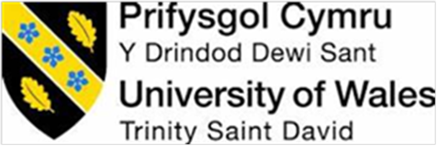

Dear Resident,
I am an MSc Student at the University of Wales Trinity Saint David, researching Communication in Private High Rise Residential Buildings.
Most apartment developments are managed by a Facilities Management Team or Managing Agent. Their role in managing the building is critical, from organising insurance for the building, maintaining equipment such as lifts and water tanks as well as softer services, such as cleaning of common areas, window cleaning and maintaining reception services: Essentially, they look after everything outside the front door of an apartment and are responsive to issues within an apartment, such as dealing with a leak on a main pipe serving the apartment.
I am grateful to the managing agents at two developments, in Swansea and Barnsley, who have assisted, in allowing me to deliver these questionnaires to complete this research. I would be very grateful if you could give 5 minutes of your time to complete this Questionnaire, and which will be treated as confidential.
As a resident, your involvement is highly valued, and will perhaps demonstrate preferred methods of communication between residents and Facilities Teams / Managing Agents of High Rise Residential Buildings.
Please could you complete and return by 23rd July 2021
If completing online, returns will be automatic. If you prefer, you can print and return to the Swansea reception, or if at Barnsley, at the Quest Property office at the building.
Thank You, Brad Wood (Email 2014427@student.uwtsd.ac.uk Mob:07747 022338)
Please scan QR code if you prefer to complete online.


Additionally, if you require a further questionnaire for a flat mate / partner, please feel free to contact and I can send an email link, or a hard copy.

Communication in Private High Rise Residential Buildings.

* Required

Introduction.
Communication is the process by
which messages or information is sent from one place or person to another, or the message itself (Source: Cambridge Dictionary).

In July 2020 a Draft Building Safety Bill was presented to the UK Parliament, which contained the requirement for all residents of High-Rise Residential Buildings, regardless of whether it is owned or rented, to have more of a say in their buildings by way of a Residents Panel. A spokesman for the Ministry of Housing Communities and Local Government said this would provide residents with routes through which to raise concerns about safety in buildings (BBC News, 2021).
At the same time the Institute of Workplace Facilities Management (IWFM) were issuing guidelines for their members on communicating with staff during the COVID-19 pandemic but fell short when advising their members on effectively communicating with residents in residential developments.

When the Building Safety Bill is fully passed, residents will have a voice, demonstrating the need for effective communication between Facilities Management Teams / Managing Agents and all residents of the building. Additionally, should we see another Pandemic, then there is perhaps a greater need for Facilities Managements Teams / Managing Agents to have a robust set of communication strategies with residents.

As an MSc Student at the University of Wales Trinity Saint David, I am researching Communication in Private High Rise Residential Buildings. I am grateful for the Facilities Management Team of two sites in Swansea and Barnsley who have allowed me the opportunity to research these developments.

As a resident, your involvement in this research is highly valued, and will perhaps demonstrate preferred methods of communication between residents and Facilities Management Teams / Managing agents of residential buildings. I would be very grateful if you could give 5 minutes of your time to complete this Questionnaire, which will be treated as confidential.

Please could you complete and return by 23rd July 2021
If completing online, returns will be automatic. If you prefer, you can print and return to the Swansea reception, or if at Barnsley, at the Quest Property office at the building.

Thank You, Brad Wood (Email 2014427@student.uwtsd.ac.uk (mailto:2014427@student.uwtsd.ac.uk) Mob:07747 022338)
If you require additional forms or wish to be advised of any results of the questionnaire, please email using the above address.

- Do you understand the role of a Facilities Management Team / Managing Agents?

 Yes

 No

 Not sure

- What is your understanding of the English Language?

 I can speak English and read English

 I can speak English and have a good understanding of written English

 I cannot read English. Someone helped me complete the questionnaire

Other

- Since moving into your property, have you had regular communication with the Facilities Management Team / Managing Agent?

 Yes

 No

 Only when I moved in

 Never had any communication

- Considering the role of the Facilities Management Team / Managing Agents, how important are the following topics to you?

Essential Very important Important Not important Prefer not to say

Cleanliness of common      areas
Security of the building      Notice of fire safety
improvements at the     
building






Residents behaviour toward each other






Awareness of Covid-19 cases in the building






Personal safety at the building





Notification of planned maintenance at the building; and which affects you

Effective and quick
communication with the      facilities team

- When was the last time your Facilities Management Team / Managing Agents communicated with you about the following topics?

Cleaning schedules Planned Maintenance
Advice on Covid-19 social distancing measures

Fire safety at the building

Offering the opportunity to discuss concerns or to suggest improvements
Less than 3 months ago








Between 3-6 months








Between 6-12
months 12 months +













Never had contact









- Have the Facilities Management Team / Managing Agents asked if you wish to be added to a vulnerable, or risk register in the event of an emergency?

 Yes  No
 No, But I would have liked to have been added  Prefer not to say

- What is your opinion of current communication methods between the Facilities Management Team / Managing Agents, and residents at your building?

 Excellent

 Very Good

 Average

 Poor

 Very Poor

Other

- What methods of communication do you most frequently use when communicating
with friends and family? Please select a maximum of 2 choices. *

 Social Media platforms

 Text message / Whats app

 Phone call

Email

Letters

Other

- When using your mobile phone, do you use mobile phone apps for any of the following? Please highlight all that apply. *

 Social Media

Gaming

 News / Weather

 Shopping

 TV / Film streaming

Food Deliveries

 QR Codes

 Podcasts

 You Tube channel

 I don’t use mobile phone apps

- How important is it to you as a resident, to feel you can have quick and effective communication with the Facilities Management Team / Managing Agents of your building? *

 Extremely important

 Very important

 Important

 Not important

 I don't care about communication

- Rank the options below in order of your preferred method of communication with the Facilities Management Team / Managing Agents. Please move your most
preferred method to the top and your least preferred method to the bottom - If completing a paper copy, please write your answers alongside, 1-8, with 1 your preferred method.
*

Letter

Residents Mobile phone App. Offering private 2-way-communication.

Email

Social Media (Facebook / Instagram / Snap chat etc.)

QR Code notice, allowing residents to access a notice board for updates

Residents podcast. Allowing residents access to recorded messages

Text message / Whats App

Phone call

I have no preferences

- If your OPTION 1 method of communication was adopted, would it encourage you
to communicate regularly with the Facilities Management Team / Managing Agent? *

 Yes

 No

 Maybe

Section 2
In order to analyse the data in section 1, please could you complete all questions in section 2. All
responses will be held in the strictest of confidence.

- How do you best describe your age group?

 18-25

 26-34

 35-44

 45-54

 55-65

 65+

 Prefer not to say

- Which of the following gender do you identify as?

 Female

 Male

 Transgender female

 Transgender male

 Gender variant / non-conforming

 Prefer not to say

Other

- Residential Status

 Own and live at property

 Rent Property (Sole or shared occupancy)

 Living with parent / friend

Other

- Employment Status

 Employed (Full or part time)

 Currently unemployed

 Student (Full or part time)

 Retired

 On long term sickness

 Prefer not to say

Other

- Marital status

 Married or Domestic Partnership

 Single (including engaged)

 Widowed

 Divorced

 Separated

 Prefer not to say

Other

- Nationality. Please insert your answer below.

- Please indicate the location of your property

 Barnsley

 Swansea

- What way did you complete this questionnaire?

 I completed a paper copy

 I received a link and completed on my phone / PC

 I scanned the QR code and completed from there

Other

- Are there any issues, recommendations, or suggestions that you would like to see or encouraged when considering communication with the Facilities Team / Managing Agents who manage your building?

This content is neither created nor endorsed by Microsoft. The data you submit will be sent to the form owner.

 Microsoft Forms

Appendix 2: Letter to Barnsley residents who did not receive a paper copy of the questionnaire

Dear Resident,
I am an MSc Student at the University of Wales Trinity Saint David, researching Communication in Private High Rise Residential Buildings.
Most apartment developments are managed by a Facilities Management Team or Managing Agent. Their role in managing the building is critical, from organising insurance for the building, maintaining equipment such as lifts and water tanks as well as softer services, such as cleaning of common areas, window cleaning and maintaining reception services: Essentially, they look after everything outside the front door of an apartment and are responsive to issues within an apartment, such as dealing with a leak on a main pipe serving the apartment.
I am grateful to the managing agents at two developments, in Swansea and Barnsley, who have assisted, in allowing me to research communication at questionnaires to complete this research. I would be very grateful if you could give 5 minutes of your time to complete this Questionnaire, and which will be treated as confidential.
As a resident, your involvement is highly valued, and will perhaps demonstrate preferred methods of communication between residents and Facilities Teams / Managing Agents of High-Rise Residential Buildings.
Sadly, if you are receiving this letter, it is because DPD lost the parcel containing the questionnaire, and as the deadline for returns is 27th July, time does not permit for further delivery of paper questionnaires.
If you would like a paper copy, please could you email me on the address below., and I can either send a link to you or soft copy of the questionnaire..
You can also scan the QR code below and will be able to complete on your mobile device.
Thank You, Brad Wood (Email 2014427@student.uwtsd.ac.uk Mob:07747 022338)
Please scan QR code if you prefer to complete online.

Appendix 3: Consent form to interviewee participants
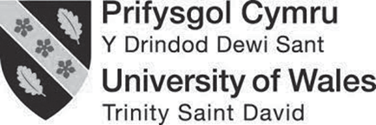

NAME AND ADDRESS
Reference – Interview to be held at XX to discuss communication methods in PHRRB’s and the study site they manage
Study site - X
Dated – xx/xx/xxxx

Dear X,
Further to our exchange of emails, I enclose :
Researcher – Bradley Wood, Student Number 2014427.
Institution – University of Wales Trinity Saint David.
Why Participant is selected – Due to fire defect issues identified at the development they manage
Purpose of the research – To evaluate existing communication methods at the development and understand residents opinions on communication channels.
Benefits of participating – To understand existing communication channels between FM’s and residents, and whether alternative communication channels would encourage residents to communicate more with FM teams.
Additionally, the questionnaire asks residents what is important to them, in terms of the services the FM team delivers.
Type of Participant involvement – The main involvement is to be interviewed over the course of one hour at the participants preferred venue. Additionally, to assist with the collection of returned questionnaires from residents, which will be collected by the researcher.
Risks to the participant – The interviews are conducted at a time when UK Government restrictions are starting to be relaxed because of Covid-19. The researcher will adhere to any protocols in place at interview locations, when visiting. Though all questionnaires contain no personal information, it is recognised there could be a risk to reputation of the FM/MA when respondents complete these as there is a free text box. However, this information can be provided to the FM/MA following the completion of the study, to allow them to assess their performance when managing their developments.
Confidentiality – It is advised the interview will be recorded and transcribed. The participant is advised they can have a copy of the transcript following the interview. The transcript will be contained in the appendices of the study, but names of participants will be omitted.
Withdrawal – The participant is advised they can withdraw at any time.
Questions – Should questions arise from the participant, which the researcher cannot give an honest or knowledgeable reply to, then the researcher will contact the University to highlight the question and to take further advice.
Yours Sincerely

Bradley Wood

Appendix 4: Question cards introduced at interviews
Interview : SWANSEA
Date : 27Th JULY, 2021
Subject : In a questionnaire, residents were asked to consider the role of the Facilities Management Team / Managing Agent. They were offered a list of topics and asked to select what is, and what is not important to them as residents.
1.
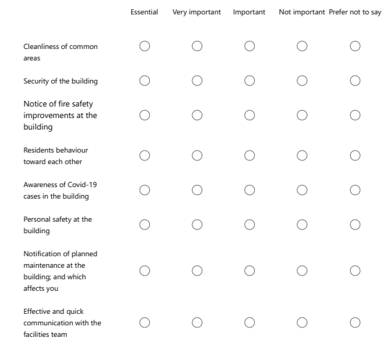
The Interviewee was asked to select what they thought most residents, completing questionnaires would choose at their building, and rate 1 to 8 the most import, where 1 is the most important and 8 the least important: based on returned questionnaires.

The Interviewee was asked to select what they believed most residents completing questionnaires would select.
Interview : SWANSEA
Date : 27 JULY, 2021
Subject : In a questionnaire, residents were asked whether they have ever been asked if the Facilities Management Team / Managing Agent at their building had asked them to be placed on a risk register or vulnerable list
2.

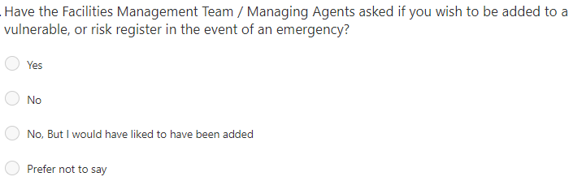

Interview : SWANSEA
Date : 27 JULY, 2021
Subject : In a questionnaire, residents were asked how important it was, to feel that they could have quick and effective communication with the Facilities Management Team, / Managing Agents of their building.
3
The Interviewee was asked to select what they believed most residents completing questionnaires would select.
Please also rate 1 to 5, with 1 being the most popular choice and 5 being the least popular choice: based on returned questionnaires.
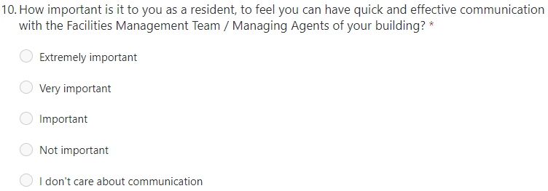

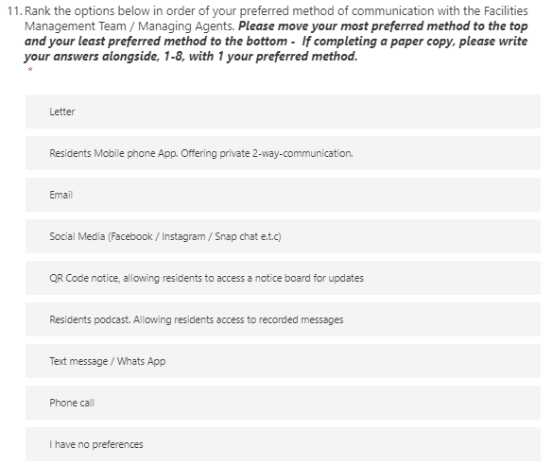
A - The interviewee was asked to rank from 1 to 9, what they believed most residents, returning questionnaires, would have selected as their most preferred channel of communication.
1 = most preferred and 9 = the least preferred.
B – The interviewees were also asked whether they thought residents would engage if their preferred method of engagement was adopted.
Interview : SWANSEA
Date : 27 JULY, 2021
Subject : In a questionnaire, residents were if their preferred methods of communication were adopted, would it encourage them to engage more with the Facilities Management Team / Managing Agent.
4.

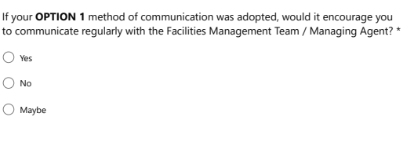

Appendix 5: Questions used by researcher during interviews

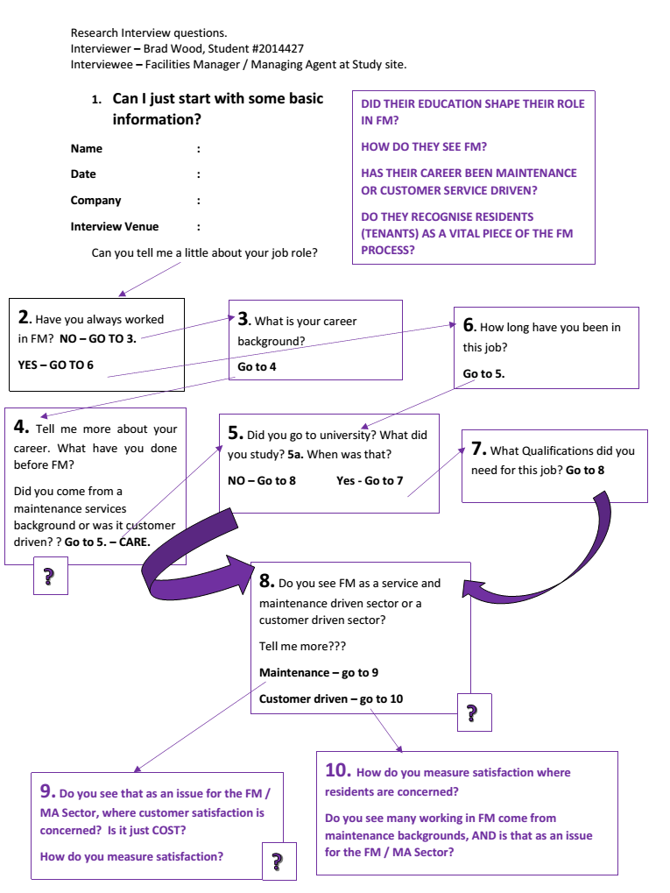

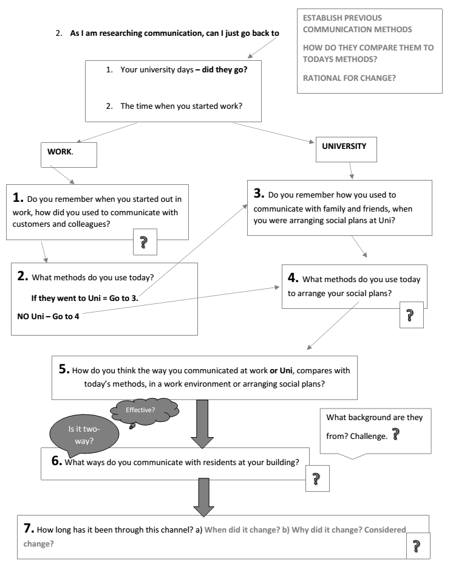
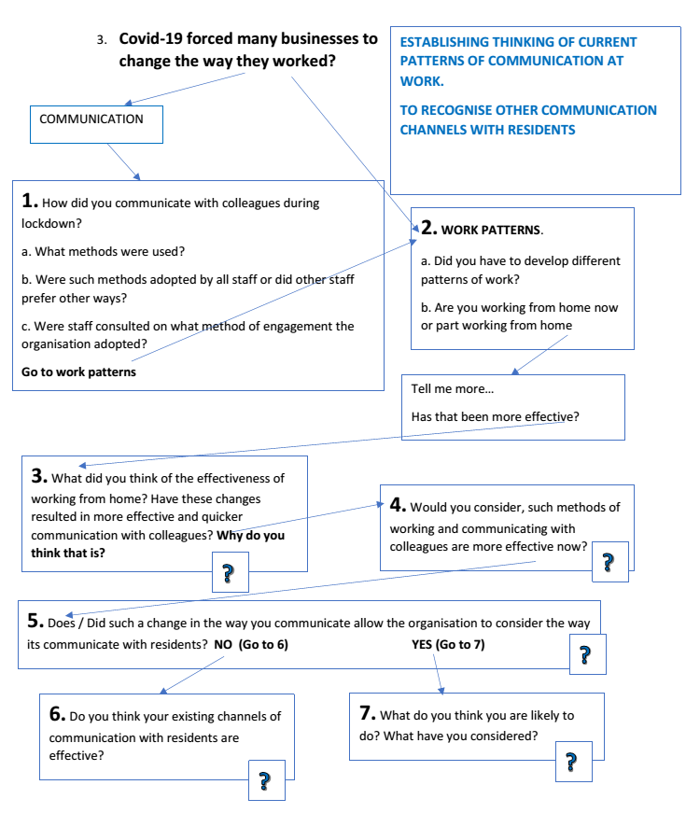

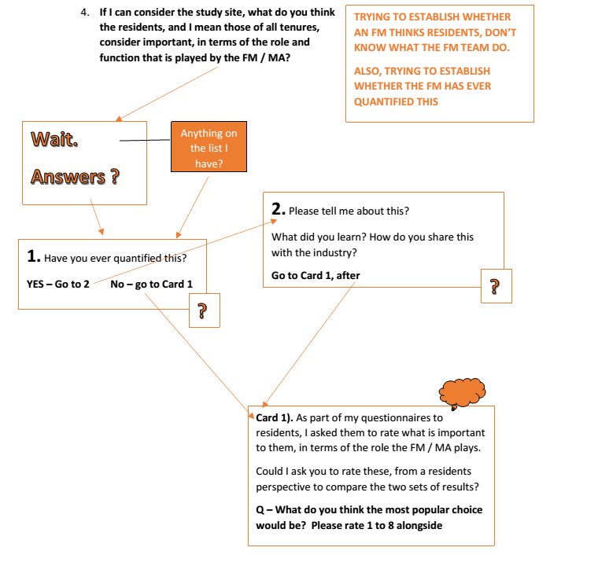
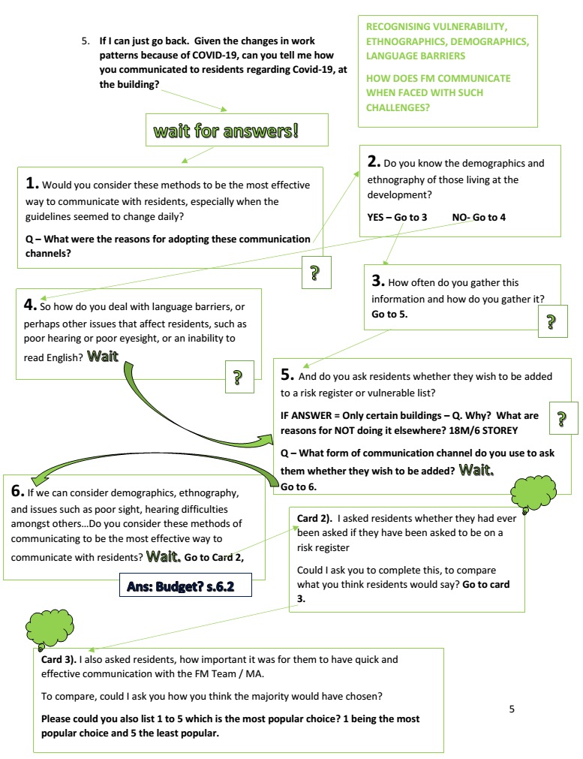
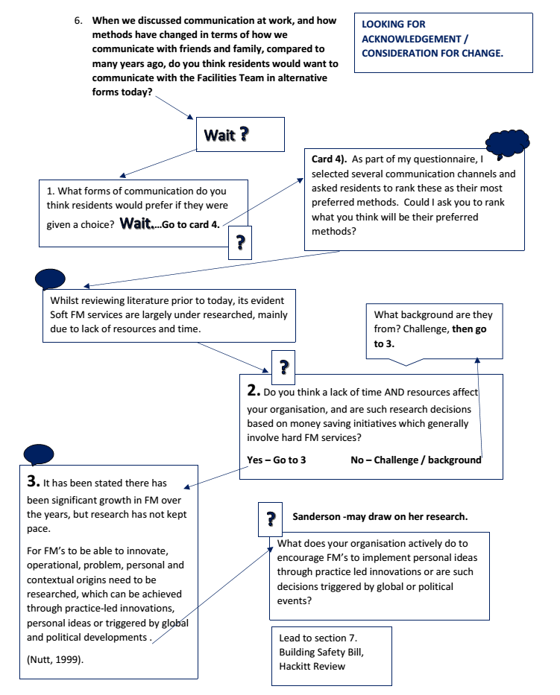

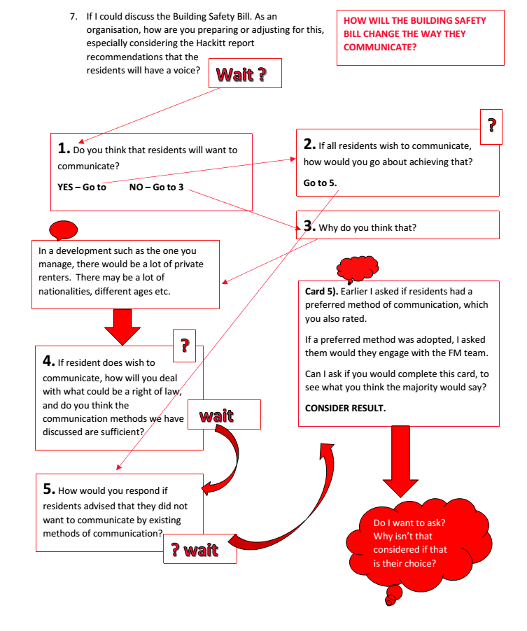

Appendix 6: Transcripts of interviews

Interview with Swansea FM
Introduction.
BW- Can I just start please with some basic Information please? Can I get your name?
SWANSEA FM – name omitted.
BW – And the date today is?
AMO- 28TH July, 2021.
BW – And you work for who Name omitted.
SWANSEA FM- So, I work for CRM Students Limited. But we trade as CRM Residential.
BW – OK, Just for the recording, can you confirm where we are today?
SWANSEA FM– So, we are at the Meridian Quay development in Swansea.
BW – Fantastic. Thank you.

Question 1 1. 38 seconds
BW – So can you tell me please, a little about your job role?
SWANSEA FM– Yes, I am the director of property services and I look after our leasehold side of the business. So we have about 22 developments that we manage all across the country. Some are mixed use, so residential and commercial, but the majority are residential leasehold properties. So what we are responsible for are, is making sure the common areas and the structure of the building are all maintained and responsible for the health and safety and upkeep of the building. Making sure the building is insured and dealing with any adhoc queries the owners have. So we have to put together a service charge budget each year which will consists of various cost categories like electricity, cleaning, and gardening, so we do that, you know to put a service charge budget together and that budget gets charged out to the owners of the apartments. And that is the money we use to run and manage the developments.
BW – Great, and have you always worked in the FM industry? 1.2
SWANSEA FM– Uh, For the last 20 years I have.
BW – OK. So what was your career before that? 1.3
SWANSEA FM– Before that I was at university. So I came out of university and then my first job was really into property management.
BW – So you have never been in anything other than Facilities Management? 1.4
SWANSEA FM– No. So, it was a bit more property management focused, before looking after the leasehold. So the property management side of things was slightly less FM Focused as it was more lettings negotiation and that kind of thing. Referencing and moving the tenants in to individual houses or apartments, so the focus wasn’t quite so much on the sort of FM services.
BW – You said you went to university. What did you study there? 1.5
SWANSEA FM– I did a history degree.
BW – OK, when was that?
SWANSEA FM– Oh, 19, I think I finished my degree in 96, I think.
BW – So you didn’t really need that qualification for the job you do today? 1.7
SWANSEA FM– No.
BW – In that case, do you see FM or Managing agent as we call it as well, as mainly a service and maintenance sector, or a customer driven sector? 1.8
SWANSEA FM– When I think of FM, I think of it more as a maintenance driven sector, but it really is both. It really is both (said twice). But I think my immediate thoughts on it, are more sort of service driven.
BW – So, you look at it from both ways. How do you, um, from a service sector, is it primarily driven by cost.
AM0 –I think it is. ABSOLUTLEY. SAID WITH CERTAINTY, 4 MINS. 1.9
BW – because of the residents?
SWANSEA FM– Yeah, because of the residents. That really rolls into the service delivery and actually the satisfaction and the feedback that you get from leasehold owners. It is very cost driven.
BW – and on that, you said satisfaction. How do you measure satisfaction, where residents are concerned? 1.10
SWANSEA FM– So, normally at the start of each financial year for the building, we would send out service charge budget and an explanation letter as to why the cost ‘x’ is this, this is what we are intending on doing. And if your budget has gone up there is a noticeable increase in the feedback and the emails that you get querying, “why is this”, “I’m not happy with this”, “By the way, I went past the other day, and I saw a light out”, “I think the gardens are overgrown”. Whereas if you send out a budget that is generally the same as it was the previous year, or maybe less, you are, you get far fewer enquiries and feedback back.
BW – So, would you say…
SWANSEA FM– an…..
BW – Sorry, go on.
SWANSEA FM– I was going to say it’s not a great measure of satisfaction, and it’s not particularly scientific, but I think people pay up and pay their charges and, you know, don’t express dissatisfaction, I suppose.
BW – So would it be fair to say the measure of satisfaction would be…the least amount of complaints you get, the more satisfaction….
SWANSEA FM– Yes.
Question 2 – 5.40
BW – OK, so on that basis as I am researching communication, if I go back to your university days to start with, do you remember how you used to communicate, back in 1996, with family and friends when you were arranging social plans at Uni? 2.3
SWANSEA FM– Yeah, so it was all by phone. So, there was a phone at the end of the halls of residence corridor, where you’d shove money into, and you would ring them.
BW – great, and that’s how you’d arrange it. So, what methods today to arrange social plans?
SWANSEA FM–(time 6.12) It would be text. A lot of text now (emphasised), texting friends. quickly said. 2.4
BW – OK. And if I just go back to your, um, workdays, do you remember when you started working. 2.1
SWANSEA FM– Hm.
BW – Do you remember how you communicated then with customers and colleagues. 2.1
SWANSEA FM– So, a lot of it was letter…and fax.
BW – OK (BRIEF PAUSE)
SWANSEA FM– So, emails were only just sort if coming onto the scene. I had probably only been working a couple of years, so it was phone calls and letters.
BW – And what methods would you use today? 2.2
SWANSEA FM– Similar. Letters, phone calls, but email. Yeah, yeah.
BW – OK – (6 SECOND PAUSE) – And do you think the way you communicated and work or Uni, how do you think they compare today’s methods, in a work environment or when arranging social plans? 2.3
SWANSEA FM– I think it is far more voluminous. “So, you get so much more” (elongated when saying this – almost word pause word) information being thrown at you, than you would have done previously. So, you, with friends, perhaps it tends to be sort of shorter communications, less meaningful. And work, the volume of what you receive is so (emphasised) different to when I started 20 years ago.
BW – As in more?
SWANSEA FM– Oh, a lot more now. So, I think previously if people had to send you a letter or fax, you know, you’re not so inclined to sit down and do that. So, it was more paced and allowed you to be able to consider things a bit more, because you weren’t just faced with a deluge which is what, you know, can quite often happen with email.
BW – So, your quicker to react to an email and you have more to think about what you want to say in a letter?
SWANSEA FM– Yeah. So I would say, quicker to react to emails, but again it depends on the volume of them.
BW – Do you consider more effective now?
SWANSEA FM– I think probably it is more effective now. It probably is more effective now.
BW – So, on that basis, perhaps it is a difficult because you came into FM, straight out of, into the sector, but what days do you communicate with residents in the building now? 2.6
SWANSEA FM– So, it is mainly email. Its letters and email.
BW – To the residents or the leaseholders? 2.7
SWANSEA FM– Oh. To, right Oh ok. To the occupiers, it would always be letter, because if the leaseholders and the owners had sub-let their apartments, we don’t necessarily have any relationship with those occupiers at all. We don’t know their name, you know, so if there is something happening in the building that we need to make them aware of we would send a sort of circular distribution or notice out to the buildings, either displayed on notice boards within the building or put into each letterbox.
BW – Is that two-way communication method? 2.7
SWANSEA FM– No, it’s not. It’s one way.
BW – So would you consider that to be as effective as the ways you communicate with leaseholders as an example?
SWANSEA FM– I think for the purpose of the way we need to communicate with the occupiers, it is effective. Because we are generally saying to them ‘window cleaning is happening on a certain date’ or reminding them to please put rubbish into the bins, so it’s not something that the residents or occupiers of those apartments could influence as to what happens. You know, if an occupier had come back and says I don’t want my window cleaned today, it’s too bad, it has to happen for the whole development on these days.
BW – So has it always been through that channel, with letters then? 2.7
SWANSEA FM– Yes.
BW – OK – 5 SECONDS
Question 3 10.55
BW – So Covid-19 forced many businesses to change the way they worked. From a communication point of view, how did you communicate with your colleagues then, during lockdown.
SWANSEA FM– It was email and phone.
BW – And were those methods adopted by all staff or did other staff prefer other ways. 3.1
SWANSEA FM– It was all staff. It had to be adopted by all staff.
BW – So, and out of interest, were they consulted on those methods of engagement? 3.1
SWANSEA FM– Um, no. And actually, we used Teams as well. We started to use a lot more video conferencing, so Teams, which we hadn’t really ever used before as a business.
BW – OK, so looking at your work patterns, did you develop different patterns of work because of the way you communicated.
SWANSEA FM– (sighs) Not necessarily different patterns, but it definitely (EMPHASISED) made everything twice as hard.
BW – It made it harder?
SWANSEA FM– Yes. Definitely made it a lot harder.
BW – Can you tell me more about that name omitted?
SWANSEA FM– So, normally with your colleagues, if you’re all in the office together, you talk face to face, and you might say we need x, y, and z to be done, and if that particular colleague is not quite sure how to do it, you can just physically show them on the computer, and it’s something that you know might take 2 minutes. When you are trying to communicate that over email, that might be 10-20 emails, rather than you know a 2-minute conversation. EMPHASIES So it definitely made everything harder, and I definitely found other business that we have to partner with to deliver our services like solicitors, accountants, the same sort of chain of reaction, was being, um, sort of, you know, was occurring in their businesses as well. So it slowed everything down.
BW – You mentioned you were on teams, could you perhaps share screens to show them what you were trying to explain, was that a policy, or something you put to use, or did?
SWANSEA FM– I think it is a bit more now. When we first went into lockdown, I think everyone was getting to grips with the conferencing, and the video, you know, like either with zoom or teams. So, I think, perhaps, like everything, it took a little while to develop to learn how to use it, so that you could share your screen, and, but it’s not quite the same as just being there and being able to show someone.
BW – OK. So, would you, do you think the patterns…. Do you work from home now much, or at all?
SWANSEA FM– No – I tend to work from the office?
BW – So are people tending to work from home?
SWANSEA FM– The majority of people are working from home.
BW – Would you say that is because they find that more effective? 3.4
SWANSEA FM– Yes. I think it is a bit of both, but our business now are trying to encourage everyone back into the office, and I think they are receiving quite a lot of resistance from some people who don’t want to come back into the office, and I think you know, reasons being given are the travel time to the office, so they lose that time in their working day. You know, It is more convenient for them to work from home, some people are saying they get more done working from home, but what you don’t get working from home is that sort of camaraderie between your colleagues, and perhaps and that joint thinking of left hand right hand where as if you’re working together in an office, you know colleague ‘x’ is doing, working on this and you know, you can feed off each other.
BW – OK. So from your opinion though, the changes as a result of home working, are not more effective. 3.4
SWANSEA FM– Hm, Hm.
BW – And they are not as quick when you are communicating with your colleagues??
SWANSEA FM– Yeah.
BW – OK, So would you consider such methods are perhaps here to stay, within your organisation?
SWANSEA FM– I think inevitably, parts of it will be, because there is more demand from employees for flexible, you know, flexibility in their working location, um, so I think it is going to become more hybrid, and a mixture of both.
BW – On that basis, when we are talking about residents, and particularly the study site at Meridian Quay, where there are a lot of people on short term tenancies, do you think perhaps the that way you have communicated, or the channels that you’re using now, um, would perhaps allow your organisation to consider other forms of communication with residents? 3.5
SWANSEA FM– Uh, Yes I think it could do. So, we have done….With the residents or with the owners?
BW – The Residents.
SWANSEA FM– So with the residents, probably not. Because we don’t have access to like who they are, what their email address is, how long they are here for. And because it’s such a moving feast, as well, so we would be relying on the owners to tell us, you know, that Jayne Smith is in apartment number 12 from this date to this date. It would be such a churn and turnover, all the time.
BW – I get all that.
SWANSEA FM– So, um, yeah, I think that would be difficult, unless it was something that was completely automated.
Question 4.
BW – Right. Ok. So if I just consider the study site here then at Meridian Quay, what do you think the residents, and I mean those of all tenures consider important in terms of the role and the function that is played by the FM or the managing agents. 4
SWANSEA FM– For the owners, I think it is definitely cost is their number one priority.
BW – OK. But more for residents actually. 4
SWANSEA FM– And so for residents, I think it is the softer side of the services, so what they see and what they notice more, so, you um, know the general cleanliness of the building, um, you know, the grounds and the estate are sort of, um, its cosmetic I think. A lot of what the residents see is cosmetic, and I think that is their initial concerns, but they also, I think in tandem with that, want to know when they need the lift, it’s there, and it’s working. Most of them probably don’t think how the water gets into their kitchen or their bathroom, but obviously behind the scenes we’ve got to make sure the water pumps are serviced and checked and, but I think, you know a lot of occupiers and residents that live in a building like this probably aren’t even aware of what has to go on in the background to make sure their water is delivered. Um, But I think, you know, the things that are a bit more tangible, like making sure their corridors are lit and they can see the way to their front door, that the lifts are working and the cleanliness. So, I think with occupiers, it is very much what they can see.
BW – OK. But you don’t really quantify that with them, as to what they consider as important then? 4.1
SWANSEA FM– No, we don’t every really gain feedback from the occupiers, as to what is important to them.
Card 1 introduced
BW – OK. Part of my questionnaires to residents, I asked them to rate what is important, to them in terms of the role of what the FM or Managing agent plays. Could I ask you to rate these from a residents perspective, just so I can compare the two sets of results.
SWANSEA FM– Yeah
BW – What you as an FM think.
SWANSEA FM– OK
BW – And what they think, and perhaps when you tick the choices here, which is my question card 1, and then also rate them 1 to 8, with 1 being you think what will be the most popular answer.
SWANSEA FM– Right.
BW – OK
SWANSEA FM– Um,
BW – That says the interview was asked to select…
SWANSEA FM– So if I tick it and then afterwards do 1 to 8.
BW – Yes please. (time 19:30)
SWANSEA FM– 20:27 There we go
BW – Excellent, thank you.
QUESTION 5.
BW – OK. So, If I can just go back a second, given the changes in work patterns because of Covid, can you tell me how you communicated with residents because of Covid in the buildings? 5.1
SWANSEA FM– UM, Yeah, So there were notices put up in the buildings, so it was a requirement to wear masks in communal areas. Um, that was only brought in when the Welsh government brought in those guidelines, so we very much tried to stick with, you know, what the government legislation is, um, and a communication went out to the leaseholders by way of a sort of letter notice that was put through everyone’s door, so we suspended parcel collection services during that time, so the staff had less face-to-face contact. We encouraged and asked residents if they needed to contact, um you know, our on-site team here to try and do it by email or by phone call, so to limit that face-to-face human contact. And, um, that so our focus would be really on more of the cleaning. So, cleaning frequently touched areas. So, we might do less hoovering and dusting, but there is going to be more wiping down. So, just a focus change slightly.
BW – OK, but in terms of the communication it was notices and letters asking them to contact you by email or by phone
SWANSEA FM– Yeah
BW – OK, UM, so would you consider those methods the most effective way to communicate with residents, especially when, and you mentioned the Welsh governments guidelines were changing almost on a daily basis at one point. 5.1
SWANSEA FM– Yeah, I think it was the only way, really for occupiers to communicate with the team – MISSED AN OPORTUNITY
BW – OK. In that case do you know the demographics and ethnography of those living at the development? 5.2
SWANSEA FM– There are a lot of, sort of foreign students here, particularly from the United Arab Emirates and a number of sort of Chinese students, and then we also have a number of sort of older occupiers, so that’s generally, that’s the main demographic of the occupiers here.
BW – So that’s from empirical observations, rather than….
SWANSEA FM– Yeah, so, yeah, we don’t have any specific data collected.
BW – OK. So how would you deal then in that instance, if you go back 12 to 18 months, how would deal with language barriers or perhaps other issues that affect residents, such as poor hearing or poor eyesight or inability to read English? How would you, if you could go back 18 months, how would you deal with it? 5.4
SWANSEA FM– So, in the past, we had a set of tenant regulations which come from the lease, things like don’t you’re washing out on the balconies, and so we got those tenants regulations interpretated into sort of mandarin and then also Arabic. (Time 24 MINS)
BW – Yeah
SWANSEA FM– Um, and we’d asked letting agents to give that, to incoming tenants.
BW - OK, that was something you adopted a while back was it?
SWANSEA FM– Yeah, that was something we done quite some time ago.
BW – Is It…..
SWANSEA FM– Its probably lapsed actually.
BW – OK. Um, So do you ever ask residents if they wish to be added to a risk register or a vulnerable list? 5.5
SWANSEA FM– In Meridian Tower we have had to change the fire strategy from stay put to a phased evacuation because of the fire risk here. So, we have sent out, um, an evacuation questionnaire to all of the properties to all of the apartments here, which…
BW – In just the tower or the bay and the wharf
SWANSEA FM– Just the tower because the bay and the wharf are still stay put. So, it’s just the tower which has changed to a phased evacuation. So, this questionnaire asked are they aware of where the emergency staircases are, are they able to evacuate unaided in the event of an alarm going off. You know, is there anything they think would prevent them from being able to evacuate when the alarm triggers. Be that, you know, perhaps, they won’t be able hear the alarm or they might not be physically able to use the stairs, um, and we have sent out that questionnaire, I think, 3 or 4 times now, and out of 123 apartments, we have had about 12 responses. It’s been really low.
BW – And do you ask people to respond even if they are…. deem themselves safe?
SWANSEA FM– Yes, Yes.
BW – OK, so on the basis perhaps the Building safety bill is coming out and the guidelines with that it will be 18 metres or 6 storeys, do you think there is a requirement to perhaps do the other buildings as well? Even if the lower buildings are 4 or 5 storeys, where you might have someone who is elderly……and I am only using Grenfell as an example, but when they abandoned the stay put policy there, there was no way of communicating to residents that ‘you need to now leave the building…’
SWANSEA FM– mmm
BW – So even though you may have a stay put policy on other buildings, when that stay put policy needs to be abandoned, how does that, how do you communicate that message, and I know it’s not your responsibility…
SWANSEA FM– Yeah,
BW – But how do you make the fire authority aware that perhaps there is a lady in number 20, on the 4th floor, who is actually in a wheelchair?
SWANSEA FM– mmm. I don’t think the facilities, or the property manager can. Because again you will have that churn and turnover who is actually staying in the apartment. So, what may have been true three weeks ago could have changed, you know, on the day of the fire. There is just, such a sort of revolving door if you like, there is no way that managing agents will be able to keep track of that and update authorities.
BW – OK, if we just go back a bit then, when we consider demographics and ethnography and you’ve had 12 returned questionnaires, UM, do you perhaps consider then….and this is no reflection of FM in this building, it’s just my observations, and having been there…..
SWANSEA FM– Hmm Hmmm.
BW – Do you perhaps consider that the letters perhaps and questionnaires are perhaps not that effective of getting that information off people? 5.5
SWANSEA FM– I think that would be true. That would be true to say.
BW – Do you think perhaps it should become a requirement from a leaseholder to tell their letting agent to complete that questionnaire before the tenant takes occupation?
SWANSEA FM– Yes, I think it should. For that, I think occupiers should almost have to self-identify whether that’s with a requirement to do that with the fire brigade directly, or for their letting agent to let the building managers UM, know so they can hold that information in a premisses information box when the fire brigade arrive on site. Um, but I think for it to be effective, it would almost have to be some kind of register that the fire brigade could hold on different buildings.
BW – I’d agree. I think, when I look at the Rent Smart Wales, there is so much obligation on landlords,
SWANSEA FM– mmm. mmm
BW – If you’re familiar with the rent smart Wales legislation, but yet there is nothing on the tenants to inform the people…
SWANSEA FM– Yeah, yeah.
BW – who manage that building that they need help in the event of an emergency..
SWANSEA FM- Exactly, and there has to be, there has to be some personal responsibility in it.
Card 2 introduced
BW – I’d agree. So going back to the risk register then, I’ve asked people as part of my questionnaire, have they ever been asked to be added to a risk register, and I know you said they have. But could I ask you, to select what you think the majority or residents who completed questionnaires would have said?
SWANSEA FM– hmm hmm.
SWANSEA FM– I am going to say no, just judging on such the poor response.
BW – OK, right. And I also asked residents, how important it was for them to have quick and effective communication with the FM team or managing agents.
SWANSEA FM– Hmm Hmm.
Card 3 introduced
BW - just to compare, can I ask you what you think the majority of these would have chosen, from extremely likely to I don’t care about communication, and also to list them 1 to 5, 1 being what you think most people would say to 5 which is obviously, least likely.
SWANSEA FM– OK (Time 29:44 -30:04)
QUESTION 6.
BW – Interesting. So, when we discussed um, methods of communication of work and how methods have changed in terms of how you communicate with friends and family compared to many years ago, do you think that residents, and I mean living here rather than leaseholders, how do you think they would want to communicate with facilities teams? Do you think they would want to communicate in alternative ways? 6
SWANSEA FM– Uh, they. I think that, particularly looking at the, what I believe to be the demographic of this building, they probably more, sort of the younger generation probably are more text and whats app focused, something along, yeah.
Card 4 introduced (includes question from card 5)
BW – OK. So, as part of my questionnaires then, I asked, I selected several alternative channels and asked residents to rank these as their most preferred methods of communication.
SWANSEA FM– Hmm Hmm
BW – So could I ask you to rank what you think would be their most preferred method,
SWANSEA FM– Right
BW – Again, 1 to 8 again
SWANSEA FM– OK. (time 31:16 – 32:08)
BW -You’ve just missed the last one.
SWANSEA FM– Sorry
BW – That’s ok. I said 1 to 8 it should be 1 to 9
SWANSEA FM– There you go (handing back)
BW – Thank you. So, whilst reviewing literature prior to today, it was evident that soft FM services are largely under researched, mainly due to lack of resources and time. 6.2
SWANSEA FM– hmm hmm
BW – Do you think a lack of time and resources affect your organisation, and in particular the FM’s who work in these developments, and are such research decisions based on money saving initiatives, which generally involve hard FM 6.2
SWANSEA FM– emphasised “ABSOLUTLEY”. So, I think I would echo, lack of resource and time to research soft FM and it is very much driven by cost.
BW – OK, it has been stated that there has been significant growth in FM over the years…
SWANSEA FM– Hmmm Hmm.
BW – But research has not kept the same pace. So, for FM’s to be able to innovate, operational problems, personal and contextual origins need to be researched, which can be achieved through practice led innovations, personal ideas or triggered by global or political events. So, what does your organisation actively do, to encourage FM’s to implement personal ideas through practice led innovations, or are such decisions triggered by global or political events?
SWANSEA FM– Um, they are probably more triggered by the corporate structure of the business I’d say. So, innovations are generally sort of quite I.T led
BW – Ok
SWANSEA FM– Nowadays. So, within our organisation there isn’t really that opportunity to…for individuals to be particularly innovative about sort of different programs we could use, as it has to be a more global package for the whole business.
BW – for your whole organisation, is it?
SWANSEA FM– yeah. For the organisation, so it’s difficult to do spin offs for different developments, or different sectors or areas of the company, it tends to be, so it’s a bit more company driven.
BW – So, as the case here, your building manager here then, how would he be encouraged to perhaps give you an idea that he thinks would be perhaps, um, perhaps make the building a bit more…
SWANSEA FM– yeah, so that sort of thing day to day would be more discussions with, so it would generally be by phone calls and meetings, as to, you know, this is working really well, this isn’t working particularly well, what can we do to improve it.
BW – ok and if the building manager said “well I think this would be better, but it’s going to cost us more” how do you think that gets dealt with by your organisation? 6.3
SWANSEA FM– That’s a tricky one, because its whether or not it is just something that would be specific and work for this particular building, or whether it is something we could apply across the board, and I think buildings do very much have their different need, so this building is quite complex, there is a lot of plant there is a lot of equipment. Um, You know, it has its only particular set of issues whereas, you know, we have other little blocks that are 20 flats, it really is just a doorway, so they are probably, there is a doorway and stairwell into their apartment, they are not going to be wanting to spend the money to, or be so interested in, um, you know sort of different, different developments, so I think its um, a little bit horses for courses and then I think it then comes down to a question of cost.
BW – OK, so would it be fair to say there is not a policy within the company to promote ideas, that, this is not generally aimed at CRM.
SWANSEA FM– Yeah, and not specifically, I would say, not specifically, but obviously there are general meetings and chats that go on with the teams, so I would say it’s a bit more organic or adhoc, rather than a specific policy, to say.
BW – But are such decisions actions within the organisation are probably led from the top rather than allowing staff below to suggest ideas.
SWANSEA FM– I think staff below can suggest ideas I think, and it’s just depending what they are and on how easy they are to be implemented, but if it’s something that requires perhaps, um, you know, something that requires a company cost, yeah, that has to come from top down, I would say.
Question 7
BW – OK. If I can just discuss with you the Building safety bill, which is something I’m sure your au-ffay with…7
SWANSEA FM– Hmm Hmm
BW - As an organisation, how are you preparing or adjusting for this, especially considering the Hackitt report recommendations that the residents, will have a voice.
SWANSEA FM– Uh, so I suppose we are, we’re waiting to see what the legislation will finally be, so things like, will residents have to self-identify, or, because I think that is the only way which that will work. Um, I know in the past that we have sent circulars out to people to say you know the fire brigade offer free home safety services, so, and I know that has not had a great take up at all. So, um, I think we are really waiting to see what that, you know, what that actually looks like in reality, because our current understanding at the moment or the way perceive things at the moment is that residents and occupiers aren’t actually that interested
BW – OK. You don’t think they are?
SWANSEA FM– No
BW - So why do you think that though?
SWANSEA FM– I just suppose, things like lack of responses previously to initiatives previously to try and, I suppose try and encourage fire safety in buildings. So, um, sort of tangible things, you know occupiers tend to have a habit of liking to leave their items in the common parts. So, you know, it’s moving things, like don’t keep your shoes there, don’t keep your bikes, remove buggies. And all of that is part of fire safety, and so when you try to explain to an occupier you know, I know its inconvenient for, you know, you to have to sort of, you know, to have to take your buggy into your apartment when you might not have much space, but actually, you really can’t leave it in the communal areas, because its, you know, potentially obstruction and fire safety. So, I think then, and then when we have said to people, you know, the fire brigade they come around they do free home surveys, you know, call this number, um, there hasn’t been any uptake on that at all, and just poor responses to things like the evacuation questionnaires.
BW – So you don’t think people would want, you don’t think residents, will want to sit on meetings to discuss the….7.1
SWANSEA FM– No, I really don’t
BW – OK, so in the development such as the one you manage in Swansea, would you, there will be a lot of private renters, there will be a lot of nationalities, different ages etc. If residents do wish to communicate….7.4
SWANSEA FM– Hmm Hmm
BW - and do want to sit on meetings, how will you deal with that, which could be as a right of law, and do you think communication methods we have already discussed are sufficient to address that.
SWANSEA FM– Um, I think that if residents do want to end up sitting on a committee, I think that the use of teams would be, um, you know really useful to implement, um, because….
BW – So, sorry to interrupt, rather than having them in the actual meeting they could view it through teams, so something?
SWANSEA FM– Yeah or hold your meeting via teams. Um, and face to face. So, I think that, you know, they would be the, so rather than having like an email group, where its impersonal at least, face to face I think would be preferable in person, all in a room, or and um, but also just, you know using, facilitating teams.
BW – OK
SWANSEA FM- So which could allow, you know, residents if their still at work but that they can log on for half an hour to join that meeting.
BW – That’s good, I hadn’t thought of that, that’s good.
SWANSEA FM– Yeah
Card 5 introduced (was covered on card 4)
BW – Well I asked residents in my questionnaire, for residents to rank their preferred channels of communication….which, sorry, You’ve already done, so going back to the one you have done, preferred channels, if they were adopted, what do you think the response would be if people said to you “would you communicate with the FM, if your preferred method was adopted?” So, it’s a yes no or a maybe.
SWANSEA FM– Right, UM,
BW – I’ll give you this back, here were your choices.
SWANSEA FM– Um, I’m going to go a maybe.
BW – You’re going to sit on the fence name omitted are you? (Laugh)
SWANSEA FM– Yeah, (Laugh) I’m going to sit on the fence.
BW – Right, fantastic, so that is everything. Thank you very much. Is there anything you would like to add?
SWANSEA FM– I think there also is, there’s like a capacity issue as well. Because you hear back from your leaseholder owners, but if you do start to get far more engagement and feedback from residents, it’s how you resource that response. So, it’s you know having the capacity to deal with it and respond to it. Because I think , you know, a typical FM property Manager, already, is just so busy.
BW – And just something I was thinking about, out of this interview. I suppose, your customers from where you sit, are your leaseholders….
SWANSEA FM– Yes (certainty)
BW – Your building managers are his residents…
SWANSEA FM– Yeah.
BW – Its two very different roles really isn’t it.
SWANSEA FM– Yeah (certainty)
BW – the way you communicate with leaseholders, is via emails or letters, whereas your building manager does it via letters.
SWANSEA FM– Yeah
BW – and I am only going to go back to the smoke detectors, which we talked about briefly prior to the interview, the effectiveness of that communication: your building manager emailing all the different agents, to ask them which properties they manage, and can they let…..
SWANSEA FM– mmm
BW – tenants know that they are going to be coming in on this date, will they be there, if they’re not there can they give keys….I think from a building managers point of view, that’s a nightmare for that person….
SWANSEA FM– Yeah, it is
BW – to try and manage ……
SWANSEA FM– Yeah
BW - that whole process…
SWANSEA FM– Yeah
BW - and when you talk about resources, its very time consuming for him…
SWANSEA FM– Yeah, it really is, yeah, it really, really is.
BW – So, would you like to add anything else?
SWANSEA FM– No, I think that’s it.
BW – Fantastic, thank you for your time.
SWANSEA FM– You’re welcome.

Interview with Barnsley FM
BW – Do you mind Name omitted if we just start with some basic information?
Barnsley FM – Go for it.
BW – Your name?
Barnsley FM – name omitted
BW- and the date today, is?
Barnsley FM – Is the second of August
BW – And the company you work for?
Barnsley FM – name confidential.
BW – And the interview venue, is being held at?
Barnsley FM – Salford Quays, Number 3 Exchange Quay.
BW – Fantastic. Can I ask you name omitted; can you just tell me a little about your role with name omitted? Q1 INTRO
Barnsley FM – Yeah, so I am director of block management for name omitted property, which is part of name omitted. Um, we are, or I am responsible for the overall kind of department performance running of the block management function within the group, and within that is overall responsibility for compliance, P+L, um, departmental performance of all the different divisions underneath us, and making sure our blocks are safe and people want to live in them.
BW – And have you always worked in facilities management? 1.2
Barnsley FM – Yeah, so kind of my background originally was I was a chartered accountant, so came out of university, did a degree, got my ACCA qualification and became an accountant, and found that really boring, and moved over to property management, 12 years ago. 1.4 1.5 1.4
BW – Prior to that, you were an accountant, straight from leaving University? 1.2
Barnsley FM – Yep, so left University straight into an accountancy practice, thinking that was what I wanted to do, but found that really boring.
BW – So, do you think, coming from what I would class as a service background, into what is FM, a maintenance services, do you think FM is focused more heavily on a services background or a customer service background? 1.8
Barnsley FM – I think customer services background, for me, and that’s what all our recruitment is based on. We can teach you how to do FM, but if you ain’t the right person to deliver that, that’s important for us. For us it’s all about making sure, that whatever we’re doing, a) obviously we communicate it out properly to leaseholders and the rest of the team and they know what they are doing, and b) and the level of service is consistent. My background I guess has given me good standing, , in terms of financial performance of the business, and that’s great, and that is a service background so it’s a good building block for the rest of these guys going forward. 1.8
BW – And do you think the majority of people here would see FM as a maintenance service or customer services? 1.8
Barnsley FM – I think a mix of both, to be fair. I think ‘cos they know you can’t do one without the other, I think Brad, is my honest opinion. You can’t provide a good FM service, without having that customer service…
BW – No
Barnsley FM – And it’s not as if we’re serving corp, we serve a bunch of corporate customers which have a different requirement in terms of the customer service and the lot of the guys we service are homeowners, renters and all that kind of stuff, which is people. 1.8
BW – Yeah, yeah.
Barnsley FM – People need that customer service to be able to pay for our services through the management fees. 1.9
BW – So do you think the people here see that there is, and I’m talking about name omitted, rather than name omitted, how do you or they define the customer, as the resident or the leaseholder?
Barnsley FM – For us, everyone is a customer. So, that’s where we are probably different for a lot of block managers that are out there, is, originally the concept of customer for us would be leaseholder full stop. We don’t deal with tenants, we don’t deal with sub tenants and all that kind of staff, but you can’t do that nowadays. You know, these people are living in there, they’re your front line of defence, if there is a leak happening you want whoever is in there to report it to you. But if you say to them that we can’t speak to you, it doesn’t work like that.
BW – No
Barnsley FM – And our industry going forward is very much about who’s going to be living at the property as well as who owns it.
BW – Ok, can you tell me a bit more about that? People are living in it, rather than owning, how would you..
Barnsley FM – Yeah, I know where you are coming at on this one. People who are living in it would be for us, be potentially a couple of different options. So you’ve got a leaseholder who owns, and potentially lives at that property, so they’re what we class as an owner occupier, a leaseholder who owns in a block of flats but then rents their apartment out, so the renter is the person we would class as the occupier in that stage, so they are the ones that are paying the rent to the landlord, but living in the building, taking in all the services that we are providing, cleaning, window cleaning and all that stuff, so that’s where we kind of differentiate between our systems as well, we still talk to the residents, we talk to the leaseholders and we talk to the directors of the management company and we talk to the client.
BW – ok, in terms of, and how do you measure satisfaction perhaps predominantly amongst residents, rather than leaseholders? I assume with leaseholders, if their budget has gone up, they’re not happy, if their budget comes down, they’re happy. 1.10
Barnsley FM – That’s it.
BW – But in terms of the residents that actually live in those buildings, how do you…..
Barnsley FM – So it’s the quality of the building is the kind of, whats happening in the corridors are they all painted, are they clean are they coming in and if there is a leak that’s been happening, has it been resolved, has the follow up action been done? You know, it’s not as simple as saying we have sorted out the leak, we’ve fixed it: Does it need painting? Does it need repairing? And then making sure we’re on top of that Brad. That the right people are being contacted if does need painting and repairing.
BW – OK
Barnsley FM – So it’s not as easy as saying, one flat has leaked into the other, that, in theory should be an issue between the two flat owners to make sure they sort that out amongst themselves, if it’s a leak from a communal pipe then clearly we need to get involved and resolve that to the end and fix anything that needs painting.
BW – OK.
Barnsley FM – etc etc
BW – Great, thank you for that. Um, so I can move on, as I am currently researching communication can I just go back to your university days to start with,
Part 2
Barnsley FM – Yeah,
BW – Do you remember how you used to communicate with family and friends when you were arranging social plans at Uni? 2.3
Barnsley FM – Yeah, telephone and the odd text message. Probably that’s it.
BW – You’re a bit younger than me (both laughing), and at work, when you started work in your accountancy days and even at name omitted, how did you communicate with customers. 2.1
Barnsley FM – Letters, emails were quite, kind of, not new but a bit of ,not everybody had an email address. And fax used to be a big thing then, and you used to send a faxes off to people, and if you didn’t have a fax number then you generally weren’t generally notified as a proper customer, or a proper business, which was a bit weird now, looking back.
BW – Yeah
BW – So what methods are you using today, and looking at your web site, your very technology advanced I would say. 2.2
Barnsley FM – So we use a few different systems. Telephone that’s still there, we use emails, we use chats, we used kind of message boards that we’ve got within developments, which are really effective in terms of, like a digital display outside of the lifts which is your kind of point of contact to the customers. We’ve got the site staff who we communicate with, who then communicate with residents and have notices on their desks and things like that. Obviously mobile, text messaging, that still happens..
BW – Is that an automated process with the mobile text messaging or…2.2

Barnsley FM – It isn’t at the moment, but we are in the process of shifting our systems, by the 5^{th of} September actually, we go live then, and that will be then part of that system. What we found is, I don’t know if it’s a thing, that’s just because of the way I am, if I get, you get deluged with emails nowadays, you get so many emails you don’t know what’s important, what’s not. If it’s important and if you follow it up with a text message you’ve got the details of someone, people tend to take a bit more notice.
BW – Yeah, yeah.
Barnsley FM – I don’t know if that’s cos it’s not among the rest of the stuff you get in your inbox, and you’ve got a separate kind of, oh this is a bit novel, it’s text messages, do I need to deal with it?
BW – Mmm. I agree.
Barnsley FM – Whats app and stuff, all link back into our web site.
BW – would that be a process with residents, or just with your leaseholders?
Barnsley FM – Everyone.
BW – Ok
Barnsley FM – The aim is to utilise it so that its deliverable to yeah, tenants, leaseholders, director, clients, and site staff. Site staff are really important with these kinds of things. If they don’t know whats going on, and they don’t know that a contractor is turning up or someone needs to pick up keys, then the whole thing starts, you know, it creates more work for us.
BW – Yeah, quite. So do you um, and only to finish off that section, how do you plan your social plans today. What methods do you use to communicate with friends and family? 2.4
Barnsley FM – Now it’s just Whats app. (time 8.12) Or the odd social media, actually that’s another thing we do at the moment as well, obviously twitter, Facebook, all that kind of good stuff
BW – OK, can you tell me a bit about that. How do you use twitter or Facebook?
Barnsley FM – Yeah so, twitter and Facebook is being switched up for us at the moment, so we’ve got a kind of communication plan that’s now in place, where we’ll do a couple of times a month, we’ll be on LinkedIn, twitter just sharing kind of generalised stories about what’s going on in the industry, and what do you think of this, just to get a bit ore engagement. As a group directive, what we’re trying to do as well, is have a bit more of an engaging content, such as videos from myself or other kind of leaders in the business to then make it a bit more personable, rather than just um a document going out “what do you think about this?”.
BW – Yeah Yeah,
Barnsley FM – So I think that will be really good in terms of um, interaction, we’ve done some of the ones within the group, which have been really successful, um, so we’re just employing, we’re doing that for ourselves as well.

BW – That’s really interesting. Can I, in terms of your digital displays, can I just go back and what you were saying about the video, will your digital displays, will they be able to put videos on there as well? 2.6
Barnsley FM – Not videos at the moment. So, uh, the digital displays that we have got at the moment are in partnership with a company that we work with that does digital media advertising, so, essentially they provide all the kit for free, they take on the bottom third of the display, for whatever adverts they want to put on, subject to us signing off on the non-tobacco, non-alcohol related, whatever we need to put on. Top third for is for us, it’s just a system that we log into from here, we update with text, that can be on a cycle or we can turn things on and off on it.
BW – That’s really good.
Barnsley FM – Yeah.
Barnsley FM – What else is really useful for us is our out of hours team have also got access to that, so if the lift is going to be off or the water pumps have gone off, they can switch on a message that has been archived in there, just bring it up on a screen and then it’s good.
BW – And is that in every development you manage?
Barnsley FM – No, so it. It was based originally off the footfall in a building and a provider could see if it’s worth their while putting it in. And if it’s a bit smaller than what they require, there’s a cost to it, and then obviously service charge, you’d have to approach directors and whatever, and a lot of them weren’t keen because its cost that they don’t need, is a benefit to us, rather than them.
BW – Yeah
Barnsley FM – And it was quite expensive at the time, but now they are switching it up to a cheaper model, which is, they can still provide, but doesn’t have the advertising. So you own the kit, we still control all of it, and that’s something we would try and push all of our clients to take up.
BW – And in the study site we’re taking about, in Barnsley, is that….
Barnsley FM – Barnsley has the screens on site
BW – Yeah. That’s really good because when I was chatting on my last interview, we were discussing briefly, perhaps residents don’t understand the process of how the water gets from the tank into your apartment.
Barnsley FM – Yeah
BW – And we were talking about maybe possibly putting a YouTube channel together to explain the processes, or this is what we’re doing today..”we’re going to change the pump”, and that’s why I’m thinking, if your digital displays allowed you to do that…..
Barnsley FM – And for us, kind of, our portal is going to the main massive thing for that, so we’ve currently signed up to a system called Fix Flow, I don’t know if you have ever come across it before?
BW – No

Barnsley FM P – It’s a really good system which helps you diagnose faults and gives the end user….a bit of, kind of, automation to work through. For example, they report a leak, it will tell them where their stop tap is, have you tried turning it off?
BW – Oh Yes, I have.
Barnsley FM – It will um, have a little helpful guide video, just like you mentioned, or a few steps to say ‘actually, you may need to contact your letting agent’, if it’s a tenanted property.
BW – Yeah
Barnsley FM – Which in a selfish way, stops enquiries that are not ours, coming to us, so the tenant self-diagnoses and gets in touch with the landlord, gets logged on our system, great.
BW – So you get to see what they have logged as well?
Barnsley FM – Yeah, definite. So if it’s a bigger problem, and trades as well so fix flow is really good at reporting so that, you know what, in a particular block, there has been 10 in the last month, of flat-to-flat leaks, which have or maybe indicative of a bigger problem.
BW – Yeah Yeah,
Barnsley FM - So do we need to get contractors to go and check this? Are all the bath seals about to go, or have the traps become loose, or, whatever, then it’s great. And we have done that previously, before fix flow, so our current system, zen desk lets you flag whats called a tick, so everything is a ticking system….
BW -Yeah
Barnsley FM – You can flag it with a certain parameter, and you can report it on the back of that. And one of our buildings across town, um, was getting regular leaks off their water inlet pipe that goes back into the stack or something, so they installed an alarm system in there, which connects to the water pump system. So as soon as the alarm triggers, it knocks of the water pump.
BW – Does it? In the apartment, or the main supply?
Barnsley FM – The main supply.
BW – OK. I’ve just written that down as I’ll pass that onto somebody, as they would be interested in that. So just, and in terms of you communicating with the residents in your building, is that a two-way process? 2.6
Barnsley FM – Yeah, so they can get In touch with us, via our portal or email us directly and goes into something called Zen Desk, which is something we use at the moment, which is a ticketing platform, that then gives it SLA’s and things like that, that we need to get back to people, within a given time by, we then communicate back with them on that sae ticket, so there is a thread there and its always there, that links back to their online login, so they can see a history of all the communications they have ever had with us, we communicate with them directly through that, so, through our portal if we’ve got window cleaning that is happening next week, we’ll email all the residents just to say “just to let you know, you know, get you stuff off your balcony, just your windows, the window cleaners will be here, from this date to that date”
BW – OK. And how long have you had that system in place? 2.7

Barnsley FM – So ZenDesk has been in place for about 6 years now.
BW – And how do you, and it’s a big challenge, when you’re working as a managing agent or an FM, trying to get contact details for every resident that’s moving in.
Barnsley FM -Yeah
BW – How do you manage that process ?
Barnsley FM – So, um, in a selfish way, with health and safety in mind as well, so things like, we need a trigger point for reasons for someone to sign up to us and 9 times out of 10 these tenants need meter readings.
BW – Yeah
Barnsley FM – All of our meter cupboards are shut, cos people can’t have access to them, so they’re coming in, and they’re requesting their meter readings online, they’ll need them on a once basis nowadays, because suppliers are requiring them, so they log into our portal, through that, cos that’s the only way they can request them.
BW – ok
Barnsley FM – We then capture all their information and log them against that property.
BW – Do you have to advise them that’s why you’re collecting that information, only from a GDPR point.
Barnsley FM – Yeah so we’ve got a privacy policy which covers off the reasons why we’re doing it and the communication which we’ll be doing off the back of it.
Question 3
BW – ok, great. So just on my next point. Covid-19 enforced many businesses to change the way they worked.
Barnsley FM – Yeah
BW – As I am just looking at communication, how did you communicate with colleagues during lockdown, I mean the first lockdown in March. 3.1
Barnsley FM – Yeah, in the first lockdown, like you mentioned in the beginning we’re quite tech savvy in the way we’ve done stuff, so before we got bought out by name omitted we were the same, everything was on technology, so we were all connected on teams, and um, obviously email as well so it was all, email communication was strong, but it was all followed up by phone calls and conversations with the line managers. Cos it’s important not just to get an email, you know, what to do, in the pandemic and how to react to what you should be doing, so every single line manager had conversations on a regular basis with their team members and then we had, you know team calls, and catch up like that, where everyone could jump in, quick updates where everyone takes 10 minutes, you can see people’s faces, if you think someone needs a conversation aside cos they look a bit worried, you pick up from the facial expressions, get that set up with the line managers, and that was done, that was internally I guess. External we did, I think, biweekly updates to customers just a whole market, uh, a whole mass email to every single person saying this is what we’re doing, this is

what we’re doing to keep you safe, if you’ve got any concerns, get in touch. And that was really well received I think.
BW – OK, in terms of the office environment, how, were you using teams and that prior to….3.2
Barnsley FM – Yeah
BW – You were.
Barnsley FM – So for us it was quite nice cos it was already there
BW – Yeah, so you were quite far advanced, where most companies were…..
Barnsley FM – It was a reactive thing
BW – Ok and in terms of your work patterns, did you as a leader, have to develop different work patterns with your staff? 3.2
Barnsley FM – Yeah, that was definitely something we had to take into account. For me, as a leader as well, it wasn’t just paint everyone with the same brush, it was quite important in these situations, everybody has a different situation at home, they have different commitments, so if you’ve got kids and stuff you’ve got to make sure that person can do whatever they need to do with the kids so we make sure they can still do their job as well as, um, do the family stuff which is as important, so, it was very much case by case specific, um and then one person coming into the office cos you still had things like post and stuff and people sending in cheques for payments for service charge, which we need to make sure we still follow our processes on to make sure they get banked on time, all that kind of stuff. So, it was very much, kind of, everybody went home, switched to that facility, then made sure they had the right technology to connect from home for that kind of stuff, be it laptops, or their own personal laptops, which then log into our system through a secured connection.
BW – Great, and when we, and before we started this, you were saying some people still worked from home….3.2
Barnsley FM – Yeah.
BW – Do you think that’s an effective way…3.3
Barnsley FM – I think so, yes, so again, it’s a mixed bag, so for a lot of people they prefer, you know, working from home, a) it cuts down on commute time, I think that’s big for everyone, they can be online, ready, most people are online earlier than they are supposed to be because they don’t have the commute, their up and ready, the kids are sorted, let’s just get on with it, so, um, we’re kind of them guys, fully supportive, carry on doing what you’re doing, we still find it quite healthy to come into the office you know once a week, a couple of times week, just to have that environment where you can bounce off people.
BW – Yeah, yeah
Barnsley FM – It’s not the same, I think for me, it’s especially ideas, you know, idea sharing between different departments, you might be making the coffee, and you think, actually, do you know what…
BW – absolutely,

Barnsley FM – Have you done this, or have you thought about this, which you don’t get on teams. That concept doesn’t exist, and a lot of people, as much as you’re following a process and you’re doing your day job, the ideas, and the kind of the new bits of information don’t flow as quick.
BW – I agree with you. So would you consider, perhaps, um, the methods, that you’ve adopted then..
Barnsley FM – Hm Hmm
BW – Are here to last, in terms of name omitted? 3.4
Barnsley FM – Yeah, I think so, so um, I think I mentioned before to you, a lot of people are in a hybrid situation now where they are working a couple of days a week from the office, the rest from home, and I think that’s definitely here to stay. As a business it works, you know, people are getting through their workload, we’ve got good measurement tools to make sure they are getting through the workload they should be getting through, and the qualities there. So yeah, I don’t see a reason for coming away from that, and as we said before, its overhead for offices, that’s kind of reduced off that back of it. It’s a win win for some people, and those that don’t fancy working from home, um, likewise, we've got space for them, we’ll make sure your safe, Covid secure and all the rest of it.
Question 4.
BW – Oh, good. I’m going to skip my own notes, here. I am going to skip question 5 and 6, so I’ll come onto my next section then, so if I can just consider the study site in Barnsley, what do you think the residents, and I mean those of all tenures, renting or living there leaseholders, what do you think they consider is important, in terms of the role and function that’s played by the FM or managing agent. 4.1
Barnsley FM – Yeah, so I think its um, speed of resolution is really important, but I think on top of that, speed of resolution is important for renters, more than anything. Um, efficiency of resolution is more important to leaseholders, in terms of you’re not just sending somebody out to deal with the thing there and then, you’re potentially looking at a bigger picture, how can we put something in place to stop this from happening again. Is it an issue that somebody has caused by vandalism, is it something we could investigate further see who caused an issue to maybe pin the cost on them we’ve got to be seen to be protecting that pot of money, because it’s not endless?
BW – No
Barnsley FM – Its service charge, that everybody, you know, works hard for, pays into every year that we have got to make sure we spend wisely.
BW – And in terms of the role of the FM or the, or the tasks that you do, and you mentioned window cleaning earlier….
Barnsley FM – Yeah,
BW – what do you think is important to residents, at a particular building? 4.1
Barnsley FM – Yeah, for residents, it’s different so you’ve got, parcels, collections, deliveries is very important right now, internet connection is more important than ever right now, because you want to make sure you’ve got stability connection, and if, you book in an appointment for someone to come and check your connection, if it’s a weekend, they’ve still got access to it, and they can get in

touch with our office, and our out of hours team, to make sure their aware and they can provide access codes and stuff like that.
BW – Yeah
Barnsley FM – Cleanliness is massively important, given what’s going on in the world right now, and you know, making sure things have been sanitised, they’ve got um hand gels in place, wherever it needs to be. That’s, in the last year has become way more important than it’s ever been before, um, in terms of making sure a) the staff are protected, and b) the residents have got different touch points….
BW – Yeah
Barnsley FM – That have been cleaned on a regular basis, and you know we’ve deployed, I can’t remember if we’ve done it at Gateway yet, you know you get like push buttons and stuff to release a door.
BW – Yeah
Barnsley FM – We’re switching out them, for, ones that you swipe your hand over, so you don’t have to touch anything. Its little things like that, they’re relatively cheap, it just gives people a little more comfort, of feeling safe.
BW – And how do you quantify the satisfaction of those particular tasks you mentioned there, and I agree with everyone you’ve mentioned there. How do you as a business, quantity whether the residents are happy with the cleaning, are they happy with the, um, window cleaning or the security of the building.
Barnsley FM – So, a couple of ways, so, within our current system, which is called Zendesk, um, every single communication we have with anybody in that, once the ticket has been solved and closed, for a period of 24 hours, they get an automatic satisfaction survey. 4.1
BW – Ok
Barnsley FM – They get to feedback on top of that, give us a rating and then feedback on anything specific to it. Um, what we also do, after a window cleaning has been done, we send out a little message to everyone, so, look are you happy with the clean? Let us know in a certain amount of days, and we’ll get the cleaners back. That, them sort of Sla’s are really important, cos we’ve had it in the past, where you know, a run of windows had been missed by a cleaner, because, I don’t know, they were talking….
BW – Yeah
Barnsley FM – somebody and forgot to latch on to that one instead of the next one, and um all of our contracts with window cleaners have got a 14-day period where they have to go back and sort something out..
BW – OK, right, Yeah
Barnsley FM – So it’s just making sure those measurements are in place, that then show the customer that you know, we’ve got solid contracts in place, and leaves a bit of room there, cos people do make mistakes and things do get missed out.

BW – They do. So as part of my questionnaire to residents….
Barnsley FM – mmm
Card 1 introduced
BW – In Barnsley and Swansea, um, I asked the residents to rate what is important to them, in terms of the role the FM…..
Barnsley FM – Yeah
BW – manager plays Do you think I could ask you to rate these,
Barnsley FM – Yeah, go for it.
BW – From a residents perspective ….
Barnsley FM – mmm
BW – just so I can compare the two sets of results,
Barnsley FM – Yeah,
BW - and once you’ve rated these, as essential and or not essential,
Barnsley FM – Hmmm, Hmmm
BW – Can you perhaps list them 1 to….
Barnsley FM – Yeah sure,
BW – 8, as to what you think….
Barnsley FM – Yeah
BW – 1 is the most important, 8 is the least important to them.
Barnsley FM – Do that now, or?
BW – Do you mind?
Barnsley FM – Yeah of course 23 mins
BW – Thank you,
Barnsley FM – This is in the perspective of a resident?
BW – Yeah, what you would perceive they would say in terms of the most popular answer, I should say.
Barnsley FM – (time 24:18) There you go.
Question 5
BW – Fantastic, Thank you. So if I can just go back name omitted, to your changes in work patterns because of Covid 19, can you tell me perhaps, and I know you briefly touched on how you communicated with residents, regarding Covid-19, at the building, was that just emailing as and when? 5.1

Barnsley FM – Yeah, so we’ve got very kind of fixed process that Tim, our senior property manager put in place, so, once we get notified of a Covid case, we’ve got a fixed process in here, which includes cleaning of the immediate areas and then notifying the residents, there is an active case. We won’t tell them exactly where, we might say it’s on floor 5, or whatever, just to make sure the person is obviously kept anonymous as much as possible and then we’ll do a clean-up of all the touch points, and then follow it through from there.
BW – So, all on email.
Barnsley FM – Yeah, all on email at the moment.
BW So, do you, and this is perhaps focused more on Swansea, knowing the….
Barnsley FM -Demographic
BW – Yeah, and the ethnography. Do you know the demographics….?
Barnsley FM – Yeah….
BW – And the ethnography…..5.2
Barnsley FM – I think for a lot of our blocks it is very kind of sub-50’s , quite techy, um, leaseholder or resident, so they get emails and we’ve got departments that we know where there’s an elder, elderly, um demographic of residents living there, which will then, switch up to letters.
BW – Ok
Barnsley FM – The letters, just take a bit more time, so it’s not as timely in terms of notifying people of something that has happened there and then. Um, and obviously there is notice boards and stuff, and we’ve got site staff who will print them off and stick them up.
BW – So, the letter as an example, is that something that gets generated from here, or from the office in Barnsley?
Barnsley FM – So it depends, with Barnsley, he’s got all the kit in the office in there to do his own thing. So Laura, the building manager will draft it, make sure it’s ready, tell site staff its gone out by email, can you print off 10 copies and stick them on notice boards?
BW – So your building manager works here…
Barnsley FM – Correct
BW – there is more of a general maintenance, sort of…
Barnsley FM – He’s kind of concierge for Barnsley anyway, so that’s what you’ve got down there and then you’ve got a kind of general handyman…
BW – OK.
Barnsley FM – Kind of handyman type of worker as well
BW – In Barnsley as well.
Barnsley FM – Yeah

BW – Is he 24 hours as well.
Barnsley FM – Not currently. Again that’s just down to budgets and stuff.
BW – So how do you perhaps deal with language barriers there, or perhaps other issues, such as poor hearing or poor eyesight? 5.4
Barnsley FM – So, that kind of stuff, we can circulate bigger copies, accessibility versions of documents. Language barriers is a big thing for us at the moment. Um, that’s why we have brought fix flow in, so, currently everything is in English and stuff, and we can offer things like ‘download the google’ translate app, and a lot of people, if their tech savvy enough will do that anyway.
BW – Yeah,
Barnsley FM – But having to do that is just another barrier. It’s not as easy as something being available in their given language. Fix flow has got 40 different languages in it, so once you have set your language, um, whatever communication we send, will be delivered to them in their language.
BW – Mmm
Barnsley FM – If they reply in their language, it will come back through us, to our standard language.
BW – OK, so do you…..Well, is fix flow something the concierge will be promoting, I say, in inverted commas, as they move in or…..
Barnsley FM – Yeah, it will be in the welcome packs and things like that, and the concierge or site staff will be kind of, encouraged to tell residents to sign up or log it in through there.
BW – OK, so whereas name omitted have perhaps a lot of units in Barnsley, then…..
Barnsley FM – Yeah.
BW – That’s perhaps an easier process to manage
Barnsley FM – Yeah
BW – Because you know whose going in and when……
Barnsley FM – Yeah.
BW – But, for the letting agent who only has, perhaps, two or three properties there, do they communicate with you in terms of telling you they have a new tenant coming in…..
Barnsley FM – Yeah, so it varies. Some letting agents will be on the ball. It’s part of their process to tell the managing agent that a new person has moved in, this is their details, just letting you know: most of the agents won’t do that.
BW – They won’t, no.
Barnsley FM – No. It’s not a thing they do, because it’s an extra piece of work and sometimes they don’t know who the managing agent is, they’re renting the properties out, on behalf of a landlord, landlord pays a service charge, it’s not a relationship they have.
BW – No, ok, and when residents move in do you ask them if they want to be risk register or…..5.5

Barnsley FM – Yes, so on the vulnerability register or things like that, so again, that’s something we do, um, if there is a welcome pack in place. But, also, once, or twice a year, we’ll send out a mail shot to everyone, just say, “look, contact the local authority or let us know to register yourself on this system”
BW – And how do you monitor the returns of that, and with 188 units in Barnsley, do you only do, and as an example Swansea only do the Tower, and we discussed the building safety bill…..
Barnsley FM – It’s for everyone
BW – It’s for everyone. So do you monitor the…..I’m just thinking of the word, or do you ask them to let you know, so it can be included in the fire brigade box, or do you ask them to notify the fire brigade?
Barnsley FM – Both. So it’s the fire brigade. They keep their own registers and their more than happy to, and for us to keep it in the PIP on site, so if anybody’s not got it registered, they can quickly check on that.
BW – OK. Sorry, whats the PIP?
Barnsley FM – Ah, premises information pocket. It’s a big red box (BOTH LAUGH 29,26)
BW – So, again, only holding on that thought a second, how do you. You mentioned about the fix flow….
Barnsley FM – Hmm Hmm.
BW – Will do different languages…..
Barnsley FM – Hmm Hmm
BW – If your asking people to advise you if they’re on a, if they’re at risk or need to be on a register, how do you do that when you perhaps consider people don’t speak English, like we speak English….
Barnsley FM – Yeah.
BW – Or ‘I’m not sure I speak it so well to be honest’ (both laugh 29:54) how do you know they have got the message that they need to be….And I only think about Grenfell as an example,
Barnsley FM – Yeah.
BW – A lot of people there couldn’t speak English and couldn’t get the message across…..
Barnsley FM – Yeah
BW – You need to leave……
Barnsley FM – Hmm Hmm
BW – your flat when it’s……….5.5
AP – I think that’s the tricky bit, that’s the massively tricky bit, because you don’t have any reason for them to sign up normally for things like that. So what we’ve kind of done with our systems is, we’ll get them translated to the obvious languages that are prominent in the development, and give them links to access them then

BW – Hmm Hmm
Barnsley FM – And what we’ve also found is, instead of emailing them or sticking something in a letter box, which often gets lost in delivery um leaflets and pizza leaflets, is drop something under everyone’s door.
BW – Yeah, far more effective isn’t it.
Barnsley FM – Yeah its very, very much more effective. We tried the whole ‘stick something to everyone’s door’ but it leaves a bit of a security risk, if it’s not been opened, and someone can see its not been opened for a little while.
BW -Yeah
Barnsley FM – So, Yeah, under the door seems to work really well, um, but again it is difficult, because there are so many dialects, it’s not just, it’s not just mandarin…
BW – No
Barnsley FM – It can be 50 different versions of that
BW – Yeah
Barnsley FM – So, it’s having it there.
BW – And do your display boards that you mentioned earlier….
Barnsley FM – Hmm Hmm
BW – Do they um, are they able to put messages in different languages as well?
Barnsley FM – Not at this stage, no..
BW – They’re not?
Barnsley FM – No, they’re just a single language platform at the moment.
Card 2 introduced
BW – Great, ok. So, again, I asked people as well, as part of my questionnaire, “have your managing agents ever asked you to, whether you want to be added to a risk register” Would you mind answering, just what their response would be.
Barnsley FM – Yeah
BW – And I always say, Anne Marie in Swansea, she won’t mind me saying it, I know she sent out 6 letters out to 123 residents in the tower and had 12 responses….
Barnsley FM – I was going to say, your uptake is going to be nothing..
BW – Yeah, and people, despite that, still come back “no one ever told me”.
Barnsley FM – I know, exactly.
BW – Thank you. Ta.31.43

Card 3 introduced
BW – And on this one, which links into it. I asked residents, how important it is for you to feel that you can have quick and effective communication with the Facilities team or managing agent at your building…
Barnsley FM – Hmm Hmm
BW – What, can I ask you to…….
Barnsley FM – Yeah, of course.
BW – think the majority of returned questionnaires would….
Barnsley FM - Hmm Hmm, yeah 32:10
Barnsley FM – There you go
Question 6.
BW – OK, thank you. So, when we, thanks Name omitted. So when we discussed communication at work, and how methods have changed in terms of how we communicate with friends and family, compared to many years ago. Do you think residents, and I think you’re a bit more advanced than a lot of managing agents in terms of the way you communicate with residents, how do you think residents would want to communicate, and what alternative forms?
Barnsley FM – Yeah, I think, one thing that we haven’t explored yet, and as and I mentioned it earlier, is what I do with my own personal life now, is whats app.
BW – Hmm
Barnsley FM – I think it’s a massive thing, I think a lot of buildings now have their own whats app groups and things like that, but um, our systems and new systems are tailored so you can drop us a whats app message which will convert into fix flow, into a job, and then we can deal with it.
BW – OK
Barnsley FM – That’s definitely one thing going forward, and I think, the languages, the different languages will be a game changer in terms of having that engagement from different groups.
BW – So, you think most residents would prefer to go through something like a text message or whats app. 6.1
Barnsley FM – Yeah, technology-based platform, I think is definitely
Card 4 introduced
BW – OK. So, do you mind, as part of my questionnaire, I asked residents and listed a few communication channels….
Barnsley FM – Yeah,
BW – Obviously whats app was included in them
Barnsley FM – Hmm Hmm

BW – would you mind, Name omitted, and there is not many left of these, but would you mind answering those, and ranking those from 1 to 9……
Barnsley FM – Yeah definitely,
BW – As to what their preferred methods would be.
Barnsley FM -Hmm Hmm.
BW – And a lot did depend, looking on the results I’ve had so far, on the age of people…
Barnsley FM – Yeah, it’s going to be the demographic and the age isn’t it, of course it is. (Time 33.51)
Barnsley FM – 34:09 Do people send messages on snap chat?
BW – (LAUGHING). I’ve no idea (BOTH LAUGHING) I got that from my daughter, she said you can, but she never does.
Barnsley FM – (time 34:35) There you go
BW – Ok. Thank you. So, whilst I was doing my review of literature prior to this, it was evident that soft FM services, cleaning and window cleaning are largely under researched, mainly due to lack of resource and time….6.2
Barnsley FM – Hmmm Hmm
BW – Do you think a lack of time and resource affect your organisation and as such, such research decisions are based on money saving initiatives, which generally involve hard FM services. 6.2
Barnsley FM – Yeah, I know, definitely, um, and that’s why we’re big on investing in technology which will speed up that process…..
BW – Yeah
Barnsley FM - which will then give the guys a bit more time for the guys to stop and think of cleverer ways of doing things, and better ways of doing things.
BW – That’s really good. My next question was going to be talking about innovation and stuff like that, which has been a problem in FM for 20 years or so, but um, do you, and you mentioned your building managers here: do you encourage, or how do you encourage as I’m sure you do, as you seem far more advanced, but how do you encourage perhaps the people who are in the buildings. You mentioned the maintenance person and the concierge, how do you encourage them to give you practice led innovations or personal ideas…6.3
Barnsley FM – Yeah, um, and again, that’s key for us, as they’re the feet on the ground. They see things and often come up with solutions which are great, and we put not place. So, the building managers have that relationship with the site staff, so the way we have structured the organisation, if the site staff is employed by us, they report directly to the building manager. They catch up on a once-a-month basis, as well, to say, anything else we can do for you, anything that’s not working, anything that’s taking a bit longer than we should have done and have you got any other ideas that we could have worked on?
BW – OK.

Barnsley FM – That works really well because it’s time for the site staff to have one on one with their line manager, which is always great. Um, time when they are not doing other things at work, so, its, we say them, take an hour off what you’re doing, get yourself in a room, or let’s go for a coffee….
BW – mmm
Barnsley FM – Have a catch up where it’s not a work environment….
BW – Yeah
Barnsley FM - which lets you speak freely, and it is stuff then, what we try and engage with is, and the building managers all know this, if there are things which are quick wins, get them done. Site staff feel that it’s really important that way around, that they came up with an idea and someone’s done something about it.
BW – Yeah, yeah.
Barnsley FM – It’s really rewarding for them. Um, and it’s for the benefit of the building so it’s only going to be a good thing.
BW – Yeah
Barnsley FM – And obviously they are going to sense check it to make sure it’s nothing crazy, but 9 out of 10 times
BW – Do their ideas then, and it’s really encouraging, to say what you’ve just said then. But do their ideas, are decisions based on whether it is going to be a cost on a particular development, or a cost across the organisation. 6.3
Barnsley FM – Yeah, so, again, if it’s something we need to implement across the whole organisation clearly its time and the process that needs to be followed on that one, um if its cost on the development and it’s below a certain threshold and it will notify the client that we are doing it, we will just crack on and do it. If there is budget left in the pot for it, and it’s going to save them money by doing it, it’s a no brainer.
BW – Great. Ok, so If I can come onto, and it’s the rationale for doing what I’m doing…
Question 7,
Barnsley FM – Yeah,
BW – Its Grenfell and the Building Safety Bill.
Barnsley FM – Hmm Hmm
BW – As an organisation, how are you preparing or adjusting for this, especially considering the Hackitt report, which recommended residents should all have a voice, regardless of tenure.
Barnsley FM – That’s it, and again, that’s good for us because we’ve almost kind of got that already, which is at the base of what we’re doing, we’ve got a project manager, that whose working on Gateway at the moment, Tom. 38:05 And he goes to all the kind of ARMA briefings that are going on with the different various organisations. And that then feeds straight into the senior team, but he’s got a slot on a once-a-week basis, where he’ll say, “this is coming down, this is what we need to do.”

We then go to the group, switch our process around, so we’re doing at the moment with all our fire risk assessments and all our health and safety stuff, where we have tightened up the processes on them, and al the follow ups, and the check sheets that happen off the back of that. Last thing we want is an FRA to be done and it just sat on someone’s desk with a bunch of actions on it.
BW – Hmm Hmm
Barnsley FM – So, it’s just tightening up on all of that and then things like flat front doors coming in soon, so making sure we’ve got directors and clients aware that this is coming down the line, so its things like pre warning, um, things like the insurances for the buildings are going up all the way around us, so we’ve done a bit of a comms piece on that, to say look, it might not be guaranteed for your building, but, general costs are going up so we thought we’d make you aware of it. And it’s Just making sure the directors and residents know that we are going to be doing something way before we do it.
BW – So do you think you’ll end up appointing a building safety manager here?
Barnsley FM – I think, Yeah, definitely, it’s going to be based on the high-rise buildings we look after and then, depending on what the report says and capacity and number of buildings they can look after, we’ll be tweaking that, but it’s going to be, we’ve already planned for it, um, surveyor’esque’ type person that’s going to be suitably qualified to do it.
BW – Ok, that’s interesting cos a lot of managing agents or FM’s I have spoken to so far, it’s a case of watch and waiting.
Barnsley FM – Cos we’ve got a couple of, um, board are aware of it already in the group in terms of it coming down the line, so we’d originally planned for October’ish, but again, nobody knows if that’s going to be a live date for whats happening but a lot of the bigger clients we’re working with, such as developers, are kind of, you know, they’re already hot on the heels of it, ”Have you got something already planned for it”, so essentially we were led to it the other way around as well as just doing it ourselves.
BW – So how are you going to deal with it, if resident a) has just moved here from China and resident b) has been living here a while, but they both want access to fire risk assessment of the fire strategy for the building.
Barnsley FM – Yeah
BW – So have you thought yet, about how you will manage that process when you’ve got two different um, nation…..
Barnsley FM – Not in as much detail, but again my view is, the systems we’re putting in pace will give access ability to both, if there is on site staff, there’s a copy of it, or, um, what we’re looking at, at the moment is, a directive that’s come from the report, is a welcome pack for the residents, so as soon as they move in, they’ve got all the information in there, including the fire safety information, and fire alarm test will happen on this day, this day, this day, so that’s a regular thing. And then instead of giving it to them when they’ve signed up and moved in, we’ll send it to them every 6 months.
BW – Great. Ok. So do you think residents then will, um, what have you got 188 units….

Barnsley FM – Yeah, in Gateway.
BW – So if every resident wanted to engage, and I don’t think they would, how do you think they would want to communicate, or how are you planning on….
Barnsley FM – Yeah so, kind of, for us it’s going to be putting on residents shoes. It’s got to be easy to do and quick to access. So both of them tick boxes, so for me it ends up in a portal where they can access it 24/7 whenever they need it. Um, and if they then want a physical copy sending out, we can organise for that.
BW – Right. Ok.
Barnsley FM – Um, the problem I have with physical copies is things like your fire risk assessments are a live document, so they’re only going to be a physical copy at that date that it’s going to be relevant.
BW – Hmm Hmm
Barnsley FM – The next day we might have done some work….
BW – Yeah Yeah
Barnsley FM – that completes off some of the stuff, so it’s not a current document, so for our kind of internal processes it’s going to be, as soon as we have done a piece of work, we’ll re-upload it back into the portal, so it’s then the current version of the document.
BW – But if residents do want to communicate with name omitted…..
Barnsley FM – Yeah,
BW – and be involved in perhaps safety decisions…..
Barnsley FM -hmm hmm
BW – or safety works that are going on in the building..,,
Barnsley FM – Yeah.
BW – How are you going to encourage that process or are you…….7.4
Barnsley FM – Yeah, so a couple of ways of doing it is a) and we’ve had it with planning related works at the moment is um, at the moment, in the current environment, zoom meetings, teams meetings with a whole host of people is the easiest way to cascade a quick bit of information and it gives them the opportunity to ask questions which is really useful (couldn’t they be trialling this now?) that can sometimes end up in uh, like we said before, in a 20 email protracted thing, where if your sat in front of someone and you can ask a question…
BW - yeah
Barnsley FM – and they can answer it for you, then great, its problem solved.
BW – Great. Ok.
Barnsley FM – I think resident, kind of, engagement meetings, and things like that will be key for them.

BW – Do you think it’s going to be a problem, um, and I’m just thinking and from empirical observations in Swansea…
Barnsley FM – Yeah…..
BW – I know there are Chinese students there, there are students from the middle east, there are students there perhaps from the far east, and……
Barnsley FM – Yeah, from all over the world, essentially yeah
BW – yeah, and there’s very, some of them have a great grasp of English, some of them haven’t, yet they will have a right……
Barnsley FM – Of course they would
BW – To sit in on those meetings.so, do you think….It’s a very difficult one to gauge because you’ve got, um, does it become the, and I say name omitted, does it become their responsibility to put a translator or does it become the residents response…
Barnsley FM – I think, what we try to do with that is, try and alleviate some of that is, all of our kind of residents meetings are highly organised in the fact, we’ll tell people a meeting is happening on ‘x’ day, if you’ve got questions let us know by ‘y’ date, which is two weeks before hand, we’ll answer all of them questions, circulate the answers to everyone, so they can translate them documents if they need to….
BW – yeah, ok
Barnsley FM - in their own time, or, you know, kind of take a bit more time to understand it, and then bring questions. Um, in a selfish way it cuts down most of the questions in the call, it’s then relevant stuff that’s there and then, um, and like you say, it covers off them people that English might not be their first language, to give them the opportunity to get translated, or use an app or whatever they’ve got to do that.
Card 5 introduced ( covered in card 4)
BW – That’s a good idea. Ok, so, my final question was Name omitted, and I asked residents as well, if they had a preferred method of communication, which you’d ticked there. Um, if that was adopted, I asked them would they engage more with the FM team…..
Barnsley FM – Interesting
BW – as a result of it. So would you mind ticking what you think people would say if, um their preferred method was adopted.
Barnsley FM – Excellent, definitely. There you go, that was an easy one.
BW – Fantastic. Um, and I think that’s it. So thanks very much for your time.
Barnsley FM – No worries.
BW – I’ve enjoyed, because, I think I have learned enough about the technology things you’re doing here, is um…..
Barnsley FM – It’s got to make life easier hasn’t it

BW – Yeah
Barnsley FM – That’s what it’s there for but at the same time, you think, its massively important to think, not forget those aren’t tech savvy, don’t want to alienate a whole host of your clients, just because they don’t prefer things by email.
BW – And your building manager team here, would they be doing a few different developments, or would they…
Barnsley FM – Yeah, so they have a portfolio of buildings they look after, between, uh, each cluster is what we call it, a cluster of buildings, um and that’s gauged on the number of units in the cluster, and complexity and then we kind of divvy it out between them and then recruit when it gets to a certain level, so just that we’re not overloading the building managers with too many buildings and service levels are staying where they should be staying.
BW – When you mention service levels, would you go out to tender for all your buildings with one company?
Barnsley FM – No, it’s too risky in my mind if we got out to tender for any works with one supplier, cos we’ve done that in the past and it does fall down when service levels with that supplier drop, and so then it’s affecting your whole base. Each cluster has its own preferred contractors they use, and then they share them contractors, again, you know, I’ve got this problem, my guys are not available have you got anybody else we can use? SO they’re all pre-approved but we try and split the work FM wise between certain contractors within a cluster, so different contractors within the different cluster, just so you’ve got a bit of fall back there. So, bigger things like insurance we group together as a bulk, so you’ve got buying power with that an electricity , and things like that, but if its window cleaning..
BW – So you do the electric across the…
Barnsley FM – Yeah communal supplies..
BW – For the whole group of properties then is it?
Barnsley FM – And it does work well for things like that, your electrics, utilities, and your insurances the main bits, to do it that way around.
BW – And do you, do you adopt a planned preventative maintenance for everything, or is it on a….
Barnsley FM – Yep so, we’ve got PPM for everything in terms of, 2 ways of doing it, if a clients got a small building and the client doesn’t want to spend the money, we do it off our experience because we know buildings, of that picture, so it’s quite easy, or get a PPM drawn up by a surveyor, programmed into our system and it just happens. Um , that kind of stuff for me is key to block management, because you’ve got things planned out, you can budget for them, you make sure they happen, you stop other things happening off the back of that the building runs smoothly.
BW – Ok, I’ll turn this off now.

Appendix 7: Interviews compared and coded
Question 1 –
The interview was planned to be relaxed and to make the interviewee feel at ease by discussing their university days and when they started work.
It was hoped question 1 would give them some consideration about the communication methods they used previously when the conversation moved onto question 2. It was hoped to get some basic information about the interviewee’s position, within their organisation, as well as understanding how they got into the FM industry, and whether they had always worked in this profession. This was important as the aim was to gain a perspective as to how the interviewee perceived FM, whether this was by a cost/maintenance or customer service driven sector.
If this could be established, would it provide an opportunity to discuss the need to recognise residents, particularly tenants of PHRRB’s as internal customers, rather than external customers to the whole FM process in PHRRB’s.
Question / questions | FM Swansea responses | FM Barnsley responses
2. Have you always worked in FM ? | Worked in FM for last 20 years  P1 | Worked in FM for 12 years  P1
3 & 4. Career background | Straight into Property Management  P1 | Worked as an accountant  P1
5. University | History  P1 | Accountancy  P1
6. How long in FM | 25 years  P2 | 12 years  P1
7. Qualifications for job | None. P1 | None. P1
8. Is FM maintenance or service driven | “When I think of FM, I think of it more as a maintenance driven sector, but it really is both. It really is both” | “I think customer services background for me, and that’s what all our recruitment is based on. We can teach you how to do FM, but if you ain’t the right person to deliver that, that’s important for us”. P.1  The researcher asked what others within the company thought,  Reply was “mix of both. “You can’t provide a good FM service without having that customer services.” – consider this quote. P2  FM recognised - people they service, not just the corporate side. P2
9. Is FM driven by cost | “I think it is. ABSOLUTLEY” (emphasised) p.2 | People need customer service to pay for management service. P2
10. How is resident satisfaction measured? | “If your budget has gone up there is a noticeable increase in the feedback and the emails that you get querying, “why is this”, “I’m not happy with this”. P.2  “it’s not particularly scientific, but I think people pay up and pay their charges and, you know, don’t express dissatisfaction, I suppose.” P.2  Reply did not centre on residents satisfaction but from a leaseholders perspective, where budgets are concerned | “So, it’s the quality of the building is the kind of, whats happening in the corridors are they all painted, are they clean” p.3  Softer services are recognised from this response – but there was no information offered to say they measured it.  Researcher considered responses in the questionnaire.
Considerations.
- Given the time ⁶ both FM’s have worked in this sector, it was felt both FM’s are shaped by what happens in FM, rather than shaping what happens. Roper (2017) suggested the majority of those in FM come from a service and maintenance background, yet both suggest its maintenance and customer driven ⁸.
- This is not the case for both FM’s, yet responses to questions suggest the focus is from both that costs, and leaseholders drive this process, as dissatisfaction is seen from leaseholders perspectives because of service charge budgets.
- Where satisfaction ¹⁰ is concerned there was no measure as to how this was assessed, particularly where residents are concerned. The word resident is more associated with leaseholder, rather than tenants.
- From residents of their building, there is no measure used to evaluate whether residents are satisfied with their service. At Swansea the measure is the least number of complaints from leaseholders, and at Barnsley it is the quality of the building. Is it right to suggest the quality of a building is a measure of satisfaction of the residents within? It was considered neither site had measured residents opinions, and echoed Roper (2017) that the onus is on getting the job done.

Question 2 –
The purpose of this section was to establish how the FM’s communicated when they were at university and when they started work.
It was hoped that recognising previous communication channels from many years ago have changed, and which may lead to recognition that there are more communication channels available now, and whether there is the potential for change.
Question / questions | FM Swansea responses | FM Barnsley responses
1. Establishing communication methods when starting work | Letter and fax p.3  “Emails were only just sort of coming onto the scene” p.3 | Letters, faxes and sometimes emails. p.3
2. Communication methods used at work today | Letters and phone calls, but mainly email p.3 | “Telephone that’s still there, we use emails, we use chats, we used kind of message boards that we’ve got within developments, which are really effective”  “and have notices on their desks and things like that.”p.3  Personal communication on site.  Obviously, text messages – The researched asked whether text messaging was automated – replied “5th September.”  “What we found is, I don’t know if it’s a thing, that’s just because of the way I am, if I get, you get deluged with emails nowadays, you get so many emails you don’t know what’s important, what’s not” Whats app and stuff all link into the web site. P.4  “a text message you’ve got the details of someone, people tend to take a bit more notice  These processes are with everyone…. it’s not among the rest of the stuff you get in your inbox, and you’ve got a separate kind of, oh this is a bit novel, it’s text messages, do I need to deal with it?” p.4  “Whats app and stuff, all link back into our web site” p.4  Social media “all that kind of good stuff” p.4
3. Communicating with family and friends at university | Public telephone p.3 | telephone and the odd text message. Probably that’s it p.4
4. How do they communicate with family and friends today | Text – emphasised p.3 | Just whats app or the odd social media p.4
5. How do they compare | Work email is more voluminous so quicker to react email. P.3  “Friends and Family, tend to be shorter communication. Less meaningful”p.3  The researcher probed whether communication was more effective now - “it is probably more effective now” p.3  “People had to send you a letter or fax, you know, you’re not so inclined to sit down and do that. So, it was more paced and allowed you to be able to consider things a bit more, because you weren’t just faced with a deluge which is what, you know, can quite often happen with email.” P.3  The researcher probed, whether your quicker to react to an email – ”I would say, quicker to react to emails, but again it depends on the volume of them” P.3
6. How do you communicate with residents now | When the researcher asked this, the first response was letter and emails. P.4  The follow up question was to query how they corresponded to residents.  “To the occupiers, it would always be letter. We don’t necessarily have any relationship with those occupiers at all. We don’t know their name, you know, so if there is something happening in the building that we need to make them aware of we would send a sort of circular distribution or notice out to the buildings, either displayed on notice boards within the building or put into each letterbox” p.4  The researcher probed whether this was two-way communication – the answer was one way. P.4 | Emails. Personal Contact at the site. P.4  The researcher wanted to know more about the digital boards. Could they be used for visual communication? “Not videos at the moment” p.5  It was asked if these are at all their sites “No... It was based originally off the footfall in a building and a provider could see if it’s worth their while putting it in…if it’s a bit smaller... there’s a cost to it..and then obviously service charge, you’d have to approach directors and whatever, and a lot of them weren’t keen because its cost that they don’t need, is a benefit to us, rather than them” p.5  Leaseholders benefit from rents
7. How long ?  Effectiveness | The researcher asked whether they considered it effective?  “I think for the purpose of the way we need to communicate with the occupiers, it is effective. Because we are generally saying to them ‘window cleaning is happening on a certain date” p.5  This perhaps suggests that the way residents want to communicate is not considered important, and neither are their needs. This example is for soft services but doesn’t address whether residents think communication needs to happen or what in terms of service is important to them.  It has always been letters p.5 | Zen Desk Portal has been in place 6 years.  Digital displays in recent years.  They say the process is managed by collecting peoples emails when they move in?  Later considered it could have been asked whether its use has measured effectiveness –  Do Residents consider its use effective?
Considerations
- Generally, both accepted todays communication methods are more effective ⁵.
- Swansea – Emails just really coming onto scene….then they are far more voluminous…texts. A lot of texts ¹.
When considering existing communication methods…
- Barnsley – the use of digital boards ⁶ seems an effective way of communicating messages such as lifts being down. However, there is a cost to installing this, so would landlords want that cost, where they see no benefit? Could have probed by it was no benefit. It’s a benefit to the managing agent, and residents, not the landlord. Yet the boards take no consideration of ethnography / demographics or whether someone is visually impaired. FM said they are really effective, but how do they know? It seems it serves a purpose for them, not residents or leaseholders. Could these be used as a more effective way to communicate with particular residents, in the same way a hotel does? The FM also recognised the cost and landlords weren’t keen to spend as there is no benefit to them. But, Atkin & Bildsten said FM Is not just a cost to be borne, and such technology can be used to address the social needs of residents to create visual messages in different languages. This also highlights the importance of Sanderson’s research, and it is suggested such boards could encourage loyalty as well as building a community within the building.
- Swansea, letters ⁶ effective for the way they want to communicate but there is no recognition of ethnography or demographics. Yet it was said no relationship with occupiers at all. So perhaps they fail to see the importance of residents in this relationship. It is suggested this channel does
- Swansea – there is at the end of the interview recognition that time is a problem, but within section 2 there is recognition that letters take far longer to compose, and it’s easier and quicker to react to emails.
- Barnsley. Access to the portal system is by email, but there is a reliance on getting residents email addresses when they move in. Can this be considered effective FM? It was considered, if they are capturing data this way, why can’t they capture additional information, such as the necessity be on a risk register, or do they prefer to communicate by a preferred method If they have access to all other technologies.
- Barnsley. It was also said “you get deluged with emails”, but they have a system that communicates by email? Is that therefore effective, if residents want to respond to them? Do residents also get deluged with emails, resulting in them missing messages.
- Barnsley. A sound acknowledgement that text messages and whats app were perhaps more novel and social media was good stuff.
- Barnsley have used a system called Zendesk ⁷ which allows data capture from a number of devices. When looking at this system, it would seem like the ideal solution, but you still have to capture tenants details when they move in, which they don’t do for vulnerable residents.
- The researcher considered, whether letters get used as the FM’s only want to get their message across and don’t want to encourage 2 way communication as they don’t have the resources to be able to continually communicate. If they had emails, does it add to the deluge and therefore they don’t want to encourage this.
- Barnsley it was also stated by the FM when questioned on work ⁵ patterns ‘you cant paint everyone with the same brush’. The researcher recognises you cant also paint residents with the same brush, and therefore the FM must also recognise this.

Question 3 –
The aim of question 3 was to look at current communication methods at work. This was driven by COVID-19, and how businesses had changed the way they communicated internally and externally. It was hoped that this line of questioning could illustrate more effective ways to communicate with residents, and how technology has played a role in making this easier.
Question / questions | FM Swansea responses | FM Barnsley responses
1. How they communicated with colleagues. Methods used. Were staff consulted | Email and phone.  Adopted by all staff  no consultation.  Teams used as well.  Video conferencing p. 4  “We started to use a lot more video conferencing, so Teams, which we hadn’t really ever used before as a business.” P.4 | They consider themselves tech savvy. P.7  “Email communication was strong, but it was all followed up by phone calls and conversations with the line managers.” P.7  Teams, emails, phone calls. “You can see people’s faces, if you think someone needs a conversation aside cos, they look a bit worried, you pick up from the facial expressions” p.7  The researcher probed whether the FM had to develop different work patterns with staff  “For me, as a leader as well, it wasn’t just paint everyone with the same brush”  “As a business it works…people getting through their workload”p.8  “Overhead for offices, that’s kind of reduced”. Costs p.9  Did a biweekly, whole mass email to customers saying what they were doing to keep them safe? “Really well received I think “ P.7
2. Different work patterns | EMPHASISED – “Definitely made everything twice as hard. Yes, definitely made it a lot harder” p.5  “If you’re all in an office together, you talk face to face…. When you are trying to communicate that over email, that might be 10-20 emails, rather than you know a 2-minute conversation. (EMPHASIES) So it definitely made everything harder. P.5  If they struggle to communicate this way with staff, does the way you communicate a message to a tenant work, especially when you have no relationship with them, and do not know the ethnography or demographic of the audience.  “Slowed everything down” p.5  Majority of people still working from home. P.5 | “I think so”. P. 9
3. is working from home effective now, because of better communication | Bit of both.  Can’t feed each off each other.  Doesn’t think it’s as effective –not as quick communicating with colleagues.  slows things down p.5 | Thinks so. But you miss out on the ideas at coffee break etc which you don’t get on teams. Don’t get new bits of information p.8
4. Are these methods here to last | Inevitably yes. Hybrid of both.  “Inevitably, parts of it will be, because there is more demand from employees for flexible working” p.6 | Yes. They have measurement tools to measure workloads. P.9  “a lot of people, as much as you’re following a process and you’re doing your day job, the ideas and the kind of the new bits of information don’t flow as quick” p.8  Why not measure satisfaction then?
5. did the way they communicate lead to consideration to change communication methods with residents | “Probably not. Because we don’t have access to like who they are, what their email address is, how long they are here for. And because it’s such a moving feast, as well, so we would be relying on the owners to tell us……. unless it was something that was completely automated” p.6 | The researcher considered the FM company had all channels of communication available.  On reflection, the researcher acknowledged it should have been challenged. See considerations below
6. Are communication channels with residents effective |  | This was not considered, as the FM advised they captured residents emails upon occupation. See my thoughts.
7. are they likely to change communication methods with residents |  | Not asked, as FM demonstrated all methods were used,
Considerations
- Teams ¹ used by both. Swansea not used before, so they accepted the forced change, but Could such a platform be used to allow residents to be invited onto teams meetings, where they could come daily for a chat?
- Swansea – stated that they used technology such as Teams which they hadn’t used before. – so, they have embraced new technologies, and suggests as they are I.T led, then they may embrace technology where communication with residents is concerned; especially as they later say at the end of the interview, it’s how you resource these things,
- How did the communication methods compare with what was being advocated by IWFM at the time of Covid?
- Barnsley – recognises you can read from people’s faces ³, and you can’t paint everyone with the same brush. This is also true of residents.
- Barnsley emailed all residents to say what they were doing to keep them safe. Did they really have everyone’s email address? How do they legislate for emails being down?
- Swansea recognised communication working from home ³ became harder. Much easier face to face. 10-20 emails to explain something, yet a letter is sent, and the resident is expected to know what is happening from 1 ‘asynchronous’ letter? Additionally, what is the impact on the facility if residents are working from home? Those maintenance tasks that maybe completed in the day. What if WFH is here to stay, does that highlight a need or opportunity to change communication methods? What if the wifi is down in residents homes, what is the impact of that on the facility.
- Both consider working from home likely to be here to stay. If this is the case, then more residents can be expected to be in property for longer periods – does that create a need to have better communication, better communities? Does it impact on the landlord, who will have more to do to retain loyalty? What is the impact on the estate, on what is important then to residents? How does that effect planned maintenance, such as turning off water, in quite times – such as during the working days. Or sudden urgent needs to do something, which can normally done as residents are perhaps not there in previous normal working hours, but are now at home? What are residents needs as a result of WFH.
- Barnsley recognised working from home, ideas wont flow as quick ^{3/4}. Think about the need for FM’s to innovate and be encouraged to implement new ideas. How can this happen if there is a need to “follow a process and get the job done”
- Swansea thought it slowed everything down ³ – but does the printing and delivering letters slow a whole process down? But it’s inevitable as people want more flexibility – if this is the case, why not recognise what residents want in terms of communication?
- Barnsley Why though if they can easily measure effectiveness of staff, can’t they measure the effectiveness of their service with residents.
- Swansea. When it comes to communication, they think methods are here to stay. Unless it was an automated process. Why can’t they also collect data? This may suggest there is more of a need to get the job done, rather than consider new technologies and encourage FM’s to be more engaged with residents to collect this data. Is there a need for legislation on landlords and letting agents to capture residents details, in the same way RSW ensures all landlords are registered; should all tenants be registered?
- Barnsley said “they emailed residents bi-weekly during Covid, and it was really well received, I think”. No measure of this.
- Barnsley said at the end of this, they capture peoples data when they get meter readings when they move in – could this be the time to capture vulnerability as well?

Question 4 –
The purpose of these questions was to quantify what FM’s thought the most important aspect of their service was to a resident at the study site and not from a leaseholders perspective. It is worth noting both study sites have defects with the installed fire protection systems, which is widely publicised. It was hoped that either FM would be able to demonstrate how it was measured.
At this stage the first response card, number 1 was introduced, to measure what the FM thought was important to residents, from those residents who completed questionnaires.
Question / questions | FM Swansea responses | FM Barnsley responses
1. What they think is important to residents in terms of the services they provide | “Owners, I think it is definitely cost is their number one priority”. P.7  The researcher probed then from a residents perspective.  “What they see and what they notice more, so, you um, know the general cleanliness of the building, um, you know, the grounds and the estate are sort of, um, its cosmetic I think”. P.6  The word think was used 8 times in the answer  Occupiers = what they can see | “So, I think its um, speed of resolution is really important, but I think on top of that, speed of resolution is important for renters, more than anything” p.9  “Efficiency of resolution is more important to leaseholders” p.9  The word think was used twice.  The researcher pressed on what was important – The FM was specific with examples.  Parcels and delivery collections and internet.  “Cleanliness is massively important, given what’s going on in the world right now” p.10  Making sure things are sanitised, hand gels in place.  Make sure staff and residents are protected. P.10  “I can’t remember if we have done it at Gateway yet...push buttons to release doors” - Switching these out as they are relatively cheap. P.10  Are these really cost considerations?
1. Is it quantified | No – they don’t gain feedback. P.6 | Through a system called Zen desk. SEE EMAIL.
Response card 1 was introduced, asking the FM to rate what they thought most residents returning questionnaires would say.  - Essential  - Very important  - Important  - Not important  - Prefer not to say  The researcher later recognised that hard services could have formed part of the questionnaire – albeit the research is based on soft services | - Cleanliness of common areas (essential - 8)  - Security of building (very important - 7)  - Personal Safety at the building (important - 6)  - Notification of planned maintenance at the building (very important - 5)  - Notice of fire safety improvement at the building (important- 4)  - Effective and quick communication with the FM team (important - 3)  - Awareness of COVID-19 cases at the building (important - 2)  - Residents behaviour towards each other (important - 1) | - Cleanliness of common areas (essential - 8)  - Security of building (very important- 7)  - Effective and quick communication with the FM team (important- 6)  - Notice of fire safety improvement at the building (very important - 5)  - Awareness of COVID-19 cases at the building (very important - 4)  - Personal Safety at the building (important - 3)  - Notification of planned maintenance at the building (important - 2)  - Residents behaviour towards each other (important - 1)
Consideration
- Swansea - First response as to what is important to residents, was owners and cost. This led to a reminder it’s from a residents perspective, and perhaps further demonstrates that tenants are seen from an external point of view, rather than an internal customer. From a residents point, it was the softer side ‘they think’, perhaps illustrating it was not quantified.
- Barnsley – it was stated speed of resolution I think is important from a renters side. From leaseholders, efficiency of resolutions.
- It is understandable that the leaseholder is the first consideration as it is they who will have contact with, but there is no real measure of what residents consider important.
- Both FM’s use the word think – 8 times in Swansea, 2 in Barnsley, but it was considered the answer in Barnsley started to deviate from the question and gave examples of a process that would be followed, whereas Swansea was more centred on actual softer services, which were provided as examples.
- Barnsley used a system called Zendesk. To measure satisfaction. – SEE EMAIL NOTES
- Card 1 –
- Recognising the relationship between residents / leaseholders / FM not seen
- Both saw cleanliness as the number 1 option they thought residents would consider as the most important aspect from a residents point of view and number 2 choice it was considered the security of the building as the 2nd choice. Much of their choices contrasted with the responding questionnaires from residents.
- Recognition that the softer services are more important.
- Is there a failure to see how residents are internal customers and important to the whole process?
- In Barnsley there was a strong acknowledgement that gels, non-touch pads were perhaps important because of covid, yet was not sure if they had been installed in the study site, despite the stated low cost. This backs up the thought that change is implemented by global events, yet it is still a cost consideration.
- In Barnsley there is a process for feedback, but an opportunity was missed to address if this could be utilised for any satisfaction measures

Comparing the introduced cards to the study sites was considered relatively straight forward but the researcher wanted to consider the responses to the introduced cards to compare to all residents at both study sites, returning questionnaires.
A marking system of 8 to 1 was applied, where 8 was awarded to the first answer and 1 awarded to the last answer.
The corresponding answers were then added together to obtain the total mark. This is illustrated by both FM’s who felt most residents would select cleanliness of common areas as the most important service was to residents. Therefore, a mark of 8 was applied to each, resulting in a total score of 16.

When this ranking system was used, the average response would be demonstrated as follows.
- Cleanliness of Common areas – 8 + 8 = 16 points (essential / essential)
- Security of the building – 7 + 7 = 14 points (very important / very important)
- Notice of fire safety improvements at the building – 4 + 5 = 9 points (important / very important).
- Personal safety at the building – 6 + 3 = 9 points (important / important)
- Effective and quick communication with the FM team – 3 + 6 = 9 points (important / important)
- Notification of planned maintenance works at the building – 5 + 2 = 7 points (very important / important)
- Awareness of Covid cases at the building – 2 + 4 = 6 points (important / very important)
- Residents behaviours towards each other – 1 + 1 = 2 points (important / important)

Question 5 –
This section was looking at vulnerability of residents and wanted to be explored following the literature review regarding the rise in the PRS and BTRS, which makes the challenge of gaining this information more difficult.
It is recognised by the researcher, residents move in and out of buildings, and though this question was largely driven by the Grenfell tragedy, especially considering the varying ethnographies and demographics at this building, but recognising vulnerabilities and social needs of tenants due to the impact COVID-19 was equally considered. Though Covid-19 and the Grenfell tragedy will result in social and legislative change, which will require better communication with residents of all tenures, the question wanted to explore the challenges of gaining such important information.
Card 2 was introduced asking what they believed the residents, returning questionnaires, would have said when asked ‘Have they ever been asked to be on a risk register’.
Card 3 was introduced asking what they considered most residents, returning questionnaires, would have selected when asked how important it is to them to have quick and effective communication with the FM team at the study site.
Question / questions | FM Swansea responses | FM Barnsley responses
1. How did they communicate with residents during the lockdown. Guidelines changed daily. Reasons for adopting these methods. | Notices were put up. Stuck to Government advice.  Communication went out by way of a letter.  Encouraged residents to contact by phone call or email and limit face to face contact.  Focused more on cleaning frequently p.7  The researcher clarified it was notices and letters asking them to contact by phone and email, but asked whether this was considered effective?  “Yeah, I think it was the only way, really for occupiers to communicate with the team” p.7 | They have a fixed process.  They would advise residents by email if there was a positive case in the buildings. P.11  How did they know of cases?  “All on email at the moment”. P.11  Cleaning immediate areas and notifying residents of an active case – clean up all touch points. P.10
2. Do they know the ethnography and demographics | “There are a lot of, sort of foreign students here, particularly from the United Arab Emirates and a number of sort of Chinese students, and then we also have a number of sort of older occupiers, so that’s generally, that’s the main demographic of the occupiers here.” P.8  The researcher questioned whether this was from empirical observations.  “we don’t have any specific data collected”.p.8 | “I think for a lot of our blocks it is very kind of sub-50’s , quite techy,” p.10 why?  “Leaseholder or resident. So, they get emails…and we’ve got departments that we know where there is an elder, so we switch up to letters.” P.10  Why? – what are demographics of those returning questionnaires from Barnsley? How did they complete the questionnaires? If they know they are elderly, why not ask them if they want to be on a register.  “The letters, just take a bit more time, so it’s not as timely in terms of notifying people” p.11  “obviously there is notice boards and stuff, and we’ve got site staff who will print them off and stick them up.” What if no one is there?  P.11  The researcher established that building Manager works in Manchester – is that effective FM?
4. How they deal with language barriers or other issues like poor eye site | “In the past, we had a set of tenant regulations which come from the lease, things like don’t you’re washing out on the balconies, and so we got those tenants regulations interpretated into sort of mandarin and then also Arabic.” P.9  Asked when this was done  “Adopted a while back – probably lapsed actually.” P.9 | So that kind of stuff we circulate bigger copies accessibility versions. P.12  It was later stated that residents can use google translate for a process they have, or in the section 7, residents can get these things translated themselves.  “Language barriers is a big thing for us at the moment”, p.12  which is why we have brought in fix flow. So, everything is in English, and “we can offer things like download the google translate app”…and if they are tech savvy, they will do that anyway.”  Fix flow has 40 different languages in it, reply in their language, translates back. P.13  It was later established fix flow is more for the lettings side of their business
5. Do they ever ask residents to be added to a risk register / vulnerable list | Just the Meridian tower.  “we have sent out that questionnaire, I think, 3 or 4 times now, and out of 123 apartments, we have had about 12 responses. It’s been really low”. P.8  They ask people to respond even if they deem themselves safe.  The researcher asked whether the Building Safety Bill is sufficient at 6 storeys, should they ask residents in smaller blocks if they are vulnerable, and how do they communicate messages to abandon a stay put policy? P.9  They can’t because of the turnover of residents. No way they can keep track of and update authorities.  So why bother asking at all?  The researcher asked - are letters perhaps and questionnaires are perhaps not that effective of getting that information off people – “I think that would be true. That would be true to say.”  The researcher asked whether it should become a requirement from a leaseholder to tell their letting agent to complete that questionnaire before the tenant takes occupation – “Yes, I think it should. For that, I think occupiers should almost have to self-identify whether that’s with a requirement to do that with the fire brigade directly, or for their letting agent to let the building managers UM, know” p.9  “there has to be some personal responsibility” p.10 | Yes, they do for all resident ‘if’ there is a welcome pack in place. P.13 Welcome pack not seen.  “once or twice a year, we’ll send out a mail shot to everyone, just say, “look, contact the local authority or let us know to register yourself on this system” p.13 what system?  The researcher questioned whether a letting agency advise the managing agent when a new tenant moves a new tenant in.  “No. It’s not a thing they do, because it’s an extra piece of work and sometimes they don’t know who the managing agent is, they’re renting the properties out, on behalf of a landlord, landlord pays a service charge, it’s not a relationship they have.” P.13  Why ? Again, tenants seen as external customers to the FM. FM has no relationship with the letting agent, but they do with leaseholders. Where is the responsibility?  Who are they managing the building on behalf of residents or leaseholders – just because leaseholders pay the service charges; without tenants there is further cost to leaseholders
6. when considering ethnography and demographics, is getting this information from existing methods of communication ineffective? | I think that would be true to say. P.9 | The researcher raised the difficulty with languages.  “I think that’s the tricky bit, that’s the massively tricky bit, because you don’t have any reason for them to sign up normally for things like that. So, what we’ve kind of done with our systems is, we’ll get them translated to the obvious languages that are prominent in the development” p.14  How do they know what languages? Can they translate, when they have said later, tenants will do that for themselves.  Additionally, ‘you don’t have any reason to sign them up’ is perhaps concerning, considering the welfare of residents is paramount.  Sometimes instead of emailing they will put something under someone’s door. P.15  The researcher asked whether that is effective.  “Yeah, it’s very, very much more effective” p.15 – but there is no measure of this. Additionally, if this is more effective, why use email?  Interviewee went on to say when pressed on languages “It can be 50 different versions of that” p.15  Again – is that effective FM?  Researcher asked if Display boards can do this in different languages, not at the moment – they are a single language platform P.15
Card 2 was introduced – how do they think most residents returning questionnaires would answer, when asked if they have ever been asked to be on a risk register. | Answered – No. “I am going to say no, just judging on such the poor response”  They have never been asked  Other 3 options  Yes.  No, but would have liked to.  Prefer not to say. | Yes  Other 3 options  Yes.  No, but would have liked to.  Prefer not to say.
Card 3 was introduced asking how they thought most residents would respond when asked if it was important to them to have quick and effective communication with the FM team | Answered as most respondents.  - Important  - Very Important  - I don’t care about communication  - Not important  - Extremely important. | Answered as most respondents.  - Very Important  - Important  - Not important  - I don’t care about communication  - Extremely important
Considerations
- Barnsley had a fixed process when dealing with covid-19, whilst Swansea recognised government guidelines continually changed, but adopted new communication methods ¹, by asking residents to call or email. The research asked whether these methods were more effective - the answer “I think it was the only way, really for occupiers to communicate with the team” should have been explored further. – Why not phones? 24-hour reception. Is the email answered at night?
- Generally, it was considered, the answers were more along the lines of what they did to keep the facility clean and de-sanitised.
- Both sites had no idea of the ethnography ² or demographics ² of the study sites, with Barnsley describing as “I think, sub 50’s, techy…but knew who were elderly and then they switch up to letters.” Why switch up to letters? Albeit in Swansea the FM was able to highlight the predominant ethnography from observations, but used ‘sort of’ 3 times in describing, but acknowledged they don’t have any specific data collected.
- Barnsley – It was established at this point the Building Manager worked in Manchester, which the researcher felt later was a missed opportunity to ask if this was effective FM?
- When discussing LANGUAGE BARRIERS ⁴ Swansea recognised it did this in the past by printing out tenant regulations, in Mandarin and Arabic which was delivered. Barnsley it was a big thing for them at the moment and encouraged residents to download google translate OR drop letters under doors. This suggests neither can be considered effective FM. The FM stated at different points, they translate them as well, and in section 7 again said residents can translate themselves if they want? It is considered that the managing agents want residents to adopt rules, but little consideration is given to their needs – very much unlike a hotel /concierge
- Vulnerability ⁵ – Barnsley said they send an email distribution twice a year, but also said they ask ‘if’ a welcome pack is in place. Swansea only sent to occupiers of the 29-storey tower and suggested the returns to which were frustrating. Is the channel of delivery to blame, for instance, is it put to one side without addressing or is it something that just does not concern residents? Given there are serious fire defects in both developments, is this not an opportunity to overcome costs, which leaseholders can recognise (would they live there). Is this an issue for FM to address or is it something that legislation needs to address? Additionally, what is the rational for only going to do the tower, just because a stay put policy is in place for the rest of the development. What is the definition of vulnerable?? The researcher discussed this with the Swansea FM and an interesting conversation centred around the need for legislation and should it be a responsibility of those managing an apartment – It was also acknowledged by the FM that delivery of paper letters and questionnaires is not the best communication channel ⁶ to obtain this information. Barnsley thinks letting agents don’t have this relationship – this suggests they too are considered, external customers in the FM process, but are important in the process as it is largely, they who supply tenants. So, who should be responsible? Should Government ensure the responsibility is placed with someone? Legislation
- It was later considered both developments have failures in the fire compartmentation of the buildings, so a stay put policy is bound to fail, and therefore all residents are vulnerable if they follow the stay put policy – Grenfell fire had risen from floor 4 to floor 23 within 32 minutes.
- Both FM’s believed that most residents returning questionnaires ^{card 3} would select it important or very important to have quick and effective communication with the FM teams, but both selected ‘extremely important’ as the least selected option.
- Barnsley – it was later considered by the researcher, could they use the display boards to get messages to specific residents, in much the same way as a hotel message its guests, airlines let you know of final boarding, fast food outlets telling you when your food is ready etc
- Barnsley – could the display boards be utilised to put different languages on? Or videos of the FM communicating a message with subtitles in different languages, or using a QR code in the prompt a translation into their language ⁴?
- Swansea – discussions ⁵ centred on residents having to self identify when moving in. It was loosely discussed there is a lot of obligations on landlords in Wales to be registered and should this be the same with tenants? Swansea said “Exactly, there has to be, there has to be some personal responsibility in it.” - See 3.5 – FM do not have access to who they are, what their email address is etc – data can be captured
Card 3.
The same point scoring was adopted to compare responses against all returned questionnaires. 5 was awarded to the first answer and 1 to the last answer.

- Important. 5 + 4 = 9 points
- Very Important. 4 + 5 = 9 points
- I don’t care about communication. 3 + 2 = 5 points
- Not important. 2 + 3 = 5 points
- Extremely Important. 1 + 1 = 2 points

Question 6 –
Following questions 1 to 5, it was hoped a reflection of how they previously communicated at work and University, together with an acceptance that the demographics and ethnography of their sites, was not known, would they consider the methods they use to communicate today to be effective.
It wanted to acknowledge changing technologies where communication was concerned, and would this have allowed reflection of new technologies, to provide an opportunity to deliver better communication between residents and FM’s in PHRRB’s.
Card 4 was also introduced, asking the FM’s to consider what residents, returning questionnaires, would have chosen as their preferred channel of communication.
Question / questions | FM Swansea responses | FM Barnsley responses
1. Having discussed communication previously, what forms of communication do they think residents would prefer. | “I think that, particularly looking at the, what I believe to be the demographic of this building, they probably more, sort of the younger generation probably are more text and whats app focused” p.10 | “One thing we haven’t explored is WhatsApp.”p16  It’s what I do in my own personal life acknowledged  “I think it’s a massive thing, I think a lot of buildings now have their own whats app groups and things like that”p.16  Recognition of a community.  “and I think, the languages, the different languages will be a game changer in terms of having that engagement from different groups” p.16  The researcher asked whether it was thought most residents would want to go through text or whats app yeah, “technology-based platform, definitely”
Card 4 was introduced. The purpose to compare what they considered residents returning questionnaires would have selected as preferred methods of communication  When this card was explained the Barnsley FM said “Yeah, it’s going to be the demographic and the age isn’t it, of course it is” – yet this was not collected by them. | 1. text / whats app  2. Residents mobile phone app offering 2-way communication  3. Email  4. Phone call  5. QR code notice  6. I have no preference  7. Letter  8. social media (Facebook / Instagram)  9 Residents podcast | - Residents mobile phone app offering 2-way communication  - Email  - Text / whats app  - Letter  - Phone call  - Social media (Facebook / Instagram)  - QR code notice  - Residents podcast  - I have no preference
2. Literature Review. Does a lack of time and resources affect the organisation and are such decisions with them based on money saving initiatives | EMPHASISES “ABSOLUTLEY. Lack of resource and time to research soft FM and its very much driven by cost” p.11 | “Yes, that’s why we are investing a bit in technology”, P.17 and to allow the guys more time to think of better ways to do things
3. How do they encourage innovation – particularly those working in the building | “They are probably more triggered by the probably more triggered by the corporate structure of the business I’d say. So, innovations are generally sort of quite I.T led”  So, within the organisation there really “isn’t an opportunity for individuals to be particularly innovative”. Has to be a more global package for the business. Very hard to do for individual business, so it’s a bit more company driven. P.11  Generally, though the BM is through day-to-day phone calls. The researcher asked, if Building Manager comes up with an idea that they think will be better but is going to cost, how does that get dealt with? “That’s a tricky one- is it one building or across the board…it comes down to a question of cost”p.11  Ideas are a bit more organic or ad hoc” p.12  The researcher asked whether such decisions to innovate are largely led from the top p.11  “something that requires a company cost, yeah, that has to come from top down, I would say.”p.12 | If site staff are employed directly by us the building manager catches up with site staff once a month.  They maybe directly employed by the management company, but nevertheless will need to recognise the important role they play  If there are things which are quick wins, get them done.  Site staff feel if they come up with an idea, something is done about it. P.17  “If it’s for the benefit of the building, then that’s a good thing.” P.18  When cost is considered, if it is for the development, below a certain threshold, they notify the client they are going to do it. If it is going to save them money, it’s a no brainer.
Considerations
- When preferred methods ¹ were discussed, both recognised texts and whats app, as well as technology being a big thing. However, the responses contained ‘believe’ ‘probably’ and ‘think’ in the replies, suggesting there has never been consideration of what residents want.
- Card 4 was introduced. At this point, and explained, and Barnsley acknowledged demographics would play a part in this, when selecting residents preferred choices of communication: yet such recognition is not reflected in the way they communicate.
- Research ². Swansea recognised soft FM under researched largely due to cost Barnsley were investing in technology to address this to speed up processes – yet the researcher considered previous answers to communication does not address this process, as they email everyone and drop letters under doors, suggesting the technology they are investing in is not being researched to meet the demands required or the needs of residents.
- Innovation ³ - Barnsley is catching up once a month effective. It was also stated ‘if it is for the benefit of the building’ which perhaps highlights the first consideration is the building, rather than the social needs of residents. Swansea said there is not an opportunity to be innovative and such innovations are I.T led, which does not rally reflect the approach suggested by Nutt and Alexander. Both answers suggest Roper is right when she said that FM has a head down approach to get the work done, yet their site staff are the feet on the ground. This perhaps confirms it is cost driven but also demonstrates whilst there is recognition that FM is both maintenance and service driven, it is the organisation which is driving the service rather than those managing the facility. It was recognised ideas are more organic or ad hoc – and which perhaps suggests that change is a result of global or political events.
- Swansea was asked if a building manager came up with a idea, how is it dealt with? The answer centred around costs, suggesting the social needs are of residents are not considered
- It was also considered both saw themselves from a services background, yet decisions are made from afar, rather than encouraged through the FM on site.
Card 4. The same point scoring was adopted to compare responses against all returned questionnaires. 9 was awarded to the first answer and 1 to the last answer. Swansea’s points are first.

- Residents Mobile phone App. 8 + 9 = 17 points
- Text / WhatsApp. 9 + 7 = 17 points
- Email. 7 + 8 = 15 points
- Phone Call. 6 + 5 = 11 points
- Letter. 3 + 6 = 9 points
- QR code notices. 5 + 3 = 8 points
- Social Media (Facebook / Instagram). 2 + 4 = 6 points
- I have no preference. 4 + 1 = 5 points
- Residents Podcast. 1 + 2 = 3 points

Question 7 –
This question centred on the Grenfell fire, the Hackitt review and the Building Safety Bill. There will be a requirement to provide residents of all tenures with an opportunity to have a voice, and the aim of this section was to see how the FM team were preparing, and what they felt when it came to allowing residents of all tenures the opportunity to communicate. Were they waiting for change, or trying to implement change now?
Card 5 was introduced to go back to the preferred methods of communication from the residents questionnaires. The FM was asked what they thought residents, who completed questionnaires would say, when asked “if their preferred method of communication was adopted, would it encourage them to communicate with the FM team.”
Question / questions | FM Swansea responses | FM Barnsley responses
1. Considering the Building safety bill, and the hackitt review which said residents should have a voice, do they think residents will want to communicate.’’  Question 2 was missed for Swansea as it was suggested by the interviewee that residents aren’t interested in communicating.  3. Why do they think residents won’t communicate. | “we’re waiting to see what the legislation will finally be”  Watching to see what the legislation will look like. “Will residents have to self-identify, because I think that is the only way it will work”.p.12  “Our current understanding at the moment or the way perceive things at the moment is that residents and occupiers aren’t actually that interested.” Because “things like lack of responses previously to initiatives previously to try and, I suppose try and encourage fire safety in buildings”  The researcher asked whether the FM thought residents will want to sit in on meetings “No, I really don’t”p.12  If a requirement of FM is to provide a safe environment for buildings, then perhaps the FM industry should drive this and recommend that anyone renting property must provide contact details of tenants of those properties and then they will be seen as internal customers. | They have someone employed who is keeping abreast of this and feeding back to senior management. P.18  But the question wasn’t really answered.
2. If all residents want to communicate what do they think will be done |  | “For us it’s going to be putting on residents shoes. It’s got to be easy to do and quick to access. So, both of them tick boxes, so for me it ends up in a portal where they can access it 24/7 whenever they need it. Um, and if they then want a physical copy sending out, we can organise for that.” P.19
4. lots of private tenants with different languages etc. If it becomes a right of law, and the resident wants to communicate, how will they do it..do they think current methods are sufficient | “I think that the use of teams would be, um, you know really useful to implement, So rather than having an email group which is impersonal, at least face to face would be preferrable”. P.13  Residents can log on if still in work. (technology) | “In the current environment, zoom meetings, teams meetings with a whole host of people is the easiest way to cascade a quick bit of information and it gives them the opportunity to ask questions which is really useful that can sometimes end up in uh, like we said before, in a 20-email protracted thing, where if your sat in front of someone and you can ask a question.” P.20  “All of our kind of residents meetings are highly organised in the fact, we’ll tell people a meeting is happening on ‘x’ day, if you’ve got questions let us know by ‘y’ date, which is two weeks before hand, we’ll answer all of them questions, circulate the answers to everyone, so they can translate them documents if they need to” p.20  I think resident kind of engagement meetings will be key for them  “Residents will need to translate those documents if they need to” p.21
Card 5 introduced. | Maybe. | Yes
Discussion at end of meeting | “Capacity issues as well.  If you start to get far more feedback from residents, it’s how you resource that response. So, you know, having the capacity to deal with it and respond to it, because a typical FM Property manager is just so busy” p.14  roper – head down  The researcher suggested to the FM, your customers are your leaseholders, your Building Managers are the residents  “Yeah”  It really is two very different roles.  “Yeah” p.15 Said with certainty. | The researcher stated it has been good to hear about the technology things you’re doing here “it’s got to make life easier hasn’t it.” P.21  “it’s massively important to think, not forget those aren’t tech savvy, don’t want to alienate a whole host of your clients, just because they don’t prefer things by email.” P.21
Considerations.
- Building Safety Bill ¹ Swansea – watching and waiting. This illustrates that change within FM is triggered by political events. Additionally, they don’t think residents will be interested in communicating ³ because of previous initiatives regarding fire protection. It was considered perhaps in the study site, given the different ethnography, did people understand the questionnaires they were sent regarding this. This was a consideration of my questionnaires also.
- Barnsley. The question wasn’t answered regarding whether they thought residents would want to communicate ², but whilst it was said “you have to put residents shoes on” it was followed up with “for me” and “for us” suggesting, the preferred methods of communication have not been considered.
- Addressing a need if all residents of different nationalities wanted to engage ⁴ – Swansea and Barnsley suggested the use of teams and face to face would be preferrable. It is considered this does not address language barriers, neither demographic or physical disabilities such as deafness. It is suggested that this demonstrates email is more impersonal, but also letters are asynchronous. In the case of Barnsley, it was stated “you have to put yourself in residents shoes…it has to be quick to do and easy to access” yet it was suggested that residents would have to translate such things themselves. Both answers demonstrated a use of technology for this.
- Swansea as the interviews finished, the FM ^{discussed} resource and how you resource feedback from residents as FM’s are so busy. Though the researcher recognised this, the needs of residents are of paramount importance, and therefore so is feedback. It was contemplated if residents were entirely all owner occupiers, then would measuring engagement, satisfaction or preferred methods of communication have been more of a concern?

