Programming 1
  - Name
James Edward Millns

Student No
1708455

Email
1708455@student.uwtsd.ac.uk

Course
BSC (Hons) Software Engineering

Module Name
Programming 1

Module Code
ACCA4004

Lecturer
Mike Dacey / Tim Bashford

Table of Contents

1. Introduction 1
2. Understanding 2
2.1 Constants, Variables and Arrays 2
2.2 Conditions, Branches and Loops 5
2.3 Functions, Procedures and Arguments 8
2.4 Classes, Structs and Objects 10
3. Interpretation 12
3.1 Overview 12
3.2 Explanation 12
3.3 Testing 18
4. Implementation 21
4.1 Exercise 1 21
4.2 Exercise 2 23
4.3 Exercise 3 25
4.4 Exercise 4 27
4.5 Exercise 5 30
4.6 Exercise 6 32
4.7 Exercise 7 36
4.8 Exercise 8 39
References 47
Appendices 48
Functions.h 48
Player.h 49
Product.h 50
Ship.h 51
Exercise 1.cpp 52
Exercise 2.cpp 53
Exercise 3.cpp 54
Exercise 4.cpp 55
Exercise 5.cpp 57
Exercise 6.cpp 58
Exercise 7.cpp 59
Exercise 8.cpp 62
Functions.cpp 66
Player.cpp 70
Product.cpp 77
Ship.cpp 78
Source.cpp 81
Problem solving notes 82

Introduction
This report will explain the nature of variables and constants and how they are used within programming to solve problems. An in-depth explanation will be given on how computers make decisions and how it can use those decisions to perform specific instructions and/or repeat instructions based off parameters set by the programmer. Functions and procedures will be examined and how they use arguments to solve specific problems will be explored. Object oriented programming will be explained and its uses will be described in the context of classes.
An analysis of the code provided in the appendix 1 of the assignment will be given which will explain the function and implementation of the code, as well as flow charts illustrating the logic behind the application. The bugs within the code will also be identified along with the implementation of fixes to the issues that were present in the application.
Finally the processes used to complete the exercises provided in the assignment will be provided. Each exercise will have an explanation on what problems needed to be solved, what coding patterns would be necessary to solve the problems, the problem solving strategies taken, and examples of the final solution working.

Understanding

Constants, Variables and Arrays
Constants and Variables are addresses in memory set by the program which allow the computer to store certain values, these values can either be an alphabetic, numeric, or alphanumeric value depending on the type it is assigned. These values can be called upon by the program during run time to solve specific problems set by the programmer to determine if a certain parameter has been met [1].
The Main difference between constants and variables is as the name suggests; Constants contain values that remain constant during the run time of the program and cannot be changed unless the code is specifically changed, for example the value of Pi may be needed for a program to run, this value will be set within the code and will remain constant for the duration of the program. A variable has the ability to be changed during the run time of the program, this can be used to record a player’s score during a play through of a video game, or record the price of a product within a shop’s stock system [2].
Figure 1: Constants and Variables being declared in C / C++.
Variables have five distinct properties associated with them which define their function and purpose:
- Name
Variable will have a name, or unique identifier. The variable will have a memory address which will be read by the computer, this address will usually be a long string of numbers which are impractical for a programmer to remember. Instead the variable is assigned an eligible name which will correctly describe the purpose of the variable. For example, having a variable within a video game which records the players score could be named “playerScore” [1].
There are certain rules which apply to naming a variable, some of these rules are strict rules set by the programming language e.g. the name cannot contain any spaces or mathematical operators (- + / * etc.) and cannot start with a number. These rules are set by the program compiler as it will return an error if these rules are not followed [2].
Other rules are more convention set by an employer within an industry, these rules are set to allow for more efficient identification and maintenance of code as multiple programmers will be working on the same project at a time. These conventions could be using all capital letters when naming a constant or using an underscore “_” at the start of a name to identify it as an attribute [2].
- Memory Address / Location
The Variable will have a physical location in the random access memory (RAM) of the computer which can be referred to by the program. The memory address is referred to by the program by using the name of the variable set by the user. The variables are only stored in the memory while the scope that the variables are used within is running. The scope is outlined by braces “{ }” within the code [3].
- Variable Type
The variable will be declared as a specific type of variable. These types could be the following; int (integer), double/float (decimal number), string (word), char (character), bool (true / false) etc. The memory type will dictate the type of information the variable can store and hence will dictate the legal operations that can be applied to the variable, for example an Integer variable could not contain a word and a Boolean could not contain a character [2] [3].
- Value
The whole point of having a variable is to store a value, otherwise it is just a reserved address in memory which serves no purpose, also known as an uninitialized variable. The value will be restricted to a specific type of information which is dependent on the variable type and will be subject to a specific set of legal operations [1] [3].
- Memory Size
The size of the memory address is determined by the variable type assigned to the address. A double will have a larger memory size than a float or integer and a string will store more memory than a char. This size is determined by how many bytes are assigned to the memory type. For example a Boolean will have 1 byte. Logically a Boolean only requires one bit, 0 or 1 which will equate to true or false, but due to computer limitations the smallest amount of memory that can be assigned is a byte, and this means the remaining 7 bits are redundant. On the other hand, a float will have 4 bytes of memory which has 4.29 billion different combinations [3].
An array is a block of variables that are declared all at once. To declare an array, the same rules are followed with declaring a regular variable but square brackets [ ] are used to declare how large the array is.
Figure 2: Array Declaration examples.
When calling a variable address within an array, the offset of the address is used as opposed to the actual number e.g. numbers[1] is the 2nd address in the numbers array. This can be counter intuitive at first, but a good way to imagine it is by thinking of the array as a street. When the street is created, the number of houses contained within the street is declared (int houses[5];), but when we want to go to a specific address on the street, we can think of it as how many houses we need to pass or how many steps we need to make before we get to the desired address from the beginning of the street.
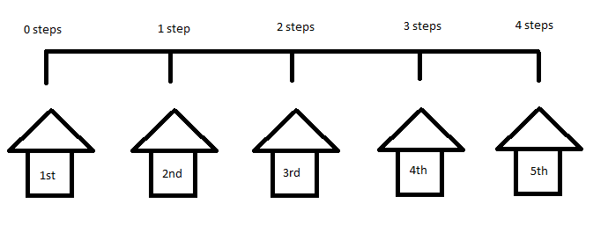
Figure 3: Illustrated representation of an array.

Conditions, Branches and Loops
Programmers often use conditional statements which dictate if a certain scope of code should be executed, these are referred to as decisions or branches and will use Boolean logic, is the condition true or false. Much like a person deciding to go to the doctor, the condition is if they feel sick [3]. These conditions will use these operators:
- (==) Equal to.
- (!=) Not equal to.
- (<) Less than.
- (>) Greater than.
- (<=) Less than or equal to.
- (>=) Greater than or equal to.
- ( || ) OR.
- (&&) AND.
The Branch logic will use “if / else / switch” statements which will check if the condition is true before executing a set of instructions, these instructions will only be executed once. If the condition is false then the optional “else” statement can be used in juncture to the “if” statement to execute a set of instructions only when the condition is false. If there is no “else” statement and the condition is false then the flow of control will skip over the statement [2].
Figure 4: If statement being used to determine if a user entered number is less than 10.
“Switch” statements are used when the programmer expects more outcomes than true or false, for example when a user wants to choose an option from a menu, they can enter a numeric value which represents the option they wish to choose. The switch will then execute the instructions associated with the option they chose, ignoring all other instructions for other options. Switch statements will have a default setting if an unexpected value was entered [3].
Figure 5: Switch statement skeleton example.
The Loop logic will use the “while / for” statements which will also check if the condition is true before executing a set of instructions much like a branch. The main difference with a loop is it will check the condition, execute the instructions within the scope and then recheck the condition to complete the loop. Loops are used when the programmer wishes to repeat a set of instructions until a certain condition is met which can be useful in a business when a problem requires the same task to be repeated for different sets of data [1] [2] [3].
The “while” loop is used when the user does not know how many iterations the loop needs to complete before the loop is provided a false condition. “While” loops have the possibility of looping infinitely if used incorrectly and can cause issues in the program if there is no escape method from the loop [3].
Figure 6: While loop example with escape method coded in by use of user input and "if" statement.
The “for” loop is used when the user knows how many iterations the loop needs to complete before exiting the loop. The for loop is also referred to as the “counting loop” because it takes an index which is initially set to 0, the index is then used in a condition to determine if it is less than a set number and then increments the index until eventually the index is no longer less than the set number. This is a safe loop as it performs self-maintenance to prevent itself from looping infinitely [3].
The versatility of the for loop makes it incredibly useful for solving problems, for example a company may want to calculate the total number of hours clocked in by their employees for a certain week, they could enter the number of employees they have hired which they could use to make a loop which would repeat for the number of employees they have while adding all the hours entered.
Figure 7: For loop used to count total number of hours worked by a set amount of employees entered.

Functions, Procedures and Arguments
When designing large applications which have multiple problems that require solving, it is far easier to separate those problems and solve each individually. This is where functions and procedures become very useful. A function / procedure is a tool used in programming to break down an application into easier to manage sections, they contain set instructions and are given a descriptive name which can be executed when called upon in the application [2] [3].
The difference between functions and procedures is often debated by programmers, however a most programmers will agree that a function returns a value whereas a procedure will not, this is dependent on the “return type” assigned to the function. The reasoning behind this definition is that a function returns a value which will be used in the application making it integral in the performance of the application, whereas a procedure will execute its code without having an impact on the core functions of the application.
The “return type” is what the function will return when it has completed its instructions, these types are that of the variables (int, double, string etc.). If a function does not return a value, making it a procedure, then it will have the “return type” void [2] [3].
Figure 8: Examples of a simple Function and Procedure.
Arguments are values which are passed into a function / procedure that can then be used in the set of instructions contained within. Arguments are declared in the parenthesis () of the function, and the function will only execute if a value has been passed in for each argument. This allows programmers to be more efficient with their code as they are able to use the same set of instructions for a different problem later on by being able to pass different values into the argument. An example of this is if the programmer wants to add two integers together, arguments can be used as placeholders for different values that could be passed into a function which then returns the result of the addition of the two integers passed in [2] [3].
Figure 9: Example of arguments being declared in functions and procedures.
When calling a function, the name of the function is used and any required values are passed into the arguments required. Arguments can be satisfied as long as a value of the same type is passed in, whether the value is hard coded in, copied from a variable, or returned from a function. This versatility makes it very useful for solving complex problems as the smaller problems can be solved individually and brought together to complete a more complex task [2] [3].
Figure 10: Example of arguments being passed into a function which is being used as an argument for a procedure.
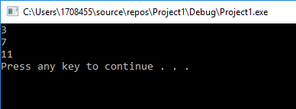
Figure 11: Results of Figure 10 code.

Classes, Structs and Objects
Object oriented programming is a style of programming that allows the programmer to group certain variables and functions together to describe the characteristics of an object. Like objects in real life, objects in programming can be imagined in the same way, where each object has its own properties and a set of things that the object can be used for [3].
To create an object, we first need a class or struct, which will be a collection of attributes and methods to describe the object. The main difference between a class and a struct in C++ is their “default visibility”, which essentially means a class will have a default visibility of private which means all the code contained within a class will only be accessible within the class whereas a struct is public by default making the code within accessible from anywhere. The visibility can be changed which means that classes and structs have no functional difference. However in industry, classes and structs are used for different purposes which relies on the complexity of the objects that are intended to be created [2] [4].
Attributes are for all intents and purposes variables which are contained within a class and method are functions which are contained within a class. Methods can be broken down into 4 categories; constructors, destructors, properties and methods.
Constructors are used to set the initial values of an object when it is created, and a destructor as suggested will destroy the object when the method is called.
Properties are functions which either fetch or assign an attribute within a class, this is used to ensure the class’s attributes are encapsulated to prevent any possibility of using the attributes in an unintended way.
Methods are functions that perform more complex tasks than a fetch or assign property. Methods are used to solve problems much like functions, they are able to take in arguments and perform set instructions to either return a value or change a value within the object.
Figure 12: Example of a Class being created in C++.
Objects are specific instances or members of a class, each holding their own individual values for their attributes, but sharing the same functionality as any other object created by the same class. An important distinction to make is a class does not contain any values as they are simply blueprints, it is the objects themselves that contain the values. Imagine a class like a cookie cutter and the objects as cookies, a cookie cutter does not contain any dough, the cookie does [2] [3] [4].

Interpretation

Overview
The source code provided in the appendix of the assignment brief is for an application that allows the user to input 3 integers and find the largest or smallest of the values entered. This application utilizes functions to break down the larger problems down into manageable problems which are then pulled together. Numerous coding tools are used to tackle each problem, for example, switch and if branches are used for menu controls and conditional calculations, and loops are used to find the largest or smallest values.

Explanation
The code utilizes constants which are declared in the Main.h file to keep consistency throughout the application, the constant MAXNUMBERS is set to 3 to identify that the maximum numbers that can be entered by the user is 3. By using a constant instead of hard coding the value into each instance the max numbers is required for reference means the code can be changed and maintained easier. If the application were to be changed to take in 5 numbers instead, the program can be altered by changing the value of MAXNUMBERS to 5 instead of changing each instance of 3 to 5, which could be problematic as human error could result in an instance of 3 being missed out which would make the application fail.

Figure 13: Constants used in source code of assignment brief appendix.

The main function declares the variables required for the application and initialises each of them to a default value. A Boolean variable with a default value of false is used as a condition to open up a while loop, this is necessary as the user should be given the option to continue using the application until they decide to quit. A for loop would be impractical here as the number of times the user wishes to repeat the program is unknown.
The crucial functions that are used for the application are then contained within the loop, these functions display the header and menu, read the users inputs, and displays the answers the user requests. Each time the user completes an option, the console is cleared to give a blank canvas for the next iteration of the loop.
The following figures illustrate how the application’s different functions operate with the use of flow chart diagrams.
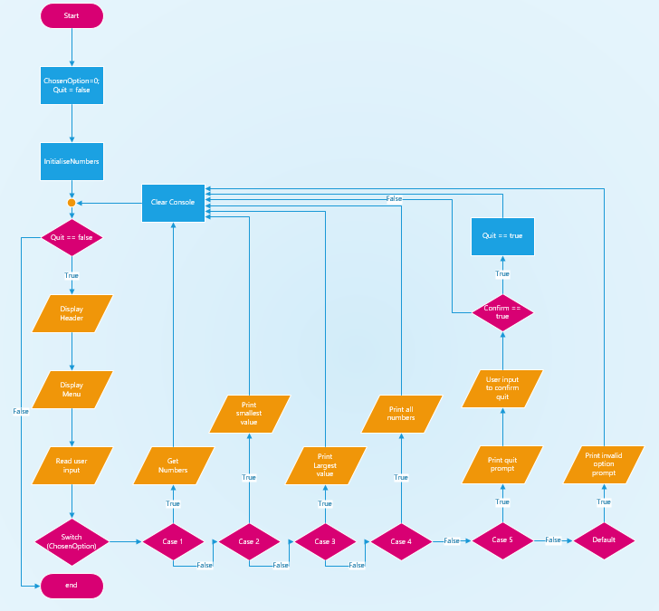
Figure 14: Flow chart of main function.

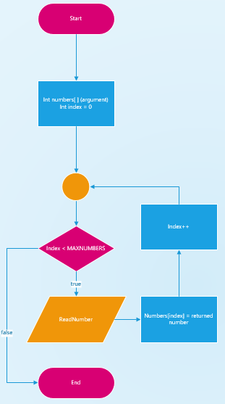
Figure 15: Flow chart of GetNumbers Function.
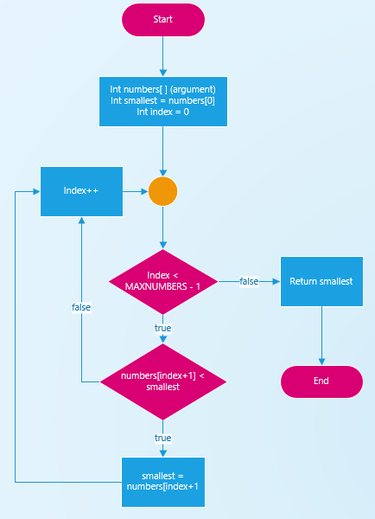
Figure 16: Flow Chart of FindSmallest function.

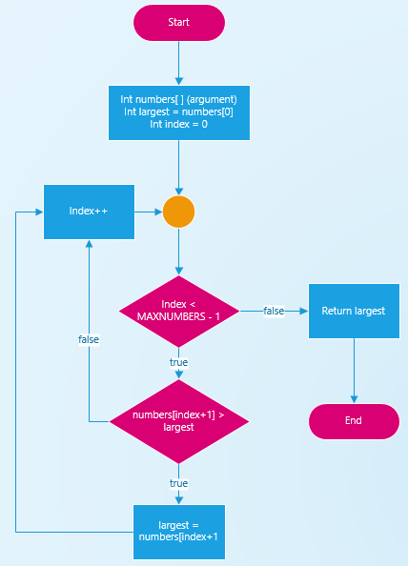
Figure 17: Flow chart of FindLargest function.

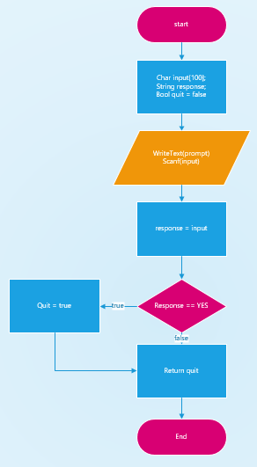
Figure 18: flow chart of IsQuitting Function.

Testing
When testing the code, there were numerous errors encountered which either caused the application to fail or return an unexpected result. The first error encountered was when the solution file was being built, an error was reported about a source file not being reachable. Below is a screenshot of the error report.
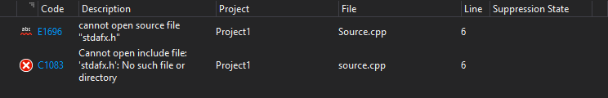
Figure 19: #include "stdafx.h" error.
This error occurred because the header file “stdafx.h” did not exist in the application but there was a #include reference to the document. To fix this, either a blank stdafx.h file could be created which could be useful for storing the other #include references which would be used for each file, or the #include can be removed. In this example, the reference was removed to allow the program to build.
The following figures identify a bug that occurs when a number is entered which has more than one digit, and how it affected the performance of the program.
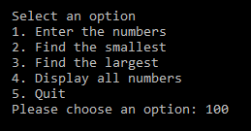
Figure 20: Number with over one digit input error part 1.
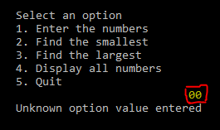
Figure 21: Number with over one digit input error part 2.
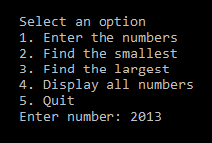
Figure 22 Number with over one digit input error part 3.
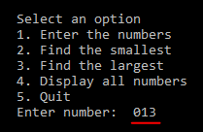
Figure 23: Number with over one digit input error part 4.
The following figures identify an issue found when the option to display all the numbers was found. Instead of performing the desired action, it proceeded to the quit option.
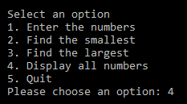
Figure 24: Option 4 error part 1.
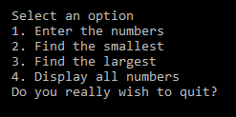
Figure 25: Option 4 error part 2.

The following figures show an error with quit option. The user is prompted with a quit confirmation message, which the user responds to with the word yes. The code only accepts the response from the user if the word is typed in capital letters.
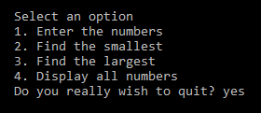
Figure 26: Option 5 error part 1.
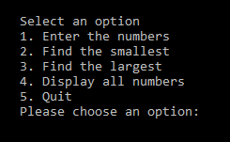
Figure 27: Option 5 error part 2

Implementation

Exercise 1
Brief
Create an application that allows the user to input an integer, decimal and word value and then displays them back to the user.
Problems identified
- Store values input by user.
- Display stored values.
Solutions required
- Create 3 variables (int, double, string).
- Scan in values (scanf)
- Print values to console (printf)
Implementation
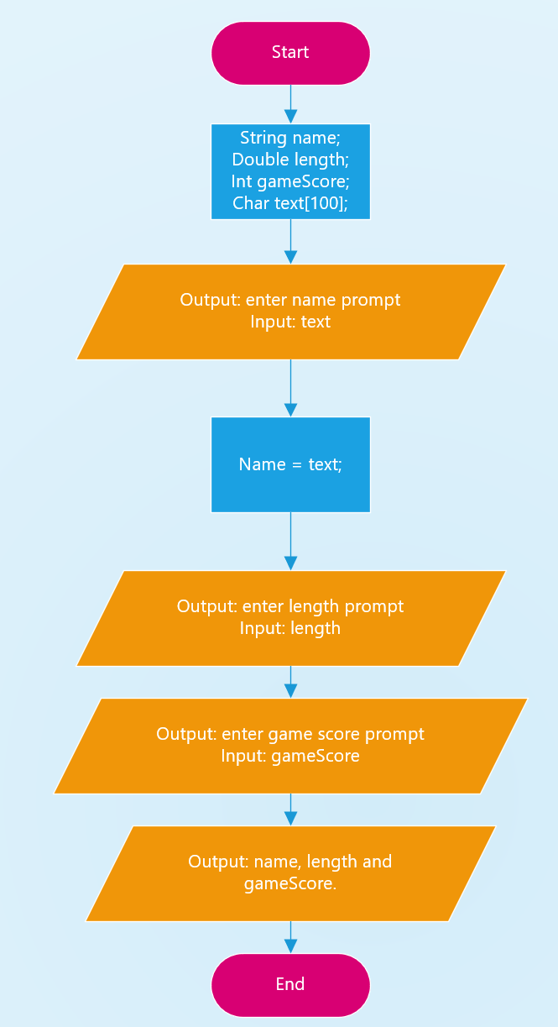
Figure 28: Exercise 1 flow chart.
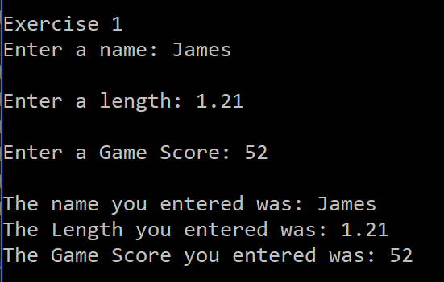
Figure 29: Exercise 1 application.
Bugs and Fixes
- Users can attempt to enter incorrect values into double and int variables, to fix this a check could be implemented to determine if the user input is valid before assigning the value to the variable.

Exercise 2
Brief
Allow the user to enter the dimensions of a circle and triangle, then calculate and display the area of the shape when the circle has the triangle as a hole.
Problems Identified
- User inputs dimensions for shapes
- Mathematics required to calculate area of the shapes
- Result needs to be displayed to user
Solutions Required
- Variable declaration
- Scan function
- Print function
- Mathematic operators
Implementation
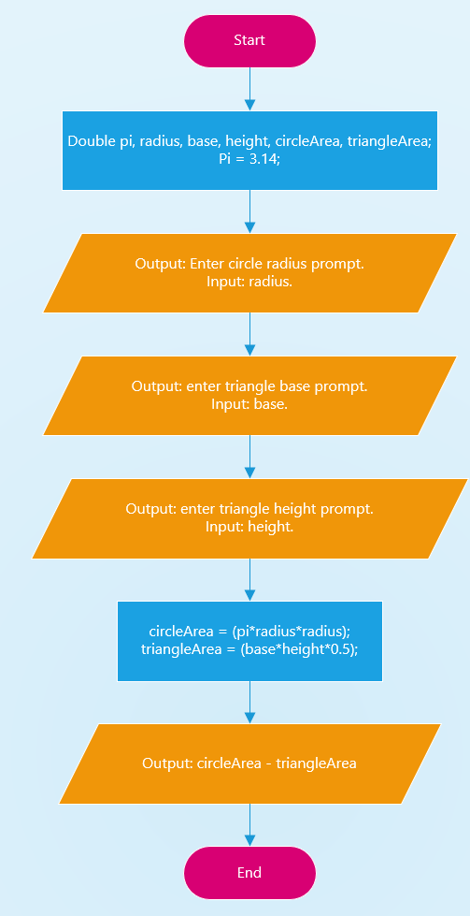
Figure 30: Exercise 2 flow chart.
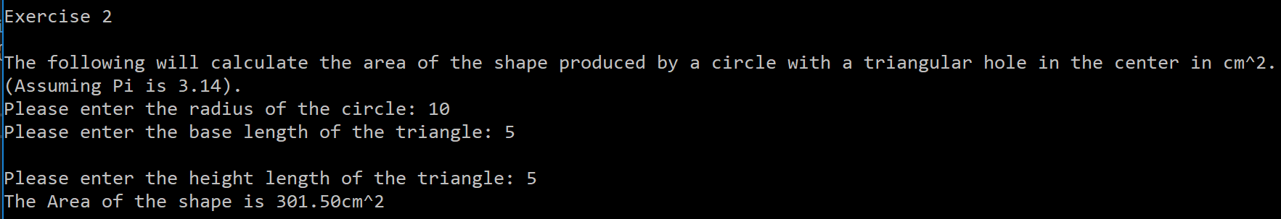
Figure 31: Exercise 2 application.
Bugs and fixes
- Users can attempt to enter incorrect values into the double variables, to fix this a check could be implemented to determine if the user input is valid before assigning the value to the variable.

Exercise 3
Brief
Allow the user to enter an amount of gravel they wish to buy along with the cost per tonne. The application will then apply a specific discount depending on the tonnage.
Problems Identified
- User inputs price per tonne and quantity they wish to buy.
- Application will need to determine what range the tonnage lies in.
- Apply a percentage discount.
- Display results.
Solutions required
- Variable declaration.
- Scan function.
- Decision making with use of if statements.
- Mathematical operators to apply percentage discounts.
- Print function.
Implementation
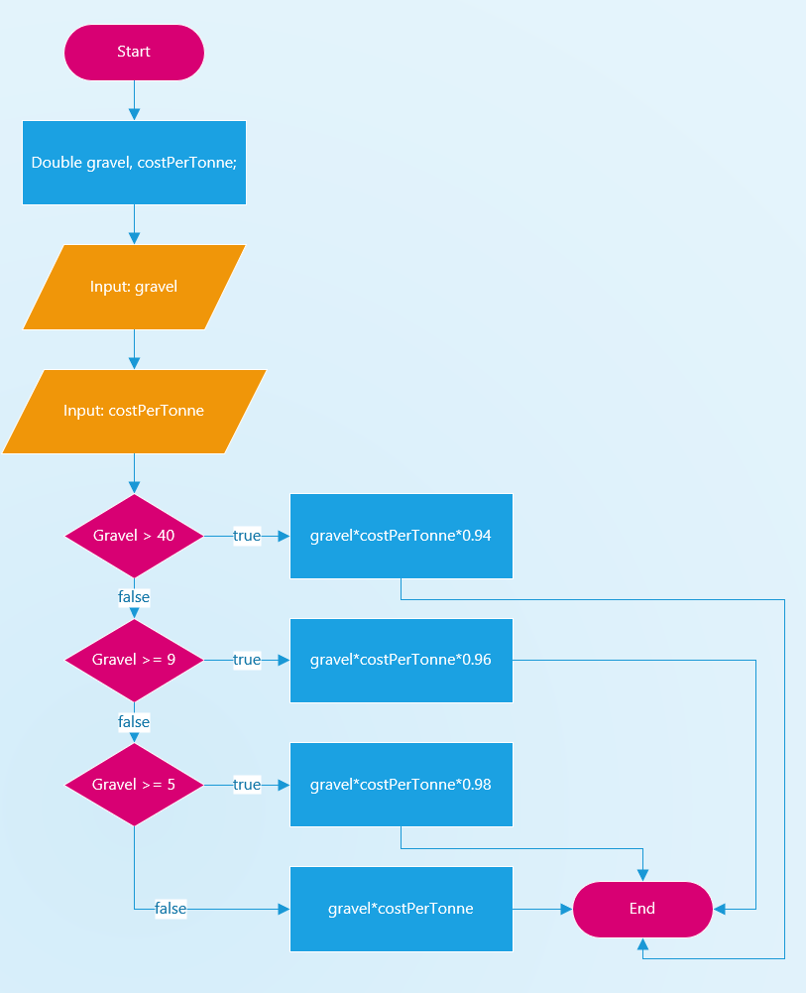
Figure 32: Exercise 3 flow chart.
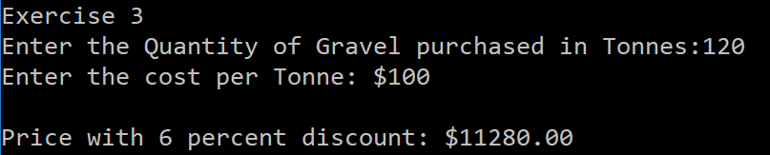
Figure 33: Exercise 3 application.
Bugs and fixes
- Users can attempt to enter incorrect values into the double variables, to fix this a check could be implemented to determine if the user input is valid before assigning the value to the variable.

Exercise 4
Brief
Allow the user to enter an integer value which will then be used to draw a large “X” on the console with width and height equal to the entered integer.
Problems Identified
- User inputs an integer.
- Print “*” in a leading diagonal line ( \ )
- Print “*” in a falling diagonal line (/)
- Identify if number is odd or even to print correct number of “*” at diagonal line intersection.
Solutions Required
- Variable declaration
- Scan function
- Decision making for the following:
  - Is the number even or odd.
  - Is the star being printed before or after the midway point.
  - Is it time to print a “_” or a “*”.
- Counted loops for the following:
  - Print consecutive “_” between each “*”.
  - Print each row after the other.
- Mathematical operators and sequences

Implementation
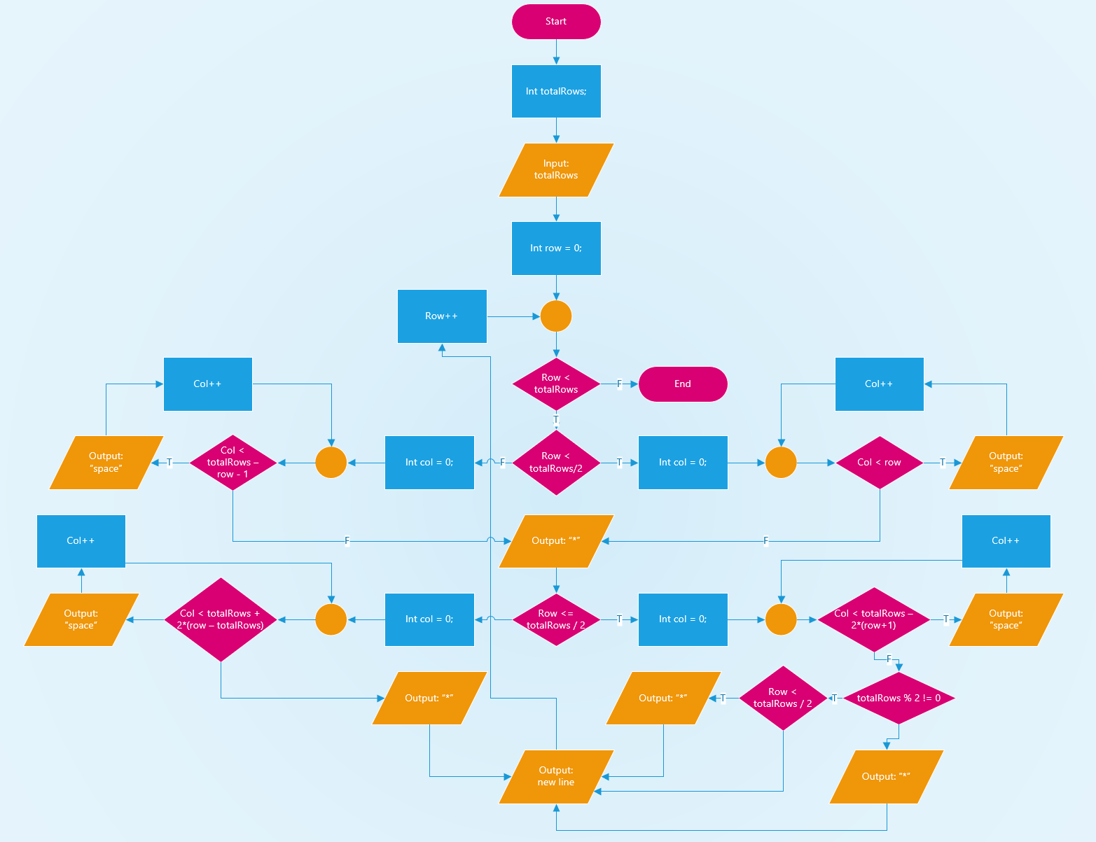
Figure 34: Exercise 4 flow chart.

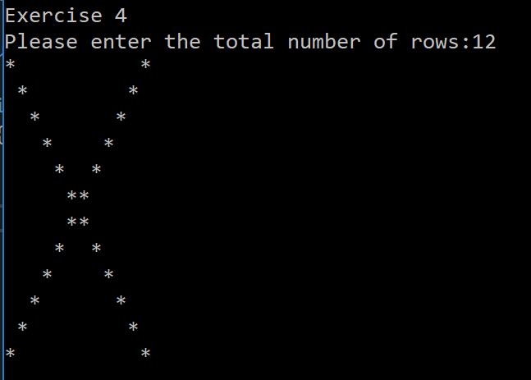
Figure 35: Exercise 4 application with even number.

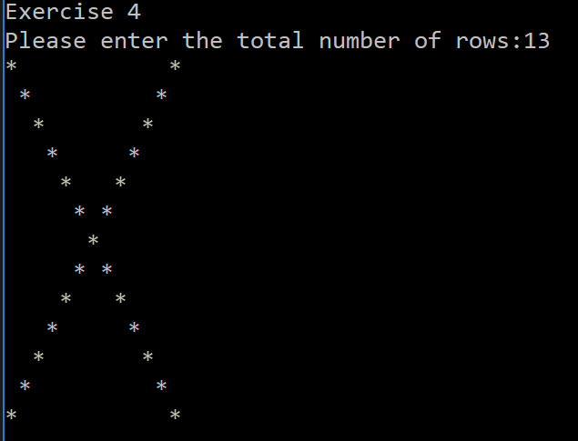
Figure 36: Exercise 4 application with odd number.

Exercise 5
Brief
Write a program that allows the user to enter the price of 5 products. As each price is entered it is added to a total maintained by a tax calculator. Once all the prices are entered the total tax and the average tax payable should be displayed.
A C++ class should be written to perform these calculations.
Problems Identified
- User enters tax percentage and product prices.
- Prices are stored.
- Tax for each product is calculated and stored.
- Tax is added to a running total.
- Average tax is calculated.
Solutions Required
- Scan function for user input.
- Mathematical operators to calculate percentages.
- Class for products to store price and tax amount individually.
- Methods for each class.
- For loop to loop through each product.
Implementation
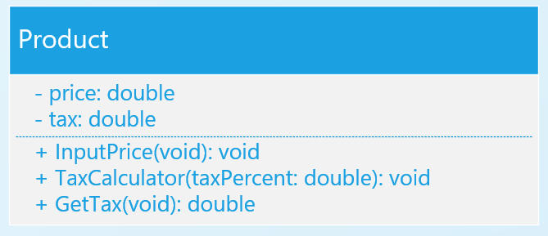
Figure 37: Product Class design in UML.
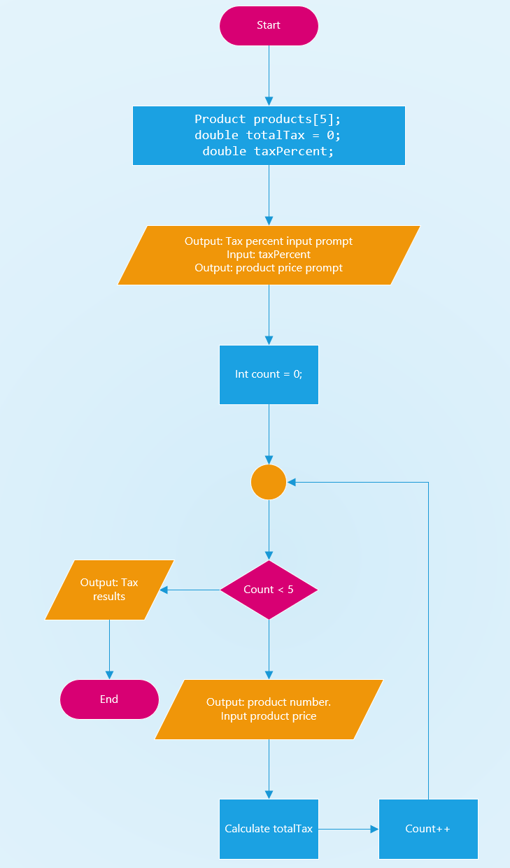
Figure 38: Exercise 5 flow chart
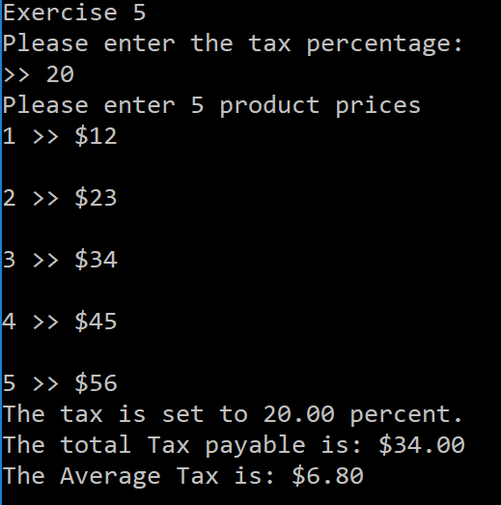
Figure 39: Exercise 5 application running.

Exercise 6
Brief
Fix the bugs identified in the appendix code of the assignment brief.
Problems Identified
- #include “stdafx.h” does not work.
- Option 4 does not work.
- Numbers with 2 or more digits are not cleared.
- IsQuitting function does not cover enough parameters.
Solutions Required
- Remove #include “stdafx.h”.
- Write function to print all numbers entered by user.
- Alter function to clear more than one digit.
- Give more possible conditions for IsQuitting function.

Implementation
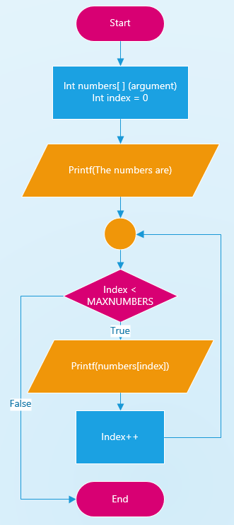
Figure 40: Flow chart of DisplayAllNumbers function.

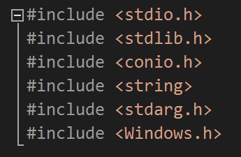
Figure 41: #include "stadafx.h" removed.
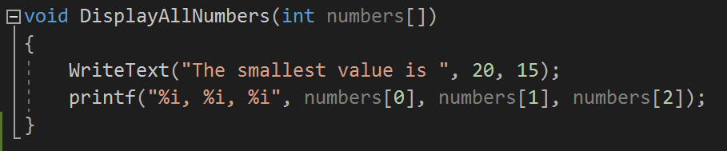
Figure 42: Implementation of DisplayAllNumbers function for option 4.

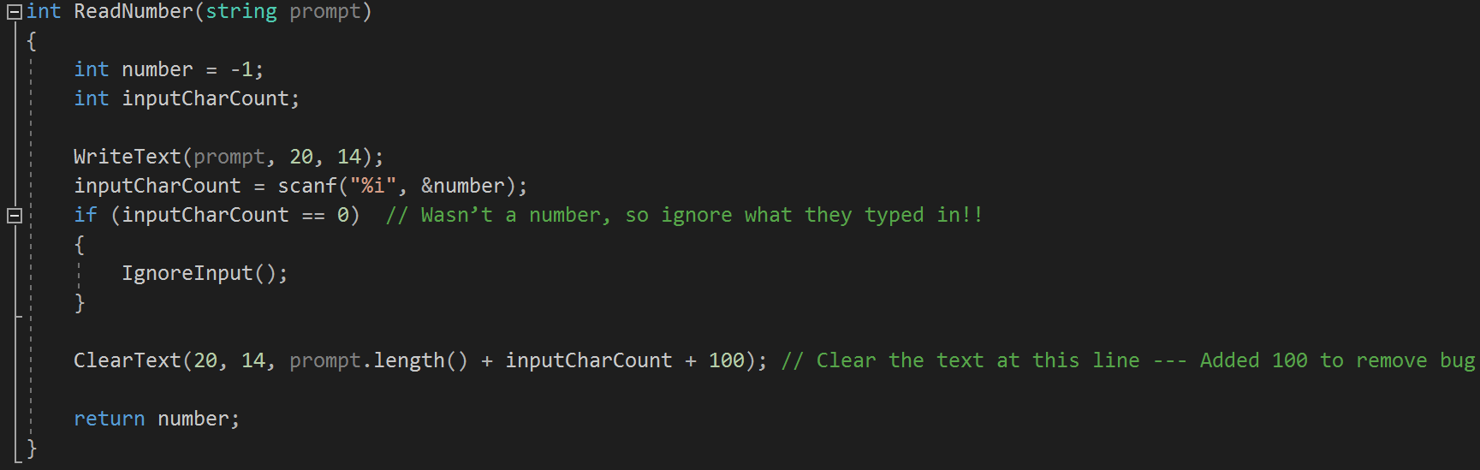
Figure 43: Fix for bug that was not removing numbers entered with 2 or more digits.

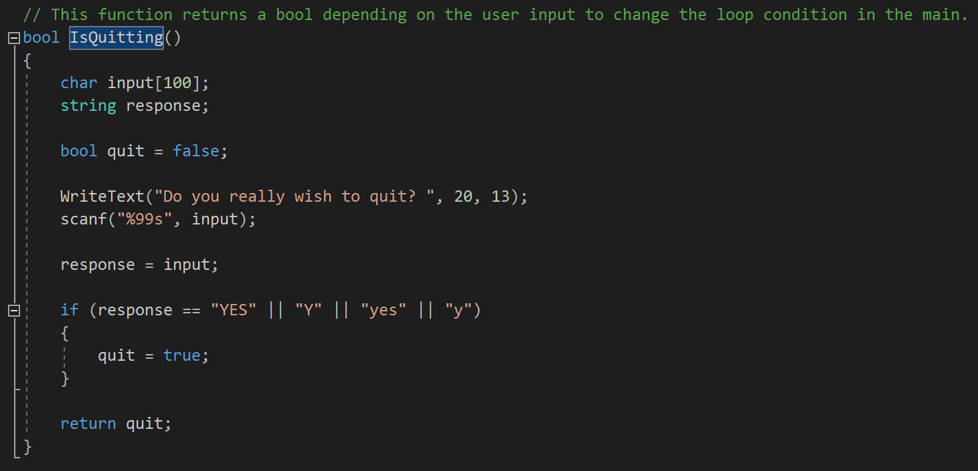
Figure 44: More acceptable inputs added into IsQuitting function.

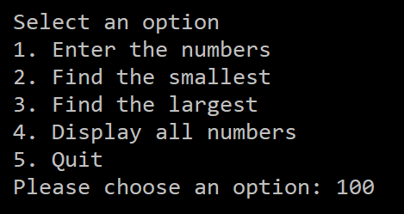
Figure 45: Application taking in number with 2 or more digits.

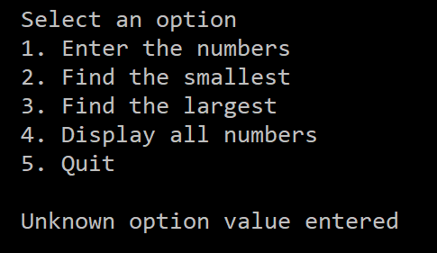
Figure 46: Application correctly clearing number with 2 or more digits.

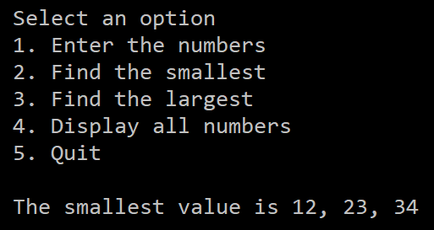
Figure 47: Option 4 correctly working in application.

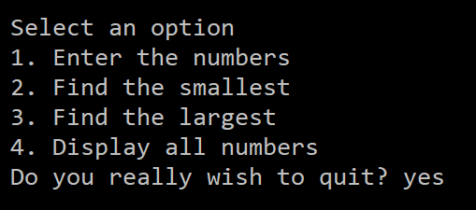
Figure 48: Application accepting yes in lower case.

Exercise 7
Brief
Build a fruit machine game but representing the 3 reels of symbols using numbers ranging from 0 to 5 that randomly chosen each time the player asks to take another go.
Problems Identified
- Generate random numbers.
- Store 3 variables to represent slots.
- Keep a running score total.
- Determine if a triple 5 was scored.
- Determine if a triple 1-4 was scored.
- Determine if a double 5 was scored.
- Determine if a double 1-4 was scored.
- Determine if no triple or double was scored.
- Display text instead of numbers based on number generated.
- Give player option to continue or quit.
Solutions Required
- Use random number generator function.
- Create integer array for slots.
- Create a score variable.
- Use mathematical operators.
- Use nested branch statements to find what was scored.
- Use logic gates in the branch conditions.
- Use loops to assign the slots a value.
- Use loops to repeat the program until user wishes to quit.

Implementation
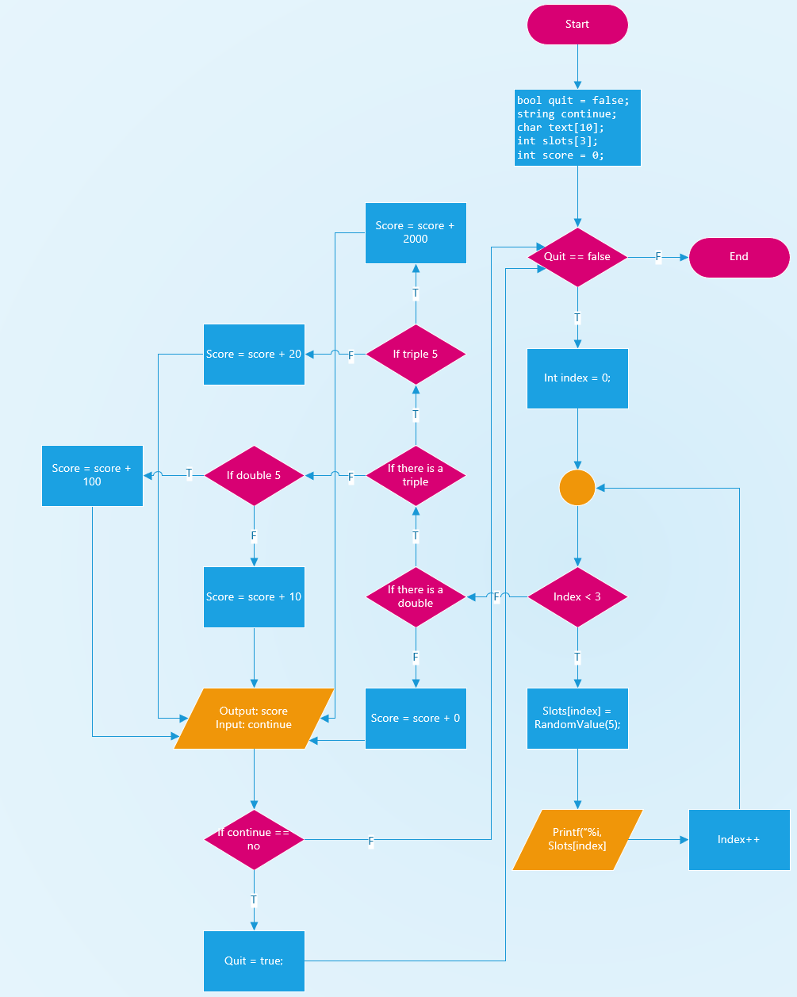
Figure 49: Exercise 7 flow chart.
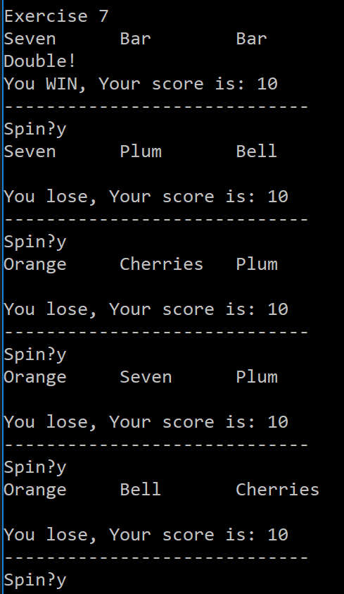
Figure 50: Exercise 7 application running.

Exercise 8
Brief
Build the battleships game. The computer should allow the players to enter the positions of their ships, and keep track of the opponent’s attempts to hit them.
Problems Identified
- Create a grid to store values.
- Print grid.
- Create class for ships.
- Create 2 players, each having a grid and 5 ships.
- Allow player to place their ships onto grid.
- Prevent ships from being placed in overlapping or out of bounds positions.
- Allow players to fire at a co-ordinate.
- Show if co-ordinate was hit or miss.
- Show if ship has been sunk.
- End game when all of a players ships have been sunk.
Solutions Required
- Create a Player Class.
- Create a Ship Class.
- Give Players a 2 dimensional array of integers for the grid.
- Give Players 5 ships with varying sizes.
- Use methods to initialise the grids and ships.
- Use methods to allow user to input orientation and coordinates of ships.
- Use methods to validate position of ship before placed on grid.
- Print game key.
- Allow users to chose coordinates to fire at.
- Use methods to change values on grid to represent if space is empty, miss, hit or sunk.
- Use while loop to alternate between players.
- Check for if ship has been sunk.
- End loop when all of a players ships have been sunk.
- Display which player won.
Implementation
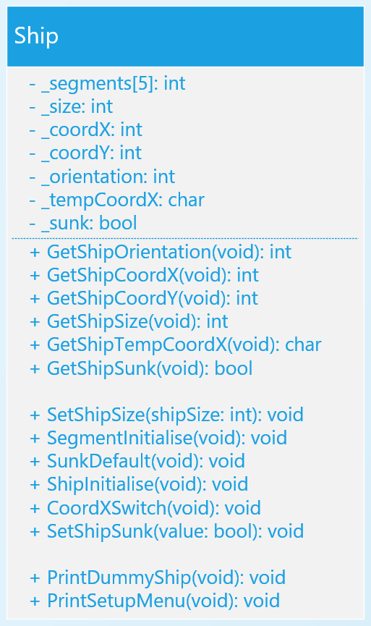
Figure 51: Ship Class in UML.

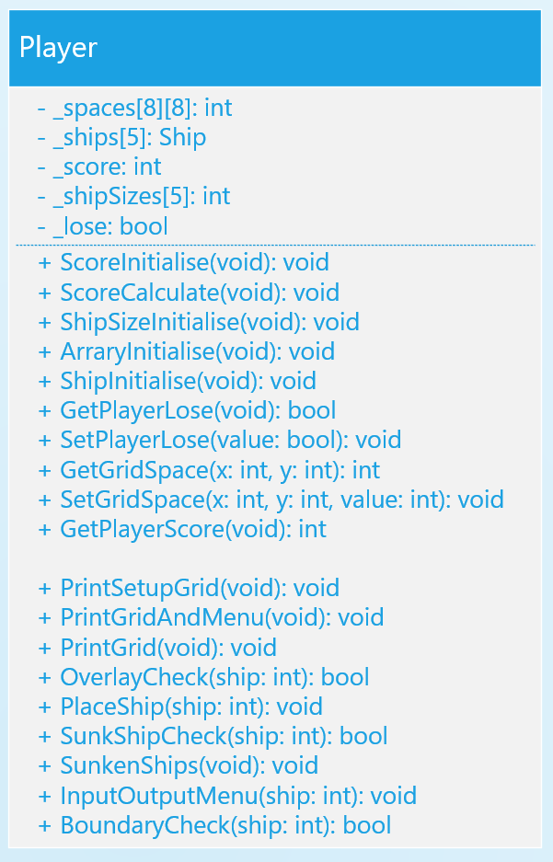
Figure 52: Player Class in UML
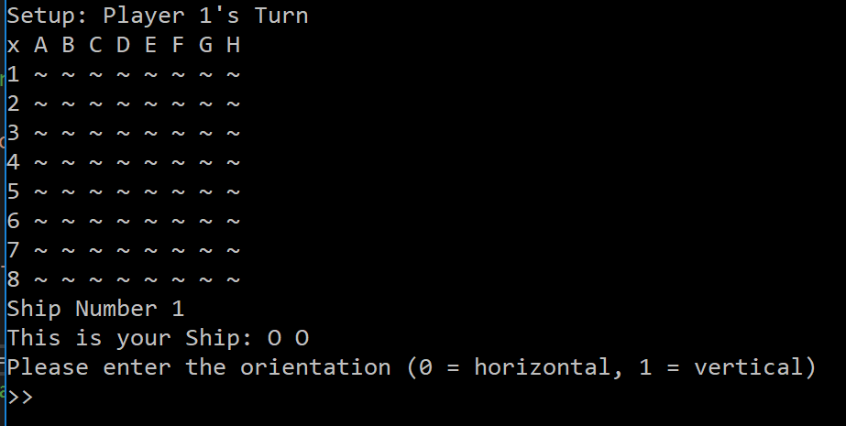
Figure 53: Opening menu for exercise 8.
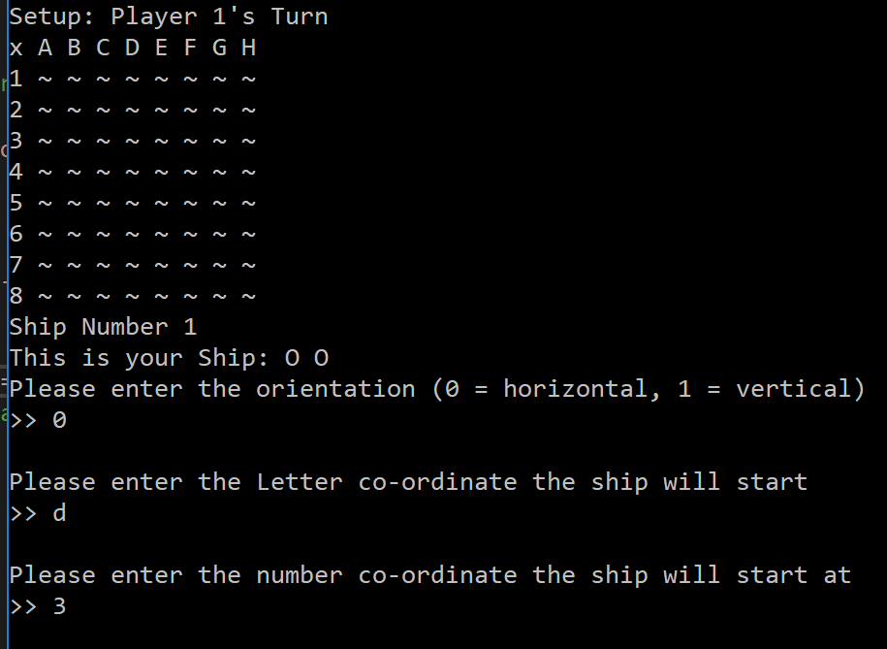
Figure 54: Example of player placing ship part 1.
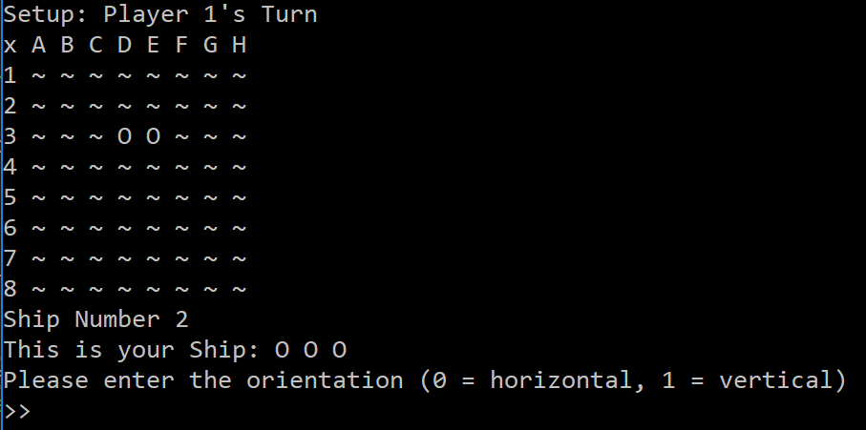
Figure 55: Example of player placing ship part 2.
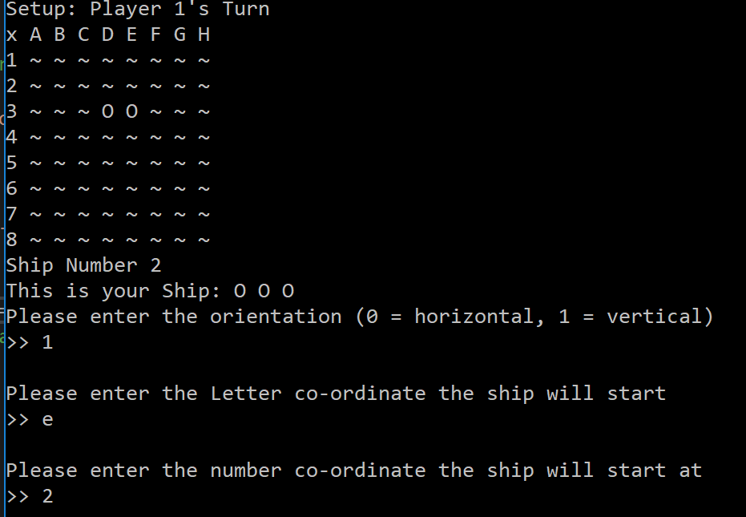
Figure 56: Example of player trying to overlap a ship.
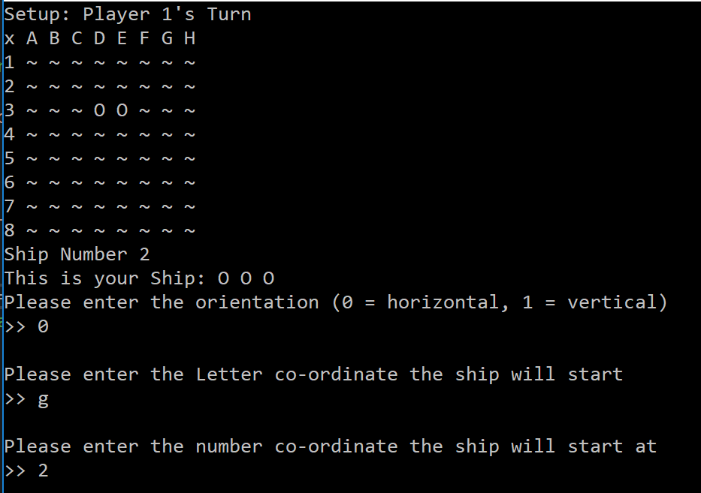
Figure 57: Example of player trying to place a ship out of bounds.
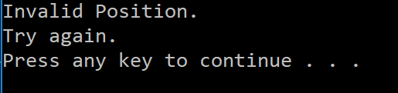
Figure 58: Result of Figure 53 and Figure 54.

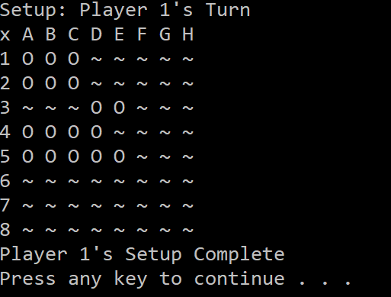
Figure 59: Screenshot of all ships placed by Player 1.
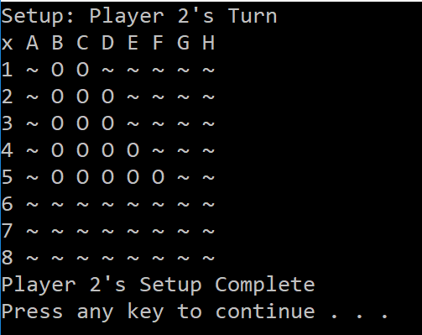
Figure 60: Screenshot of all ships placed by Player 2.
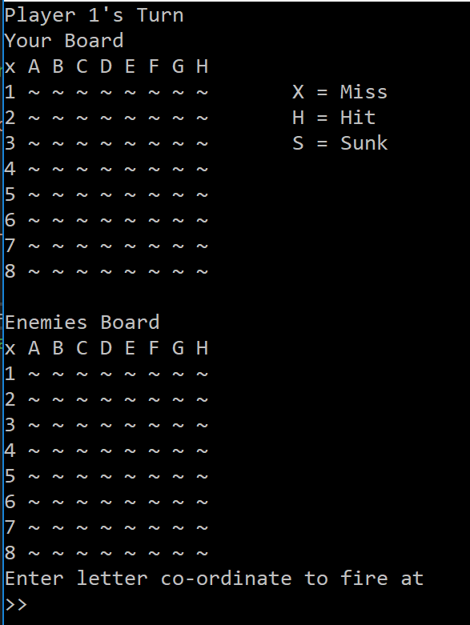
Figure 61: Opening Gameplay menu.
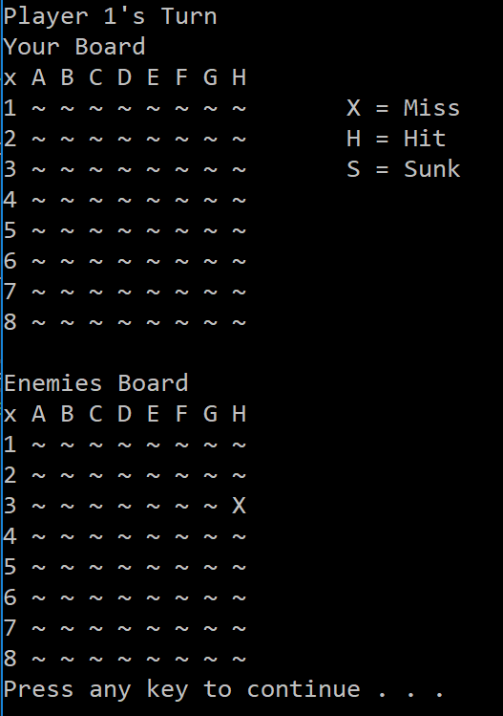
Figure 62: Player 1 firing at H3 and missing.
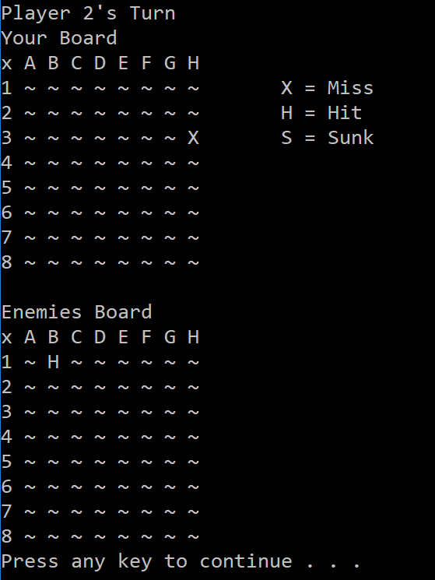
Figure 63: Player 2 Firing at B1 and hitting.
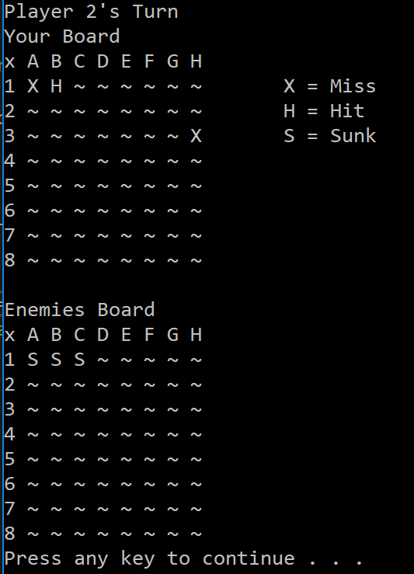
Figure 64: Player 2 sinking Player 1's Ship.
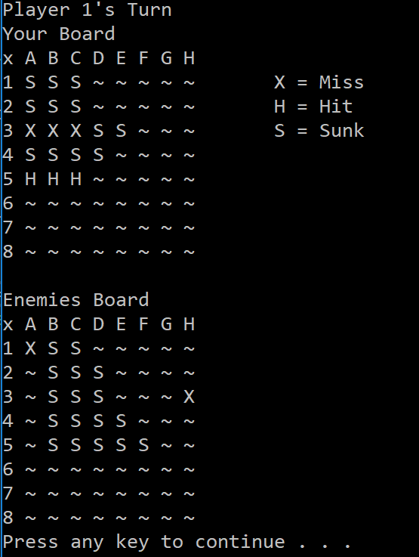
Figure 65: Player 1 sinking all of Player 2's ships.
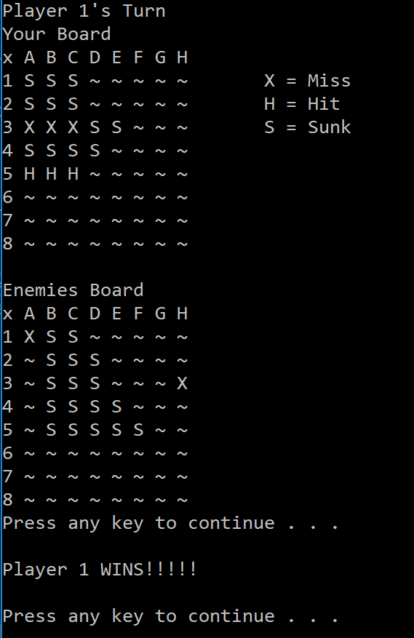
Figure 66: Application showing Player 1 won the game and exiting the application.

References

[1] | B. Bitesize, “How do computer programs use variables?,” BBC Bitesize, [Online]. Available: http://www.bbc.co.uk/guides/zw3dwmn. [Accessed 19 03 2018].
[2] | M. Sprankle and J. Hubbard, Problem Solving & Programming Concepts, London: Pearson, 2012.
[3] | M. Lee, C++ Programming for the absolute beginner, United Kingdom: Course Technology Cengage Learning, 2009.
[4] | R. Lafore, Object-oriented programming in C++, Indianapolis: Sams Publishing, 2002.

Appendices

Functions.h

Player.h

Product.h

Ship.h

Exercise 1.cpp

Exercise 2.cpp

Exercise 3.cpp

Exercise 4.cpp
#pragma warning(disable:4996)

#include <string>

#include <stdio.h>

#include <stdlib.h>

#include <time.h>

using namespace std;

// Exercise 4
void Exercise4()
{
int totalRows;
printf("Please enter the total number of rows:");
scanf("%i", &totalRows);

// This opens a loop which will repeat for the total number of rows input
for (int row = 0; row < totalRows; row++)
{
// This if statement checks if the loop is before or after the midway point
if (row < totalRows / 2)
{
// This for loop adds the spaces before the * in accending order.
for (int column = 0; column < row; column++)
{
printf(" ");
}
}
else
{
// This for loop adds the spaces before the * in decending order
for (int column = 0; column < totalRows - row - 1; column++)
{
printf(" ");
}
}
// This places the first * on the row
printf("*");
// This if statement checks if the loop is before or after the midway point
if (row <= totalRows / 2)
{
// This loop adds the spaces between the * on each row. Each row having 2 less spaces as the previous row.
for (int column = 0; column < totalRows - 2 * (row + 1); column++)
{
printf(" ");
}
// This if statement checks if the total amount of rows is odd or even.
// This is done because we want to only have one * in the center of the cross.
if (totalRows % 2 != 0)
{
// If it is odd, then it will check for rows that are not the center, and put a * at the end
if (row < (totalRows) / 2)
{
printf("*");
}
}
else
{
// If it is even then it will put a *
printf("*");
}
}
else
{
// This loop will add spaces between the * on the bottom half of the cross, increasing by 2 each time.
for (int column = 0; column < totalRows + 2 * (row - totalRows); column++)
{
printf(" ");
}

printf("*");
}
// This enters onto a new row
printf("\r\n");
}
}

Exercise 5.cpp

Exercise 6.cpp
#pragma warning(disable:4996)

#define _CRT_SECURE_NO_WARNINGS

#include "Functions.h"

void Exercise6()
{
int theNumbers[MAXNUMBERS];
int chosenOption = 0;
bool quit = false;
ClearConsole();
InitialiseNumbers(theNumbers, MAXNUMBERS);

while (quit == false)
{
DisplayHeader();
DisplayMenu();
chosenOption = ReadNumber("Please choose an option: ");
quit = ProcessMenu(chosenOption, theNumbers);

ClearConsole();
}

system("pause");
}

Exercise 7.cpp
#pragma warning(disable:4996)

#include <string>

#include <stdio.h>

#include <stdlib.h>

#include <time.h>

#include "Functions.h"

using namespace std;

// Exercise 7
int RandomValue(int maxValue)
{
return rand() % (maxValue + 1);
}

void Exercise7()
{

bool quit = false;
string cont;
char text[10];
int slots[3];
int score = 0;

while (quit == false) // This opens an infinite loop which will only close upon the user's request
{
for (int index = 0; index < 3; index++) // this loop writes the 3 slots next to eachother
{
slots[index] = RandomValue(5); // This function assigns the slot a random value between 0 and 5
switch (slots[index]) // This Switch function prints the relevant icon text depending on the value generated
{
case 0:
printf("Seven ");
break;
case 1:
printf("Bar ");
break;
case 2:
printf("Bell ");
break;
case 3:
printf("Plum ");
break;
case 4:
printf("Orange ");
break;
case 5:
printf("Cherries ");
break;
}
}
if (slots[0] == slots[1] || slots[0] == slots[2] || slots[1] == slots[2]) // This if statement checks if any doubles were generated -
// by checking slot 1 to 2, 1 to 3 or 2 to 3.
{
if ((slots[0] == slots[1]) && (slots[1] == slots[2])) // If there is a double, then it will check if there is a triple by using an and gate
{
if (slots[0] == 5) // If there is a triple, then it will check if it is a triple 5, which will be a jackpot.
// Only one value needs to be checked as the triple has already determined that they are equal.
{
score = score + 2000;
printf("\r\nJackpot!!!!!\r\nYou WIN, Your score is: %i", score);
}
else // If it is not a triple 5, then it must be a standard triple
{
score = score + 20;
printf("\r\nTriple!!\r\nYou WIN, Your score is: %i", score);
}
}
else // If there is no triple, then it needs to be checked for double 5's as the parent if statement has already determined that there is a double.
{
if ((slots[0] == 5 && slots[1] == 5) || (slots[0] == 5 && slots[2] == 5) || (slots[1] == 5 && slots[2] == 5))
// This will check if it is a double 5, which will be worth more than a standard double
{
score = score + 100;
printf("\r\nDouble Cherries!!!\r\nYou WIN, Your score is: %i", score);
}
else // If it is not a double 5, then it must be a standard double.
{
score = score + 10;
printf("\r\nDouble!\r\nYou WIN, Your score is: %i", score);
}
}
}
else // If no doubles scored, then the user loses
{
printf("\r\n\r\nYou lose, Your score is: %i", score);
}

printf("\r\n-----------------------------\r\nSpin?"); // This asks if the user wants to continue, while adding a break line to make the spins separate
scanf("%99s", text);
cont = text;
if (cont == "no" || "No" || "NO" || "nO" || "N" || "n")
// if they say no in any of the above configurations, then quit will be changed to true, which will end the loop
{
quit = true;
}
}
}

Exercise 8.cpp
#include <string>

#include <stdio.h>

#include <stdlib.h>

#include <time.h>

#include "Ship.h"

#include "Player.h"

#include "Functions.h"

using namespace std;

// Exercise 8

int fireXconvert(char xCoord)
{
switch (xCoord)
{
case 'a':
case 'A':
return 0;
case 'b':
case 'B':
return 1;
case 'c':
case 'C':
return 2;
case 'd':
case 'D':
return 3;
case 'e':
case 'E':
return 4;
case 'f':
case 'F':
return 5;
case 'g':
case 'G':
return 6;
case 'h':
case 'H':
return 7;
}
}

int fire(int coordinate)
{
switch (coordinate)
{
case 0:
return 2;
case 1:
return 3;
}
}

void displayKey(int row)
{
// This function displays the key next to the grid. It will be placed into a for loop and will print the lines of the key only on the specific rows.
switch (row)
{
case 0:
printf(" X = Miss");
break;
case 1:
printf(" H = Hit");
break;
case 2:
printf(" S = Sunk");
break;
}
}

bool ValidatePosition(bool overlay, bool boundary)
{
if (overlay == true && boundary == true)
// in order for the position to be valid, both checks must come back true
{
return true;
}
else
{
system("cls");
printf("Invalid Position.\r\nTry again.\r\n");
system("pause");
return false;
}
}

void Exercise8()
{
player players[2];
int playerTurn = 0;
bool validPosition = false;
bool overlayCheck = false;
bool boundaryCheck = false;
char fireXTemp;
int fireX, fireY;

for (int count = 0; count < 2; count++) // This loop will perform all the initialisation methods for both players.
{
players[count].arrayInitialise();
players[count].ScoreInitialise();
players[count].shipSizeInitialise();
players[count].ShipInitialize();
}

for (int player = 0; player < 2; player++) // This loop will allow both players to input their battleships before the game starts.
{
for (int ship = 0; ship < 5; ship++) // This loop will repeat for all the ships the player has.
{

validPosition = false; // this resets the check before the check loop begins

while (validPosition == false) // This starts a loop which will only end once the user enters a valid position.
{
system("cls");
printf("Setup: Player %i's Turn\r\nx A B C D E F G H ", player + 1);
players[player].PrintSetupGrid();
printf("\r\nShip Number %i\r\nThis is your Ship: ", ship + 1);
players[player].InputOutputMenu(ship);
overlayCheck = players[player].OverlayCheck(ship);
boundaryCheck = players[player].BoundaryCheck(ship);
validPosition = ValidatePosition(overlayCheck, boundaryCheck);
}
players[player].PlaceShip(ship); // Once the user has entered a valid position, it will place the ship on the grid

if (ship == 4)
{ // This will show the final board once all the ships have been placed by the player.
system("cls");
printf("Setup: Player %i's Turn\r\nx A B C D E F G H ", player + 1);
players[player].PrintSetupGrid();
printf("\r\nPlayer %i's Setup Complete\r\n", player + 1);
system("pause");
}
}
}

while (players[0].GetPlayerLose() == false && players[1].GetPlayerLose() == false)
{ // This Loop switches between player 1 and player 2 until a loser is determined. If one is true, the loop ends.
if (playerTurn == 0)
{
system("cls");
printf("Player 1's Turn\r\nYour Board \r\nx A B C D E F G H ");
players[0].PrintGridAndMenu();
printf("\r\n\r\nEnemies Board\r\nx A B C D E F G H ");
players[1].PrintGrid();

printf("\r\nEnter letter co-ordinate to fire at\r\n>> ");
scanf_s(" %c", &fireXTemp);
printf("\r\nEnter Number co-ordinate to fire at\r\n>> ");
scanf_s("%i", &fireY);
fireX = fireXconvert(fireXTemp);

players[1].SetGridSpace(fireX, fireY-1, fire(players[1].GetGridSpace(fireX, fireY - 1)));
players[1].SunkenShips();

system("cls");
printf("Player 1's Turn\r\nYour Board \r\nx A B C D E F G H ");
players[0].PrintGridAndMenu();
printf("\r\n\r\nEnemies Board\r\nx A B C D E F G H ");
players[1].PrintGrid();

playerTurn = 1;
}
else
{
system("cls");
printf("Player 2's Turn\r\nYour Board \r\nx A B C D E F G H ");
players[1].PrintGridAndMenu();
printf("\r\n\r\nEnemies Board\r\nx A B C D E F G H ");
players[0].PrintGrid();

printf("\r\nEnter letter co-ordinate to fire at\r\n>> ");
scanf_s(" %c", &fireXTemp);
printf("\r\nEnter Number co-ordinate to fire at\r\n>> ");
scanf_s("%i", &fireY);
fireX = fireXconvert(fireXTemp);

players[0].SetGridSpace(fireX, fireY - 1, fire(players[0].GetGridSpace(fireX, fireY - 1)));
players[0].SunkenShips();

system("cls");
printf("Player 2's Turn\r\nYour Board \r\nx A B C D E F G H ");
players[1].PrintGridAndMenu();
printf("\r\n\r\nEnemies Board\r\nx A B C D E F G H ");
players[0].PrintGrid();

playerTurn = 0;
}
printf("\r\n");

for (int player = 0; player < 2; player++)
{ // This loop will add up the score of each of the players.
players[player].ScoreCalculate();
if (players[player].GetPlayerScore() == 34)
{ // if all the ships have been sunken, it will change their lose status to true, which will then exit the While loop
players[player].SetPlayerLose(true);
}
}
system("pause");
}

if (players[0].GetPlayerLose() == true)
{ // This branch will check to see if player 1 has lost in order to display the correct message
printf("\r\nPlayer 2 WINS!!!!!\r\n\r\n");
}
else
{ // The only way this branch statement would execute is if at least one of the players lost, therefore if it wasnt player 1, then it must be player 2.
printf("\r\nPlayer 1 WINS!!!!!\r\n\r\n");
}

}

Functions.cpp
#pragma warning(disable:4996)
#include "Functions.h"

void WriteText(string text, int x, int y)
{
SetCursorPosition(x, y);
printf(text.c_str());
}

// This function takes in an array of int and initialises all the addresses to 0
// will this need an array of pointers to be passed in? will this change the actual array or the array within the scope?
void InitialiseNumbers(int numbers[], int size)
{
for (int index = 0; index < size; index++)
{
numbers[index] = 0;
}
}

// This function displays the header which decribes the purpose of the application
void DisplayHeader(void)
{
WriteText("*******************************************************************************", 0, 0); // Top left hand corner of screen is x = 0, y = 0
WriteText("* This application is designed to allow you to choose numbers *", 0, 1); // Next line down is x = 0, y = 1, etc
WriteText("* and finds the biggest and the smallest value *", 0, 2);
WriteText("*******************************************************************************", 0, 3);
}

// This function displays the menu of options avaliable in the application
void DisplayMenu()
{
WriteText("Select an option", 20, 8); // Display menu at at x = 20, y = 8
WriteText("1. Enter the numbers", 20, 9);
WriteText("2. Find the smallest", 20, 10);
WriteText("3. Find the largest", 20, 11);
WriteText("4. Display all numbers", 20, 12);
WriteText("5. Quit", 20, 13);
}

int ReadNumber(string prompt)
{
int number = -1;
int inputCharCount;

WriteText(prompt, 20, 14);
inputCharCount = scanf("%i", &number);
if (inputCharCount == 0) // Wasn’t a number, so ignore what they typed in!!
{
IgnoreInput();
}

ClearText(20, 14, prompt.length() + inputCharCount + 100); // Clear the text at this line --- Added 100 to remove bug when user entered number with more than 1 character.

return number;
}

void IgnoreInput(void)
{
char ch;
while ((ch = getchar()) != '\n' && ch != EOF);
}

void ClearText(int x, int y, int length)
{
// Write space ' ' characters starting at x, y for 'length' times
string spaces(length, ' ');
WriteText(spaces, x, y);
}

void DisplayAllNumbers(int numbers[])
{
WriteText("The smallest value is ", 20, 15);
printf("%i, %i, %i", numbers[0], numbers[1], numbers[2]);
}

bool ProcessMenu(int option, int numbers[])
{
string message;
bool quit = false;

switch (option)
{
case 1:
GetNumbers(numbers);
break;
case 2:
WriteText(FormatText("The smallest value is %i", FindSmallest(numbers)), 20, 15);
Pause();
break;
case 3:
WriteText(FormatText("The largest value is %i", FindLargest(numbers)), 20, 15);
Pause();
break;
case 4:
DisplayAllNumbers(numbers);
Pause();
break;
case 5:
quit = IsQuitting();
break;
default:
WriteText("Unknown option value entered", 20, 15);
Pause();
break;
}

return quit;
}

void GetNumbers(int numbers[])
{
for (int index = 0; index < MAXNUMBERS; index++)
{
numbers[index] = ReadNumber("Enter number: ");
}
}

int FindSmallest(int numbers[])
{
int smallest = numbers[0];

for (int index = 0; index < MAXNUMBERS - 1; index++) // <-- subtract 1
{
if (numbers[index + 1] < smallest)
{
smallest = numbers[index + 1];
}
}

return smallest;
}

int FindLargest(int numbers[])
{
int largest = numbers[0];

for (int index = 0; index < MAXNUMBERS - 1; index++) // <-- subtract 1
{
if (numbers[index + 1] > largest)
{
largest = numbers[index + 1];
}
}

return largest;
}

// This function returns a bool depending on the user input to change the loop condition in the main.
bool IsQuitting()
{
char input[100];
string response;

bool quit = false;

WriteText("Do you really wish to quit? ", 20, 13);
scanf("%99s", input);

response = input;

if (response == "YES" || "Y" || "yes" || "y")
{
quit = true;
}

return quit;
}

// JUST USE THIS FUNCTION
// This function positions cursor in Console window,
// and you DON'T need to understand it!!!
void SetCursorPosition(int x, int y)
{
static HANDLE handle = NULL;
if (!handle)
{
handle = GetStdHandle(STD_OUTPUT_HANDLE);
}
COORD coords = { x, y };
SetConsoleCursorPosition(handle, coords);
}

// JUST USE THIS FUNCTION
// This function does creates a string
// using a format string and values i.e.
// FormatText("Number is %i", 5) returns "Number is 5",
// and you DON'T need to understand it!!!
string FormatText(const char *c_format, ...)
{
char ch[100];
va_list args;
va_start(args, c_format);
vsnprintf(ch, 100, c_format, args);
va_end(args);
return string(ch);
}

// JUST USE THIS FUNCTION
// This function clears the screen,
// and you DON'T need to understand it!!!
void ClearConsole(void)
{
system("cls");
}

void Pause(void)
{
// Pause
while (1) { if (_kbhit()) break; }
_getch(); // Clear the keypress
}

Player.cpp
#pragma warning(disable:4996)

#include <string>

#include <stdio.h>

#include <stdlib.h>

#include <time.h>

#include "Ship.h"

#include "Functions.h"

#include "Player.h"

#pragma region Properties

void player::ScoreInitialise()
{
this->_score = 0;
this->_lose = false;
}

void player::ScoreCalculate()
{
this->_score = 0;
for (int row = 0; row < 8; row++)
{
for (int col = 0; col < 8; col++)
{
switch (this->_spaces[row][col])
{
case 3:
this->_score = this->_score + 1;
break;
case 4:
this->_score = this->_score + 2;
break;
}
}
}
}

void player::shipSizeInitialise() // In order to initialise the ships, the sizes of each of the ships needs to be initialised. This procedure will do so.
{
this->_shipSizes[0] = 2; // These are the different sizes of ships chosen to be in the game
this->_shipSizes[1] = 3;
this->_shipSizes[2] = 3;
this->_shipSizes[3] = 4;
this->_shipSizes[4] = 5;
for (int count = 0; count < 5; count++) // This loops through the ships sizes and assigns them the values chosen in the above array
{
this->_ships[count].setShipSize(this->_shipSizes[count]);
}
}

void player::arrayInitialise() // In order to make the grid array useful it needs to be initialised to 0 which is done by this procedure.
{
for (int row = 0; row < 8; row++)
{
for (int col = 0; col < 8; col++)
{
this->_spaces[row][col] = 0;
}
}
}

bool player::GetPlayerLose()
{
return this->_lose;
}

void player::SetPlayerLose(bool value)
{
this->_lose = value;
}

int player::GetGridSpace(int x, int y)
{
return this->_spaces[y][x];
}

void player::SetGridSpace(int x, int y, int value)
{
this->_spaces[y][x] = value;
}

int player::GetPlayerScore()
{
return this->_score;
}
#pragma endregion

#pragma region Methods

void player::PrintSetupGrid()
{
for (int xAxis = 0; xAxis < 8; xAxis++)
{
printf("\r\n%i", xAxis + 1);
for (int yAxis = 0; yAxis < 8; yAxis++)
{
switch (this->_spaces[xAxis][yAxis])
{
case 0:
printf(" ~");
break;
case 1:
printf(" O");
break;
}
}
}
}

void player::PrintGridAndMenu()
{
for (int xAxis = 0; xAxis < 8; xAxis++)
{
printf("\r\n%i", xAxis + 1);
for (int yAxis = 0; yAxis < 8; yAxis++)
{
switch (this->_spaces[xAxis][yAxis])
{
case 0:
case 1:
printf(" ~");
break;
case 2:
printf(" X");
break;
case 3:
printf(" H");
break;
case 4:
printf(" S");
break;
}
}
// This function displays the key next to the grid. It will print the lines of the key only on the specific rows.
switch (xAxis)
{
case 0:
printf(" X = Miss");
break;
case 1:
printf(" H = Hit");
break;
case 2:
printf(" S = Sunk");
break;
}
}

}

void player::PrintGrid()
{
for (int xAxis = 0; xAxis < 8; xAxis++)
{
printf("\r\n%i", xAxis + 1);
for (int yAxis = 0; yAxis < 8; yAxis++)
{
switch (this->_spaces[xAxis][yAxis])
{
case 0:
case 1:
printf(" ~");
break;
case 2:
printf(" X");
break;
case 3:
printf(" H");
break;
case 4:
printf(" S");
break;
}
}
}
}

bool player::OverlayCheck(int ship)
{
bool overlayCheck;
if (this->_ships[ship].getShipOrientation() == 0) // The overlay check will first check the orientation of the ship
{
for (int check = 0; check < this->_ships[ship].getShipSize(); check++)
// if the ship is horizontal it will check all the spaces the ship would occupy going along the x axis
{
if (this->_spaces[this->_ships[ship].getShipCoordY() - 1][this->_ships[ship].getShipCoordX() + check] == 0)
{
overlayCheck = true;
// if the space comes back as 0 (empty), it will set the check to true.
}
else
{
overlayCheck = false;
// if one space is found to be already occupied, then it will set the check to false, and break out of the loop
break;
}
}
}
else
{
for (int check = 0; check < this->_ships[ship].getShipSize(); check++)
// if the ship is vertical it will check all the spaces the ship would occupy going along the y axis
{
if (this->_spaces[this->_ships[ship].getShipCoordY() - 1 + check][this->_ships[ship].getShipCoordX()] == 0)
{
overlayCheck = true; // if the space comes back as 0, or empty, it will set the check to true.
}
else
{
overlayCheck = false; // if one space is found to be already occupied, then it will set the check to false, and break out of the loop
break;
}
}
}
return overlayCheck;
}

void player::PlaceShip(int ship)
{
if (this->_ships[ship].getShipOrientation() == 0)
{
for (int segment = 0; segment < this->_ships[ship].getShipSize(); segment++)
{
this->_spaces[this->_ships[ship].getShipCoordY() - 1][this->_ships[ship].getShipCoordX() + segment] = 1;
}
}
else
{
for (int segment = 0; segment < this->_ships[ship].getShipSize(); segment++)
{
this->_spaces[this->_ships[ship].getShipCoordY() - 1 + segment][this->_ships[ship].getShipCoordX()] = 1;
}
}
}

bool player::SunkShipCheck(int ship)
{ // This method will check if all the segments of the ships have been hit, if they have, it will return a value of true.

int sunk = 0;
for (int check = 0; check < this->_ships[ship].getShipSize(); check++)
{ // This will loop through the segments of the ship based on the size of the ship
switch (this->_ships[ship].getShipOrientation())
{ // this will check the ship's orientation.
case 0: // if the ship is horizontal

if (this->_spaces[this->_ships[ship].getShipCoordY() - 1][this->_ships[ship].getShipCoordX() + check] == 3)
{ // if the space is marked as hit, it will increase the sunk value
sunk++;
}

break;
case 1: // if the ship is vertical

if (this->_spaces[this->_ships[ship].getShipCoordY() - 1 + check][this->_ships[ship].getShipCoordX()] == 3)
{ // if the space is marked as hit, it will increase the sunk value
sunk++;
}

break;
}
}

if (sunk == this->_ships[ship].getShipSize())
{ // If the amount of sunken segemnts is == to the amount of segments in the ship, then the ship has been sunk, which will return a value of true
return true;
}
else
{
return false;
}
}

void player::SunkenShips()
{
for (int ship = 0; ship < 5; ship++)
{ // This will loop through all the ships, checking if the ship has been sunk, if it has it will set the sunk status of the ship to true
this->_ships[ship].setShipSunk(SunkShipCheck(ship));
if (this->_ships[ship].getShipSunk() == true)
{ // this checks if the ship has been sunk
for (int sink = 0; sink < this->_ships[ship].getShipSize(); sink++)
{ // If the ship has been sunk, it will loop through the spaces of the grid the ship occupies changing the value to sunk.
switch (this->_ships[ship].getShipOrientation())
{
case 0:
this->_spaces[this->_ships[ship].getShipCoordY() - 1][this->_ships[ship].getShipCoordX() + sink] = 4;
break;
case 1:
this->_spaces[this->_ships[ship].getShipCoordY() - 1 + sink][this->_ships[ship].getShipCoordX()] = 4;
break;
}
}
}
}
}

void player::ShipInitialize()
{
for (int index = 0; index < 5; index++)
{
this->_ships[index].segmentInitialise();
this->_ships[index].shipInitialise();
this->_ships[index].SunkDefault();
}
}

void player::InputOutputMenu(int ship)
{
this->_ships[ship].PrintDummyShip();
this->_ships[ship].PrintSetupMenu();
this->_ships[ship].coordXSwitch();
}

bool player::BoundaryCheck(int ship)
{
if (this->_ships[ship].getShipOrientation() == 0) // The boundary check will first check the orientation of the ship
{
if (this->_ships[ship].getShipCoordX() + this->_ships[ship].getShipSize() < 9)
// if horizontal, it will check if the x axis co-ordinate plus the size of the ship will fit within the boundary
{
return true;
}
}
else
{
if (this->_ships[ship].getShipCoordY() + this->_ships[ship].getShipSize() < 10)
// if Vertical, it will check if the y axis co-ordinate plus the size of the ship will fit within the boundary
// The boundary limit is higher because the user entered a number from 1-8, where the arrays will work with 0-7
{
return true;
}
}
}
#pragma endregion

Product.cpp
#pragma warning(disable:4996)

#include <string>

#include <stdio.h>

#include <stdlib.h>

#include <time.h>

#include "Functions.h"

#include "Product.h"

using namespace std;

void Product::InputPrice()
{
scanf("%lf", &this->price);
}

void Product::TaxCalculator(double taxPer)
{
this->tax = this->price*taxPer;
}

double Product::GetTax()
{
return this->tax;
}

Ship.cpp
#pragma warning(disable:4996)

#include <string>

#include <stdio.h>

#include <stdlib.h>

#include <time.h>

#include "Ship.h"

#include "Functions.h"

// Properties
int Ship::getShipOrientation()
{
return this->_orientation;
}
int Ship::getShipCoordX()
{
return this->_coordX;
}
int Ship::getShipCoordY()
{
return this->_coordY;
}
int Ship::getShipSize()
{
return this->_size;
}
char Ship::getShipTempCoordX()
{
return this->_tempCoordX;
}
bool Ship::getShipSunk()
{
return this->_sunk;
}

void Ship::setShipSize(int shipSize)
{
this->_size = shipSize;
}
void Ship::segmentInitialise()
{
// This method will set all the values in the segment array to 0 (0,0,0,0,0)
for (int count = 0; count < 5; count++)
{
this->_segments[count] = 0;
}
}
void Ship::SunkDefault()
{
this->_sunk = false;
}
void Ship::shipInitialise()
{
// This method will set a specific amount of segments in the ship to 1 depending on its size. eg. size = 3 will set the first 3 values to 1 (1,1,1,0,0)
for (int count = 0; count < _size; count++)
{
this->_segments[count] = 1;
}
}
void Ship::coordXSwitch()
{
// The user will enter a Char for the x coordinate which needs to be converted to a number in order to be used for the array of spaces.
switch (this->_tempCoordX)
{
case 'a':
case 'A':
this->_coordX = 0;
break;
case 'b':
case 'B':
this->_coordX = 1;
break;
case 'c':
case 'C':
this->_coordX = 2;
break;
case 'd':
case 'D':
this->_coordX = 3;
break;
case 'e':
case 'E':
this->_coordX = 4;
break;
case 'f':
case 'F':
this->_coordX = 5;
break;
case 'g':
case 'G':
this->_coordX = 6;
break;
case 'h':
case 'H':
this->_coordX = 7;
break;
}
}
void Ship::setShipSunk(bool value)
{
this->_sunk = value;
}

// Methods
void Ship::PrintDummyShip()
{
for (int length = 0; length < 5; length++)
// This loop prints out a dummy of the ship they are about to place on the board.
{
if (this->_segments[length] == 1)
{
printf("O ");
}
}
}
void Ship::PrintSetupMenu()
{
// First the user enters the orientation and the x and y co-ordinate they wish the ship to start
printf("\r\nPlease enter the orientation (0 = horizontal, 1 = vertical)\r\n>> ");
scanf("%i", &this->_orientation);
printf("\r\nPlease enter the Letter co-ordinate the ship will start\r\n>> ");
scanf(" %c", &this->_tempCoordX);
printf("\r\nPlease enter the number co-ordinate the ship will start at\r\n>> ");
scanf("%i", &this->_coordY);
}

Source.cpp
#pragma warning(disable:4996)

#define _CRT_SECURE_NO_WARNINGS

#include <string>
#include <stdio.h>
#include <stdlib.h>
#include <time.h>
#include "Functions.h"
#include "Ship.h"

using namespace std;

int main(int argc, char** argv)
{
time_t theTime;
srand((unsigned) time(&theTime));

printf("\r\nExercise 1\r\n");
Exercise1();
printf("\r\nExercise 2\r\n");
Exercise2();
printf("\r\nExercise 3\r\n");
Exercise3();
printf("\r\nExercise 4\r\n");
Exercise4();
printf("\r\nExercise 5\r\n");
Exercise5();
printf("\r\nExercise 6\r\n");
Exercise6();
printf("\r\nExercise 7\r\n");
Exercise7();
printf("\r\nExercise 8\r\n");
Exercise8();

system("pause");

return 0;
}

Problem solving notes


