INTERNATIONAL MEETINGS MANAGEMENT FOR HOTEL INDUSTRY
BMIH6007

BOGDAN-ADRIAN GISCA (2118571)

Lecturer: KATHRYN FLYNN

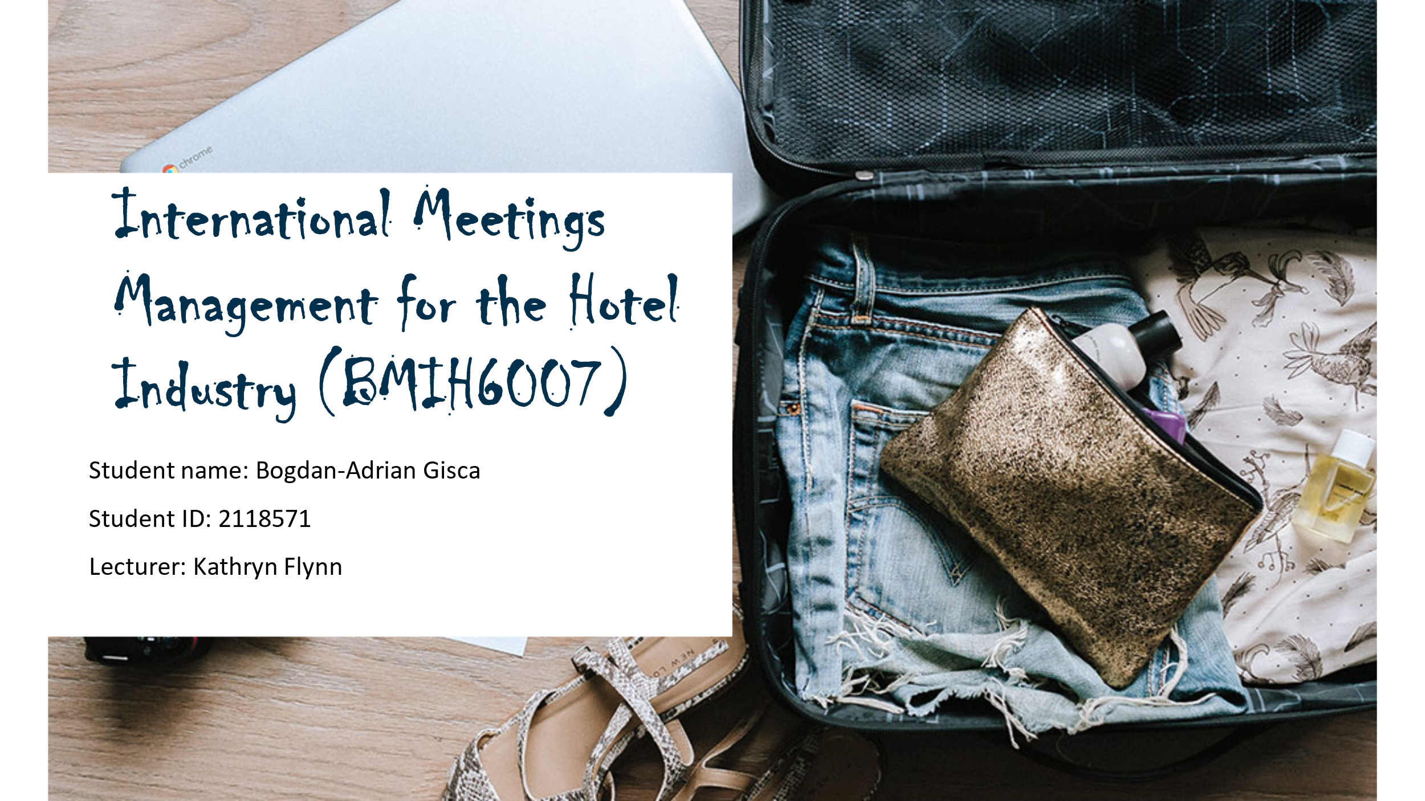

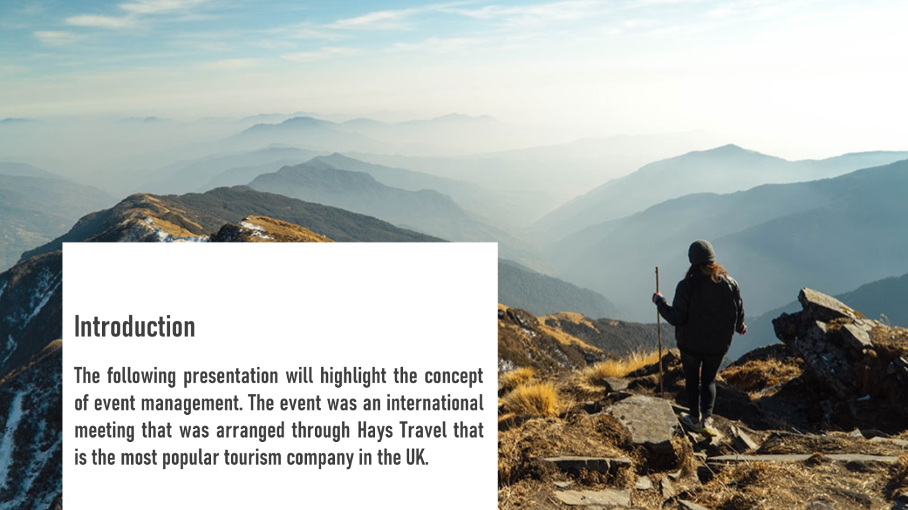

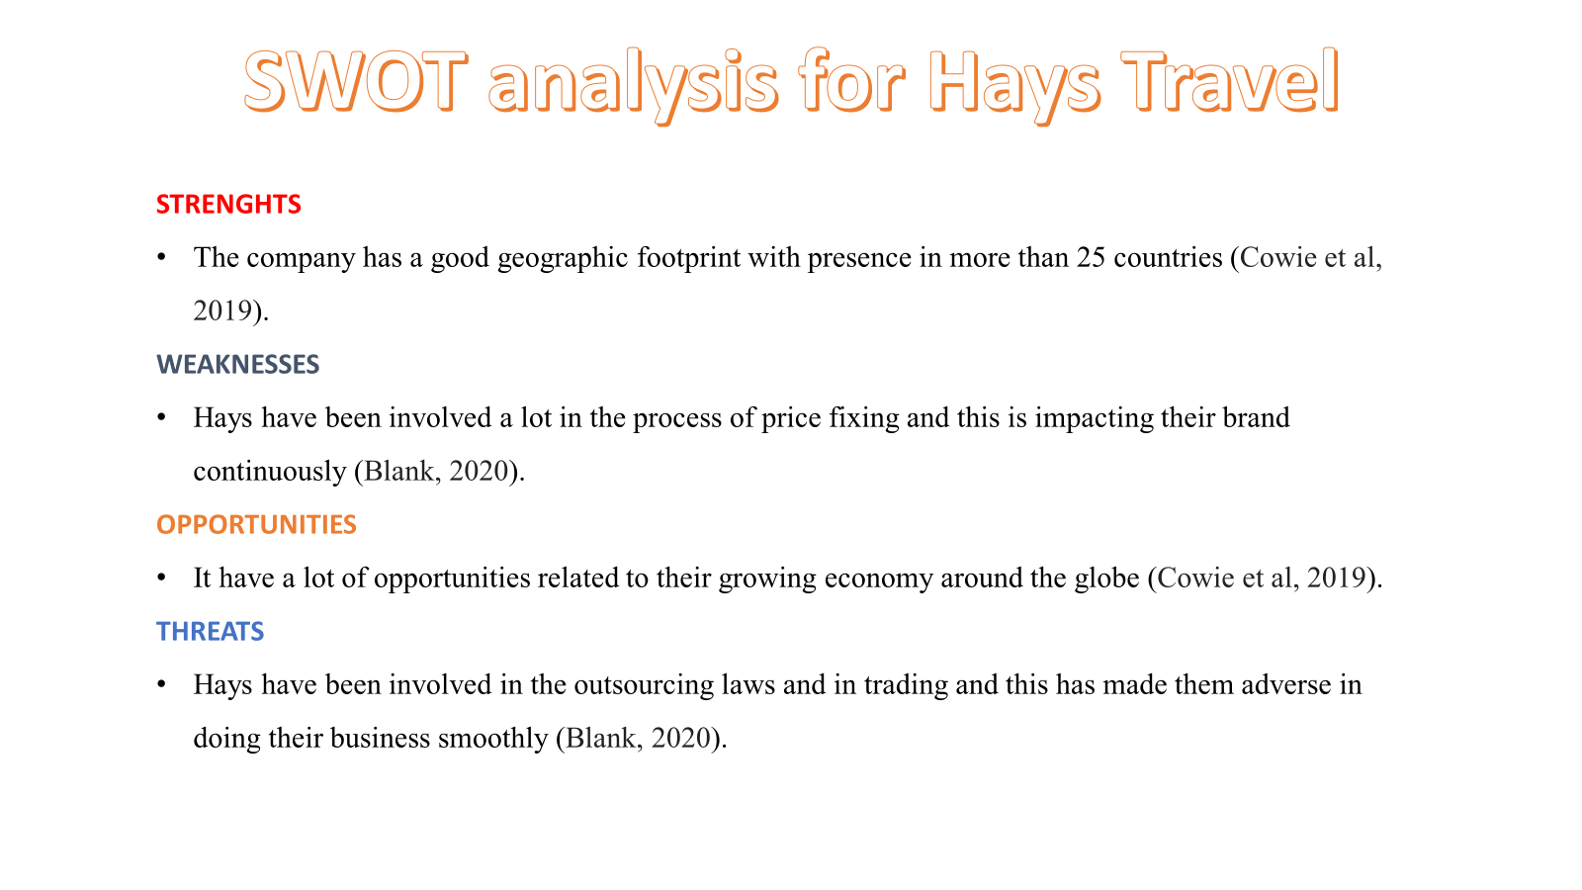

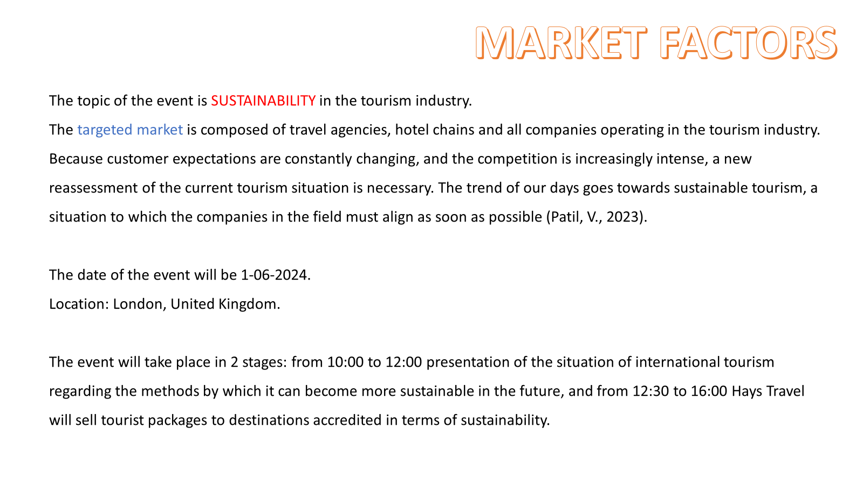

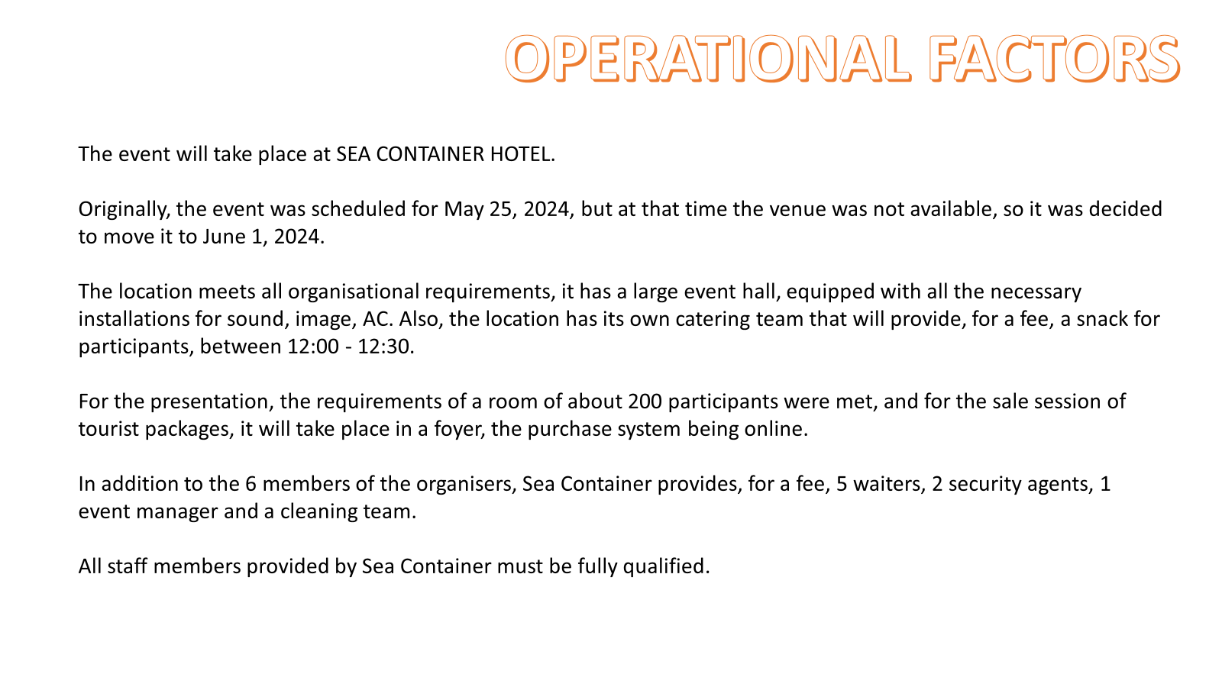

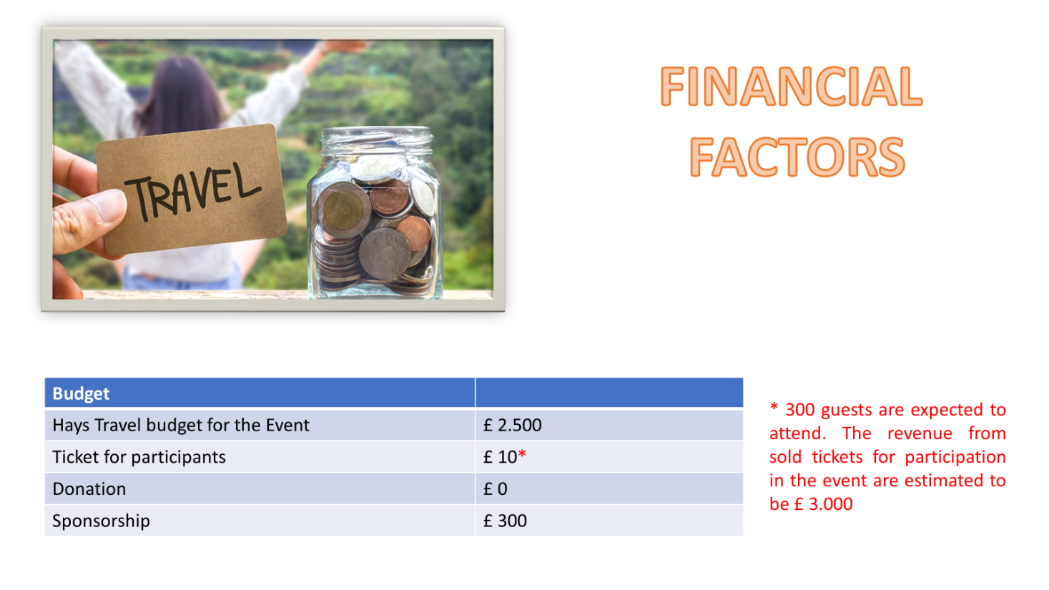

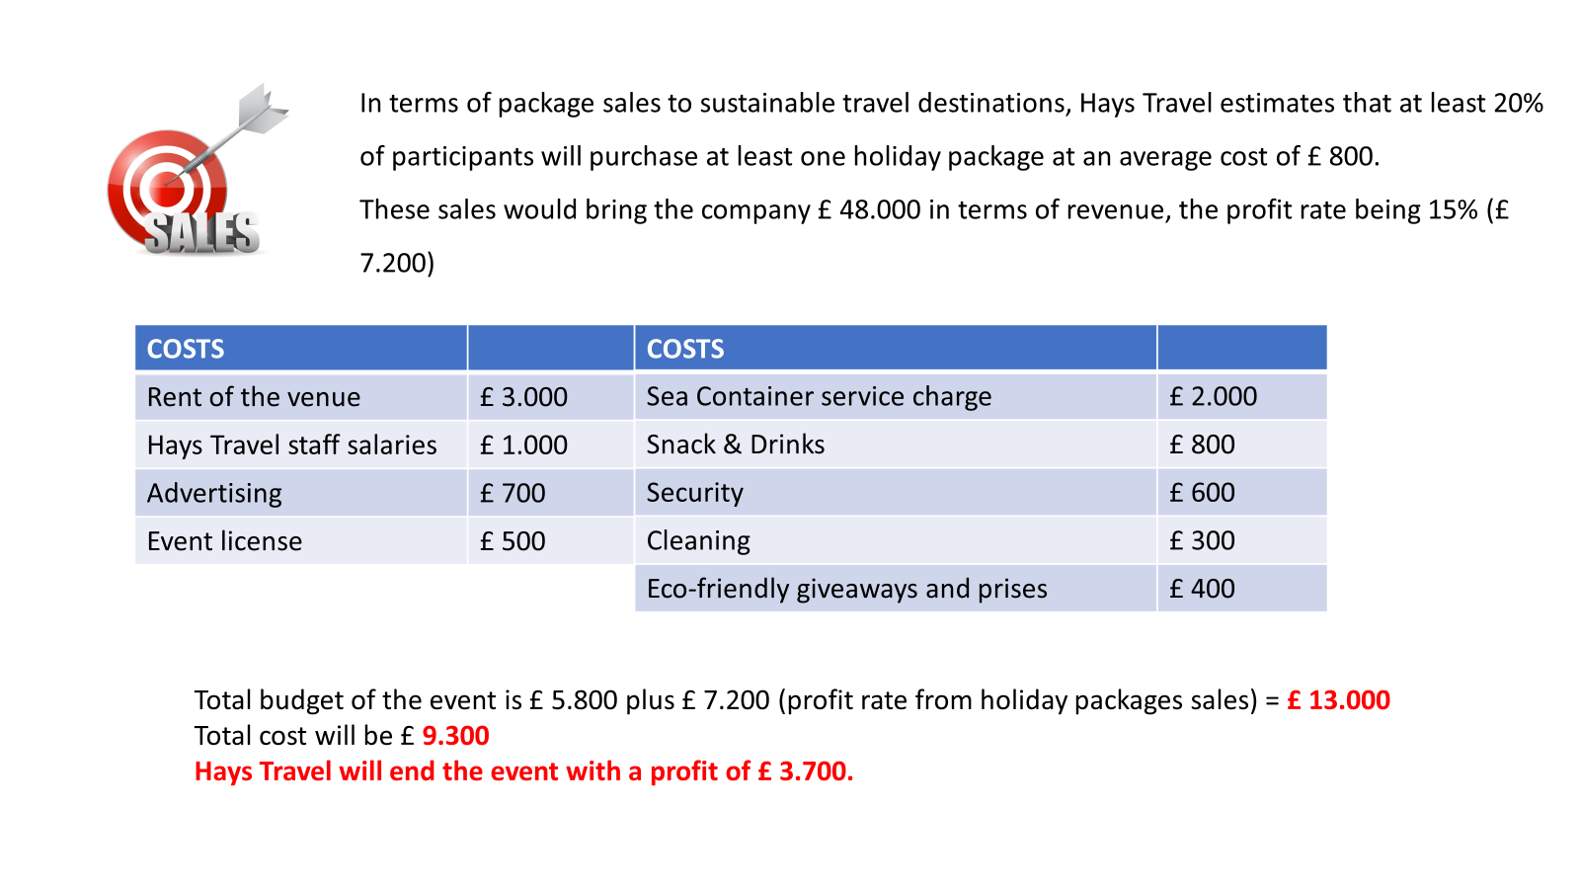

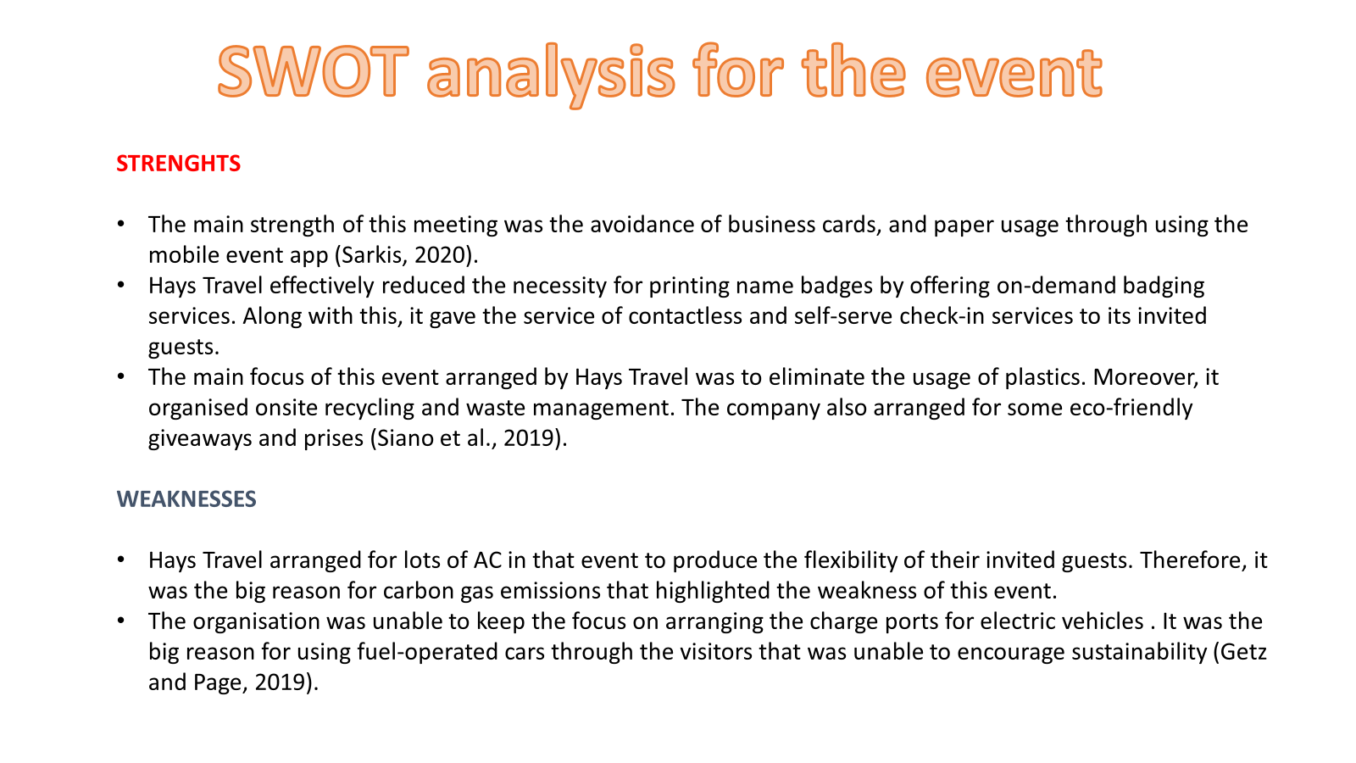

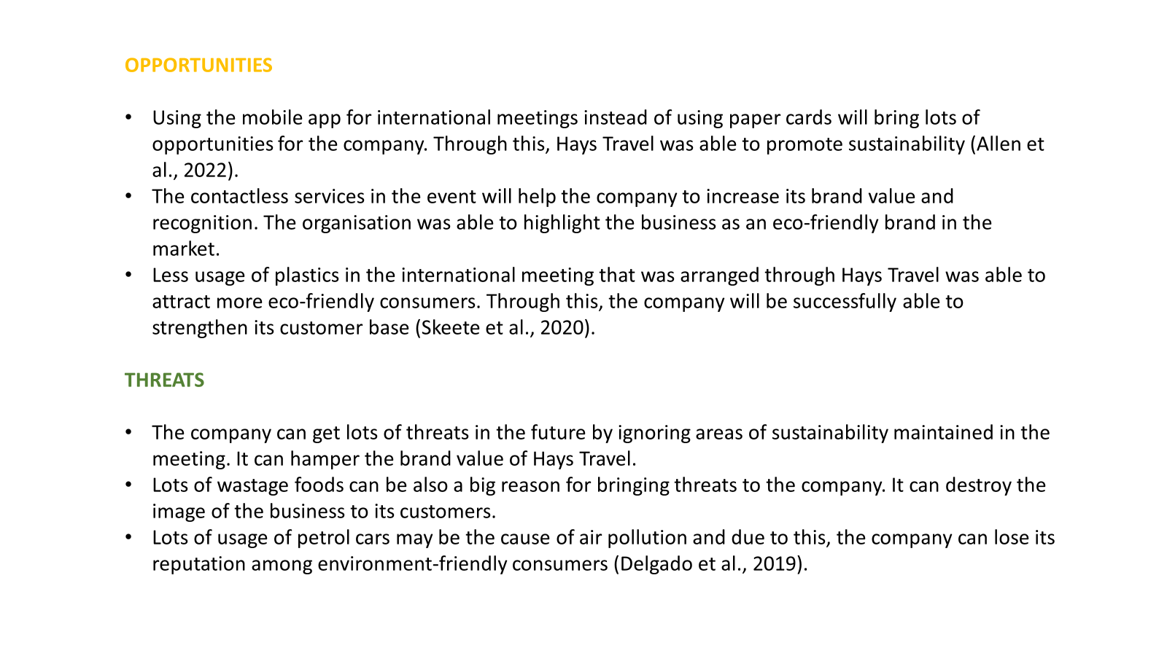
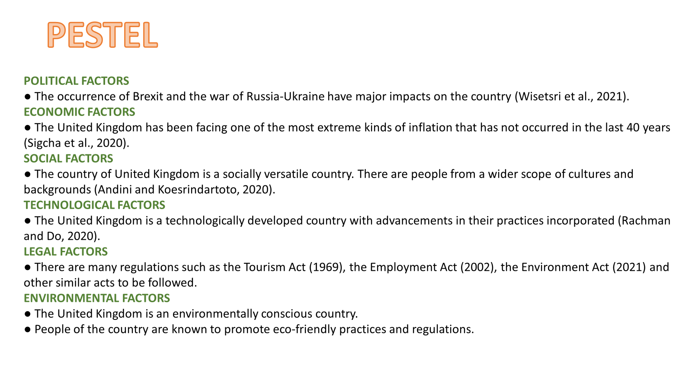
PRESENTATION LINK
https://uowtsd-my.sharepoint.com/:v:/g/personal/2118571_student_uwtsd_ac_uk/EcbSa8_uaftMhw83PMaWQfMBKB_3E5dRwdTT9thhSdjdgQ?referrer=Teams.TEAMS-WEB&referrerScenario=MeetingChicletGetLink.view.view

REFERENCE LIST
Allen, J., Harris, R., Jago, L., Tantrai, A., Jonson, P. and D'Arcy, E., (2022). Festival and special event management. John Wiley & Sons.
Blank, S., (2020). The four steps to the epiphany: successful strategies for products that win. John Wiley & Sons.
Cowie, P., Tiwasing, P., Phillipson, J. and Gorton, M., (2019). Rural innovation and small business development. The Routledge Companion to Rural Planning.
Delgado, J.A., Short Jr, N.M., Roberts, D.P. and Vandenberg, B., (2019). Big data analysis for sustainable agriculture on a geospatial cloud framework. Frontiers in Sustainable Food Systems, 3, p.54.
Getz, D. and Page, S.J., (2019). Event studies: Theory, research and policy for planned events. Routledge.
Patil, V. (2023). Top 10 Challenges faced by the hotel industry in 2024. Available at: https://hotelweb.io/challenges-of-hotel-industry/. Accessed: 26-01-2024.
Rachman, G.P. and Do, A.D., (2020). Business Strategy for Atlantic City Hotel Facing Covid-19 Pandemic. International Journal of Current Science Research and Review, 5(2), pp.333-340.
Sarkis, J., (2020). Supply chain sustainability: learning from the COVID-19 pandemic. International Journal of Operations & Production Management, 41(1), pp.63-73.
Siano, P., Haes Alhelou, H., Hamedani-Golshan, M.E. and Njenda, T.C., (2019). A survey on power system blackout and cascading events: Research motivations and challenges. Energies, 12(4), p.682.
Skeete, J.P., Wells, P., Dong, X., Heidrich, O. and Harper, G., (2020). Beyond the EVent horizon: Battery waste, recycling, and sustainability in the United Kingdom
Sigcha, E., Martinez-Moscoso, A., Siguenza-Guzman, L. and Jadan, D., (2020, July). PESTEL analysis as a Baseline to support decision-making in the local textile industry. In International Conference on Systems and Information Sciences (pp. 144-156). Cham: Springer International Publishing.
Wisetsri, W., Mangalasserri, K., Cavaliere, L.P.L., Mittal, P., Chakravarthi, M.K., Koti, K., Rajest, S.S. and Regin, R., (2021). The Impact of Marketing Practices on NGO Performance: The Pestel Model Effect. Turkish Online Journal of Qualitative Inquiry, 12(3).

