EMOLE LAWRENCE FAVOUR 1908220
BNS400I
INTRODUCTION: This essay aims to discuss my academic and employability skills reflecting on class activities learned from this module; it will further define what a skill and employability skills are. Thereafter it will explore the definitions of soft or transferable and hard skills, also including good communication skills such as listening, writing, reading, and speaking. It will also discuss the essence of teamwork and time management, punctuality and the effective use of time and also using the SWOT analysis to identify my weaknesses and strength and finally the conclusion.
MY OWN SKILLS ANALYSIS: from mind tools analysis is about my strengths, weaknesses, opportunities, and threats. {SWOT} analysis.
1 STRENGTHS: l am fluent in English, Spanish, Dutch and Igbo languages, fully qualified first aider, punctual, reliable and able to case initiative, possess a caring and understanding attitude, excellent computer skills, interpersonal and communication skills, ability to relate to people of all backgrounds, patience, honesty, a supportive attitude to words health and wellbeing.
2 WEAKNESSES
My greatest weakness is that l spend too much time to do things, l am a slow writer, which I am trying to improve on. l needs to improve on my technology and also l have trouble saying no. I get impatient projects run beyond the deadline. I have no employment experience, even the part-time job experience.
I am weak in problem solving; when I face problems usually I can not see all sides of them and can not provide good solution of them.
My Communication skills are weak. I am an introvert (result in appendix 1) and I am not good at communicate with others .I feel shy when I talking to strangers.

3 Opportunities I have bachelor's in leadership it provides me the opportunity to work as a director in IFYBELLA KIDNEY ORGANISATION it helps me to reach out to add value in people's life. It has been a wise time to go to other countries helping some people who have a problem in the kidney being there, it allows me to encourage them, giving hope for them and paying some of their bills. To be a Pastor has helped me to reach out to all people in respective of who they are.
4 Threats: is a force for something bad to happen or gives room for unfortunate things being to create bad feeling over an issue such as, when you get a letter from council or court you begins to develop hate around you. Because their letters always come with threats or one ugly story that comes with lying in other to get money from you. Childcare is another issue that wears me down, l have many things to do but through childcare cannot do it, because of time.
WHAT IS A SKILL
According to Webster, (2019) defined skill as a capability or capacity to make someone's understanding to become effective in his or her acquired knowledge and willing to carry out a task or duty.
While employability skill is a skill that someone acquired to fit certain positions based on their experience and practice that they have gained.
According to the statement made by In employability, employers want employees who have the kind of skills the company requires for the improvement of their organization or business, examples are acquired skills like being able to communicate effectively.
Employability skill is defined as a transferable skill that people need to for effective employment and having a good understanding and topics that are knowledgeable. Employers always have a description of what they need from workers. Below are the lists of employability skills.
1 Communication and interpersonal skills are the ability to communicate effectively through writing, speaking, listening ready and being able to one another.
2 Problem-solving skill is to be able to know a problem and know how to solve it based on his or her experience and practical knowledge. Problem-solving people do not favor one side or discriminate but to bring peace for the benefit of the company or organization.
3 What are soft skills
Soft skills are personal attitude and skills people use for communicating and interacting with each other, for example in a working place, soft skills is a personal behavior ability to complete a task, (Hurrell,2009,pg397)
The demand of soft skill from employer to employees is a speed feeling with intelligence based on ability to communicate well with one another and with relational skill which is being able to have a good communicative goals with a good team management that will bring good result and this very vital for a multidisciplinary teams that are cultural and geographic. Example of soft skills are honesty and integrity, to be confident, enthusiastic, having good character, to be friendly, to have good listening skills, self-motivation, ability to make a good decision, empathy for others, ability to deal with conflict by (LinkedIn,2018).

According to( kagan,2019)defined hard skills as acquired skill gained, or achieved through learned abilities by education, practicing new courses to enhance more experience. Hard skill is vital because it speeds an employed production, efficient and teachable abilities that are required in a candidate.
Examples of: Hard skills are cloud computing is an advanced internet and based on technology. It is an easy way to secure Data and many organizations, factory and companies are turning into Cloud.
Communication skills are very useful skills. Being able to speak fluently different languages helps the companies to have a greater impact on their business.
Data analysis is a capability that is rated highly across industries and it is an ability to use data effectively for the growth of the company. Many companies marketing their businesses through it.
Computer technology it is necessary to have a basic knowledge of how to use the computer and searching for job or advertisement, it goes quicker than then given it to individuals working in the street for examples you can be in your homes accessing or searching for millions of jobs easily and sending application for vacancy than taking it to companies personal. The computer helps to access any information you needed for that period and also helps you to study and get your degree. Through the computer, it helps the companies to buy things they are needed.
Mobile and web development creates a lot of websites and apps everyday which makes it possible or easier for people to be creative and able to be skilled in using apps and websites. Mobile makes things easier for sending messages and others etc.
Project Management: is an important skill that is necessary for the use of many industries from constructing to industrial technology, Project Management it is a total body that comes together to see the future of companies or organizations is well structured. Hard skill is very important to help the employers to grow effectively and easier way to established.

Soft or transferable skills: are skills that are important when applying for a job in many organizations, industries, companies and help easily to acquire jobs at any different level. It helps you to be placed in a high position. This is what makes you different from other people's skills. Examples can communicate effectively, be a good listener, having a good leadership quality, being flexible, responsible, decision making, able to collaborate as a teamwork, work in truth as a person and having a self- confidence(Hislop,2019)
Working within a team means working with a group of people and working together to achieve a collected effort in a good manner by listening to everyone's ideas and not only your idea only. It is the ability to see everybody potential and make use of it, learn from any of them regardless of their colors. Working together to achieve that greatness.
TIME MANAGEMENT: is a way of planning and putting time in order, the time between certain activities, punctuality or using time efficiently. Good time management helps one to be smart and not stressful to get a job done in a short time even when there are pressures of high demands and without being able to manage time is dangerous for anyone by Mind tools.com.
What is a swot stand for:
SWOT STAND FOR: It stands for Strengths, Weaknesses, Opportunities, and Threats, so a SWOT breakdown is a system used to know our four aspects of my future. SWOT-analysis helps to see if l am in the right direction or not. It helps to reduce the chances of failure, accepting what you are missing, and eradicating threats that would otherwise catch you unexpectedly
How to do a SWOT Analysis: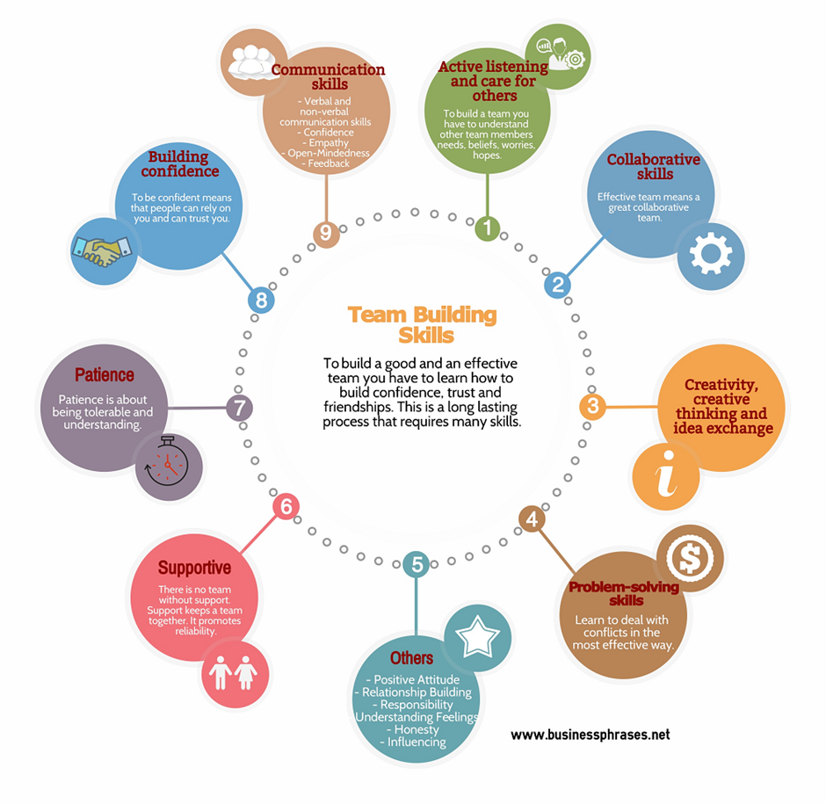

MY OWN SKILLS ANALYSIS: from mind tools analysis is about my strengths, weaknesses, opportunities, and threats. {SWOT} analysis.
1 STRENGTHS: l am fluent in English, Spanish, Dutch and Igbo languages, fully qualified first aider, punctual, reliable and able to case initiative, possess a caring and understanding attitude, excel ent interpersonal and communication skills, ability to relate to people of all backgrounds, patience, honesty, a supportive attitude to words health and wellbeing.
2 WEAKNESSES
My greatest weakness is that l spend too much time to do things, l am a solo writer, l want to improve in this area. l needs to improve on my technology and also l have trouble saying no. I get impatient projects run beyond the deadline.
3 Opportunities I have bachelor's in leadership it provides me the opportunity to work as a director in IFYBELLA KIDNEY ORGANISATION and helps me to reach out to add value in people's life. It has been a wise time to go to other countries helping some people who have a problem in the kidney Being there, it gives me opportune to encouraging them, giving hope for them and paying some of their bills. To be a Pastor has helped me to reach between big and small.
4 Threats: is a force for something bad to happen or gives room for unfortunate things being to create bad feelings over an issue such as, when you saw a letter from council or court you being to develop hate around you. Because their letters always come with a threat or one ugly story that comes with lying in other to get money from you. Childcare is another issue that wears me down, l have many things to do.

Conclusion: This essay has discused my academic and employability skills by using the SWOT analysis tools to identify my strenght and weekness. It has also provide the definations of a skill and employability skills and the varioius forms of skills such as the soft and hard skills. The essay further mention what a good communication, team work and time management and the essential of theses skills between employer and employee in terms of building a good working relationship.

References
http://www.businessdictionary.com/definition/skill.html
References:
Needleman, E. C. (1995). Preparing Youth for Employable Futures. Washington, DC: National 4-H Council
Secretary’s Commission on Achieving Necessary Skills (no date). Skills and Tasks for Jobs. A SCANS Report for America
2000. Washington, DC: U.S. Department of Labor
Dodds, P. S., Harris, K. D., Kloumann, I. M., Bliss, C. A., & Danforth, C. M. (2011). Temporal Patterns of Happiness and Information in a Global Social Network: Hedonometrics and Twitter.
Giddens, A., & Sutton, P. W. (2017) Sociology, 8th edn. Cambridge: Polity
Hogg, M. A, Vaughan, G.M. (2017) Social psychology, 8th edn, Harlow: Princeton Hall.
Revchav, I. (2018) The impact of media type on shared decision processes in third-age population. International journal of medical informatics Volume: 112 (2) 1386-5056.
Scott K, Gome G, Richards C, Caldwell P., (2016) How trustworthy are apps for maternal? and child health? Health Technol. vol;4(4):329–36
Salter, M. (2013)’ Justice and revenge in online counter- public: Emerging response to sexual violence in the age of social media. Crime media culture, vol 9(3) pp.225-43.

