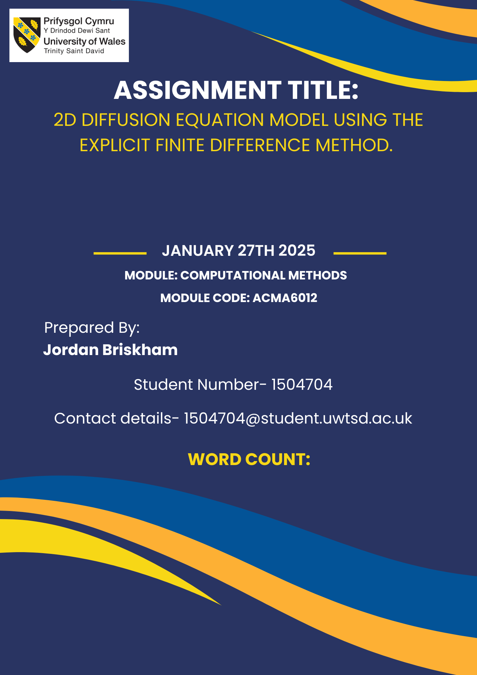
3280
Abstract
Accurate modelling of heat diffusion is essential across various engineering and applied science fields, influencing the optimisation of thermal management systems and material processing techniques. This study focuses on developing and evaluating a two-dimensional heat diffusion model using the Explicit Finite Difference Method (EFDM). The numerical model is implemented in MATLAB and validated against an analytical solution to ensure reliability. A detailed sensitivity analysis assesses the influence of key numerical parameters, including grid spacing, time step size, and convergence criteria tolerance, on solution accuracy and computational efficiency. The results indicate that while EFDM is computationally accessible, its stability is constrained by the Courant-Friedrichs-Lewy (CFL) condition, which imposes strict timestep limits. The study highlights numerical errors impacting solution accuracy, such as truncation and round-off errors. Furthermore, limitations regarding structured grids and fixed boundary conditions restrict the model’s applicability to complex geometries. Future work should explore implicit and hybrid numerical methods to enhance stability, efficiency, and adaptability for broader engineering applications.

Table of Contents
1. Introduction 1
2. The governing equation of the problem 3
2.1 The heat equation 3
2.2 Mathematical Definition for 2D Geometry 3
2.2.1 Thermal diffusivity 4
3. Explicit finite form of the constitutive equation 5
3.1 Taylor Series General Formula 5
3.2 Forward Difference Approximation 5
3.3 Backward Difference Approximation 5
3.4 Central Difference Approximation 6
3.4.1 First derivative: 6
3.4.2 Second derivative: 6
3.5 Discretisation of the Spatial Domain 7
3.6 Discretisation of the Temporal Domain 8
3.7 Derivation of the explicit finite form of the heat equation. 8
3.8 Definition of the stability criterion. 9
4. The initial boundary conditions and analytical solution 10
4.1 Initial Boundary Conditions 10
4.2 Constant Boundary Conditions 11
4.2.1 Dirichlet Boundary Conditions 11
4.2.2 Neumann Boundary Conditions 11
4.3 Analytical Solution 12
5. Illustrative descriptions of MATLAB code. 13
5.1 Initialising the workspace and defining material properties 13
5.2 Setting plate dimensions on the X and Y axes 13
5.3 Setting grid spacing value (h) 13
5.4 Calculating and initialising matrix Parameters 14
5.5 Application of Dirichlet boundary conditions and Calculation of time step 14
5.6 Initialisation of T2 matrix key parameters definition of the convergence criteria tolerance 15
5.7 Calculation of the maximum temperature difference by applying the modified heat equation 15
5.8 Displaying numerical results, iterations counter, and time to equilibrium 16
5.10 Calculation of difference between TA and T2 Generation of heat map figures 17
6. Code Validation 18
7. Sensitivity analysis of code 22
7.1 Parameters of the sensitivity analysis 22
7.2 Analysis of the influence of grid spacing on thermal equilibrium time 22
7.3 Analysis of the influence of time step spacing on thermal equilibrium time 23
7.4 Analysis of the influence of convergence criteria tolerance on Thermal equilibrium time 24
8. Limitations of Model 25
8.1 Numerical Limitations 25
8.2 Coding Limitations 25
9. Suggestions for future developments and improvements 26
9.1 Suggestions for future work 26
9.2 Suggestions for improvements 26
10. Conclusions 27
11. References 28
12. Appendix 32
Appendix 1 - MATLAB code for reference. 32

Figures list
Figure 1- Representative free body diagram of plate spatial domain. Adapted from Source-(Pantakar, 1980) 7
Figure 2-CFL stability criterion. 9
Figure 3-Initial and Boundary conditions schematic diagram. 10
Figure 4- Initial boundary conditions criterion. 10
Figure 5- Dirichlet boundary conditions criterion. 11
Figure 6-Neumann boundary conditions criterion. 11
Figure 7- Screenshot of MATLAB code line 1-8. 13
Figure 8- Screenshot of MATLAB code line 9-17 13
Figure 9- Screenshot of MATLAB code line 18-24 14
Figure 10-Screenshot of MATLAB code line 25-29 14
Figure 11-Screenshot of MATLAB code line 30-45 14
Figure 12-Screenshot of MATLAB code line 46-54 15
Figure 13-Screenshot of MATLAB code line 55-80 15
Figure 14-Screenshot of MATLAB code line 81-98 16
Figure 15-Screenshot of MATLAB code line 99-115 16
Figure 16-Screenshot of MATLAB code line 116-157 17
Figure 17-Numerical solution matrix data and heat map. 19
Figure 18-Analytical solution matrix data and heat map. 20
Figure 19-Absolute temperature differences between T2 and TA matrixes data and heat map. 21
Figure 20-Grid spacing analysis graph 22
Figure 21- Time step analysis graph 23
Figure 22- Convergence criteria analysis graph 24

Equation list
Equation 1- The Heat Equation (2D). 3
Equation 2- Thermal diffusivity equation. 4
Equation 3- Taylor series general equation. 5
Equation 4- Forward difference approximation. 5
Equation 5-Backward difference approximation. 5
Equation 6- First derivative central difference approximation. 6
Equation 7-Second derivative central difference approximation. 6
Equation 8- Approximate second derivatives by central difference approximation in the direction of $x.$ 7
Equation 9- Approximate second derivatives by central difference approximation in the direction of $y$. 7
Equation 10-Approximate first derivative by forward difference approximation. 8
Equation 11-EFDM form of the heat equation. 8
Equation 12- Fourier’s number equation. 8
Equation 13- A modified discretised form of the heat equation to set Neumann conditions on the East plate boundary 11
Equation 14-Modified discretised form of the heat equation to set Neumann conditions on the West plate boundary. 11
Equation 15-Analytical temperature solution at thermal equilibrium to which the numerical result is tested. 12

Table list
Table 1-Grid spacing analysis parameters 23
Table 2- Time step analysis parameters. 23
Table 3-Convergence criteria tolerance parameters. 24

1. Introduction
The ability to accurately model heat diffusion is fundamental to numerous engineering and applied science fields (Pop and Ingham, 2001), influencing the design and optimisation of thermal management systems (Norton et al., 2013) (Agyeman et al., 2023) and material processing methods (Gunasegaram and Steinbach, 2021). Among the various approaches for numerically simulating heat transfer, the Explicit Finite Difference Method (EFDM) is a widely used and accessible technique favoured for its conceptual simplicity and direct implementation (Miltat and Donahue, 2007).
This report aims to describe the development and evaluation of a two-dimensional heat diffusion model based on the EFDM. Its central objective is to establish a computational method to accurately approximate solutions to the 2D heat equation under different operational parameters. A key component of this work is verifying the numerical model by comparison with an analytical solution to assess whether the proposed methodology is reliable. Additionally, this report includes an analysis of critical modelling parameters to determine their effects on solution accuracy and stability.
The report is organised into nine distinct sections:
- The Governing Equation of the Problem: This section introduces the heat equation in two dimensions, outlines its derivation, and highlights the physical significance of each parameter in the absence of internal heat sources.
- The Explicit Form of the Constitutive Equation: This section explores the discretisation approach using Taylor series expansions and details the derivation of the EFDM scheme.
- Initial and Boundary Conditions: These define the problem setup and identify the analytical solution used for model validation.
- Illustrative examples of MATLAB code: This section presents key elements of the computational code and explains their functions for reproducibility and future modifications.
- Code validation: Compares the numerical results with the analytical solution, assessing the model’s accuracy and reliability.
- Sensitivity Analysis of the code: Investigates the impact of critical numerical parameters (Grid spacing, time step and Convergence Criteria tolerance) on the solution quality, focussing on spatial and temporal discretisation.
- Limitations of the model: This section identifies the constraints inherent to the EFDM and suggests avenues for refining the model and broadening its applicability.
- Future developments and possible improvements: Explores alternatives to EFDM and suggests improvements for future work.
- Conclusion: This section summarises the main findings, discusses their implications, and suggests potential future research and development directions.

2. The governing equation of the problem

2.1 The heat equation
The heat equation derived by Joseph Fourier in the early 19th century- is a fundamental partial differential equation (PDE) (Narasimhan, 1999). Its development provided an integral framework for studying heat transfer in solids, and it is widely used within engineering and physics applications for simulating thermal conduction through matter- a process governed by Fourier’s law of heat conduction. Fourier’s law establishes that the heat flux is proportional to the temperature gradient, and this principle forms the foundation of the heat equation (Wang and Wang, 2022). The equation simulates the heat flow within a material, although it is not purely theoretical. It is crucial for predicting how temperature evolves in time and space. It has extensive practical applications in engineering, such as designing and analysing thermal systems and simulating cooling or heating patterns in industrial automation processes (Pandey et al., 2023).

2.2 Mathematical Definition for 2D Geometry
The heat equation for a two-dimensional spatial domain (without any internal heat source) is expressed as (Incropera et al., 2013):

$$\frac{∂^{2}T}{∂x^{2}} + \frac{∂^{2}T}{∂y^{2}}= \frac{1}{α}∙\frac{∂T }{∂t }$$
Equation 1- The heat equation (2D).
Where:
T(x, y): Temperature at position x & y
$t$: time
α: Thermal diffusivity of the material.
$\frac{∂T }{∂t }$: Rate of change of temperature with respect to time.
$\frac{∂^{2}T}{∂x^{2}}$ and $\frac{∂^{2}T}{∂y^{2}}$: Second PDEs of temperature with respect to spatial coordinates x and y, representing heat diffusion in these directions.

2.2.1 Thermal diffusivity
The thermal diffusivity equation is expressed as (Incropera et al., 2013):
$$α = \frac{k}{(ρcₚ)}$$

Equation 2- Thermal diffusivity equation.
Where:
k: Thermal conductivity (W/m·K).
ρ: Density of the material (kg/m³).
cₚ: Specific heat capacity (J/kg·K).

3. Explicit finite form of the constitutive equation
The Taylor series expansion is used to discretise the heat equation by replacing the first and second derivatives with difference approximations derived from the Taylor Series. Since many PDEs do not have analytical solutions, numerical methods replace continuous derivatives with discrete approximations at specific grid points. These grid-based approximations allow the numerical scheme to compute approximate solutions iteratively, satisfying the given initial and boundary conditions.

3.1 Taylor Series General Formula
Taylor series approximate functions as a polynomial such as (Croft et al., 1977):
$f\left(x\right) = f \left(x_{0}\right) + f' {(x}_{0}).\frac{\left(x - x_{0}\right) }{1!}+f^{'' }{(x}_{0}).\frac{{\left(x - x_{0}\right)}^{2}}{2!}+f^{''' }{(x}_{0}).\frac{{\left(x - x_{0}\right)}^{3}}{3!}+f^{(4) }{(x}_{0}).\frac{{\left(x - x_{0}\right)}^{4}}{4!}+ …$
Equation 3-Taylor series general equation.
Where $x_{0}$ is the location of interest around which the polynomial is generated (Croft et al., 1977).

3.2 Forward Difference Approximation
From the Talor Series expressed in Eq. 2, the forward difference approximation (FDA) to the first derivative can be derived as (Croft et al., 1977):
$$f^{'}\left(x_{0}\right) = \frac{f\left(x_{0} + h\right) -f \left(x_{0}\right)}{h}+O\left(h\right)$$
Equation 4-Forward difference approximation.
Where O(h) is the truncation error of order h, therefore, h must be particularly small for the error to be negligible and the approximation sufficiently accurate (Chapra, 2012).

3.3 Backward Difference Approximation
Similarly, from Taylor Series Eq. 3, the backward difference approximation (BDA) can be generated as (Chapra, 2012):
$$f^{'}\left(x_{0}\right)=\frac{f\left(x_{0}\right)-f\left(x_{0}-h\right)}{h}+O\left(h\right)$$
Equation 5-Backward difference approximation.
Where the truncation error is of the same order as the FDA in section 3.2.

3.4 Central Difference Approximation

3.4.1 First derivative:
The forward and backward approximations can be combined to get a more accurate approximation to the first derivative. The Central difference approximation (CDA) is given by (Chapra, 2012):
$$f^{'}\left(x_{0}\right)=\frac{f\left(x_{0}+h\right)-f\left(x_{0}-h\right)}{2.h}+O\left(h^{2}\right)$$
Equation 6-First derivative central difference approximation.
Where $O\left(h^{2}\right)$is the truncation error of the order $h^{2}$ which is an error that is less sensitive to the h value (Iserles, 2012).

3.4.2 Second derivative:
The second derivative is formed by essentially applying the CDA again to the first derivative approximation shown in Eq.6 (Chapra, 2012) :
$$f^{'}'\left(x_{0}\right)=\frac{f\left(x_{0}+h\right)-2.f(x_{0})+ f\left(x_{0}-h\right)}{h^{2}}+O\left(h^{2}\right)$$
Equation 7-Second derivative central difference approximation.
Where the truncation error is of the same order as the CDA first derivative in section 3.4.1.

3.5 Discretisation of the spatial domain

The spatial domain is divided into a uniform grid of discrete points to calculate the heat propagation across the plate, as shown in Fig. 1. Each grid point is separated by the distance $h$ where $h=∆x= ∆y$
N
E
S
W
Y
X
P
h
h
h
h

Figure 1- Representative free body diagram of plate spatial domain. Adapted from Source-(Pantakar, 1980)
P= A typical point of interest on the grid with its four cardinal neighbouring points identified as:
N= North
S= South
E= East
W= West
Using this notation, the CDA to the second derivative can be expressed as:
$$\frac{∂^{2}T}{{∂x}^{2}}=\frac{T_{E}^{t}-2.T_{P}^{t}+T_{W}^{t}}{h^{2}}+O(h^{2})$$
Equation 8- Approximate second derivatives by central difference approximation in the direction of $x.$
$$\frac{∂^{2}T}{{∂y}^{2}}=\frac{T_{N}^{t}-2.T_{P}^{t}+T_{S}^{t}}{h^{2}}+O(h^{2})$$
Equation 9- Approximate second derivatives by central difference approximation in the direction of $y$.
Where:
$T_{N}^{t}=$ The temperature at the North of the location point P at the current time t.
$T_{S}^{t}=$ The temperature at the South of the location point P at the current time t.
$T_{E}^{t}=$ The temperature at the East of the location point P at the current time t.
$T_{W}^{t}=$ The temperature at the West of the location point P at the current time t.

3.6 Discretisation of the temporal domain
Time is continuous, although, for this simulated activity, the temporal domain must be discretised by dividing time into discrete steps shown as $∆t$.
The EFDM uses the forward difference approximation to discretise $\frac{∂T}{∂t}$.
$$\frac{∂T}{∂t}=\frac{T_{P}^{t+∆t}-T_{P}^{t}}{∆t}+O(∆t)$$
Equation 10-Approximate first derivative by forward difference approximation.
Where:
$T_{P}^{t}$ = This represents the temperature at the location point (P) at the current time.
$T_{P}^{t+∆t}$ = The temperature at the same location point (P) at the succeeding timestep.

3.7 Derivation of the explicit finite form of the heat equation.
To derive the discretised explicit finite difference form of the heat equation, the FDA is used to discretise $\frac{∂T}{∂t}$ and the CDA to discretise the second derivative.
Thus, the EFDM form of the heat equation is given by (Croft et al., 1977):
$$T_{P}^{t+∆t}=F_{O}×\left[T_{N}^{t}+T_{S}^{t}+T_{E}^{t}+T_{W}^{t}-\left(4-\frac{1}{F_{O}}\right).T_{P}^{t}\right]$$
Equation 11-EFDM form of the heat equation.
Where the Fourier Number $F_{O}$ is (Croft et al., 1977):
$$F_{O}=\frac{αΔt}{h^{2}}$$
Equation 12- Fourier’s number equation.

3.8 Definition of the stability criterion.
While using the Explicit Finite Difference Equation, The Courant-Friedrichs-Lewy (CFL) stability criterion (Iserles, 2012) applies, which applies a constraint on the time step and spatial grid spacing. This is the main disadvantage of this model, as once $α$ and $h$ are quantified, a maximum time step can be selected.
This criterion is shown (in 2D) as(Hensen and Nakhi, 1994):
$$0<F_{O}≤ \frac{1}{4}$$
Figure 2-CFL stability criterion.

4. The Initial Conditions, Boundary Conditions and analytical solution
The geometry to be considered in this case is a rectangular plate of width 𝑋𝑑𝑖𝑚 and height 𝑌𝑑𝑖𝑚, which need to be set by the code user, depending on the dimensions of the plate. Boundary conditions specify how the system interacts with its surrounding environment, defining whether heat is held constant, insulated or flowing freely (Aliabadi, 2002). The boundary conditions facilitated in this case are shown in Fig.3.
Aluminium Plate
Initial Domain Condition:
T= $0℃$
$$\frac{∂T\left(X_{dim},y,t\right)}{∂x}=0$$

$\frac{∂T\left(0,y,t\right)}{∂x}=0$

$(0, Y_{dim})$

$( X_{dim}, Y_{dim})$

$(0, 0)$

$( X_{dim}, 0)$

$$T\left(x,0,t\right)=-T_{0}$$
$$T\left(x,Y_{dim},t\right)=T_{0}$$

Figure 3-Initial and Boundary conditions schematic diagram.

4.1 Initial Boundary Conditions
The initial domain condition is:
$$T\left(x,y,0\right)=0, 0<x<X_{dim},0<y<Y_{dim}$$
Figure 4- Initial boundary conditions criterion.
This ensures that the entire plate initialises at a uniform temperature of 0°C. This temperature will be applied to all grid points at the start of the simulation.

4.2 Constant Boundary Conditions
4.2.1 Dirichlet Boundary Conditions
Fixed temperature for the north and south edges of the plate:
$T\left(x,0,t\right)=-T_{0}$
$$\text{for }0≤x≤X_{dim}\text{ and }0≤t≤\text{thermal equilibrium}$$
$T\left(x,Y_{dim},t\right)=T_{0}$
Figure 5- Dirichlet Boundary Conditions criterion.
The Dirichlet boundary conditions dictate the maximum and minimum temperature within the plate by setting fixed values for the north and south edges of the plate. The temperature of the South boundary is set to $-T_{0}$ .The North boundary is held at $T_{0}$.

4.2.2 Neumann Boundary Conditions
Insulated Edges for the East and West edges of the plate:
$\frac{∂T\left(0,y,t\right)}{∂x}=0$
$\text{for }0<y<Y_{dim}\text{ and }0≤t≤\text{thermal equilibrium}$
$\frac{∂T\left(X_{dim},y,t\right)}{∂x}=0$
Figure 6-Neumann Boundary Conditions criterion.
These conditions enforce zero heat flux through the east and west boundaries. The temperature gradient at these boundaries is zero, meaning these edges are fully thermally insulated (Venkateshan and Swaminathan, 2014). To facilitate these conditions, Eq. 11 is modified, shown as:
East Boundary
$$T_{P}^{t+∆t}=F_{O}×\left[T_{N}^{t}+T_{S}^{t}+T_{E}^{t}+T_{E}^{t}-\left(4-\frac{1}{F_{O}}\right).T_{P}^{t}\right]$$
Equation 13- Modified discretised form of the heat equation to set Neumann conditions on the East plate boundary
West Boundary
$$T_{P}^{t+∆t}=F_{O}×\left[T_{N}^{t}+T_{S}^{t}+T_{w}^{t}+T_{w}^{t}-\left(4-\frac{1}{F_{O}}\right).T_{P}^{t}\right]$$
Equation 14-Modified discretised form of the heat equation to set Neumann conditions on the West plate boundary.

4.3 Analytical solution
The rationale for implementing such boundary conditions is that for such a cartesian geometry and simple boundary condition, an analytical solution can be derived against which the code will be tested (Chang and Ma, 2001).
$T\left(x,y\right)=-T_{0}+\frac{2T_{0}}{Y_{dim}}y+\sum_{k=1}^{∞}{\left(\frac{1}{{\left(100kπ\right)}^{2}}\left[1-{\left(-1\right)}^{k}\right]\sin\left(\frac{kπy}{Y_{dim}}\right)\sinh\left(\frac{kπX_{dim}}{Y_{dim}}\right)\left[\cosh\left(\frac{kπx}{Y_{dim}}\right)-\cosh\left(\frac{kπ\left(x-X_{dim}\right)}{Y_{dim}}\right)\right]\right)}$
Equation 15-Analytical temperature solution at thermal equilibrium to which the numerical result is tested.

5. Illustrative descriptions of MATLAB code.
An illustrative synopsis of the completed MATLAB code is displayed between 5.1 and 5.10, expounding the code’s function at key intervals for reproducibility and future modifications.

5.1 Initialising the workspace and defining material properties
The MATLAB code in Fig. 7 initialises the workspace by clearing previous commands, variables, and figures. It then defines the thermal properties of aluminium by assigning values to key material parameters. Using these values, the code calculates the thermal diffusivity (alpha) as seen in Eq. 2.
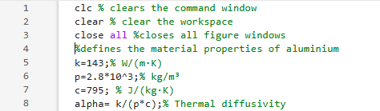
Figure 7-Screenshot of MATLAB code line 1-8.

5.2 Setting plate dimensions on the X and Y axes
The code in Fig. 8 prompts the User to input a plate’s x and y dimensions. It then verifies that both values are positive. Suppose the User enters a non-positive value (zero or negative) for either dimension. In that case, the code enters a while loop that displays an error message and repeatedly requests valid inputs until both dimensions are positive. This ensures that the plate dimensions are always valid before proceeding with further calculations or operations.
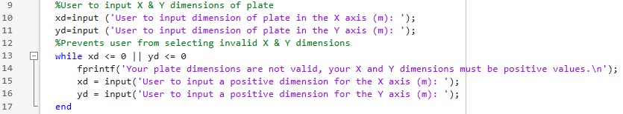
Figure 8-Screenshot of MATLAB code line 9-17.

5.3 Setting grid spacing value (h)
The code in Fig. 9 prompts the User to input a grid spacing value (h) in metres and ensures it meets specific validity criteria. The while loop checks if h is a valid input by ensuring it evenly divides both the xd (x-dimension) and yd (y-dimension) of the grid, is positive, and does not exceed the smallest grid dimension (min (xd, yd)). An error message is displayed if the input is invalid, and the User is prompted to enter a new value until a valid grid spacing is provided.
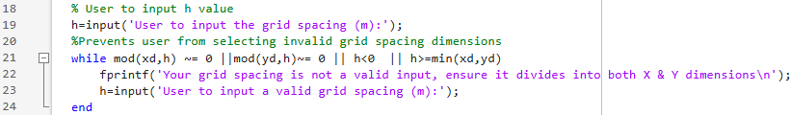
Figure 9-Screenshot of MATLAB code line 18-24.

5.4 Calculating and initialising matrix parameters
The code in Fig.10 calculates the dimensions of a matrix based on the values of yd, xd, and h. It first determines the number of rows (row) and columns (column). The resulting values define the size of a matrix T, which is then initialised as a zero matrix with dimensions (row, column).
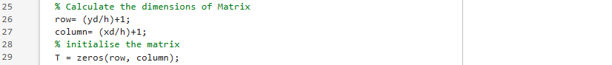
Figure 10-Screenshot of MATLAB code line 25-29.

5.5 Application of Dirichlet Boundary Conditions and calculation of time step
In Fig.11, Dirichlet boundary conditions are applied, as shown in Fig.5.The User inputs the temperature for the north boundary (T0), which is assigned to the top row of the temperature matrix T. In contrast, the south boundary is set to -T0. The code calculates the maximum allowable time step (maximum dt) in seconds, based on the CFL criterion, as shown in Fig.2. The User is prompted to enter a time step value (dt), which is used to compute the Fourier number (Fo) as shown in Eq.12. If the dt is invalid the User alerted to the maximum allowable dt and to re-enter a valid time.
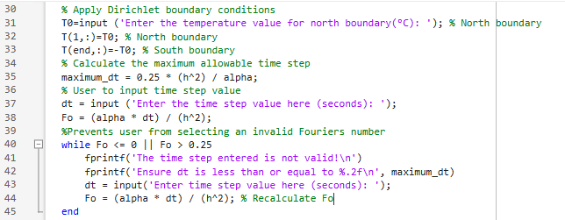
Figure 11-Screenshot of MATLAB code line 30-45.

5.6 Initialisation of T2 matrix key parameters definition of the convergence criteria tolerance
Fig.12 shows that the Matrix T2 is set equal to T to store an initial or previous state of temperature values. The convergence criterion (CCMax_T_change) will determine when the iterative process has stabilised. The variable maximum temperature difference (MD) is initialised to a value greater than the convergence criterion to ensure the loop runs at least once. An iteration counter (iterations_counter) is set to zero to track the number of iterations. Finally, a time variable is initialised to zero to track the elapsed time during the process.
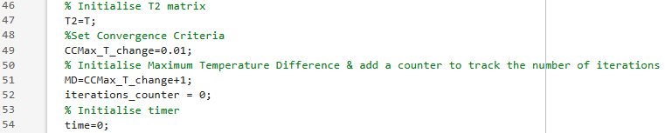
Figure 12-Screenshot of MATLAB code line 46-54.

5.7 Calculation of the maximum temperature difference by applying the modified heat equation
Fig. 13 shows that the simulation iterates until the maximum temperature difference between successive temperature fields is below the convergence criteria, indicating equilibrium. For loops iterate over the grid points (excluding boundary rows) to compute the new temperature (T2) each time step, the code updates temperatures using EFDM, applying Neumann boundary conditions at the west and east edges by replacing out-of-domain neighbours with mirrored values as shown in Eq.13 and 14. Interior nodes use the standard explicit equation. The final time is recorded once the temperature difference criterion is met (time_to_equilibrium).
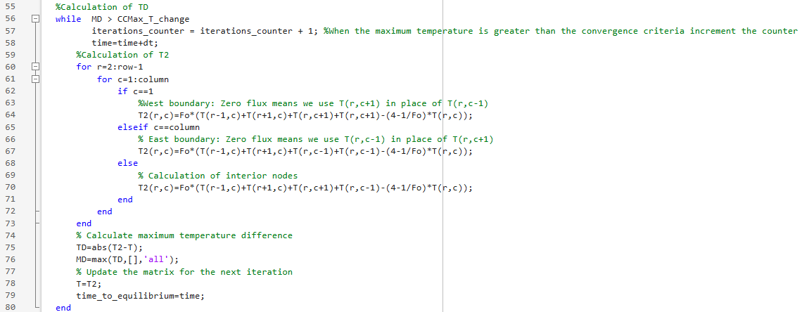

Figure 13-Screenshot of MATLAB code line 55-80.

5.8 Displaying numerical results, iterations counter, and time to equilibrium
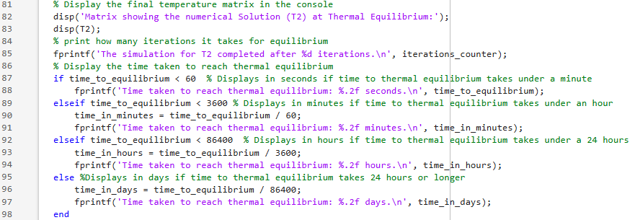
In Fig.14, the results of the Thermal equilibrium simulation are displayed. The temperature matrix (T2) is printed in the command window, showing the numerical solution. Then, it outputs the number of iterations required for the simulation to reach equilibrium. The script also reports the total time taken to achieve equilibrium, formatting the output based on the duration. If the time is under a minute, seconds are displayed; if under an hour, minutes are displayed; if under a day, it is shown in hours; and if it exceeds 24 hours, it is displayed in days. This is to facilitate a user-friendly representation of the simulation’s completion time.

Figure 14-Screenshot of MATLAB code line 81-98.5.9 Analytical solution calculation and display of results
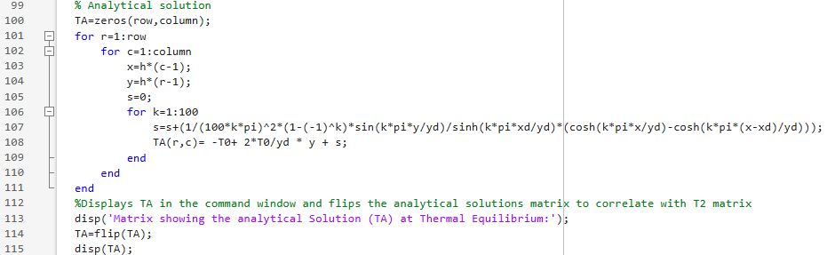
In Fig.15, the code calculates the analytical solution; it initialises the Matrix (TA) with dimensions (row, column) to store temperature values. The nested loops iterate over each grid point, computing the temperature based on the analytical solution shown in Eq.15. The final temperature value at each point is computed using the given formula, including boundary conditions and a summation term. Once the temperature distribution is calculated, the Matrix TA is flipped vertically to align with the Matrix (T2) and displayed in the command window. This ensures that the solution correctly corresponds to the expected orientation of the numerical results.

Figure 15-Screenshot of MATLAB code line 99-115.

5.10 Calculation of difference between TA and T2 Generation of heat map figures
In Fig.16, the code generates three heat map figures to visualise the temperature distribution from the calculated matrixes over a defined 2D grid. It first creates coordinate arrays XC and YC using a step size h to represent the spatial domain. A filled contour plot is generated for the T2 and TA matrixes, while a final matrix displays the absolute results between TA and T2. A colour bar is added to indicate temperature values, and the colour axis range is set symmetrically between -T0 and T0 while it is set as the maximum and minimum values of TA-T2. Labels for both axes and a title are included to describe the plot. Additionally, the axes are set to equal scaling, and the Y-axis direction is reversed to align with the expected visualisation format.
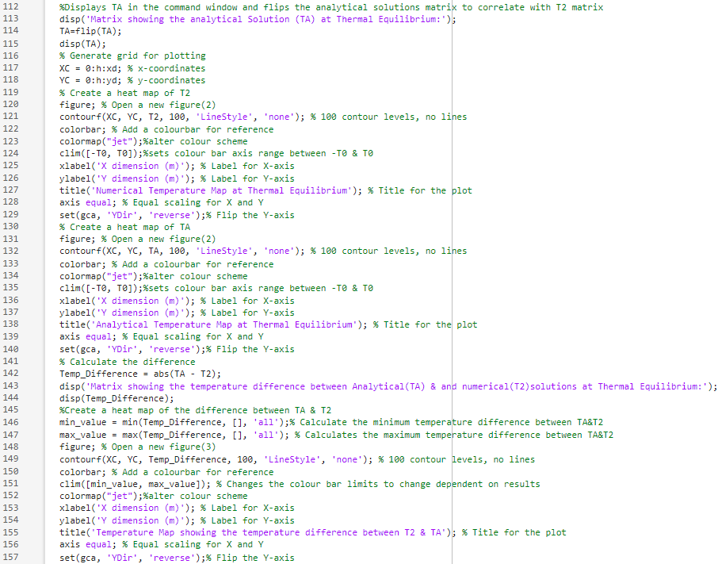

Figure 16-Screenshot of MATLAB code line 116-157.

6. Code Validation
Three heatmap figures were generated using MATLAB to display the temperature flow through the plate: the numerical results(T2), the analytical results (TA), and finally, the absolute differences between TA & T2, which are displayed at thermal equilibrium. It could be argued that there are no observable differences in Fig. 17 and 18, which suggests that the numerical and analytical solutions concur. Although, despite the close agreement, some distinctions exist between the numerical and analytical approaches, as shown in Fig. 19. The analytical solution provides exact theoretical values (Ardourel and Jebeile, 2017). In contrast, the numerical method introduces slight errors due to discretisation and truncation inherent in EFDM (Chapra, 2012; Iserles, 2012). Based on the difference matrix, the error analysis reveals that the most significant deviations occur in the intermediate regions, particularly at ±30°C, with a maximum error of 0.0174°C. The most negligible errors, shown as 0.0107°C, appear in the central regions of the plate. In comparison, no deviation is observed at the boundary conditions (50°C and -50°C), as these are explicitly enforced in the numerical and analytical models.
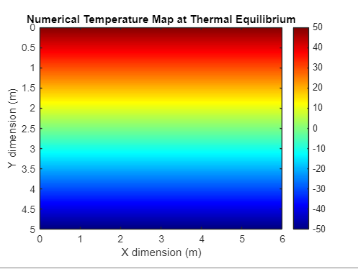
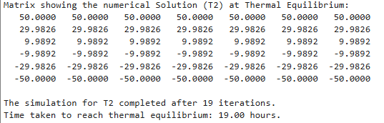

Figure 17-Numerical solution matrix data and heat map.

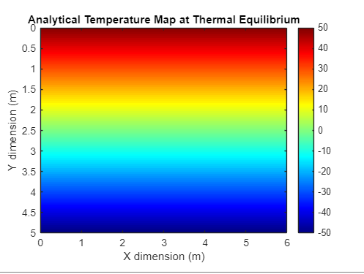
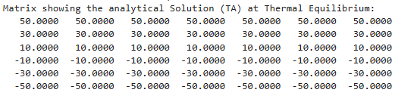
Figure 18-Analytical solution matrix data and heat map.

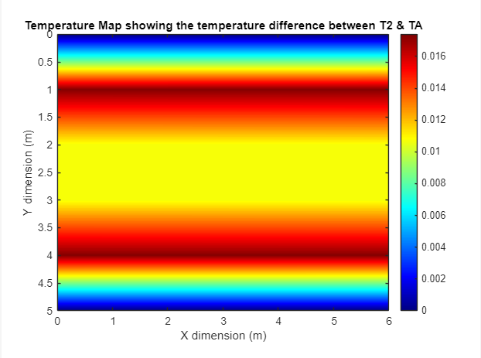
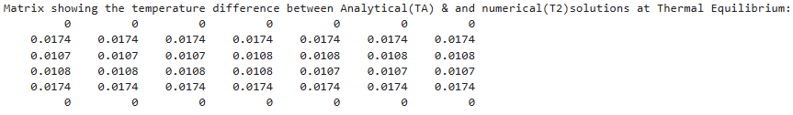
Figure 19-Absolute temperature differences between T2 and TA matrixes data and heat map.

7. Sensitivity analysis of code

7.1 Parameters of the sensitivity analysis
A sensitivity analysis evaluated the influence of grid spacing, time step size, and numerical tolerance on thermal equilibrium time (data and parameters shown in Tab.1,2 and 3). Plate dimensions parameters were set as 12x12 metres on the X & Y axes and 50°C at the North boundary of the plate.

7.2 Analysis of the influence of grid spacing on thermal equilibrium time
As shown in Fig. 19, the grid spacing significantly affects the numerical resolution of the simulation. The data reveals that the time required to reach thermal equilibrium converges to an optimum solution as the grid spacing decreases. This trend suggests that finer grids increase the accuracy. This is directly linked to the truncation error defined in Eq.8 and 9 (Chapra, 2012) (Incropera et al., 2013). However, while a smaller grid spacing improves accuracy by decreasing the truncation error, it also increases computational performance due to the higher number of nodal points (Abouelatta et al., 2020). Additionally, as can be observed, diminishing returns occur below a 0.5m spacing, indicating that reducing grid size beyond this threshold does not yield proportionally significant improvements to the equilibrium time. Moreover, larger grid spacing values may lead to excessive numerical smoothing (Sun, 2009), potentially causing the loss of finer heat propagation details.

Figure 20-Grid spacing analysis graph.
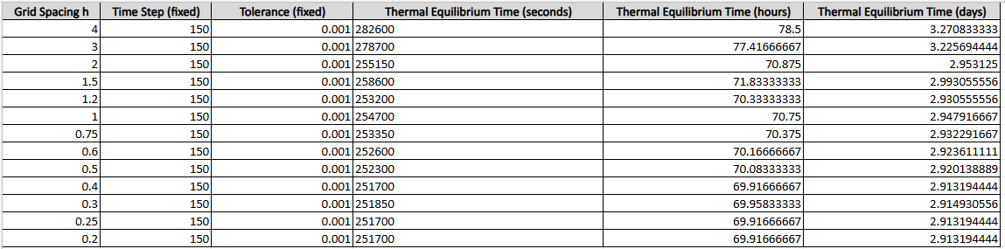
Table 1-Grid spacing analysis parameters

7.3 Analysis of the influence of time step spacing on thermal equilibrium time
The effect of the time step on the simulation’s convergence rate and stability is indicated in Fig. 20. As defined in Eq. 10, as the time step decreases, the truncation error correspondingly diminishes, yielding a more accurate approximation. However, decreasing the time step will increase the number of iterations to reach thermal equilibrium, influencing round-off errors (Chapra, 2012; Liu et al., 2021). Therefore, selecting an optimal time step is essential to balance the effects of these errors to ensure accuracy and computational efficiency (Li et al., 2017).

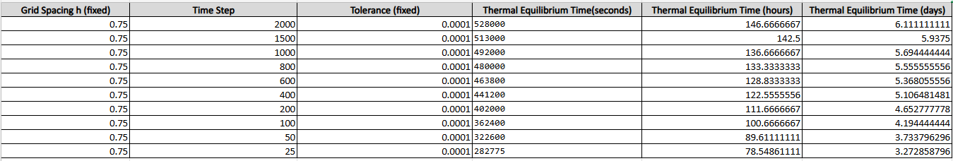
Figure 21- Time step analysis graph.

Table 2- Time step analysis parameters.

7.4 Analysis of the influence of convergence criteria tolerance on thermal equilibrium time
The tolerance defines the stopping criteria for iterative solvers in numerical simulations. The data in Fig.22 shows that stricter tolerances increase the time required to reach an optimal solution. This behaviour is expected because lower tolerance values require the solution to meet stricter convergence criteria, increasing the number of iterations required. While this enhances accuracy, it also leads to substantial computational costs (Ande et al., 2022). Hence, an optimal tolerance level should be selected (Li et al., 2015), as excessively low tolerances exponentially increase the time it takes to converge to an optimum solution (as observed below a tolerance of 0.01).

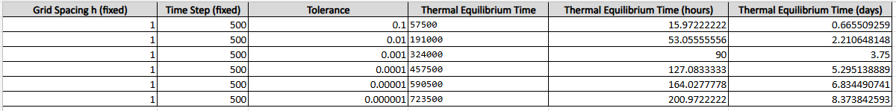
Figure 22- Convergence criteria analysis graph.

Table 3-Convergence criteria tolerance parameters.

8. Limitations of model
The simulation model faces two categories of limitations: numerical and coding-induced.

8.1 Numerical limitations
Numerically, finite precision in computation leads to round-off errors (Chapra, 2012), while neglecting higher-order terms when deriving the forward, backward and central difference equations using the Taylor series causes truncation errors (Iserles, 2012). These errors can either occur over single iterations (local errors) or accumulate over multiple iterations (global errors), reducing the model’s accuracy (Boldo et al., 2017). Moreover, the reliance on structured grids restricts the method’s applicability to complex geometries, and the CFL criterion imposes strict timestep limits to maintain stability (Iserles, 2012).

8.2 Coding limitations
From a coding perspective, the model defines thermal equilibrium using a simple minimum temperature-difference criterion, which may not fully capture gradual or localised changes and may not necessarily provide the best representation of the physics involved.

9. Suggestions for future developments and improvements

9.1 Suggestions for future work
Future work on this numerical model should prioritise improving stability, handling complex geometries, and enhancing thermal equilibrium modelling. First, the reliance on the EFDM imposes strict timestep constraints due to the CFL conditional stability (Iserles, 2012). Alternatives, such as Alternating Direction Implicit (ADI) schemes (Halif and Rusli, 2019) and implicit methods (e.g., Crank–Nicolson), permit more significant time steps that are unconditionally stable (Adak, 2020) ( Al-taai and Ali, 2020).
Second, expanding beyond EFDM is vital for simulating complex geometries. The Finite Element Method (FEM) provides flexibility for irregular domains (Baccouch, 2021) (Gao et al., 2023), the Finite Volume Method (FVM) excels in conservation law applications (Eymard et al., 2000), and the Boundary Element Method (BEM) can be computationally efficient due to the need to only to discretise their boundary domain (Brebbia and Dominguez, 1992) (Aliabadi, 2002). Mesh-free methods (Li and Zhang, 2020) and hybrid approaches (FEM–FVM, FDM–FEM) (Lee and Hwang, 1996) (Cakay and Selim, 2024) present further potential for efficiency and adaptability.

9.2 Suggestions for improvements
Improvements to the thermal equilibrium criterion are recommended, such as applying a time-weighted temperature average over successive time steps to assess the temperature gradient (Li, 2015). Artificial Intelligence algorithms could also be utilised to model steady-state problems with more dynamic heat flux conditions (Gawronska et al., 2023) (Deepak et al., 2024). In combination with these two points, experimental validation may also be applied; this would benefit the model by providing physical data that could be used to either support or negate the results of the simulation, allowing for more accurate modelling in future numerical analysis (Sobieski, 2010) (Yang et al., 2014).

10. Conclusions
The report has presented the development, implementation, and validation of a computational model for solving the two-dimensional heat equation using EFDM. The numerical results closely match the analytical solution, confirming the model’s accuracy and reliability. The sensitivity analysis demonstrated the crucial impact of spatial and temporal discretisation on solution stability and computational performance. Despite its effectiveness, the EFDM approach exhibits limitations, particularly in stability constraints due to the CFL condition (Iserles, 2012) and increased computational costs, a higher order of accuracy (Li et al., 2017).
To enhance the model’s robustness, future research should explore alternative numerical methods such as implicit schemes (e.g., Crank-Nicholson)(Adak, 2020) or hybrid approaches to improve stability and efficiency (Lee and Hwang, 1996). Expanding the model to accommodate complex geometries through Finite Element or Finite Volume Methods (Baccouch, 2021) (Gao et al., 2023) could further enhance its applicability. Additionally, incorporating experimental validation (Sobieski, 2010) (Yang et al., 2014) and machine learning techniques could refine numerical approximations, making the model more adaptable to dynamic thermal conditions (Gawronska et al., 2023) (Deepak et al., 2024). These advancements would extend the computational framework’s usability in engineering simulations and scientific research.

11. References
Abouelatta, M.A., Omar, A.M. and Ward, S. (2020) ‘Optimal grid size for precipitators using finite difference method based on full multi-grid method’. Electric Power Systems Research 189, p. 106575. Available at: doi:10.1016/j.epsr.2020.106575.
Adak, M. (2020) ‘Comparison of Explicit and Implicit Finite Difference Schemes on Diffusion Equation’. in Bhattacharyya, S., Kumar, J., and Ghoshal, K. (eds.) Mathematical Modeling and Computational Tools. Springer Proceedings in Mathematics & Statistics. Singapore: Springer Singapore, pp. 227–238. Available at: doi:10.1007/978-981-15-3615-1_15 (Accessed: 25 January 2025).
Agyeman, E.K.K., Duret, S., Flick, D., Laguerre, O. and Moureh, J. (2023) ‘Computational Modelling of Airflow and Heat Transfer during Cooling of Stacked Tomatoes: Optimal Crate Design’. Energies 16(4), p. 2048. Available at: doi:10.3390/en16042048.
Aliabadi, M.H. (2002) The boundary element method. Chichester: J. Wiley & sons.
Al-taai, E.A. and Ali, A.R.A. (2020) ‘Improved Alternating Direction Implicit Method’. Journal of Physics: Conference Series 1591(1), p. 012084. Available at: doi:10.1088/1742-6596/1591/1/012084.
Ande, R., Manickavasagam, A.K., Gutschmidt, S. and Sellier, M. (2022) ‘Convergence and computational cost analysis of a boundary integral method applied to a rigid body moving in a viscous fluid in close proximity to a fixed boundary’. Journal of Engineering Mathematics 132(1), p. 9. Available at: doi:10.1007/s10665-021-10196-2.
Ardourel, V. and Jebeile, J. (2017) ‘On the presumed superiority of analytical solutions over numerical methods’. European Journal for Philosophy of Science 7(2), pp. 201–220. Available at: doi:10.1007/s13194-016-0152-2.
Baccouch, M. (2021) Finite Element Methods and Their Applications. Available at: doi:10.5772/intechopen.83274 (Accessed: 24 January 2025).
Boldo, S., Faissole, F. and Chapoutot, A. (2017) ‘Round-off Error Analysis of Explicit One-Step Numerical Integration Methods’. in 24th IEEE Symposium on Computer Arithmetic. London, United Kingdom. Available at: doi:10.1109/ARITH.2017.22 (Accessed: 25 January 2025).
Brebbia, C.A. and Dominguez, J. (1992) Boundary elements: an introductory course. 2nd ed. Southampton (GB) Boston New York St. Louis San Francisco [etc.]: Computational mechanics publ. Computational mechanics publ. McGraw-Hill.
Cakay, A.B. and Selim, S. (2024) ‘A New Efficient Hybrid Method Based on FEM and FDM for Solving Burgers’ Equation with Forcing Term’. Journal of Applied Mathematics 2024(1), p. 5497604. Available at: doi:10.1155/2024/5497604.
Chang, C.-Y. and Ma, C.-C. (2001) ‘Transient thermal conduction analysis of a rectangular plate with multiple insulated cracks by the alternating method’. International Journal of Heat and Mass Transfer 44(13), pp. 2423–2437. Available at: doi:10.1016/S0017-9310(00)00292-1.
Chapra, S.C. (2012) Applied numerical methods with MATLAB for engineers and scientists. 3. ed., internat. ed. New York, NY: McGraw-Hill.
Croft, D.R., Lilley, D.G., Croft, D.R. and Lilley, D.G. (1977) Heat transfer calculations using finite difference equations. London: Applied Science Publ.
Deepak, G., Parthiban, M., Nath, Srigitha.S., Sulaiman Alfurhood, B., Mouleswararao, B. and Ravi Kishore, V. (2024) ‘Ai-enhanced thermal modeling for integrated process-product-system optimization in zero-defect manufacturing chains’. Thermal Science and Engineering Progress 55, p. 102945. Available at: doi:10.1016/j.tsep.2024.102945.
Eymard, R., Gallouët, T. and Herbin, R. (2000) ‘Finite volume methods’. in Handbook of Numerical Analysis. Elsevier, pp. 713–1018. Available at: doi:10.1016/S1570-8659(00)07005-8 (Accessed: 25 January 2025).
Gao, W., Lu, J., Gao, X., Zhou, J., Dai, H., Sun, M. and Xu, J. (2023) ‘Biomechanical effects of joint disc perforation on the temporomandibular joint: a 3D finite element study’. BMC Oral Health 23(1), p. 943. Available at: doi:10.1186/s12903-023-03521-x.
Gawronska, E., Zych, M., Dyja, R. and Domek, G. (2023) ‘Using artificial intelligence algorithms to reconstruct the heat transfer coefficient during heat conduction modeling’. Scientific Reports 13(1), p. 15343. Available at: doi:10.1038/s41598-023-42536-w.
Gunasegaram, D.R. and Steinbach, I. (2021) ‘Modelling of Microstructure Formation in Metal Additive Manufacturing: Recent Progress, Research Gaps and Perspectives’. Metals 11(9), p. 1425. Available at: doi:10.3390/met11091425.
Halif, N. and Rusli, N. (2019) ‘Alternating Direction Implicit (ADI) Method for Solving Two Dimensional (2-D) Transient Heat Equation’. ASM Science Journal 12(6). Available at: https://www.akademisains.gov.my/asmsj/?mdocs-file=4319.
Hensen, J.L.M. and Nakhi, A.E. (1994) ‘Fourier and BIOT numbers and the accuracy of conduction modelling’. in Facing the future. Glasgow, pp. 247–256. Available at: https://www3.nd.edu/~amoukasi/CBE358_Lab1/FOURIER%20AND%20BIOT%20NUMBERS.pdf.
Incropera, F.P., DeWitt, D.P., Bergman, T.L. and Lavine, A.S. (eds.) (2013) Foundations to heat transfer. 6. ed., internat. student version. Singapore: Wiley.
Iserles, A. (2012) A first course in the numerical analysis of differential equations. Second edition. Cambridge: Cambridge University Press. Available at: doi:10.1017/CBO9780511995569.
Lee, J. and Hwang, K.-Y. (1996) ‘A hybrid numerical analysis of heat transfer and thermal stress in a solidifying body using FVM and FEM’. International Journal of Engineering Science 34(8), pp. 901–922. Available at: doi:10.1016/0020-7225(95)00135-2.
Li, H. (2015) ‘The numerical analysis of the weighted average method for heat conduction equation in one dimension’. Journal of Computational Methods in Sciences and Engineering 15(4), pp. 653–661. Available at: doi:10.3233/JCM-150584.
Li, H. and Zhang, Q. (2020) ‘A meshfree finite volume method with optimal numerical integration and direct imposition of essential boundary conditions’. Applied Numerical Mathematics 153, pp. 98–113. Available at: doi:10.1016/j.apnum.2020.02.005.
Li, J., Yu, B., Zhang, X. and Wang, Y. (2015) ‘An improved convergence criterion based on normalized residual for heat transfer and fluid flow numerical simulation’. International Journal of Heat and Mass Transfer 91, pp. 246–254. Available at: doi:10.1016/j.ijheatmasstransfer.2015.07.106.
Li, Y., Choi, Y. and Kim, J. (2017) ‘Computationally efficient adaptive time step method for the Cahn–Hilliard equation’. Computers & Mathematics with Applications 73(8), pp. 1855–1864. Available at: doi:10.1016/j.camwa.2017.02.021.
Liu, J., Möller, M. and Schuttelaars, H.M. (2021) ‘Balancing truncation and round-off errors in FEM: One-dimensional analysis’. Journal of Computational and Applied Mathematics 386, p. 113219. Available at: doi:10.1016/j.cam.2020.113219.
Miltat, J.E. and Donahue, M.J. (2007) ‘Numerical Micromagnetics: Finite Difference Methods’. in Kronmüller, H. and Parkin, S. (eds.) Handbook of Magnetism and Advanced Magnetic Materials. 1st edn. Wiley. Available at: doi:10.1002/9780470022184.hmm202 (Accessed: 25 January 2025).
Narasimhan, T.N. (1999) ‘Fourier’s Heat Conduction Equation: History, Influences and Connections’. Reviews of Geophysics 37(1), pp. 151–172.
Norton, T., Tiwari, B. and Sun, D.-W. (2013) ‘Computational Fluid Dynamics in the Design and Analysis of Thermal Processes: A Review of Recent Advances’. Critical Reviews in Food Science and Nutrition 53(3), pp. 251–275. Available at: doi:10.1080/10408398.2010.518256.
Pandey, G.K. et al. (2023) ‘Thermal Mapping and Heat Transfer Analysis of an Induction Motor of an Electric Vehicle Using Nanofluids as a Cooling Medium’. Sustainability 15(10), p. 8124. Available at: doi:10.3390/su15108124.
Pantakar, S. (1980) Numerical Heat Transfer and Fluid Flow.1st edition. Boca Raton. FL: CRC press.
Pop, I. and Ingham, D.B. (2001) Convective heat transfer: mathematical and computational modelling of viscous fluids and porous media. 1st ed. Amsterdam New York: Pergamon.
Sobieski, W. (2010) ‘Use of Numerical Models in Validating Experimental Results’. Journal of Applied Computer Science 18(1). Available at: https://www.researchgate.net/publication/256667130_Use_of_Numerical_Models_in_Validating_Experimental_Results (Accessed: 24 January 2025).
Sun, T. (2009) ‘Numerical smoothing of Runge–Kutta schemes’. Journal of Computational and Applied Mathematics 233(4), pp. 1056–1062. Available at: doi:10.1016/j.cam.2009.08.118.
Venkateshan, S.P. and Swaminathan, P. (2014) Computational methods in engineering. 1st. edition. Oxford [England] Waltham, MA: Elsevier Academic Press.
Wang, Y. and Wang, P. (2022) ‘Application of Fourier’s Law in One-Dimensional Steady Heat Conduction Calculation of Cylinder Wall’. Journal of Physics: Conference Series 2381(1), p. 012002. Available at: doi:10.1088/1742-6596/2381/1/012002.
Yang, J., Ma, L., Bock, J., Jacobi, A.M. and Liu, W. (2014) ‘A comparison of four numerical modeling approaches for enhanced shell-and-tube heat exchangers with experimental validation’. Applied Thermal Engineering 65(1), pp. 369–383. Available at: doi:10.1016/j.applthermaleng.2014.01.035.

12. Appendix

Appendix 1 - MATLAB code for reference.
clc % clears the command window
clear % clear the workspace
close all %closes all figure windows
%defines the material properties of aluminium
k=143;% W/(m·K)
p=2.8*10^3;% kg/m³
c=795; % J/(kg·K)
alpha= k/(p*c);% Thermal diffusivity
%User to input X & Y dimensions of plate
xd=input ('User to input dimension of plate in the X axis (m): ');
yd=input ('User to input dimension of plate in the Y axis (m): ');
%Prevents user from selecting invalid X & Y dimensions
while xd <= 0 || yd <= 0
fprintf('Your plate dimensions are not valid, your X and Y dimensions must be positive values.\n');
xd = input('User to input a positive dimension for the X axis (m): ');
yd = input('User to input a positive dimension for the Y axis (m): ');
end
% User to input h value
h=input('User to input the grid spacing (m):');
%Prevents user from selecting invalid grid spacing dimensions
while mod(xd,h) ~= 0 ||mod(yd,h)~= 0 || h<0 || h>=min(xd,yd)
fprintf('Your grid spacing is not a valid input, ensure it divides into both X & Y dimensions\n');
h=input('User to input a valid grid spacing (m):');
end
% Calculate the dimensions of Matrix
row= (yd/h)+1;
column= (xd/h)+1;
% initialise the matrix
T = zeros(row, column);
% Apply Dirichlet boundary conditions
T0=input ('Enter the temperature value for north boundary(°C): '); % North boundary
T(1,:)=T0; % North boundary
T(end,:)=-T0; % South boundary
% Calculate the maximum allowable time step
maximum_dt = 0.25 * (h^2) / alpha;
% User to input time step value
dt = input ('Enter the time step value here (seconds): ');
Fo = (alpha * dt) / (h^2);
%Prevents user from selecting an invalid Fouriers number
while Fo <= 0 || Fo > 0.25
fprintf('The time step entered is not valid!\n')
fprintf('Ensure dt is less than or equal to %.2f\n', maximum_dt)
dt = input('Enter time step value here (seconds): ');
Fo = (alpha * dt) / (h^2); % Recalculate Fo
end
% Initialise T2 matrix
T2=T;
%Set Convergence Criteria
CCMax_T_change=0.01;
% Initialise Maximum Temperature Difference & add a counter to track the number of iterations
MD=CCMax_T_change+1;
iterations_counter = 0;
% Initialise timer
time=0;
%Calculation of TD
while MD > CCMax_T_change
iterations_counter = iterations_counter + 1; %When the maximum temperature is greater than the convergence criteria increment the counter
time=time+dt;
%Calculation of T2
for r=2:row-1
for c=1:column
if c==1
%West boundary: Zero flux means we use T(r,c+1) in place of T(r,c-1)
T2(r,c)=Fo*(T(r-1,c)+T(r+1,c)+T(r,c+1)+T(r,c+1)-(4-1/Fo)*T(r,c));
elseif c==column
% East boundary: Zero flux means we use T(r,c-1) in place of T(r,c+1)
T2(r,c)=Fo*(T(r-1,c)+T(r+1,c)+T(r,c-1)+T(r,c-1)-(4-1/Fo)*T(r,c));
else
% Calculation of interior nodes
T2(r,c)=Fo*(T(r-1,c)+T(r+1,c)+T(r,c+1)+T(r,c-1)-(4-1/Fo)*T(r,c));
end
end
end
% Calculate maximum temperature difference
TD=abs(T2-T);
MD=max(TD,[],'all');
% Update the matrix for the next iteration
T=T2;
time_to_equilibrium=time;
end
% Display the final temperature matrix in the console
disp('Matrix showing the numerical Solution (T2) at Thermal Equilibrium:');
disp(T2);
% print how many iterations it takes for equilibrium
fprintf('The simulation for T2 completed after %d iterations.\n', iterations_counter);
% Display the time taken to reach thermal equilibrium
if time_to_equilibrium < 60 % Displays in seconds if time to thermal equilibrium takes under a minute
fprintf('Time taken to reach thermal equilibrium: %.2f seconds.\n', time_to_equilibrium);
elseif time_to_equilibrium < 3600 % Displays in minutes if time to thermal equilibrium takes under an hour
time_in_minutes = time_to_equilibrium / 60;
fprintf('Time taken to reach thermal equilibrium: %.2f minutes.\n', time_in_minutes);
elseif time_to_equilibrium < 86400 % Displays in hours if time to thermal equilibrium takes under a 24 hours
time_in_hours = time_to_equilibrium / 3600;
fprintf('Time taken to reach thermal equilibrium: %.2f hours.\n', time_in_hours);
else %Displays in days if time to thermal equilibrium takes 24 hours or longer
time_in_days = time_to_equilibrium / 86400;
fprintf('Time taken to reach thermal equilibrium: %.2f days.\n', time_in_days);
end
% Analytical solution
TA=zeros(row,column);
for r=1:row
for c=1:column
x=h*(c-1);
y=h*(r-1);
s=0;
for k=1:100
s=s+(1/(100*k*pi)^2*(1-(-1)^k)*sin(k*pi*y/yd)/sinh(k*pi*xd/yd)*(cosh(k*pi*x/yd)-cosh(k*pi*(x-xd)/yd)));
TA(r,c)= -T0+ 2*T0/yd * y + s;
end
end
end
%Displays TA in the command window and flips the analytical solutions matrix to correlate with T2 matrix
disp('Matrix showing the analytical Solution (TA) at Thermal Equilibrium:');
TA=flip(TA);
disp(TA);
% Generate grid for plotting
XC = 0:h:xd; % x-coordinates
YC = 0:h:yd; % y-coordinates
% Create a heat map of T2
figure; % Open a new figure(1)
contourf(XC, YC, T2, 100, 'LineStyle', 'none'); % 100 contour levels, no lines
colorbar; % Add a colourbar for reference
colormap("jet");%alter colour scheme
clim([-T0, T0]);%sets colour bar axis range between -T0 & T0
xlabel('X dimension (m)'); % Label for X-axis
ylabel('Y dimension (m)'); % Label for Y-axis
title('Numerical Temperature Map at Thermal Equilibrium'); % Title for the plot
axis equal; % Equal scaling for X and Y
set(gca, 'YDir', 'reverse');% Flip the Y-axis
% Create a heat map of TA
figure; % Open a new figure(2)
contourf(XC, YC, TA, 100, 'LineStyle', 'none'); % 100 contour levels, no lines
colorbar; % Add a colourbar for reference
colormap("jet");%alter colour scheme
clim([-T0, T0]);%sets colour bar axis range between -T0 & T0
xlabel('X dimension (m)'); % Label for X-axis
ylabel('Y dimension (m)'); % Label for Y-axis
title('Analytical Temperature Map at Thermal Equilibrium'); % Title for the plot
axis equal; % Equal scaling for X and Y
set(gca, 'YDir', 'reverse');% Flip the Y-axis
% Calculate the difference
Temp_Difference = abs(TA - T2);
disp('Matrix showing the temperature difference between Analytical(TA) & and numerical(T2)solutions at Thermal Equilibrium:');
disp(Temp_Difference);
%Create a heat map of the difference between TA & T2
min_value = min(Temp_Difference, [], 'all');% Calculate the minimum temperature difference between TA&T2
max_value = max(Temp_Difference, [], 'all'); % Calculates the maximum temperature difference between TA&T2
figure; % Open a new figure(3)
contourf(XC, YC, Temp_Difference, 100, 'LineStyle', 'none'); % 100 contour levels, no lines
colorbar; % Add a colourbar for reference
clim([min_value, max_value]); % Changes the colour bar limits to change dependent on results
colormap("jet");%alter colour scheme
xlabel('X dimension (m)'); % Label for X-axis
ylabel('Y dimension (m)'); % Label for Y-axis
title('Temperature Map showing the temperature difference between T2 & TA'); % Title for the plot
axis equal; % Equal scaling for X and Y
set(gca, 'YDir', 'reverse');% Flip the Y-axis

