
Case Study: Urban Heights Hotel

Module: Financial Management for the Hotel Industry
Module code: BMIH5007
Student Name: Madalin Liviu Noada
Student ID: 2232425
Module Lead: Tristan Hawkins
Table of Contents
I. Introduction: 3
II. Financial Performance Analysis 3
Trends in Revenue 3
Operating Expenses 4
Profitability 4
Liquidity and Solvency 4
Balance Sheet Analysis 6
III. Factors Contributing to Decline 6
Real-World Events Affecting the Hospitality Industry: 6
Economic Factors Impacting Consumer Behavior: 6
Internal Issues Within Urban Heights Hotel: 7
IV. Turnaround Strategy 7
Cost-Cutting Measures 7
Revenue Enhancement Strategies 7
Operational Improvements 7
Marketing and Branding Initiatives 8
Customer Experience Enhancements 8
V. Implementation Plan 9
Timeline for Executing Turnaround Strategies: 9
Allocation of Resources and Responsibilities: 9
Performance Metrics to Monitor Progress: 9
VI. Conclusion 9
VII. References 10

I. Introduction:
Urban Heights Hotel located in an urban environment offers the guests and clients a diverse hospitality service offer – from accommodations to dining and events. However, the establishment has recorded low sales, low occupancy, and low customer satisfaction level in the last few years. These challenges have elicited concern on the sustainability and profitability of the hotel. Therefore, the objective of the following assessment is to analyse the given company, Urban Heights Hotel, in terms of its financial results for the previous three financial years in detail. By analysing the factors that led to the decline in performance and developing a comprehensive strategic plan to be implemented, the goal to revive the financial performance of the hotel and reaffirm its status as a leading hospitality brand.

II. Financial Performance Analysis
The financial performance analysis of Urban Heights Hotel shows the company’s profitability, solvency, and operational efficiency.

Trends in Revenue
As for sales which refer to the revenues, Urban Heights Hotel experienced a reduction of its revenues during the past three years, namely from £2,500,000 during the year ending in 2021, and reducing to £1,800,000 during the year ending in 2023. There appears to be a more significant decline, which is more evident in the year ending 2022 by a £300,000 reduction in total income and a £400,000 reduction in the year ending 2023. In contrast, the decline percentage increased from 12% between 2021- 2022 to 18.2% for the period between 2022 and 2023. These may include changes in the buying behaviour, changes in the market, or any other extraneous circumstances which may have resulted in this steep decline, meaning that efforts to address these are relevant in order to turn around the revenue growth of the hotel (Kim, Parker and Schoar, 2020).
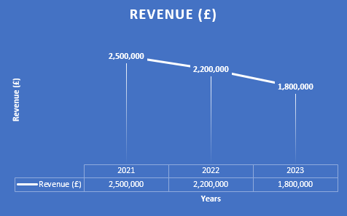

Operating Expenses
Over the three-year period, operating expenses in Urban Heights Hotel have been on the rise and have reached £2,300,000 in 2023 from £1,800,000 in 2021. In particular, the expenditures increased from £1,800,000 in 2021 to £2,000,000 in 2022, which is 11.1% increase. This trend continued through to year 2023 where operating expenses rose to £2,300,000 up by a further 15.0%.
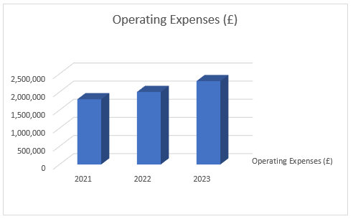
The expanding operating costs have remained a major threat to the realisation of healthy profits at the Urban Heights Hotel. The expenses have also increased and are growing at a faster rate than the hotel revenue hence reducing the income-expenditure gap. Therefore, this partly emphasises the imperative of integrating efficient cost control measures to ease the pressure on the bottom line and enhance financial performance as discussed by Bello (2020).

Profitability
Financial performance has declined significantly with the hotel registering £700,000 net profit in 2021 and a net loss of £500,000 in 2023. This trend shows a progressive deterioration in the level of financial stability and requires immediate attention. Comparing profitability metrics across the three years reveals a stark contrast: The gross profit margin reduced from 28.00% in 2021 to -27.78% in 2023, while the operating profit margin grew similarly and decreased from 28.00% to -27.78%. These shocking declines clearly show the need to look for the root cause for this trend and to find ways and means of reversing this trend to ensure profitability and long-term sustainability of this hotel (Barakagira and Paapa, 2023).

Liquidity and Solvency
Liquidity position of the firm has been deteriorating in the last three years, hence, the decrease in the balance in cash and equivalents from £300,000 to £100,000 as at 2023. This declining cash position presents a bleak picture on the hotel’s capacity to meet its short-term cash obligations in a timely manner. Furthermore, accounts receivable reduced from £150,000 in 2021 to £80,000 in 2023 and may imply other issues that affect cash flows management and compound liquidity problems.
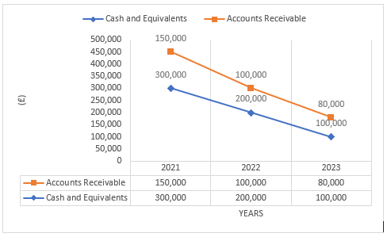
A critical review of the liquidity ratios strengthens the argument that the financial position of the hotel is worsening. The current ratio which established the hotel’s capability to meet the current liabilities with current assets decreased from 1. 80 in 2021 to a shocking 0.60 in 2023. Likewise, the quick ratio also changed in the same way, decreasing from 1.80 to 0.60 over the same period. These declining ratios suggest a decline in the ability of the firm to meet its immediate financial obligations – a potential sign of a liquidity crisis (Rodney and Xi, 2018).
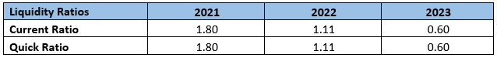
Moreover, an analysis of solvency ratios implies the growth of the financial leverage ratio for the Urban Heights Hotel. The debt-to-equity ratio increased from 1.48 in 2021 to 2.39 in 2023, which implies increasing use of credit financing. Moreover, the interest coverage ratio came down significantly reducing from a healthy 7.00 in 2021 to -5.00 in 2023, indicating that it will be difficult for the company to meet its interest costs with operating revenues alone. These trends combined call for strategic efforts to address the challenges affecting liquidity, leverage and general financial stability in order to avoid insolvency.
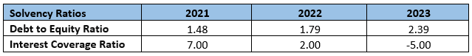

Balance Sheet Analysis
The total amount of assets of Urban Heights Hotel reduced from £5,450,000 in the year ended 2021 to £4,680,000 in the year ended 2023. Accounts such as cash and equivalents were reduced from £300,000 to £100,000, accounts receivable from £150,000 to £80,000 and property and equipment from £5,000,000 to £4,500,000. These trends signify declines in liquidity and difficulties in managing property assets.
Total liabilities are also expected to increase from £3,250,000 in 2021 to £3,300,000 in 2023 with account payable £25000 to £30000 and the long-term debt remaining constant at £3,000,000. Equity reduced from £2,200,000 to £1,380,000 due to financial pressure and rising leverage pointed to the necessity for proper debt control (Vengesai, 2023).

III. Factors Contributing to Decline

Real-World Events Affecting the Hospitality Industry:
The real-world events have taken toll to the hospitality industry in the recent years. The outbreak of the COVID-19 virus significantly changed travel and tourism hence resulting to cancellations, reduced travels and low hotel occupancy. With restrictions such as occasional lock-downs and limitations on movement, consumers’ demand still remains relatively constrained (Chang & Wu, 2021). Furthermore, due to the existing conflict, such as Russia and Ukraine and trade war between economies, investors’ confidence has decreased and has affected the economy in a way that discourages international travelers hence reducing customer traffic at the Urban Heights Hotel (Liu and Shu, 2023).
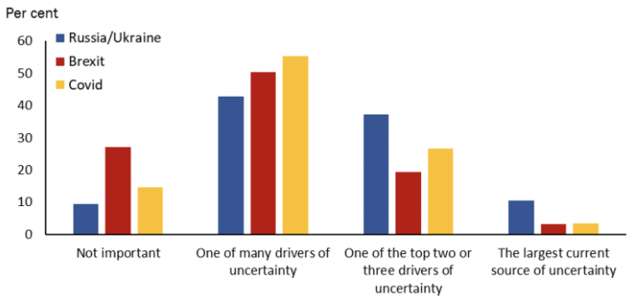
Figure: Economic Uncertainty; Source: (Yotzov et al., 2022)

Economic Factors Impacting Consumer Behavior:
Increase in inflation and the pandemic economic impacts triggered reduced spending on travel hence a decreased demand for Urban Height Hotel’s luxury services. This has been worsened by changes in exchange rates and Brexit that has made travelling more expensive for the international tourists (Singh and Corsun, 2023).

Internal Issues Within Urban Heights Hotel:
Deficiencies in cost control and service delivery such as poor staff training and dated infrastructure have increased operating costs and reduced consumer value and satisfaction (Johnson and Karlay, 2018). Lack of proper marketing and product diversification decrease occupancy as well as revenues even further. The exploitation of these internal threats through costs reduction and services delivery is fundamental to the hotel’s financial restoration.

IV. Turnaround Strategy
To revitalize Urban Heights Hotel financially healthy and to rebuild its positive image, a strong and consistent strategy has to be implemented. This plan outlines targeted strategies for several problems found in the analysis, including cost reduction, revenue generation, operational changes, marketing and branding efforts, and customer satisfaction improvement.

Cost-Cutting Measures
Expense Audit and Optimization:
Carry out a thorough analysis of all running costs with a view of minimizing the levels of expense throughout the operation while maintaining high standards of service delivery (Baibossynov et al., 2020). One has to negotiate for better terms and identify if there are any possibilities of buying in bulk to reduce expenses.
Energy Efficiency:
Practical energy saving technologies like Light Emitting Diode (LED) lighting, smart thermostats, water-efficient fixtures in the effort to lower the utility bills. Purchase renewable energy, such as solar energy, to reduce energy expenses in the long term.

Revenue Enhancement Strategies
Dynamic Pricing:
Strategize on the pricing strategies in order to increase micro –pricing by varying the room rates for specific periods depending on the demand, seasonality, event occurrences etc (Bayoumi et al., 2012).
Package Deals and Partnerships:
Promote such options as meal and accommodation options bundled with spa and entertainment offerings. To appeal to the different target markets, agree on the provision of joint packages with travel agencies, airlines, or event planners.
Event Hosting:
Maximise utilisation of event spaces for corporate event, wedding venues or business conference to increase incremental sources of revenue.

Operational Improvements
Staff Training and Development:
Implement frequent trainings with the goal of enhancing the quality of services delivered as well as working productivity. Set up systems that reward productivity and encourage employees to increase their efficiency.
Technology Integration:
Implement appropriate technology solutions like mobile check-in/check-out, property management systems, and guest feedback systems to enhance guest experience and overall operations (Han et al., 2021).

Marketing and Branding Initiatives
Enhanced Online Presence:
Enhance the online presence and promotion of the hotel via SEO, social media interactions, and paid advertisements (Dwivedi et al., 2021). The website of the hotel should be updated to reflect the following aspects: easy to navigate, informative and portable.
Brand Positioning:
Redesign the hotel logo to help promote other salient features for instance, environmentally friendly or green hotel, VIP and quality services. Promote the image of the hotel so that it can be easily marketed to the public through public relations.

Customer Experience Enhancements
Facility Upgrades:
Modernize and redesign old-looking guest rooms and public spaces to enhance guests’ experience and satisfaction. Introduce modern commodities and keep up high level of sanitation and tidiness.
Personalized Services:
To manage and monitor customer information for better delivery of services, we need to integrate a CRM system to track guests’ preferences (Wani, 2023). Establish promotional offers such as welcome packages, anniversary and birthday bonuses, etc. that would help in building client loyalty.
Feedback and Continuous Improvement:
Ensure you capture feedback from your guests in the form of online reviews and surveys and use this information to make changes constantly. Correct any imperfection on time and inform the guests on positive changes and improvements to demonstrate the ability to be proactive and provide high-quality service.
By applying these considerations, Urban Heights Hotel can guarantee its better financial condition, increase productivity, attract more customers, and strengthen its position as a leading hotel. These strategies can be considered as the key priorities that will let the hotel perform the ultimate goal of the sustainable and profitable development.

V. Implementation Plan

Timeline for Executing Turnaround Strategies:
- Months 1-3: Conducting audit of expenses, negotiating the terms with suppliers, implementing energy saving measures.
- Months 4-6: Use dynamic pricing, offer package offerings, create strategic partnerships.
- Months 7-9: Improve infrastructure, advance technological strategies, reinvent image.
- Months 10-12: Training of the staff, implementation of the technological solutions, initiation of CRM.

Allocation of Resources and Responsibilities:
- Finance Team: Expenditure control, economies.
- Marketing Team: Electronic commerce, image transformation.
- Operations Team: Increased capacity of facilities, implementing new technologies.
- HR Team: Staff training and development.

Performance Metrics to Monitor Progress:
- Revenue Growth: Financial reports on monthly and quarterly revenues.
- Occupancy Rates: They can involve weekly or monthly monitoring depending on the organization’s structure and circumstances.
- Customer Satisfaction: Customer satisfaction ratings, customer complaints.
- Cost Management: Overseeing the daily decrease in expenses, savings (Stobierski, 2020).

VI. Conclusion
In the last three years, the financial performance of Urban Heights Hotel shows a decrease in revenue, an increase in operating expenses, and, therefore, lower profitability, liquidity, and solvency ratios. Savings can be achieved by conducting expense audits as well as energy efficiency, while revenues can be increased through dynamic pricing and partnership strategies; business processes enhancements can be addressed to staff development and use of information technologies. Potential benefits of restructuring include the financial stabilization, better performance, and customers’ satisfaction. Despite external issues like economic volatility and internal issues like inefficiency, the formulated strategic plan of the detailed plan of action can indeed provide a way forward towards the restoring of Urban Heights Hotel.

VII. References
Baibossynov, S.B., Nevmatulina, K.А. and Shakeyev, S.S. (2020). Ways of optimization and cost reduction of the enterprise. BULLETIN OF THE KARAGANDA UNIVERSITY. ECONOMY SERIES, 97(1), pp.6–15. doi:https://doi.org/10.31489/2020ec1/6-15.
Barakagira, A. and Paapa, C. (2023). Green practices implementation for environmental sustainability by five-star hotels in Kampala, Uganda. Environment, Development and Sustainability, 3(3). doi:https://doi.org/10.1007/s10668-023-03101-7.
Bayoumi, A.E.-M., Saleh, M., Atiya, A.F. and Aziz, H.A. (2012). Dynamic pricing for hotel revenue management using price multipliers. Journal of Revenue and Pricing Management, 12(3), pp.271–285. doi:https://doi.org/10.1057/rpm.2012.44.
Bello, D. (2020). Cost Reduction and Sustainable Business Practices; A conceptual approach. Journal of Economics and Administrative Sciences, [online] 26(118), pp.78–87. doi:https://doi.org/10.33095/jeas.v26i118.1862.
Chang, D.-S. and Wu, W.-D. (2021). Impact of the COVID-19 Pandemic on the Tourism Industry: Applying TRIZ and DEMATEL to Construct a Decision-Making Model. Sustainability, [online] 13(14), p.7610. doi:https://doi.org/10.3390/su13147610.
Dwivedi, Y.K., Ismagilova, E., Hughes, D.L. and Carlson, J. (2021). Setting the Future of Digital and Social Media Marketing research: Perspectives and Research Propositions. International Journal of Information Management, [online] 59(1), pp.1–37. Available at: https://www.sciencedirect.com/science/article/pii/S0268401220308082.
Han, S.H., Lee, J., Edvardsson, B. and Verma, R. (2021). Mobile technology adoption among hotels: Managerial issues and opportunities. Tourism Management Perspectives, 38(2), p.100811. doi:https://doi.org/10.1016/j.tmp.2021.100811.
Johnson, E. and Karlay, J. (2018). Impact of Service Quality on customer Satisfaction Liberia Revenue Authority. [online] Available at: https://www.diva-portal.org/smash/get/diva2:1246475/FULLTEXT01.pdf.%E0%B8%AA%E0%B8%B7%E0%B8%9A%E0%B8%84%E0%B9%89%E0%B8%99%E0%B9%80%E0%B8%A1%E0%B8%B7%E0%B9%88%E0%B8%AD%2025%20%E0%B8%98%E0%B8%B1%E0%B8%99%E0%B8%A7%E0%B8%B2%E0%B8%84%E0%B8%A1%202564.
Kim, O.S., Parker, J.A. and Schoar, A. (2020). Revenue Collapses and the Consumption of Small Business Owners in the Early Stages of the COVID-19 Pandemic. [online] www.nber.org. Available at: https://www.nber.org/papers/w28151.
Liu, Z. and Shu, M. (2023). The Russia–Ukraine conflict and the changing geopolitical landscape in the Middle East. The Russia–Ukraine conflict and the changing geopolitical landscape in the Middle East, 5(3). doi:https://doi.org/10.1007/s42533-023-00134-5.
Rodney, C. and Xi, J. (2018). THE IMPACT OF LIQUIDITY ON PROFITABILITY An explanatory study of the banking sector between 2008 and 2017. [online] Available at: https://www.diva-portal.org/smash/get/diva2:1222709/FULLTEXT01.pdf.
Singh, A. and Corsun, D.L. (2023). Price elasticity of demand and its impact on hotel revenue performance during the COVID-19 pandemic. Cornell Hospitality Quarterly, 64(4), pp.415–435. doi:https://doi.org/10.1177/19389655231184475.
Stobierski, T. (2020). 13 Financial Performance Measures Managers Should Monitor | HBS Online. [online] Harvard Business School Online. Available at: https://online.hbs.edu/blog/post/financial-performance-measures.
Vengesai, E. (2023). Unveiling the Role of Investment Tangibility on Financial Leverage: Insights from African-Listed Firms. Risks, [online] 11(11), p.192. doi:https://doi.org/10.3390/risks11110192.
Wani, S. (2023). CRM in the Hospitality Industry: Creating Memorable Guest Experiences. [online] Medium. Available at: https://medium.com/@shreesagarwani/crm-in-the-hospitality-industry-creating-memorable-guest-experiences-708da0725704 [Accessed 1 Jun. 2024].
Yotzov, I., Thwaites, G., Mizen, P., Bunn, P., Bloom, N. and Anayi, L. (2022). The impact of the war in Ukraine on economic uncertainty. [online] CEPR. Available at: https://cepr.org/voxeu/columns/impact-war-ukraine-economic-uncertainty.

