Name of Author: Dipesh Prakash Wankhede
Affiliation: University of Wales Trinity Saint David, London Campus.
Role: DBA Student year- I
Email ID: 29001992@student.uwtsd.ac.uk
` Abstract:
In India there is a discussion going on the private and public-school education, many people believe that the education need to be affordable and accessible to all socio-economic strata as it is human rights and fundamental rights of citizens of India. In India context, there was free education was provided to all citizens but after the 1991 new economic policy the privatization has been promoted by policy makers and the private schooling era has started in India. This study will examine analytically the demand of different socio-economic levelled parents and what they think about the affordability and accessibility of education and compare public and private schools on the basis of quality education as well.
This study has collected the data sampling the different socio-economic representative parents and investigates critically the affordability, accessibility, and quality of education in the private and public schools in Indian case. In addition, this study strives to understand the restoration of public schools in the perspectives of parents. Further, this study will compare the private and public education to examine the cost of education and accessibility for the lower income group to private school or public school including the rural area population. Also, it is interesting to see the government’s intervention and involvement to revive the public schools in India in the eyes of parent. The study also focuses on the commercialization of education and education as fundamental right and discuss the issue empirically.
Private Vs Public Education in India: A quantitative study on Affordability, Accessibility, Quality, and parent’s preference of school education.

Introduction:
There is the discussion on the private and public schools globally about the parents’ preferences. The parents mostly prefer to study in those schools where their pupil get quality and world class education. This parental choice is not categories in the developed or developing country, the issue of parental preference we can see in all corner of the world (Mousumi and Kusakabe, 2017). In this context, the parents mostly now preferring the private schools as the quality of education in the public schools are deteriorating (Zuilkowski et al., 2017). There is predicament in the mind of parents about the school’s preference based on the affordability, accessibility and the most important aspect is quality of the education. The people from the affluent class can have easy access to those private schools where they can find the good private education and with quality, but the question is about the poor, lower middle class and upper middle class about the cost of education and the accessibility. There are many people who are willing to offer high quality education like private good schools but due to the financial issue they cannot enroll their children to those schools where they find quality education.
In the Indian reference, according to poverty and inequality platform of world bank in India, in 2020, there were 216.24 million people in poverty and their purchasing power parity (PPP) was just $2.15 (World Bank, 2023). In Indian rupees PPP is just 180 Rupee and in Pounds it is just 1.60 Pounds. So, it is very negligible spending capacity of the population on their living various need and the education is just a part of the spending. As per the research of Institute of Human Development in Delhi they categorized the private education cost in three different cost and this representative study shows that there are 72.8% private schools have above 800 Indian Rupees monthly fees, 17.2% schools have 500-800 Indian Rupees monthly fees, and 10 % private school has below 500 Rs. Monthly fees. Still, the quality of education is these schools is a part of debate in India. There are still 60 % students are not having access of these Low Fees Private (LFP) schools for marginalized economic, in addition the people are trying to enroll their kids in private schools only the public schools are not performing well (Härmä, 2011), This discussion leads us towards the affordability issue of the Indian education and what parent think about the affordability of the education. Hence, it is the responsibility of this research to light on the issue in relation to the cost of the education and accessibility of the education and quality perspective in the both private and public education in the view point of parents. In 2023, a study conducted by the Waxen University has also notice that the education in India has become expensive for the people (Rodriguez, 2023).
The most of the private schools has at a distance from the city or villages and due to constraint in transportation there is need to arrange travelling mode for students. Also need to spend money on travel expenses other than the school education fees, this incurs extra cost on the education (Chakraborty and Behl, 2011). The students from villages are facing this issue to earn quality education as they need to travel for cities for school education in search of quality education, but this is not possible for every student. Hence, this research will also examine the accessibility issue if any in the rural and urban area and what as an important stakeholder in the education parents expect from the private and public education related to accessibility of the education.
There is also a discussion on the quality of public education and private education in India as the public education has some drawbacks in providing the quality education like infrastructure, innovative education techniques, skilled and professional teaching staff, overcrowded or less enrollment rate of student, lack of teachers etc. Whereas, the private schools use the unemployed people and utilize them in the less salary and trying to provide affordable education (Kingdon, 2017). There is no monitoring and control of government on salary of the private schools’ teachers and student education fees of the as they are self-funded. Hence, in this situation the schools are becoming more commercialized and uncontrolled. So, point of the discussing is really private schools provide the quality education in the schools as they use the unemployed people with low salary, and question arises are they productive enough in the classroom teaching. Apart from this, some private schools provide quality education in India but now there are expansion of the private schooling in India and many people came up to invest in private education for profitability. In all this discussion, it is also important to see the quality of education in the private and public school comparatively in this study.
Hypothesis:
H0: There is no significant difference in the affordability, accessibility, and quality of private and public schools in India.
H1: There is significance difference in the affordability, accessibility, and quality of private and public schools in India.
Aim:
The aim of this study to identify the affordability, accessibility and quality of the private education as in India there is expansion of the private schools rapidly. The public schools are shutting down giving reason of less enrollment in the school by government. Hence, this study is going to see the views of the parents who are different salary groups and different age groups about this changing nature of the education in India and what they prefer in the education, are they find private or public education convenient considering the variables.
Research Objectives:
- To investigate the affordability of the education in private or public schools in India.
- To identify the accessibility of the private and public schools in India.
- To recognize the quality in the private and public schools in India.
- To examine the preference of the parents for education, private or public schools.
- To see the revival of public education what parents put their views.
Research Questions:
What different group of people contemplate about the private and public education in regards of affordability, accessibility, quality of education, and revival of public schools.
Problem Statement:
The is great debate on the public and private education in India as it is developing country and many people live their life in the poverty and lower middle class. The school education in India getting expensive in India day by day so it is not affordable to middle class and higher middle class as well and the public schools and closing down due to various issue like less funding, infrastructure, outdated curriculum etc. Hence, this study examines the facts about the private and public education in India related to affordability, accessibility and quality of the school education through the specs of parents.

Literature review:
This research is going to see the relation of the private and public schools in regards of the affordability of the school education, accessibility, and quality of the school education, and the preference of the parents regarding the schooling education. Hence, it is significant to understand the background of the private and public education considering the affordability, accessibility, quality of education and preference of the parents. So, we can get a clear idea on the present issue and discussion regarding the problem and the facet of the problem in the different literature and studies so we can make path for our study on the basis of the secondary source of information and execute this study in proper direction.

A) Private and Public education:
Though the private education looks a new phenomenon to us but it has a history from the classic period in the worlds and in India we can find the start of private education in 90s. As we claim the root of the private and public education we can see in classical period, there was discussion in the time of Adma Smith as well. In the Scotland the private education started in the 1696 (National Library of Scotland, no date) by government order but due to teachers’ payment had to paid by students and parents and it was criticized that the education is sold like a grocery shop in Scotland. England the school education done by the endowment (West, 1964, pp1). In India, first private school founded in Uttarakhand, Dehradun in 1935 for the affluent class based on Britain’s Bording schools. This school was mainly for the people who belongs to sophisticated rich people (The Doon School, no date). In India now 60% students are studying in private schools (Tabarrok, 2022) which is very drastic expansion in the privatization of schooling and declining of the public school.
There is difference in the private and public in the funding status public schools are funded by government and private schools are self-funded, endowment or charities (National Center for Education Statistics, 1997) and in private public partnership school they have private management and runed on government fund (Liu, Clegg and Pollack, 2023, Kumari, 2016). There is significant difference between private and public schools in the operation. Though the government is funding and providing resources to the public schools the private schools are increasing drastically in India (Muralidharan and Kremer, 2008, (Zancajo; Verger and Fontdevila, 2021)). There is also difference in public and private schools in the operation and management. In the private schools they have their own management and in the public school the government have monitoring and interventions with funding. The private schools have better resources than the public schools to compete and due to lack of resources and funding they public schools are in the struggling position and can not compete with private schools in quality and facilities.

B) Affordability of education- Public Vs Private:
Under this heading we will discuss the affordability of the education for the common population of India and the cost of education India. The discussion would be bifurcated in Private and Public-school education.
I) Public school: The public school are free in India and funded by the government, local authority or Central government. These provide education regardless of the socio-economic group and it is free for all the citizens of India. The students are not paying the fees in the government schools only they pay exam and other negligible fees in the schools (Tilak, 1996). The government education is affordable to all household group of India and it is less expensive than those private school because though the government schools are free but there are other expenses need to be bare like uniform, books, stationary etc. (Bhattacharya, 2012). In the context of the India, many students assist their parents in earning daily wages so it is important to justify the right to free and compulsory education. So, it is important to alleviate the public schools as they are free for these class of the society (Cheruvalath, 2014; Pradeep Kumar Choudhury, Joshi and Kumar, 2023).
.
II) Private Schools: It appears in India there is expansion of the private education (Bagde, Epple and Taylor, 2022), but the main trend of the expansion is related to the low-cost private schools which may be affordable to poor class as well (Singh and Bangay, 2014). So, it is it important to see their affordability of the private schooling especially low fees private schools. The parents in India strive to enroll their children in the private school as they teach in the English medium considering the importance of the English in the competitive world. This private education imposes the economic burden on the parents. As per the study of Endow (2019) there are burden of private school education fees on the low-income parents and with tuition fees there are other expenses they have to spend like school uniform, private tuitions classes, books, etc. and it cost parents around per month Rs. 8000-14000 in Noida (Near Delhi-Capital of India) and if a family have more school going children this education is not affordable. On the other hand, the study of Kingdon (2020) argues that the trend of increasing in the low private school due to affordability of private schools as they pay less salary and claims that these wages removing unemployment, but this study do not light on the productivity or salary satisfaction of this private teachers. The study of Garg (2011) supports this claim that the low private schools are affordable to the underprivileged group in India and they spend around US $ 2.5 to $15 per month and it varies school to school. Study of Tooley (2023) support the Low Fees Private schools and better opportunity for the poor class of the India but he didn’t explain the affordability and facts about private education.

C) Accessibility of the education

The accessibility we can consider in two senses first, the students who cannot get access of school education due to various reasons and secondly transportation mode or distance from home to school.
The parents are always striving to enroll their children the place which is convenient and easily accessible to them. The distance also an important factor for the parents’ selection of the school and they search nearest school for admission (Roy et al., 2022; Anburaj, 2022). In this part we are going to discuss the parents’ preference about the accessibility (Meena, Tripathi and Agrawal, 2022).
As per the data of the UNESCO 258 Million children are out of school’s education and this is striking number of children out of school education around 15 country included India (UNESCO, 2016; UNESCO, 2023) and they do not have access to education due to number of reasons like in India children work with their parents in the farm or daily wages or some are living in the remote area where they cannot find schools (Shelley Briggs Callahan, 2017; Mihigo, Vermeylen and Munguakonkwa, 2024). There are many parents who are unable to educate their children due to economic condition or impose the public education where their lack of quality education, infrastructure and worse education conditions and they do not have access to quality education, sometimes they do not have documents to enroll their children as they are migrating class (Yunus, 2021). The study of Roy, Singh and Roy (2015) shows that there is poverty and migration of parents make student inaccessible to education and further this study argues that seasonal mobility of parents, poverty has a adverse effect on the school accessibility and increase drop-out.

D) Quality of Education- Public Vs Private:
Though India has imprints significant output in the education sector and improving in the literacy rate in the country but still the quality of education is also most debatable issue in schooling. There are drastic reforms in the India education system and many people have received a better education and working in the better positions. But in the discussion of private and public education the quality of education is centralized point of discussion.
I) Public school: There is barrier in the school education in rural and urban area (Wood, 2023)
, in the urban area you can find the availability of quality education but it absents of resources which deliver quality education in the rural area (Wood, 2023; Kanaujia, 2020; Muduli, 2012). There is need of improvement of the quality of the education by improving the infrastructure, online education, parent involvement (Garg, Chowdhury and SK, 2022). Now, India public schools are in the worse condition of the quality as they are beaten by the competition of private schools and these public schools some places overcrowded and some places facing less enrollment (Mehra, Bali and Arora, 2013; Epple and Romano, 1998).
There are some main reasons behind the spoiled quality of education are professional attitude of teachers, lack of skilled teachers, lack of training and skilled development program of teachers (Parvin, 2021), traditional educational curriculum, etc. the engagement of the teachers in the public school we cannot see competitive (Berry et al., 2020; (National Center for Education Statistics, 1997b)). When we see the curriculum in the government school, it has been structured only in the state language and outmoded curriculum. The competition in the education system has increase severely and this outdated curriculum can not be worked in the innovative era (Jain, 2020). The other concern in the public school we can see that the lack of infrastructure and building, there is no maintenance or renovation of classrooms due to lack of funding. In many of the India school there is no library service, around 11 Lakhs of Indian schools not have internet facility (Bhattacharya, 2021). We cannot find any learning and teaching aid and resources to provide quality education in India (Kumari, 2016). Now, people are searching for English medium schools for betterment of their children in the competitive world but public schools are teaching in the same native state language (Padmini Boruah and Mohanty, 2022).
In addition, the public schools are facing the lack of teachers, one teacher is teaching to parallelly two classes. There is no recruitment of expert arts and sports teachers for the overall development of the children for extra-curriculum activities (Alam, 2020). Rural area mainly depend on the public schools and urban area students can have better option of quality education of private school (Dholakia and Iyengar, 2008). The children from the economical weaker section mainly enrolled in the public school as they cannot access the quality education available in the private schools. This is creating the disparity among the population and unequal distribution of the quality education (Sahoo, 2016). Though the government is trying to address this gap they fail to remove this educational disparity. This issue needs to be address seriously and should be privatized to improve the quality of education (Poornima and Kaur, 2020).
II) Private Schools:
In comparison with the public school in India the quality of education in private schools is good and people are interested to enroll their children in the private schools. There is difference in the private school educational performance and output than public schools (Kumar and Choudhury, 2021). In India majority of the schools concentrate on providing the quality education and attained popularity among the parents (Pal, 2010); QAHE Association, no date). The Indian privative schools are providing innovative education, and they have world class infrastructure, and the all facilities are available in the private school and these schools teaching medium is English (Pal, 2010). In private school offers limited class size, personal attention on the children and extra curriculum activities. Hence, the private education trend is increasing rapidly as their Low Fees Private schools which are affordable to poor class claims by Kingdon (2020).

E) Preference of the Parents- Public Vs Private
Parents are selective related to their child education and the try to educate their children in the best school they could afford. In the study of Hunter (1991), conducted study on preference of parents considering four variables like good behaving children school, best exam output, closeness of school to house, and the sex of the children (boys or girls’ school). He found that; African parent prefer to enroll their children in best exam output, Asian Parents considers single sex schools, the white people consider discipline, and in the UK 86% parents prefer to enroll their girls in the same sex school. Hence, the preference of the parents changes as per demographic area, different parents have different stand points about school preference. On the other study conducted in England, parent prefer exam performance and reputation of the school, in which result 42.8 parents of primary school children 58.8 % of secondary school children parents (Leroux, no date). The parents are concern about the quality of education and majority of parents prefer the school on the basis of the academic performance of the schools for the enrollment of the children (Burgess et al., 2014). The distance of the school education also calculates in the preference of the parent to select the school, because parent avoids the schools which at a distance than convenience (Roy et al., 2022).
Maily the parents prefer to enroll their children or they have choices according to the economic condition, the study of Härmä (2011), notice that in her research in India, there is relation between wealth and school choices and even half of the respondents in her study cannot even afford the Low Fees Privates school, but people in rural area are happy to enroll their children in Low Fees Private Schools as well and argue that depend on the Lower Fees Private school is risk for the society as it creates disparity (Alcott and Rose, 2017). She further argues that the Low-caste people, Muslims and girls are more affected by this privatization of schools as they have income constraints. This claim supported by the study of Ghosh and Dey (2020), and they argued that the income is prime factor for schools’ choice the parents who are affluent class and educated prefer private school education that public school, it means that the affordability in a factor impact on the schools’ choices. Also, they claim that public schools have major role to accommodate the poor class people of India despite the income level of people. Household income is important variable to select the private of public school (Akee et al., 2010). This discussion led us to show that the parent’s preference mainly lies on the hoe hold income level and income of parents decides the option of education but this may create the barriers between poor and affluents class and this will strengthen the disparity among the different socio-economic groups (Alcott and Rose, 2017). According to Alcott and Rose (2017) the policy makers should address the issue of poverty and education and need to construct a plan to lessen this gap. The social class also has an impact on the school preference in the India lower middle-class people prefer their kids to study in the state public schools as per the economic status and social status, whereas the middle-class people send their children to central board schools. This study draws our attention that the distribution of the education in India as per the socio-economic status, this is unequal distribution of education (Ullah and Mukherjee, 2023).
The discussion on the above literature directs us that there are many factors which impact on the choice of parents while selecting the school the exam result, sex of students studying, socio-economic status, household income, discipline, performance of the school, distance of the school from home.
Theoretical Framework and Philosophy:
Now the educational sector has been divided in to private education and pubic education as we know that the pubic education id funded by the government and private education is self-funded and operated. In the below diagram we can see how these two sectors work and control in the different manner. There is constrain and the control of the government norms for any decision on the other hand in the private sector the sole proprietor can take easy and fact decision, there is absent of long administrative process in the private sector. There is also Public-Private-Partnership concept where the government fund used by the private management and the control and administer the schools. This is called PPP model in education.
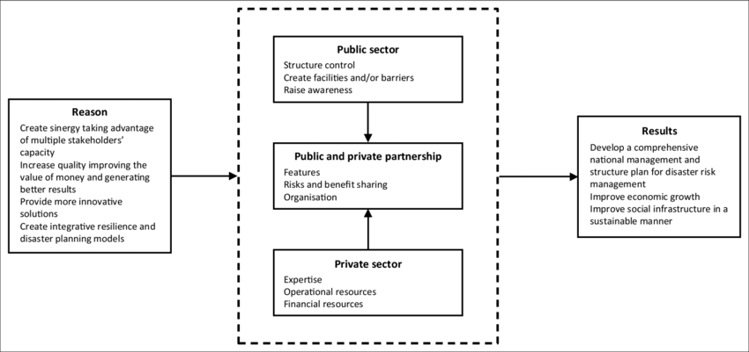
Source: (Eyerkaufer, Lima and Gonçalves, 2016).
There are many theories which can be based on the education like Social Justice Theory, Human Rights Theory, Economic Theory and Educational Theory. In the present study the Economic Theory will be studied to understand the economic aspect in the education.
Theory of Economy in Education:
The theory of Economic promotes the education as it is the means of human development so there is need of investment in the education as it is the asset in the economy. The skilled worker is productive and they shape the economy and it leads to progress of the economy. The education has a great contribution in the economic development of the country. This theory concentrates on education as human capital, so the significance of education has increasing int economic context (Osmankovic, Jahic and Sehic, 2011).
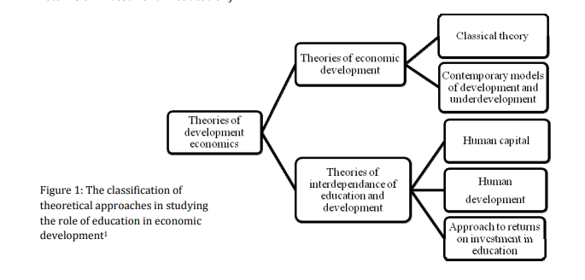
Source: (Osmankovic, Jahic and Sehic, 2011)
The above conceptual framework shows us how the education contributes in the different economic frame. Education has a great role in the invest on the education for the human capital expansion, the human resource is asset for the country and it is investment for the country (Breton, 2013). In the present research context, the education need to be free and compulsory regardless of private or public education as it will generate human capital for country and it contributes in the development of the country. The government should consider the education is an investment of the country on the human resource which would be productive for the country in the future.
.

Methodology

This study wants to explore the private and public school education and strive to understand the affordability, accessibility and quality of the education in India. In the literature we can see the different views about the private and public education can be seen in this research as per that the private schools are expensive than the public schools and not affordable to the poor class people in India. On the other hand some views comes that the private education is affordable and accessible to the poor class people as well as they are providing the low fees private education which is affordable and that is the reason the private schools are increasing rapidly in India.

Data Collection:

As we have discussed the different views regarding the private and the public education and the cost of the education, it is vital to comprehend the views of the parents as they are the important stakeholders and they are who spends their expenses on the education.
Hence, in this research the questions has been formed which could justify the issue and the 18 questions has been generated to collect the data from the participants. There total 56 participants has been recorded their response out of that two responses missing in the data. Hence, 54 responded has recorded their valuable responses out of that 15 were female and 39 were male.

Participants:
In this present study the random sample were collected from the different salary groups and different age group for the valid data collection related to proposed topic. The survey method was used to collected the data from responded there were total 18 questions formed in the google form and shared with the respondents. This strategy assisted for this research to gather the data in short span of time for the study. The study mainly focused on the parents’ opinions about the private and public education so parents are the only targeted respondents. To collect the demographic data three consecutive question were formulate to know gender, age group, and salary group. The survey questions were structure to understand the affordability, accessibility, quality (question no.4 to question no.17) and preference of parents (question no.18) about the private and public education. There were 56 respondents responded, and out of that two responses are missing. So total 54 male and females recorded their responses where 72.2 were male (n=39) and 27.8% were female (n=15).
Data Analysis Strategy:
In the present research the MS-Excel and the SPSS tool have been applied to understand the meaning of data and present the data in relation to the responses and has been analyzed using Descriptive Linkert’s scale significance te3st the gender frequency and percentage analysis, Reliability Test(Cronbach’s Alpha), Component analysis done using the One-Way ANOVA Test. Then non-parametric test conducted for hypothesis testing.

Data Analysis and Interpretation:
Figure.1 Gender Tubular Presentation
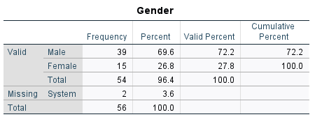
In the above table we can see the participants who have take part in the survey and we can see there were 56 in total participants took part but 2 respondent’s record missing or they couldn’t fill the information.
Figure No.2 Gender Pie Chart:
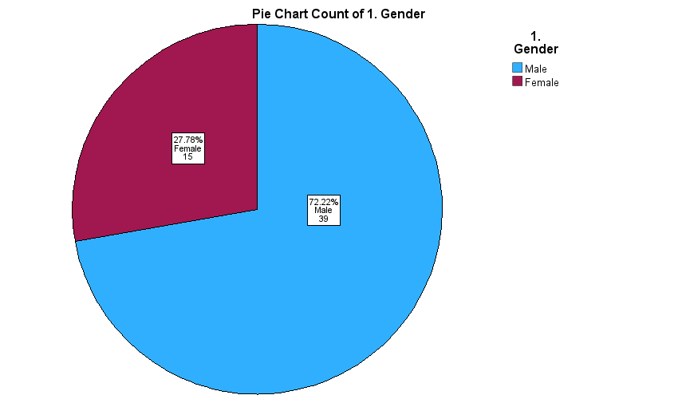
In the above table and Pie Chart we can see the participants who have taken part in the survey and we can see there were 56 in total participants took part but 2 respondent’s record missing or they couldn’t fill the information.
Figure No. 3
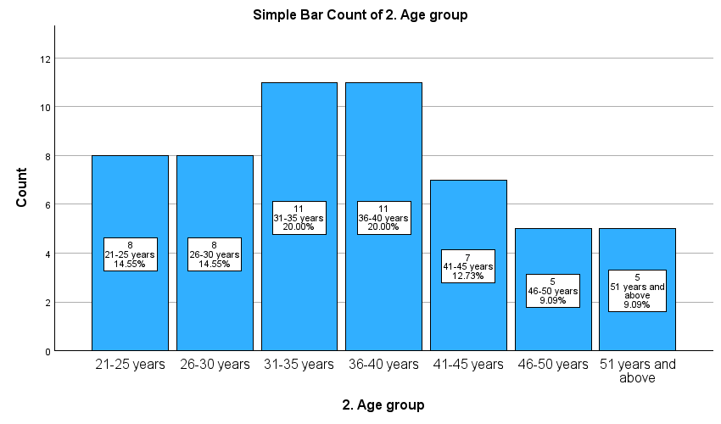
In the above figure No-3 we can see that a Bar Chart represents the age group of the respondents. In that around 80% respondents were below the 45 years age group and considered as a younger population and the above 45 age group there were 20% respondents. The trends shows that participants of different age group.
Figure No.4

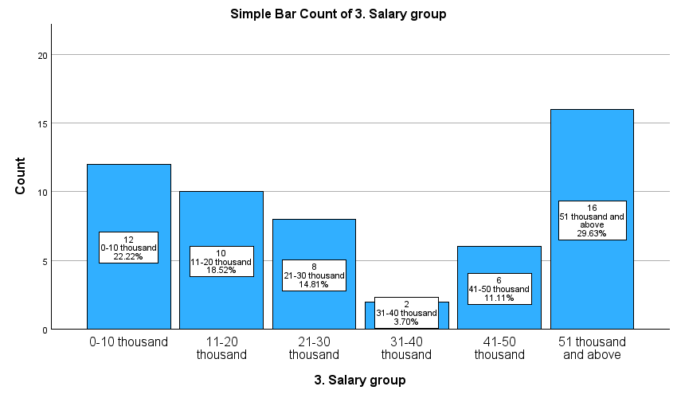
In the above Figure N0-4 there is Bar Chart which shows the different salary groups of parents, where in the trends we can see that there are most of the people are blow the India Rupees 30 thousand consider as lower middle class. The people in India below the 125,000 Rs considered as Poor and the People between annual income 50,0000 Rs to 30,00000 considered as middle class and above the annual income 30,00000 Rs. are rich population. In the above survey there is no person in the reach class only 14% respondents are in the Middle-class category and remained respondents (28%) to be considered as poor in India as they are below the annual income 125000 Rs annual income.
Figure No.5
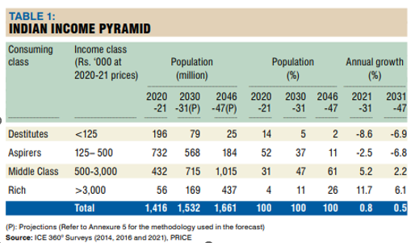
Source: People Research on India’s Consumer Economy (PRICE)
The study has trying to see the affordability, accessibility, quality of the education in India and what parents thinks about the private and public education. To collect the data this study has structure the total 18 questions where question number 1-3 are demographic questions and 4-17 are question related to the affordability-accessibility-quality of education and the18 number question is personal response question for the preference of parent to private and public.
Descriptive Statistic Analysis (Five-point Linkert’s Scale Significance):
Initially, we are going to check the significance of the five-point Linkert scale considering the mean and Standard Deviation.

Figure No.6 :
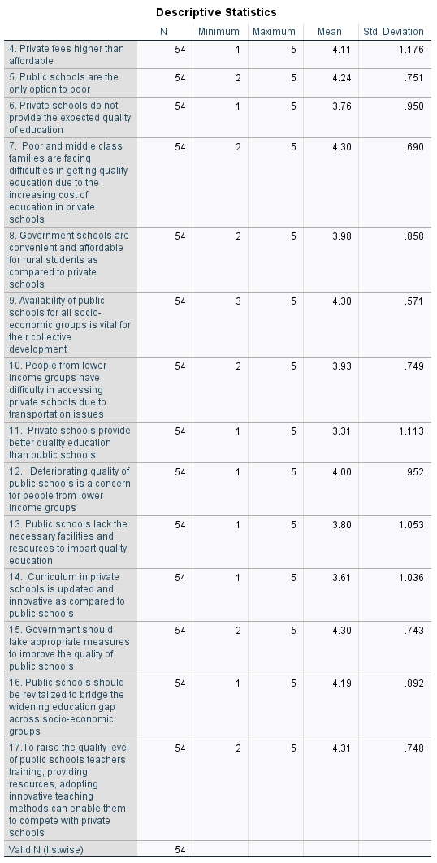
Figure No-7 :
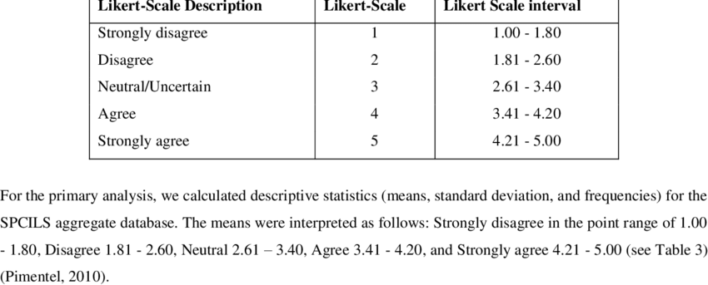
Source: (Nyutu, Cobern and Pleasants, 2020).
In the figure No- 6 we can see the descriptive analysis of the 5-Scale Linkert’s scale where mean and standard deviation of each question is appeared. Whereas, in the second table we can see the intervals for the interpretation of significance of scales Strongly disagree, Disagree, Neutral Agree and Strongly agree.
Here, the variable Number 4.6, 8, 10, 12, 13, 14, and 16 are between Scale 3.41 to 4.20, it means that the respondents are Agree to these statements and the standard deviation (SD) of these variables above is above the 0.5. Whereas the Variable number 5, 7, 9, 15, and 17 having the mean between 4.21 to 5.00, it means that the respondents are strongly agree to the statement. On the other hand, the standard deviation of variable 4,11,13 and 14 is above the ‘1’ it means that there is variation in the view of respondents and shows scattered views and the other variable are above the 0.5 and below the 1, so there is no variation find in the other variables and respondent are firm to the statement or close to the statement. It shows that instead of 4 variable show bit variation but the other variable is close to the statement made. Hence, it has found the significant relation among the variable considering the mean and standard deviation. Accordingly, majority of the parents are not decisive about the private and public schools and they are having dilemma in their mind about the affordability, accessibility and quality of the schooling education.

Reliability Analysis (Cronbach’s Alpha):
This test mainly conducts to show the relation or the connection of the questionnaire formed in the Linkert’s Scale. In the simple word it evaluates the questionnaire and validate the questionnaires. When the questions are well-connected the further test results would not be errored in the study. Hence, the Cronbach’s Alpha is used to check to validity and reliability of the Linkert’s scale variables (Tavakol and Dennick, 2011).
The Cronbach’s Alpha Reliability Test or analysis coefficient is important factor to check the validity of the questionnaires and this ranges from 0-1. If the coefficient is greater than 0.5 is test is Poor, greater than 0.6 is questionable, greater than 0.7 is acceptable, greater than 8 is considered as good and greater than 0.9 to 1 considered as excellent.
Result:
Figure No.8
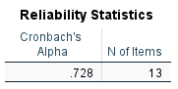
Figure No. 9

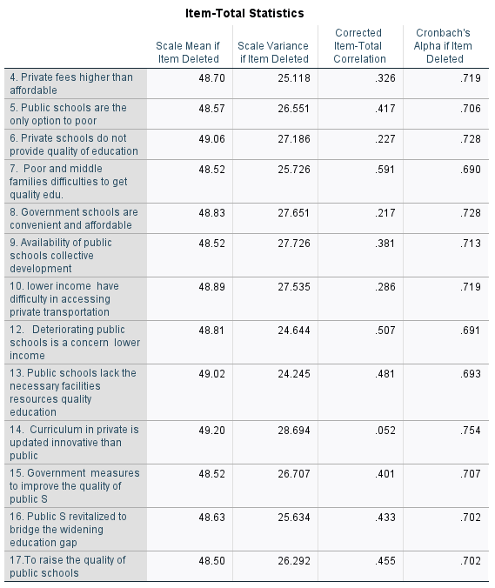
In the above Figure No.8 The Cronbach’s Alpha coefficient is 7.28, it means the Alpha value is between 7-8 and it is acceptable in relation to the connection of the questions formed in the study and the internal consistence of questionnaires is good. To get the valid internal consistence the question number-11 removed from the Scale. In the present study the 13 variables related to affordability, accessibility and quality of the private vs public school education shows acceptable internal consistency and it is unfailing. The Cronbach’s Alpha analysis indicates the significant reliability among the 13 items (One item adjusted/removed).

Component Analysis Using One- Way ANOVA:
This test is generally known as analysis of variance and it is utilized to check the hypothesis i.e. to reject the hypothesis or accept the hypothesis. The null hypothesis (H0) and the alternative hypothesis both can be tested by this tool of analysis. ANOVA tool is most effective for the test of the more than three factor analysis to get the considerable output. This method is use to check the identicalness of the variables in the study.
Figure No-10 -
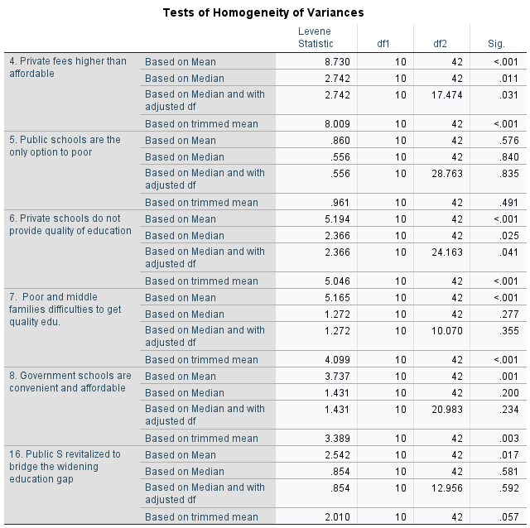

Figure No-11
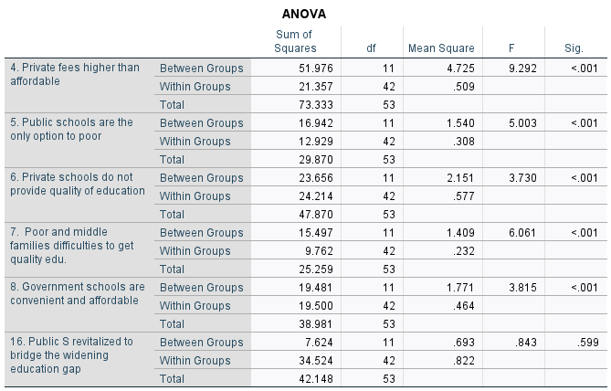

Figure No-12
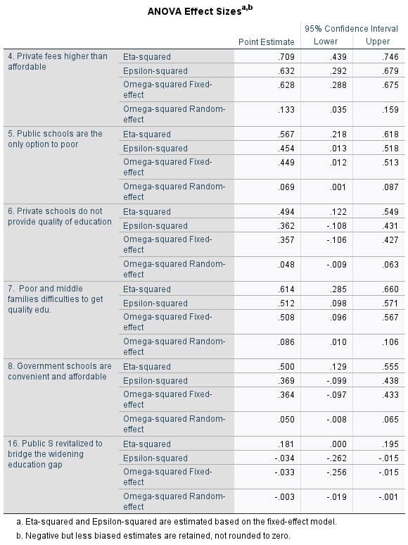
In the above Figure- 10, Figure-11, and Figure we can see ANOVA analysis table. In the figure -10, df1 and df2 are the degree of freedom there is representation of the homogeneity variance and the Lavene Test doesn’t show significant relation between the variance because the P- value is greater than the 0.05. So, it shows this study Faile to reject the Null Hypothesis (Ho).
In Figure 11 of ANOVA, we can see that the P value is <0.001, it means that homogeneity of variance violated and variability in the affordability of the education and the salary is differ, means there is very much difference between salary concern and the affordability and accessibility. Now, we will do a non-parametric analysis.

Non-Parametric Analysis/Test: (Figure No-13)
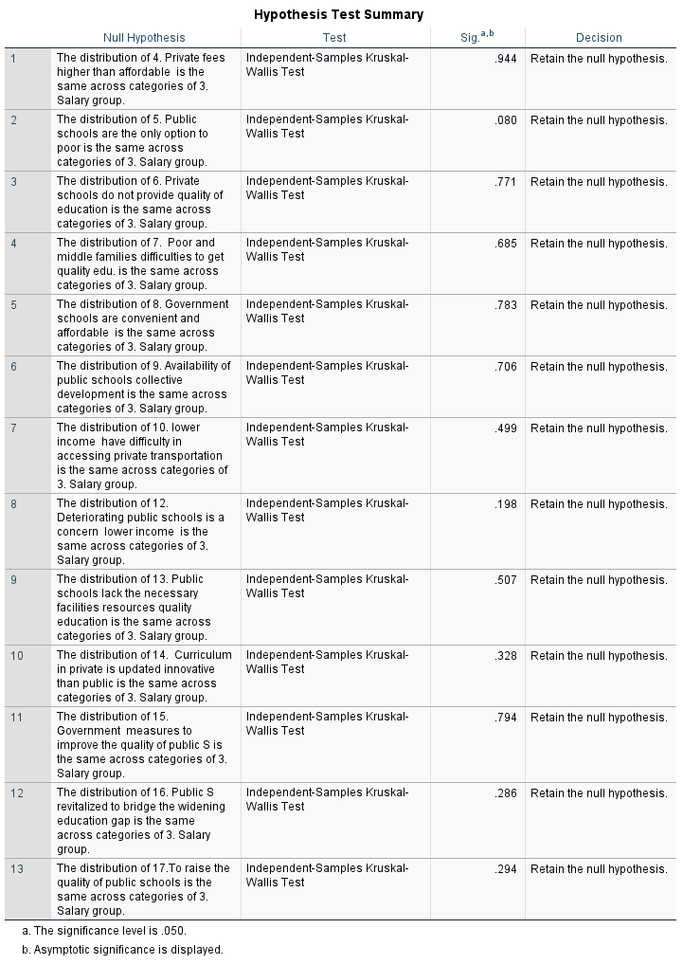
Figure No 14
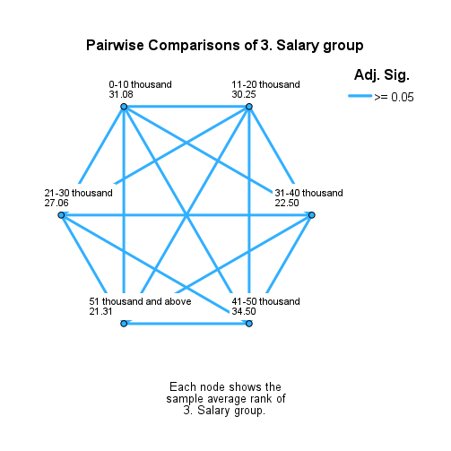

Result Discussion: In the figure No-13 there is a non-parametric test conducted and we can see the results of the whole variance in the table. In the Kruskal-Wallis Test of Independent Variable.
The result shows that the sig. value of the all variable is >0.05 and this is indicated that the Null Hypothesis is retained and there is no significant difference between private and public education in relation to the affordability, accessibility, quality of the parents’ salary. Hence, fail to reject Null Hypothesis (Ho) as per the result of Kruskal-Wallis Test of Independent Variable.

Conclusion:
The present study has been conducted to understand the relation of the income/salary of the parents and their preference to school education like private and public-school education and is there any effect of the private school cost on the parents’ preference. There were 56 respondents of the India Maharashtra has been targeted for the study randomly to understand the affordability, accessibility, and quality of education. The study shows that there is no significant relation between salary and the preference of the school, but it is has found that there is no relation of these variables.
This study draws our attention that the low fees private school are affordable, accessible, and having the good quality education and there is not that much cost involved in the low fees private school. This is the reason the parents are preferring to the private schools. In the literature shows that public schools have quality issue related to teacher skill, infrastructure, curriculum, and innovative study etc. There is need of government intervention for the revival of the public schools.

Recommendation:
In the private education era, there are many students work as child labor, seasonal migrate with parents from one place to another, some are living in remote area, and the economic weaker section are needy group of education so government should address the issue in the public education as these people and rural area population has only option of public education due to transportation issue, economic issue or other socio-economic constraints. Hence, government should work on the revival plan of the public schools.
Secondly, this study found that the salary of the private school teacher is less that’s why the low fees private school are expanding as they became affordable for poor. So there is need to check the quality of the teacher and their contribution and satisfaction index in private school and in private school there should be monitoring and control of the policy makers.

