Professional Career Development Student Name: Marva Walters Cadogan

Student ID:1711042

Module tutor: Sylvia Hoffman

Date of submission: 17/01/2019

Contents
Introduction 3
Self-evaluation 4
Self Motivation 4
Learning styles 7
My own learning style 7
Life Objectives (S.M.A.R.T) 16
Johari Window 18
Expectations of the world employment 19
Career ambitions and aspirations 20
Personal Development Plan 21
Conclusion 25
References 26

Introduction
The term professional career usually refers to the time span of a person in which he/she applies all the knowledge he/she has gathered throughout the life to earn livelihood and at the same time recognition. This is a competitive world and the achievement of a good professional career is not always easy and convenient. A person has to go through a lot of hurdles to obtain the career he/she desires for and which is why professional career development is a very significant aspect of an individual’s life. This kind of development plan can be carried out by a number of tools and techniques such as self-evaluation techniques, SMART objectives, Personal Development Plan, SWOT analysis, Johari Window Model, and so on. This report has been made as a portfolio by which I will describe the professional career development which I have planned for myself by mentioning and assessing all the skills and abilities which I already possess and which I will have to acquire further.

My Lifeline:

A lifeline exercise is the procedure by which the life history of a person can be showed with the help of a graph (Rogers, 2007). The basic criterion of a lifeline exercise is that it describes all the high points and the low points which have been experienced throughout the life (Hightower, 2011).

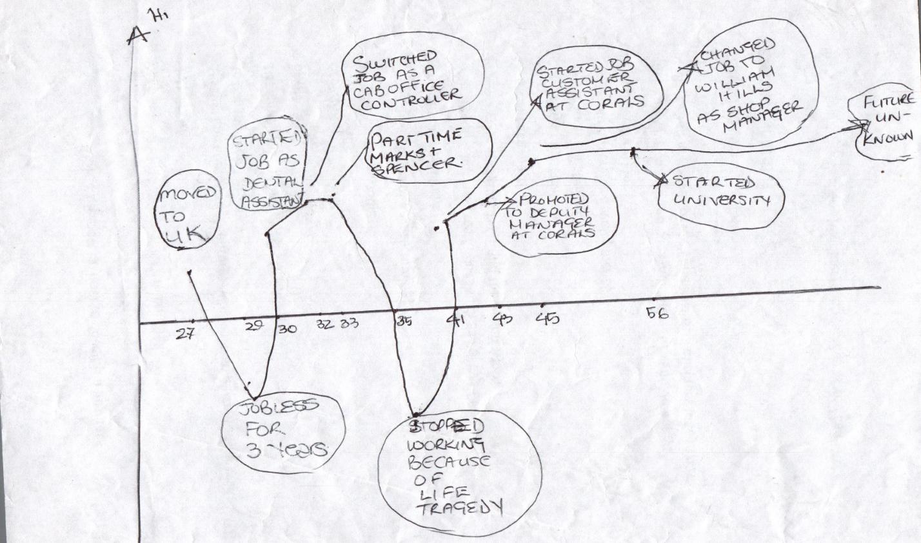
I grew up in Jamaica. In Jamaica I was working full-time as a dental assistant. I was always high ambitious for a better career. I have moved to London at the age of 27 and have remained unemployed for 2/3 years as I could not find a suitable job for me. That was the low point of my life. At the age of 30, I got a job to act as an assistant to a dentist from which I soon shifted to work as a cab office controller. I also started working part time at Marks & Spencer at that same time period. I worked at those companies for 3 years. These were the high points of my life. However, due to some life tragedy I stopped working at the age of 35 which was a very low point of my life. This tragic period of my life ended when I got the opportunity to work as a customer assistant at Corals at the age of 41. I was promoted to the post of deputy manager at the age of 43 which was a very high point of my life. After that I was offered to join William Hills to work as the store manager of the company. I joined the university at the age of 56 which is also a high point of life as this is the place which will further assist me in achieving more extended skills and abilities to be a more competent professional.

Self-evaluation
The concept of “Self Evaluation” depicts the process of assessing the skills, capabilities and competencies of a particular individual by his or her own self and relating these factors with the professional and academic life of the person and with the overall success or failure experienced by the individual throughout the life time (Maund, et al 2017). This approach is assistive for comparing the overall professional condition of any person with the personal level of aptitudes in order to find out whether the person has succeeded to achieve the desired level of growth in the professional as well as the personal life.

Self Motivation
Self motivation is another concept related to personal development process which is strongly correlated with the idea of self evaluation (Donnelly, 2002). This concept or idea exhibits the drivers which force any individual or person to engage his or her own self in an incessant process of developing skills, competencies and professional aptitudes that are essential to achieve desired level of accomplishment (Greenhaus, et al 2006). Self confidence is the most common factor in achieving this aforementioned mission. Besides this, a positive attitude towards life is also obligatory for any person wishing to thrive in life. Each and every person must set some specific aspirations and purpose of life so that they can design the courses of actions in accordance with these predetermined plans (Van Emden, et al 2010).
I have experienced a lot of ups and downs in both my personal and professional career. Although I have felt very disheartened or depressed at times, but the level of myself motivation has always helped me a lot to gather the courage and energy required to get myself out of every adverse situation. Throughout my professional life, I have developed self confidence through my hard work and successes attained. I was fortunate enough to receive courage and inspiration from my work environments in most cases and also was able to learn something new from each job that I have done throughout my professional life. My strong personality and leadership traits were assistive to drive myself towards attaining my goals and objectives of life.
A motivational quiz is presented below which will present my actual stand regarding self motivation and related factors.
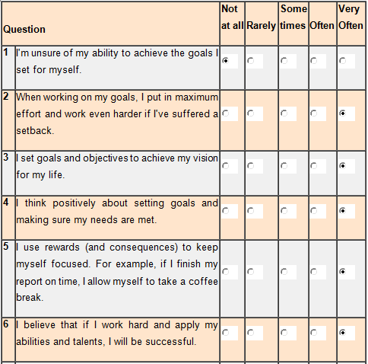

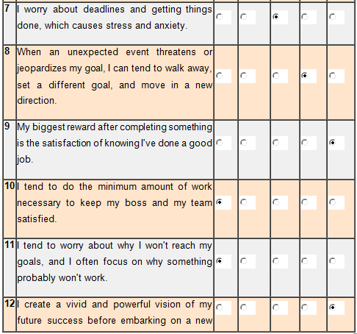

My total score in the self evaluation quiz was 45 out of 60 which depicts that I am a practitioner and a doer who likes to face challenges and enjoys the process of overcoming any adversities or hindrance in the professional and personal life. It is my inherent personality trait to keep myself self motivated and focused on career development as well as achieving success. Additionally, my personality is inspiring to others and the overall situation in my life is quite positive. Last but not the least; I have a positive and practical attitude towards life.

Learning styles
Learning styles depicts the techniques and methods used by individuals to learn something new and develop aptitudes and competencies on a specific sector. It is evident that, different people have dissimilar learning styles (Maund, et al 2017). In most cases, a person utilizes more than one learning style and customizes the learning process in accordance with the learning condition and requirements (Van Emden, et al 2010).

My own learning style
From a large number of learning styles developed by researchers and academicians, I have found out that 2 specific learning styles are very effective for me. These are:
- VAK (Visual, Auditory and Kinesthetic sensory modalities)
- Honey and Mumford learning style

Honey and Mumford learning style
This specific learning style was initiated through the efforts of Peter Honey and Alan Mumford, based on exertion of Kolb. 4 different learning styles were included in this theory or concept (Morgan, 2016). These are:
- Activist
- Theorist
- Pragmatist
- Reflector.
The aforementioned learning styles are usually utilized by learners. It is suggested by these two academicians that, each and every learner must strive to identify the learning style that is the most effective for his or her own learning efforts and showcase proper effort to practice and implement that style in real life learning procedures in order to ensure the best possible outcome from the overall learning process and to avoid failure as well as waste of valuable time and resources (McMillan, et al 2006).
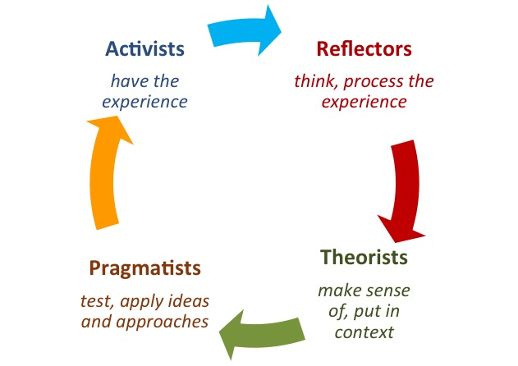
Fig: Honey & Mumford Learning Style (Greenhaus, et al 2006).
According to my personal self assessment, I am a “Pragmatist” learner and possess the ability to see how to implement the learning into practice in real life. It is also evident that, theoretical concepts are of inadequate use for me except situations where I can see a technique to put the thoughts into action in my own professional or academic life. The most enjoying activities for me are thinking about the processes to pertain learning in real life, solving case studies, engaging myself in problem solving activities etc.

VAK learning style
In the VAK learning style, visual, auditory and kinesthetic styles of learning are suggested or described by researchers. The visual learners prefer to learn by watching or seeing things in real (McMillan, et al 2006). Some common tools for visual learning are: maps, diagrams, charts, flowcharts, presentations etc. The auditory learners prefer to learn by hearing things as it helps them to memorize things and increase the rate of information retention. The kinesthetic learning style requires doing something in real life and learning by practicing (McMillan, et al 2006).
My assessment and score of the VAK learning style is presented below:
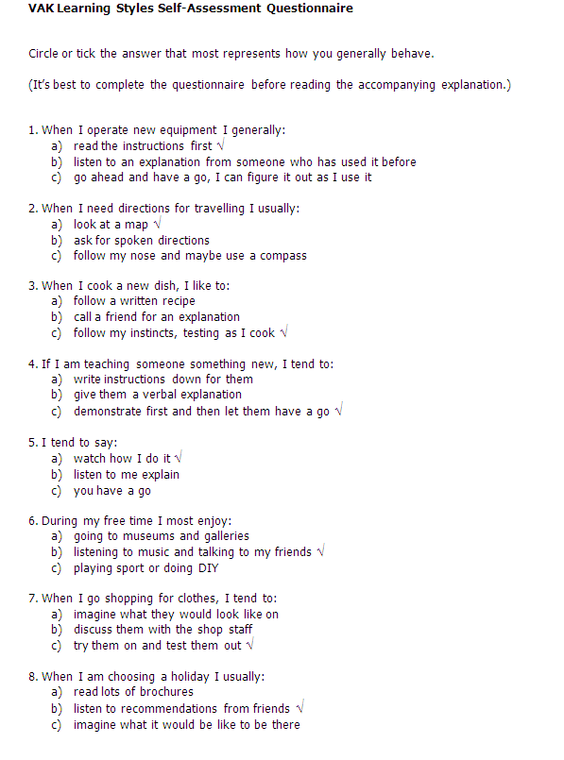
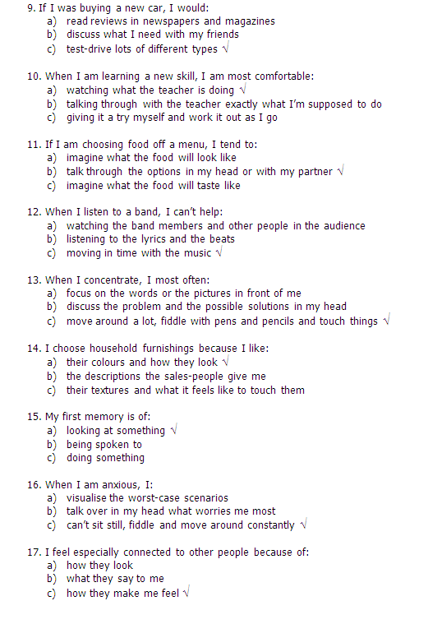
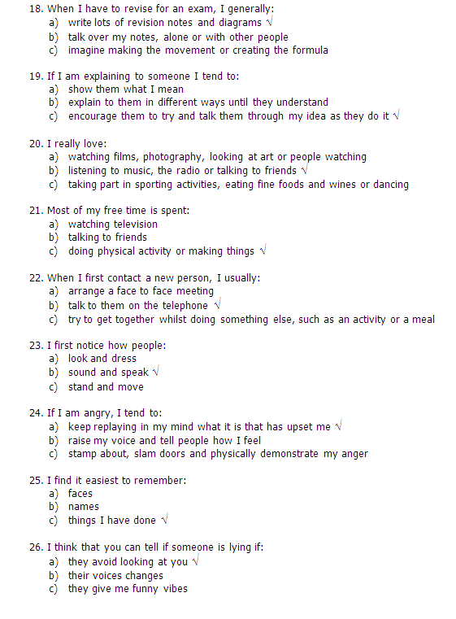
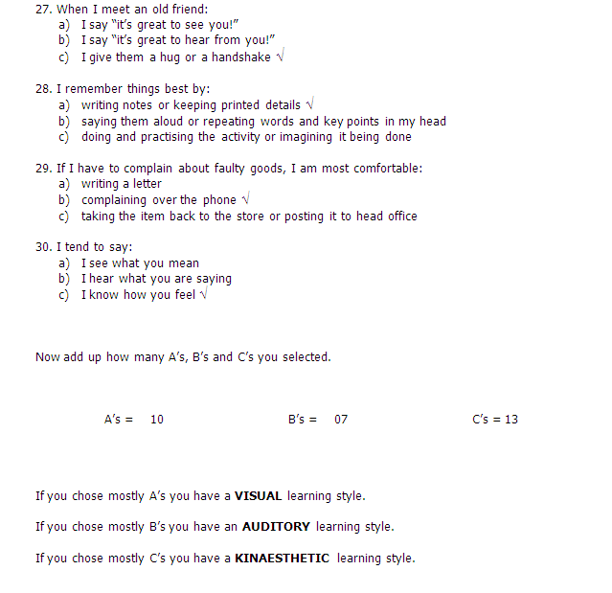
According to the assessment, I am a kinesthetic learner. This is also known as tactile learning. I prefer to learn things by carrying out physical activities in reality instead of attending class lectures or watching learning materials. In most of the cases in my learning activities, I require whole-body movement to comprehend information and learning related things.

Reflecting on my Learning Style using VAK Worksheet
Yes | Visual | Auditory | Kinesthetic | Other | Reflections
Leadership |  |  |  | Visual and auditory | I have a short attention span so therefore I get bored get distracted and lose concentrationinspirational
Ethics | Following my role models |  | yes | Cognitive? | Need it to be demonstarated to me
Team Building | yes |  |  | Verbal | Working as a part of a group helps to keep my brain active, it enables brainstorming and ideas are formed which in which can help me to think and I can put my thoughts onto paper .
Conflict Resolver |  | yes |  |  | Demonstrating to each individual how part of a group is essential to build ideas from each other and treat each other with respect
Numerical Skills |  | yes | Doing lots of examples |  | I think the only way for me to get better is to practice. I will find myself some free examples, and practice twice a week for the next 6 weeks. It will help me to feel more confident in this area in future.
Time Management |  |  | pryesactice |  | Need to improve my time management skills therefore have started using a diary and started to apply the pareto principle in my study life and work
Communication |  |  | yes |  | This is my favourite learning style love communication in lectures wher I always g a feedback when lecturerer
Motivator |  | yes |  |  | Encouragement seems to get the best work done by me
Negotiator |  |  | yes |  | I need to be demonstrated to before agreeing with the results
Written Skills | Yes |  |  |  | Taking notes in lectures helps my learning process as I can later read what was written to help with directing me with my assignments

Personal Strengths and Weaknesses analysis
Strengths | Weaknesses
What are you good at  - Team player  - Read a lot of books  - Hard working  - Punctual  - Honest  - Disciplined  - Respectful  - Trustworthy  - Great customer service skills  - Using my own initiative | What do you need to improve?  - Active listening  - Sometimes procrastinate  - Takes too much risks  - Over talking
What special resources do you have (e.g. qualifications, experience, contacts etc)?  - Qualified dental nurse  - Shop manager at William hills  - Being in a career and at university it makes it easy to apply for other jobs if the need arises  - Career progression | In what areas do you have fewer resources than other people? (eg qua experiences, contacts etc)  - Low salary  - Hard workload  - New government legislation  - Advancing technology from rival companies
What do you think other people see as your strengths?  - Confidence  - Strict  - Opportunist  - Helpful  - resourceful | What do you think other people will see as your weaknesses?  - Weak listening skills

Opportunities | Threats
What opportunities are available to you?  - Career growth  - Higher level jobs  - Increase in personal income  - Better quality of life | What threats could damage your ambitions or career prospects?  - Unexpected health hazards  - Economic downturn in the world economy  - Laws affecting the industry in which I am currently employed  - Poor performance of my current employer
How can you turn your strengths into opportunities?  - Continuously striving to identify available opportunities  - Developing more skills and competencies | What threats arise because of the personal areas of weakness you have identified?  - Failure occurrence due to random risk taking initiatives  - Disputes because of garrulous nature

Life Objectives (S.M.A.R.T)
The SMART objectives refer to diverse variety of measure which is considered by learners to identify the ability or chances of his or her own self to achieve the desired level of success and career growth. The letters S,M,A,R,T stand for specific, measurable, achievable, relevant and time-bound and it is evident from the work of researchers that, if all these aforementioned criteria are met, in that case a particular aim or aspiration will be considered as an ultimate objective or target (Bellanca, 1996).
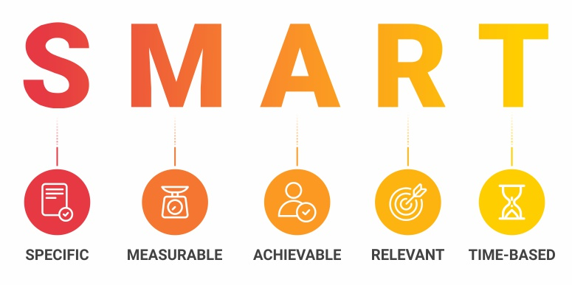
Fig: SMART Objectives (Donnelly, 2002).
As a professional, I have developed and decided a specific set of goals and objectives regarding my professional career. I am determined and motivated enough to perform in accordance with these plans and giving my best efforts to achieve my predetermined life goals.
Skill or ability | Specific task (What is the task or objective? Attach details if appropriate | Measures (Standards and Parameters) | Agreed (Is it?) | Realistic (Is it?) | Timings (Start/finish dates) | Comments/actions (Follow up notes. Attach details if appropriate)
Eager and willing to increase knowledge | Researching and gathering information for my assignments as well as completing them | 2-3 years | Yes | Yes (Studying to develop my soft and hard skills) | Feb 2018 – Feb 2021 | Gain a diploma to enhance my work life
Leadership and resilience | To use my diploma to gain promotion at work from shop manager to BDM to area manager | 3-5 years | Yes |  | 2021-2024 | Using diploma to show professionalism
Determination and persistence | Use skills at work and from my degree to pursue my dream of becoming a business owner | 5-10 years | Yes | Yes | 2024-2034 | Using knowledge and research skills to apply for start up business loan

From the above SMART table it is clear that the goals which I have targeted to fulfill are specific, measurable, achievable, relevant and time-bound. Thus I have achieved all the objectives of SMART.

Johari Window
This specific concept or theory is considered as a straightforward and helpful system which is utilized by a number of different persons to comprehend the reciprocated perceptive of learners willing to increase self-awareness. This method is specifically useful to establish a strong and effective communication among employees working for a business organization (Blake, 2014).
There are 4 divisions in the Johari Window model (Morgan, 2016).
- Open self
- Blind self
- Hidden self
- Unknown self
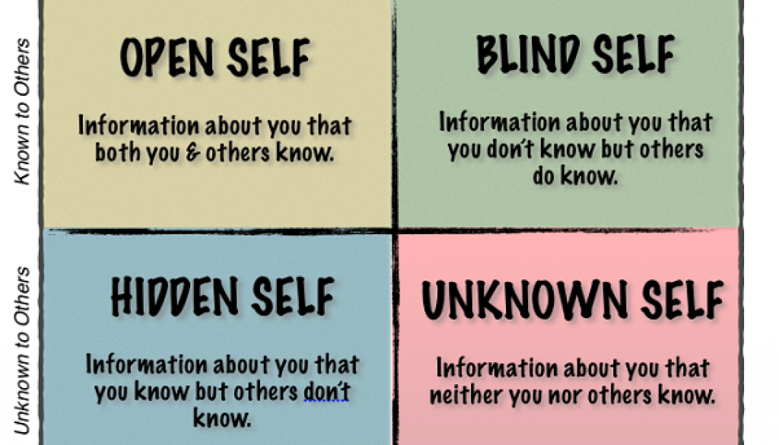
Fig: Johari Window Model (Morgan, 2016).
This will be an effective approach for my self-development. The open self traits of mine are those which are known to me and my coworkers and are useful to build and maintain positive relationship with them. The blind self depicts the personality traits that are unknown to me but other people notice them. I must strive to know these issues from others by communicating with them because these issues can often be negative and hamper my organizational or professional performance. The hidden self is the personality traits or facts about me that are unknown to people around me. I should share these with my coworkers in order to give them the opportunity to know myself better and simultaneously build a strong association with them. The last one is the unknown self of me which is not known or noticed by anyone including me. I must make attempts to discover any hidden strength or aptitude of mine in order to leverage that to gain success in life. Additionally, I must identify my unknown weaknesses which are affecting my overall performance and hindering my personal growth. Then I must engage myself in other process of overcoming these adverse factors effectively.

Expectations of the world employment
The world of employment is getting tougher with the passage of time. Now-a-days, the job seekers have to go through a lot of processes and procedures to get their desired job and even if they go through all of those, it is not assured that they will be able to obtain that job (Cottrell, 2010). As I have been working as the store manager of the William Hills bookmaker company, it is one of my responsibilities to appoint employees for the organization. And while doing that, I have come to know about the recent trends and procedures which are taken into account to select the best potential candidate for any kind of organization. The first step which I have to follow in this regard is to create a detailed job description for whatever post is vacant in my organization. The job description has the details about the skills and abilities we have been looking for in the potential candidate and at the same time about every duty and responsibility which the employee is supposed to perform when he has been selected. The opportunities and facilities which he will receive are mentioned as well. After the job description is published, naturally a lot of CVs come for the job opportunity. Then it becomes my duty to screen though all of those CVs to separate the more competent ones and the suitable ones for the job. After I have finished doing that, we, the members of the recruitment team call them for an interview. The interview is designed as such so that the candidates could be assessed face to face and examine if they are fit for the job. It contains a lot of questions which are asked by me along with other team mates so that we could understand and judge the nature of the candidates along with their abilities. After the interview section is done properly, the right candidate is chosen for acting as the employee of the organization. The employees have certain rights and privileges which are very necessary to know and maintain in any workplace. There are a number of laws and legislations regarding the welfare of the employees such as the Employment Act of 2002, the Employment Relations Act of 2004, the Health and Safety Act, the Equality Act of 2010 etc. (Hirsch, 2014). I have come to know about all these during my lessons at the university and also known the importance of the prevalence of these laws and legislations at William Hills. I have learned that these laws, legislations, rules and regulation are what make any workplace a better place to work and to provide the employees an ideal place to work.

Career ambitions and aspirations
I have some specific ambitions and aspirations which I have targeted to acquire within a specific time limit and which will help in shaping a good professional care for me. The short term goals which I have targeted are to learn more about computer and different tools and techniques to use computer proficiently and to enhance my organizational skills which will make me a more competent worker at my workplace. For the mid-term goals, I have decided that I will pass my B.A degree with good marks and make my lifestyle a better one as I have already suffered from a lot of sufferings which have made by life a dull one. Personal sufferings and sorrow can impact the development of professional career of a person (Mc Kee, et al 2012). For this reason, it is important that I put focus on this area. The long-term goal which I have is to achieve the master’s degree in the field of my education and to make myself a very competent and skilled employee of any organization.

Personal Development Plan
A Personal Development Plan or a PDP is basically a framework or a tool which helps an individual to develop a scheme to determine the goals and objectives which have to be achieved along with the necessary resources which will be needed throughout the time period and the time required achieving those goals and objectives (Rogers, 2007). The Personal Development Plan which I have made to make my professional career a more developed and successful one is given below-

Personal Development Plan
 | Short-Term Time Frame (6 month) | Mid-Term Time Frame (2 years) | Long-Term Time Frame (3 years)
Section 1 - My Goals | I would like to be able to be more competent on the computer during this time period to enhance my studies and to show more competency at work  Practise my listening skills  Improving my time management and organisational skills | I want to achieve my B.A degree which can be used to get the promotions at work that I am yearning for as this would mean a significant pay rise  Also to be a more balanced person as life tragedies had made my life surrounded by my grief and I want to surpass that with a more positive lifestyle and to say to myself if the person was here what would I be doing to make them proud of me | Focus on going to do my masters to achieve the ultimate goal of education where I can see myself, and to use this to do something worthwhile like holding business workshops back in my country Jamaica
Section 2 - Skills and  Knowledge to be  Learned | Understanding how to download  Analysing data  Using a file backup system  Understanding the good uses of the web  How to put raw data into excel to create graphs  Keep a daily diary of my time keeping and prioritise what is more important and the time frame I should be doing it in for example my time spent studying  Forming a study group | Improving my study skills by covering all the books on my module using set times for reading  Going to the library using more e books and e journals, form a study group so we can brainstorm to improve our ideas | Finding out if my place of work has a graduate training scheme or move on to a place of business that can fulfil my requirements
Section 3 - Next Steps | The skills and knowledge which I have mentioned can be achieved by me in a number of ways. The short-term goals which I have targeted can be achieved by attending an extensive computer course.  At the same time, some books from the store in which I am working as the manager will help me in this regard. | The skills and knowledge which I have intended to acquire regarding the mid-term goals can be achieved by me by using the library and the bookstore of William Hill. Also internet cafes will be ideal places for me to surf and collect information from.  The formation of a study group will be of great use to me in which I can discuss everything with my fellow learners. | I will set up a project outline for the long term goal I have set and research on the potential job circular which will benefit me more than this place. And also join classes of the training courses to develop my skills and abilities in a more detailed way.

 | Short-Term Time Frame  What do I want to accomplish in the next three to six months? | Mid-Term Time Frame  What do I want to accomplish in the next six months to two years? | Long-Term Time Frame  What do I want to accomplish in the next two to three years?
Section 4 - Resources | The resources which I will need for this goal will be financial help or funding to attend the courses and also some time to attend the classes of the course from my schedule of work. | The resources needed for this goal will be some time and space to study and to form the study group. | As I will have to attend courses for this goal and need to search for more new opportunities I will need both funding and free time for this particular goal.
Section 5 - Time Schedule  What is my time schedule? | My time schedule for this goal is from March 2019 to May 2019. | My time schedule for this goal is from June 2019 to January 2020. | My time schedule for this goal is from March 2019 to December 2020.
When will I start? | I will start at March 1, 2019. | I will start at June 1, 2019. | I will start at March 1, 2019.
When do I expect to finish? | I expect to finish acquiring this goal by May 30, 2019. | I expect to acquire this goal by January 31st, 2020. | I expect this goal to be acquired by December 31st, 2020.
Section 6 - Completion | □__________  Date  □__________  Date  □__________  Date | □__________  Date  □__________  Date  □__________  Date | □__________  Date  □__________  Date  □__________  Date

From the above development plan, it is clear that I have set some specific targeted goals and objectives for short term, midterm and long-term which will be beneficial for me as a professional in the present and will also be beneficial for me to become a more competent and skilled employee for any kind of organization.

Conclusion
Choosing the right professional career and to generate appropriate schemes to maintain and develop that professional career is a must for every individual. The competition in the job market is increasing rapidly and this is the primary reason behind the necessity of this kind of professional development frameworks. This assignment has described in details about all kind of development activities which I have taken into account for developing my own professional career along with the assessment of the skills and abilities which I have within me.

References

- Bellanca, J. (1996). Designing professional development for change. Cheltenham, Vic.: Hawker Brownlow Education.
- Blake, B., (2014). The Johari Window Model, [online video]. Available at:< https://www.youtube.com/watch?v=BWii4Tx3GJk>
- Cottrell, S. (2010) Skills for Success: The Personal Development Planning Handbook (2nd edition). Hampshire: Palgrave MacMillan.
- Donnelly, J. (2002). Career development for teachers. London: Kogan Page.
- Greenhaus, J. and Callanan, G. (2006). Encyclopedia of career development. Thousand Oaks, Calif.: Sage Publications.
- Hightower, L. (2011). Professional sitecore development. Hoboken, N.J: Wiley.
- Hirsch, A. (2014). Job Search and Career Checklists. JIST Publishing.
- Maund, A. Schriek, M. and Tinkler, P. (2017). Certificate in Higher Education: Skills for the Workplace Student Yearbook. Sage Publications.
- McMillan, K. and Weyers, J. (2006). The smarter student: Skills and strategies for success at university. London: Prentice Hall.
- Mc Kee, A. and Eraut, M. (2012). Learning trajectories, innovation and identity for professional development. Dordrecht: Springer.
- Morgan, P. (2016). The Business Student’s Guide to Study and Employability. Sage Publications.
- Rogers, J. (2007). Career stories. University Park (Pa.): The Pennsylvania State University Press.
- Van Emden, J. & Becker, L. (2010). Presentation Skills for Students (2nd edition). Palgrave Macmillan.

