E-Portfolio

Chloe Rees

Contents Page

- Page 3: Article Summary
- Page 4: Infographic
- Page 5 & 6: Essay plan
- Page 7: Library search
- Page 8: Summary of sources
- Page 9: References for all tasks

Task one- Summary of an article

How does music make you feel?

Music is an important part of many people’s lives. Many people will put on their favourite song and immediately feel a range of emotions, this raises many questions about why music makes us feel a certain way and does everyone feel the same way?
A fundamental rule the author learnt was that major music sounds happy and minor music sounds sad. She considered the role of individual differences as most people will have memories attached to certain songs. The enjoyment of music is usually associated with reward areas in the brain. The author focused on the work of Patrik Juslin and his team who drew together a number of theories. In his book Musical Emotions Explained (2019) he notes that music psychologists have lacked a theoretical framework of underlying emotional responses to music. Juslin and colleagues have now developed a theoretical framework to explain how emotions are induced by music. This theory is known as the BRECVEMA framework (Juslin & Västfjäll, 2008; Juslin, 2013). The framework is at a very early stage, there may be further research about these mechanisms and emotional responses to music from different personalities. Many factors may affect music-induced emotions, including external and internal factors. Think about the difference of how you listen to music now compared to 10, 20 or 30 years ago, many people now use Spotify or Apple Music. There are now playlists that are made specifically for your mood or chosen genre, songs played on the radio have been chosen for us for years, however streaming services have now made listening to music more personalised. Music therapy can be closely linked to the study of emotional responses to music, many of these techniques are also used in music therapy. Some people are said to have music anhedonia as they get very little pleasure from listening to music. Then there is musicophilia where people may have very high amounts of pleasure from music. Ask yourself some questions regarding which songs make you feel a certain way, maybe you will notice something new about music.

Nendick, Z. (2022, September 12). How does music make you feel? – The British Psychological Society. Www.bps.org.uk. https://www.bps.org.uk/psychologist/how-does-music-make-you-feel

Task two- Infographic
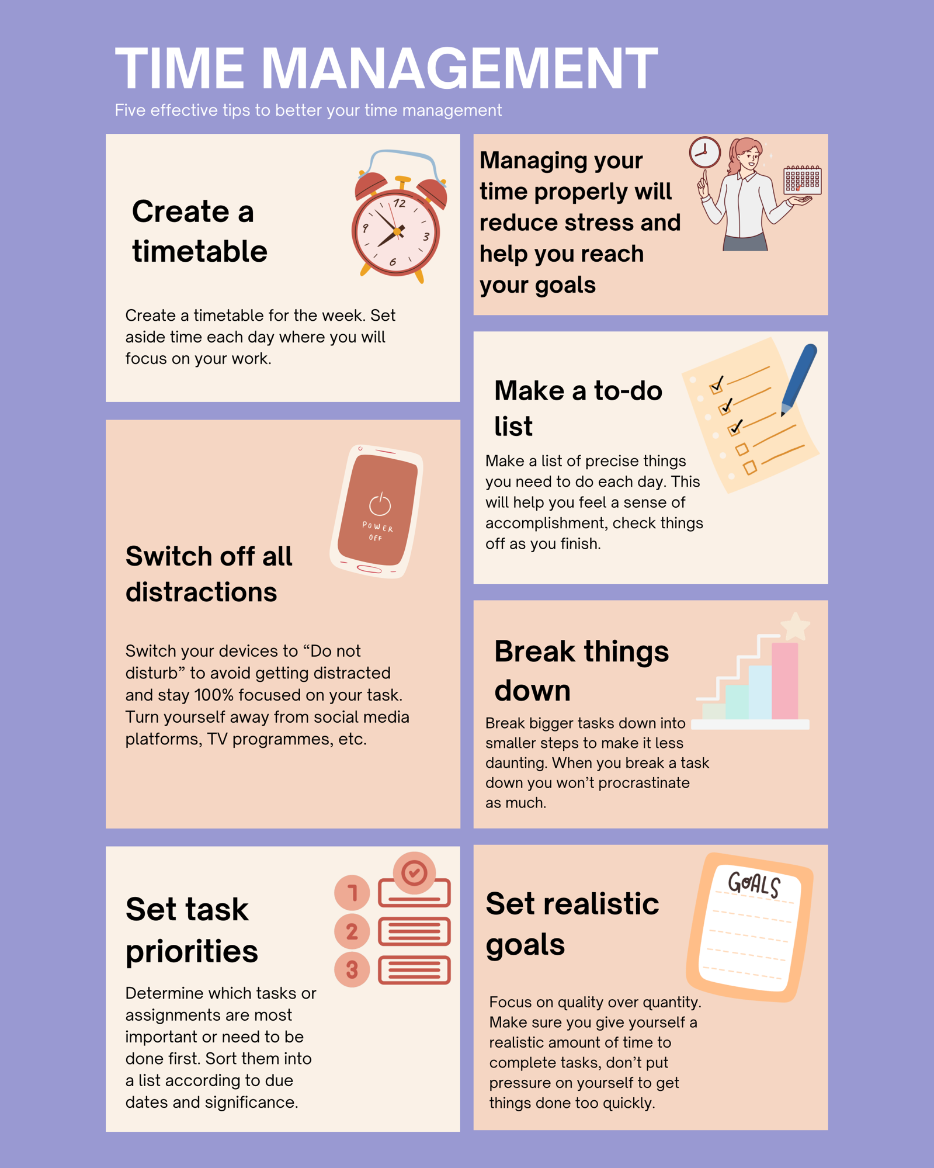

Task three- Essay Plan

Title Describe and discuss the psychological, social and physical benefits of owning a pet.

Introduction | General  introductory  comments | The bond between a human and their pet is increasingly becoming stronger every year. Owning a pet doesn’t just bring you companionship but can also bring psychological, social and physical benefits. For some they bring emotional support and reduce stress, for others they can encourage physical activity. In this essay I will explore why owning a pet can lead to a healthier and happier life.
Paragraph 1 | Topic sentence | The physical benefits to owning a pet are amazing for adding structure and healthy routines to your day-to-day life.
Paragraph 1 | Support | An article by UC Davis Health states that “over 60% of dog owners meet the recommended weekly amount of exercise”. The regular exercise needed to own a pet, such as walking your dog, also lowers the risk of heart disease. Sykes, J (2024).
Paragraph 2 | Topic sentence | An important benefit of owning a pet is the social interactions and opportunities it can lead to. Pet owners tend to engage in conversation with eachother, possibly when out on a walk or even in online forums. This can lead to life-long friendships etc, creating a sense of belonging for the owner.
Paragraph 2 | Support | An article by Patrick J. Skerrett shows that pet owners are “60% more likely than non-pet owners to get to know people in their neighbourhoods they hadn’t known before”. This highlights how pets not only make us happy at home but also help build our social lives.
Paragraph 3 | Topic sentence | Pets can also provide great emotional support, they are said to offer unconditional love and affection. The routine and responsibility of owning a pet can distract from negative thoughts and keep the owner busy and productive.
Paragraph 3 | Support | Specifically emotional support animals have been shown to help individuals with anxiety, depression and other mental illnesses. An article posted on positive psychology by Jeremy Sutton (2021) states that people suffering with mental health issues report “the combination of caring for animals and the unconditional love they receive back is life changing”. (Sutton, 2021)
Paragraph 4 | Topic sentence | Owning a pet can also make a significant impact on children. Having a pet can teach a child many important skills such as responsibility, empathy and time management.
Paragraph 4 | Support | An article by Kathy Fitzpatric (2023) states that when children grow up with pets it “instills a sense of responsibility and empathy” and can also “teach kids responsibility for their behaviour and respect for others”. The lessons that can be learnt from a pet extend beyond the household.
Conclusion | Summary of main ideas | In conclusion, owning a pet can benefit you in numerous ways. Psychologically they can offer significant emotional support, physically they can encourage you to be more active and push you to your exercise goals, and socially they can help you make connection with new people that could last a life time.
Conclusion | Concluding remarks/recommendations | From my research it is visible that owning a pet can definitely impact your life positively. It can help your child grow into an empathetic and responsible individual, or remind you to stay active and healthy. If you are someone who struggles with mental health, a pet could possibly change your life and help you if you’re lonely.

References (in full)
Sykes, J. (2024, April 11). Health benefits of pets: How your furry friend improves your mental and physical health. Cultivating-Health. https://health.ucdavis.edu/blog/cultivating-health/health-benefits-of-pets-how-your-furry-friend-improves-your-mental-and-physical-health/2024/04

Sutton, J. (2021, March 30). Pets & Mental Health: 15 Benefits of Emotional Support Animals. PositivePsychology.com. https://positivepsychology.com/pets-mental-health/

Skerrett, P. J. (2015, October 30). Pets can help their humans create friendships, find social support - Harvard Health Blog. Harvard Health Blog. https://www.health.harvard.edu/blog/pets-can-help-their-humans-create-friendships-find-social-support-201505067981

Library Search

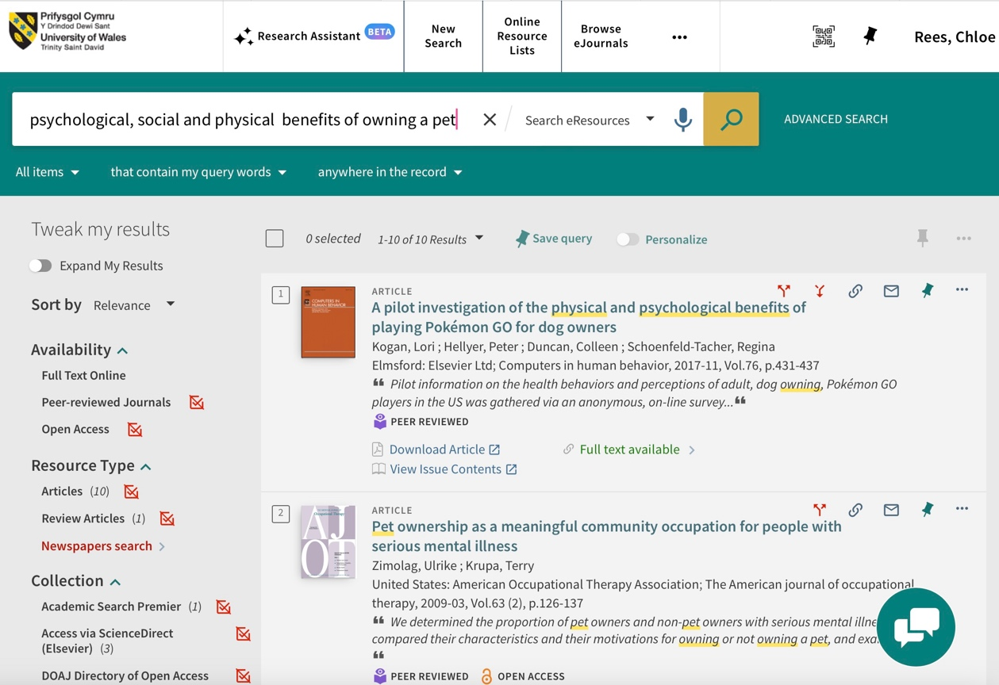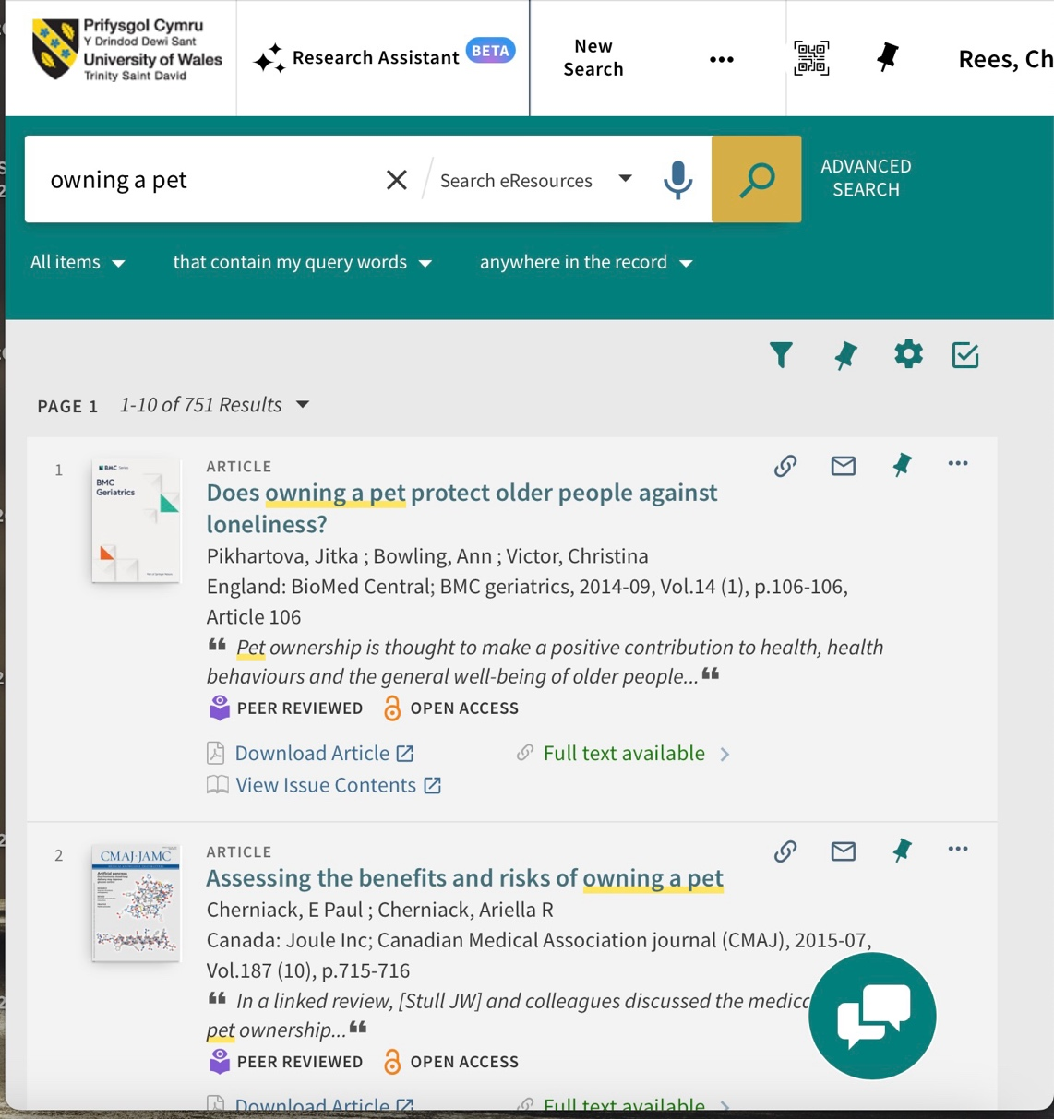

Summary of sources
The sources that I have used provided me with relevant facts and statistics that are relevant to my work.
I checked the publication dates to ensure all the information is up to date.
I also checked to see if articles had been peer-reviewed which usually increases reliability.
I tried to make sure I was using reputable organisations, academic institutions or well-known publishers.

References for all tasks
Fitzpatric, K. (2023, September 25). Raising Kids With Pets: How Do Pets Teach Responsibility? Portage Park Animal Hospital & Dental Clinic. https://www.portagepark.com/blog/kids-and-pets-how-do-pets-teach-responsibility

Sykes, J. (2024, April 11). Health benefits of pets: How your furry friend improves your mental and physical health. Cultivating-Health. https://health.ucdavis.edu/blog/cultivating-health/health-benefits-of-pets-how-your-furry-friend-improves-your-mental-and-physical-health/2024/04

Sutton, J. (2021, March 30). Pets & Mental Health: 15 Benefits of Emotional Support Animals. PositivePsychology.com. https://positivepsychology.com/pets-mental-health/

Skerrett, P. J. (2015, October 30). Pets can help their humans create friendships, find social support - Harvard Health Blog. Harvard Health Blog. https://www.health.harvard.edu/blog/pets-can-help-their-humans-create-friendships-find-social-support-201505067981

Zimolag, U., & Krupa, T. (2009). Pet ownership as a meaningful community occupation for people with serious mental illness. The American Journal of Occupational Therapy, 63(2), 126–137. https://doi.org/10.5014/ajot.63.2.126

Krause-Parello, C. A. (2012). Pet Ownership and Older Women: The Relationships Among Loneliness, Pet Attachment Support, Human Social Support, and Depressed Mood. Geriatric Nursing (New York), 33(3), 194–203. https://doi.org/10.1016/j.gerinurse.2011.12.005

I confirm that I have not used any AI tools in the research and creation of this assignment. I confirm that I have not presented any AI generated materials as my own work. I confirm I have copies of my drafts, notes, and other resources I used, which I may be asked to provide in evidence.

