Research Portfolio
Games For Positive Impact
Ethan Clee (2400846)
In the 21st century, the social issue of over consumption and mass consumerism has become more prevalent than ever. With the introduction of “Fast Fashion” and constant electronic upgrades, we are using, and wasting, more than ever before. This is a topic that many video games have touched on, and I believe they can be a tool to raise awareness for how serious of an issue overconsumption has become.
One of the most prevalent examples of raising awareness of overconsumption in video games, is Cyberpunk 20771. This title, released in 2020 by CD Projekt Red, is set in the fictional Night City. This city is a cesspool of corporate greed, consumerism, and mass advertising. The entire game could be seen as a commentary on the overconsumption problems facing our society. From the pervasive advertisement cluttering the walls of skyscrapers, to the interactable stores, vending machines, and websites asking the player to indulge in product after product, CD Project Red portrays a dystopia in which, advertisements have replaced the stars in the sky2. Within the world of Cyberpunk 2077, overconsumption has become not only a social issue, but also an environmental one. This is outlined by the vast landfills that lay outside the city. Mountains of discarded technology, rubble, and other mass commercial waste litter the expanses of the desert, due to the constant upgrading, rebuilding, and commercialism of Night City. This is a reality for many modern cities in our world, too. Landfills are reaching maximum capacity, with more waste than ever piling up outside urban areas due to these same problems. CD Projekt Red brings attention to this real-world issue through their design of Night City.

Fig.1 Screenshot of landfill outside of Night City in Cyberpunk 2077
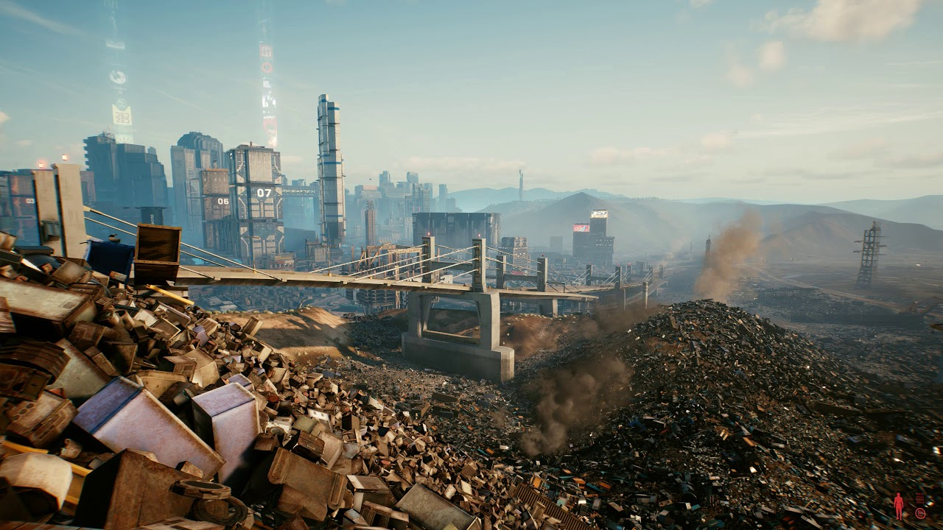

Not only does CD Projekt Red display this level of overconsumption having an impact on the environment, but also on the people of Night City. In certain passive encounters around the city, the player can find NPCs discussing the latest “fashion trends” or “cybernetic enhancements”. One of the more staggering of these encounters, comes at the top of Jig-Jig Street. Here, the player can find a group of female NPCs discussing a new article of clothing that one of them is wearing. Listening to this encounter further, the player discovers that the NPC that has purchased this, high end, luxurious piece of clothing, has not been able to cover her next rent payment; instead, spending the last of her savings on said article of clothing. The NPC claims that the clothes will help her secure a higher paying job. This certainly puts into perspective how serious this consumerism pandemic has become.
At face value, this could be taken solely as a fictitious encounter designed to heighten the dystopian feel of Night City. However, one can certainly see a distinct parallel to our world. With social media constantly showcasing celebrity lives, the super-rich, and commercialistic ideals, one could see how a person may be pushed to very dramatic actions in order to emulate the lives they have seen on these platforms. They are pushed to consumerism by these advertisements and accounts, in order to copy their online idols. With this cycle of consumerism, comes overconsumption, waste, and environmental deterioration. Cyberpunk 2077 acts as a tool to raise awareness for this problem and makes it relatable to the player. Using NPCs, and parallels to consumerism in our world, makes the player realise that this issue may not be as fictitious as it may seem.
Another aspect of overconsumption that Cyberpunk 2077 raises awareness for, is the general overuse of technology in society. One could argue that the entirety of the story of Cyberpunk 2077 is trying to show how technology is not compatible with humanity3. It depicts how there will come a juncture when we will have to choose between one or the other. There is a gang in Night City, known as “Maelstrom”, who have chosen technology, and artificial enhancement, over preserving their humanity and emotion. Furthermore, one of the main antagonists of the game, “Adam Smasher”, has also forsaken his humanity; instead, implementing cybernetic enhancements, and relying on technology to enhance his body. During the final boss fight with Adam Smasher, there is a voice line of “Your meat is failing you”, which shows just how superior Adam Smasher believes technology is to biology. Whilst the particular technology focused on in Cyberpunk 2077, “Cybernetics”, are not yet a reality, we can see that the point stretches far past just physical enhancement through technology. Cyberpunk 2077 paints a dark narrative of a world where technology has become more important to people than their lives. We are beginning to see this in our world as well. We are seeing growing rates of being “Chronically online”, social media and video game addiction, and mental health concerns from posting and consuming content online. It is not difficult for one to see how humanity is already pushing the boundaries for how much we are willing to welcome technology into our lives. Cyberpunk 2077 can be used to raise awareness for where we may be headed as a society. If we allow technology to continue to invade our everyday lives, how long will it take for us to start sacrificing our humanity in order to have the newest devices, trends, or looks?

Fig.2 Screenshot of “DumDum” character, a member of Maelstrom, from Cyberpunk 2077

The game also shows more traditional forms of the overconsumption of technology. The aforementioned landfills also are home to discarded “relics” of technology. People throwing away old parts, old devices for the newer models is also something that is all too true in our society. People need to get the latest iPhone, GPU, or other piece of technology, and simply discard their old devices as waste to end up in landfill. CD Projekt Red again attempt to raise this issue in their game, highlighting how our desire for what is advertised as “hot” or “new” is starting to overwrite our desire for environmental protection.
Cyberpunk 2077 continues raising awareness of the potential abuse of technology, with the introduction of “Holos”. In the world of Night City, Holos have replaced mobile phones, now a holographic interface, wired straight to the brain is displayed. This means that the messages, calls, emails, advertisements, all happen right in front of your eyes, and also that it can never be turned off. This is once again Cyberpunk 2077 attempting to warn us that our abuse and overuse of technology as of present will only get worse, continue to degrade, and eventually lead us to this dystopian future that seems so far off. One may also raise the point that Cyberpunk 2077 makes the issues feel so much more real, by setting the story only 50 years in the future4. This makes the player realise that this dystopia, this technology filled, overconsumption rampant future, may not be as far away as it may seem.
Another title which is rather well known for its commentary on consumerism and advertisement, is the Fallout series. In every entry of this series, the issues of consumerism, capitalism, and advertisement are so blatantly obvious that it borders on comedy. Despite this, Fallout still has a positive impact on our society by raising these issues, even if it is in a more comedic sense.
Unlike Cyberpunk 2077’s realistic, gritty approach, Fallout seems to take a more satirical stance on the issue, while still raising awareness. The way that overconsumption is portrayed in Fallout, with the retro themed advertisement, to the on the nose “Super Duper Mart”, and “Atomic Queen” ovens is a direct parallel to our world. We can see videos of people rushing to malls or shopping centres on black Friday to get the newest brands, technology, or other consumer goods. Fallout raises awareness for this, outlining how bizarre our consumerism may seem, in a world more detached from the cushion of modern society5.

Fig. 3 Screenshot of Super Duper Mart, Fallout 4
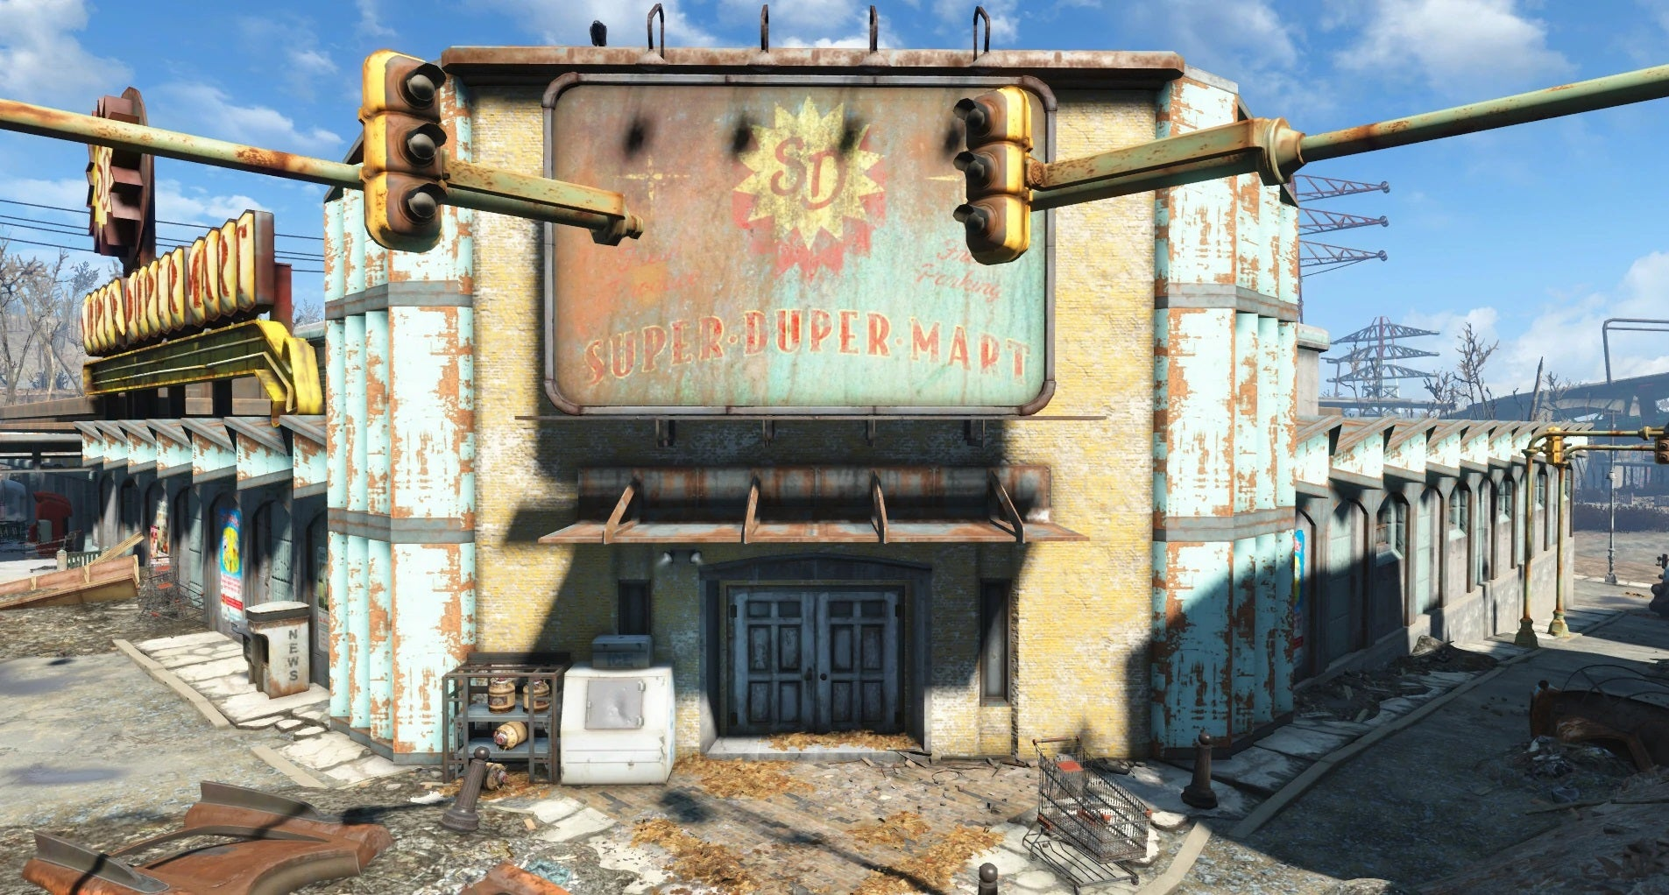
While fallout may not focus on the designer brands, technology abuse, and wastefulness of modern-day society. It is still a useful tool in noticing trends in society, and where our current overconsumption comes from6. Fallout seems to focus less on the sole impact of consumerism, and more the abuse and exploitation of customers and buyers. Fallout is a message of how easily we can be tricked into wanting something, feeling like we need the latest thing, through pure advertisement alone. It also raises awareness for the exploitation of these consumers by the companies. This is seen in our world, though to a lesser extent. We can see day after day new cases of companies taking advantage of their loyal customers, because they believe the cycle of consumerism will keep them wanting more from them. Fallout raises awareness for this issue, highlighting how easy it may be for consumers to fall prey to malicious companies.
Fallout also shows how consumer culture and product obsession seems to take priority over human survival, with the “pre-war” world focusing on how brands were taking over the world. Nuka-Cola and Vault Tech are two major examples of this. Even in the wasteland of the main story of fallout, we can see how the remnants of previous consumerism bleed through. “Rare variants” of Nuka Cola bottles serve as luxury, coveted items in the post war wasteland, collectables and branded items valued at more than survival and food. Furthermore, in the main story and mechanics of the game, the remnants of previous over consumption and consumerism literally function as the currency of the franchise. With Nuka Cola caps being the money of the new, post war society7. This has become synonymous with the franchise. Whilst its take on consumerism here may seem far detached from our society, we can see true parallels. Many people may find their luxury items, or branded accessories as their most valuable possessions. We are living in a world where brand identity and consumerism plague humanity. Fallout is a testimony to the runaway consumer culture of our world, showing that even in a post-apocalyptic nuclear wasteland of a world, consumerism still thrives. Nuka Cola machines and memorabilia are still being collected by scavengers in the new society, truly showing how the vicious cycle of consumerism can continue, even after the brands have “died”.

Fig.4 Screenshot of Nuka Cola advertisement, Fallout 4
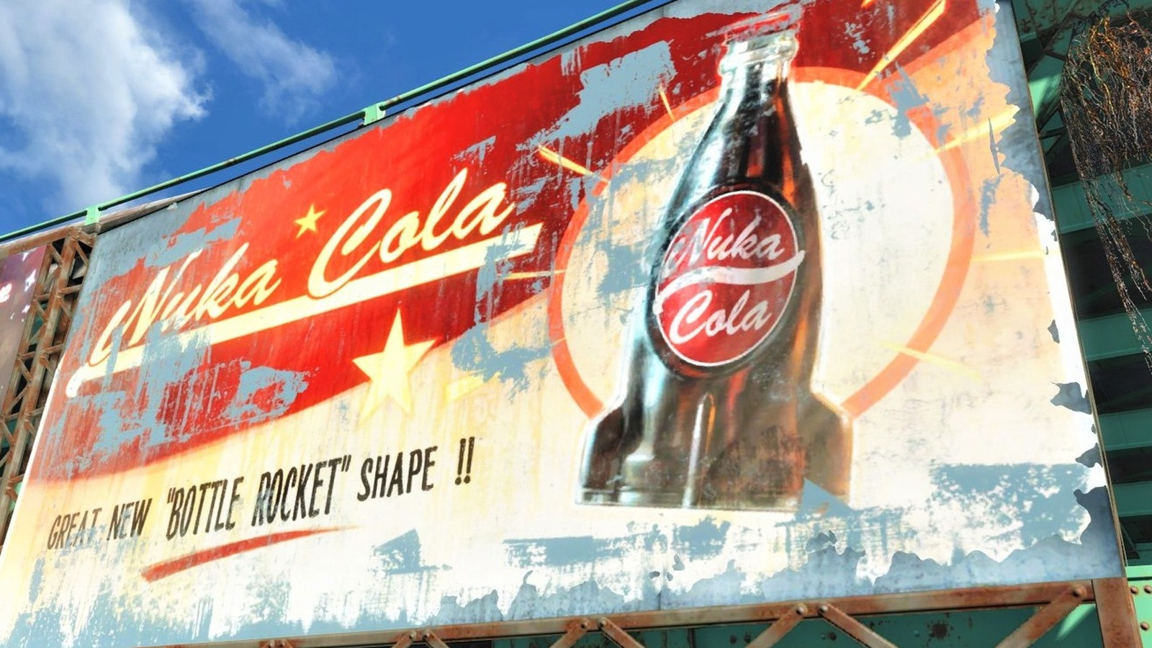
The wars that devastated the world of Fallout were labelled the “Resource wars”. Natural resources had become so sparse, due to the overconsumption, runaway consumer culture, and corporate greed, that it led to mass war and destruction. This culminates in an overarching message, that our demand for comfort, consumption, and brand loyalty will eventually lead to scarcity, lacking natural resources, and in extreme circumstances the collapse of society. Fallout raises awareness for real world issues in doing this. In our world, due to the rise of consumerism, resources are starting to run out. We are starting to see inflating prices of technology, due to this same issue8.
Whilst fallout does remain satirical, taking consumerism and its downfalls to a complete extreme, that does not demerit its positive impact. It is hard for many to picture a life without brands, consumerism, luxury items, and this is where we begin to see the parallels once again. The Fallout series has a serious positive impact on our society, raising the social issues of consumerism facing us at the moment, and potentially showing how we need to end the cycle of giving in to corporate greed. The series shows us how if we do not do something to kill this destructive cycle of overconsumption in our modern-day society, it can eventually lead to serious problems of resource scarcity, tension in communities, and a detachment to what should really matter to our lives. Brand identity and loyalty have become commonplace in our society, and we are beginning to see the side effects of this consumerist culture that we inhabit. Fallout provides an example of where this current cycle may take us in the near future, if the cycle of consumerism and over consumption doesn't stop.
In conclusion, both Cyberpunk 2077 and the Fallout series have a genuine positive impact on our society by highlighting the issues we will face if our cycles of consumerism and over consumption do not stop. They raise the questions of, when does it stop being acceptable to devote your life to technology? When will brands and luxury replace the things that matter in life? These games not only serve the purpose of being a genuine portrayal of how consumerist culture is destructive to both the environment and our society but also provides examples of where our society may be headed if these cycles do not change. Resource scarcity, mass advertisement, extreme urbanisation, city sized landfills, all sound dystopian and the works of fiction, but these games show how that could become a reality for our society.

Bibliography:
- CD Project Red, Cyberpunk 2077, 10th December 2020
- John Parker, “The Societal Commentary in Cyberpunk 2077”, Global Play Now, 25th October 2025.
- Luis, “How Social Commentary Breathe Life into Night City”, The Path Witcher, 12th September 2024.
- Paul Walker-Emig, “Neon and corporate dystopias: Why does cyberpunk refuse to move on?”, The Guardian, 16th October 2018.
- Ignorantsavant, “Fallout: an obvious warning to the future and its relevancy in today’s conflicts”, Medium, 15th January 2026.
- Eugene Panikidis, “Exploring Societal Reflections and Lessons in the Fallout Video Game Series”, 17th April 2024.
- Kaylee Nichole Lopez-Nunez, “Caps as Currency in the Fallout Franchise: an Anthropological Analysis”, Medium, 25th May 2025.
- Thomas Bishop, “What if Cold War Consumerism Never Ended?”, Zocalo Public Square, 13th May 2024.
- Fandom, “Fallout Wiki”, Fandom.com.
- Fandom, “Cyberpunk 2077 Wiki”, Fandom.com.
- Black Isle Studio, “Fallout”, 10th October 1997.
Image List:
Fig 1. Screenshot from Cyberpunk 2077
Fig 2. Screenshot from Cyberpunk 2077
Fig 3. Screenshot from Fallout 4
Fig 4. Screenshot from Fallout 4

