University of Wales Trinity St David

LCBB5005

Assessment 1

Student name: Luminita Capmoale
Student ID: 2030541

Lecture name: Dr Molly Jack

December 2022

Executive Summary
This study is trying to discuss the project performance of the UK’s cross rail for developing an understanding of its impacts on maintaining sustainability in the business progress. This study is defining the goals of their respective projects such as providing the proper transport facilities to their respective common people in the Elizabeth line. This paper identifies the expected outcome of their results such as reducing the unemployment rate in the UK and increasing the rate of trained employees which can enhance their overall business progress. In order to develop the process, they can use the highest-tech drone camera and thermal imaging monitoring systems to identify the strategy of their respective projects. At the end of this study provides some recommendations for mitigating the different challenges to maintaining the quality of their respective projects.

Table of Content

Introduction 4
Introduction of the project 4
Project goal 4
Project scope 5
Project objectives 5
Project parameters 6
Expected quality 6
Cost 6
Time 7
Expected benefits from the project 7
Delivery of the project assumes 8
Critical success factors 9
Project constraints 10
Conclusion and recommendation 11
References 13

Introduction

Introduction of the project
The project is based on the Elizabeth line that provides rail services from Reading and Heathrow to Paddington. The Elizabeth line opened on 24 May 2022 and approximately 23 million passengers utilised the Elizabeth from opening day to September 2022. The Elizabeth line also travels through the heart of London to Abbey Wood. Further, the introduction of the Elizabeth line has ensured smooth travel across London to Southeast for passengers. The line was developed by the Government of UK to make it easy for passengers to travel across stations of London. Thus, the Elizabeth line is once in a generation addition to London’s transport.
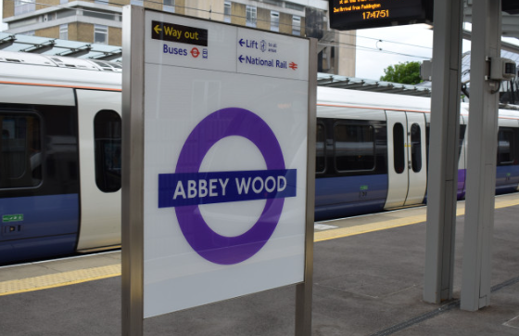
Figure 1: Abbey wood station of Queen Elizabeth Line
(Source: Crossrail.co.uk, 2022)

Project goal
The main goal of the Cross-rail project is to aid the people of London to reach different destinations on time without any delay. The cross-rail hybrid bill was submitted in 2005 to parliament and was achieved in 2008. The main purpose of the cross-rail project was to increase Central London’s rail capacity by 10% and to transfer an additional 1.5 million people to central London inside 45 minutes (Chodorowski et al. 2021). The government of UK was destined to develop the cross-rail project with the help of world-renowned architects that have previously built iconic buildings and structures. Moreover, the government was looking to develop the project by ensuring the optimal demolition of buildings.

Project scope
The cross-rail project was developed by the government of UK to help the people of London to travel places much faster. However, there is still some scope of the project that needs to be looked after by the government. One of the scopes is implementing more trains and stations to help passenger reach destinations much faster. However, the government has already planned to increase the number of trains to 24 by the end of May 2023. The other thing that the government of UK must look to implement in this project is to provide direct trains from Reading and Shenfield to Central London. It is necessary for the government of UK to open Elizabeth Line in phases to ensure that it is safe and reliable (Worsfold et al. 2018). Further, there is a requirement to upgrade stations in East and West of London. There is a requirement to improve the customer information screen as well as the ticket machines.

Project objectives
The Elizabeth line is developed by the Government of UK to provide a new journey option for passengers and help them to avoid a personal car. The line is regarded to be one of the important projects that can improve the transport link of London. Cutting journey times is one of the important factors that led the government to develop the Elizabeth Line (Sillerico et al. 2019). The walk-through trains for the Elizabeth line have additional capacity and have several new stations. The Elizabeth line is expected to help the entire of London to support regeneration. There are 12 trains per hour that are running from Paddington to Whitechapel. However, the government is looking to increase the number of trains from 12 to 22 at the end of November 2022 during the busiest time.
The main goal of developing the Cross-rail project is to help people to attend their office within time and without any traffic issues. This is one of the main reasons why the government increased the number of trains from 12 to 22. Another important reason to develop Elizabeth's services is to provide a transition between a central section of Paddington to Stratford (Kumar, 2022). The Elizabeth line is also going to begin Sunday services from the central section of the railway. As a result, the cross-rail project of the Government of UK is going to provide services every day of the week.

Project parameters

Expected quality
The Cross-rail project (Elizabeth Line) is developed with renowned architects of the world to ensure the project is developed with quality. The government of UK incorporated one of the most extensive archaeological investigations before the project began. As a result, more than 100 archaeologists found thousands of items. The development of the Elizabeth Line was done with tried and trusted methods to ensure the safety of passengers. Thus, the project was developed with the help of sprayed concrete. The quality of the project was focused more on the design phase to ensure the project is developed without hampering the economic and environmental benefits. The Elizabeth line was developed by minimizing environmental impact and almost 99% of the material was reused (Muruganandan et al. 2022).

Cost
The funding allocated to the Cross-rail project by the Government of UK was £15,789 million however the actual costs to complete the entire project rose drastically. The final bill after completing the project was £15,939, which is £150 more than the estimated costs of the project. The costs of the entire project rosed drastically due to several reasons and one of the major reasons is recruiting the most expensive contractors for this project. Further, the conflict between the CEO of the cross-rail project and the department of transport (DFT) is one of the reasons behind the increase in project costs. The conflicts triggered the commissioner of DFT to not transfer any funds to the Elizabeth Line (Anderson, 2022).
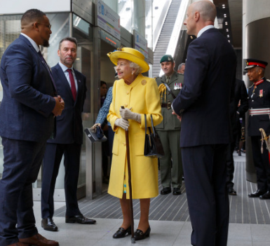
Figure 2: Opening day of Elizabeth Line in May 2022
(Source: Crossrail.co.uk, 2022)

Time
The construction of the project started in 2009 and the official opening was done in 2022 after 13 years of construction (Lazarus, 2018). During 2009, the construction was started, and the design phase was implemented however, the main construction of the project started in 2011. In 2016, the cross-rail project was named the Elizabeth Line. In 2021, the railway trails took place without taking any passengers to check the running time of trains as the final phase of testing. In May 2022, Queen Elizabeth herself visited the Paddington station to officially open the Elizabeth Line. Thus, the whole cross-rail project was completed after taking long 13 years of time.

Expected benefits from the project
The Cross-rail project is one of the biggest project which can develop the UK’s economy and develop society's life by developing sustainability in terms of reducing the rate of unemployment rates by creating job opportunities for different people which can improve their overall business progress. The construction of their cross-rail projects in the Elizabeth line has supported 10 thousand job opportunities for people of different backgrounds to complete their respective projects. On the other hand, it can also provide training sessions for its new employees which can manage them to develop skills for their countries which is a great contribution to upgrading the sustainability in the social structures. Through this project, they can create 1,000 apprenticeships with the help of Network Rail, Alstom, and other attributes which can be managed to develop their society's structures (Crossrail.co.uk, 2022).
These projects can also provide the chance to their respective youth or young generation people to enhance their overall business performance through developing their skills and knowledge level about Cross rail steel structures and underground projects. Through these projects, their students can enhance their skills and develop concepts with the help of their respective tunneling and underground construction academy (Kumar, 2022). This academy provides the chance to 20000 students to gain knowledge and develop their skills with different new or modern technology. Apart from the unemployed rates, it can also create opportunities for their different SMEs to manage certain factors developing the overall business performance through generating contracts for their SMEs. In this way, they can develop their business growth models and improve the national economy which can support them to develop their overall business structures. Moreover, it can also develop certain attributes such as developing 65000 new homes and increasing the capacity of traveling by 10% across the UK which can help them to manage their overall project performances (Crossrail.co.uk, 2022).

Delivery of the project assumes
Through the projects, it can be estimated that 10000 employees can get full-time job opportunities from these projects within 10 or more than 41 sites across the UK which can help them to focus on their economy. Apart from the economy, their government or their researchers can also estimate that they can increase the standard of innovation in their respective industries. This project also broke molding structures for developing a strategic decision for this mega project by identifying the appropriate strategies which can support them to enhance their overall business progress (Kumar, 2022). This construction project is the largest infrastructure project in all of Europe. Due to this reason, 1000 ideas were submitted, and a 60 trials funding process was developed to create these projects and develop their infrastructures. They are also making assumptions about providing different contracts to their SMEs and 62% of contracts are getting from their tier 1 SMEs and developed suitable relationships to complete these respective projects.
Through these projects, they are trying to use modern technology for identifying the issues in their respective business progress which can support them to manage their overall business performance. In this case, they can use the thermal imaging monitoring process for identifying the strength of their concrete by using the thermal heat camera technology which can support them to manage their overall project performances.
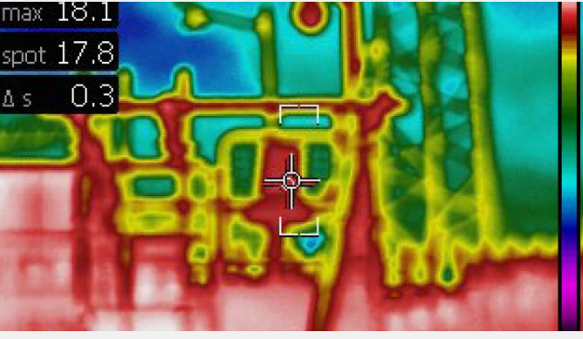
Figure 1: Thermal image from developing monitoring process
(Source: Crossrail.co.uk, 2022)
Through this process, they can identify the different risk factors and improve their overall business progress, reduce the risks, and develop the risk management process. In order to develop a sustainable solution, they also used TAMs (Tubes a Manchette) for creating the energy through the heat exchange process into the grout shafts for reading the carbon emissions in the UK (Tyner, 2022). On the other hand, they can also use the drone camera to inspect their overall project sites daily to maintain a high-quality project in the UK.

Critical success factors
The critical factors of this project are identifying the appropriate goals, defining the resources, and defining the recent technology to reduce the errors in the business process which can improve the overall business progress. In this case, the critical success factor is that the resources are used for completing their respective projects within deadlines which can help them to enhance their respective projects and maintain their overall business performances. This respective CSF is the resources such as funding with 60 trials and 15 organization collaborations for completing these respective projects which can enhance their project's performances in their respective business progress.
According to Ma et al. (2018), this best utilization of resources can develop certain attributes such as preparing the trained employees across the UK that help them to innovate their workplace atmospheres and enhance the quality of the projects. Apart from that, they have also used the thermal imaging camera and the most innovative BIM model of their respective construction which can support them to enhance their overall business performance. In order to handle these projects, they are providing the way for maintaining the project with effective modern technology such as AI, machine learning, and other technology which can help them to manage their respective business progress. Through this process, they can improve their data analysis process through automation techniques and enhance their project's performance in cross-rails projects.

Project constraints
In order to develop these projects 15+ organizations are collaborating with each other to complete these projects within deadlines and in effective ways. However, these projects can create certain problems or issues in their societies such as increasing the noise and other activities which can help them to manage their overall business performance. During the structural analysis, they are also facing certain issues in their ground settling segment because of creating some vibration for creating the hole into the ground (Lobo and Abid, 2020). It can cause some movement into the ground that can affect the above building and increase the risk of any accidents.
On the other hand, it can also develop some challenges in terms of the safety of the people, because these projects take many years to be fully completed during these operational times. They can develop certain criteria such as maintaining the safety concerns of the people which can generate the maximum benefits in the business progress. These aspects can be increasing the cost of their projects which can affect their operating expenses and develop the overall business projects' performances. This project can also increase the difficulties for the common people in handling the population for this project (Anderson, 2022). Moreover, their common people can also handle the light and noises for the operation of this project for Elizabeth line residents or other people.

Conclusion and recommendation
Recommendations
This project has many advantages in terms of their government point and the UK people's point of view. On the other hand, they are handling different concerns such as handling the noise and light that helps their people to maintain their daily lives because these projects can take many years, or it is one of the long-term projects. In order to handle the noise pollution, they are identifying the Cross-rail Information Paper D9 which can guide them to invent noise insulation systems and manage their overall business progress in the UK. In order to handle this aspect, their engineers can increase the mass and thickness of their respective walls which helps them to insulate their respective noises. Moreover, they can also use the air spaces to create a vacuum chamber and restrict the noises that help them to manage their business progress and manikin the government norms in terms of maintaining noise cancellations.
Furthermore, they are also developing health and safety concerns by enhancing their transportation systems by providing the training of their 1000 lorry drivers to maintain cycling awareness and reduce the risk of any type of accidents at their respective sites which can support them to maintain the development rates of their respective projects. Moreover, they are also provided all the safety equipment and other attributes to their lorry drivers which can help them to enhance their overall business performance. Apart from this, they are also trying to spread awareness by enriching their safety module with 18 different languages. Moreover, they can also develop common language safety guides and describe the risks through the identification of every region such as the red zone being a highly hazardous area and other attributes.

Conclusion
This study concludes the cross-rail projects' performances in the Elizabeth line which can enhance their business process. This study defines their goals by providing the best in terms of transport to their common people with their government and 15 other organization collaborations. This project has also discussed the cost of their respective projects such as £15,789 million and the duration of the projects is up to 2022 from 2009 which helps. This study also identifies the different expected outcomes in the future such as developing the skills of their respective employees through different programs. This study also identifies the different technologies for generating the maximum impact on their business such as drone cameras and thermal imaging cameras and other attributes.

References
Anderson, M. (2022) ‘Elizabeth Line Earthing Electrode Testing Lessons Learned’, In Cross rail Project: Infrastructure Design and Construction, (pp. 157-164), ICE Publishing. https://doi.org/10.1680/cpidc.66502.157 (Accessed: 20th November 2022).
Chodorowski, A., Ingram, P. and Black, M. (2021) ‘Crossrail project: the impact of 4–18 Bishop's Bridge Road on the new Elizabeth line’, Proceedings of the Institution of Civil Engineers-Geotechnical Engineering, 174(1), pp.83-90. DOI: https://doi.org/10.1680/jgeen.19.00212 (Accessed: 20th November 2022).

Crossrail (2022) DELIVERING THE ELIZABETH LINE. Available at: https://www.google.com/url?q=https://www.crossrail.co.uk/project/our-plan-to-complete-the-elizabeth-line/&sa=D&source=docs&ust=1667561216281366&usg=AOvVaw3W2PX4Dp4gVgdKWLpWaMJl (Accessed: 20th November 2022).

Crossrail (2022) SOCIAL SUSTAINABILITY. Available at https://www.crossrail.co.uk/benefits/social-sustainability (Accessed: 26th November 2022).

Crossrail (2022) DELIVERING ECONOMIC BENEFITS IN LONDON, THE SOUTHEAST AND ACROSS THE UK. Available at:https://www.crossrail.co.uk/benefits/economic-sustainability/wider-economic-benefits (Accessed: 26th November 2022).

Crossrail (2022) DELIVERING RAISING THE BAR FOR INNOVATION IN THE CONSTRUCTION INDUSTRY. Available at: https://www.crossrail.co.uk/benefits/innovation/ (Accessed: 26th November 2022).
Kumar, B.R. (2022) ‘Case 8: London Cross Rail Project’, In Project Finance (pp. 131-137). Springer, Cham. DOI: https://doi.org/10.1007/978-3-030-96725-3_12 (Accessed: 20th November 2022).
Lazarus, D. (2018) ‘Structural engineering for the Elizabeth line: Damage assessment and monitoring for buildings on the Elizabeth line’, The Structural Engineer: journal of the Institution of Structural Engineer, 96(7), pp.14-24.

Lobo, S. and Abid, A.F. (2020) ‘The role of social media in intra stakeholders’ strategies to influence decision making in a UK infrastructure megaproject: Cross rail 2’, Project Management Journal, 51(1), pp.96-119. DOI: https://doi.org/10.1177/8756972819864456 (Accessed: 26th November 2022).

Ma, S., Jiang, M. et al. (2018) ‘Temperature effect and thermal impact in lithium-ion batteries: A review’, Progress in Natural Science: Materials International, 28(6), pp.653-666. DOI: https://doi.org/10.1016/j.pnsc.2018.11.002 (Accessed: 26th November 2022).
Muruganandan, K. et al. (2022) ‘The dynamics of systems integration: Balancing stability and change on London's Crossrail project’, International Journal of Project Management, 40(6), pp.608-623.DOI: https://doi.org/10.1016/j.ijproman.2022.03.007 (Accessed: 20th November 2022).
Project Management Institute (2013). A guide to the project management body of knowledge (PMBOK guide) : an American National Standard ANSI/PMI 99-001-2013. 5th ed. ed. Newton Square, Pennsylvania Project Management Institute.
Sillerico, E.J. et al. (2019) ‘Design methodology of permanent linings of junctions at Crossrail project contract C121 (the Elizabeth line)’, In Tunnels and Underground Cities: Engineering and Innovation meet Archaeology, Architecture and Art, pp. 6200-6208.

Tyner, D. (2022) ‘Crossrail Systems Integration–Lessons Learned and Good Practice in Managing Interdisciplinary Systems Integration through each Stage of the Crossrail Programme’, In Crossrail Project: Infrastructure Design and Construction (pp. 137-144). ICE Publishing. DOI: https://doi.org/10.1680/cpidc.66502.137 (Accessed: 20th November 2022).
Worsfold, T., Bryant, M. and Crank, J. (2018) ‘Structural engineering for the Elizabeth line: Design of Canary Wharf Elizabeth line station and Crossrail Place oversite development’, The Structural Engineer: journal of the Institution of Structural Engineer, 96(7), pp.78-83.

