Name: Matthew Morris
Student Number: 1908777

Human Evolution and the Origins of Modern Human Behaviour

Practical exercise 2021

Please indicate your response clearly

Looking at faces 1
Look at the following images and then compare them to the list below. Indicate clearly (circle or highlight) the name of the early hominin skull you believe this to be.
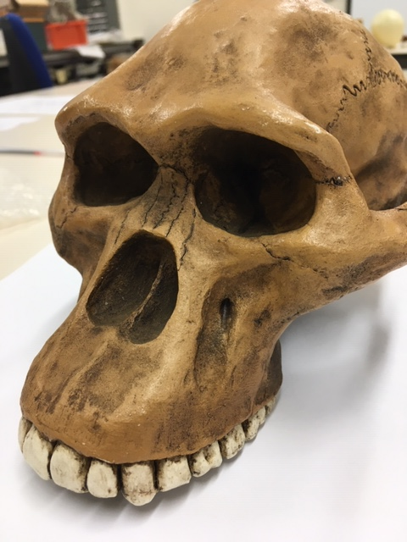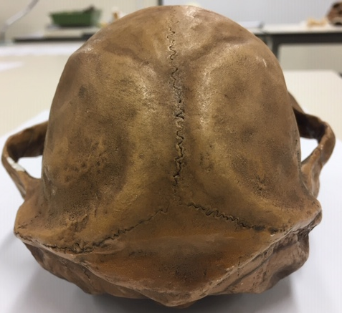

Chimpanzee

Australopithecus afarensis

Australopithecusafricanus

Australopithecus robustus

Homo habilis
A= Australopithecus africanus

Looking at faces 2
Look at the following images and then compare them to the list below. Indicate clearly (circle or highlight) the name of the early hominin skull you believe this to be.
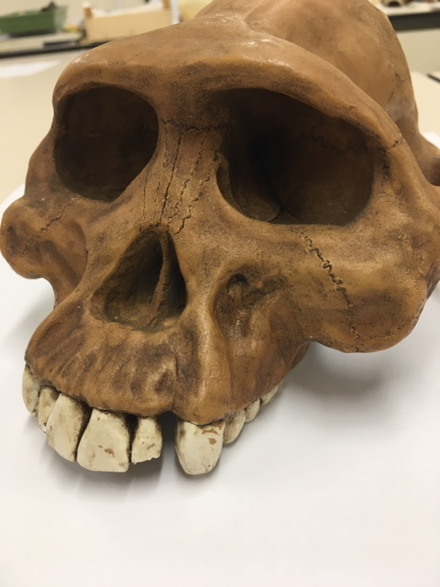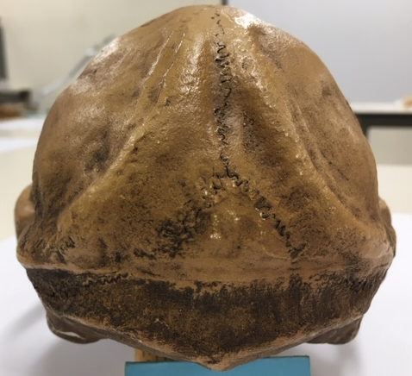

Chimpanzee

Australopithecus afarensis

Australopithecusafricanus

Australopithecus robustus

Homo habilis
A= Australopithecus afarensis

Looking at faces 3
Look at the following images and then compare them to the list below. Indicate clearly (circle or highlight) the name of the early hominin skull you believe this to be.
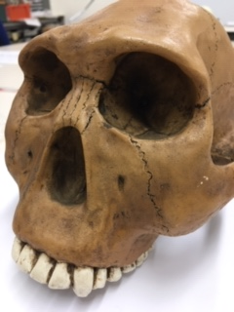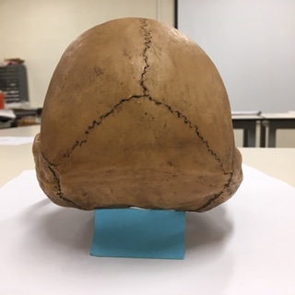

Chimpanzee

Australopithecus afarensis

Australopithecusafricanus

Australopithecus robustus

Homo habilis
A= Homo habilis

Maxilla (upper jaw): Identify the species these belong to
A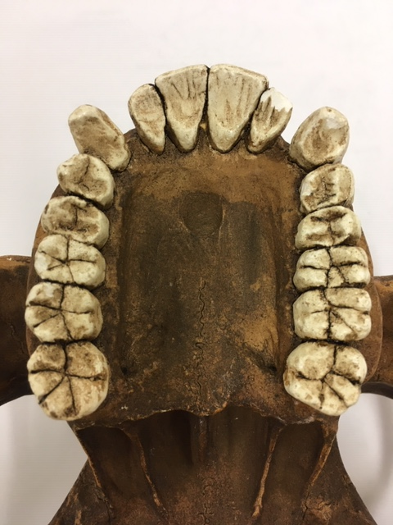B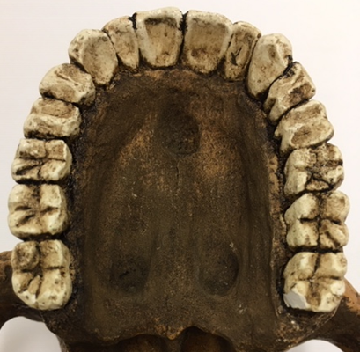
A Australopithecus afarensis B Homo sapiens
Top row left Chimpanzee, Middle Australopithecus afarensis, Right modern human
Lower row Left Australopithecus africanus, Right Australopithecus robustus
Indentify the skull to genus and species level
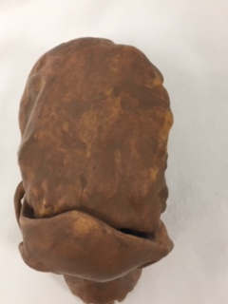
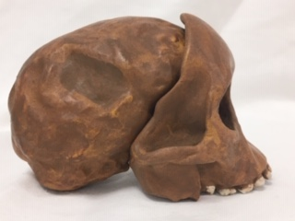
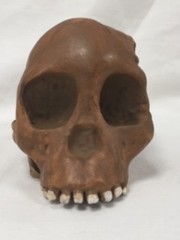
Answer Australopithecus africanus
Indentify the skull to genus and species level
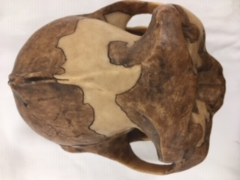
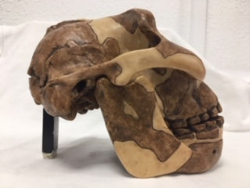
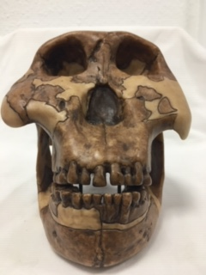
Answer Paranthropus boisei
Identify the hominin skull to genus and species level
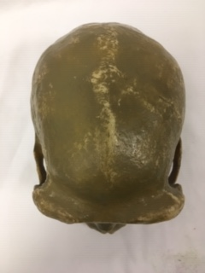

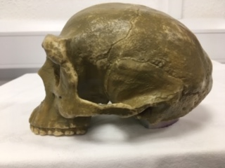

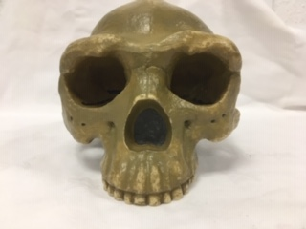
Answer Homo erectus pekinensis (or Sinanthropus pekinensis)
Indentify the skull to genus and species level
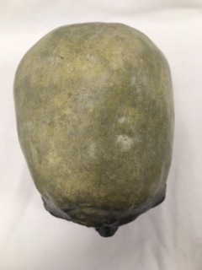
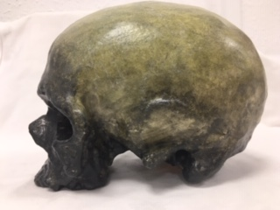
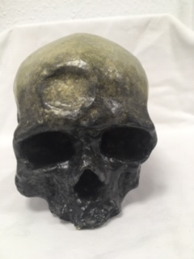
Answer Cron magnon (Homo sapien)
Identify, compare and contrast these two mandibles. Use the illustration below to help if you need to.
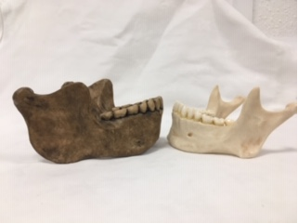
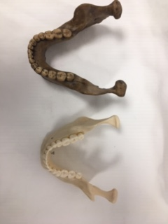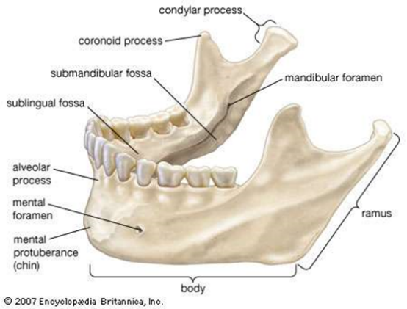

Answer:
The Jaw on the left is that from Homo hiedelbergensis, notably a larger and thicker manible, while the smaller (more gracile) jaw on the right is that of a modern Homo sapien.
The jaw strucutre of the hiedelbergensis, possess more prognathic features than that of a contemporary H. sapien. The H. hiedelbergensis’s more prognathic facial structure, is observed through the lack of a ‘pointed’ mental proturbance, in which the chin appears to slopped inwards. In H. sapiens the chin is convexed outwards leading to a flatter cranial and mandible appereance. The width of ramus and the larger more-rounded coronoid process is a prominent feature H. hiedelberhensis, suggesting a greater muscular capacity for grinding and chewing tough foods. Simiarily however, the H. Sapien and the H. Hiedelbergensis both possess the typical parabolic dental arcade that many hominids do. Despite this, the H. Hiedelbergensis has suprisngly small teeth for such a long and large mandible. Furthermore, it possess no space between canines and first pre-molars unlike H. sapien, it’s jaw length also creates exessive space for wisdom teeth. H. sapiens also possess a reccessed alvelor process which further excentuates the pointed chin, while H. Hiedelbergensis possess a prognathic variant, displaying a more robust mandibular anatomy. The condylar process is also enhanced on the H. hiderbergensis, suggesting a powerful and resilent jaw, compartively to the smaller and more angular anatomy of the H. sapien.

Stone tools and tool technology: How to tell a stone is worked.
What suggests this has been worked?
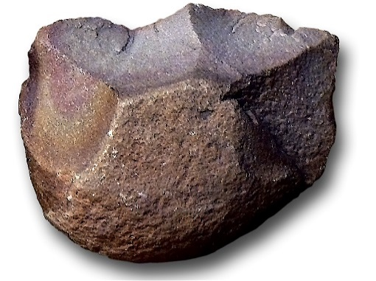
Answer:
This stone tool is suggestive of worked modification through a number of observations. Notably, the ‘edges’ formed along the top which would of involved the work of a hammerstone to create flakes (on the Dorsal Surface) which can be observed through the flake scars and the flake scar ridge formed along the striking platform. It possess asymetrical lithic reduction, with it primaily being focused to create a unifacial edge, acting as what Leaky (1979) would describe as a chopper and or scraper for organic material. Furthermore, it seems to possess a bulb of precussion central to the flaking with additional small fractures and fissures forming along the striking platform, yet not on the ventral surface. Suggesting a prominance for the use of the flaked edge in cutting and chopping, with and the rounded ventral surface as a possible handgip. Additionally, the shape of the flake scar ridge is not random, as the flake scars appear to follow a simialar direction, suggesting something (or someone) was using stone in unison with other material to produce a flakes leading to a flaked tool.

Features of stone tool flaking: identify features 1-5
1. Striking Platform
2. Point of Precussion
3. Bulb of Preccussion
4. Fissures
5. Ripples

Stone tools and tool technology: Stone tools not to scale
Below left: Oldowan Below Right: Acheulean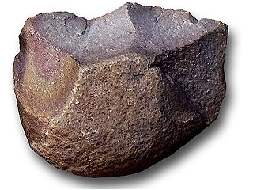 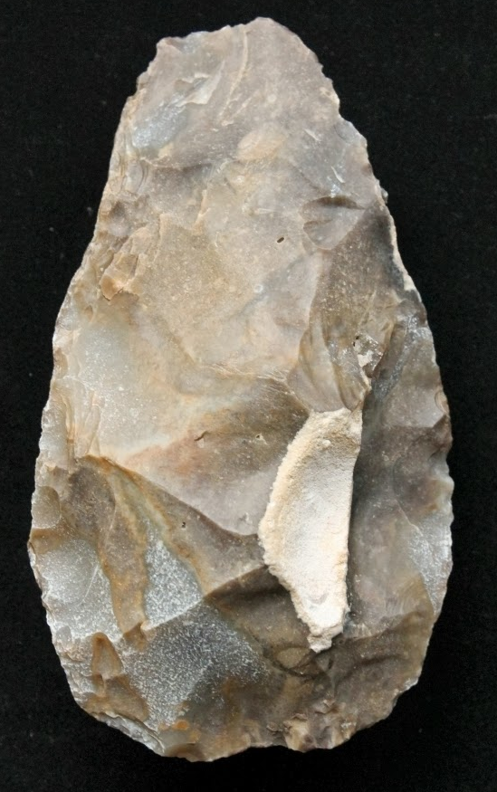
Images taken from https://images.search.yahoo.com

Task: Compare and contrast these two stone tools
Oldowan and Acheulean tools both possess distinct and unique lithic characteristics, from these features the construction process of these stone tools can be inferred. This process involves the selection of a stone core which is then flaked by repetitive percussion impact to form and shape a lithic assemblage. Oldowan and Acheulean construction techniques use flaking to produce ‘edges’ and ‘blades’, which could then be articulated for cutting, chopping, and scrapping organic material.
The Oldowan tool was created by flaking the dorsal surface of the stone core to create a unifacial edge, acting as a chopper or scraper. Relative to the Acheulean tool, the Oldowan tool appears less artisanal in its design considerations with the primary focus being on forming the dorsal surfaces cutting edge and quickly producible tool. Additionally, the design of the Oldowan tool appears to be more robust than that of the Acheulean tool, featuring a large heavy-duty edge or chopper (Leaky, 1979), opposed to the more precise striking platform refinement noted in Acheulean tool development. This robust appearance is also displayed in the larger size and singular striking direction of the flake scars, which also appear to be larger flakes with less retouching. Implying the known use of a hammerstone to quickly and efficiently creates a rudimentary edged tool.
The Acheulean tool was created by repetitive and multi-directional flaking and percussion impact, observed through multiple negative scars and arrises across the dorsal and ventral surface of the tool creating a ‘tear drop’ shape. This tear drop bladed shape could suggest a use for prehensile articulation, akin to the Oldowon tools rounded base to fit in the palm of the hand. Furthermore, the materiality of the Acheulean assemblage displays a ‘pointed’ bifacial edge, and symmetrical design to the tool, suggesting a regularity (in manufacturing process) and heightened level of physical and mental cognition to produce such an aesthetic and ergonomic design. When compared to the Oldowan tool, it appears to have a sharper and more advanced cutting edge, which may have offered less resistance when disarticulating organic matter. The high quality and standard of the tool could be suggestive of the Acheulean tool’s practical significance in addition to its ability as a social and material artefact, in which it embodies design but also possible cultural identities.

