Athénée Palace Hilton Bucharest
雅典皇宫酒店布加勒斯特

Breakfast
早餐

Scrambled farm-eggs 12.00 euro
炒鸡蛋 12.00欧元

Oriental scrambled eggs with tomatoes and feta cheese 20.00 euro
东方西红柿炒鸡蛋和芝士奶酪20.00欧元

Fresh orange juice or apple juice 5.00 euro
新鲜的橙汁或苹果汁5.00欧元

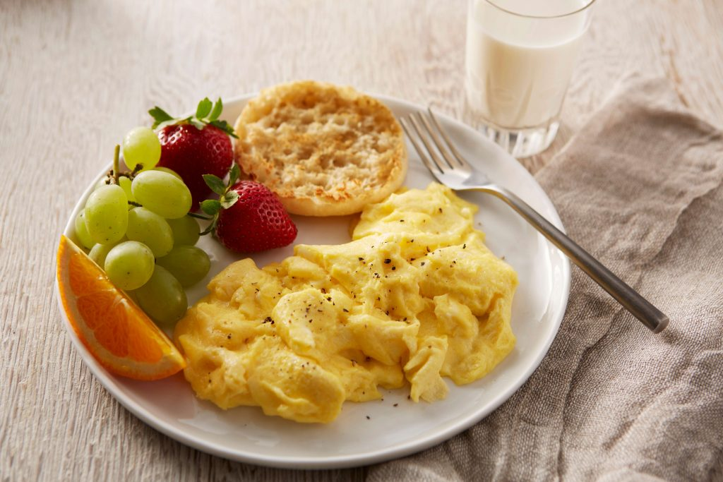
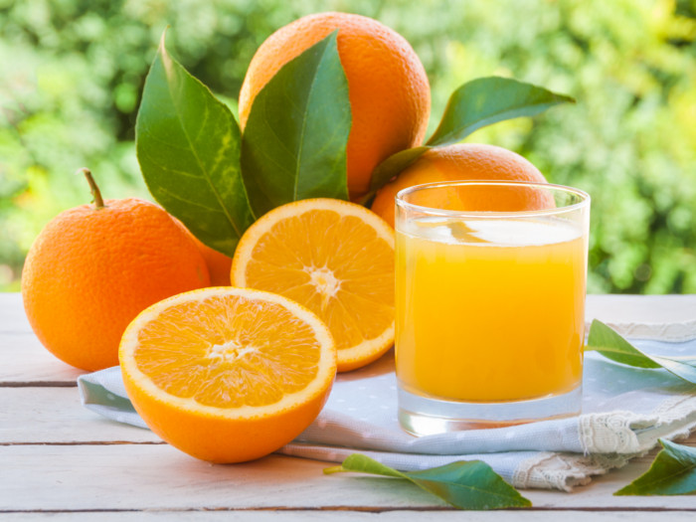

Name: Sorin Relu Brozban

Student ID: 1816277

