
Programme | MSc Public Health and Social Care in Practice
Module code | LCHS7006
Module | Quality Assurance and Service Improvements
Assignment Title | Component 2 Service Improvement Report
Lecturer | Dr Christopher Mafuva
Student Name | Amiben patel
Student ID | 2526924
Word Count | 3144

Table of Contents
1. Introduction 3
1.1 Background and Organisational Context 3
1.2 Identified maternity quality and patient-safety problem 3
1.3 Rationale for service improvement and Report Aim 4
2. Main Body 4
2.1 Nature and complexity of the service-quality failure 4
2.2 Root-cause analysis: Application of Fishbone Diagram, 5 Whys and Donabedian Model 5
2.3 Strategic Planning analysis using SWOT 9
2.4 Policy, Governance and Regulatory Implications 10
3. Recommendation 10
3.1 Improving Risk Recognition, Escalation and Communication 10
3.2 Reducing inconsistencies and strengthening governance 11
3.3 Monitoring and Sustaining Improvement through KPIs 12
4. Conclusion 13
References 14

1. Introduction

1.1 Background and Organisational Context
Maternity services are a highly critical part of any healthcare organisation, such as the UK NHS, to ensure essential medical, nutritional, and emotional support is available for women throughout pregnancy and the postnatal period (Wojcieszek et al., 2023). However, failures in care delivery can lead to serious lifelong consequences for the mothers and their children. In the UK, the Shrewsbury and Telford Hospital NHS Trust (SaTH) is a well-established NHS trust, known for its offering of maternity services within the UK (SaTH, 2026). However, since 1979, the organisation has been accused of poor maternal care, which has caused numerous neonatal deaths (Weaver, 2020).
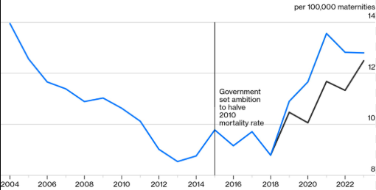
Figure 1: Maternal Death rates UK
(Source: Williams, 2026)
Since 2004, maternal deaths have been rising in the UK, which is 20% higher in 2022 than in 2010 (Williams, 2026). Donna Ockenden, a British midwife and community activist, performed an investigation between 2017 and 2022, which revealed longstanding concerns regarding maternity care at SaTH and persistent failure in the last 20-year period (BBC, 2022). This investigation revealed leadership issues within the NHS trust as well as weak governance, which indicates that the root causes of the Maternity failure extend beyond clinical decisions by involving broader organisational systems (BBC, 2022).

1.2 Identified maternity quality and patient-safety problem
The central quality concern across SaTH NHS Trust, as revealed in the Ockenden review, was the failure to provide safe, evidence-based and responsive maternity care to all women in their perinatal and postnatal condition. Evidence from nearly 1600 investigations by Ockenden reveals the presence of weak clinical governance and accountability within the chosen trust, which resulted in higher rates of unsafe practices, thereby increasing preventable maternal and neonatal harm (BBC, 2022). The investigation further reveals poor communication and coordination between SaTH staff members, including midwives, obstetricians and neonatal professionals, which further increases the risk of avoidable harm and leads to tragic maternal and neonatal morbidity (BBC, 2022). Therefore, these insights clearly highlight systematic failures within the leadership and governance of SaTH, which significantly compromised maternity quality and endangered patient safety. The investigation also reveals that despite the concerns raised by multiple families in the past, the organisation still chose to neglect those concerns to improve care quality, leading to serious unsafe outcomes (Weaver, 2020). This deliberately hinders overall care quality within the NHS trust, resulting in deaths, stillbirths, neonatal deaths and serious birth injuries, requiring implementation of necessary quality improvement procedures to ensure overall service improvement.

1.3 Rationale for service improvement and Report Aim
The scale and persistence of nearly 1600 patient-safety issues within SaTH NHS Trust clearly necessitates a systematic service improvement instead of any intervention targeted for improving any particular clinical procedure (BBC, 2022). Hence, an overall sustainable improvement within the selected trust is essential, which will require strong attention towards governance, leadership, staff competence, clear monitoring and reporting standards. This will improve the quality of maternity and neonatal care services in future.
Therefore, this report aims to critically examine all the underlying causes of maternity service failure within the SaTH NHS trust and propose actionable evidence-based strategies for mitigating the issues and improving care quality.

2. Main Body

2.1 Nature and complexity of the service-quality failure
The maternity failures at Shrewsbury and Telford Hospital NHS Trust represent a complex quality issue within their care practices from multiple interconnected systemic weaknesses. The Ockenden investigation confirms that over 1,486 families suffer from the leadership negligence of the NHS trust, which caused 201 avoidable infant deaths and approximately 9 maternal deaths in the past (SHBN, 2022). Multiple families, including Rhiannon Davies and Kayleigh Griffiths, raised concerns regarding the poor maternal care quality; the organisational leaders chose to ignore them, indicating persistent service quality failure (Woods, 2022).
Additionally, the maternity care-related effective decision-making is also affected by poor communication among staff members, which escalates the risks of maternal and neonatal harm (BBC, 2022). As a consequence of the leadership negligence, overall clinical governance became ineffective, which hindered the monitoring mechanisms and limited the organisation’s ability to identify recurring risks, which consistently jeopardises patient safety. Overall, the case clearly demonstrates that maternity care does not solely depend on the clinical competence of healthcare organisations; instead, it relies on effective leadership, governance, communication among staff members and monitoring systems.

2.2 Root-cause analysis: Application of Fishbone Diagram, 5 Whys and Donabedian Model
Conducting root-cause analysis is essential to identify the key underlying reasons for the maternity scandals within the SaTH NHS Trust. This will help the organisational leaders to pinpoint all the organisational areas that need improvements and encourage leaders to take immediate action to address them (Okes, 2019). However, conventional root cause analysis can often overemphasise individual actions while neglecting broader systemic failures. Therefore, to avoid this issue, multiple academic models of root-cause analysis, including the Fishbone Diagram, 5 Whys and Donabedian Model, are being utilised in this section to highlight the broader organisational issues within SaTH NHS Trust. These models will help in critically examining the interaction between workforce, processes, governance and organisational culture, and highlight key areas of improvement (Zonsius and Milner, 2021).
Application of Fishbone Model
The Fishbone diagram is a structured model which will be highly essential to categorise SaTH NHS Trust's quality issues under four categories, including People, Process, Management and Cultural factors. The critical discussion under these four factors can clearly showcase how poor maternity care is a result of multiple interacting factors rather than an outcome of any single clinical or individual practice (Moeng and Luvhengo, 2022).
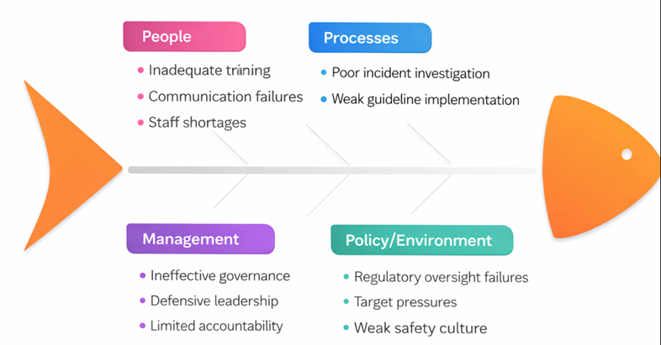
Figure 2: Fishbone Diagram
(Source: Adopted from Component 1)
People
People-related factors highlight that the poor maternal care is the result of inadequate staff training, lack of communication and overall staff shortages in the SaTH NHS trust. The finalisation of the Ockenden investigation disclosed that the trust has significant staffing and training gaps, which have weakened effective departmental communication and negatively affected the operational running of maternal health services (DHSC, 2022). As a result, Midwives, obstetricians and neonatal professionals failed to deliver high-quality care for the mothers and their infants, leading to deaths of mothers and often stillbirths.
Process
Similarly, the process-related factors highlight poor incident investigation and weak guideline implementation within the chosen Trust. The SaTH Trust was accused multiple times by patient families that their fetal monitoring is inconsistent and the workers lack the ability to follow national clinical guidelines (Weaver, 2020). These process failures ultimately delayed recognition and intensified maternal health risks as well as neonatal harm.
Management
Management-related factors help identify that the trust's governance is weak, leadership is poor and defensive, which limits accountability significantly. The Ockenden review examined past 1600 cases of maternal failures by the SaTH trust, which revealed that clinical governance processes and documentation of maternal issues were inconsistent, and even the governance team of the organisation intentionally downgraded serious illnesses (DHSC, 2022). This confirms weak governance, defensive leadership and overall poor accountability across the trust, which endangered the lives of countless mothers and even led to 9 maternal deaths.

Policy/environmental
Finally Policy/environmental factors indicate poor regulatory oversight and the presence of an overall unsafe organisational culture. The Ockenden review clearly reveals that the organisation's management repeatedly failed to address the patient concerns for the last 20 years and consistently ignored and even tried to hide their poor care-related consequences (DHSC, 2022). This further contributed to the continuation of the maternal scandal across the trust.
Overall, the fishbone approach proved to be valuable enough because it prevents the root-cause analysis of the SaTH NHS trust's maternal scandal from becoming overly focused on individual outcomes.
Application of 5 Whys
The 5 Whys technique is another useful approach, which can assist in identifying the underlying reasons for the persistent maternal care failure within the SaTH NHS trust in the UK. The main problem within the trust is found to be repeated unsafe maternity outcomes for the last 20 years, despite allegations and concerns being raised (BBC, 2022). The ‘first why’ in the model helps identify the key organisational factor contributing to the care quality problem in the first place (Nguyen et al., 2020). Therefore, this indicates that the SaTH staff failed to consistently recognise maternal deterioration and communicate the escalation properly, which resulted in poor care quality (DHSC, 2022). The 'second why' assists in identifying further reasons for the problem, such as why the staff failed to manage the maternal risks consistently. In answer to this, it can be recognised that the trust management failed to offer proper training to its staff, while also putting less emphasis on fetal monitoring (DHSC, 2022). This directly reduces the clinical-decision-making ability of the staff members and makes the communication inconsistent, which continuously deteriorates maternal care quality.
Then the ‘third why’ helps in examining further underlying reasons, such as why the Trust management failed in maintaining proper training and clinical oversight. This helps in disclosing that the trust lacked effective clinical governance and monitoring mechanisms, which prevented the leaders from arranging training for staff and failed to monitor the maternal risk escalations (Weaver, 2020). Afterwards, the ‘fourth why’ recognises the final reason behind the trust’s governance failure. This helps in disclosing that the governance and leadership systems in the SaTH trust did not adhere to the National Institute of Health and Clinical Excellence (NICE) guidelines (DHSC, 2022). As a consequence, the trust failed to properly implement the required patient-safety standards in the last 20 years, which jeopardised maternal health and risked infant lives. Finally, the 'fifth why' pinpointed the causes behind the trust leaders' failure in producing sustained improvement even after concerns were raised. This fifth stage helps in revealing the overall poor safety culture within the SaTH NHS trust, which requires effective organisational action and accountability.
The complete 5 whys analysis helps in disclosing the presence of governance system-level failure in SaTH, along with poor accountability and risk monitoring, which contributed to the maternal failure.
Application of the Donabedian Model
The structure-process-outcome model of Donabedian can be crucial to link the identified systematic weaknesses of the SaTH NHS trust to its delivery and consequences in maternal care (Moayed et al., 2022).
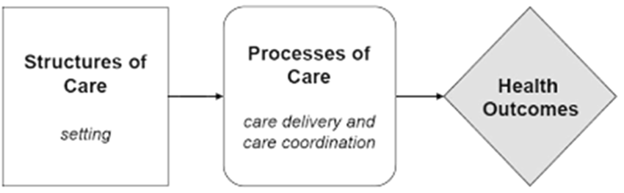
Figure 3: Donabedian Model
(Source: McCullough et al., 2023)
The ‘structure’ dimension in the model assists in identifying inconsistencies in the Trust’s care setting and resources (Tossaint-Schoenmakers et al., 2021). The Ockenden review disclosed that the SaTH trust lacked qualified obstetric anaesthetists and appropriate monitoring and review mechanisms, which led to unsafe maternity services (DHSC, 2022). Next, the 'Process' dimension helps in identifying the actual delivery of maternal care across the trust, which consists of poor fetal monitoring and escalation identification, which delayed treatment and hindered communication with patients and their families (BBC, 2022). Thus, the failures in the care delivery process indicate structural weakness that the organisation consistently failed to address. Lastly, the 'Outcome’ dimension indicates the final effect of the weaknesses in SaTH Trust’s organisational structure and process, which compromised maternal care delivery process quality and contributed to maternal mortality, stillbirths and neonatal deaths (BBC, 2022).
Overall, the combined application of three root-cause analysis approaches highlighted the contributing factors and deeper systematic weaknesses within the SaTH Trust, while connecting those weaknesses with the main maternal failure-related issue within the trust.

2.3 Strategic Planning analysis using SWOT
The SWOT framework is an essential tool for identifying internal strengths, weaknesses, possible opportunities and threats of the SaTH NHS Trust in future (Rahman et al., 2021). This will help in building realistic goals to address the identified problems and seize the opportunities.
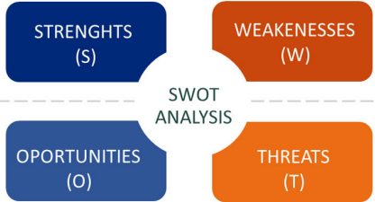
Figure 4: SWOT Matrix
(Source: Cañizares and Bourotte, 2021)
The key strengths of the trust include its established multidisciplinary workforce of around 7,000 staff and access to NHS clinical guidelines, which is essential for delivering better care (SaTH, 2026a). However, weaknesses such as poor leadership accountability and clinical governance within the trust are limiting staff training and clinical monitoring, which is reducing maternal care quality (BBC, 2020).
In terms of opportunities, the NHS Maternity Transformation Programme (MTP) can enable SaTH NHS Trust to harness digital tools and strengthen digital patient-safety monitoring under data-driven maternity surveillance (NHS England, 2026). This can help the Trust in speeding up risk identification, recording information, and supporting evidence-based decision-making (Katapalli and Ibrahim, 2023). Finally, threats such as consistent staff shortages and monitoring resource constraints can hinder public confidence and trust in the Trust's maternity care, which can lower hospital admissions in future and financially strain the organisation in the long term (Alam et al., 2025).
Overall, the SWOT analysis highlights the necessity of strategic refinement within the SaTH NHS Trust. The analysis indicates that the organisation needs to prioritise strengthening governance and leadership first, and then ensure workforce competency development, which will improve staff performance and maternal care (Tomblin et al., 2022).

2.4 Policy, Governance and Regulatory Implications
The quality compromise in maternal care and failures in maintaining patient safety clearly highlight an organisational gap within the SaTH NHS Trust, particularly between national policy and organisational implementation. The Ockenden review clearly highlighted an absence of strong governance within SaTH Trust, as it consistently failed to adhere to NICE guidelines and CQC expectations of safe, tailored maternity care through early risk assessment (Bolarinwa, 2026). Consequently, SaTH requires stronger mechanisms to ensure alignment between its care practices and regulatory guidelines, to ensure overall maternal and neonatal safety.

3. Recommendation

3.1 Improving Risk Recognition, Escalation and Communication
The SaTH NHS Trust should prioritise addressing the poor maternal care by introducing a standardised safety and escalation process with the support of regular multidisciplinary training among staff. To help the organisation formulate the plan, the four-step PDSA approach is being applied in this section, which will help in testing the change and mitigating the problem (Rafaai et al., 2018).
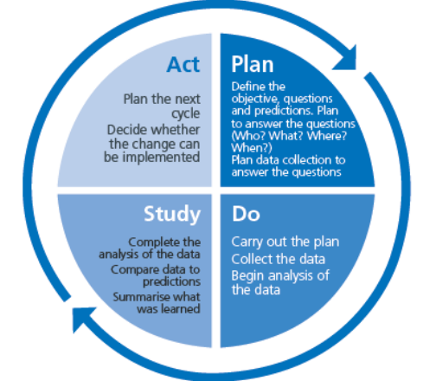
Figure 5: PDSA Cycle
(Source: Rafaai et al., 2018)
Plan: At first, the trust should plan a clear escalation pathway by precisely defining the roles of each staff member and establishing measurable targets for maternal care quality improvement. This will deliberately support timely clinical decision-making and reduce inconsistencies in care management (Zajac et al., 2021).
Do: Then, in this phase, the new escalation pathway will be piloted in a single maternity unit in the trust hospital, which will allow the staff, including midwives, obstetricians and neonatal professionals, to strengthen coordinated risk recognition and escalation (Amatullah, 2018).
Study: In this stage, the trust management will take notes from the pilot test of the pathway, assess and compare findings such as escalation response time, staff communication and treatment quality with pre-defined expectations. This will further assist them to make necessary changes and improve final planning.
Act: In the Act stage, the trust leaders should introduce the new plan across all the maternal wards and continuously monitor the outcomes to modify weaknesses consistently and ensure better maternal care delivery. This will not only improve their care quality and patient safety, but also strengthen leadership in the long run (WHO, 2024).
Overall, this PDSA-driven strategic approach will assist SaTH NHS Trust to ensure organisation-wide learning, staff engagement and patient safety improvement. However, staff resistance in following the new escalation pathway can hinder plan implementation, which needs tailored support from supervisors to address permanently (Fonseca and de Medeiros, 2026).

3.2 Reducing inconsistencies and strengthening governance
To reduce inconsistencies in timely patient condition recognition, fetal monitoring, and documentation, the organisational leaders should prioritise applying Six Sigma to eliminate clinical errors and strengthen governance (McDermott et al., 2022).
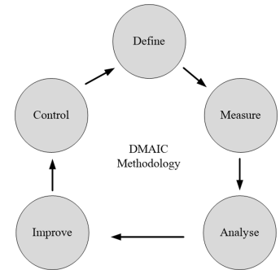
Figure 6: DMAIC Approach
(Source: Noman, 2016)
Define: This is the first stage, where SaTH leaders should identify all the clinical inconsistencies in the organisation in terms of delayed fetal monitoring, escalation, inaccurate documentation and poor communication to set targeted goals to improve all of them.
Measure: In this stage, the organisational leaders should focus on collecting present baseline data on guideline compliance, response times, documentation errors and incident patterns. These measures will assist in assessing whether the changes will produce meaningful benefits or not (Riley-Tillman et al., 2020).
Analyse: Afterwards, the SaTH leaders should utilise relevant diagnostic tools such as Training Needs Analysis (TNA) and Pulse surveys to identify possible root causes of clinical inconsistencies, including deficiencies in training, communication, and supervision (Markaki et al., 2021).
Improve: This is the stage where the trust leaders should roll out standardised procedures such as competency-based training, clear escalation pathways, and regular supervision reviews to mitigate the root causes related to clinical inconsistencies (Grillo et al., 2025). This will ultimately strengthen organisational governance and boost maternal safety.
Control: In this final stage, the trust leaders should monitor the performance of the workforce after implementing the suggested improvement changes by performing weekly clinical audits and using performance dashboards, which will ensure broad-level monitoring (Sravanthi et al., 2025).
Overall, the DMAIC approach under the Six Sigma framework will not only lower the clinical inconsistencies within SaTH Trust but also strengthen governance oversight, which will ensure safe maternal and neonatal care outcomes. Nevertheless, the complete Six Sigma process will require the collection of accurate baseline data; otherwise, inaccurate data will lead to ineffective recommendations and clinical decisions (Abdelwanis et al., 2024).

3.3 Monitoring and Sustaining Improvement through KPIs
To sustain the suggested changes, the SaTH trust leaders should utilise key performance indicators to continuously measure whether the overall care delivery process is improving or not (Yurtay et al., 2023). Below, a clear KPI table is being highlighted to facilitate the monitoring process.
KPIs | Target/Expected Outcome | Purpose
Fetal-monitoring compliance | Achieve over 80% compliance with NICE and CQC standards. | Reduce missed or delayed fetal monitoring.
Staff Training Completion | Train over 90% of staff with required maternity neonatal knowledge. | Strengthen staff competence and ensure timely risk mitigation.
Escalation response time | Ensure 95% of high-risk maternal cases receive appropriate clinical recognition within 30 minutes of risk identification. | Ensure timely risk identification and improve maternal care.
Maternal incidents | Reduce maternity accidents by 50% after overall change implementation. | Prevent maternal health risks and mortality.
Table 1: KPIs
(Source: Self-Produced)

4. Conclusion
To summarise the complete report, it can be highlighted that the Shrewsbury and Telford Hospital (SaTH) trust is experiencing long-standing deficiencies in maternal care quality and patient safety failures. The root cause analysis based on fishbone, 5 whys and the Donabedian model reveals that the organisation has been persistently weak in clinical governance, leadership, communication, staff competency and monitoring. This indicates that the maternity failure is not a result of a single clinical error, but a consequence of multiple underlying systematic weaknesses. Later, the strategic analysis based on the SWOT framework confirms the necessity of governance and staff competency improvement. To address these systematic weaknesses and clinical shortcomings, the trust is suggested to use PDSA and DMAIC-driven risk recognition and governance strengthening, which will help address possible inconsistencies in risk identification and monitoring and reduce delays in maternal care delivery. The standardised approaches can further allow the trust to continuously improve quality of care and ensure long-term patient safety through leadership improvement.

References
Abdelwanis, M., Alarafati, H. K., Tammam, M. M. S., and Simsekler, M. C. E. (2024). Exploring the risks of automation bias in healthcare artificial intelligence applications: A Bowtie analysis. Journal of Safety Science and Resilience, 5(4), 460-469. https://www.sciencedirect.com/science/article/pii/S2666449624000410
Alam, C. E., Abou-Abbas, L., Ramadan, M. S., and Asmar, M. K. (2025). Exploring the barriers to accessing antenatal care at the primary health care center level of a tertiary hospital in Lebanon: a qualitative study. BMC health services research, 25(1), 304. https://link.springer.com/content/pdf/10.1186/s12913-025-12444-y.pdf
Amatullah, A. (2018). Improving Management of Obstetrical Emergencies: Using Simulation-Based Training. Available at: https://repository.usfca.edu/cgi/viewcontent.cgi?article=1173&context=dnp
BBC. (2020). 'Failing leadership' at Shrewsbury and Telford Hospital Trust. Available at: https://www.bbc.com/news/uk-england-shropshire-53764432 (Accessed: 03 August 2026).
BBC. (2022). Shrewsbury maternity scandal: Repeated failures led to deaths. Available at: https://www.bbc.com/news/uk-england-shropshire-60925959 (Accessed: 03 August 2026).
Bolarinwa, O. (2026). Advancing maternal health equity: the need for cultural awareness and inclusivity in maternity service delivery in the UK: anchored in the MBRRACE-UK 2025 findings. International Journal for Equity in Health, 25(1), 177. https://link.springer.com/content/pdf/10.1186/s12939-026-02956-2.pdf
Cañizares, A. D., and Bourotte, C. L. M. (2021). Strategic diagnosis of geocommunication using SWOT analysis in the Varvite Geological Park, São Paulo, Brazil. Journal of the Geological Survey of Brazil, 4(SI1). https://jgsb.sgb.gov.br/index.php/journal/article/download/118/9
DHSC. (2022). Ockenden review: summary of findings, conclusions and essential actions. Available at: https://www.gov.uk/government/publications/final-report-of-the-ockenden-review/ockenden-review-summary-of-findings-conclusions-and-essential-actions (Accessed: 03 August 2026).
Fonseca, M. J. D. A., and de Medeiros, D. D. (2026). A Five-Stage Closed-Loop Lean Routine for Daily Factory Management: A Field Intervention in a UK Pharmaceutical Plant. Systems, 14(1), 86. https://www.mdpi.com/2079-8954/14/1/86
Grillo, C., Abd-Elsayed, A., Yousef, T. A., Misercola, B., Hussaini, Z., Rabii, M., ... and Deer, T. (2025). The American Society of Pain and Neuroscience (ASPN) Guidelines for Advanced Practice Providers in Interventional Spine and Pain Management Practice. Journal of Pain Research, 6319-6344. https://www.tandfonline.com/doi/pdf/10.2147/JPR.S533331
Katapally, T. R., and Ibrahim, S. T. (2023). Digital health dashboards for decision-making to enable rapid responses during public health crises: replicable and scalable methodology. JMIR Research Protocols, 12(1), e46810. https://www.researchprotocols.org/2023/1/e46810/
Markaki, A., Malhotra, S., Billings, R., and Theus, L. (2021). Training needs assessment: tool utilization and global impact. BMC medical education, 21(1), 310. https://link.springer.com/content/pdf/10.1186/s12909-021-02748-y.pdf
McCullough, K., Andrew, L., Genoni, A., Dunham, M., Whitehead, L., and Porock, D. (2023). An examination of primary health care nursing service evaluation using the Donabedian model: A systematic review. Research in nursing & health, 46(1), 159-176. https://onlinelibrary.wiley.com/doi/pdfdirect/10.1002/nur.22291
McDermott, O., Antony, J., Bhat, S., Jayaraman, R., Rosa, A., Marolla, G., and Parida, R. (2022). Lean six sigma in healthcare: a systematic literature review on challenges, organisational readiness and critical success factors. Processes, 10(10), 1945. https://www.mdpi.com/2227-9717/10/10/1945
Moayed, M. S., Khalili, R., Ebadi, A., and Parandeh, A. (2022). Factors determining the quality of health services provided to COVID-19 patients from the perspective of healthcare providers: Based on the Donabedian model. Frontiers in public health, 10, 967431. https://www.frontiersin.org/journals/public-health/articles/10.3389/fpubh.2022.967431/full
Moeng, M. S., and Luvhengo, T. E. (2022). Analysis of surgical mortalities using the fishbone model for quality improvement in surgical disciplines. World Journal of Surgery, 46(5), 1006-1014. https://www.researchgate.net/profile/Maeyane-Moeng/publication/358362784
Nguyen, V., Nguyen, N., Schumacher, B., and Tran, T. (2020). Practical application of plan–do–check–act cycle for quality improvement of sustainable packaging: a case study. Applied Sciences, 10(18), 6332. https://www.mdpi.com/2076-3417/10/18/6332
NHS England. (2026). Maternity Transformation Programme (MTP): Harnessing Digital Technology. Available at: https://www.england.nhs.uk/mat-transformation/harnessing-digital-technology/ (Accessed: 03 August 2026).
Noman, M. (2016). Six Sigma DMAIC phases application in Y company: a case study. International Journal of Collaborative Enterprise. https://www.academia.edu/download/109937176/IJCENT.2016.08233020240103-1-by2w7l.pdf
Okes, D. (2019). Root cause analysis: The core of problem solving and corrective action. Quality Press. https://books.google.com/books
Rafaai, Z. F. B. M., Majid, N. N. B., and Rasib, A. H. B. A. A (2018). Review of PDSA Method to Improve Productivity in Education Sector. https://www.researchgate.net/profile/Amir-Hamzah-Abdul-Rasib/publication/338107838
Rahman, M., Mousa, M. M., and Elwalda, A. (2021). SWOT analysis applications: An integrative literature review. Journal of Global Business Insights, 6(1), 55-73. https://www.academia.edu/download/97055247/SWOT_analysis_applications_An_integrative_literature_review.pdf
Riley-Tillman, T. C., Burns, M. K., and Kilgus, S. (2020). Evaluating educational interventions: Single-case design for measuring response to intervention. Guilford Publications. https://books.google.com/books
SaTH. (2026). Maternity – SaTH. Available at: https://www.sath.nhs.uk/wards-services/az-services/maternity/ (Accessed: 03 August 2026).
SaTH. (2026a). Working with us – SaTH. Available at: https://www.sath.nhs.uk/working-with-us/ (Accessed: 03 August 2026).
SHBN. (2022). Summary – Ockenden Report. Available at: https://shbn.org.uk/summary-ockenden-report/ (Accessed: 03 August 2026).
Sravanthi, P., Koppala, R., Mitra, S., and Kumar Pera, N. (2025). 6S management project to improve workplace productivity in Primary Health Centre in India. BMC Health Services Research, 25(1), 1278. https://link.springer.com/content/pdf/10.1186/s12913-025-13379-0.pdf
Tomblin Murphy, G., Mtey, G., Nyamtema, A., LeBlanc, J., Rigby, J., Abel, Z., and Mselle, L. T. (2022). Building leadership and managerial capacity for maternal and newborn health services. BMC health services research, 22(1), 1129. https://link.springer.com/content/pdf/10.1186/s12913-022-08448-7.pdf
Tossaint-Schoenmakers, R., Versluis, A., Chavannes, N., Talboom-Kamp, E., and Kasteleyn, M. (2021). The challenge of integrating eHealth into health care: systematic literature review of the Donabedian model of structure, process, and outcome. Journal of medical Internet research, 23(5), e27180. https://www.jmir.org/2021/5/e27180/
Weaver, M. (2020). 'I was told, just shrug it off': Shropshire's baby death scandal started decades earlier, mother reveals. Available at: https://www.theguardian.com/society/2020/oct/16/i-was-told-just-shrug-it-off-shropshires-baby-death-scandal-started-decades-earlier-mother-reveals (Accessed: 03 August 2026).
Williams, L. (2026). UK Maternity Care Is a Disaster and Getting Worse. Available at: https://www.bloomberg.com/opinion/articles/2026-07-14/uk-maternity-care-is-a-disaster-and-getting-worse (Accessed: 03 August 2026).
Wojcieszek, A. M., Bonet, M., Portela, A., Althabe, F., Bahl, R., Chowdhary, N., ... & Oladapo, O. T. (2023). WHO recommendations on maternal and newborn care for a positive postnatal experience: strengthening the maternal and newborn care continuum. BMJ global health, 8(Suppl 2). https://gh.bmj.com/content/bmjgh/8/Suppl_2/e010992.full.pdf
Woods, R. (2022). Shrewsbury maternity scandal: 'We've had to fight all the way for this'. Available at: https://www.bbc.com/news/uk-england-shropshire-60926390 (Accessed: 03 August 2026).
World Health Organization. (2024). Global patient safety report 2024. World Health Organization. https://iris.who.int/bitstreams/ae1caeae-bc04-4a71-a6b0-ab478f9a8c79/download
Yurtay, Y., Yurtay, N., Demirci, H., Zaimoglu, E. A., and Göksu, A. (2023). Improvement and implementation of sustainable key performance indicators in supply chain management: the case of a furniture firm. Ieee Access, 11, 41913-41927. https://ieeexplore.ieee.org/iel7/6287639/10005208/10109804.pdf
Zajac, S., Woods, A., Tannenbaum, S., Salas, E., and Holladay, C. L. (2021). Overcoming challenges to teamwork in healthcare: a team effectiveness framework and evidence-based guidance. Frontiers in Communication, 6, 606445. https://www.frontiersin.org/journals/communication/articles/10.3389/fcomm.2021.606445/full
Zonsius, M. C., and Milner, K. A. (2021). Continuous quality improvement. Research for advanced practice nurses: from evidence to practice. 4th ed. New York: Springer Publishing Company, 71-90. https://books.google.com/books

