Report Title: Reflective Report
Student Name: Florin Valentin Luca
Student Number: 2415104
Module Code: LCLM4001_LON
Module Title: Academic Skills
Lecturer: Tim Hopkins
Date: 16.12.2024

Table of Contents
1.0 Introduction 3
2.0 Reflection topic 3
2.1 Note-taking skill 3
2.2 Academic writing skill 4
2.3 Reflective writing skill 5
3.0 Conclusion 6
References 7
Appendix 1: Screenshot of Note taking skill 8
Appendix 2: Screenshot of academic writing skill 13
Appendix 3: Screenshot of Reflection writing skill 16

1.0 Introduction
In academic context and career-related development, such as academic writing, note taking, and reflective writing are core competencies. In addition to improving the ways of handling information, these skills help dig further into the way we learn and develop. Writing scholarly involves use of coherent and logical arguments and supports the Readers with meaningful and relevant information for them to make critical judgments. This present study will shed light on the learning procedure for note-taking, and academic and reflective writing skills with the utilisation of Gibb's reflective model.

2.0 Reflection topic

2.1 Note-taking skill
Holistically, these steps will involve applying Gibb’s Reflective Cycle on a specific event in notetaking and the overall process of assessment will involve describing the process, evaluating the outcomes, analysis and planning for future actions.
Description
I took notes during my first semester of university while studying in one of my courses. At first, I used what most students do, jotting down notes with pen and paper during the lectures I attended. I got overwhelmed by the rate at which information is shared in class and sometimes I was overwhelmed by the amount of notes to take. Sometimes, I left the notes random and it was sometimes difficult when beating the notes to find some of the main points in preparation.
Feelings
I was getting frustrated and anxious while realizing my discomfort of not being able to follow the classes as intensively as I wished. I also had somewhat of a defeatist attitude, especially when it came to integrating information and ensuring I recall important information during the tests.
Evaluation
Note-taking will have a close relation with high academic performance and career achievements (Nakayama et al., 2021). In retrospect, I realized that taking notes in the conventional way was not very productive. Although it was effective at first, I then thought that merely writing down practically everything that the lecturer said would not assist in the retention or knowledge of the content. This is why I had to look for something that would give me better direction so that I could concentrate on distinct ideas. Here again, unlike the previous studies, I did not use any specific note-taking approach and that hampered the organization of notes. But since I wanted to do better, I sought other ways of doing it.
Analysis
The first problem was that I was not clear in my message when note-taking. I was not involved in the material and did not have a plan of how to draw attention to the key information. Thus, I never considered the notes as an efficient study aid. A study shows that note-taking methodologies like the Cornell Method or Mind Mapping promote active listening and enhance absorption of material, something which I lacked.
Conclusion
Throughout my note-taking skill development journey, I had the major beneficial aspect on developed of key understanding of tabular note-taking and mindmap for memory development and achieve the desired outcome in my academic career.
Action
In order to improve my note-taking skills, I started using various approaches to taking notes. Therefore, I adopted the Cornell Method and tabular note-taking tactics, which see the page divided into three sections, namely for points, notes and summaries. Such structure also allowed staying only on critical information (Refer to Appendix 1).

2.2 Academic writing skill
Description of the Experience
A learning issue that I have met in my academic life was during my research paper which was assigned to do as part of a university course. This happened in my second semester of the first year when I was assigned to write an essay of 3000 words touching a complicated subject of the area of study for submitting the file without any grammatical error and plagarism.
Feelings
At first, I lacked experience in how my ideas flow out coherently, how I should organize my thoughts, and where and how to cite my resources. It was a very disturbing occasion because I felt helpless and did not know how to write any longer.
Evaluation
But this experience was also helpful in the end. It was very useful because it made me face my inadequacies; especially in writing hand it also presented me with a chance to enhance some of the most vital academic skills. I found it stressful and unsatisfactory to produce first drafts, although the efforts entailed progress in seeking opportunities to improve myself.
Analysis
The reason for the trouble was poor planning and inadequate orientation in terms of academic writing skills. I had not closely paid attention to how essential the structure, the coherence or the critical approach and usage of some sources are. However, one major issue, which I did not foresee, was the inadequate time, which I dedicated to the revision, and therefore produced a rather unclear work. Nevertheless, the exercise showed how it is easier to plan, organize ideas and take time for review before posting or writing. Academic writing skills have a positive impact on developing creative thinking skills (Knight et al., 2020).
Conclusion
During the essay writing and academic writing skill-related development, I have learned about the significance of paraphrasing skills, and proper referencing in the lecture session on the key facts about academic misconduct [Refer to Appendix 2].
Action Taken
As a result, I need to make some systematic changes to my approach towards writing better. First, I planned my paper in terms of topics and subtopics to guide me as I wrote and to make certain that each part of the paper had a specific goal. I also made more appointments to revise the content, concentrating on making the text more clear, structuring the content, and referencing. Additionally, I joined workshops on academic writing from the Writing Center of the University.
Future Action
It is for this reason that I will ensure that planning in my academic writing will remain high in future. Dividing large assignments into parts and providing time for each part is required in order to do a proper job at each stage.

2.3 Reflective writing skill
Description: In this stage, I have analysed that as an efficient writer, I have to explain what happened and not generalize, but strictly narrate.
Feelings: Instead, people encourage themselves to discuss their emotions during the experience or activity, accepting both content and negative emotions that may occur.
Evaluation: During this stage, I focus on conception and what part of it was good and what part of it was either negative or could have been done better.
Analysis: Here, a broader discussion is pursued in which the causes of the experience and the implications are discussed further. This stage provides meaning-making to the situation. In addition to that, Reflective writing skill adds value to exploring, learning growth opportunities (Sari et al., 2021).
Conclusion: I reflect on what has been picked from the experience, and lessons learned that will help in the future.
Action Plan: In the final step is an identification of measures for enhancement as well as an indication of measures that need to be taken the next time a similar situation occurs.
When applied to reflective writing, Gibb’s model hones the critical thinking abilities of a person, strengthens practice areas of a profession and increases the level of self-awareness.

3.0 Conclusion
In conclusion, free writing which includes both academic writing and note-taking together with reflective writing forms a strong foundation on learning and development. Academic writing promotes good thinking techniques and effective writing and note-taking improve the memory and understanding abilities. While progressive writing is very forward-moving and task-oriented, reflective writing affords the chance for self-analysis, and thus improvement. These skills enable persons to participate more effectively in educational tasks, enhance their approaches to learning and thus enhance their success in many areas of education and life.

References
Knight, S., Shibani, A., Abel, S., Gibson, A. and Ryan, P., 2020. AcaWriter: A learning analytics tool for formative feedback on academic writing. Journal of Writing Research.
Nakayama, M., Mutsuura, K. and Yamamoto, H., 2021. Impact of learner’s characteristics and learning behaviour on learning performance during a fully online course. Note taking activities in e-learning environments, pp.15-36.
Sari, Y.I., Utomo, D.H. and Astina, I.K., 2021. The Effect of Problem Based Learning on Problem Solving and Scientific Writing Skills. International Journal of Instruction, 14(2), pp.11-26.

The University of Edinburgh (2024). Gibbs' Reflective Cycle. [online] The university of Edinburgh. Available at: https://reflection.ed.ac.uk/reflectors-toolkit/reflecting-on-experience/gibbs-reflective-cycle.

Appendix 1: Screenshot of Note taking skill
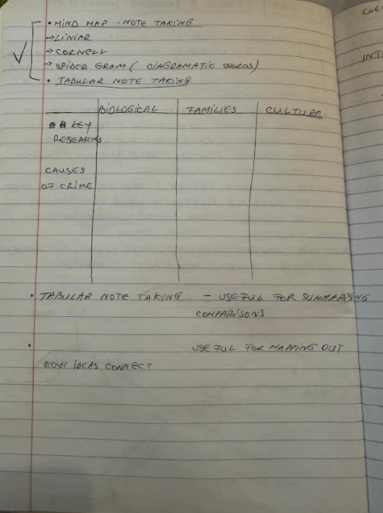
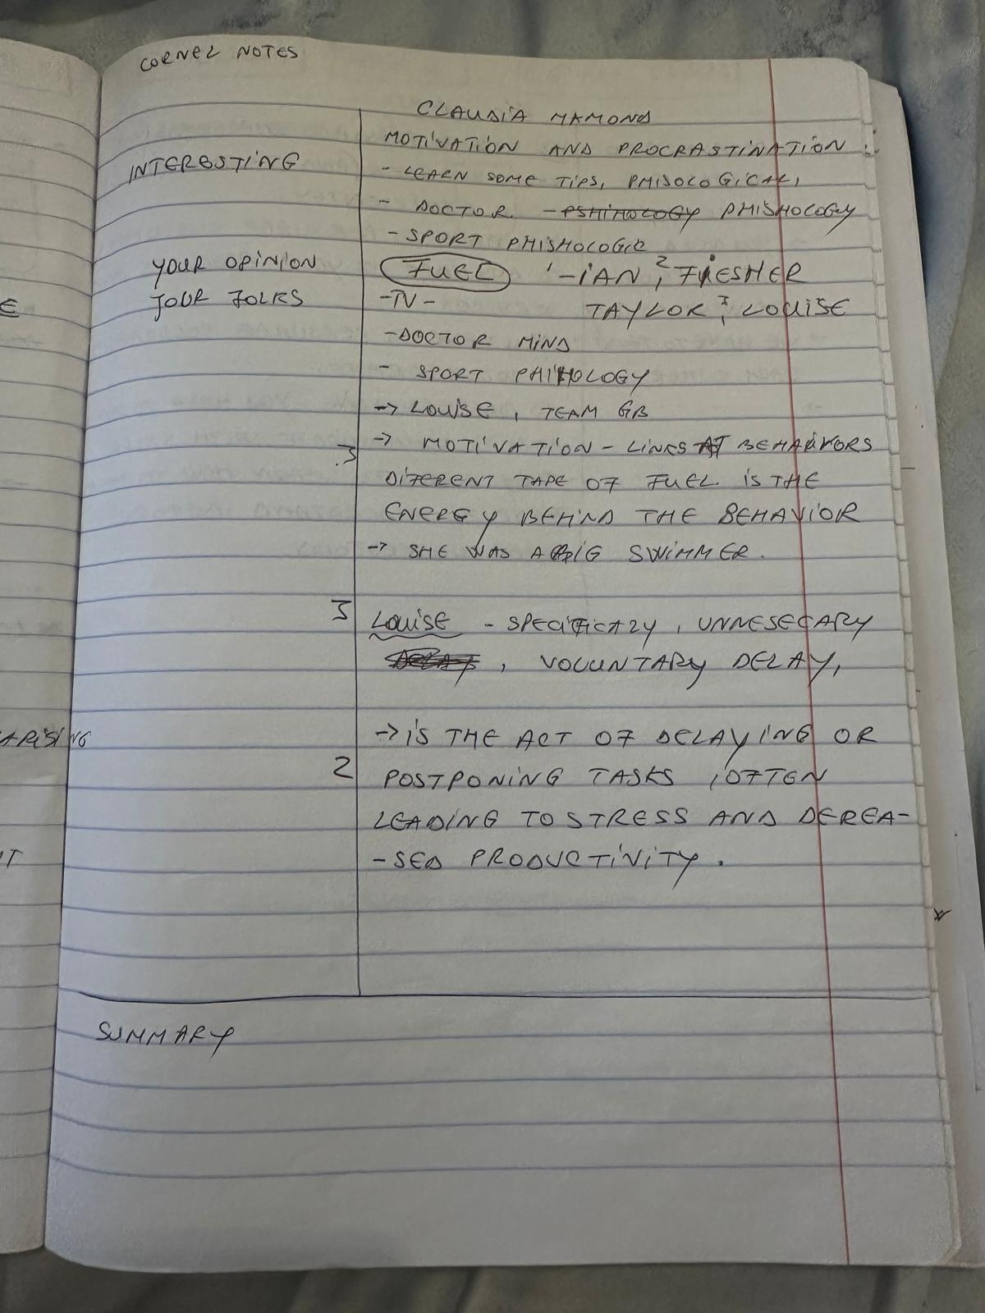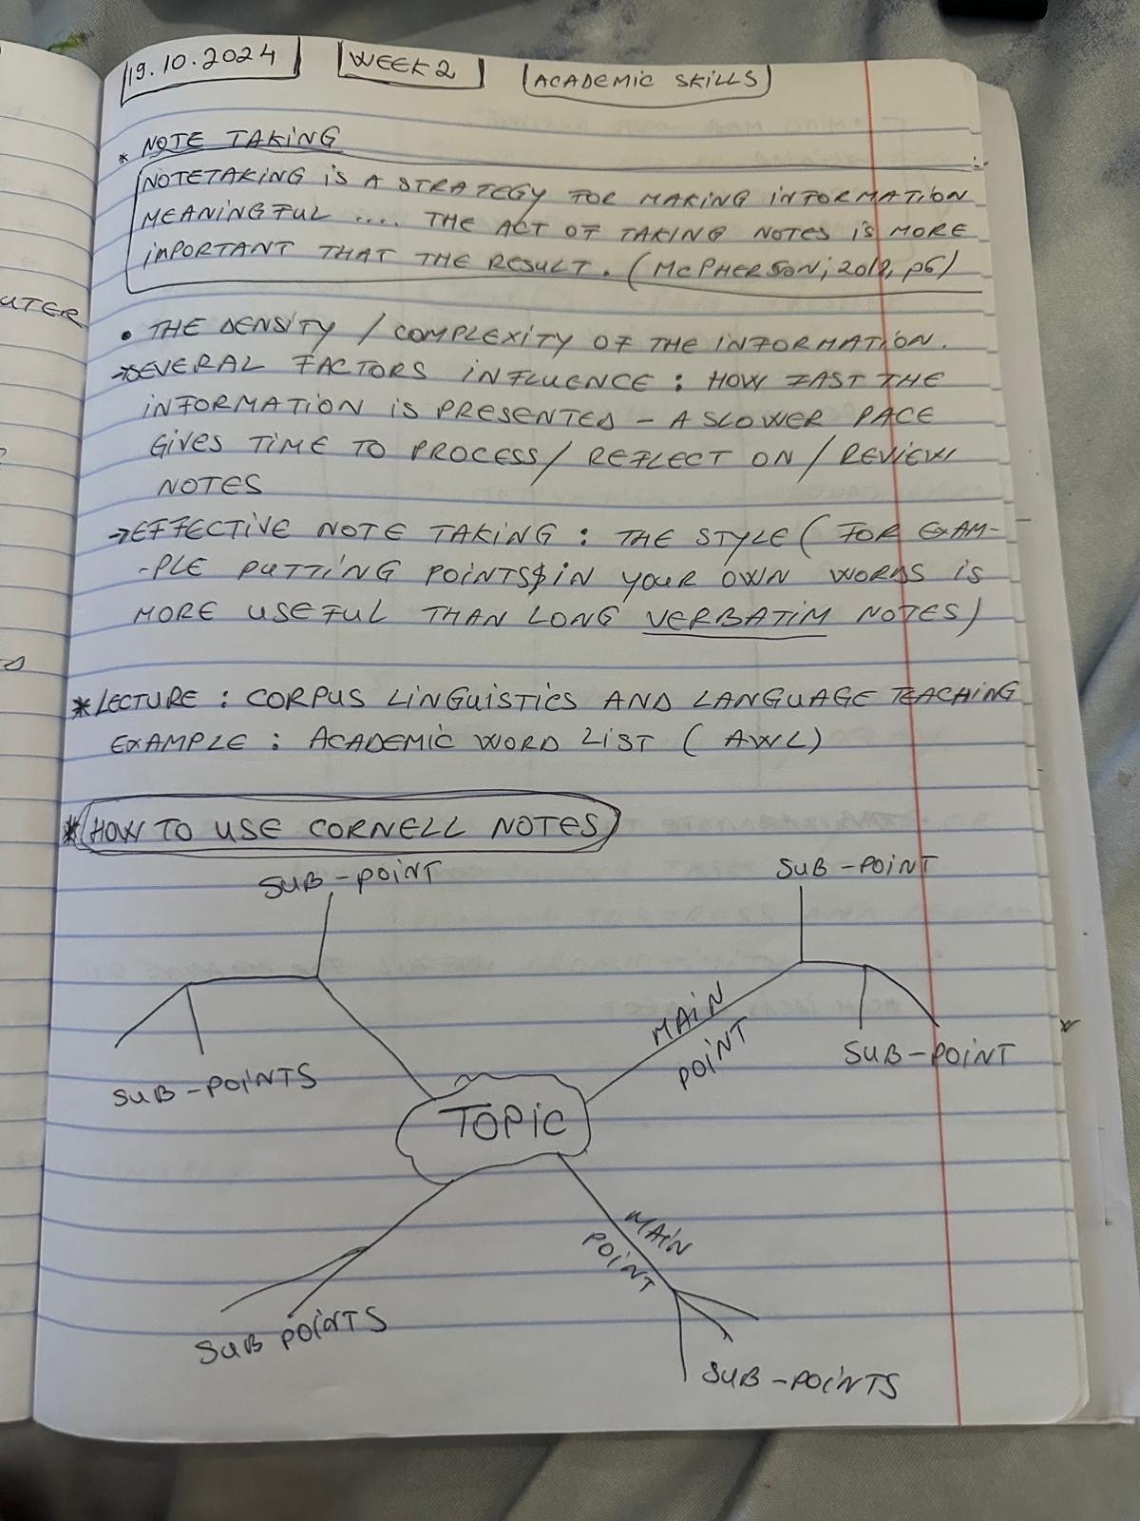
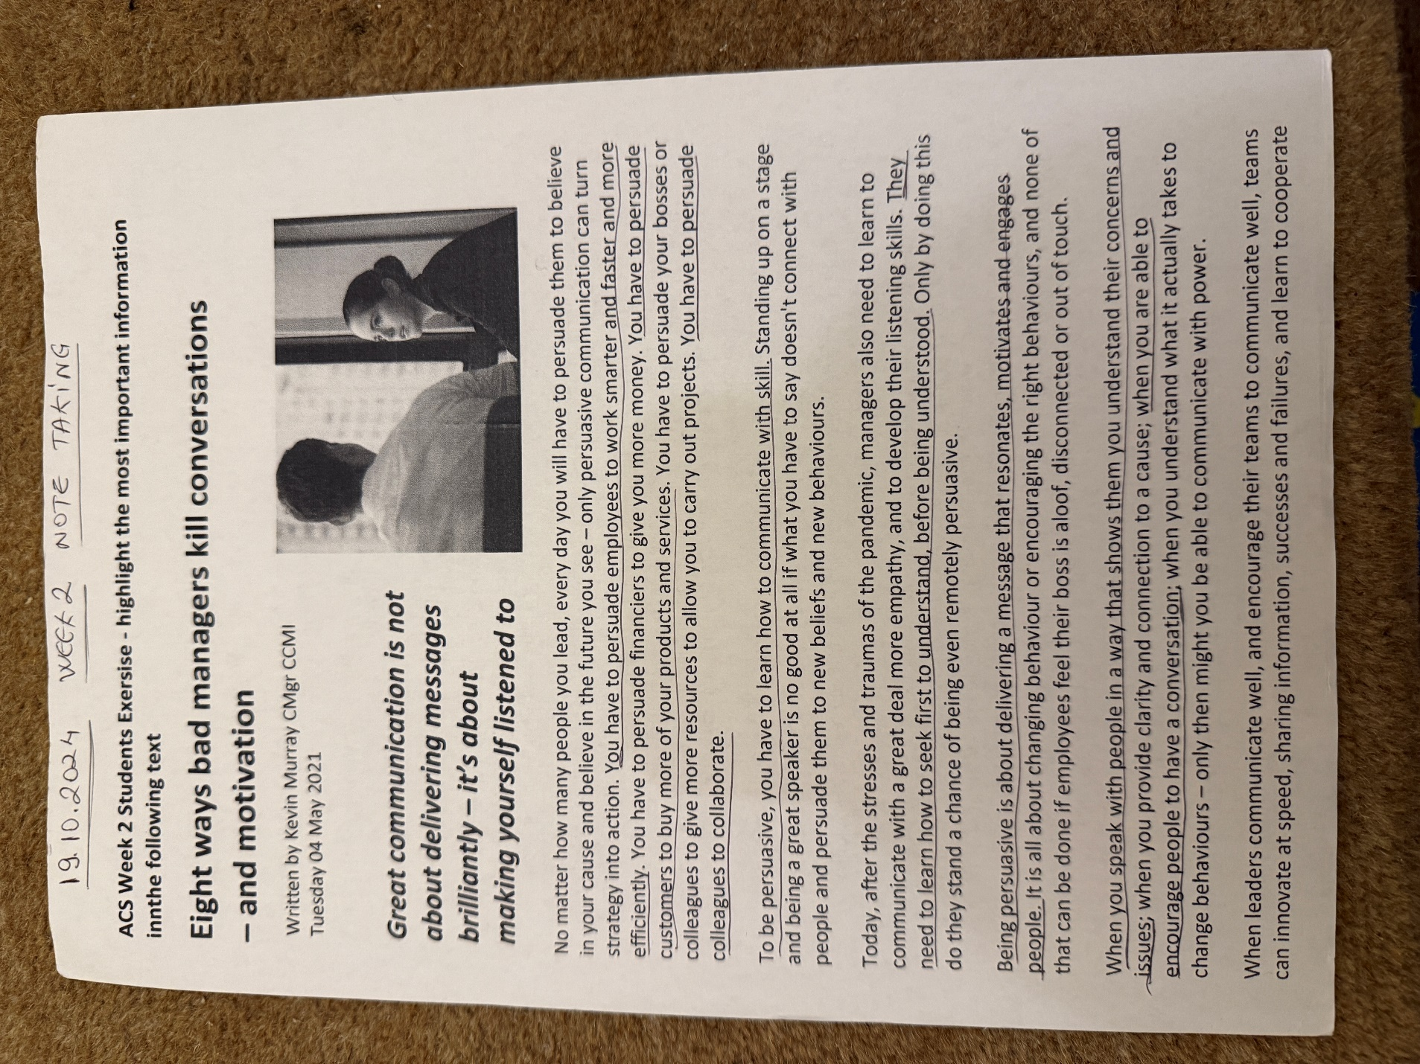
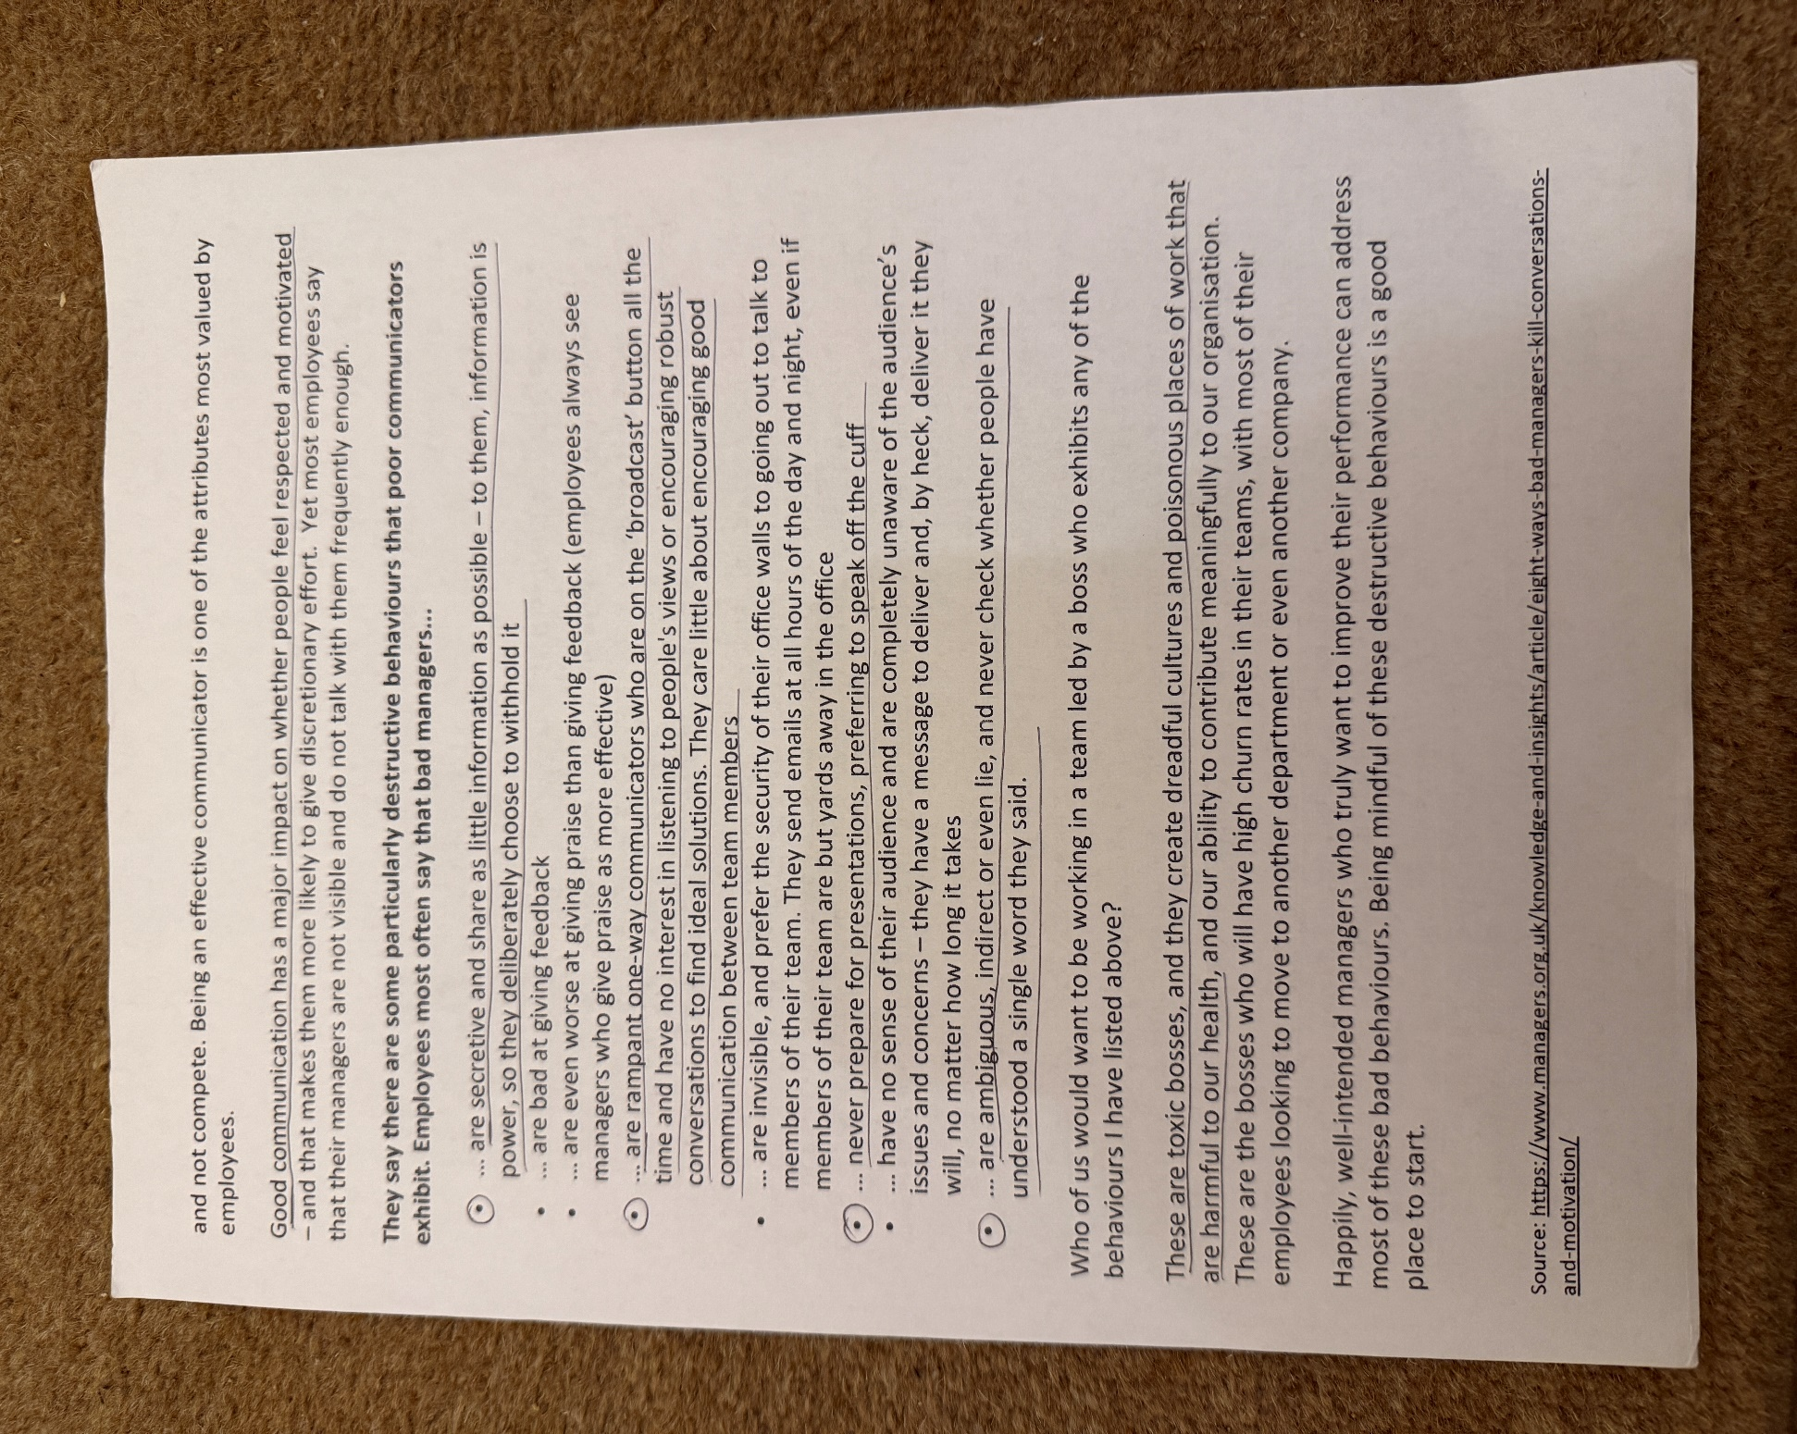

Appendix 2: Screenshot of academic writing skill
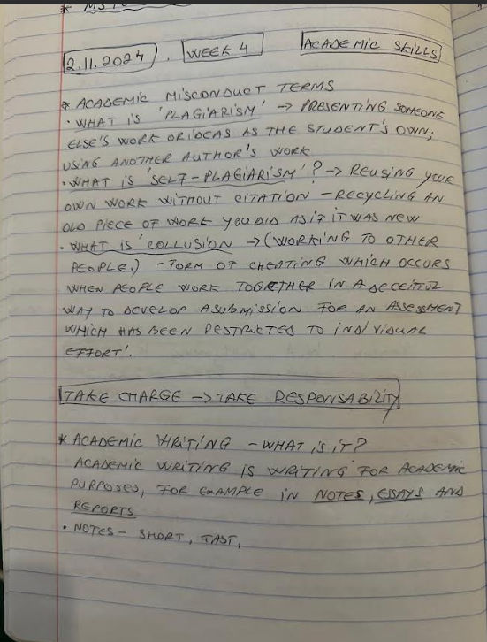
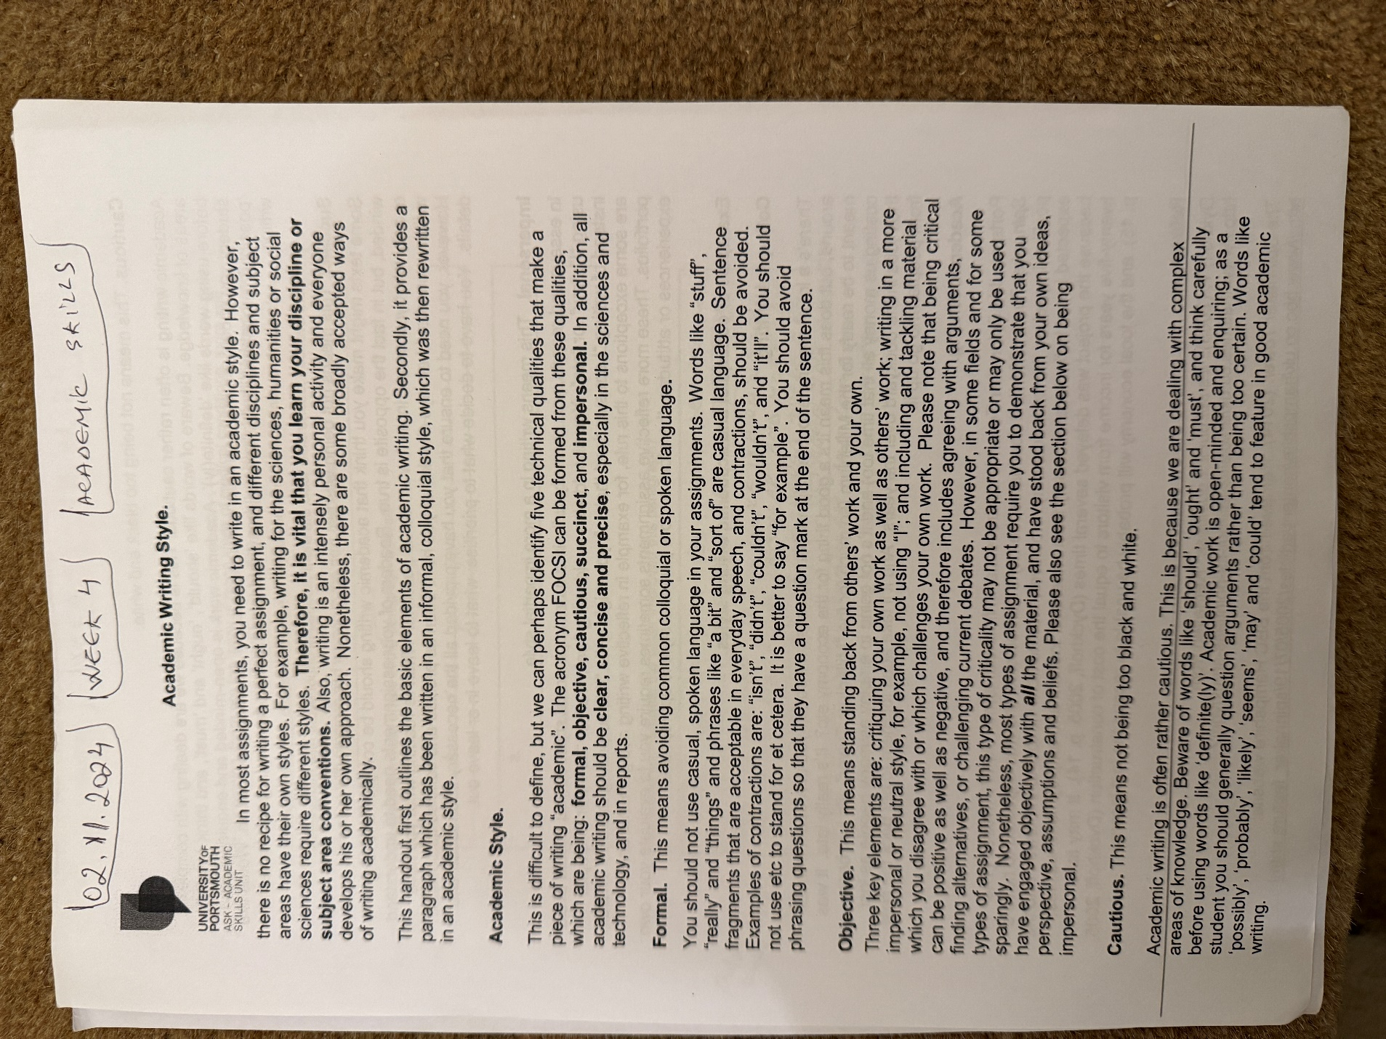
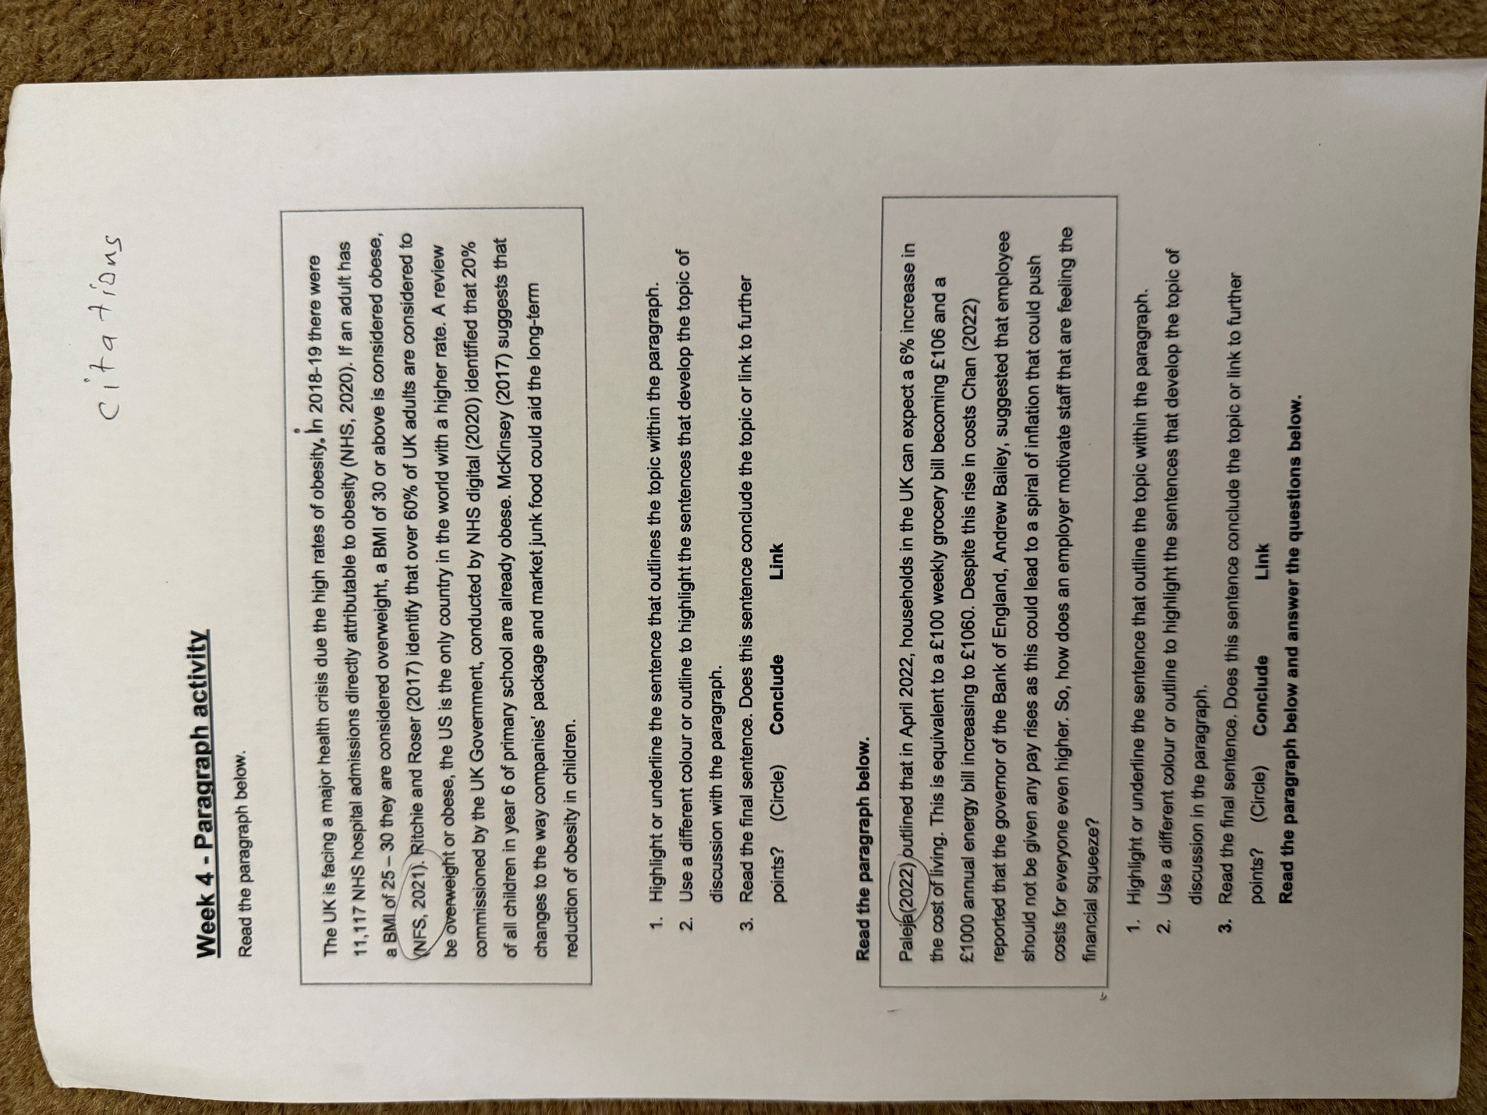

Appendix 3: Screenshot of Reflection writing skill


