“It makes me a better human:” the role of private singing instruction
in the lives of amateur adult singers

by
Emily DenBleyker
ID #2219580
BMPF7010

Proposal word count: 1407
Report word count: 14491
Total word count: 15,898 (max 15840)
DEDICATION

For the coffee shops all over the world where I spent hours working.

For the seals at the Ballard Locks who kept me grounded.

For the friends who stayed friends when I had my entire personality taken over by research.

For the family who fed me.

For the husband who has read everything I’ve ever written.

But most of all, for the people who sing even when it’s scary.

TABLE OF CONTENTS

Project proposal
Context and justification................................................................................................................5
Intended impact.............................................................................................................................5
Outlined intention...........................................................................................................................6
Proposed project timeline..............................................................................................................8
Ethics and insider research...........................................................................................................9
Expected learning outcomes.........................................................................................................9

Project report
Chapter 1: Introduction and literature review...............................................................................10
What is an amateur? .......................................................................................................11
Amateurs in music...........................................................................................................13
Adult learners in music education...................................................................................16
Chapter 2: Methodology..............................................................................................................18
Chapter 3: Findings.....................................................................................................................23
The journey to singing lessons........................................................................................23
Inside the lesson.............................................................................................................29
Outside the lesson...........................................................................................................35
The role of singing lessons..............................................................................................42
Chapter 4: Conclusion and future directions...............................................................................44

References..................................................................................................................................49

Appendices
Appendix A: Approved ethics form...............................................................................................69
Appendix B: Employer approval letter.........................................................................................70
Appendix C: Blank consent form.................................................................................................71
Appendix D: Signed consent forms.............................................................................................72
Appendix E: Lesson transcripts...................................................................................................73
Appendix F: Interview transcripts................................................................................................74

Table of tables
Table 1: Ten rewards of a serious leisure pursuit........................................................................13
Table 2: Formal, nonformal, and informal learning practices.......................................................14
Table 3: Professional vs. amateur singers' view of singing lessons............................................15
Table 4: Participant information...................................................................................................19
Table 5: Themes and subthemes generated by data analysis....................................................23
Table 6: Themes from the journey to singing lessons.................................................................28
Table 7: Themes from inside the lesson......................................................................................34
Table 8: Themes from outside the lesson....................................................................................42
Table 9: Participants’ larger motivations to pursue singing lessons.............................................43
Table 10: Recommendations for further research.......................................................................44

Project proposal
Context and justification
More people than ever have the opportunity to sing. For example, in the United States, participation in choirs has continually increased over the past decade, with 17% of adults reportedly singing in choirs (Chorus America, 2019). Technology allows an increasing amount of students to access teachers all over the world (Seavey, 2015; Waldron and Bayley, 2012) and social media gives singers accessible opportunities to share their artistry and get feedback (McDaniel, 2024). With this increase in accessibility comes an influx of students who may not necessarily desire a career in music but who wish to take singing lessons as an enjoyable hobby (Bayley and Waldron, 2020; Välisalo, Myllykoski, and Ojala, 2022). Despite this, very little research has examined the experience of amateur singers in the private voice studio (Smith, Kleinerman, and Cohen, 2022). Studies have examined the impact of singing on people’s wellbeing (Clift, et al., 2008), especially in choral settings (Batt-Rawden and Andersen, 2020), as well as the motivations for and benefits from engaging in community music (Einarsdottir and Gudmundsdottir, 2016; English, et al., 2024), but studies investigating the experiences of amateur singers taking private singing lessons are lacking.
I am a private voice teacher and my students are mainly adult amateur singers across all levels. In reading the literature, I have found that most of the information aimed at voice teachers is centered around teaching children and/or pre-professional or professional adult singers, and rarely considers the specific needs and desires of adult amateur singers. For example, since 2010, The Journal of Singing (ed. Hoch) has published 40 articles with the keyword “professional,” 12 articles with the keyword “child,” and only three articles with the keyword “amateur.” Of course, voice lessons for all students – no matter their age, level, or motivations – will include emphasis on technical skills and musicality, but it is presumable that the goals and expectations of amateur singers may differ from those who seek a professional career in singing. This may affect how an amateur singer approaches each lesson, as well as their overall experience in the voice studio. This proposed research aims to understand how amateur singers view the role of private voice lessons in their lives so that voice teachers may better serve the amateur singers in their studios.

Intended impact
This research will ask the question, “What role does private voice instruction play in the lives of amateur adult singers?” As amateur singers are likely to hold different goals than professional singers – namely, that they may not wish to pursue a career in singing and do not gain any professional benefit from being able to sing skillfully (Stebbins, 2024) – it is hypothesized that amateur singers will engage with and respond to their private voice lessons differently as well. It is possible, too, that the role that singing plays in the amateur singer’s life and their unique perspective on voice lessons may require their teacher to hold different expectations of their student or use different techniques to keep the singer engaged. This proposed research will examine amateur singers’ experiences in the private voice studio, motivations, goals, and opinions on private voice instruction, as well as how this may affect their lessons. This will address a gap in the current literature, and the findings will be used to discuss considerations for voice teachers working with adult amateur singers.

Outlined intention
This qualitative research question necessarily takes on a relativist ontological and a subjectivist epistemological view (Moon and Blackman, 2014), as each singer creates their own relative reality of what singing and vocal instruction mean to them. The research will be structured as a focused ethnography (Knoblauch, 2005; Andreassen, Christensen, and Møller, 2020). The field of ethnography was developed in order to study culture through observation and immersion with people in that culture, resulting in a “truthful account of people’s stories in their own words and local context” (Cruz and Higginbottom, 2013, p. 37). Focused ethnographies, specifically, allow researchers to examine “specific issues in a single situation among a limited number of people within...a defined period of time” (Shannon, Soltani, and Sugrue, 2024, p. 778).
This project’s methodology will have three main stages. The first stage will be a literature review which explores how amateurs, amateur musicians, and adults in music education are currently discussed in the literature. This narrative literature review (Winter, 2022), while it will center itself on white literature, will also utilize grey literature to paint a more detailed picture (Levin, 2014). As this research question addresses a gap in the literature, some context surrounding the subject will come from outside traditional scholarship such as journals, which can “lag” behind less formalized knowledge (Adams, Smart, and Huff, 2017, p. 433).
In the second stage (data collection), participants will be recruited via purposive sampling from my studio and professional networks (Etikan, Musa, and Alkassim, 2016). After signing consent forms, participants will be asked to complete a questionnaire that establishes eligibility and collects basic demographic information. Next, they will be asked to video record three of their own voice lessons. These will be recorded using whatever methods are most accessible to the participant and their teacher, but it is anticipated that online lessons will be recorded using Zoom and in-person lessons will be recorded on a phone or laptop. Then, semi-structured interviews will be conducted and recorded via Zoom. Finally, in the data synthesis stage, I will code the voice lesson videos and the interviews using inductive coding methods such as descriptive coding and pattern coding (Saldaña, 2013). The analyzed data will then be compiled into the final report.

Proposed project timeline
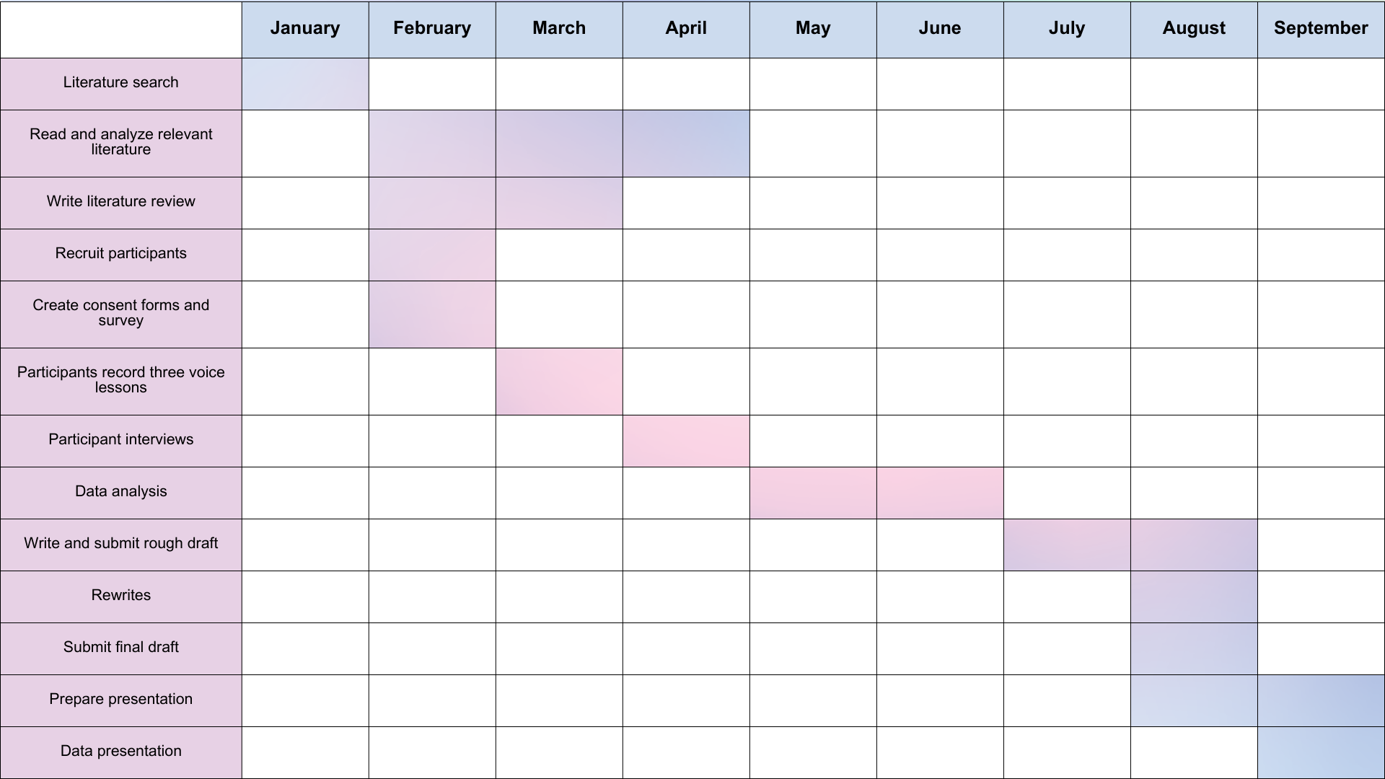
Ethics and insider research
As a voice teacher, adult amateur singers make up a majority of my students, and so this research is deeply intertwined with my day-to-day work. As such, I am an insider researcher (Bonner and Tolhurst, 2002), and it is likely that my own students will make up a majority, if not all, of my participants. While this has its benefits, as I am able to draw on my own personal relationships and knowledge of my students, committing to ethical research practices will also be of the utmost importance (Israel and Hay, 2006), as well as establishing ethical boundaries (Greene, 2014). Aburn, Gott, and Hoare (2021) identified four challenges for insider researchers in conducting interviews with colleagues, which in this case are my voice students:
- Power differentials in relationships.
- Managing your own emotions as a researcher.
- The risk of assumed understanding.
- The risk of participants over-disclosing due to the shared experience. (p. 24)
To mitigate the risk of power differential, I will submit the interview questions for approval before conducting the interviews. Additionally, throughout each interview, I will endeavor to listen more than talk, which will also moderate the risk of assumed understanding.
Potential participants could feel that their experience is “not good enough” to partake in the research. As such, participants will be informed that their experiences will not be judged to any standard, and that all experiences are valuable and important. Participants will also be shown transcripts of their interviews and voice lessons, and they will be sent copies of the final report so that they are able to see the raw data before it is analyzed. Also, as other voice teachers may be recorded in the participants’ voice lessons, they may feel as though their teaching practices will be judged. Voice teachers will be informed that their teaching practices will not be analyzed in the data analysis stage. All participants and voice teachers will be asked to sign consent forms, and they will be informed that they may withdraw their consent at any time. Finally, all data from the project will be anonymized and kept on my personal, password-protected computer, which only I can access.

Expected learning outcomes
With this project, I expect to learn to conduct a literature review and a qualitative focused ethnographic study. I also anticipate learning to analyze large amounts of data, as well as synthesizing data and describing implications for the field and recommendations for further research. Finally, I expect to be able to utilize the findings to better serve my students.
Project Report
Chapter 1: Introduction and literature review
As music education has become more accessible (CITE), more and more people are choosing to pursue singing as a hobby (CITE). This has led to an increase in adults who consider themselves “amateur” singers and may not hold any desire to perform publicly and yet put considerable effort into pursuing private (one-to-one) lessons (CITE). Despite this, vocal pedagogy literature has often neglected to consider amateur singers as well as adult students, focusing instead on children and professional singers (CITE). This study attempts to fill that gap in the literature, examining the experiences of adult amateur singers (AAS) and the role that singing lessons play in their lives.
While of course singing technique is an important aspect of lessons, this study mainly concerns itself with the singers instead of the art and science of singing itself. This is not to say that music itself is not meaningful, but that it is just part of an amateur singer’s life:
To say the music was secondary was to acknowledge the limitations of seeing music only in its objective form. To see music in an integrated context, however, is to recognize it and the larger meanings it has in the lives of the music-makers. (Hibbard, 2017, p. 185)
For the purposes of this study, an amateur singer is defined as someone who many sing in any public or private setting but does not intend to pursue singing in a professional capacity and whose main source of income does not come from singing.

Aims and objectives
- Conduct a literature review that examines how amateurs and adult learners (in music and in other subjects) are currently discussed in the literature
- Explore the experiences of AAS
- Synthesize data so that voice teachers may better understand their adult amateur students’ perspectives and reflexively adjust studio practices

Individual learning outcomes
- To learn to conduct a literature review and a qualitative focused ethnographic study
- To learn to analyze large amounts of data
- To learn to synthesize data and describe implications for the field and recommendations for further research
- To be able to utilize the findings to better serve my students
WHAT IS AN AMATEUR?
When conducting research centered on amateur singers, it becomes important to identify what an amateur is and what distinguishes them from their professional counterparts. While the word amateur is not uncommon, its meaning and implications for society have been examined in the literature for many years. The word “amateur” comes from French via Latin, meaning “a lover of,” and was first used in the late 18th century to describe rich gentleman who took on work to “portray occupation” (Hamilton, 2013, p. 179) or whose fortunes and flexible careers gave them “a great deal of spare time and surplus energy with which to follow certain interests” (Hudson, 1981, p. 12). Taylor (1995) points out that many fields of science – especially archaeology – benefitted from these “gentleman amateurs,” including Lord Carnarvon, who “discovered” the tomb of the Pharaoh Tutankhamun after his doctor recommended visiting Egypt for his health and he took up amateur “digging,” with “the idea of keeping me out of mischief, as well as keeping me employed” (qtd. in Hoving, 1980, p. 23).
The common understanding of an amateur has now come to be the opposite of a professional, for better or for worse. Merrifield (2017) frames amateurism as a good thing, characterizing modern professionalism as being too specialized and professionals too hampered by day-to-day routine and loyalty to the boss (see also Said, 1993). Ingold (2021) also frames amateurism in a positive light, not in contrast to professionalism but as a completely different “groove” (p. 164). He writes that – much like ethnography – “participant observation” is the hallmark of amateurism, using the example of a shepherd who observes his sheep and becomes “the student of his herd” (Ingold, 2021, p. 164). This idea is similar to citizen science, in which professional researchers rely on data collected by community members (Lerg, Östling, and Weiß, 2022; Viola et al., 2022). While professional researchers may be contending with demands on their time and resources, citizen scientists are free to focus on small subsets of data (for example, a specific species of bird) and provide more accurate data than if the researchers gathered and interpreted the data themselves (Viola, et al., 2022).
Some authors argue that the professional standardization of a field introduces power structures that ostracize those who are unwilling or unable to become professionals, reducing the respect and resources given to amateurs (Fox, 2004; Hamilton, 2013; Lerg, Östling, and Weiß, 2022). With this view, then, modern amateurism becomes “the very act of rebellion against normative standards [being] in itself political” (Gilbert at al., 2020, p. 8). This means that while amateurs may be viewed as less skilled than their professional counterparts (Gilbert et al., 2020), they may also be respected for “[drawing] their creativity and innovation from sources unaffected by the marketplace” (Hamilton, 2013, p. 183).
What this produces, then, is a cultural view of the amateur as too unskilled to become a professional yet courageous and determined enough to be respected for the time they devote to their chosen activity. Gilbert et al. (2020) uses the word “shoddy” in both a positive and negative sense to describe this dichotomy (p. 5). This creative, scrappy side to the amateur takes time to develop, time which may not be available to those whose work must be held to a commoditized (professional) standard. Merrifield (2017) discusses the value of free time for amateurs:
The good use of free time is crucial for full human individuality, for any expressive amateurism, for self-unfolding, for expanding individual capacities.... It’s a recipe for the creation and perpetuation of a better society, with happier people. (pp. 169-170)
Stebbins (1979, 2024), a sociologist who has written extensively about amateurs and leisure, developed the Serious Leisure Perspective. In this theory, which he has refined and written about extensively over the years, Stebbins (1979) does not attempt to define what an amateur is, instead choosing to observe and describe the amateur in sociological terms. He writes that amateurs’ attitudes separate them from their professional counterparts, with the professionals displaying greater confidence, perseverance, commitment, and preparedness. In addition, both parties self-identify as either amateurs or professionals (Stebbins, 1979). Stebbins (2013) creates a distinction between amateurs and those who “dabble.” Dabbling, he writes, is:
a kind of play – disinterested activity engaged in for its own sake, for curiosity, for hedonic experience. It is disinterested in the sense that no long-term goal is pursued when dabbling; the participant simply wants certain immediate experiences. (p. 147)
Stebbins (2013) views amateurs as more serious about their activity than dabblers, possessing an expectation to improve and engage in the social world of their hobby.
He also proposes that amateurs are socially positioned near their professional counterparts and the professionals’ work must be visible to the amateurs so that the amateurs may observe the professionals’ “prowess” in order to become motivated to take their activity seriously and not just view it as a hobby (Stebbins, 1979, p. 11). Stebbins (2024) identifies ten rewards that the amateur receives from their activity (see Table 1); he writes that “when many individuals profit from amateur pursuits...the entire community profits from the resulting personal satisfaction” (Stebbins, 1979, p. 268).

Table 1: Ten rewards of a serious leisure pursuit
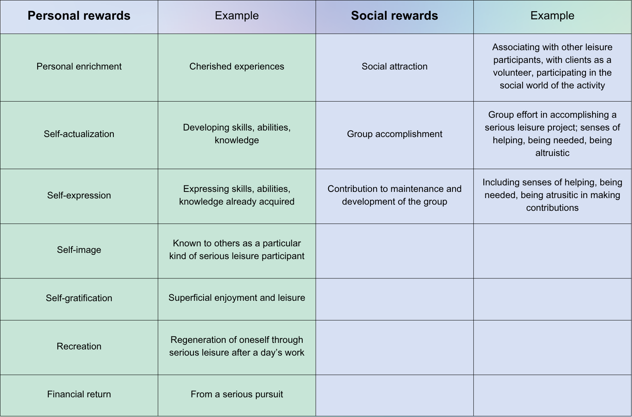
(from Stebbins, 2024, pp. 18-19)

AMATEURS IN MUSIC
The literature rarely considers amateurs in music, although it may be enough to begin to frame their experience. Stebbins (1979), who himself identifies as an amateur musician, identifies three types of amateur musician: the “pure amateur,” who does not wish to become a professional and is content to play music as a hobby; the pre-professional, who wishes to be a professional and “is undergoing music education” (Einarsdottir and Gudmundsdottir, 2016, p. 40); and the former professional musician who still plays music as a hobby. It is interesting to note that in this typology, the pre-professional musician is the only one who is actively taking lessons.
However, Vaizman and Harpaz (2023) point out that amateur musicians are more likely to engage in informal learning practices, and this is in agreement with other recent literature on the subject (Veblen, 2018; Mok, 2020; Ojala, Välisalo, and Myllykoski, 2024). Informal learning is experiential, “on-the-job” learning, and when applied to music, may not utilize tools such as written music or Western music theory or traditions (Finnegan, 1989, p. 136; see also Veblen, 2018). This type of learning often takes place in environments such as the family home and places of worship (Findsen, 2006), where people may be encouraged to sing or play music regardless of training, and may be conscious or unconscious (Green, 2002). Formal learning experiences, on the other hand, are “carefully designed, scaffolded learning sequences... assessed by specific measures” (Bucura, 2020, p. 18). This type of education is most often employed in schools and universities and through curricula used by independent teachers (see, for example, The Royal Conservatory [2025] and The Associated Board of the Royal Schools of Music [2024]). It is in these formal environments that most research on musicians has taken place (Ben-Eliyahu, et al., 2018), thus leaving many amateur musicians out of the scope of the literature.
Veblen (2018) suggests that adult music learners, who are often amateurs, engage in nonformal learning, a practice that blends aspects of both formal and informal learning (see Table 2). Nonformal learning practices may utilize the “systematic and deliberate” aspects of formal education, but occur outside of official educational environments and are therefore “more responsive to social action” (Veblen, 2018, p. 245). Ojala, Välisalo, and Myllykoski (2024) describe nonformal learning as “easily accessible, participatory, learner-centered, and holistic” (p. 433).

Table 2: Formal, nonformal, and informal learning practices
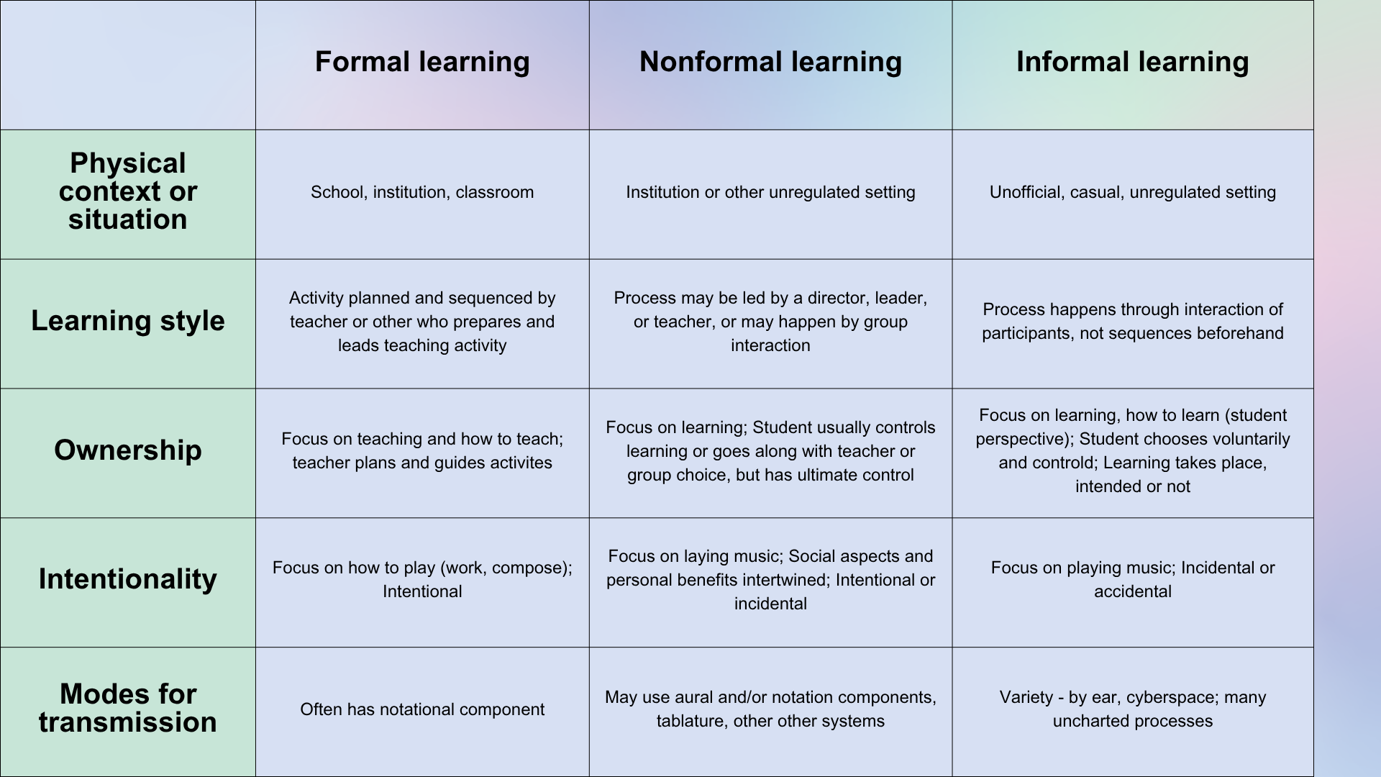
(from Veblen, 2018, p. 246)

Stebbins (2013) considers what may push adults who “dabble” in music to begin to take their musical practice more seriously and begin to consider themselves amateurs (p. 147).
While evolving from dabbler to amateur, the musician experiences certain “constraints and facilitators” (Stebbins, 2013, p. 149). Constraints are those things that may prevent a dabbler from pursuing their instrument more seriously; facilitators are the things that encourage the dabbler to continue to pursue music. These may include the support of family and friends, financial and geographic access to lessons, and time to practice. He emphasizes that access to an instrument is imperative to dabbling, making singing one of the most accessible ways to dabble – and perhaps eventually become an amateur – in music (Stebbins, 2013).
Amateurs in music also seem to enjoy playing their instrument more and receive more of the well-being benefits than professional musicians do (Juniu, Tedrick, and Boyd, 1996; Grape et al., 2003). The greater enjoyment may be due to the amateur possessing greater intrinsic motivation to practice and play than the professional, as the professional musicians are “more strongly influenced” by financial compensation and amateur musicians are more motivated by having a positive experience (Juniu, Tedrick, and Boyd, 1996, p. 54). Likewise, when Grape et al. (2003) interviewed amateur and professional musicians about their singing lessons, the amateur singers “experienced more well-being and were clearly more enthusiastic...[and] reported increased joy after the lesson, which the professionals did not” (p. 73). See Table 3 for direct quotes from participants that were used to illustrate this point.

Table 3: Professional vs. amateur singers' view of singing lessons
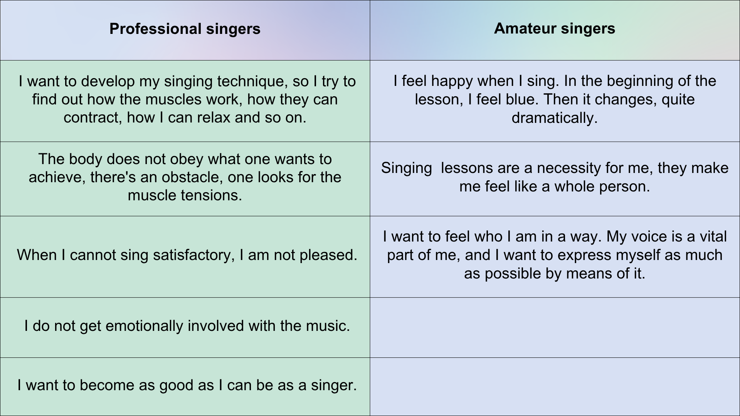
(from Grape et al., 2003, pp. 71-72)
ADULT LEARNERS IN MUSIC EDUCATION
Adult music learners are also underrepresented in the literature, although recent studies have begun to consider their unique experiences. Most of the literature about AAS discusses their participation in choral singing; very little literature examines those who take individual singing lessons (Grape et al., 2003; Smith, Kleinerman, and Cohen, 2022). Research indicates indicating that who choose to participate in music education may be influenced by experiences both in early life and in adulthood (Bonshor, 2017; Välisalo, Myllykoksi, and Ojala, 2022). Adults with limited experience in music may be hesitant to begin taking music lessons, and those who overcome that hesitance may have difficulty finding a teacher who wants to take on an adult beginner (Burgos, 2014). This aversion is seen from the teacher’s perspective in Huhtanen (2008): one teacher in a community music school called her students “not good enough” to sing Western classical music and spoke of her desire to teach “normal” singing students (p. 58).
Those that do engage in vocal training (both private and group training) report diverse goals and motivations, both musical and non-musical. Musical motivations include improved confidence and technique, learning repertoire, and participation in choral or solo singing, while non-musical motivations include “[fulfilling] a childhood dream,” and singing for personal development and enjoyment (Smith, Kleinerman, and Cohen, 2022, p. 918; see also Love, 2019; Välisalo, Myllykoksi, and Ojala, 2022; DenBleyker, 2024). After receiving training, students reported learning not only about the artistic and technical aspects of singing, but also “about themselves...and others” (Smith, Kleinerman, and Cohen, 2022, p. 920).
While some AAS do seek out choral settings, some are inclined to pursue private training instead (Smith, Kleinerman, and Cohen, 2022). In this setting, teachers are able to work one-on-one with students, helping the student “[focus their] attention on the sound of their own voice and its connection to the bodily mechanisms that control it” (Smith, Kleinerman, and Cohen, 2022, p. 913). This may be appealing for students with little to no experience in singing, allowing the student to reconceptualize their musical self-concept (Creech, et al., 2013; Wise and Halpern, 2024) and encouraging them to participate in music in other more public settings, such as joining a choir or singing with friends and family (Demorest, Kelley, and Pfordresher, 2017; Smith, Kleinerman, and Cohen, 2022).
While adult music learners may be underrepresented in music education literature, there is much more literature concerning general theories of adult learning, especially self-directed and self-determined learning. In self-directed learning, or andragogy, “teachers invite learners to take responsibility and initiative for their own growth” and the learning experience is “characterized by learner autonomy and responsibility” (Bucura, 2020, p. 8). Knowles (1984), a leading author on andragogy, identifies six main characteristics of self-directed learning: autonomy, use of knowledge and life experience, goal-orientation, relevancy-orientation, application to real-life situations, and collaboration (see also Perera, 2022). As seen here, the learners’ experiences and goals are used to frame learning while emphasizing how classroom learning may be used in the real world. The teacher is still active in the process, helping the learner “set learning goals, pinpoint applicable resources, identify strategies, and evaluate their own efforts,” but reducing their influence as the learner becomes increasingly self-directed (Bucura, 2020, p. 8).
Self-determined learning, or heutagogy, is similar to andragogy in that it takes into consideration the learners’ life experience, perspective, and values; however, the teacher is not directly involved as an educator but as an equal mentor or collaborator (Bhoryrub et al., 2010; Bucura, 2020). Heutagogy is closely aligned with practice-based learning strategies, in which learners engage in self-reflection to challenge not only the outcomes of their learning, but their beliefs and worldviews (Blaschke, 2012). Intrinsic motivation is also an important factor in heutagogy, as learners must set their own goals and enact a plan that helps them reach their goal (Bucura, 2020).
Bucura (2020), one of the only authors to write about heutagogy in music education, describes a pathway from pedagogy to andragogy and toward heutagogy. New students with little understanding or skill in the subject are presented with pedagogical methods that are indicative of formal learning. As they learn, the learner gains the skills to be able to contribute to their learning experience and progress to andragogy; the focus is on what to do with the developing knowledge. In turn, a heutagogical learner is able not only to apply their skills but to critically reflect on how to use those skills to develop new perspectives (Bucura, 2020).
With this context in mind, adult musical learners may be anywhere on this pathway. Some adults may be receiving pedagogical teaching methods, learning basic technical skills and learning rudimentary repertoire. Some may be engaging in andragogical practices, setting their own goals and leading their learning experience with a teacher. Some more may be involved in heutagogical learning, able to reflect on their experience and use that observation to transform themselves and the world around them (Mezirow, 1997; Cranton and Taylor, 2012; Chacko, 2018). However, because the literature has mainly focused on formal learning environments or amateur singers in group singing environments, the field of vocal pedagogy hitherto has been limited in its ability to observe these adult music learners engage in these processes.
Chapter 2: Methodology

This project was devised and designed as an ethnography to support the goal of understanding how private voice lessons fit into and influence the lives of AAS. Ethnographic studies strive to “learn about people by learning from them” (Roper and Shapira, 2000, p. ix). Ethnographic studies generally recruit participants through purposive sampling, in which participants are selected for their unique experiences and participation in a culture or activity (Higginbottom, Pillay, and Boadu, 2013). After participants are recruited, three types of data collection are typically employed: participant observation, interviews, and document evaluation (Cruz and Higginbottom, 2013). In participant observation, the researcher observes the participant as they engage in their “natural settings” (Cruz and Higginbottom, 2013, p. 37), and interviews allow the researcher to clarify observations, direct future observations, and collect data on things that have not or cannot be observed, such as past experiences and emotions (Higginbottom, Pillay, and Boadu, 2013). Document evaluation allows the researcher to use further written data, often not generated from the participant, to understand the broader cultural context in which the participant exists (Roger and Shapira, 2000).
This study was carried out specifically as a focused ethnography, in which a subset of a culture is observed and studied for a particular limited amount of time to answer a specific research question (Shannon, Soltani, and Sugrue, 2024). Muecke (1994) identified seven characteristics of focused ethnographies when used in nursing research, which can easily be applied to other fields as well:
- Problem-focused and context-specific
- Focus on a discrete community or organization or social phenomena
- Conceptual orientation of a single researcher
- Involvement of a limited number of participants
- Episodic participation observation
- Participants usually hold specific knowledge
- Used in academia as well as for development in healthcare services (qtd. in Cruz and Higginbottom, 2013, p. 38)
While the methods of general ethnographies and focused ethnographies may remain the same, it is the specificity of the research question and the focus on a specific, limited number of people that make focused ethnographies distinct (Knoblauch, 2005). For required timeframe of this project, a longitudinal, large-scale study was not possible and I wanted to highlight the experiences of a specific group of singers; therefore, the focused ethnography methodology appeared fit.
For this study, participants were recruited via purposive sampling by inviting participation from my students and from members of a treble choir that I sing with. Of the 33 invitations, seven people replied and were identified as eligible for the study. Eligible participants were over 18 years old, took a private voice lesson at least once a month, and identified as an “amateur singer.” The study received ethical approval from the University of Wales Trinity Saint David (see Appendix A). During data collection, one individual dropped out, leaving the study with six participants, five of whom are my own students. Biographical information about each participant may be viewed in Table 4; all names are pseudonyms. The participants and their voice teachers signed consent forms (see Appendix B for blank consent forms and Appendix C for signed consent forms). The participants then video recorded three of their voice lessons, which acted as the participant observation data (see Appendix D for transcripts of the lessons). Semi-structured interviews were then conducted with each participant (see Appendix E for transcripts of the interviews). No documents were evaluated for this focused ethnography, as the time for data collection was limited and no relevant documents were uncovered.

Table 4: Participant information
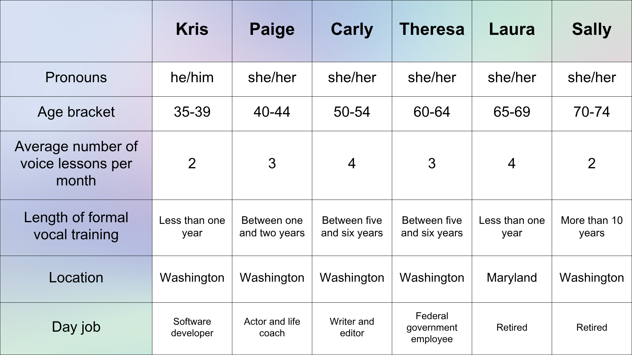

The data analysis phase took the form of three phases. First, in the descriptive phase, the data underwent its first round of coding, using the Delve coding software. The first cycle utilized an inductive approach and descriptive, subcoding, and in vivo coding methods. Descriptive coding uses a word or phrase to describe what may be happening in a passage, while subcoding allows codes to “nest” within one another, organizing related codes and enhancing the analyzed data (Saldaña, 2013). In vivo coding creates codes from the participants’ own quotes, allowing their voices to remain at the forefront of the data (Saldaña, 2013). This first phase identified similarities and differences in the data, while still preserving its original context (da Silva Barreto, Marcan, and Garcia-Vivar, 2017).
Next, in the contextual analysis phase, a second cycle of coding utilized pattern coding, which identified the overarching themes (Saldaña, 2013). This second cycle was both inductive and deductive, refining existing codes while also creating new codes. The interview and lesson transcripts were analyzed at the same time, allowing themes to appear in both environments and enrich the understanding of the participants’ experiences. This also helped to identify when, for example, a situation or emotion that the participant discussed in the interview would appear in their lesson. Finally, the third phase of the data analysis was the development of the themes and “theoretical formulations” reported in the findings and discussion (da Silva Barreto, Marcan, and Garcia-Vivar, 2017, p. 636).
While some ethnographic studies may not use recordings and may instead rely on field notes (Higginbottom, Pillay, and Boadu, 2013), the nature of this project required video recordings to be made. Knoblauch (2012) calls video recordings a more “reliable” data set than field notes (p. 73), but more practically, it allowed the participants and their teachers to be able to record lessons on their own schedules and did not require special lessons to be conducted for this research. This also may have allowed the lessons to be recorded in a more natural state than if they had been specially organized.
Having personal relationships with all six participants, and being the teacher for five of them, provided both benefits and limitations to the research. Focused ethnographic researchers may use their pre-existing knowledge of people and situations to help them decide how to structure the research in order to efficiently answer their research question (Shannon, Soltani, and Sugrue, 2024). During data collection for this project, I used my pre-existing relationships with the participants to prompt them to discuss areas they may have forgotten to bring up, such as reminding Kris to discuss his podcast during his interview. It is also possible that the participants were more participating in research conducted by someone they knew rather than an unknown researcher, perhaps exemplified by some participants’ use of profanity both in lessons and in interviews. This language is preserved in the data and report because an important goal of ethnography is to observe an environment with as little interference as possible (Castañeda, 2006; Diaz, 2024). While still discouraged in some formal settings, profanity can be used as a tool to express emotion and “convey world views or internal states” (Feldman, et al., 2017, p. 816; see also Jay, 2009). Censoring the participants during data collection would be changing the environment, and sanitizing the language during data analysis would misrepresent their experiences.
While recording the lessons with my students, I was acting as both a participant and an observer (Higginbottom, Pillay, and Boadu, 2013). In the lesson, I was a participant in the activity, but while creating the transcripts and analyzing the data, I became an observer. These roles were intertwined with my larger role as an insider researcher, embedded in the environment I was researching (Bonner and Tolhurst, 2002). However, the personal relationships and the multi-layered roles of insider researchers requires significant transparency and reflexivity, especially during ethnographic data collection and analysis (Higginbottom, Pillay, and Boadu, 2013).
While qualitative research will always be influenced by the researcher (Denscombe, 2003), I attempted to mitigate my own influence in two ways. First, during the lessons recorded with my own students, I did not change the content or structure of the lesson at all, although occasionally the interviews, the research project would be mentioned. This also occurred in the lessons for the participant who is not my student (Sally): her teacher recommended that I reach out to another voice teacher to solicit participants and made sure I knew about a vocal fold injury that Sally had suffered. Other than these occurrences, the lessons were conducted as they usually would have, with no interference or special content.
Second, while conducting the interviews, my goal was for the participants to talk as much as possible, with as few interruptions from me as possible. Since the interviews were conducted over Zoom, I held myself accountable by staying on mute unless I had a question or prompt and had to make the choice to unmute myself. This was originally serendipitous, as I was attempting to preserve the sound quality of the recording during the first interview while there was landscaping work being done outside of my apartment, but I quickly realized that keeping myself on mute would help to minimize my influence and allow the interviews to be driven by the participants.
A concern with ethnographic studies, and all qualitative research, is the ability to generalize the findings and the subsequent ability to apply them in settings that are not those directly studied (Hammersley and Atkinson, 2007). This is especially true in focused ethnographies (Shannon, Soltani, and Sugrue, 2024). While this study aims to analyze participant data while respecting the context in which it was gathered, broad generalization is not a goal of this research. Amateur adult singers are grossly underrepresented in the current literature, and the act of describing and analyzing the experiences of six singers in this context is the first step to grasping their understanding of singing and the role that lessons play in their lives. With relevance instead of transferability as a goal, then, it is hoped that this research is a launching point for further research concerning amateur adult singers.

Chapter 3: Findings
The stories of the participants fell into a pattern: the experiences that led them to take singing lessons, the experiences inside the lesson, and their lives outside of singing lessons. These larger themes are broken down into smaller subthemes (see Table 5) and discussed in detail in this chapter.

Table 5: Themes and subthemes generated by data analysis
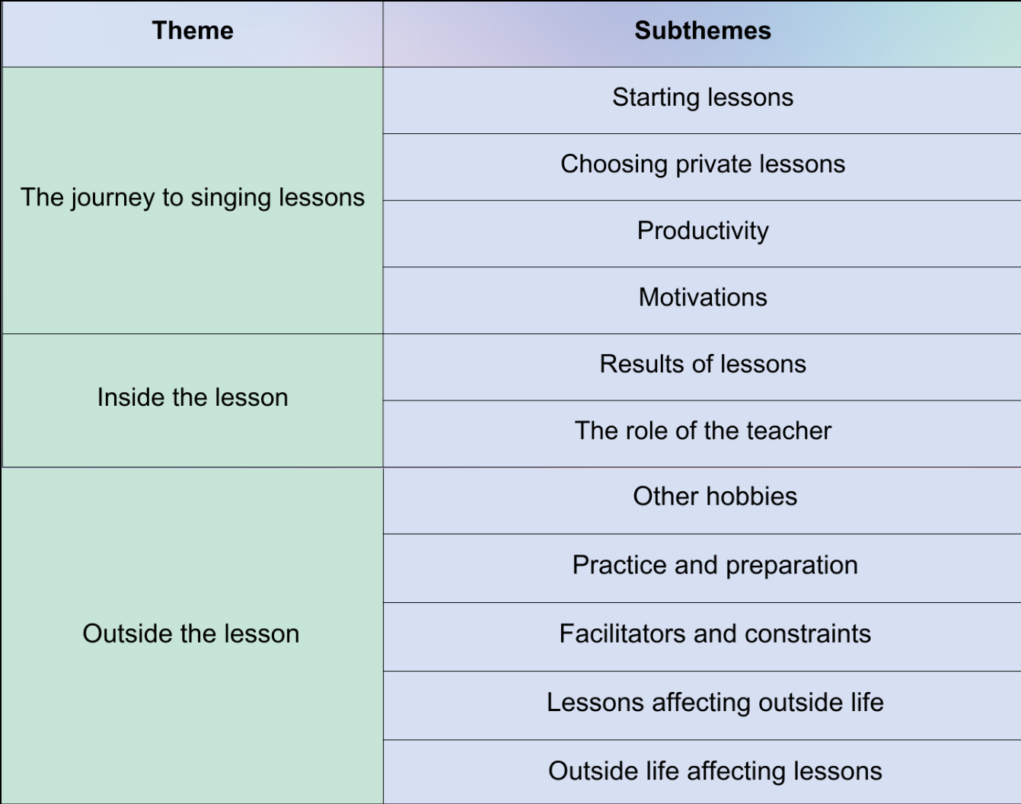

THE JOURNEY TO SINGING LESSONS
For many participants, the journey to singing lessons began before they actually began looking for a teacher. Looking back fondly, Sally described singing in the car with her family on road trips. Theresa sang with a female barbershop choir and now performs with a ukelele rock band. However, some participants’ previous singing experiences were less positive. Laura said when she was in her teens, she had a “secret wish” to take singing lessons, but when she told her best friend, the friend laughed: “It seemed like for 10 minutes. I’m sure it was like 20 seconds, but I thought, ‘Well, okay,’ so I never did it.” Carly also described hearing her mom call herself tone deaf and say that “nobody in our family is musical,” which discouraged Carly from singing or playing an instrument.

Starting lessons
The catalyst that pushed participants into taking lessons appears to be a matter of timing and proximity. Participants describe how being older has changed their perspective:
I really love acting and I want to act.... I will be 45 this year and these things shouldn’t matter in totality, but they do matter in practical senses. (Paige)
If I started in my teens, I don’t know how long I would have lasted. I would have been so self-conscious.... I was also, in my teens, not inclined to listen to authority figures. So even though I wanted to please the teacher, I also didn’t.... And I do think when you’re older, you realize, well, I could blow this off, but... then I lose. The teacher doesn’t lose. I do. (Laura)
But also, I am middle aged and I do have more of a goal to do more things that are difficult for me because I do think it’s worth doing as a human and I do wish I had done it... earlier. And I’ve also realized... there are great things about being a middle-aged woman. Like, nobody is really paying attention to you, as if they ever really were.... You can kind of do whatever the hell you want when you get to be a middle-aged woman. (Carly)
For these participants, aging has played a role in how they see themselves and how they choose to spend their time. Paige is beginning to pursue a career as an actor after studying acting on the evenings and weekends while working a day job; for her, singing is a skill that gives her an advantage in a field that is especially challenging for middle-aged and older women (Robb, 2019; Geena Davis Institute, n.d.). For Laura and Carly, the self-consciousness that they might have felt when they were younger seems like less of a barrier. Carly attributes this to the perceived invisibility of white middle-aged women in America, a phenomenon described in Bouson (2016), while Laura posits that the anti-authoritarian attitude she held in her youth would have hurt her learning experience.
In addition to age, a personal connection to the teacher, either direct or indirect, also seems to have acted as a catalyst to begin singing lessons. Most of the participants who are my students were connected to me through the theatre company where I am a member. Paige and Kris are both members in the theatre company as well, and that led them to reach out to me for lessons:
Being able to have somebody that I have worked with... and a friendly face and... [someone who] comes highly recommended from other friends... made it very enticing. (Kris)
I just feel so much desire to learn from people that I am connected to through theatre. And so it was a lovely way in which to... bridge that desire to learn how to sing and be able to support a fellow actor who is in my community. (Paige)
Laura’s daughter is also in the company and Theresa is friends with another member, who she asked for a recommendation. Carly is not connected to the theatre company, but she is a family friend and began lessons after her husband began lessons with me. Sally is not my student, but she met her teacher while taking a group singing class.
While this sample size is not large enough to generalize from these findings, it is possible that AAS either seek out a teacher they know personally or rely on recommendations because they feel more comfortable going to these teachers than one they have no prior connection to. Some participants in this study called singing “scary” and described feeling “very vulnerable,” “nervous,” and “self-conscious” in the lessons and when practicing. Participants in other studies on adult “non-singers” often described negative interactions with musical authority figures such as music teachers or choir leaders that lead them to refrain from singing (Pascale, 2002; Abril, 2007; Knight, 2016). Participants, both in this study and in others (Whidden, 2009), also describe feeling intimidated by the cultural expectations of what a singer is:
It's extremely vulnerable because there's so many expectations of what a singer is, looks like, and [it] has these societal norms.... It's the best of the best.... So that that's what singing is. And if I had to reach for that, I will never do it. (Paige)
So many people sing in so many settings. It's such a widespread thing. I just feel there's almost this expectation that you're going to be decent at it just naturally because everybody sings at something. (Carly)
Very little literature considers how students find their teachers, most being books for aspiring singers, such as Marquart (2005) and Stohrer (2006). Based on these findings, it seems likely that adults taking private voice lessons seek out someone who they perceive as safe, which may mean they stay close within their social circle to find a teacher.

Choosing private lessons
Participants also discussed why they chose to take private lessons instead of a joining a group singing class. They identified wanting personal attention that they felt would be difficult to get in a group setting:
It's a one-on-one relationship that I feel like, as cheesy as it sounds, I'm getting the focus that helps me build my instrument as I am.... There is this sense that I'm being seen and heard and I'm not having to compete. I'm not having to stand out and not having to do anything other than just be me in order to get to where I would like to go with this skill. (Paige)
I haven't done group lessons or looked into group lessons because I don't know how much specific focus I would get in a group lesson. (Kris)
Before looking for a private teacher, Theresa had tried an asynchronous online singing course where the lessons were pre-recorded for a general audience and students would record videos that an instructor would evaluate. She felt, however, that she was not getting enough feedback with this format and “it wasn’t very fun, really.” Carly also said that she would not take group singing lessons because she “would literally melt into the floor and die.”
Participants also discussed the importance of having a regularly scheduled lesson to help them prioritize singing.
I've kept taking them primarily because I know that if I don't keep taking lessons, I will not keep practicing and improving on my own. I know that about myself.... So a lot of it is just to, to keep me doing it. (Carly)
Kris, who often works in theatre as a sound designer, composer, and band member, talked about how singing lessons help him bridge the gap between shows so his singing “doesn’t... atrophy as a muscle.” He compared the peripatetic nature of working in theatre to having a regularly scheduled lesson:
[It’s nice to take] a lesson and [know] that like, okay, well, I don't have to solve everything today. I don't have to get to the end goal today because who knows when that next opportunity is going to be.

Productivity
Participants viewed learning to sing as a hobby that feels productive, and having regular lessons helps them to feel as though they are making progress:
In a weird way, it's kind of hard for me to do things that are just for fun, unless it's like a scheduled, planned, just-for-fun thing. So that's how I do singing. Because even though it is fun, I won't do it so much if I don't schedule it. (Carly)
I'm not very good at not doing something just to do it.... For whatever reason, my mind has been so programed to – it has to have an end goal. (Paige)
It could be argued that this sentiment is connected to the concept of “hustle culture – the idea that every nanosecond of our lives must be commodified and pointed toward profit and self-improvement” (Martin, 2020, n.p.). While this idea is mainly connected to work culture, it also may affect how people choose to spend their free time and how hobbies are viewed. If, as hustle culture would lead us to believe, every moment must be optimized as an opportunity for improvement, and perhaps monetization, then hobbies must have a point; hedonism is not an option. This will be further considered in the conclusion.

Motivations
The motivations that led the participants to take private singing lessons were diverse. Participants wanted to learn a new skill that challenged them, which was demonstrated in lessons as participants chose difficult repertoire or challenged themselves to sing along to a karaoke track. For some, this was related to their age, saying that they are more willing to do difficult things as adults than they were when they were younger. Participants also called singing “inherently fun” (Laura) and described having fun in their lessons:
It's just fun to sing songs and bounce the song ideas back and forth and learn new songs. It’s just fun. (Kris)
I do this for fun...Regardless of whatever we work on, it’s always fun. (Theresa)
Participants also mentioned wanting to feel more comfortable when singing, both for their own sake and for the sake of the people around them.
I don't want to be that person in the choir that everybody's thinking, “She should just go somewhere else because she doesn't understand counting.” We've all had that experience, right? (Sally)
[The primary motivation for me was] the potential for public humiliation and to be able to understand what the heck I needed to do. (Theresa)
I am one of those people who is motivated by other people's experience in life. So I want other people to have a good experience while I'm singing. (Carly)
Despite this, performing for an audience did not seem to be a significant motivator for the participants, although most participants do perform in some fashion. Kris said he does not want to join a choir, but does enjoy singing in smaller groups. Carly loves organizing sing-a-longs for her family and friends, but did not express a desire to perform in a more formal setting. When Sally began singing lessons, perhaps because she had experience taking private viola lessons and understood how she worked in that environment, she set specific goals, the first of which was being able “to sing in front of an audience without choking up.” Once she accomplished that, by becoming a song leader in her Rotary Club, she set other goals. Now, ten years after beginning lessons, she says that her main motivation is keeping her aging voice healthy and “performance really isn’t a part of it.”
As a member of a ukelele rock band, Theresa did identify performing as a motivator for taking lessons because she feels she brings “something that’s unique to the area” – specifically, her identity as a Chinese-American woman in her sixties:
Representation of the underserved or underviewed audience is important to me. So that would actually be the reason why I [perform]. It’s not because I really want to. It’s because there aren’t any women doing it, there aren’t any older people, there aren’t any Asians.... I mean, I definitely don’t see Asian women my age doing this stuff ever.
She says that she joined the band “because she was asked:”
It’s not something that I ever wanted to do... But, you know, when someone asks, you have to do it. I mean... you don’t want to have some guy fill that role. If you’re asked to do something that no one else is doing, you have to do it.
She also identified a long-term goal of starting an “all-girls” band, but she hasn’t “gotten any takers on that.”
The participants’ motivations discussed here represent both extrinsic and intrinsic motivations. Extrinsic motivations are those that come from outside forces and intrinsic motivations are those that come from within oneself (Sinclair, 2008). The external motivations described by these participants are those driven by public perception. The intrinsic factors identified are those related to the perceived inherent value of singing, such as being fun and staying healthy. Research has suggested that intrinsic motivational factors are better predictors of continued involvement in music (Renwick and McPherson, 2009; Lamont, 2011; Burnard, 2012). Therefore, while external motivations may always be present in music education, adult singing students should also be encouraged to find intrinsic motivation in their studies (see Whidden, 2009; Knight, 2016; Ruhnke, 2020; DenBleyker, 2024).

Table 6: Themes from the journey to singing lessons
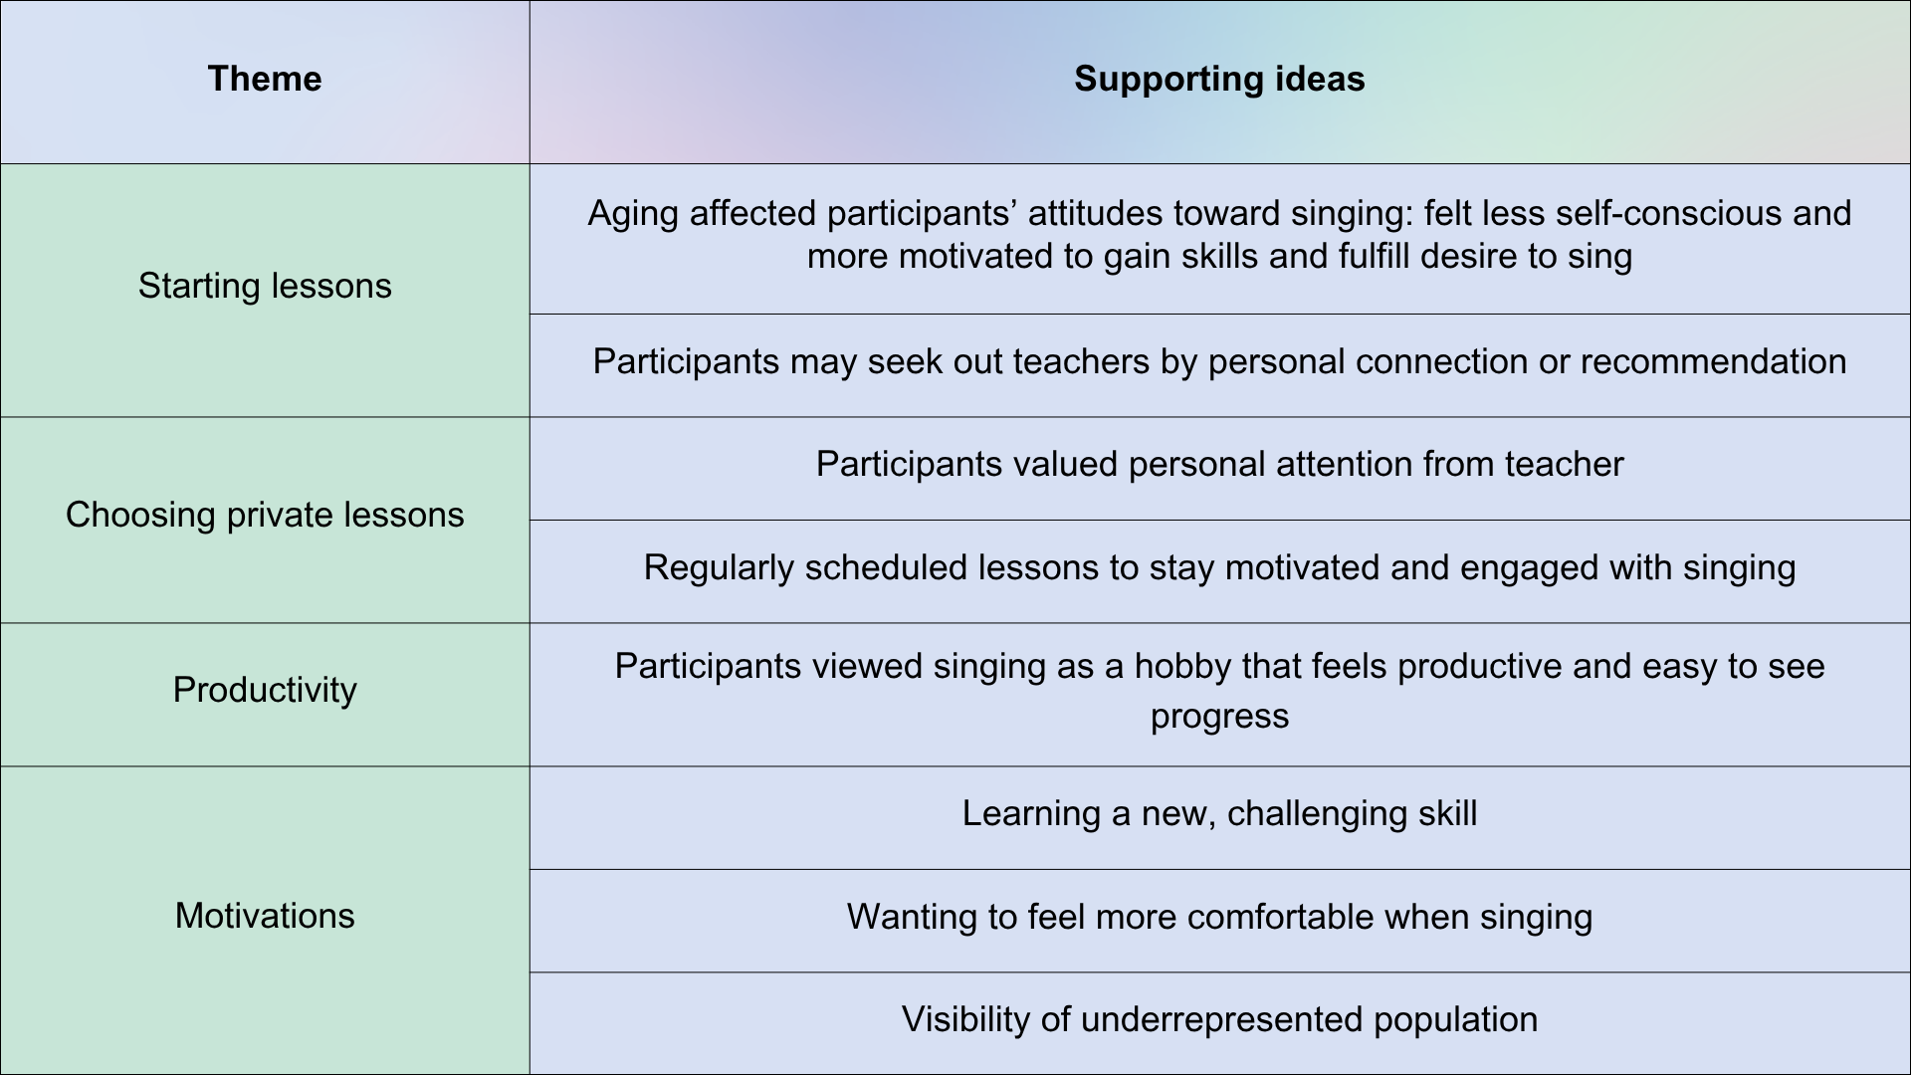

INSIDE THE LESSON
Results of lessons
While technical skills were not examined in the aims of this research, once in a pattern of regular lessons, many reported noticing improvement in their technique, such as a wider pitch range and a greater awareness of breath and vowels. They also described a greater knowledge of music and singing and an understanding of how the voice works.
I was taking private singing lessons and I just... really enjoyed the sense of learning about my voice and about how to use my voice and my breath in ways that I had never been exposed to before taking private lessons. (Sally)
[Before taking lessons,] I didn't know the structure of music, the structure of the throat and the breathing. (Laura)
What I like about it is how much I'm learning compared to how much I didn't know. (Theresa)
These changes were noticed by others as well, such as Theresa’s choir mentor who told her how much she had improved. Kris also noticed that he was better able to help the singers he worked with in theatre, giving them feedback that helped them to sing more efficiently.
I’ve been on both sides of it now... On my own side, [we did] instead of “Ah," we go “Aw.” I could actually hit that note and it sounds great. And it's this great reveal. And then like I was talking to [an actor] like, “Try to ‘Aw’ instead of ‘Ah’ for this note.” He’s like, “That's amazing!” It's like, “I know!”
With this increased skill and knowledge also came greater confidence, which the participants directly attributed to their lessons.
I think the lessons actually have given me the confidence to do things that I wouldn’t have done without the lessons. You know, singing in front of a crowd of people or even singing with the choir or even being willing to and able to audition. Those are things I... can’t imagine doing without the lessons. (Sally)
[Taking lessons] has... changed my life in terms of, like, being able to perform because I honestly don’t think I could have done it without having a breakdown. (Theresa)
Participants reported a sense of pride, both in pursuing lessons and in the work that they have done, saying, “I’m glad I didn’t talk myself out of it” (Laura) and “I am proud of myself for exploring” (Carly).
Participants also described a change in how they think about their bodies and the relationship they have with their body.
It gives me a sense of living in myself and my body. It's being able to see and understand and accept where I am in my in my physical form.... It makes me more aware of my physical form and therefore my physical form in relation to other physical forms. (Paige)
I think I'm more conscious of the relationship of body to voice. And so, outside I'm more conscious of the tightness... that I have to try to get rid of. Because before I would... just kind of deal with it, but now I have to actively work on releasing whatever tension I have in different places. (Theresa)
It's kind of like when I do yoga. I'm just amazed, like "My body can do this," and singing is kind of the same, right? Like, I can actually hit that high note. That's pretty cool. So kind of exploring what you – not just what you can do, but the relationship with the physical body, in your own-body experience. (Carly)
In the lessons, participants were able to tell the teacher how their voice felt when beginning a lesson (“I’m a little bit on the stuffy side”), as well as demonstrating an understanding of vocal health and hygiene by taking care of their voices in between lessons. Participants described making sure they were hydrated and being conscious of how they were using their voice throughout the week, especially those who use their voices a lot for their jobs. Research has shown that incidences of vocal injury are higher in amateur singers than professional singers (Cohen, Noordzji, and Garrett, 2008; Vella, Brown, and Phyland, 2021), likely due to lack of training and education. Some research has examined amateur choral singers’ use of warm-up and cool down exercises (Levett and Pring, 2023), but further research could investigate how gaining understanding of vocal health affects the habits and practices of amateur singers.
This study did not seek to measure indicators of physical or psychological well-being, as many other studies on amateur musicians have done (Cuypers, et al., 2012; Theorell, 2014; Bonde, Juel, and Eckholm, 2018). However, these findings reflect increased confidence, pride, and physical awareness, as well as improved knowledge of vocal technique and vocal health, which may align with the types of benefits described elsewhere. These results may only be accurate when considered in relation to singing; for example, it is possible that an increase in confidence when singing does not spill over into increased confidence in other areas, and improvements in vocal technique may not ripple out beyond a voice lesson or performance. However, participants did seem to suggest that the positive effects they attributed to their singing lessons impacted other areas of their lives as well. This will be discussed later in the chapter.
Despite these positive responses, participants also expressed ongoing anxiety and nervousness around singing, and this was reflected in their lessons as well. Laura said that she shuts the doors and makes her husband put in earphones while she takes her lesson on Zoom, even though “[he] doesn’t care what I sound like.” Carly said that while she doesn’t feel nervous doing things like public speaking, singing still makes her feel anxious. This self-consciousness was apparent in lessons when students would say things like, “That was terrible,” “The sound is still not great,” or “Some days it goes better than that.” Paige was perhaps the most vocal about her discomfort with singing, often releasing nervous energy by sighing loudly, swearing, or engaging in self-talk:
[After singing a verse of her song] Fuck. Fuck. That’s what I got out of that.
[After singing her voice cracked] Oh God, breathe.
The participants who were the most open about their anxiety, both in interviews and in the lessons, also tended to be the ones who were the newest to vocal training. At the time of the study, Paige had taken lessons for about one year while Laura had only had one voice lesson before data collection began. Carly, while candid about her anxiety around singing, had been taking singing lessons for about five years, but she thinks her anxiety will never go away:
I have to admit I always have anxiety before every lesson because there is still some anxiety attached to singing for me, there probably always will be.... It's really hard for me to sing, even for one person, even for a really supportive person.
Despite these nerves, the participants also showed resiliency. Often, after expressions of frustration or self-deprecating comments, the student would immediately try again or acknowledge that they had tried their best:
Normally I know the lyrics, but I forgive myself for that ‘cause I know it’s just nerves. (Laura)
[It felt] awful. It felt really, really awful. But I did it, and that is huge. I’m just going to get that out there. (Paige)
The concept of resiliency in adult education is described in terms of persistence in response to outside forces that may cause a student to quit (Comings, 2007) as well as resilience when facing difficult material in the classroom (Martin, 2012). Cousins et al. (2019) investigated this academic resilience in the context of a math course for adult learners, using the concept of mathematical resiliency (Johnston-Wilder and Lee, 2010). Math and music are both subjects which can evoke feelings of “anxiety and avoidance” (Cousins, et al., 2019, p. 46; Abril, 2007); as such, resiliency is needed when adult learners work toward obtaining these skills. Johnston-Wilder and Lee (2010) identified four aspects of mathematical resilience that translate to musical resilience and were observable in this study’s participants: having a growth mindset (Dweck, 2006), “finding personal value in... achievement, [willingness] to engage and struggle with learning, and [ability] to effectively recruit support” (Cousins, et al., 2019, p. 52).
Singer identity also shifted for some participants, with the lessons helping them to believe that “singing is something I can do” (Carly) and to “see myself as a singer now” (Theresa). These identity shifts can be complicated and inconsistent, especially if the student has identified as a “bad singer” or “non-singer” for many years (Wise and Halpern, 2024). Some participants still felt hesitant to identify as a singer, even while describing the positive changes they saw in themselves and in their voices; Carly described herself in a singing lesson as a “non-singer.” Very little research has been conducted on changing identity in adult singers (Wise and Halpern, 2024), and more research on this topic could help both teachers and students navigate this transformation.

The role of the teacher
While analyzing the work of the teacher was not part of this research, participants still chose to discuss how their teacher supported them in the learning process. Paige described lessons as a “cycle” where “no matter where I am, I’m accepted,” which makes her want to continue to work hard in lesson. She also discussed her desire to work with a teacher who helps her to be independent and build self-efficacy:
I look for instructors who give me tools to be able to find my own opinion of myself and my abilities.... [Building self-efficacy comes from] finding that instructor [who] will help ask the questions like, “How did it feel to you? What was your experience? How do you know?”
Sally said that the confidence she found while taking lessons was because her teacher “makes me feel like I can do those things... that I’m capable of doing this.” Laura agreed, saying her teacher doesn’t make her feel like she should “just leave.” Carly also said that it’s important that she has a teacher that supports her “unconditionally:”
Like, “Wherever you're starting out, whatever level you are, however close you are to your goal or not close, I'm going to support you. I'm not going to be critical. I'm not going to tell you you're terrible....” Well, hopefully no singing teacher would do that. But just the feeling of that kind of unconditional support, like, “We'll get there together...” is super important because I do have these anxieties tied up with it.
To Carly, this type of support feels therapeutic. In a lesson, she mentioned that “there’s a lot of therapy involved in something musical... because no one’s going to be able to achieve anything if they don’t feel comfortable.” Laura also drew a parallel between her lessons and therapy:
I’m doing something that I was so afraid to do.... So I think every time you can kind of just do that, it is a good thing. And I don’t think we’re talking about, like, our deep-seated problems, but just talking with someone and focusing with a coach or a teacher on something that you are accomplishing together is therapeutic.
There is an ongoing conversation among voice teachers about the boundaries between voice lessons and therapy. The literature is clear about the link between group singing and mental health (Morrison and Clift, 2012; Williams, Dingle, and Clift, 2018; Malviya, Zupan, and Meredith, 2022) and approaches such as trauma-informed voice care (Monti, Durhan, and Reynolds, 2024) and Acceptance and Commitment Therapy (Juncos, et al., 2017) have begun to gain traction with voice teachers. Still, voice teachers do not receive the training of psychotherapists or mental health counsellors and the work they can do is limited by professional and ethical boundaries (American Academy of Teachers of Singing, 2021; Moniz, 2025). However, if students are viewing their lessons not just as a means to learn singing but as a way to overcome specific anxieties, then teachers may benefit from training to help understand appropriate ways to support these students. Voice teachers could look to speech-language pathologists, who are trained to use a technique called solution-focused counseling to work with their clients (Tellis and Barone, 2018).
Participants said one thing they liked about their lessons was a balance between focused work time and socializing with the teacher.
We're on task, but we have fun and it's a very nice balance of... technical and social and human. (Laura)
I really value the chitchat, which probably lets me relax a little bit from that anxiety, but then once we kind of get into the singing part, I like the fact that we can be pretty focused...it's not just, “Okay, let's just sing.” (Carly)
Sally values singing as a community activity and is part of a community choir. However, she still views her private lessons as a social activity:
[My teacher] always has news about what’s going on with people that we know...There have been times when one of us, either [she] or I, will say, “You know, we should probably sing....” So I do think it’s a different kind of social engagement in some ways. It’s not 100% just, “I’m hiring you to help me sing.”
In the recorded lessons, participants and the teachers chatted about a wide range of topics unrelated to singing: travel plans, other hobbies, farmer’s markets, baseball, and pets were all discussed. Again, this may be due to the fact that many participants are my own students with whom I have a social relationship, but based on Sally’s experience, it appears possible that this may happen in other teachers’ studios as well.
Informal social interaction has not been examined in this context, although social interaction with peers has been shown to improve student learning in other contexts (Hommes, et al., 2012). Some research has been done on student-teacher relationships in private lessons (Serra-Dawa, 2014). For the participants in this study who are new to singing, socializing with the teacher appears to have made them feel more comfortable and less anxious. The more experienced participants also seem to appreciate the social aspect of their lessons as well. This may also benefit the teacher, as understanding a student’s life, even on a surface level, may help the teacher to respond reflexively in their teaching. In an article on transformative pedagogy in the private voice studio, one teacher said:
I do a lot of … getting to know [the students], so that if they come in and they're not well, if they come in and they're stressed, I can be aware of it really quickly … I don't want to sit and be a counsellor. I want to work with their voice, but I have to work differently according to their mood. (Carey and Grant, 2016, p. 58)
These last two findings, the perceived therapeutic role of the lesson and the apparent importance of informal socializing in the lesson, suggest that amateur adult singers expect their teachers to do more than just teach them how to sing. The limited research available on the expectations of singing students has been conducted mainly with university students and only discusses expectations in relation to vocal technique and lesson content and structure (i.e., private or group instruction and advice for career development) (Simones, 2017; Şakalar and Gürel, 2023), making this a novel finding that should be researched further. While teaching may take up a majority of the lesson time, it appears that emotional support and ability to connect on non-musical subjects are almost equally as important to the participants. Voice teachers are encouraged to think about their “ideal client” when building their studio (Deveaux, 2021; Perna and Pigott, 2021; Canchola, 2025), but it may also help to recognize what these students are looking for in a teacher.

Table 7: Themes from inside the lesson
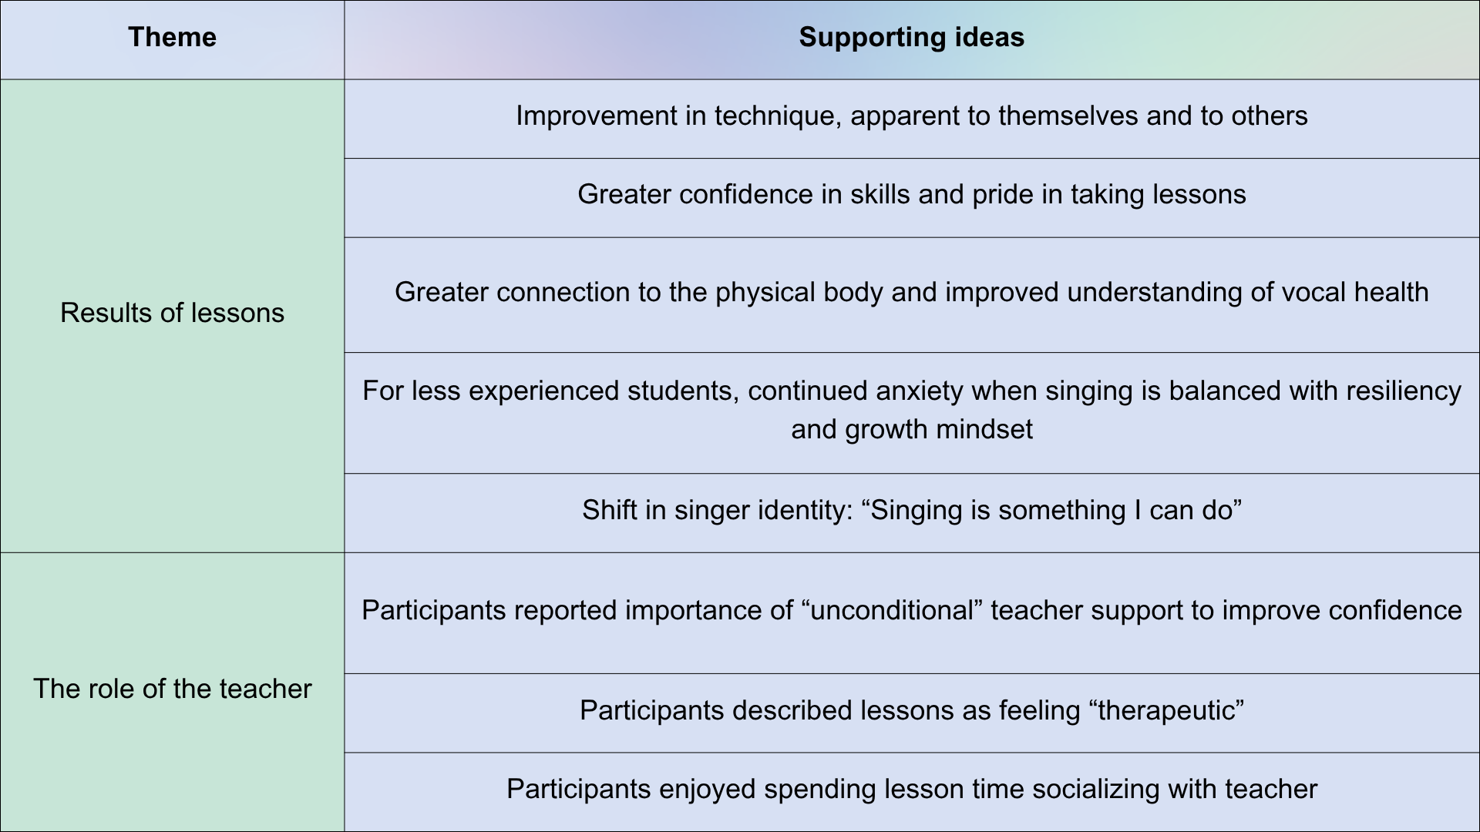

OUTSIDE THE LESSON
Other hobbies
It is interesting to note that most participants began playing another instrument before beginning singing lessons. Theresa and Carly play the ukelele, Sally plays the viola, Kris plays the guitar, and Laura plays the piano. While Sally and Carly did not play their instruments in the recorded lessons, the others used theirs in some way, either accompanying themselves or using an instrument to check a pitch. Some would also talk about their instrumental teacher in their singing lesson, bringing up things that they had discussed with them or what they had done in a recent lesson. This suggests that adults who take voice lessons are likely to explore singing after learning another instrument. This may be because they want to sing along with their instrument; in this study, the piano, guitar, and ukulele are all instruments that are common to sing with. However, since participants described singing as “vulnerable,” perhaps their experiences with the other instruments helped them to build confidence to try singing lessons; however, further research should be conducted in this area.
Participants also reported enjoying hobbies unrelated to music. Theresa enjoys baking bread and physical activities like working out. Kris plays board games and hosts a podcast. Carly has recently started “guerilla gardening,” where she maintains public green spaces that have been neglected. Paige is committed to “be good at something” and so has limited her hobbies to those that help her reach her acting goals, like reading and listening to podcasts.
When comparing singing lessons to their other hobbies, participants said that they approach their lessons differently. Kris called his approach to voice lessons “novel” because he is more likely to “try to figure out a lot of stuff by myself,” and so he hasn’t sought training for many of his other hobbies. Sally said that she approaches singing in a “somewhat similar” way to how she approaches the viola because she is trying to build a skill, but it differs in that she “treasures” singing for its community; her other hobbies are more solitary. Theresa also reported that she approaches her singing lessons differently because, unlike her other hobbies, she has a goal. Carly also said that her singing lessons feel different than her other hobbies because she experiences anxiety around singing that she doesn’t experience with other activities.
Examining the other hobbies in the participants’ lives and comparing their approaches to lessons and to other hobbies allows better understanding of the role of lessons in the participants’ lives. Some of the other hobbies described by the participants involved much less regular commitment, or were more “passive,” as Theresa said; some did involve more engagement, such as Kris’s podcast. However, the participants in this study seem to view their lessons as “serious leisure,” the “systematic pursuit of an... amateur activity” (Stebbins, 2016, p. 875), which was described briefly in the literature review. Leisure activities have been shown to provide meaning and well-being to people’s lives, and these benefits are more likely to occur when the activity is intentionally and reflexively pursued (Iwasaki, Messina, and Hopper, 2018). Singing lessons, therefore, may provide more of a benefit to the lives of the participants than the other leisure activities which they engage in.

Practice and preparation
Spending time practicing in between lessons is an expectation when taking singing lessons (Smith, Kleinerman, and Cohen, 2022). Participants in this study reported various attitudes toward practicing, with many describing their practice time as limited. Laura said she practices a few days a week, doing “a little bit, steadily,” although “it kind of depends what’s going on in the week.” Paige says that her “ideal” practice routine would involve looking at her notes once or twice in between lessons, but she often needs to tell herself, “Paige, just sing:”
The key part of any practice that I found for myself as a human is... to make it as simple and accessible as possible so that I actually do the work. Whether I do it perfectly, I have to let go of that idea and truly just do it. And sometimes that is the hardest part.
Carly describes her practice time as “casual.” For her practice time, she puts on a “giant” playlist of songs she likes to sing along to:
[I] just sing along with them because even that is something that was difficult for me before, even just singing along to myself... I was really self-conscious about it. So now... singing along with whatever I'm playing, I consider that part of my practice because really any singing for me is, again, way more than I used to do.
Kris also uses recordings when practicing, emphasizing that repetition is important for him:
[Google] Chrome has this fun feature where the tabs... reload and YouTube will just start playing again. So as I'm going through tabs to clean them... the song [restarts].... So it's less focused practice time when I'm busy with a lot of things, but... just finding times to just like play it, hear it, either sing along to it or just like hum along to it or get it in... the ear is useful.
Sally admitted that she doesn’t spend time practicing between her lessons unless there’s an upcoming event like a recital.
In a study on older adults taking voice lessons, participants averaged about 45 minutes per practice session, although it is unclear how many times per week this was repeated, which the researchers found to be “consistent with the value ascribed to voice lessons of this set of older adults” (Smith, Kleinerman, and Cohen, 2022, p. 929). In the current study, the participants do seem to value their voice lessons, but tend to spend very little time practicing formally or do so in unorthodox ways. This may be due to a lack of time, especially for those who are still working, but further research could be conducted on the correlation between value ascribed to singing lessons and amount of time spent practicing, as it may vary between participant groups. It’s also been shown that teaching style affects practice habits (Barry, 2007; Baughman, 2017), which is relevant to this study since five of the six participants are my students and therefore their practice habits are affected by my teaching style.

Facilitators and constraints
The experience of taking voice lessons is framed by facilitators and constraints (Stebbins, 2013). Facilitators are factors that encourage participation in an activity and/or provide the necessary resources to do so; constraints are factors that discourage or limit participation (Raymore, 2002). A common facilitator for participants in this study was a supportive spouse. Carly’s husband took singing lessons before her and encouraged her to begin lessons; she says that she is more likely to practice when she hears him practicing. Laura says that, to mitigate her self-consciousness when signing, she asks her husband to put on headphones and go to a different part of their house, even though “he doesn’t care.”
The participants in this study identified their spouses as facilitators, but it may be that those with less supportive partners are not able to take voice lessons and therefore are not represented in these results. In the literature, spouses and families have also been shown to be a constraint, with women facing the largest barrier (Lilliestam, 2013; Liu and Stebbins, 2014; Smith, Kleinerman, and Cohen, 2022). Coffin (2004), describing the experiences of the members of a female barbershop chorus, recognized a trend where the members’ husbands were supportive when their wives first joined the choir, but “as the wives became more enthusiastic and interested in this hobby, the husbands fell sullen and often created barriers to their wives attending rehearsals” (pp. 23-24).
Another common constraint for adult learners is the limited time that they are able to commit to learning outside of the classroom due to “life demands,” such as family or work responsibilities, and occasionally these demands require them to drop out altogether (Comings, 2007, p. 60). In this study, participants were asked what would make them quit their lessons. Some participants said that if they were no longer able to prioritize lessons, either for positive or negative reasons, they would stop taking them:
If we're traveling, if we go on like a round-the-world cruise for a year, and then if I stopped doing it for a year, I might not restart. (Carly)
Paige also discussed her desire to prioritize lessons, saying she would stop taking lessons if she felt she had stopped making progress or was “wasting too much time.” Kris responded that he might move from regularly-scheduled to more occasional lessons if he began to feel more comfortable with his skills. Theresa and Sally both said they would stop taking lessons if they were physically no longer able to sing. Sally also added that she would be discouraged from taking lessons if she had to find a new voice teacher: “It’s like starting to date after you’ve been married.”
However, almost every participant identified financial strain as a reason they would stop taking lessons. Paige said that she is currently living off of her savings while building her life coaching practice and finding work in theatre, and so anticipates a time when she will have to rebalance her budget and minimize her discretionary spending. Laura and Sally are both retired and are using their retirement savings to pay for lessons:
Yes, this is all coming out of my retirement. It’s fine. Again, [I’m] very lucky that I can do that. (Sally)

I mean, we are retired, so if our retirement account disappears, and Social Security and Medicaid, then probably I wouldn’t be able to take [lessons]... When that happens, I’ll be living in a tent anyway. (Laura)
Kris identified a specific circumstance in which he would have to stop taking lessons. His wife works in American public broadcasting, which is funded indirectly by the federal government (Corporation for Public Broadcasting, n.d.). Recently, the current U.S. president accused certain broadcasters of being biased and threatened to withdraw funding to these broadcasters (Folkenflik and Neuman, 2025), including the organization where Kris’s wife works. In his interview, Kris said that if his wife’s job were jeopardized, they would need to reorganize their finances and he would have to reconsider taking lessons. In fact, a week after his interview, funding for his wife’s organization was cut (Executive Order No. 2025-08133, 2025) and he was forced to pause his lessons “in anticipation of a lean period.” He and his wife gave permission for this information to be used in this report.
For the AAS in this study, singing lessons seem to be budgeted as discretionary expenses. While those experiencing financial scarcity still spend money on discretionary items, perhaps proportionally more than who are financially secure (Sarial-Abi, et al., 2023), this study demonstrates how influential personal finances can be in the decision to begin or continue singing lessons. It must be noted that all participants in this study live in states with median incomes that rank in the top ten highest in the United States (United States Census Bureau, 2023a); the greater Seattle area, where most participants live, has a median income higher than the richest state (United States Census Bureau, 2023b). However, Seattle also has a cost of living higher than the national average (Council for Community and Economic Research, 2023), which makes it difficult for some to live in the area (Nickelsburg, 2025) – to live “comfortably,” a single adult would need to earn $128,000 (DeJohn, 2025).
Participants acknowledged their privilege, using words like “fortunate” and “lucky” to describe their ability to afford lessons with little impact on their daily lives. Some literature discusses the correlation between socioeconomic status and participation in musical activity, but they are focused on school-age students and music education in schools (Hoffman, 2013; Nichols, 2020; Shaw and Auletto, 2022). Burton (2022) and Smith, Kleinerman, and Cohen (2022) may be the only literature that discuss financial equity and private music lessons.
When considering the constraints faced by participants, the ideas of resiliency and value again become relevant. Every participant encountered some form of constraint – financial, geographic, temporal, emotional – that could have caused them to stop taking lessons. However, whenever possible, participants showed resiliency and therefore demonstrated the value that they find in taking lessons. For professional singers, the value of singing lessons lies in the outcome, in the performances they are able to give. For amateur singers, especially those who may not desire to perform publicly, the value lies in the lesson itself, which is shown by their resiliency in overcoming constraints. This is not to say that professional singers do not face constraints; however, since singing is at least part of their income, they are more likely to experience external motivation to overcome constraints.

Lessons affecting outside life
Participants were asked if they felt their singing lessons affect their lives outside of the lesson. Sally and Laura both said that their training allowed them to listen to music in a different way:
Once I started learning vocal technique, and especially when I worked on learning arias, I had a much greater appreciation and admiration for professional singers.... This appreciation has become such an integral part of my life that I almost forgot that it developed as a result of taking lessons. (Sally, in an email following her interview)
I'm listening more to phrasing and emphasis.... What are they drifting back on? What are they punching? (Laura)
Carly and Sally both talked about how learning to sing has made them feel more comfortable doing things that they’re not immediately good at.
I’ve kind of decided in my adult life that I’m going to do more things I’m not good at, or at least that I’m not inherently good at, and I’m going to be cool with that. And singing is a big part of that. (Carly)
Paige said that learning to sing has made her a “better human:”
It’s made me more confident as a person.... I'm a better human because I have more empathy... for that high pitched voice that I didn't enjoy.... And I think that allows for more connection to others. So, then, now I have the confidence to be able to say, “I want to connect with you.”
She does admit that this perspective on singing is shaped by her acting experiences as well “because we’re using the same tool.”
Participants also said that they have started to encourage others to take singing lessons as well. Carly said she’s become an “evangelist” for singing lessons. Theresa is also part of a large network of amateur ukulele players and has encouraged them to take singing lessons:
I know they would benefit from it. There are people that say, “I can’t do that....” I think people don’t what they don’t know. And then when people start knowing, then they realize, “Oh, there’s so much more to know.”
Laura has also become a “firm believer” that older adults should be involved in some activity outside the home:
I am a huge proponent that... the senior center ought to hire music teachers and vocal teachers... because I think... people ought to do it. I think it’s – healing might be too strong a word, but again, therapeutic. It's fun. And why not?
These perspectives again point to the well-being benefits that the participants have received from taking singing lessons. It seems that participants credit the lessons, at least in part, in helping them live a better life and want others to experience these benefits as well.

Outside life affecting lessons
While the participants reported that their lessons impacted their life, they also said that their lives affected their lessons, most often when their voices were affected by outside activities. In one lesson, Theresa said that her voice felt tired because she had to talk a lot at work that week. During the lessons that were recorded, Kris was playing in the band for a play and was often tired during his lessons, which made his voice feel “crunchy.” Before one lesson, Carly did some volunteer work and talked with the other volunteers, and so felt more warmed up coming into her lesson. This reflects a passing observation made in Grape et al. (2003), who studied the voice lessons of professional and amateur singers. They noted that while both professional and amateur singers had lessons during the day, only the amateur singers had lessons in the evening, presumably after they had finished working. All of the lessons for this study were recorded during the day, but it’s apparent that having to schedule lessons around other commitments has an impact on the state of the voice.
In some situations, life outside of lessons and the lessons’ effect on outside life became intertwined. Two participants, Laura and Carly, both said that their decision to take lessons was influenced by the COVID-19 pandemic. Laura said that the pandemic “was a hard time.... [My husband and I] lost track of some of the things that we enjoyed doing.” She said that starting lessons was an intentional choice to “reopen that.” They also both indicated that they feel uneasy with current American politics and that lessons helped them cope with “outside turmoil” (Laura). Carly’s political discomfort affected the repertoire she chose, saying, “I think these are times for cheesy songs.” The pandemic (Penninx, et al., 2022; Kupcova, et al., 2023) and political and economic issues (Brown, 1983; Qamar, 2024) have both been shown to have a negative effect on mental health. The literature has reported singing to have a positive effect on mental health, especially in relation to stress reduction (Bullack, et al., 2018; Kang, Schlop, and Jiang, 2018), which has been discussed outside of the scientific literature (Stanborough, 2020; Geist, 2024). It stands to reason, then, that people aware of the well-being benefits of singing may turn to singing with stress reduction as a main motivator or that people will shape their singing experience specifically to help alleviate stress.

Table 8: Themes from outside the lesson
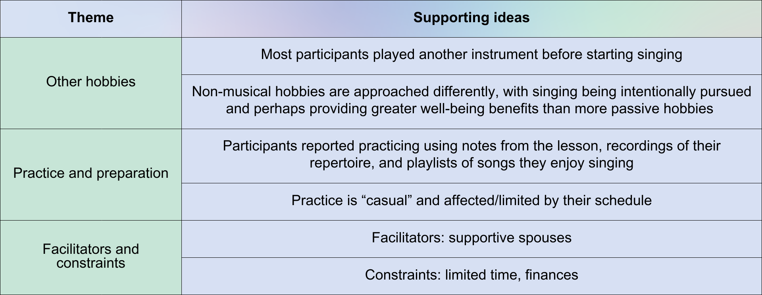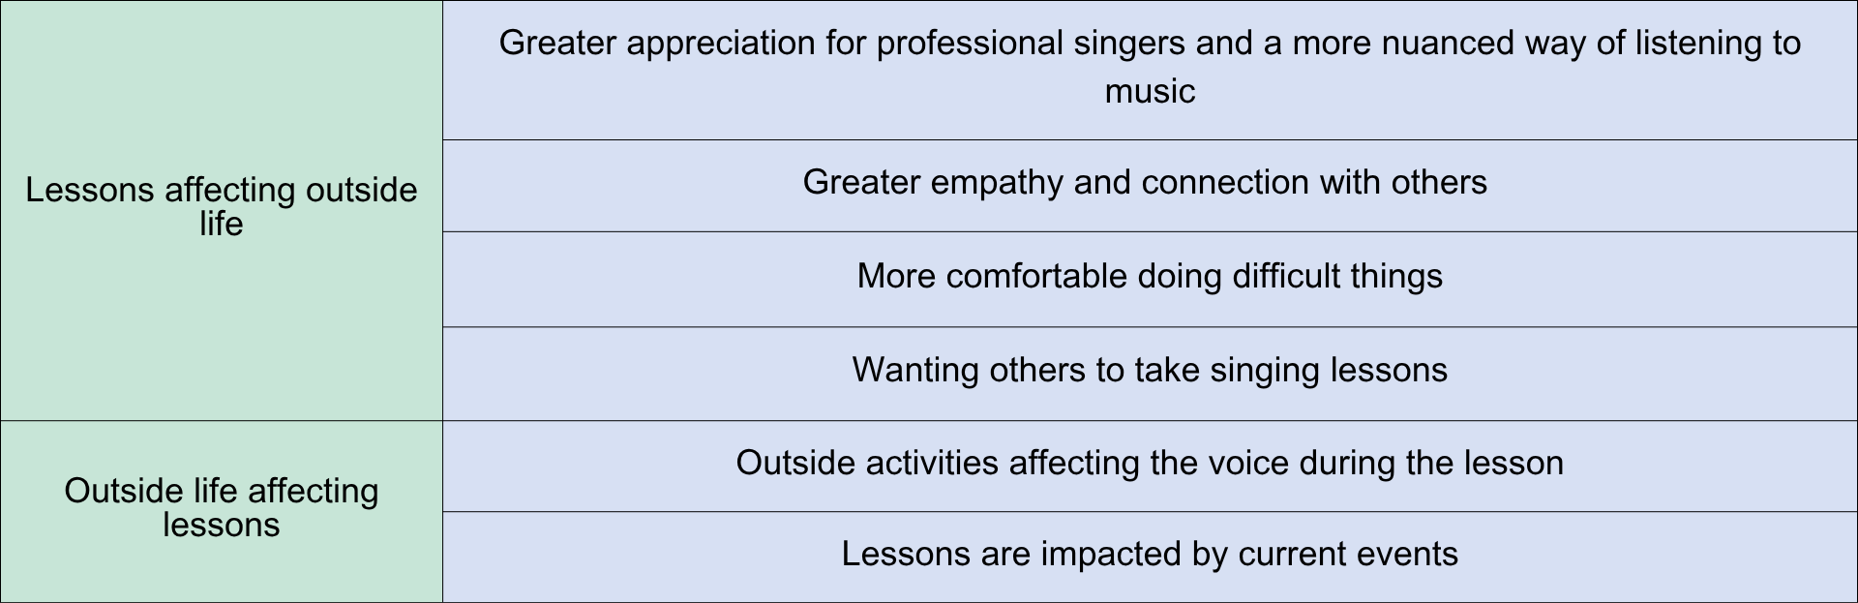

THE ROLE OF SINGING LESSONS
By examining these participants’ experiences both inside and outside of their singing lessons, as well as considering their journey to singing lessons, the role of singing lessons in the lives of AAS begins to emerge. It seems that, for most participants, singing lessons are integrated into the larger goals for their lives as a whole (see Table 9). Except for Kris, whose main goal was to improve his singing skill so that he could be a more confident singer and more effective music director, the participants signed up for singing lessons not only because they wanted to improve their singing skill, but because it brought them closer to living their ideal lives. The singing lessons were the medium through which this was accomplished, making the role of singing lessons to be an activity of meaning-making.

Table 9: Participants' larger motivations to pursue singing lessons
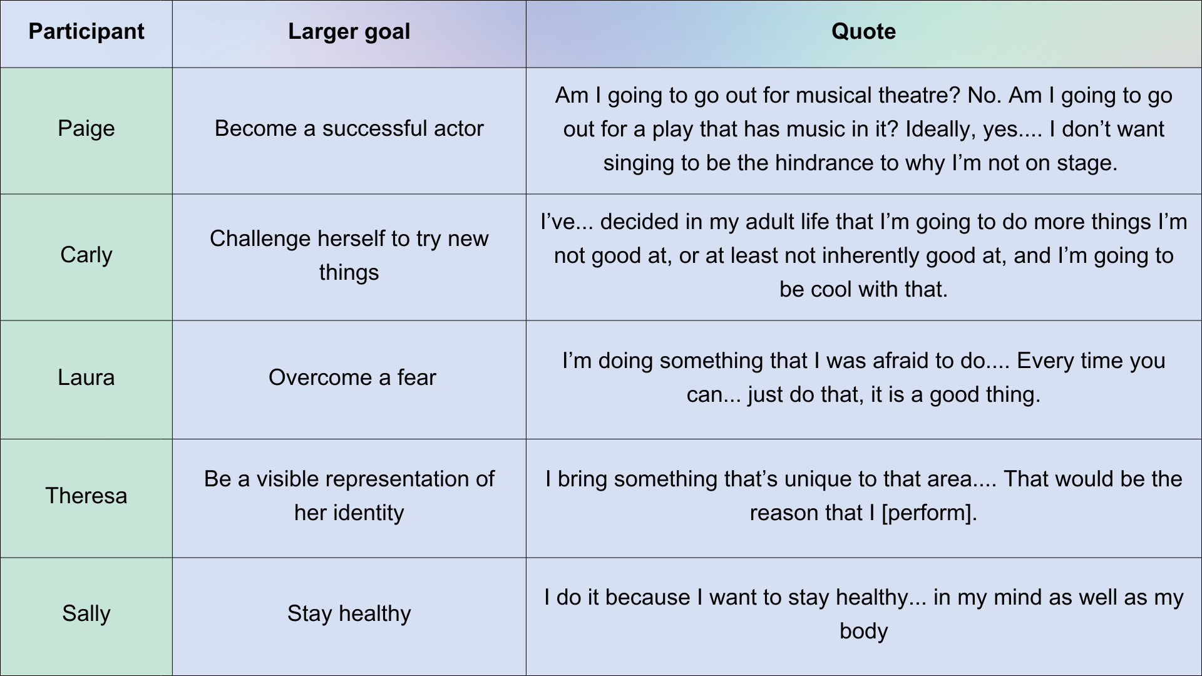

Meaning-making is the “process by which a person derives meaning(s) from an activity to find a purpose of life and make sense of [their] life” (Iwasaki, Messina, and Hopper, 2018, p. 29). This idea has only begun to be considered in vocal literature, and is currently mainly focused on the experiences of children (Kullenberg and Pramling, 2017; Barrett and Tafuri, 2018) and in European environments (Aho, 2009; Fisher, 2021; Sandberg-Jurström, 2022). While this research fills a gap in exploring the experiences of AAS, it also reveals a large gap in our understanding of how adults create meaning for their lives from music lessons, especially in the United States. It is a strong recommendation that future research attempt to better understand how adults – amateur or professional – use singing as an act of meaning-making, perhaps following the auto-ethnographic practices of Page (2021) or utilizing the Practical Epistemological Analysis method like Larsson and Öhman (2018), and how meaning-making, in turn, may influence the learning experience.

Chapter 4: Conclusion and future directions

This research asked the question, “What is the role of singing lessons in the lives of AAS?” Most vocal pedagogy literature concerns itself with the development of the singing voice (Kayes and Barlett, 2024; Michael, 2024; Maxfield, 2024; Perna, Redman, and Glasner, 2024), which is, of course, the main goal of all singing lessons. However, as seen in the lives of these AAS, singing lessons take on a greater role than mere musical skill-building: it becomes an act of meaning-making. By conducting interviews and observing the participants’ voice lessons, I was able to identify certain themes about how the participants view their singing lessons and how their singing lessons play a role in their life, fulfilling an aim of the research. While recommendations for further research were identified throughout the findings, a list of possible topics can be found in Table 10.

Table 10: Recommendations for further research
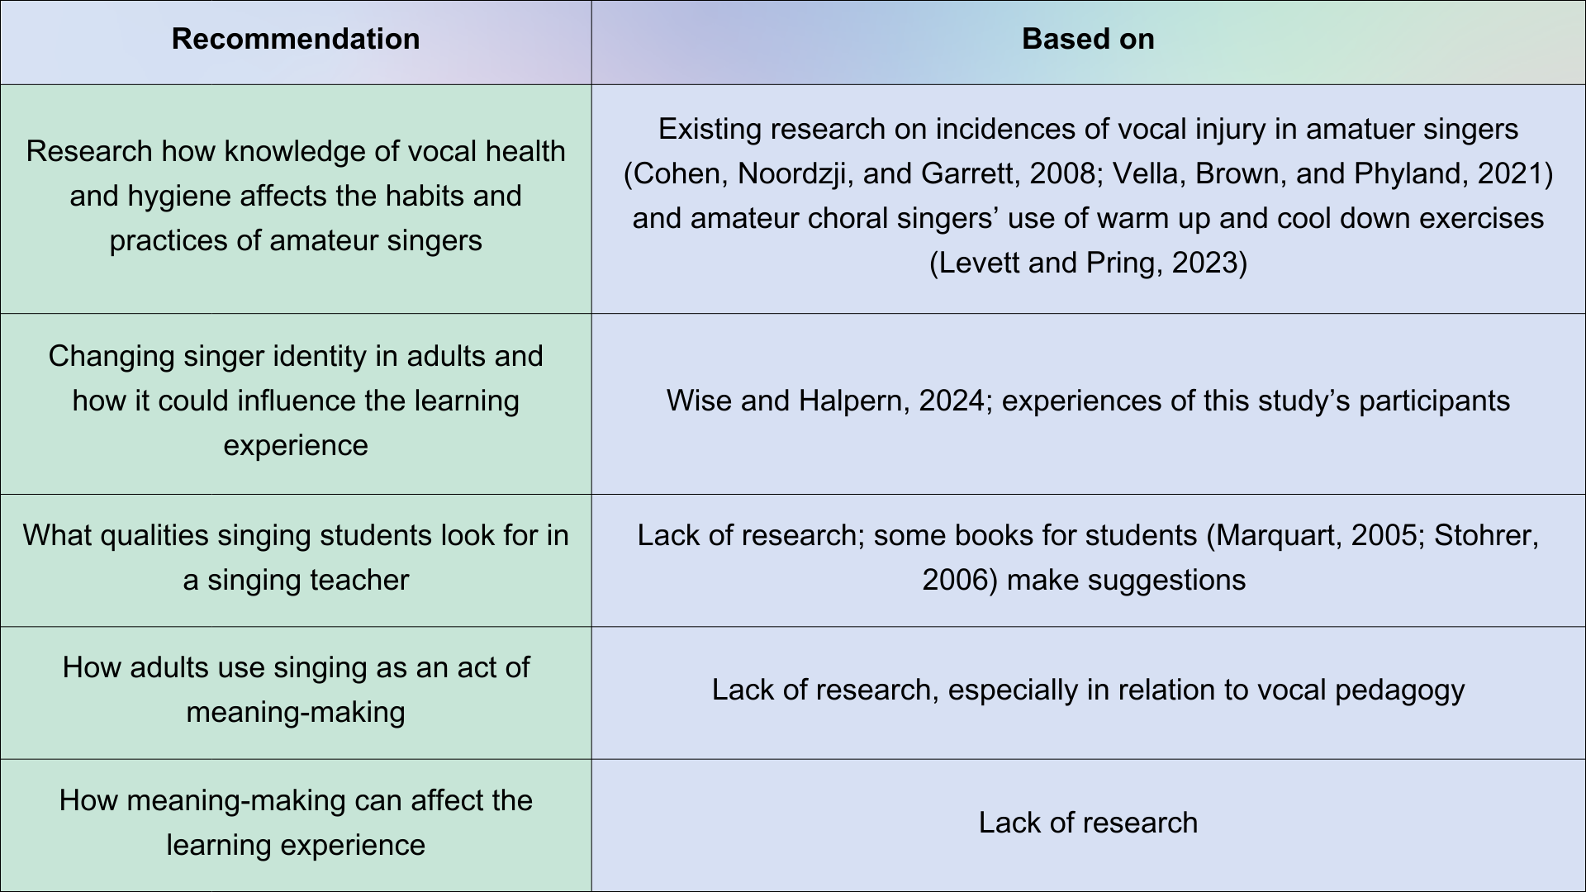

In addition to examining the original research question, one surprise in these findings is the sociocultural, financial, and political factors that the participants identified as influential to their overall experience of voice lessons. As discussed below, the combined influence of these factors is slightly different for each participant, but these factors were present in some form for all participants. It is these factors that form a practical application for this research, fulfilling an additional aim for this module.
Sociocultural factors
The sociocultural expectation of “what a singer is” (Paige) was a significant factor for the participants. In a void, singing involves the coordinated efforts of the vocal folds and vocal tract to produce sound (Gárcia-López and Bouzas, 2010). Culture and genre dictate what the result of these efforts should sound like (Edwin, 2018; Panteli, et al., 2017; Xia, 2022); society then establishes how an individual may be viewed when their singing skills fall outside of expectations (Knight, 2016; Abril, 2007; Whidden, 2009). In Western society, singing is often seen as a “God-given artistic gift,” and those who possess this “talent” are highly revered while those who do not immediately display a propensity for the skill are discouraged from singing (Ruhnke, 2020, p. 8).
Some participants felt this societal expectation so strongly that they felt self-conscious when singing and put off singing lessons for many years before gaining the confidence to learn to sing or sing in front of others. Even in lessons, participants expressed anxiety when their skills did not live up to what they felt is expected from a “singer.” Aside from personal sentiments, participants also discussed wanting to improve their singing skill to make those around them feel more comfortable. As Carly expressed, “There’s... more judgment of whether you are bad at [singing] than with other activities.”
The participants in this study made clear their desire to sing for the pure pleasure of singing. While the health and well-being benefits of singing and the satisfaction of building skills are important, this research suggests that singing teachers should encourage hedonistic singing: singing for pleasure. “Hedonism” may evoke negative connotations for some, but this reaction may be related to the previously discussed “hustle culture” where every action must be productive (Hammerton, 2025). Hedonistic singing does not preclude or negate the desire to sing for an audience or to work towards a goal, but it encourages singers to find joy in the act of singing itself, in the journey and not just the destination. It asks singers to explore sounds without judgment.
Voice teachers can promote hedonistic singing in various ways. This study discussed participants’ appreciation for informal socialization during their lesson. Allowing time for off-topic discussion creates a welcoming environment that helps students to feel safe to explore the pleasure of singing. Also, while those motivated by public performance can still participate in hedonistic singing, creating a studio that is not driven by recitals or competition can promote this philosophy. This is similar to the idea of participatory music making introduced by Turino (2008) and applied to the classroom by Bernard and Cayari (2020).

Financial factors
Finances were identified as a hugely influential factor in the participants’ ability to take singing lessons. In the United States, private music instruction often involves additional financial cost. Private voice teachers are encouraged to charge a rate that is “appropriate” for their geographic area and level of experience (Borm-Krüger, 2016) as well as take into consideration necessary business expenses (Brown, 2024). However, this means that the cost of voice lessons may be prohibitive for prospective students. Many participants in this study described themselves as “fortunate” or “lucky” to be able to afford voice lessons, but Kris’ need to stop taking lessons when his wife’s job became endangered highlights the financial discretion involved in private singing lessons. The participants did recognize that group lessons may be more affordable but they also spoke of their preference for private lessons.
In the field of vocal pedagogy, there is a need for a system that is more financially accessible and equitable. Burton (2022) suggests that teachers utilize private fundraising, either through a platform such as GoFundMe or events like a bake sale or benefit concert. She also suggests bartering partnerships between students and teachers, in which the student does tasks such as yardwork in exchange for partial or full tuition. The MusicLink Foundation also offers non-financial support for low-income families, such as instrument repair and music camp scholarships, although this seems to only be available for students under age 18 (MusicLink Foundation, n.d.). The National Association of Teachers of Singing offers fellowships for students “from communities not typically able to access voice lessons,” but these are designed for students who want to pursue a professional career in singing (National Association of Teachers of Singing, n.d.). While these are all valuable resources, there is a need for financial assistance for adult singing students. To promote equity in adult music education in the United States, it may be necessary for private organizations like the National Association of Teachers of Singing or MusicLink to create funds specifically for adult students of all levels. If equity and accessibility are values that singing teachers claim to hold (National Association of Teacher of Singing, 2022), then we must develop a better understanding of how finances play into music education for adults and respond in kind:
It seems wrong that enhancement of well-being arising from voice lessons be confined to a privileged demographic. (Smith, Kleinerman, and Cohen, 2022, p. 928)

Political factors
Participants described how politics and current events (such as the COVID-19 pandemic) influenced their lessons, but it’s also important to consider how politics influences the day-to-day lives of individuals and families, which in turn affect singing lessons. Another common personal and political condition that affects singing lessons is parenthood. Smith, Kleinerman, and Cohen (2022) found a significant correlation between the number of children one had and the age at which they started singing lessons, “consistent with the view that increasing numbers of children may require more years dedicated to childcare with the consequent delay of available resources (e.g., time and funds) for personal voice lessons” (p. 917). Laura mentioned this in her interview as well, saying that she would have taken singing lessons earlier in her life but “I was working and we had two daughters.” There is an acknowledged gender gap in parenting, with women shouldering the majority of affective, physical, and developmental care (Negraia, Augustine, and Prickett, 2018). In the United States, non-parental childcare (such as sending a child to preschool) is becoming more common but also increasingly expensive, leaving it inaccessible to many families (Herbst, 2023).
While some teachers may want to keep a separation between the work in the lesson and these “personal issues” (see, for example, O’Bryan, 2014, p. 108), their influence is clear to this study’s participants. Therefore, a holistic approach to vocal training that considers these factors may be appropriate. For example, voice teachers training pre-professional or professional singers may require a certain amount of practice per week or certain practice routines to help the singer make linear, consistent progress (Klickstein, 2009; Bonneville-Roussy and Bouffard, 2015). However, adult amateur students may have limited time to practice or may not practice at all, as seen in this study. If there is an expectation that these students practice with the same vigor as professional students, both the student and the teacher may become frustrated – the teacher because the student is not meeting expectations, and the student because the teacher is not showing an understanding of their availability or perspective. The practical application becomes, therefore, a willingness to understand an individual student’s capacity to practice and perhaps an expectation of practice that varies from student to student instead of a universal assumption for all students.
Studio policies may also be framed to make private lessons more achievable for AAS. Independent teachers often set their own cancellation and make-up policies; as teaching is their source of income, it is important for them to be able to make a financial plan (Swanson, 2010; Schwefel, 2016). However, as AAS may be juggling family and work commitments, they may need to cancel or reschedule more lessons than someone pursuing a career in singing and prioritizing lessons does. Flexible cancellation policies (that still respect the teacher’s time and effort) may attract AAS to a particular studio. Payment structures may also be adapted to allow for greater flexibility, perhaps by allowing students to pay per lesson instead of monthly.

Conclusion and limitations
This study aimed to not only fill a gap in the literature by examining the experiences of AAS, but to provide practical applications for voice teachers working with these students. I believe that this project did fulfill its aims. Additionally, I fulfilled my learning objectives for the module by successfully conducting an ethnographic study and handling large amounts of observational and interview data and synthesizing the data to be able to provide practical uses for both my teaching practices and for other voice teachers. Recognizing patterns in the lives of these singers helps scholars and teachers to identify and address needs, making the field more accessible and allowing more people to learn to sing.
In reflecting on my experience, I have recognized several limitations, not least of which was the low number of participants. Both conventional and focused ethnographies tend to involve 30 or fewer participants (Cruz and Higginbottom, 2013; Trundle and Phillips, 2023); Guest, Bunce, and Johnson (2006) suggest that participants be recruited until data saturation is reached. However, the limited time frame of this study required that participant recruitment be limited to a few weeks, resulting in a low number of participants.
Additionally, five of the six participants were my own students and were therefore influenced by my own teaching philosophies. While qualitative research is always influenced by the researcher (Denscombe, 2003), this data could have been made more rigorous by involving students of other teachers. Although I attempted to recruit participants who were not my students, only one was successfully recruited for the study. In addition, all of my students take their lessons online, and it’s possible that online lessons attract AAS with specific needs. To strengthen the relevance and validity of this data, a similar study could be done that involves both in-person and online lessons, as well as successful recruitment from multiple voice studios.

References

Aburn, G.E., Gott, M., and Hoare, K. (2021) ‘Experiences of an insider researcher – interviewing your own colleague’, Nurse Researcher, 29(3), pp. 22-28.

Abril, C.R. (2007) ‘“I have a voice but I just can’t sing”: a narrative investigation of singing and
social anxiety’, Music Education Research, 9(1), pp. 1-15.

Adams, R.J., Smart, P., and Huff, A.S. (2017) ‘Shades of grey: guidelines for working with the
literature in systematic reviews for management and organizational studies’, International
Journal of Management Reviews, 19, pp. 432-454.

Aho, M. (2009) ‘Gestures in vocal performance and the experience of the listener: a cast study of extra-semantic meaning-making in the singing of Olavi Virta’, Popular Music, 28(1), pp. 33-51.

American Academy of Teachers of Singing (2021) ‘Ethical behavior within the voice teaching profession 2021’, Journal of Singing, 78(1), pp. 7-9.

Andreassen, P., Christensen, M.K., and Møller, J.E. (2020) ‘Focused ethnography as an approach in medical education’, Medical Education, 54(4), pp. 296-302.

Barrett, M.S. and Tafuri, J. (2018) ‘Creative meaning-making in infants’ and young children’s musical cultures’, in G. McPherson and G.E. Welch (eds) Music Learning and Teaching in Infancy, Childhood, and Adolescence: An Oxford Handbook of Music Education, vol. 2. Oxford, UK: Oxford University Press.

Barry, N.H. (2007) ‘A qualitative study of applied music lessons and subsequent student practice sessions’, Contributions to Music Education, 34, pp. 51-65.

Batt-Rawden, K. and Andersen, S. ‘“Singing has empowered, enchanted and enthralled me” – choirs for wellbeing?’, Health Promotion International, 35(1), pp. 140-150.

Baughman, M. (2017) ‘An examination of methods used to teach practice strategies in the college voice studio’, Update: Applications of Research in Music Education, 35(2), pp. 15-22.

Bayley, J.G. and Waldron, J. (2020) ‘“It’s never too late”: Adult students and music learning in one online and offline convergent community music school’, International Journal of Music Education, 38(1), pp. 36-51.

Ben-Eliyahu, A., Moore, D., Dorph, R., Schunn, C.D. (2018) ‘Investigating the multidimensionality of engagement: affective, behavioral, and cognitive engagement across science activities and contexts’, Contemporary Educational Psychology, 53, pp. 87-105.

Bernard, C. and Cayari, C. (2020) ‘Encouraging participatory music making through
differentiation on the ukulele’, General Music Today, 34(1), pp. 29-36.

Bhoryrub, J., Hurley, J., Neilson, G.R., Ramsay, M., and Smith, M. (2010) ‘Heutagogy: an alternative practice based learning approach’, Nurse Education in Practice, 10(6), pp. 322-326.

Blaschke, L.M. (2012) ‘Heutagogy and lifelong learning: a review of heutagogical practice and self-determined learning’, International Review of Research in Open and Distributed Learning, 13(1), pp. 56-71.

Bonde, L.O., Juel, K., and Ekholm, O. (2018) ‘Associations between music and health-related outcomes in adult non-musicians, amateur musicians and professional musicians - results from a nationwide Danish study’, Nordic Journal of Music Therapy, 27(4), pp. 262-282.

Bonner, A. and Tolhurst, G. (2002) ‘Insider-outsider perspectives of participant observation’, Nurse researcher, 9(4), pp. 7-19.

Bonneville-Roussy, A. and Bouffard, T. (2015) ‘When quantity is not enough: disentangling the roles of practice time, self-regulation and deliberate practice in musical achievement’, Psychology of Music, 43(5), pp. 686-704.

Bonshor, M. (2017) ‘Conductor feedback and the amateur singer: the role of criticism and praise in building choral confidence’, Research Studies in Music Education, 39(2), pp. 139-160.

Borm-Krüger, S. (2016) How much should I charge for voice lessons? Available at: https://www.vocaladvancement.com/en-us/blog/article/how-much-should-i-charge-for-voice-lessons (Accessed 13 July 2025).

Bouson, J.B. (2016) Shame and the Aging Woman: Confronting and Resisting Ageism in Contemporary Women’s Writings. Cham, Switzerland: Palgrave Macmillan.

Brown, B.S. (1983) ‘The impact of political and economic changes upon mental health’, American Journal of Orthopsychiatry, 53(4), pp. 583-592.

Brown, C.K. (2024) ‘Voice teacher rates’ [Instagram]. 4 September. Available at: https://www.instagram.com/reel/C_gYdYEy1LP/?hl=en (Accessed 13 July 2025).

Bucura, E. (2020) ‘Becoming self-directed and self-determined: learning music pedagogically, andragogically, and heutagogically’, Problems in Music Pedagogy, 19(1), pp. 7-24

Bullack, A., Gass, C., Nater, U.M., and Kreutz, G. (2018) ‘Psychobiological effects of choral singing on affective state, social connectedness, and stress: influences of singing activity and time course’, Frontiers in Behavioral Neuroscience, 12, article no. 223. Available at: https://www.frontiersin.org/journals/behavioral-neuroscience/articles/10.3389/fnbeh.2018.00223/full (Accessed 11 July 2025).

Burgos, J.A. (2014) ‘Adult learner perceptions: perspectives from beginning musicians (ages 60-86 years old). Update, 32(2), pp. 26-34.

Burnard, P. (2012) Musical creativities in practice. Oxford, UK: Oxford University Press.

Burton, N. (2022) ‘Equitable access to private lessons: making music affordable for those in need’, American Music Teacher, June/July, pp. 22-24. Available at: https://www.mtna.org/downloads/DEI/Studio/2022_JJ_Equitable.pdf (Accessed 1 July 2025).

Canchola, A. (2025) ‘Building an independent voice studio that caters to your strengths’, Inter Nos, 58(1), pp. 21-23. Available at: https://www.nats.org/_Library/Independent_Voices_Articles/Building_an_Independent_Voice_Studio_That_Caters_to_Your_Strengths.pdf (Accessed 7 July 2025).

Carey, G. and Grant, C. (2016) ‘Enacting transformative pedagogy in the music studio: a case study of responsive, relational teaching’, Proceedings of the 21st International Seminar of the ISME Commission on the Education of the Professional Musician, St. Andrews (Scotland). Queensland, AU: Griffith University, pp. 54-63. Available at: https://research-repository.griffith.edu.au/server/api/core/bitstreams/d115cce0-a043-55ee-8f3f-a535b6cbad46/content (Accessed 3 July 2025).

Castañeda, Q. (2006) ‘The invisible theatre of ethnography: performative principles of fieldwork’, Anthropological Quarterly, 79(1), pp. 75-104.

Chacko, T.V. (2018) ‘Emerging pedagogies for effective adult learning: from andragogy to heutagogy’, Archive of Medicine and Health Services, 6(2), pp. 278-283.

Chorus America (2019) The Chorus Impact Study: Singing for a Lifetime. Bethesda, MD: Grunwald Associates LLC. Available at: https://chorusamerica.org/sites/default/files/ChorusImpactStudy_SingingforaLifetime.pdf (Accessed 9 January 2025).

Clift, S., Hancox, G., Staricoff, R., and Whitmore, C. (2008) Singing and Health: A Systematic Mapping and Review of Non-Clinical Research. Canterbury, UK: Sidney De Haan Research Centre for Arts and Health. Available at: https://www.researchgate.net/publication/238688798_Singing_and_Health_Summary_of_a_Systematic_Mapping_and_Review_of_Non-Clinical_Research (Accessed 16 January 2025).

Coffin, J.D.G. (2004) ‘Why did we join? Why have we stayed? Membership in a women’s barbershop chorus: a narrative inquiry into leadership, learning, and the development of the voice through singing.’ Master’s thesis, University of Prince Edward Island. Available at: https://islandscholar.ca/islandora/object/ir%3A21615/ (Accessed 22 January 2025).

Cohen, S.M., Noordzij, J.P., Garrett, G., and Ossoff, R.H. (2008) ‘Factors associated with perception of singing voice handicap’, Otolaryngology – Head and Neck Surgery, 138, pp. 430-434.

Comings, J.P. (2007) ‘Persistence: helping adult education students reach their goals’, in J. Comings, B. Garner, and C. Smith (eds) Review of Adult Learning and Literacy: Volume 7. 1st edn. New York: Routledge, pp. 23-46.

Corporation for Public Broadcasting (no date) About CPB. Available at: https://cpb.org/aboutcpb (Accessed 30 June 2025).

Council for Community and Economic Research (2023) 2023 Annual Average Cost of Living Index Released. Available at: https://www.coli.org/2023-annual-average-cost-of-living-index-released/ (Accessed 22 July 2025).

Cousins, S., Brindely, J., Baker, J., and Johnston-Wilder, S. (2019) ‘Stories of mathematical resilience: how some adult learners overcame affective barriers’, Widening Participation and Lifelong Learning, 21(1), pp. 46-70.

Cranton, P. and Taylor, E.W. (2012) ‘Transformative learning’, in P. Jarvis and M. Watts (eds) The Routledge International Handbook of Learning. New York: Routledge, pp. 194-203.

Creech, A., Hallam, S., McQueen, H., Varvarigou, M. (2013) ‘The power of music in the lives of older adults’, Research Studies in Music Education, 35(1), pp. 87-102.

Cruz, E.V. and Higginbottom, G. (2013) ‘The use of focused ethnography in nursing research’, Nurse Researcher, 20(4), pp. 36-43.

Cuypers, K., Krokstad, S., Holmen, T.L., Knudsten, M.S., Bygren, L.O., and Holmen, J. (2012) ‘Patterns of receptive and creative cultural activities and their association with perceived health, anxiety, depression and satisfaction with life among adults: The HUNT study, Norway’, Journal of Epidemiology and Community Health, 66(8), pp. 698-703.

Da Silva Barreto, M., Marcon, S.S., and Garcia-Vivar, C. (2016) ‘Patterns of behaviour in families of critically ill patients in the emergency room: a focused ethnography’, Journal of Advanced Nursing, 73(3), pp. 633-642.

DeJohn, J. (2025) Salary Needed to Live Comfortably in U.S. Cities – 2025 Study. Available at: https://smartasset.com/data-studies/salary-needed-live-comfortably-2025 (Accessed 22 July 2025).

Demorest, S.M., Kelley, J., Pfordresher, P.Q. (2017) ‘Singing ability, musical self-concept, and future musical participation’, Journal of Research in Music Education, 64(4), pp. 405-420.

DenBleyker, E. (2024) ‘“Living beyond culture:” the motivations of adult non-singers to sing’. Assignment for BMPF7013, MA Vocal Pedagogy, University of Wales Trinity Saint David. Unpublished.

Denscombe, M. (2003) The good research guide for small-scale social research. 2nd ed.
Maidenhead, UK: Open University Press.

Deveaux, M.M. (2021) How to Transition to an Online Voice Business – Reviewing Your Ideal Client. Available at: https://thespeakeasycooperative.com/blog/online-voice-business-ideal-client/ (Accessed 7 July 2025).

Diaz, R. (2024) ‘Decolonizing ethnography: a reimagined framework for teaching radical ethnography’, Fieldsights, February 15. Available at: https://www.culanth.org/fieldsights/decolonizing-ethnography-a-reimagined-framework-for-conducting-radical-ethnography (Accessed 6 August 2025).

Dweck, C. S. (2006) Mindset: The New Psychology of Success. New York: Ballantine Books.

Edwin, R. (2018) ‘1500 genres...and counting!’, Journal of Singing, 74(3), pp. 323-324.

Einarsdottir, S.L. and Gudmundsdottir, H.R. (2016) ‘The role of choral singing in the lives of amateur choral singers in Iceland’, Music Education Research, 18(1), pp. 39-56.

English, H., Lewis, S., Davidson, J., and Goodwin, N. (2024) ‘Transformative engagement with community music-making for older adults: a scoping review’, Musicae Scientiae, OnlineFirst, pp. 1-23. Available at: https://doi.org/10.1177/10298649241291796 (Accessed 16 January 2025).

Etikan, I., Musa, S.A., and Alkassim, R.S. (2016) ‘Comparison of convenience sampling and purposive sampling’, American Journal of Theoretical and Applied Statistics, 5(1), pp. 1-4.
Fraenkel, J.R. and Wallen, N.E. (2009) How to design and evaluate research in education. 7th ed. New York: McGraw-Hill.

Executive Order No. 2025-08133 (2025) Available at: https://www.federalregister.gov/documents/2025/05/07/2025-08133/ending-taxpayer-subsidization-of-biased-media (Accessed 30 June 2025).

Feldman, G., Lian, H., Kosinski, M., and Stillwell, D. (2017) ‘Frankly, we do give a damn: the relationship between profanity and honesty’, Social Psychological and Personality Science, 8(7), pp. 816-826.

Findsen, B. (2006) ‘Social institutions as sites of learning for older adults: differential opportunities’, Journal of Transformative Education, 4(1), pp. 65-81.

Finnegan, R. (1989) The hidden musicians: music-making in an English town. Cambridge: Cambridge University Press.

Fisher, V.J. (2021) ‘Embodied songs: insights into the nature of cross-modal meaning-making within sign-language informed, embodied interpretations of vocal music’, Frontiers in Psychology, 12, article no. 624689.

Folkenflick, D. and Neuman, S. (2025) Trump plans order to cut funding for NPR and PBS. Available at: https://www.npr.org/2025/04/15/nx-s1-5352827/npr-pbs-public-media-trump-rescission-funding (Accessed 30 June 2025).

Fox, B. (2004) ‘Rethinking the amateur: acts of media production in the digital age’, Spectator, 24(1), pp. 5-16

Gárcia-López, I and Bouzas, J.G. (2010) ‘The singing voice’, Acta Otorrinolaringológica Española, 61(6), pp. 44-451.

Geena Davis Institute (no date) Women Over 50: The Right to be Seen on Screen. Available at: https://geenadavisinstitute.org/research/women-over-50-the-right-to-be-seen-on-screen/ (Accessed 25 June 2025).

Geist, l. (2024) Effects of Singing on Mental Health and Wellbeing. 26 April. Available at: https://www.youtube.com/watch?v=5DAyhgHVY8o (Accessed 11 July 2025).

Gilbert, D., Hawley, J., Nicholson, H., and Worth, L. (2020) ‘On amateurs: an introduction and a manifesto’, Performance Research, 25(1), pp. 2-9.

Grape, C., Sandgren, M., Hansson, L., Ericson, M., and Theorell, T. (2003) ‘Does singing promote well-being?: an empirical study of professional and amateur singers during a singing lesson’, Integrative Physiological and Behavioral Science, 38(1), pp. 65-74.

Green, L. (2002) How popular musicians learn: a way ahead for music education. London: Ashgate.

Greene, M.J. (2014) ‘On the inside looking in: methodological insights and challenges in conducting qualitative insider research’, The Qualitative Report, 19(29), pp. 1-13.

Guest, G., Bunce, A., and Johnson, L. (2006) ‘How many interviews are enough? An
experiment with data saturation and variability’, Field Method, 18, pp. 59–82.

Hammersley, M. and Atkinson, P. (2007) Ethnography: Principles in Practice. 3rd edn. London: Routledge.

Hammerton, M. (2025) ‘What is wrong with workism?’, Journal of Applied Philosophy, 42(2), pp. 668-682.

Hamilton, C. (2013) ‘Symbolic amateurs: on the discourse of amateurism in contemporary media culture’, Cultural Studies Review, 19(1), pp. 177-192.
Herbst, C.M. (2023) ‘Child care in the United States: markets, policy, and evidence’, Journal of Policy Analysis and Management, 42(1), pp. 255-304.

Hibbard, S.L. (2017) Music Teacher Presence: Toward a Relational Understanding. PhD thesis. University of Michigan. Available at: https://deepblue.lib.umich.edu/bitstream/handle/2027.42/140905/hibbards_1.pdf?sequence=1 (Accessed 18 July 2025).

Higginbottom, G.M.A., Pillay, J.J., and Boadu, N.Y. (2013) ‘Guidance on performing focused ethnographies on healthcare research’, The Qualitative Report, 18, article 17, pp. 1-16.

Hoffman, A.R. (2013) ‘Compelling questions about music, education, and socioeconomic status’, Music Educators Journal, 100(1), pp. 63-68.

Hommes, J., Rienties, B., de Grave, W., Bos, G., Schuwirth, L., and Scherpbier, A. (2012) ‘Visualizing the invisible: a network approach to reveal the informal social side of student learning’, Advances in Health Sciences Education, 17, pp. 743-757.

Hoving, T. (1980) Tutankhamun: The Untold Story. Harmondsworth, UK: Penguin.

Hudson, K. (1981) A Social History of Archaeology: The British Experience. London: Macmillan.

Huhtanen, K. (2008) ‘Adults as learners in the field of music: a pedagogical challenge’, Educating musicians for a lifetime of learning: proceedings of the 17th international seminar of the Commission for the Education of the Professional Musician, International Society for Music Education. Conference at Spilamberto (Italy), 15-18 June. Nedlands, Western Australia: International Society of Music Education, pp. 57-61. Available at: https://www.isme.org/sites/default/files/documents/proceedings/2008 CEPROM Proceedings.pdf (Accessed 5 March 2025).

Ingold, T. (2021) ‘In praise of amateurs’, Ethnos, 86(1), pp. 153-172.

Israel, M. and Hay, I. (2006) Research ethics for social scientists: between ethical conduct and regulatory compliance. London: Sage Publications, Ltd.
Iwasaki, Y., Messina, E.S., and Hopper, T. (2018) ‘The role of leisure in meaning-making and engagement with life’, The Journal of Positive Psychology, 13(1), pp. 29-35.

Jay, T. (2009) ‘The utility and ubiquity of taboo words’, Perspectives on Psychological Science, 4(2), pp. 153-161.

Johnston-Wilder, S. and Lee, C. (2010) ‘Mathematical resilience’, Mathematics Teaching, 218, pp. 38-41.

Juncos, D.G., Heinrichs, G.A., Towle, P., Duffy, K., Grand, S.M., Morgan, M.C., Smith, J.D., and Kalkus, E. (2017) ‘Acceptance and commitment therapy for the treatment of music performance anxiety: a pilot study with student vocalists’, Frontiers in Psychology, 8, article no. 986.

Juniu, S., Tedrick, T., and Boyd, R. (1996) ‘Leisure or work? Amateur and professional musicians’ perception of rehearsal and performance’, Journal of Leisure Research, 28(1), pp. 44-56

Kang, J., Schlop, A., and Jiang, J.J. (2018) ‘A review of the physiological effects and mechanisms of singing’, Journal of Voice, 32(4), pp. 390-395.

Kayes, G. and Barlett, I. (2024) ‘Singing voice teaching and voice science: where is the meeting point?’, Journal of Singing, 81(1), pp. 69-76.

Klickstein, G. (2009) The Musician’s Way: A Guide to Practice, Performance, and Wellness. Oxford, UK: Oxford University Press.

Knight, S. (2016) ‘Addressing the needs of the adult “non-singer (“NS”)”’, in G. Welch, D.M.
Howard, and J. Nix (eds) The Oxford Handbook of Singing. Oxford, UK: Oxford Library of
Psychology, pp. 621-650. Available at: https://doi.org/10.1093/oxfordhb/9780199660773.013.48
(Accessed 27 June 2025).

Knoblauch, H. (2005) ‘Focused ethnography’, Forum: Qualitative Social Research, 6(3), article number 44. Available at: https://doi.org/10.17169/fqs-6.3.20 (Accessed 16 January 2025).

Knoblauch, H.K. (2012) ‘Videography: focused ethnography and video analysis’, in H. Knoblauch, B. Schnettler, J. Raab, and H. Soeffner (eds) Video Analysis: Methodology and Methods: Qualitative Audiovisual Data Analysis in Sociology. 3rd rev. edn. Frankfurt am Main: Peter Lang, pp. 69-84.

Knowles, M.S. (1984) Andragogy in Action: Applying Modern Principles of Adult Learning. Hoboken, NJ: Jossey-Bass.

Kullenberg, T. and Pramling, N. (2017) ‘Children’s musical and emotional meaning making: dialogicality in instructional interaction’, Mind, Culture, and Activity, 24(4), pp. 338-352.

Kupcova, I., Danisovic, L., Klein, M., and Harasnyi, S. (2023) ‘Effects of the COVID-19 pandemic on mental health, anxiety, and depression’, BMC Psychology, 11, article no. 108. Available at: https://link.springer.com/article/10.1186/s40359-023-01130-5 (Accessed 11 July 2025).

Lamont, A. (2011) ‘The beat goes on: music education, identity, and lifelong learning’, Music
Education Research, 13(4), pp. 369-388.

Larsson, C. and Öhman, J. (2018) ‘Music improvisation as an aesthetic event: towards a transactional approach to meaning-making’, European Journal of Philosophy in Arts Education, 3(1), pp. 121-181.

Lerg, C.A., Östling, J., and Weiß, J. (2022) ‘Participatory knowledge: conceptual thoughts’, in C.A. Lerg, J. Östling, and J. Weiß (eds) History of Intellectual Culture 1/2022. Berlin: De Gruyter Oldenbourg, pp. 85-96. Available at: https://doi.org/10.1515/9783110748819-005 (Accessed 22 January 2025).

Levett, J. and Pring, T. (2023) ‘Amateur choir singers – does good vocal health matter?’ International Journal of Language and Communication Disorders, 58, pp. 1286-1293.

Levin, L. (2014) Literature Search Strategy Week: Len Levin on Understanding and Finding
Grey Literature. Available at: https://aea365.org/blog/literature-search-strategy-week-len-levin-
on-understanding-and-finding-grey-literature/ (Accessed 6 August 2025).

Lilliestam, L. (2013) ‘Music, the life trajectory and existential health’, in L.O. Bonde, E. Ruud, M.S. Skanland, and G. Trondalen (eds) Musical Life Stories: Narratives on Health Musicking. Oslo, Norway: Norwegian Academy of Music, pp. 17-38. Available at: https://nmh.brage.unit.no/nmh-xmlui/handle/11250/196378 (Accessed 17 February 2025).

Liu, H. and Stebbins, R.A. (2014) ‘Concerted singing: leisure fulfilment in a university faculty chorus’, Leisure Studies, 33(5), pp. 533-545.

Love, M. (2019) ‘Learning to overcome my fear of singing was as easy as do-re-mi’, The Guardian, (15 June). Available at: https://www.theguardian.com/lifeandstyle/2019/jun/15/learning-to-overcome-my-fear-of-singing-was-as-easy-as-do-re-mi (Accessed 22 January 2025).

Malviya, S., Zupan, B., and Meredith, P. (2022) ‘Evidence of religious/spiritual singing and movement in mental health: a systematic review’, Complementary Therapies in Clinical Practice, 47, article no. 101567.

Marquart, L. (2005) The Right Way to Sing. New York: Allworth Press.

Martin, A. (2012) ‘Resilience and learning’, in N.M. Steel (ed) Encyclopedia of the Sciences of Learning. Boston, MA: Springer.

Martin, N. (2020) ‘Against productivity in a pandemic’, The New Republic, (March 17). Available at: https://newrepublic.com/article/156929/work-home-productivity-coronavirus-pandemic. (Accessed 27 June 2025)

Maxfield, L. (2024) ‘Efficiency in singing and learning requires effort’, Journal of Singing, 80(3), pp. 331-333.

McDaniel, B. (2024) ‘Singing into a smartphone: the persuasive affordances for collaboration on karaoke and lip-syncing apps’, in K. Norton and E.M. Morgan-Ellis (eds) The Oxford Handbook of Community Singing. Oxford, UK: Oxford University Press, pp. 50-62.

Merrifield, A. (2017) The Amateur: The Pleasures of Doing What You Love. London: Verso.

Mezirow, J. (1997) ‘Transformative learning: theory to practice’, New Directions for Adult and Continuing Education, 74, pp. 5-12.

Michael, D.D. (2024) ‘Don’t throw the baby out with the bathwater: the muscular basis for register adjustment’, Journal of Singing, 80(5), pp. 543-552.

Mok, A.O. (2020) ‘”I can follow”: self-directed informal learning strategies adopted by choristers in an adult amateur choir’, Music Education Research, 22(4), pp. 421-431.

Moniz, J.J. (2025) ‘Examining ethics in voice teaching’, Journal of Singing’, 81(3), pp. 327-331.

Monti, E., Durham, M., and Reynolds, A. (2024) ‘Focusing the scope: the voice practitioner’s role in trauma-informed care’, Journal of Singing, 80(4), pp. 455-462.

Moon, K. and Blackman, D. (2014) ‘A guide to understanding social science research for natural scientists’, Conservation Biology, 28(5), pp. 1167-1177.

Morrison, I. and Clift, S. (2012) Singing and Mental Health. Canterbury, UK: Canterbury Christ Church University. Available at: https://www.artsandhealth.ie/wp-content/uploads/2013/01/Singing-and-Mental-Health-PDF.pdf (Accessed 2 July 2025).

MusicLink Foundation (no date) What is MusicLink? Available at: https://musiclinkfoundation.org/about-us/what-is-musiclink/ (Accessed 14 July 2025).

National Association of Teachers of Singing (no date) NATS Vocal Music Fellowships. Available at: https://www.nats.org/vocalmusicfellowships.html (Accessed 14 July 2025).

National Association of Teachers of Singing (2022) I.D.E.A. Best Practices Guide. Available at: https://www.nats.org/_Library/docs/NATS_IDEA_Best_Practices_Guide_Final_1_17_22_rev.pdf (Accessed 1 July 2025).

Nichols, B.E. (2020) ‘Equity in music education: access to learning during the pandemic and beyond’, Music Educators Journal, 107(1), pp. 68-70.

Nickelsburg, M. (2025) Paycheck to Paycheck on $200k? What it really costs to live comfortably in Seattle. Available at: https://www.kuow.org/stories/paycheck-to-paycheck-on-200k-year-what-it-really-costs-to-live-comfortably-in-seattle (Accessed 22 July 2025).

O’Bryan, J. (2014) Investigating participant values, beliefs and practices in one-to-one tertiary classical signing lessons: a collective case study. PhD thesis. The University of Queensland. Available at: https://core.ac.uk/download/pdf/43364697.pdf (Accessed 14 July 2025).

Ojala, A., Välisalo, T., and Myllykoski, M. (2024) ‘Adults’ engagement in music learning during and after online coaching’, Music Education Research, 26(4), pp. 432-442.

Page, D.L. (2021) ‘Music & soundscapes of our everyday lives: music & soundmaking, meaning-making, and self-making’, Personal and Ubiquitous Computing, 25, pp. 705-721.

Panteli, M. Bittner, R., Bello, J.P., Dixon, S. (2017) ‘Towards the characterization of singing styes in world music’, IEEE International Conference on Acoustics, Speech and Signal Processing. New Orleans, LA, USA, 5-9 March. IEEE, p. 636-640. Available at: https://ieeexplore.ieee.org/abstract/document/7952233/authors#authors (Accessed 13 August 2025).

Pascale, L.M. (2002) Dispelling the myth of the non-singer: changing the ways singing is
perceived, implemented, and nurtured in the classroom. PhD Thesis. Lesley University.
Available at:
https://digitalcommons.lesley.edu/cgi/viewcontent.cgi?referer=&httpsredir=1&article=1088&cont
ext=education_dissertations (Accessed 27 June 2025).

Penninx, B.W.J.H., Benros, M.E., Klein, R.S., and Vinkers, C.H. (2022) ‘How COVID-19 shaped mental health: from infection to pandemic effects’, Nature Medicine, 28, pp. 2027-2037.

Perera, M. (2022) ‘Self-directed learning in the distance mode’, International Conference on Constructivism in Teaching and Learning. Conference at Pondicherry University, Puducherry, India, 13-14 October. Puducherry: Pondicherry University, pp. 5-17. Available at: https://www.researchgate.net/profile/Chennupati-Ramaiah-2/publication/365824395_Constructivism_in_Teaching_and_Learning/links/6385eb50c2cb154d293c10af/Constructivism-in-Teaching-and-Learning.pdf#page=35 (Accessed 21 June 2025).

Perna, N. and Pigott, S. (2021) VocalFri: Now you’re a voice teacher part 3: Rebecca Pieper and Leigh Usilton [Podcast]. 3 April. Available at: https://www.vocalfri.com/e/now-youre-a-voice-teacher-part-3-rebecca-pieper-and-leigh-usilton/ (Accessed 7 July 2025).

Perna, N., Redman, Y.G., and Glasner, J.D. (2024) ‘Fipping the vocal pedagogy frame: background, foundation, and framework’, Journal of Singing, 81(2), pp. 177-188.

Qamar, W. (2024) ‘Navigating the storm: coping with conflict and political change for mental health resilience,’ Journal of Gandhara Medical and Dental Sciences, 11(2), pp. 1-2. Available at: https://doi.org/10.37762/jgmds.11-2.576 (Accessed 11 July 2025).

Raymore, L.A. (2002) ‘Facilitators to leisure’, Journal of Leisure Research, 34(1), pp. 37-51.

Renwick, J.M. and McPherson, G.E. (2009) ‘Multiple motives: profiles of young Australians’
reasons for musical engagement’, in A. Williamon, S. Pretty, and R. Buck (eds) Proceedings of
the International Symposium on Performance Science 2009. Conference at Auckland (New
Zealand), 15-18 December. Utrecht, NL: Association Européenne des Conservatoires,
Académies de Musique et Musikhochschulen, pp. 469-474. Available at:
https://findanexpert.unimelb.edu.au/scholarlywork/321652-multiple-motives--profiles-of-young-australians'-reasons-for-musical-engagement. (Accessed 28 June 2025).

Robb, D. (2019) SAG: Over-40 Actresses Are Losing Out. Backstage. Available at: https://www.backstage.com/magazine/article/sag-actresses-losing-48800/ (Accessed 25 June 2025).

Roper, J.M. and Shapira, J. (2000) Ethnography in Nursing Research. Thousand Oaks, CA: Sage Publications.

Ruhnke, M.W. (2020) To sing or not to sing, again: perspectives on the journey of reclaiming
one’s voice as an adult non-singer. PhD Thesis. University of Toronto. Available at:
https://tspace.library.utoronto.ca/handle/1807/101190 (Accessed 28 June 2025).

Said, Edward. (1993) The Reith Lectures: Representation of the Intellectual: Professionals and Amateurs. BBC Radio 4, 14 July. Available at: https://www.bbc.co.uk/programmes/p00gxqz0 (Access 12 June 2025).

Şakalar, A. and Gürel, S. (2023) ‘Career development dynamics and expectations of singing students receiving vocational music education’, Kahramanmaraş Sütçü İmam University Social Sciences Journal, 20(3), pp. 1197-1212. Available at: https://doi.org/10.33437/ksusbd.1371080 (Accessed 15 August 2025).

Saldaña, J. (2013) The Coding Manual for Qualitative Researchers. London: SAGE.

Sandberg-Jurström, R. (2022) ‘Creating space for reflection: meaning-making feedback in instrumental/vocal lessons’, Frontiers in Education, 7, article no. 842337.

Sarial-Abi, G., Ulqinaku, A., Viglia, G., and Das, G. (2023) ‘The effect of financial scarcity on discretionary spending, borrowing, and investing’, Journal of the Academy of Marketing Science, 51, pp. 1214-1243.

Schwefel, J.T. (2016) ‘Effective strategies and suggestions for writing your studio policy’, Journal of Singing, 72(3), pp. 349-353.

Seavey, A.A. (2015) Distance learning and its effect on the future of one-on-one string instruction. DMA thesis, Northwestern University. Available at: https://scholar.archive.org/work/2jkzf4jdrbdhfhhqe4k7fso2fq/access/wayback/http://arch.library.northwestern.edu/downloads/gx41mj13c (Accessed 9 January 2025).

Serra-Dawa, S. (2014) ‘The teacher-student relationship in one-to-one singing lessons: an investigation of personality and adult attachment’, in S. Harrison and J. O’Bryan (eds) Teaching Singing in the 21st Century. Landscapes: The Arts, Aesthetics, and Education, vol. 14. Dordrecht, NL: Springer. Available at: https://link.springer.com/chapter/10.1007/978-94-017-8851-9_13#citeas (Accessed 8 July 2025).

Shannon, P.J., Soltani, L., and Sugrue, E. (2024) ‘Exploring the use of focused ethnography in social work research: a scoping review’, Qualitative Social Work, 23(5), pp. 777-796.

Shaw, R.D. and Auletto, A. (2022) ‘Is music education in tune with the pursuit of equity? An examination of access to music education in Michigan’s schools’, Journal of Research in Music Education, 69(4), pp. 364-381.

Simones, L.L. (2017) ‘Beyond expectations in music performance modules in higher education: rethinking instrumental and vocal music pedagogy for the twenty-first century’, Music Education Research, 19(3), pp. 252-262.

Sinclair, C. (2008) ‘How can what we know about motivation to teach improve the quality of
initial teacher education and its practicum?’ in P.A. Towndrow, C. Koh, and T.H. Soon (eds)
Motivation and Practice for the Classroom. Rotterdam, NL: Sense Publishers, pp. 37-62.

Smith, A.M., Kleinerman, K., and Cohen, A.J. (2022) ‘Singing lessons as a path to well-being in later life’, Psychology of Music, 50(3), pp. 911-932.

Stanborough, R.J. (2020) 10 Ways That Singing Benefits Your Health. Available at: https://www.healthline.com/health/benefits-of-singing (Accessed 11 July 2025).

Stebbins, R.A. (1979) Amateurs: On the Margins Between Works and Leisure. London: SAGE Publications, Inc.

Stebbins, R.A. (2013) ‘From dabbler to serious amateur musician and beyond: clarifying a crucial step’, International Journal of Community Music, 6(2), pp. 141-152.

Stebbins, R.A. (2016) ‘Education for self-fulfillment: process and context’, Educação & Realidade, 41(3), pp. 873-887.

Stebbins, R.A. (2024) ‘Serious leisure perspective: essential features’, International Forum for Logotherapy, 47(1), pp. 5-32. Available at: https://vfia.org/wp-content/uploads/2024/09/IFL-2024-Spring-Vol-47-No-1-Rev2-1.pdf#page=5 (Accessed 28 January 2025).

Stohrer, S.L. (2006) The Singer’s Companion. New York: Routledge.

Swanson, C. (2010) ‘Your first studio’, Journal of Singing, 67(2), pp. 201-205.

The Associated Board of the Royal Schools of Music (2024) Singing. Available at: https://www.abrsm.org/en-us/instruments/singing (Accessed 16 June 2025).

Tellis, C.M. and Barone, O.R. (2018) Counseling and Interviewing in Speech-Language Pathology and Audiology. Burlington, MA: Jones and Bartlett Learning.

Theorell, T. (2014) Psychological Health Effects of Musical Experiences: Theories, Studies, and Reflections in Music Health Science. Dordrecht, NE: Springer Nature. Available at: https://doi.org/10.1007/978-94-017-8920-2 (Accessed 29 June 2025).

The Royal Conservatory (2025) Voice series, 2025 edition. Available at: https://www.rcmusic.com/about-us/rcm-publishing/voice-series-2025-edition (Accessed 16 June 2025).

Turino, T. (2008) Music as social life: the politics of participation. Chicago: University of Chicago
Press.

Trundle, C. and Phillips, T. (2023) ‘Defining focused ethnography: disciplinary boundary-work and the imagined divisions between “focused” and “traditional” ethnography in health research – a critical review’, Social Science & Medicine, 332, article no. 116108.

United States Census Bureau (2023a) B19013: Median Household Income in the Past 12 Months (in 2023 Inflation-Adjusted Dollars. Available at: https://data.census.gov/table/ACSDT1Y2023.B19013?g=010XX00US,$0400000&moe=false&tp=true (Accessed 1 July 2025).

United States Census Bureau (2023b) QuickFacts: Seattle city, Washington. Available at: https://www.census.gov/quickfacts/fact/table/seattlecitywashington/EDU685223 (Accessed 1 July 2025).

Veblen, K.K. (2018) ‘Adult music learning in formal, nonformal, and informal contexts’, in G.E. McPherson and G.F. Welch (eds) Special Needs, Community Music, and Adult Learning: An Oxford Handbook of Music Education. Oxford, UK: University of Oxford Press, pp. 243-256.

Välisalo, T., Myllykoski, M., and Ojala, A. (2022) ‘Adults’ motivations in participating in an online music course’, International vistas of music education research: proceedings of the 29th international seminar of the ISME research commission. Conference at Brisbane (Australia), 11-15 July 2022. Nedlands, Western Australia: International Society for Music Education, pp. 184-192. Available at: https://helda.helsinki.fi/server/api/core/bitstreams/a34a71c7-6f1d-402f-a9f7-0c5924340073/content (Accessed 5 March 2025).

Vella, B., Brown, L., and Phyland, D. (2021) ‘Amateur music theatre singers’ perceptions of their current singing voice function’, Journal of Voice, 35(4), pp. 589-596.

Viola, B.M., Sorrell, K.J., Clarke, R.H., Corney, S.P., and Vaughan, P.M. (2022) ‘Amateurs can be experts: a new perspective on citizen scientists’, Biological Conservation, 274, article number 109739. Available at: https://doi.org/10.1016/j.biocon.2022.109739 (Accessed 22 January 2025).

Waldron, J., & Bayley, J. G. (2012). ‘Music teaching and learning in the Online Academy of Irish Music: An ethnographic and cyber ethnographic field study of music, meaning, identity, and practice in community.’ In D. D. Coffman (ed), Proceedings of the International Society for Music Education 2012 Commission for Community Music Activity, pp. 62–66. Available at: https://www.isme.org/sites/default/files/documents/proceedings/2012%2BCMA%2BProceedings.pdf (Accessed 5 August 2025).
Whidden, C. (2009) The adult non-singer: connection, context, and culture. PhD Thesis.
University of Calgary. Available at: https://prism.ucalgary.ca/items/adf01cb8-6448-42e5-9103-
234e40c07b41 (Accessed 21 February 2024).

Williams, E., Dingle, G.A., and Clift, S. (2018) ‘A systematic review of mental health and wellbeing outcomes of group singing for adults with a mental health condition’, European Journal of Public Health, 28(6), pp. 1035-1042.

Winter, D. (2022) ‘Exploring the narrative: voice practitioner research and the literature review process’, Voice and Speech Review, 17(2), pp. 131-150.

Wise, K.J. and Halpern, A.R. (2024) ‘The activated singer: components of an emerging singing
identity in adults learning to sing’, Music Perception, 41(4), pp. 288-306.

Xia, W. (2022) ‘Peculiarities of singing in Chinese popular and traditional music: influence of musical genres on vocals’, Música Hodie, 22. Available at: https://revistas.ufg.br/musica/article/view/73226 (Accessed 13 August 2025).

Appendix A: Approved ethics form

Form

Appendix B: Employer approval letter

Emily DenBleyker
Emily DenBleyker Vocal Studio
29 November 2024

Dear UWTSD,
Re: The role of private instruction for amateur adult singers: an ethnographic study

I confirm that I approve of the research proposed into “the role of private instruction for amateur adult singers” to be carried out by Emily DenBleyker of Emily DenBleyker Vocal Studio, to be carried out between January 1 and September 4, 2025.

Sincerely,

Emily DenBleyker

Appendix C: Blank consent form

For participants: https://forms.gle/xxme5Evn6GSmG8H5A

For participants’ teachers: https://forms.gle/tY3VwqttrQ883myM9

Appendix D: Signed consent forms

Signed participant forms: https://docs.google.com/spreadsheets/d/1vLtU6-HCrRHlnnKGDV8Hksnh0ymR7ZWRFy172GfpkEg/edit?usp=sharing

Signed voice teacher forms: https://docs.google.com/spreadsheets/d/1fiCvwqO1YnaxMveKos9H_Ugsp9VdnW8HnCpJtRnUWsc/edit?usp=sharing

Appendix E: Lesson transcripts

Paige

Carly

Laura

Kris

Theresa

Sally

Appendix F: Interview transcripts

Paige

Carly

Laura

Kris

Theresa

Sally

