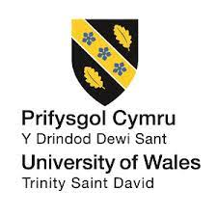

Module: International Marketing
Module Code: LCMB 7006
Assignment Title: Assessment 1 (International Marketing)

Student Name: Taruna Sewani
Student ID: 2124613

Table of Contents
Introduction 2
Company Brief 3
The Macro Environment of Subway Corporation 4
Hofstede's cultural model 6
Porter’s 5 Forces Model 10
SWOT Analysis of Subway Corporation 13
STP Analysis of Subway Corporation 15
Marketing mix (7p’s) of Subway Corporation 17
Market Entry Method 19
Directional Development Strategy 20
BCG Matrix 21
Recommendation 23
Conclusion 24

Introduction
The act of trading goods and services worldwide in order to cater to the expectations and requirements of a diverse range of customers is what is meant to be included by the noun phrase "international marketing (Andrade et al., 2019)." It also includes deciding the target audience and doing consumer research in international locations. There is a popular notion among entrepreneurs that their goals cannot be accomplished if they restrict their attention to a specific market, such as the United States market, because of the tremendous level of competition in that market. As a result, in order to expand their market position, such businesses are always exploring greater chances located all over the globe. In this report, the international marketing of SUBWAY Corporation will be analysed as the company expands its business activities in different countries like India and United Kingdom. In the report, specific essential models and theories will be analysed from the perspective of SUBWAY Corporation.

Company Brief
SUBWAY is a restaurant company that specializes only in serving sub sandwiches. As of 2002, it has the most locations of any quick-service restaurant company in the U.S., making it the most of its kind. In addition, the organisation has a presence in more than one hundred nations worldwide. The headquarters is based in Milford, Connecticut. In August of 1965, Fred DeLuca and Peter Buck formed a partnership agreement that would eventually become known as SUBWAY Corporation. The company belongs to the restaurant industry, and the company accommodates more than 0.41 million employees throughout the world (Alina, 2018). Dr.'s Associates, which owns and operates Subway in India, owns and operates the chain. It does not own a specific place. However, each franchisee generates 8% of the profits. The company has a 6% stake in India's Rs 18,800 crore controlled quick service restaurant market (Ben Rayana et al., 2022). The UK and Ireland, along with the outer world, both rank Subway as the most successful franchised firm network in the world. local businesses employ local people in their respective localities around the country.
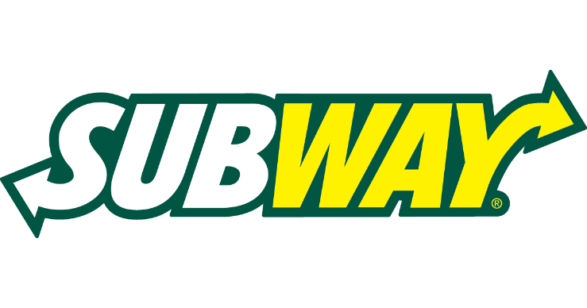
Picture 1: Logo of SUBWAY Corporation
Vision
The vision of SUBWAY Corporation is to reshape restaurants into welcoming environments where customers can enjoy and feel more comfortable.
Mission
In its mission statement, SUBWAY strives to be known worldwide as a restaurant that is both popular and conducive to healthy eating.

The Macro Environment of Subway Corporation
Analysis of Subway's PESTLE focuses on the brand's business strategy and tactics. As part of a Subway PESTLE Analysis, it investigates the different external elements that affect its company, as well as the legal and environmental considerations. The PESTLE Analysis identifies the many external factors that influence a brand's business model.

Figure 1: PESTEL Analysis of Subway Corporation (Alina, 2018)
Political factors: Subway operates in over 100 countries. Therefore, the franchisee leader must keep up with local requirements. For example, while conducting business in India, Subway had to face specific governmental regulations and tax barriers which the union government of India issues. In doing business in the UK, the company faces such political barriers known as BREXIT as the government of the UK is determined to leave the EU. In contrast with the UK’s political factors, the political factors of India are more favourable for the company because the company has low taxation in India.
Economical factor: India's economy has been relatively steady since industrial legislation was enacted in 1991. The policy's decreases in industrial licensing, legalisation of foreign investment, and development of FIBP have improved India's economic climate. Hence, Subway can run its business in India without any economic tensions. However, in 2020, worldwide shutdowns impacted Subway's sales in the UK the most. Economic conditions, including expendable income, jobless, and low wages, have damaged the restaurant's sales in the UK. Hence, it can be said that the economic condition in India is more favourable for Subway Corporation compared with the UK’s market.
Social factors: 70% of India's 1.2 billion citizens are between 15 and 65 years old. So, there are age-based percentages. The structures differ in education, work ethic, wealth distribution, etc. (Biliavska, 2022). In several places, Subway must follow religious law. For example, it must supply Halal beef to Muslim nations. Subway serves Halal cuisine in the UK, USA, and EU despite no government compulsion. In this case, the UK’s social factors are more favourable than India’s because the company does not bother about religious preferences for halal food.
Technological factors: Today, technology determines a business's success or failure. In India, Subway has responded successfully to evolving social media trends. It gives updates and answers questions on social media (Czinkota et al., 2021). In the UK, many consumers criticise Subway for its lack of technology. The restaurant has lately adopted a lot of digital initiatives. The scenario of India is favourable for the corporation compared with the UK’s market since the people of India accept the technological approach of Subway more cordially than UL’s people.
Environmental factors: Industrialisation and urbanisation have negatively damaged India's air quality, causing health concerns. There are now environmental pressure organisations, noise limits, and waste management and disposal rules. Subway corporation needs to focus on these aspects. In the United Kingdom, Subway reduces food waste via intelligent forecasting and ethical procurement. Subway's tissue and paper towels are 100% recyclable. The environmental condition of the Indian market is unfavourable for the company as the country is full of pollution and less care about the sustainable environment. In contrast, the environmental condition of the UK is favourable because the people of the UK support a sustainable environment.
Legal factors: Recent regulatory reforms in India have impacted companies like Subway, including recycling, minimum wage increases, and disability discrimination (Escandon-Barbosa et al., 2022). European and British food hygiene laws are rigorous. Some governments do not enforce these restrictions. Subway needs to focus on such aspects while doing business in the UK. Hence, it can be said that the legal environment of the UK’s market is unfavourable for Subway Corporation compared to the market of India.

Hofstede's cultural model
It is essential for every business and enterprise to have to grow accustomed to their competitive strategies and interaction operations to the expectations and desires of the local community. The beliefs, conventions, and practices of a particular area, nation, or culture generally drive and impact consumer choices, buying habits, and purchasing behaviours. Subway, for example, regularly tailors its advertisements and approaches to local tastes because of the enormous cultural effect it has (Ganatra et al., 2021). The Hofstede model of national culture may be employed in order to get a better understanding of the macroenvironment in which SUBWAY Corporation operates in the context of India and the United Kingdom. Following the model of Hofstede is shown for SUBWAY Corporation in the context of India and United Kingdom locations.
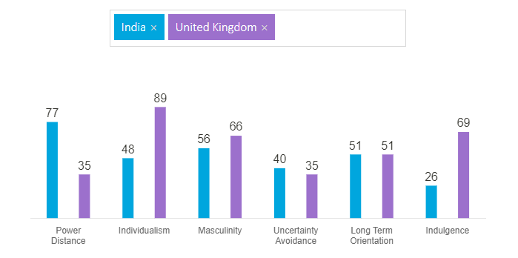
Figure 2: Hofstede's Cultural Dimensions Model (Country Comparison - Hofstede Insights, 2022)
Power distance index
Power distance refers to a measure and breadth of differences that exist between individuals and different business members inside an organisation on the basis of the power they continue to maintain. The vast majority of individuals have no problem with this type of unbalance. At large, the culture of Subway is characterized by a short power distance (Gheibi et al., 2018). The company follows flat organizational culture in the organization. Like other regions, Subway maintains this power distance in India and UK within the organisation. In both locations, the power distance is low, and hence the company requires fewer supervisors to control the number of employees.
Individualism versus collectivism
This conforms to the attributes of the functions and responsibilities involved in working for an organisation. Individualistic businesses concentrate on the accomplishments of their workers, and personnel at these firms prefer to compete with one another in order to accomplish difficult jobs and strive for the same aspirations (Hambrick et al., 2020). This is undertaken not just to promote one's performance but also, where possible, for the purpose of financial benefit. Collective organisations, on the other side, focus more on collaborating with teamwork to achieve a mutual objective that can only be attained via collective work. In order to encourage the highest level of performance in its workforce and to accelerate the expansion of the company in the most effective manner, Subway has developed its work environment to strike a healthy balance between individuality and collectivism. In the Indian region, the company offers employees enough space to balance their work and social life. In the United Kingdom, the company puts its genuine concern on the time of the personnel and values their time as well. At Subway, workers are constantly challenged to perform for aspirational targets. In order to keep the workforce motivated and engaged, numerous responsibilities and targets have been instated. Subway places great importance on assuring that its personnel is never exhausted or unsatisfied with their work.
Masculinity vs Femininity
This is an allusion to the way in which the numerous responsibilities and roles of the work have been partitioned among the male and female individuals in the organization. Subway has a minimal MAS score, which signifies that the work schedules in the organisation commonly match men and women, and employment contracts are not gender-biased or conventional in any manner. Furthermore, the MAS index shows that Subway does not have a wage gap (Helmold, 2021). The organisation is wholly concerned about greater lifestyle and does not support gender discrimination. Even though, there are some times in the Indian region, the company faces such inconvenience and the they resolve the issue so professionally with the help of their company policy. The ability to accomplish success inside the Subway is somewhat more highly probable to be accomplished via collaboration efforts in contrast to via confrontation. This is because the firm implements its workers with a healthy work-life balance as well as a flexible schedule environment that may satisfy their individual needs. For this, the company can manage different employee productivity rates more effectively.
Uncertainty avoidance index
An organisation's desire to be in comprehensive possession and retain adequate details is more significant when it has a culture of solid uncertainty avoidance. Instead of encouraging new ideas and approaches, these cultures place a higher priority on reducing risk. Consequently, a more relaxed and open culture is represented by lower avoidance of uncertainty levels (Jurevicius, 2022). The culture of Subway is a mixture of the two, with a preference for lower uncertainty avoidance ratings. Within the company itself, Subway encourages exploration that is adaptive to different perspectives and views and leads to doing things. The organisation often collaborates in change programs to boost its operations, cultures, and activities by engaging in team-building exercises. Subway maintains a flexible culture in the organisation so that they can adapt to any changes and get the advantages of the competitive business world. However, the company also retain rigidly and avoids uncertainty in some regions like India.
Long-term orientation vs short-time orientation
The character of a culture's thriftiness and pragmatism tends to be more evident when it has a higher level of long-term orientation. The company express their perception of time by different applications as having many other impacts that will be felt far into the conceivable future. On the other contrary, organisations that have a short orientation are often more nationalistic and values-oriented than civilizations with a long orientation (Klimenko et al., 2020). In terms of the need to encourage and sustain its business, Subway performs with a long-term perspective; however, the operation of its business and the activities connected to it are influenced more by a short-term orientation. When there is an issue, Subway and its personnel are typically more displeased with the what or how of the circumstance than they are with the why. This implies a deeper problem-solving perspective, as well as a tendency toward a concentration on the long term. This provides an opportunity for individuals to realise the core of the problem instead of the indications of it, which empowers them to entirely fix problems and increase both their own as well as the productivity of their organisations. In most regions like India and UK, Subway undertakes its organisational decisions concerning long-term perspectives.
Advantages and disadvantages of the Hofstede model:
Advantages:
- Hofstede's model enables individuals and organisations to engage in regular activities and makes them comprehend diverse cultures (Fang, 2013).
- Using Hofstede's model, corporations like Subway Corporation can successfully grow their international presence without encountering unpleasant cultural shocks. For instance, the corporation analyses the impact of cultural differences on advertising and global brand strategy.
Disadvantages:
- Hofstede was met with widespread criticism regardless of his accomplishments. Dissent on the model's usefulness. Those who have looked into the matter have indicated that this is incorrect (Fang, 2013).
- The planet has undergone significant cultural and political shifts. This transformation has transformed global thought and behaviour. However, the model does not consider recent changes in the world.

Porter’s 5 Forces Model
The assessment of Subway applying Porter's Five Forces needs to consider the company's competitive marketplace and the variables that determine its industry. The purpose of this analysis is to determine how well the company is structured in relation to a number of different factors, such as the threat posed by new entrants, the threat posed by substitutes in the market, the bargaining power of consumers, the supplier power, and the pressure posed by competition (Pandey et al., 2019). With the help of the Five Forces analysis, Subway can identify helpful methods for examining the company's current market position according to a wide range of diverse aspects, such as the company's rivals, consumers, vendors, financial strength, advantages, and possible approaches.
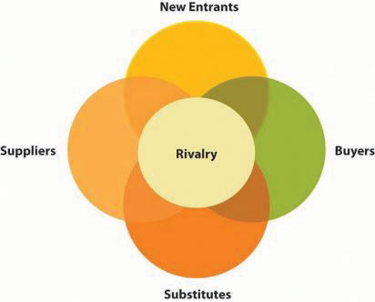
Figure 3: Porter's 5 Forces of Subway Corporation (Team, 2022)
Threats of new entrants
Subway is one of the biggest fast-food businesses in the world, with outlets in more than 100 countries. Because of the considerable investment requirements of the business, new entrants have a challenging time obtaining substantial investments as essential (Sohir, 2021). The vast majority of money spent on research and development contributes to the substantial financial investment made. Hence, it can be said that, in the United Kingdom, the risk of new competitors of Subway corporation is comparatively lower (Zhang, 2022). Although in the Indian region, there is a high chance of entering new competitors into the marketplace because this marketplace has lower bindings and needs low cost to enter the market. Nevertheless, Subway has introduced a bunch of products, and the company adapted to get cost-minimizing techniques which are pretty difficult for new entrants in both India and UK region.
Threat of substitute products
In the UK, compared to Subway's product offerings, there are few other firms. As a consequence, the threat of substitute products in the UK is comparatively lower than the market of India. In the Indian market, the low-profit-making businesses create the substitute that is offered. It is feasible that these alternatives are of lower quality, but they are still a lot more expensive than the original versions. In the Indian region, compared to Subway, other companies in the same industry operate at a lesser cost while corresponding increased standards of coverage and quality, creating a high threat for Subway of substitute products (Team, 2022).
Bargaining power of consumers
Compared to the number of enterprises that produce the products, the number of sellers in the Subway business is far higher in India. It denotes that in the Indian region, consumers have a constrained variety of businesses from which to choose, and as a consequence, they have very little authority over price. Hence, it can be said that the bargaining of the Indian consumer is minimal. Since there is a lot of product diversification within the industry of the United Kingdom, consumers will not easily retrieve any other enterprises that produce the same item because there are not many other firms that produce it (Zhang, 2022). As a result, the bargaining power of the consumers are very high. This indicates that consumers feel pressured to buy at low costs, making them increasingly price-conscious.
Bargaining power of suppliers
In the industry of restaurant business in India in which Subway competes, there is frequently a higher number of vendors than buyers. It signifies those vendors or suppliers have low power of authority over the amount they charge. The products produced by these suppliers are, for the most part, identical, have little scope for uniqueness, and have switching costs. It increases its profitability, like Subway moving between several suppliers. In the UK's industry, not all suppliers compete directly with one another over the commodities they offer. It signifies that there are no other accessible opportunities for purchasing the goods other than the suppliers, which enables suppliers high bargaining power (Team, 2022). Subway's continued forward incorporation into the marketplace is not under any severe danger from the competitiveness posed by the suppliers.
Rivalry
It has an edge with few competitors in the UK region where Subway operates. In addition to their size, most of them are massive. McDonald's, KFC, Burger King, and Starbucks are just a few of the many rivals in the market. As a result, no company move will go unrecognised in these surroundings. In the Indian region, Subway may face only a few competitive rivalries with a significant market share. In order to get an advantage in the Indian marketplace, organisations must put in their best effort to compete against one other (Zhang, 2021). The products that Subway offers set it apart from its rivals. Since each of their offerings is unique, competitor businesses find it quite challenging to attract and retain customers from one another.
Analysing the two countries, India and UK, for Subway Corporation with the help of Porter’s Five Forces model, it can be said that both the countries have similarities in the lower threat of substitute products. Both countries have dissimilarities in the other four dimensions of Porter’s Five Forces model.

SWOT Analysis of Subway Corporation
Strength
- Customizable subs: Customers almost universally like having a range of options from which to select when making a purchasing decision. The higher the number of customisable features a product offers, the more delighted customers tend to be ((Helmold, 2021). When it comes to the accessibility of individualised menu choices, Subway is head and shoulders above any other major fast-food company. In India and UK, the consumers of Subway products can easily customise their food menu according to their taste and choice.
- Fast-food franchise with the most locations: The corporation runs more restaurants than McDonald's or any other operator of a fast-food franchise does right now, with 36,821 locations spread over more than 100 countries. Currently, the company has more than 700 outlets in India. In the United Kingdom, the company operates more than 2200 locations (Jurevicius, 2022). A significant number of locations by which Subway is serving a vast number of consumers.
- Techniques of advertising and marketing: In order to expand its clientele, Subway makes use of cutting-edge advertising and public relations tactics. For example, when Subway launched a $5 footlong deal, it set a new bar for the price of a sandwich (Sohir, 2021). In India, Subway implies classic marketing techniques to attract consumers. For example, Subway promotes their products through TV advertising or email marketing.
- Healthy meals: One cannot find the same combination of low, delicious, and nutrient-dense cuisine offered at Subway at other quick-service restaurants in India and UK, at certainly not the same amount as at Subway. Moreover, this quality of Subway connects with the contemporary movement toward consuming healthier meals.
Weaknesses
- The interiors of stores appear cheap: There are few Subway outlets in India and the UK that have the quality of interior design that would encourage customers to remain longer and feel valued than their rivals.
- Low retention rate of employees: In India and the UK, the position of a Subway Sandwich Artist requires little in the way of training and comes with a low salary. It leads to poor performance as well as a high employee turnover rate, all of which raise Subway's training expenditures and contribute to the company's total expenses.
- Inconsistent store services: It is difficult for the company to maintain a consistent level of service quality throughout all of its locations in India and the UK. As a result, a client may be satisfied with a service provided in one store while being disappointed with the same service provided in another.
Opportunities
- Healthful food demand grows: Because of this possibility, Subway is already expanding its business and might release new sandwiches that are lower in fat and salt and provide a higher level of nutrition.
- Food delivery: Subway can boost its client base by focusing on the potential to deliver sandwiches to consumers' households.
Threats
- Local fast-food businesses: Fast food outlets in the Indian and UK region may provide more nutritious options and craft menus that are tailored specifically to the needs and desires of the locals.
- Legal actions against Subway: Due to the poor standards that the corporation has in place concerning the implementation of franchisees, Subway has been a party to many litigations in the past. It has been unsuccessful in all of them. The company suffers financial and reputational losses due to the dispute. In addition to the time and energy it takes to conduct and settle the case. It can be a significant threat for the company to conduct business in India and the United Kingdom.
With the help of SWOT analysis, a number of similarities and dissimilarities can be identified between the two countries. Both countries offer a customized and healthy meals to customers. Other similarities are inconsistent store services, high churn rate, and threats from local fast-food businesses. Both countries have some differences as well. For example, in the UK, Subway has more outlets, but the marketing techniques of both countries are different., legal actions differences, and so on.

STP Analysis of Subway Corporation
Fast food chains like Subway, which have outlets worldwide, are owned and operated by the Subway franchise. This American firm covers a diverse range of tasty and nutritious options while also minimizing its impact on the environment and having a constructive impact on the society it serves all over the world. There are three distinct strategies that Subway employs: Segmentation, Targeting, and positioning.
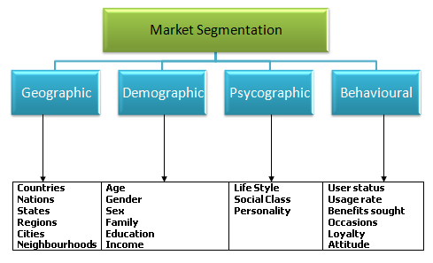
Figure 4: Market Segmentation (Helmold, 2021)
Segmentation
Subway corporation serves its products and services in more than 700 locations throughout India. In the United Kingdom, the number of their outlets is about 2200 (Team, 2022). In both the Indian and UK region, Subway generally targets people of 18 to 39 aged people because these people concern more about their health and desire tasty and healthy food. The company also offers a kid subway to attract kids to both locations. People from all social statuses can take their products and services.
Targeting
In the both Indian and UK region, Subway's primary target demographic consists of men and ladies in the middle class between the ages of 16 and 39 (Zhang, 2021). In addition, in the United Kingdom, it is typically geared toward those who reside in urban and rural regions and prioritise eating a nutritious diet. On the other hand, in India, it is more significant that metropolitan sites have a greater chance of receiving new menu items than rural ones. In both regions, the nutritive benefits of Subway's kids' meals have been boosted by switching out the high-calorie cookie for a juice roll-up, converting from a carbonated beverage to vitamin juice, and engaging children with cartoons like Dory.
Positioning
Subway places its products in the Indian and UK market by maintaining the foundation of its brand on the principle of freshness. The tagline of Subway has always been the same in both regions, which is "Eat fresh," and the current endeavour focuses on the "appetite for better" of the firm and the customers it serves (Pandey et al., 2019). The company offers value-for-money products to its consumers in India and the UK to retain its customers' trust and create strong customer relationships.
Serving in both regions, Subway Corporation maintains some similarities. For example, the targeted consumers are the same, who are 18 to 39 aged people; they also offer kid meals in both regions (Sohir, 2021). However, there are some differences in market positioning. In India, the corporation applies different marketing tactics to attract the consumers, such as TV ads, email marketing, and billboards, whereas, in the UK, they apply social media marketing techniques most

Marketing mix (7p’s) of Subway Corporation
Product
Subway's subs are famous. Subway's famous sandwiches also serve salads, kids' packs, sides, and beverages. Sandwiches may be whole or half. Customers may customise their sandwiches with bread, vegetables, and toppings. Some goods depend on the restaurant and location (Zhang, 2022). For example, in India, the meal is vegetarian and lacks pig and meat. Whereas in the UK, Subway offers both meat and pig.
Price
Subway is a worldwide restaurant; thus, pricing varies by region and country. Subway's price is more expensive than KFC and McDonald's. A 6-inch sandwich costs £3.99 in the UK, whereas a foot-long costs £5.99. In India, Subway's sandwiches are more costly than its rivals. This is because it has different qualities, and the outrageous price covers them. Moreover, bundle pricing is now being used in the Indian market (Klimenko et al., 2020).
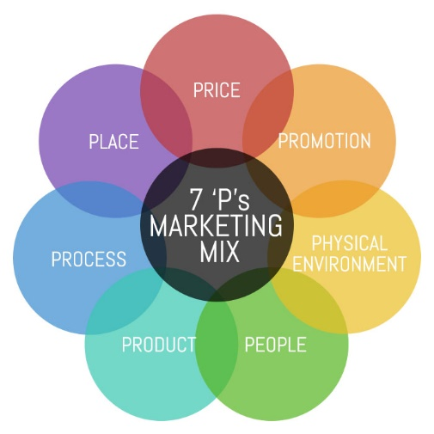
Figure 5: Marketing Mix of Subway Corporation (Jurevicius, 2022)
Place
Subway's products are sold in two distinct ways. The first is its online marketplace. It also sells to retail outlets, which sell to shops throughout the nation. These go to consumers. Over 700 shops in India and 2200 in the UK sell its products. It strives to get its items in as many stores as possible. In both region, Subway delivers its foods and products through Uber Eats and Grubhub.
Promotion
Subway advertises on various platforms. It incorporates TV and radio ads in both the Indian and UK regions. It has a broad reach and attracts many consumers. In the Indian region, social and online marketing is cheaper and more practical owing to internet use. So, in this region, Subway promotes through online platforms. In the UK, it promotes on several social media channels, focusing on YouTube, Facebook, and Twitter, owing to their sizeable monthly use. It has almost 100,000 likes on various sites, which are updated often (Team, 2022).
People
Subway's sales personnel contribute to marketing. These personnel are skilled in practical approaches and respecting company clients' preferences. Its customer service staff: Customers approach them with product difficulties and help them address them. They are taught to respect clients and fix their difficulties. In India, subway hires employees on a full-time basis. Whereas in the UK, the company offers part-time jobs to the students.
Process
In the UK, to ensure large chain stores always have their products, it installs systems to notify clients when inventory is inadequate. Refills its inventory by purchasing additional items from vendors. It assures consumers always have essential items. In the Indian region, the corporation has an automated delivery mechanism where orders are generated, and the required goods from inventories are dispatched to the logistics company.
Physical evidence
In both the Indian and UK region, Subway offers items in colour-coded packaging that's easy to spot. These are arranged on shelves offered by the corporation, which are coloured and designed differently. As a result, it is simpler for consumers to find these shelves in congested shops. In addition, the company's user-friendly website offers high-quality photos of its items from different perspectives, which are available in both locations.

Market Entry Method
Subway Corporation entered the market through the franchisee method in both regions, India and UK. When a company's owner agrees to let another company use the identity, trademarks, and other identifying features in return for a royalty payment, the company is said to operate as a franchise (Helmold, 2021). A franchisee's franchisor is the company from whom franchisees get permission to conduct business. According to the Franchise Rule, franchisors must provide prospective franchisees access to relevant, nonconfidential business information.
The first Indian franchised Subway restaurant opened in 2001 in Saket, New Delhi, and currently, there are more than 590 such locations in 70 cities throughout the country (Klimenko et al., 2020). The organisation values its franchisees' opinions and actively incorporates their recommendations into its efforts to enhance its offerings. In addition, they get ongoing assistance from the company through coaching and educational opportunities.
Franchisees of Subway may be certain that their investment will be successful since the Subway name is well-known worldwide and has earned countless consumers' loyalty. As a franchisee, businesses will have the opportunity to provide high-quality items that are recognised and adored all over the world. The number of places in the UK alone is around 2,500 (Pandey et al., 2019). The plan is to keep the initial investment cheap for franchisees, keep the business model simple, and provide consumers with outstanding, freshly prepared meals. Franchisees benefit from running their businesses inside a proven system, providing them with resources and assistance in location, lease, inventory, promotion, and more (Sohir, 2021).
Advantages of franchise business
- Franchises provide the freedom of self-employment and the resources of a large enterprise's infrastructure.
- As opposed to new enterprises, franchises are more likely to succeed.
- Franchises have a successful track record, a well-known brand image, working methods of operation, extensive exposure, and continuous backup from the franchisor.
Disadvantages of franchise business
- Individuals who purchase a franchise sign a legal contract with the franchise company.
- Individuals who buy a franchise agree to pay the franchisor royalties.

Directional Development Strategy
Companies can maintain their attention in the most strategic manner possible with directional strategy, facilitating the development of their customer base as well as the services and goods they offer consumers. Companies do this by assuring that all of the sections inside the company coordinate to achieve the company's ultimate goals rather than concentrating on their objectives. There are two distinct sorts of directed strategies that various firms use (Helmold, 2021). One of these is a high-level strategy that a firm devise in order to expand its customer base, boost its earnings, and achieve its many missions and vision. For instance, companies such as Subway corporation concentrates on the customers satisfaction and desires to provide healthier food to its consumers.
The second directional strategy enhances the company's value, which may boost its reputation. Some examples of this type of strategy include being a "green" corporation, a business that offers all of its personnel a salary that allows them to live comfortably, or a company that contributes a portion of its revenues to a charitable organization (Sohir, 2021).
Generally, a company's development may be accelerated by either vertical or horizontal expansion when using directional strategies. For example, to expand vertically, the company may concentrate on increasing the spending of its present consumers and clients, or the company can produce new items for them. However, vertical growth refers to extending the company's customer base in the same direction as its present customers. In contrast, horizontal expansion is focused on finding new clients and consumers inside the same geographic region.
Subway corporation applies a directional development strategy to reinforce its mission and vision. With the help of a directive approach, the company assures its employees' engagement so that they can accomplish their desired outcomes. Furthermore, subway corporation applies this strategy to extend the business vertically and horizontally. That means the company focuses on increasing the rate of consumers as well as expanding the business into multiple regions like India and United Kingdom.

BCG Matrix
Subway will be able to more effectively execute business-level approaches for its functional departments with the help of the BCG Matrix that has been created specifically for the company.
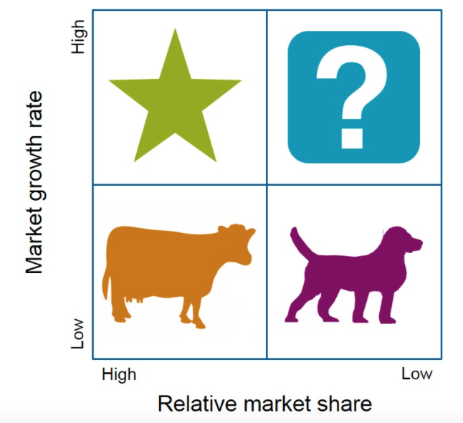
Figure 6: BCG Matrix of Subway Corporation (Biliavska, 2022)
Star
In the BCG matrix that represents Subway, the strategic business unit for financial services is represented as a star. It is engaged in a sector of the market that has promise for the foreseeable future. Since Subway has a market share of 20% in this industry, the organization's strategic business in the BCG matrix represents the company (Alina, 2018). Additionally, it has the number one position in sales for this particular segment. The whole category is anticipated to expand at a pace of 5 percent over the subsequent five years, which indicates that the market rate of increase is anticipated to remain positive.
Cash cow
In Subway's BCG matrix, the business segment for supplier management services is a cash cow. For over a decade, Subway has made a process of maximizing this operation. Since more companies manage their suppliers in-house rather than outsource them, the total market share of Subway is increasing. As long as this company is successful, Subway's best plan is to prevent additional investment and continue running this key segment. According to the BCG model, Subway's regional and international corporate strategy segment is a cash cow. Market share in this business unit is 30 percent, although consumers are now less interested in foreign restaurants (Andrade et al., 2019).
Question mark
Subway's local foods strategy is a question mark on the BCG matrix. Recent financial trends suggest people favour local cuisine. This market is expanding. Subway's share is low in this area. Subway should spend on R&D to innovate. This product development approach will make this critical business unit a cash cow for the organisation.
Dogs
A dog in Subway's BCG matrix, the plastic bags business strategy unit. This core operating segment has been in the red for the last five years (Andrade et al., 2019). As a result of environmental concerns, the market in which it works is diminishing. It is proposed that Subway sell this crucial strategic segment to minimize its losses.

Recommendation
Following some recommendations have been given using the TOWS matrix:
Internal factors
External factors |  | Strength (S) | Weakness (W)
External factors | Opportunities (O) | (SO)  Since the company offers customised products to its consumers, it can meet the growing fast-food demand, especially the demand for subway sandwiches. | (WO)  Subway Corporation can make a contract with third-party food delivery businesses to home-deliver foods by which it can reduce the low retention rate of the employees because this approach will reduce the employees’ responsibilities.
External factors | Threats (T) | (ST)  As the company’s marketing strategy is so strong and has an established brand image, it can reduce the threat to local fast-food businesses. | (WT)  Subway Corporation needs to maintain consistency in providing service at all of its outlets so that the company can reduce the growing threat to local businesses.

Conclusion
Subway corporation is considered a giant in the sandwich business, which is running its business activities throughout the world successfully. The company operates in more than 100 countries, including India and the United Kingdom (Biliavska, 2022). In the UK, Subway corporation has a number of outlets where thousands of consumers are offered the best quality sandwiches. This report is based on Subway’s international expansion, where two regions, India and UK, have been chosen. Through the report, a bunch of models and analyses have been shown to provide a clear idea of the business activities of Subway in the mentioned regions.

References
Alina, B., 2018. BASIC DIRECTIONAL DEVELOPMENT AND IDENTIFICATION OF THE POLICY OF INTERNAL POWER SUPPLY OF UKRAINE. Modern Science-Moderni Veda, 5(5), pp.18-26.
Andrade, C.E.S.D. and D’Agosto, M.D.A., 2019. Evaluation of subway systems in CO 2 emissions: Comparative analysis of emissions from cars, buses and subways. Engenharia Sanitaria e Ambiental, 24, pp.919-927.
Ben Rayana, T., Debatisse, A., Jouannique, V., Sakthithasan, K., Besançon, S., Molle, R., Wild, P., Guinhouya, B.C. and Guseva Canu, I., 2022. Sixteen-Year Monitoring of Particulate Matter Exposure in the Parisian Subway: Data Inventory and Compilation in a Database. Atmosphere, 13(7), p.1061.
Biliavska, A., 2022 BASIC DIRECTIONAL DEVELOPMENT AND IDENTIFICATION OF THE POLICY OF INTERNAL POWER SUPPLY OF UKRAINE. Moderní věda, p.18.
Czinkota, M.R., Kotabe, M., Vrontis, D. and Shams, S.M., 2021. Product and Service Decisions. In Marketing Management (pp. 341-397). Springer, Cham.
Escandon-Barbosa, D., Ramirez, A. and Salas-Paramo, J., 2022. The Effect of Cultural Orientations on Country Innovation Performance: Hofstede Cultural Dimensions Revisited?. Sustainability, 14(10), p.5851.
Fang, T., 2013. A critique of Hofstede’s fifth national culture dimension. International journal of cross cultural management, 3(3), pp.347-368.
Ganatra, V., Utama, A.G.S., Puran, P., Pandey, R., Qi, L.M., Kee, D.M.H., Ling, I.S.A., Sien, L.H., Tien, T.J., Ramadhan, H.S. and Sin, L.G., 2021. A Study of Subway Marketing 4P Strategy. Asia Pacific Journal of Management and Education (APJME), 4(2), pp.47-64.
Gańko, M., 2018. ANALYSIS AND EVALUATIION OF ITS SOLUTION IN SUBWAY (Doctoral dissertation, Zakład Podstaw Budowy Urządzeń Transportowych).
Gheibi, M., Karrabi, M., Mohammadi, A. and Dadvar, A., 2018. Controlling air pollution in a city: A perspective from SOAR‐PESTLE analysis. Integrated environmental assessment and management, 14(4), pp.480-488.
Hambrick, M.E. and Pond, A.M., 2020. Evaluating the Rise of Electric Scooters Through Porter’s Five Forces Framework. In SAGE Business Cases. SAGE Publications: SAGE Business Cases Originals.
Helmold, M., 2021. Successful Management Strategies and Tools. Management for Professionals.
Hofstede Insights. 2022. Country Comparison - Hofstede Insights. [online] Available at: <https://www.hofstede-insights.com/country-comparison/india,the-uk/> [Accessed 26 August 2022].
Jurevicius, O., 2022. Subway SWOT Analysis 2022 - SM Insight. [online] Strategic Management Insight. Available at: <https://strategicmanagementinsight.com/swot-analyses/subway-swot-analysis/> [Accessed 20 July 2022].
Klimenko, N.S., Tyakht, A.V., Toshchakov, S.V., Shevchenko, M.A., Korzhenkov, A.A., Afshinnekoo, E., Mason, C.E. and Alexeev, D.G., 2020. Co-occurrence patterns of bacteria within microbiome of Moscow subway. Computational and structural biotechnology journal, 18, pp.314-322.
Pandey, A. and Das, S., 2019. Customer satisfaction survey of quick-service restaurant with special reference to subway: A study in Navi Mumbai.
Sohir, Y., 2021. Marketing Mix-Subway. Publications Études & Analyses.
Team, M., 2022. Subway Porter Five Forces Analysis | MBA Skool. [online] MBA Skool. Available at: <https://www.mbaskool.com/five-forces-analysis/companies/18341-subway.html> [Accessed 20 July 2022].
Zhang, H., 2022, April. Methods for Luckin Coffee to Develop its Core Competence. In 2022 7th International Conference on Social Sciences and Economic Development (ICSSED 2022) (pp. 1527-1532). Atlantis Press.
Zhang, P., 2021. SWOT Analysis of Disinfection Products under the New Crown Epidemic. In E3S Web of Conferences (Vol. 253, p. 01046). EDP Sciences.

