Integrating project – Travel Companion
James Chappel
2015997
April 2021

Table of contents
1. Introduction…………………………………………………………………...Page 3

2.1. Research into current products……………………………………………...Page 3,4,5

2.2. Life cycle diagram…………………………………………………………..Page 6

2.3 Project Initiation Diagram (PID)…………………………………………….Page 7

2.4. Requirements Analysis……………………………………………………...Page 8,9,10

2.5. Risk Assessment…………………………………………………………….Page 10,11

3. Project plan (Gant chart) ……………………………………………………...Page 12,13

4.1 Feasibility Study……………………………………………………………..Page 13

4.2 Code & Test …………………………………………………………………Page 14

4.3 Flow chart……………………………………………………………………Page 15

4.4. Application Layout………………………………………………………….Page 16

4.5. Hardware & Software……………………………………………………….Page 16,17,18

5. Evaluation & Results………………………………………………………….Page 18

6. References……………………………………………………………………..Page 19

1. Introduction.
This is an assignment to design a prototype active travel application. The general purpose is to design and implement a fully operational prototype. The active travel aspect integrates walking and cycling with combined journeys with other transport means such and a bus or train via public transport.
Entailed will be a full written report into the challenges that arise while tackling the project through all stages of the procedure.
Finished off with an evaluation into how the project went, what could be improved, and what could have been done differently.

2.1. Research into existing products.
In order to establish what is possible, research into the current market is essential. Here are a detailed list of the current Travel/fitness applications that are available on the market today:
Google maps.
Google maps is the leading application for everyday travel. It is commonly used for all modes of transport and you can get directions straight to your phone, and then accustom them to different transportation methods. It has the ability to pre-load maps so you don’t have to have internet connection for a planned trip.
Within Google Maps you can also create your own 'Saved Lists' where you can pin attractions, restaurants, bars, even simple street addresses and view them all on a custom map. They are a straightforward, visual way to organise all your must-visit places and can be easily shared with friends or kept private.

Trip Advisor.
Trip Advisor is one of the dominant travel planning apps. Save all the details of the places you are interested in, check out reviews for them as well as important information such as opening times and book them as you go. The Trip Advisor app will also show your local attractions on a map so you can find exactly what you are looking for.
PackPoint
Answer a few easy questions about your trip and PackPoint creates a customisable packing list for you. This includes recommendations based on weather forecasts, activities and whether you'll have access to laundry facilities. It's simple to cross things off as they're packed or add more as you go along. The standard version of the PackPoint app is free but does include ads and in-app purchases, you can upgrade to the premium version for £2.49 on the Play Store or £2.99 on the App Store to remove these.
Heha holiday extras.
Heha is great for the 'planning and preparation' stages of your holiday. You can search and compare all the best travel extras such as airport parking, airport hotels, lounges to transfers and a lot more, and it will cleverly tailor these towards your trip based upon your flight, destination and any app history you have.
There are exclusive app discounts, you can receive notifications if any products fall in price, create a 'Watch' list, browse related travel content, and even check the weather forecast for your holiday.
SkyScanner.
With Skyscanner you can search and compare the cheapest flights. Once you have your travel dates you can then filter by flight duration, price, number of stops greener flights and more. They advise you with colour coded calendars and graphs to establish the cheapest time to travel. You can also use the app to set price alerts for offers and compare hotels and car hire prices.
Culture Trip.
The Culture trip is an app for travel planning. It includes destination guides and travel stories with videos on destinations. It includes recommendations from local experts on 450+ locations and handpicked accommodation. You can save your content and make wish lists that you can then access offline while you are out and about.
Headout.
This application is mainly an events planner. You can search and book the best shows and activities near your location. There are estimated 3000 experiences worldwide, from cruises to helicopter tours headout covers it all. It’s great for getting discounts on last minute tickets.
Citymapper.
You search for your destination and it provides you with every possible method of getting there, from cycling to Uber cars. It includes offline maps, live departure times, disruption alerts and a calorie counter. Available in 41 cities around the globe.
Komoot.
Komoot an app designed to help you plan, navigate, and get the most out of your hike, road cycle or mountain bike adventure. You can obtain information about path/trail difficulty, surface, and distance. The app includes offline maps, turn-by-turn navigation, smart device connectivity, and the option to save and share your favourite routes.
Polarsteps.
Polarsteps is an app for logging and recording your trip. You can create your journey and itinerary in advance and edit it on the more. It automatically tracks and plots your journey, building a digital map of your adventure. You can attach photos, text and videos to locations, there are good sharing options including leaving tips and recommendations for other users. You can also create a Travel Book of your trip at the end. [1]
40 Best Travel Apps to Download for 2021 | Travel Made Easy (holidayextras.com)

Strava.
Strava is a running app. You can share your runs and rides with a large community, congratulate others on their efforts, ask for advice, and compete with friends and rivals to nab the (virtual) King of the Mountain jersey for your local hill. Strava is also very simple to get started on. Paying for the premium version gets you better training analysis, access to a new mobile route suggestion feature and more.

Nike run club.

This app has run tracking that covers stats like pace, distance and time. It has guided sessions and training plans. The audio-guided runs feature Nike coaches and famous athletes like Mo Farah, and there are also mindfulness-focused sessions through a partnership with Headspace, while the training plans are tailored to your current fitness and future targets.
Cyclemeter.
There is a stunning array of data available for cyclists to pore over on this smartphone app, making it comfortably the best pick for stat, map and graph junkies. You can sync all your Cyclemeter rides to Strava easily and enjoy the benefits of both.

My fitness pal.
My fitness pal is a calorie-counting apps. It assists in tracking your calorie intake and detailed macros. You can scan the items of food you buy and it will calculate the calorie intake. Good for monitoring your diet. [2]
The Best Health And Fitness Apps Of 2021 | Coach (coachmag.co.uk)

2.2. Life cycle diagram.
Below is a diagram that represents the life cycle of a product, it will be the basis for the spine of the project:
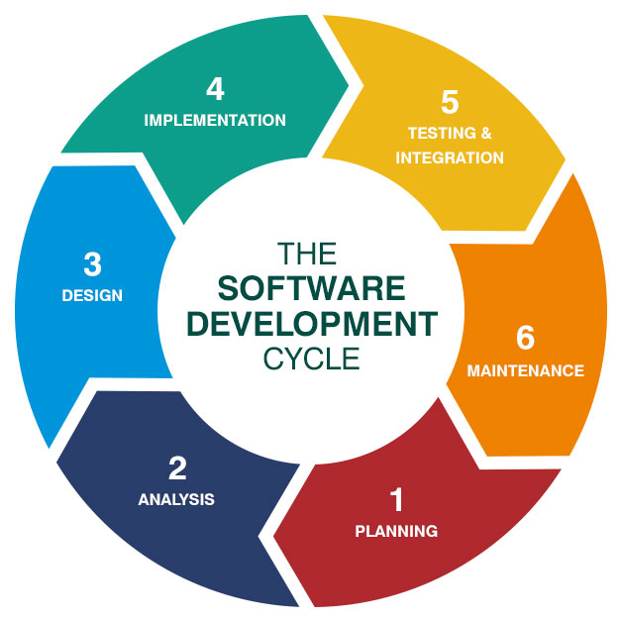

[3]
sdlc diagram - Bing images

2.3. Project Initiation Document
A PID outlines the context of the project and defines what is needed to be done, when it needs to done by and who needs to do it.
The challenge for constructing a prototype Travel application can be explained in the following:
Project definition:
- Purpose – to create a prototype of an active travel application whilst working as a team.

- Objectives – 1. To learn the importance of project management.
2. Develop teamwork skills.
3. Learn how to manage projects efficiently.
4. Produce a finished prototype for an active travel application.
- Scope – The project has the possibility to go as far as designing a proposed well calculated solution. Implementation will be theory based.
- Constraints – the main constraint to consider is productivity. The output will only be determined by the effort put it. Absence could become an issue. The deadline itself I a constraint as it limits the available time to produce the prototype. Technology could fail or severe weather could affect performance.

Roles & Responsibilities
- Project team: James Chappel, Barry Bradshaw, Alexandra Craciun, Omer Faruk Kaynar
- Responsibilities: Planning – James Chappel
Design – Barry Bradshaw
Implementation – Alexandra Craciun

[4]

2.4. Requirements Analysis
Functions
The functions of the app will be determined by the research done into the current market. What is standard on the majority of the applications will feature on the active travel application. The app will have the following functions:
- GPS – it will have a navigation map that can pinpoint your movement while traveling and show you where you are going.
- Travel guide – the app will have a detailed travel guide with top tips for destinations.
- A step counter – As you progress on your travels a step counter will monitor your journey, calculating every step as you go.
- Alerts & notifications – when you have reached a certain milestone, for example if you have walked 10 miles a notification will pop up with a thumbs up, encouraging the user to walk more often.
- Modes of transport - there will be an option to select information for all forms of public transport.
- Cycle route guide – for the cycle enthusiasts there will be a section on the nearest cycle routes and latest information.
- Traffic updates – while on the move traffic will automatically update and notify the user.

Resource constraints.
Schedule: there is a limited time for completion of the project, no extension possible
Cost: a budget will be set out and cost’s could fluctuate causing prices to go up.
Technology: hardware, software and general components may no longer become available or even outdated. A new module could come out making the project obsolete.
Policy: could cause restrictions on production due to clients rules and regulations.
System requirements.
The application hardware will be designed to work on the most basic of mobile phones or PC tablets. Taking this into account here is a list of both hardware and software minimum requirements:
Hardware – mobile phone.
- Android OS, v4.4.2, KitKat
- 16MP Full HD Camera
- Quad-core 2.5 GHz Krait 400
- 5.1 inches 1080 x 1920 pixels, Super AMOLED capacitive touchscreen
- HSDPA, 42.2 Mbps, HSUPA, 5.76 Mbps, LTE
- Fingerprint sensor
- Wireless charging
- 2GB RAM
Network
- Nano-SIM
- 2G: GSM 850 / 900 / 1800 / 1900
- 3G: HSDPA 850 / 900 / 1900 / 2100
- 4G: LTE 800 / 850 / 900 / 1800 / 2100 / 2600
Battery
- Type: Li - Ion
- Capacity: 2800 mAh
- Talktime: 21 hours
- Standby: 390 hours
- Wireless Charging (depends on market)
Camera
- Camera: 16 Megapixel
- Resolution: 5312 x 2988 pixels
- Camera Features: Flash (LED), Dual Shot, Simultaneous HD video and image recording, geo-tagging, touch focus, face and smile detection, image stabilization, HDR, digital zooming
- Video Resolution: 2160p @ 30fps, 1080p @ 60fps, dual-video rec.
- Additional Camera: 2.0 MP,1080p @ 30fps>
- Video Calling: Dual Video Call
Memory
- Inbuilt Memory: 16/32 GB
- Memory Slot: microSD, microSDHC
- Maximum Card Size: 128 GB
- Dropbox (50 GB storage)
Connectivity
- Wifi: 802.11b, 802.11g, 802.11n (Wi-Fi hotspot), ac, dual-band
- Wi-Fi Direct, Wi-Fi hotspot
- DLNA
- Bluetooth: 4.0 with A2DP, EDR, LE
- USB: microUSB 2.0 with MHL 2, USB On-the-go, USB Host, Mass Storage, Charging
- 3.5mm Headphone Jack

OS/Software
- Smartphone
- Operating System: Android OS, v4.4.2 (KitKat)
- Processor: Quad-core, Krait 400
- Speed: 2.5 GHz
- Chipset: Qualcomm MSM8974AC Snapdragon 801
- Memory: 2 GB RAM
- GPU: Adreno 330
- Adobe Flash Support
- Java: Java MIDP emulator
[5] Samsung Galaxy S5 Full Phone Specifications | Specifications (samsungsfour.com)

2.5. Risk Assessment.
Risk Description | Likelihood of the risk occuring | Impact if the risk occurs | Severity | Owner | Mitigating action | Contingent action | Progress on actions | Status
Lack of clear communication. | Medium | High | High | The group. | Ensure regular meetings are arranged to discuss project. | Organise an urgent meeting to address the issue. | Meeting to be scheduled. | Open
Poor Documentation. | Medium | High | High | The individual. | Practice literature and researching skills. | Research documentation to clarify it’s authenticity. | Research is dynaimic. | Open
Unplanned absence of a team member. | High | High | High | The individual, | Make sure every team member is clear on their task and delegate the extra work accordingly. | Delegate the extra work amongst the present team members. | Several absences have been addressed, and extra work load delegated evenly. | Close
Failure to complete the project with the deadline. | Medium | High | High | The group and client. | Set a project plan to identify each person’s role with deadlines. | Arrange an emergency meeting to brainstorm all possible outcomes to salvage project. | Project still ongoing on schedule. | Open
Unresolved conflicts not dealt with accordingly. | Low | Medium | Medium | The individual. | Create a clear line for communication for when a problem occurs, such as the email thread. | Address the conflict as a group and come up with a solution. | Online meeting Scheduled. | Open
Acts of god, such as the extreme weather. | Low | High | Medium | The group. | Plan ahead and initiate a back up plan for an emergency procedure. | Notify appropriate authorities. Follow health and safety procedures. | Procedures set in place. | Closed.
Theft of materials, intellectual property or equipment. | Low | Medium | The individual. | Implement a security procedure and insurance for all possession. | Notify the appropriate authorities. Activate security procedure and insurance policy. | Security procedure and insurance policy implemented.
Potential threats such as a virus or malware. | Medium | High | High. | The individual and the group | Install anti-virus software on all platforms. Create several backups | Revert to backups and continue with project. | Anti-virus software installed and backups created. | Open.
Delay in earlier project phases cause further complications. | Medium | Medium | Medium | The group. | Actively make sure the project plan is clear and concise, outlining deadlines and consequences. | Revert to project plan and schedule a meeting to discuss the issue. | Project ongoing, progress to be monitored | Open.
Additional workload added to project due to a change in project direction. | Low | Medium | Medium | The group. | Within the project plan, evaluate the possibility of an additional workload and address as best as possible. | Revert to project plan and try to delegate the workload accordingly. | Project ongoing. | Open.
Pressurised to reduce task durations and run tasks in simultaneously, causing possible health risks. | Low | Medium | Medium | The group. | Include within work policy appropriate health & safety guidelines. | Escalate to project manager or company director to address the issue. | Project ongoing, no pressure yet. | Closed

[6] 20 Common Project Risks - example Risk Register (stakeholdermap.com)

3. Project Plan – Gant chart.
To establish efficiency a project plan was laid out with a timescale for completion of each task. Here is a screen shot followed by a few snips.
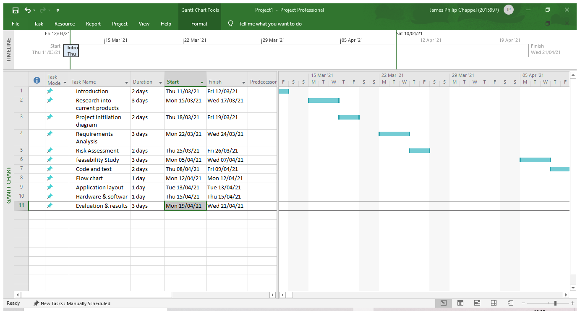
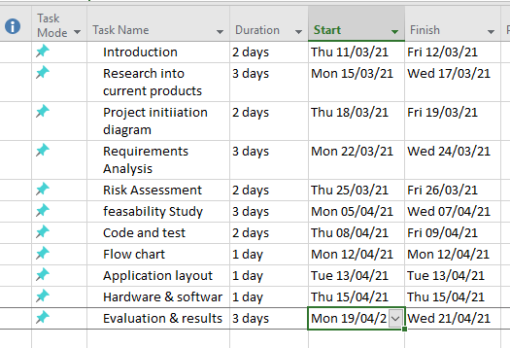
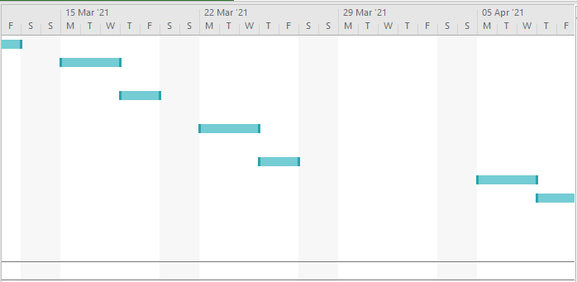
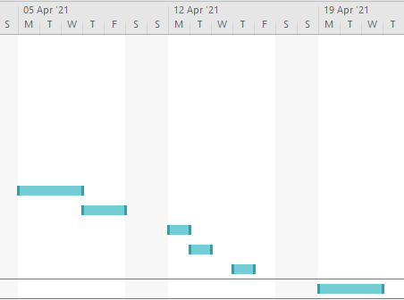

4.1. Feasibility study.
Information on current apps – From the research done into what other similar apps are currently available it was established that there aren’t that many active travel applications available. There are apps for most individual purpose, for example google maps is great for finding or plotting a destination how ever it has no incentive towards fitness or active travel.
Economic information - the cost effectiveness of producing the prototype shouldn’t be an issue. However, the progress of cost should be closely monitored throughout the project.
Financial information - similar to the economic information but focused on feasibility of the overall cost of the project from start to finish. A budget will be laid out and a timescale of completion.
Technical information - the current climate has to be taken into consideration, due to Covid 19 restrictions, supply and demand can cause some tools to become unavailable or overpriced, for example software and hardware.
Organisational information – the project has to be well organised in order to succeed. Tasks have been individually allocated and ongoing discussions will commence to monitor each others progress.
Client & Marketplace – from researching the current market , it is clear that that is a gap from active travel applications. There are many apps that do individual tasks, but not many that integrate several all in one. The aimed client base would be those individuals who appreciate useful information when traveling and monitors their fitness by counting the steps that they do, thus encouraging a healthy lifestyle.
Risk – for this element a detailed risk assessment has already been completed.
Time – the duration to complete the project must be closely monitored and each stage should follow the gant chart that was initially proposed.
4.2. Code and test
One of the last stages of the design phase is to create sufficient code that can be implemented and tested. There will be many variables to consider, some of them would include:
userName, phoneNo, stepCount, gPs, meNu, oP1, oP2, oP3, oP4, oP5, saTnav, desTin,

An average user experience in pseudocode would be broken down like this:
- Display “Hello, welcome to TravelPal! Would you like to enter your name?”
- Input userName
- Display “Would you like you enter your phone number?”
- Input phoneNo
- Display menu
- Input oP1, or oP2, or oP3, or oP4, or oP5
- If oP1 go to satNav
- Input oP1
- Display “Enter your destination”.
- Input desTin
- Display “Would you like to count your steps?”
- Input Y/N
- stepCount = 1, while stepCount <= 10,000, myCount = myCount + 1
- Display “You have trekked 10,000 steps, congratulations!”

4.3. Flow chart.
Here is a flowchart outlaying a basic user experience:
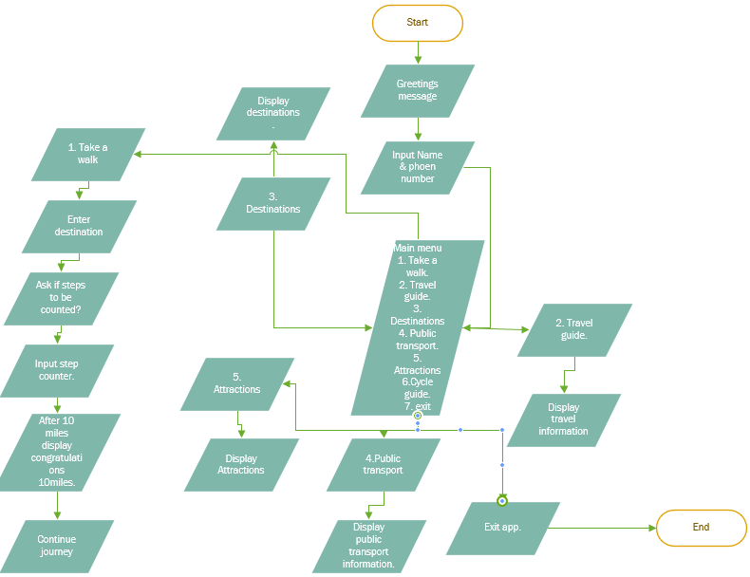

4.4. Apllication layout.
Here is a Layout of application design:

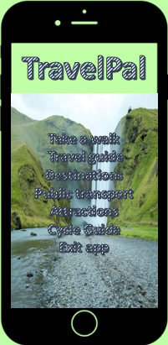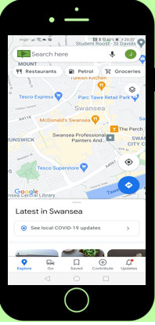

[7] phone app design template for free - Bing images

4.5 Hardware & software
The hardware & software will be taken from a Samsung S5 mobile phone. This is a good module to base the minimum requirements on as the application needs to be compatible with as many users as possible. The minimum requirements for the hardware are still the same as from the requirements specification:
- Android OS, v4.4.2, KitKat
- 16MP Full HD Camera
- Quad-core 2.5 GHz Krait 400
- 5.1 inches 1080 x 1920 pixels, Super AMOLED capacitive touchscreen
- HSDPA, 42.2 Mbps, HSUPA, 5.76 Mbps, LTE
- Fingerprint sensor
- Wireless charging
- 2GB RAM

Network
- Nano-SIM
- 2G: GSM 850 / 900 / 1800 / 1900
- 3G: HSDPA 850 / 900 / 1900 / 2100
- 4G: LTE 800 / 850 / 900 / 1800 / 2100 / 2600
Battery
- Type: Li - Ion
- Capacity: 2800 mAh
- Talktime: 21 hours
- Standby: 390 hours
- Wireless Charging (depends on market)
Camera
- Camera: 16 Megapixel
- Resolution: 5312 x 2988 pixels
- Camera Features: Flash (LED), Dual Shot, Simultaneous HD video and image recording, geo-tagging, touch focus, face and smile detection, image stabilization, HDR, digital zooming
- Video Resolution: 2160p @ 30fps, 1080p @ 60fps, dual-video rec.
- Additional Camera: 2.0 MP,1080p @ 30fps>
- Video Calling: Dual Video Call
Memory
- Inbuilt Memory: 16/32 GB
- Memory Slot: microSD, microSDHC
- Maximum Card Size: 128 GB
- Dropbox (50 GB storage)
Connectivity
- Wifi: 802.11b, 802.11g, 802.11n (Wi-Fi hotspot), ac, dual-band
- Wi-Fi Direct, Wi-Fi hotspot
- DLNA
- Bluetooth: 4.0 with A2DP, EDR, LE
- USB: microUSB 2.0 with MHL 2, USB On-the-go, USB Host, Mass Storage, Charging
- 3.5mm Headphone Jack

OS/Software
- Smartphone
- Operating System: Android OS, v4.4.2 (KitKat)
- Processor: Quad-core, Krait 400
- Speed: 2.5 GHz
- Chipset: Qualcomm MSM8974AC Snapdragon 801
- Memory: 2 GB RAM
[5]
5. Evaluation & results.
During the production of the project communication was the biggest issue. Initially it was just Barry and I out of the four who participated and agreed to split the assignment between us if we had no participation from the other two members. Just before easter Alexanra was added to the group and I managed to get some communication with Omer, however his lack of English was making it very difficult for both of us. Since then, Alexandra and I agreed to work on the project, I was responsible for the planning and she was going to do the implementation, leaving Barry and Omer responsible for the design. However Barry and Omer have gone AWOL and now Alexandra is not responding either. Leaving no option but to do the whole report myself.
So from start to finish, a lack of communication has haltered the projects progression and reduced it’s maximum output. Everything in the report is my own work, as a group we have only discussed a project plan but have not stuck to it at all.
Considering the lack of input from other members I am quite pleased with the overall result. A functional active travel application has been designed and in a real time situation it could be implemented into the real world. There is a market niche for active travel and the idea could genuinely work.
An assessment at each stage was conducted by me to ensure the right path was taken. After each section I would thoroughly go back over what was written to make sure it made sense and was relevant to the task.
Learning project management skills is crucial and the biggest lesson from this project is better communication and a project manager should have been selected from the start.
There are also some things that could be improved on the app also, such as a fitness guide and diet advice could have been added. As well as a heart monitor feature as people who are keen on fitness would be interested.

6.

References

[1] | "Holiday extras," [Online]. Available: https://www.holidayextras.com/best-travel-apps.html. [Accessed March 2021].
[2] | N. Harris-Fry, "Coach," [Online]. Available: https://www.coachmag.co.uk/gear/fitness-apps. [Accessed 26 March 2021].
[3] | "Bing," [Online]. Available: https://www.bing.com/images/search?view=detailV2&ccid=kOKhUX6V&id=D78C5731CA3FF88B5BF34D75EFB53BC5B23E3B99&thid=OIP.kOKhUX6Vr2TFqi8vDK1qnQHaHa&mediaurl=https%3a%2f%2fth.bing.com%2fth%2fid%2fR90e2a1517e95af64c5aa2f2f0cad6a9d%3frik%3dmTs%252bssU7te91TQ%26ri.
[4] | D. Williams, "Notes from Inegtrated project," James Chappel, 2021.
[5] | S. Electronics, "Samsungs4," Samsung, 11 April 2014. [Online]. Available: https://www.samsungsfour.com/specifications/samsung-galaxy-s5-full-phone-specifications.html.
[6] | "Stakeholdermap," stakeholdermap.com, 2008. [Online]. Available: https://www.stakeholdermap.com/risk/register-common-project-risks.html.
[7] | bing, "Bing search," [Online]. Available: https://www.bing.com/images/search?view=detailV2&ccid=p8maWqrV&id=D451132170A4B9518C8301D375C1917E663FD48D&thid=OIP.p8maWqrV1O2pAv6fADAGJAHaHa&mediaurl=https%3a%2f%2fth.bing.com%2fth%2fid%2fRa7c99a5aaad5d4eda902fe9f00300624%3frik%3djdQ%252fZn6RwXXTAQ%26ri.

