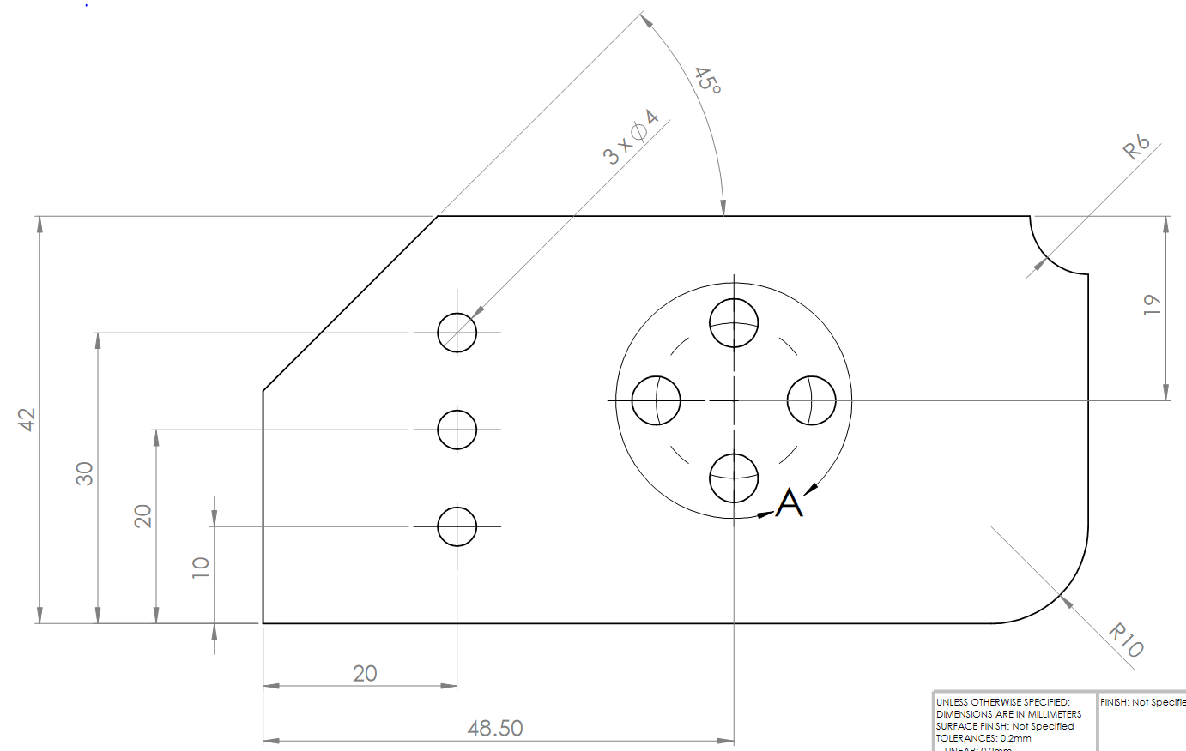
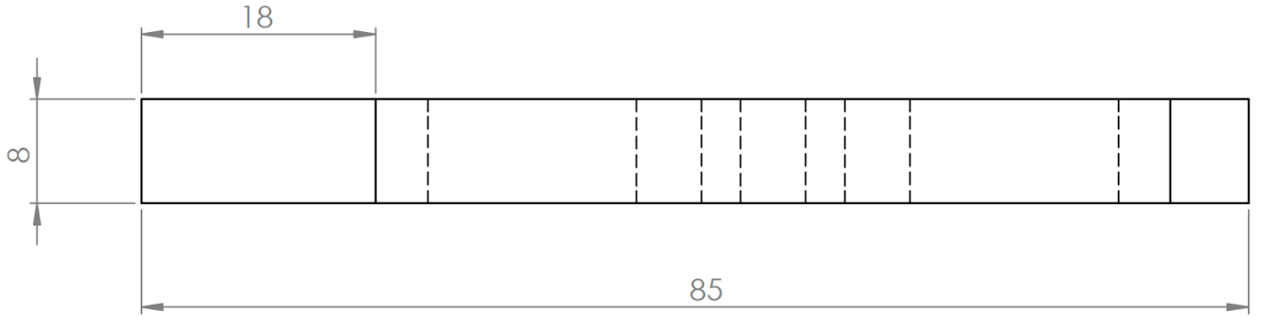
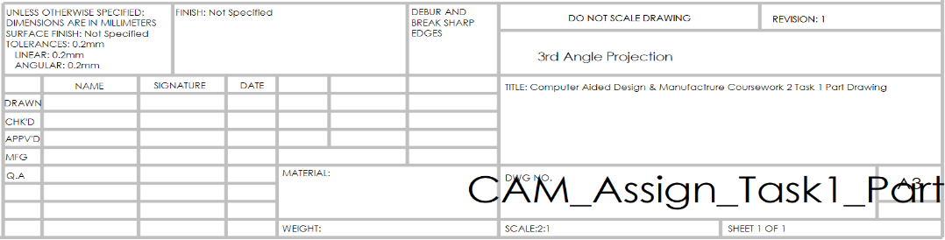
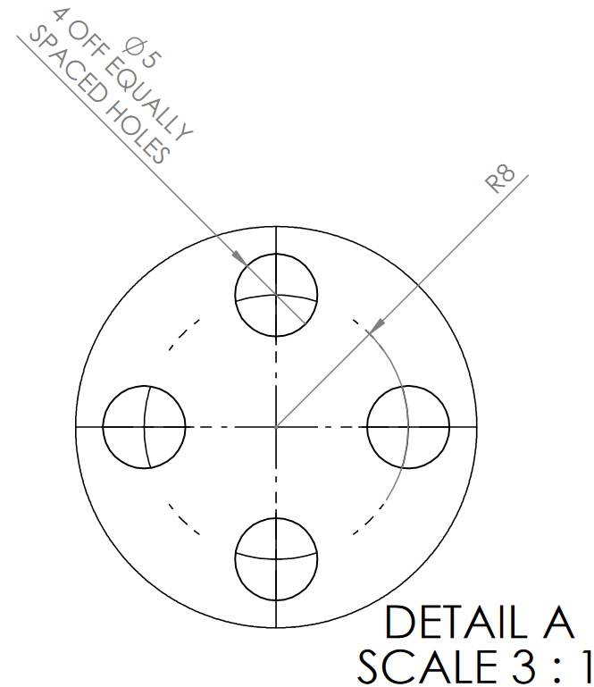
4.3

5.1

Manufacturing Notes Use lower left corner as X,Y datum and top surface of part as Z datum. Allow a minimum clearance of 15mm between tool and top surface of part when traversing in rapid interpolation. Assume the stock material, from which the part will be machined to be 12mm thick.

