Health Plus Analytics (HPA)Data Security and Governance Framework
A Comprehensive Cybersecurity Report: IT Security Manager, Health Plus Analytics

Module code: ACCA4024
Lecturer: Amit Naik

Student Name: Jomir Ali
Student Number: 2442127
Date: 27/04/2026

CertHE Computing Skills for Workplace Network
Networks and Cyber Security Essentials

Table of Contents
Table of Contents 1
Executive Summary 3
Introduction 4
1. Threat Identification 5
1.1 External Threats: 6
1.2 Internal Threats 7
2. Security Policies 8
2.1 Overarching Information Security Policy 8
2.2 Access Control and Identity Management Policy 8
2.3 Data Classification and Handling Policy 9
2.4 Acceptable Use and BYOD Policy 9
2.5 Patch and Vulnerability Management Policy 9
2.6 Incident Response Policy 9
2.7 Third-Party and Supplier Security Policy 9
3. Mitigation Measures 10
3.1 Technical control 10
3.2 Administrative Controls 11
3.3 Physical Controls 12
5. Monitoring and Incident Response 13
5.1 Continuous Monitoring Architecture 13
5.2 Incident Response Process (Flowchart) 13
5.3 Key Performance Indicators 14
6. Staff Training and Awareness Program 16
6.1 Role-Differentiated Training Matrix 16
6.2 Delivery Methods 17
6.3 Measuring Programmed Effectiveness 17
Conclusion 18
References 19
Appendix A – PowerPoint Presentation Slides 20

Executive Summary

Given that Health Plus Analytics (HPA) manages patient data, which is among the most sensitive types of information, security lapses have far-reaching effects. The company has already seen this personally after dealing with a ransomware attack and illegal access to cloud servers. These occurrences serve as a reminder of how easily things may go wrong, especially with so many employees working remotely and using personal devices to do tasks. This fact makes it vulnerable to threats from both external attackers searching for a way in and well-intentioned staff members who might unintentionally leave one open.
The goal of the suggested framework is to organise that complexity. It lays forth a workable strategy for cybersecurity and data governance that is manageable and uniform throughout the entire organization by drawing on well-known standards like ISO 27001 and NIST. [1]. This entails stricter guidelines for who can access what, more robust encryption to safeguard private data, and more stringent restrictions on the usage of personal devices. Technically speaking, the suggestions include multi-factor authentication, endpoint security solutions, network segmentation, and ongoing monitoring techniques that cooperate to both avoid incidents and minimise their impact.
But this cannot be resolved by technology alone. Human error, such as clicking a link, using a weak password, or assuming something was safe when it wasn't, is often the cause of security mishaps. People are therefore at the centre of this framework rather than an afterthought. From the beginning, there is a hands-on training and awareness program that includes regular workshops, phishing simulations, and clear instructions on safe daily activities. The intention is to make employees feel truly prepared to identify dangers and react confidently, not to intimidate them or overwhelm them with policy documentation.
When combined, these strategies provide HPA with something more robust than a collection of technical solutions. It serves as the cornerstone of an environment at work where everyone understands, shares, and takes security seriously.

Introduction

Cybersecurity has become a major concern in today's rapidly evolving digital environment, particularly with cloud technologies, remote work, and growing cyber threats. A UK healthcare technology business that handles sensitive patient data, Health Plus Analytics (HPA), is especially vulnerable and must adhere to stringent UK GDPR and NHS regulations. Recent events, such as a ransomware attack and unauthorised access, revealed serious flaws and sparked worries about reputation and security. This research proposes a workable framework for HPA's cybersecurity and data governance, outlining key threats, countermeasures, and the significance of both robust technology and employee awareness in maintaining data security.

1. Threat Identification

Health Plus Analytics (HPA) faces a range of cybersecurity threats that can seriously affect the Confidentiality, Integrity, and Availability (CIA) of its systems.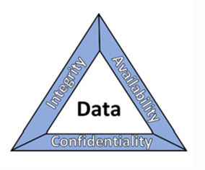 Figure 1: [2]
The CIA model explains three key goals of cybersecurity: Confidentiality, Integrity, and Availability. Confidentiality means keeping sensitive information secure so only authorized people or systems can access it, helping protect data like passwords and medical records from misuse. Integrity ensures that data stays accurate and unchanged unless properly authorized, since even small unwanted changes can lead to errors or corrupted information. Availability focuses on making sure that systems and data are accessible to authorized users whenever they need them. This includes using backups, redundancy, and recovery plans so services continue running smoothly even during cyberattacks or system failures. [3]
Sensitive patient data, which is mostly at risk from external assaults, including ransomware, phishing, advanced persistent threats (APTs), and supply chain hacks, can also interfere with services. For instance, phishing deceives employees into disclosing login credentials, while ransomware can lock vital healthcare systems. APTs can take data covertly over time and are more covert. Internal errors like incorrect cloud configurations or negligent staff behaviour can unintentionally reveal or change patient data. Denial-of-service attacks mostly result in system outages, rendering services unavailable when required. Man-in-the-middle attacks, on the other hand, can covertly intercept or alter data being transferred between systems. Overall, these risks demonstrate how healthcare data and services can be seriously jeopardised by both human mistakes and outside adversaries.
Internal threats are security hazards that come from within a company, frequently from staff members, outside contractors, or mistakes in internal systems. The CIA trial may be significantly impacted by these threats. Insider risks, for instance, might entail employees purposefully stealing patient data or unintentionally disclosing it because of bad security practices, compromising confidentiality and integrity. IT personnel's incorrect cloud configurations may also reveal private data or permit unapproved modifications. Weak access restrictions may also allow users to read or modify data that is not related to their employment position. Risk is also increased by poor security practices, such as using unreliable personal devices or falling for phishing emails. In general, abuse and human mistakes continue to be serious internal security issues.

1.1 External Threats:

Threat Category | Attack Vector / Method | CIA Triad Impact
Ransomware | Encrypt analytics servers and patient datasets to make them unusable. Additionally, data may be exfiltrated before encryption (double extortion). | - Confidentiality: High  - Integrity: High  - Availability: Critical
Phishing & Social Engineering | obtains patient records and cloud systems without authorization by stealing the login credentials of healthcare analysts or administrators. | - Confidentiality: High  - Integrity: Medium  - Availability: Low
Advanced Persistent Threats (APTs) | The purpose of long-term infiltration is to steal confidential patient information and intellectual property covertly. | - Confidentiality: Critical  - Integrity: High  - Availability: Medium
Distributed Denial of Service (DDoS) | overloads HPA's cloud-based analytics systems, making it impossible for clinics and hospitals to get vital services. | - Confidentiality: None  - Integrity: Low  - Availability: Critical
Man-in-the-Middle (MitM) | intercepts patient data while it is being sent between hospitals, cloud systems, and remote employees, possibly changing or stealing private information. | - Confidentiality: High  - Integrity: High  - Availability: Low
SQL Injection (malicious database queries via web apps) | enables hackers to alter medical information in analytics systems or retrieve complete patient databases. | - Confidentiality: Critical  - Integrity: Critical  - Availability: Medium
Zero-Day Exploits | Before updates are released, unknown vulnerabilities are exploited by external attackers. | - Confidentiality: High  - Integrity: High  - Availability: High
Supply Chain Attacks (third-party compromise) | HPA's software updates or reliable vendors are compromised by outside attacks. | - Confidentiality: Critical  - Integrity: Critical  - Availability: High

1.2 Internal Threats

Threat Category | Attack Vector / Method | CIA Triad Impact
Insider Threat (malicious or negligent employee actions) | Due to inadequate security procedures (such as weak passwords or improper data processing), employees or contractors may purposefully steal patient data or unintentionally disclose it. | - Confidentiality: Critical  - Integrity: High  - Availability: Medium
Cloud Misconfiguration (open storage buckets, weak IAM policies) | Internal IT personnel may set up cloud storage or permissions improperly, making private health information accessible to the public or permitting unwanted alteration. | - Confidentiality: Critical  - Integrity: High  - Availability: Medium
Weak Access Control Abuse (privilege misuse) | Overly privileged internal users can access or modify patient records beyond what is necessary for their roles. | - Confidentiality: High  - Integrity: High  - Availability: Medium
Poor Security Hygiene (internal user behaviors) | Internal compromise risks are introduced when employees use insecure devices (particularly in BYOD contexts) or fall for phishing emails. | - Confidentiality: High  - Integrity: Medium  - Availability: Low

2. Security Policies

Data breaches, no matter how big or small, can cause major operational, financial, and reputational harm. Organizations must safeguard their data from unauthorized access and disclosure. Sensitive information may be made public during a breach via unapproved access, leaks, or unintentional sharing with the public. Organizations must properly identify and safeguard their most valuable assets to lower these risks. They must also be able to promptly identify any continuing breaches and take appropriate action utilizing security measures and well-thought-out recovery procedures. The National Institute of Standards and Technology (NIST) provides guidance, especially through its National Cybersecurity Center of Excellence, that aids companies in putting into practice workable solutions to safeguard data confidentiality and improve their overall cybersecurity posture. This practice guide assists companies in identifying potential risks that could result in a data breach, identifying assets that may be at risk, and implementing the appropriate security procedures to better safeguard their data. [2]

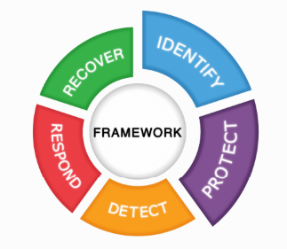 Figure 2: [2]

2.1 Overarching Information Security Policy
This is the primary policy that establishes the framework for all organisational security procedures. It guarantees that everyone is aware of their part in maintaining data security, identifies responsibilities, and emphasises the significance of information protection.

2.2 Access Control and Identity Management Policy
This policy ensures that the appropriate systems are only accessible to the appropriate individuals. It guarantees that workers only have access to what they require for their jobs and addresses how users log in, use passwords, or use multi-factor authentication.

2.3 Data Classification and Handling Policy
This policy aids employees in comprehending the sensitivity of various kinds of data. Patient data, for instance, is extremely private and needs to be treated with care, whilst less sensitive data might be subject to fewer limitations.

2.4 Acceptable Use and BYOD Policy
This guideline outlines how staff members should utilise their own devices and business services. It helps reduce risks when staff use their own phones or laptops for work.

2.5 Patch and Vulnerability Management Policy
This guarantees that systems are updated often to address security flaws. Updating software keeps known vulnerabilities from being exploited by attackers.

2.6 Incident Response Policy
This policy describes what to do in the event of a cyberattack or data breach. It facilitates prompt response and damage mitigation for the organization.

2.7 Third-Party and Supplier Security Policy
This lowers threats from partners or suppliers by ensuring that any other businesses collaborating with HPA adhere to appropriate security standards.

3. Mitigation Measures

Health Plus Analytics (HPA) needs a combination of administrative, technical, and physical safeguards to improve security. Together, these actions lower risks, boost compliance, and increase resilience.

3.1 Technical control

Multi-Factor Authentication (MFA):
- Make MFA mandatory for all vital systems, including cloud platforms, email, and remote access.
- When feasible, use safe techniques like authenticator apps rather than SMS.
- Include conditional access (such as device-based or location-based checks).

Endpoint Detection and Response (EDR):
- Install EDR on all devices, including servers, laptops, and mobile phones.
- Keep an eye on things in real time to spot questionable conduct.
- Turn on automatic reaction to swiftly contain threats.

Zero Trust Architecture and Network Segmentation: Data Loss Prevention (DLP):
- Before allowing access, confirm each person and device.
- Use "least privilege" to restrict access to only what is required.
- To lessen the transmission of danger, separate networks (such as patient data vs general systems).

Security Information and Event Management (SIEM):
- Keep an eye on and regulate the sharing of sensitive data
- Stop or mark dangerous activities, such as transmitting patient data outside of the country.
- Safeguard data on detachable devices, cloud platforms, and email.

Encryption at Rest and in Transit:
- Gather logs from every system in one location.
- Early detection of anomalous trends or possible dangers.
- Encourage quicker and more efficient incident response.

Vulnerability and Patch Management:
- Regularly scan systems for vulnerabilities.
- Apply security patches quickly, especially for critical issues.
- Maintain an up-to-date inventory of systems and software.

3.2 Administrative Controls

Security Policies and Governance:
- Clearly define policies (allowed use, data processing, access control).
- Comply with NHS and UK GDPR.
- Review and update policies regularly.

Security Awareness and Training:
- Provide ongoing staff training on cybersecurity risks.
- Teach employees how to recognise phishing and scams.
- Run simulated phishing exercises to build awareness.

Access Control Management:
- Use job roles to determine access (RBAC).
- Regularly review access rights.
- As soon as access is no longer required, remove it.

Incident Response Planning:
- Create a precise incident response strategy.
- Specify who is responsible for what during incidents.
- Conduct routine drills to guarantee preparedness.

Third-Party Risk Management:
- Before granting access to systems or data, evaluate vendors.
- Verify if contracts have security and data protection clauses.
- Keep an eye on third-party access and activities

Data Governance and Compliance:
- Appoint a Data Protection Officer (DPO).
- Keep records of how data is processed.
- Perform DPIAs, or risk assessments, for the usage of sensitive data.
- DBS check

3.3 Physical Controls

Secure Facilities:
- Limit access to server rooms and offices.
- Make use of biometrics, key cards, or other comparable control methods.
- Keep track of and record every visitor
- The CCTV surveillance room.

Device Security:
- Strong passwords and screen locks should be enforced.
- Avoid leaving gadgets unattended.
- Turn on remote wiping for misplaced or pilfered devices.
Alarms and CCTV.

Environmental Protection:
- Install systems for suppressing fires.
- Make use of backup power sources (UPS).
- Keep the humidity and temperature under control.

Clear Desk and Clear Screen Policy
- When not at a desk, lock screens.
- Don't make private documents visible.
- Maintain tidy and safe work areas.

5. Monitoring and Incident Response

To keep Health Plus Analytics secure, continuous monitoring and a strong incident response process are essential. The organization should actively track system activity using tools like SIEM and EDR to quickly spot unusual behavior, such as unauthorized access or ransomware activity. When an incident is detected, a clear response plan should guide the team through containment, investigation, recovery, and communication steps to reduce damage and downtime. Regular testing of this plan helps ensure everyone knows their role during a real event. [4]

5.1 Continuous Monitoring Architecture
A continuous monitoring system that monitors everything occurring in its IT environment in real time should be in place at Health Plus Analytics. This comprises activity from networks, devices, cloud platforms, and apps, all of which are combined into a single, central perspective. By doing this, the company can promptly identify anything out of the ordinary, such as suspect logins, odd data movement, or early ransomware indicators. When something seems off, the system ought to notify the security team automatically so they can take prompt action. This strategy guarantees that possible hazards are addressed before they develop into major incidents, minimises damage, and speeds up reaction times.

5.2 Incident Response Process (Flowchart)

STEP 1  DETECT | Identifying any unexpected activity, such as suspicious login attempts, system alerts, or odd network activity, is the first step.
STEP 2  TRIAGE | As soon as the problem is identified, it is promptly evaluated to determine its severity, and which systems may be impacted.
STEP 3  CONTAIN | To prevent the issue from propagating throughout the network, the impacted systems are separated.
STEP 4  NOTIFY | For the appropriate individuals to react promptly, the security team and pertinent stakeholders are alerted.
STEP 5  ERADICATE | By eliminating malware or repairing the exploited vulnerability, the underlying cause of the problem is eliminated.
STEP 6  RECOVER | While maintaining security, systems and services are meticulously returned to regular functioning.
STEP 7  REVIEW | To comprehend what went wrong and strengthen defences so it doesn't happen again, the occurrence is finally examined.

Key Performance Indicators

Health Plus Analytics can use a few distinct KPIs to gauge how well its security is working. These aid in demonstrating the speed at which problems are resolved and the level of system security.

KPI | Descriptions
  Incident detection time | How quickly is suspicious conduct detected once it begins
  Response time | The speed at which the security team responds when a problem is reported
  Containment time | How long does it take to prevent the spread of a threat?
  Recovery time | How soon can systems function normally again?
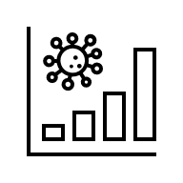  Number of incidents | monitors the frequency of security issues over time
  Patch compliance | demonstrates the frequency of system updates and security
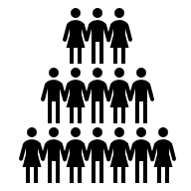  Staff awareness | evaluates how well staff members comprehend and adhere to security procedures

When combined, these KPIs provide an easy-to-understand yet powerful picture of HPA's security performance and enhance the safeguarding of private health information.

6. Staff Training and Awareness Program

Employees can better grasp their roles, duties, and workplace standards by participating in a staff training and awareness program. It lowers errors, increases adherence, and fosters a culture of safety and responsibility. Regular training, updates, and awareness campaigns help employees stay knowledgeable and self-assured so they can support organisational standards and ongoing development while working efficiently.

6.1 Role-Differentiated Training Matrix
Audience | Frequency | Core Content Areas
All Staff | Annual + onboarding | Fundamentals of data protection, security awareness, incident reporting, code of conduct, and appropriate system use
IT and Engineering Teams | Bi-annual | System security, vulnerability management, access control, secure coding techniques, and incident response protocols
Data Controllers and Managers | Annual | Data handling protocols, risk management, reporting requirements, data governance duties, and regulatory compliance (such as GDPR)
Executive Leadership and Board | Annual | Strategic cybersecurity risks, data protection accountability, organisational risk overview, and compliance obligations
New Joiners (all roles) | Within 30 days of start | Workplace behaviour, security fundamentals, policy overview, induction training, and reporting protocols

6.2 Delivery Methods

Staff members may readily comprehend and implement what they learn through a variety of training methods, such as onboarding meetings, online courses, workshops, and hands-on exercises, and frequent refreshers help keep their knowledge current.

6.3 Measuring Programmed Effectiveness

The number of employees who finish the training program, their comprehension of the subject matter as determined by brief assessments, and their comments are used to gauge its effectiveness. Frequent reviews and audits help identify any weaknesses, and fewer errors or occurrences indicate that it is operating effectively. This keeps the training current and helpful.

Conclusion

In conclusion, due to its heavy reliance on cloud services and handling of sensitive patient data, Health Plus Analytics poses significant cybersecurity threats. Stronger safeguards and increased awareness are required, as demonstrated by recent security incidents. Through well-defined policies, enhanced technical controls, ongoing monitoring, and a methodical reaction plan, the suggested framework aids in addressing these problems. Additionally, staff training is essential for lowering errors and guaranteeing adherence to NHS and UK GDPR. By implementing these safeguards, HPA may lower risks, improve data security, and restore confidence in its offerings.

References

[1] | P. P. Roy, "A High-Level Comparison between the NIST Cyber Security Framework and the ISO 27001 Information Security Standard," in National Conference on Emerging Trends on Sustainable Technology and Engineering Applications (NCETSTEA), Durgapur, India, 2020.
[2] | R. E. C. M. E. J. S. J. S. William Fisher, "Data Confidentiality: Identifying and Protecting Assets Against Data Breaches," NIST SPECIAL PUBLICATION 1800-28A, vol. A, February 2024.
[3] | L. O. Nweke, "Using the CIA and AAA Models to Explain Cybersecurity Activities," PM World Journal, vol. Vol. VI, no. Issue XII, pp. 1-3, December 2017.

Appendix A – PowerPoint Presentation Slides

Slide 1:
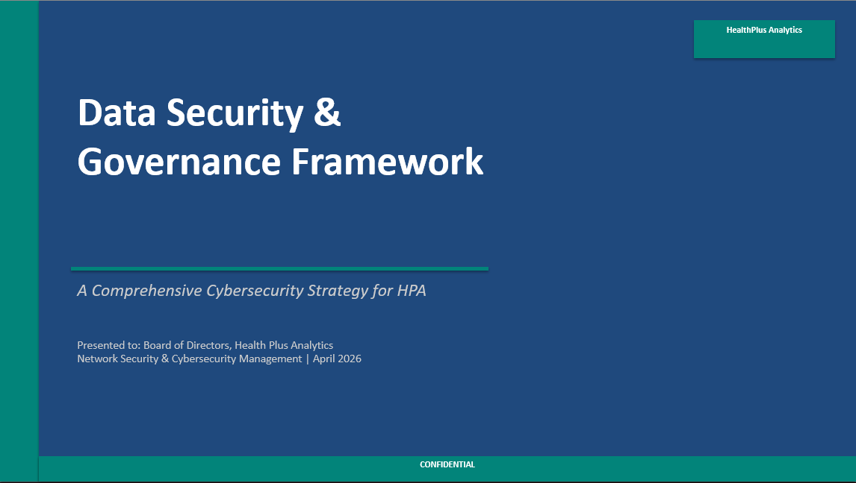
Slide 2: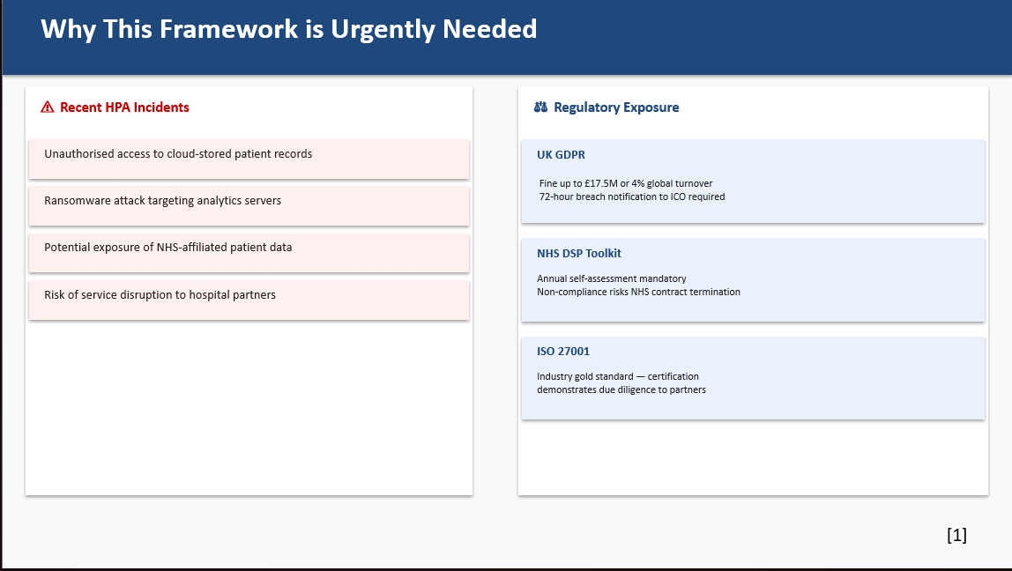

Slide 3:
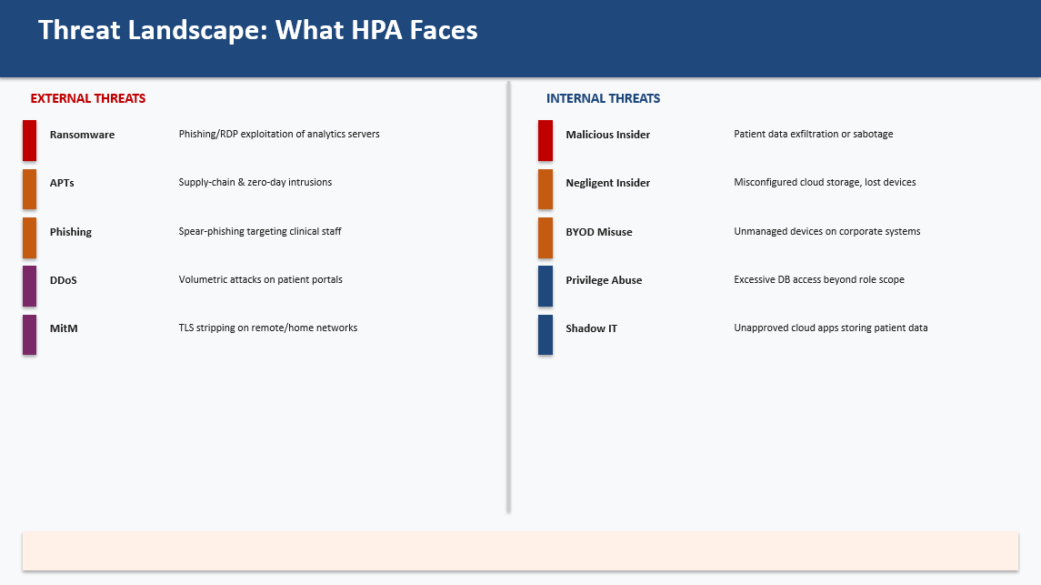
Slide 4:
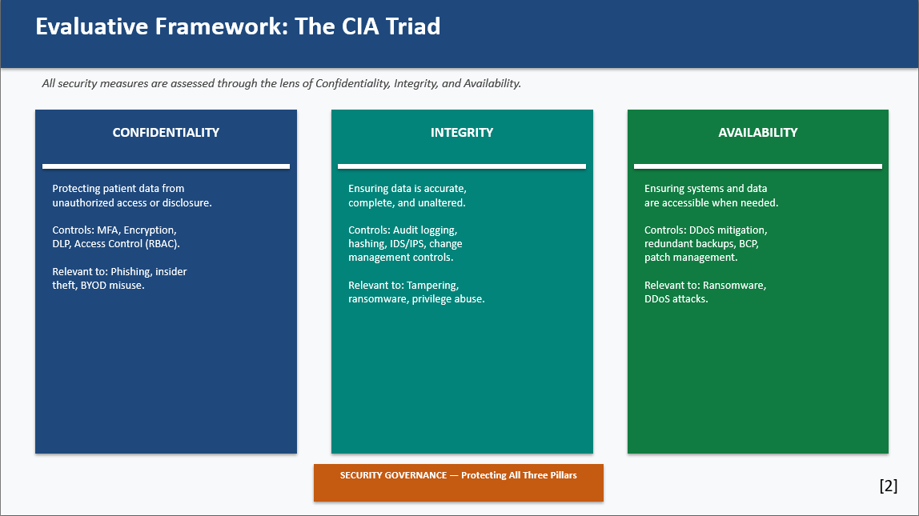

Slide 5:
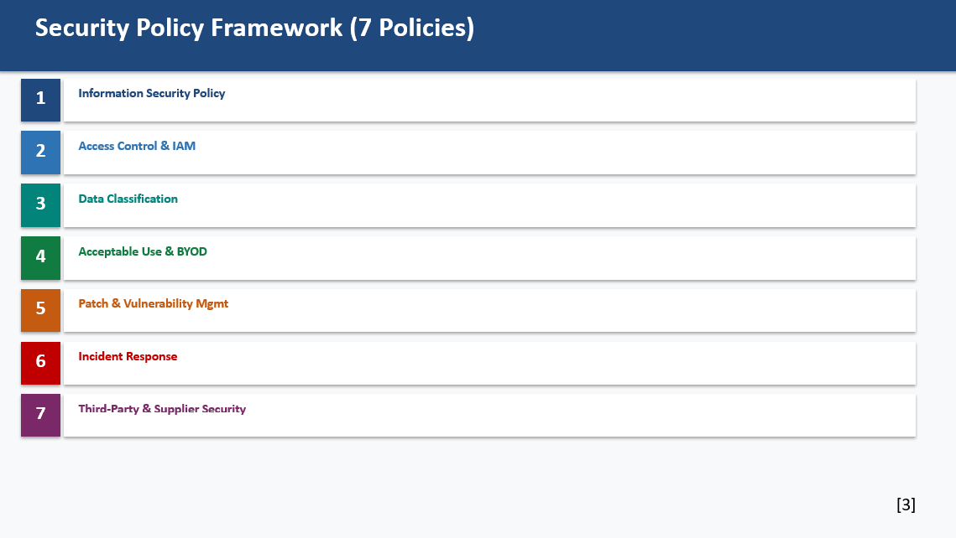
Slide 6:
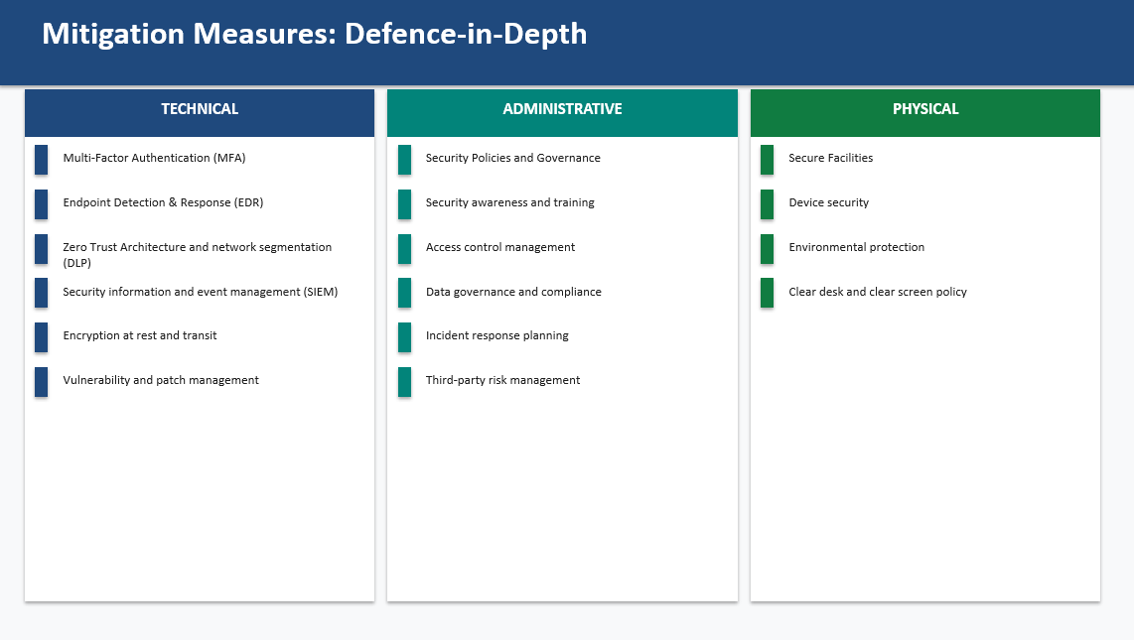

Slide 7:
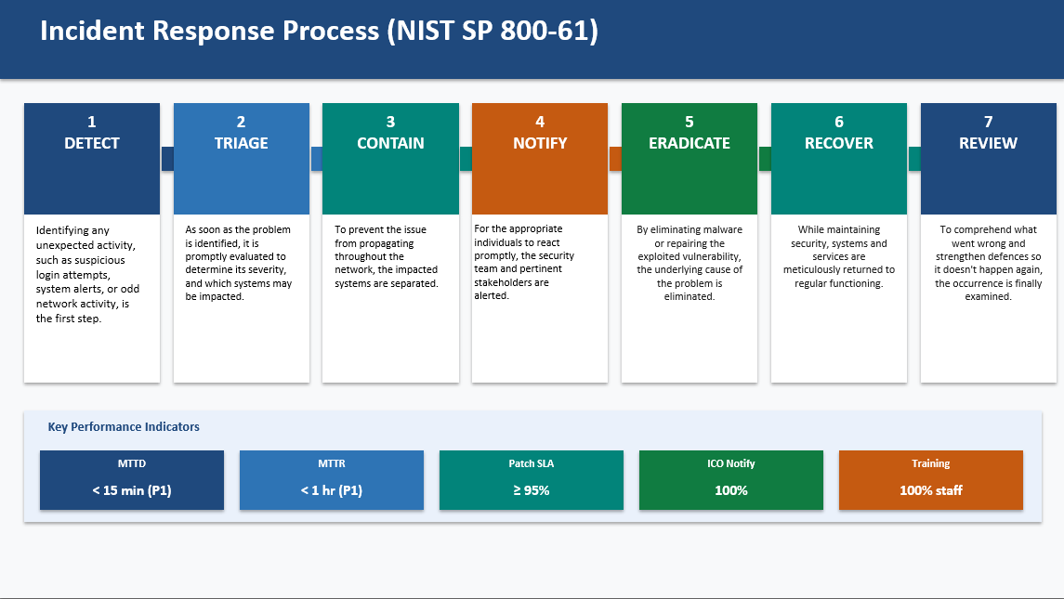
Slide 8:
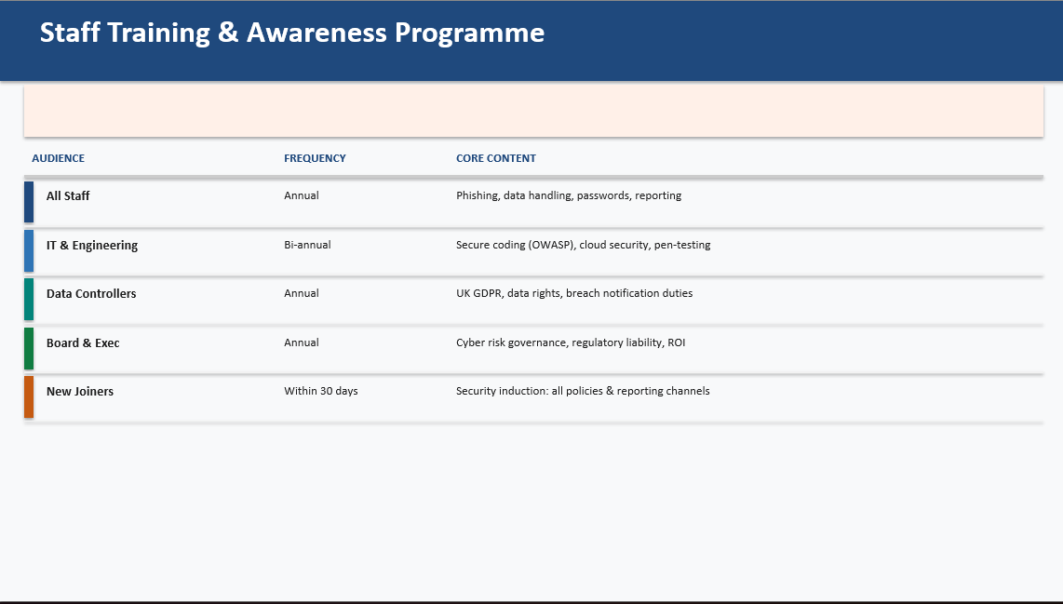

Slide 9:
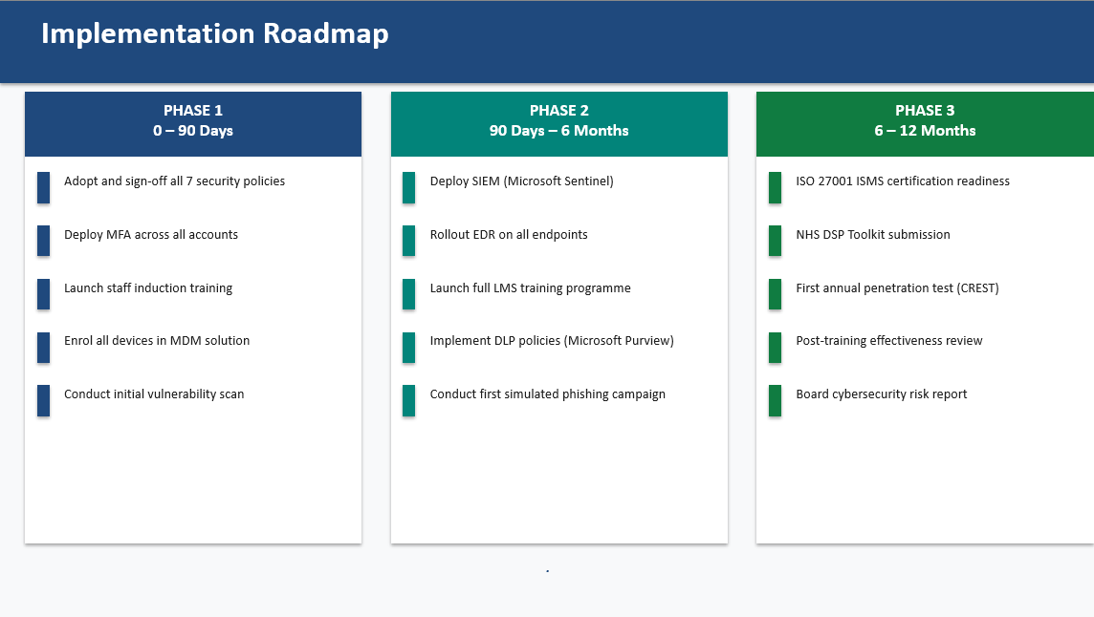
Slide 10:
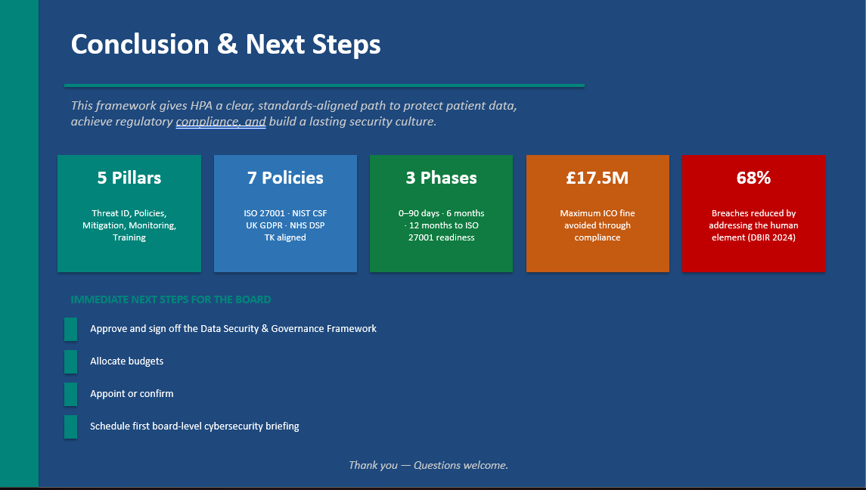

Slide 11:


