Witness Interview Assault Task Sheet
Scenario 5 Road Rage Assault – Witness brief

Road Rage Assault- Witness brief
Assault- Witness brief
Witness details: (use your own name)
Witness address: (use your own address)
Vehicle: (use your own vehicle details)
Offender type: Male

Circumstances
At 10.30am this morning you were driving your car along Ty Coch Way, Cwmbran.

As you were travelling along Ty Coch Way, Cwmbran, you become aware of a silver coloured Ford C max, index number CN 07 DBF travelling behind you.



The driver of the vehicle was flashing his headlamps and sounding his horn repeatedly. This vehicle followed you onto Hollybush Way, Cwmbran across the roundabout onto Llantarnam Park Way, finally stopping outside Screwfix 3, Llantarnam Industrial Park, John Baker Cl, Cwmbran NP44 3AW.



You are then aware that the driver has exited his vehicle and is approaching your vehicle. You wind down the driver’s side window.

!! Watch the film clip !!

The male driver has punched you in the face before walking back to his vehicle.

You sit in your car quite shocked at what had happened, you can taste blood and when you look in the mirror you see that you lip is bleeding.

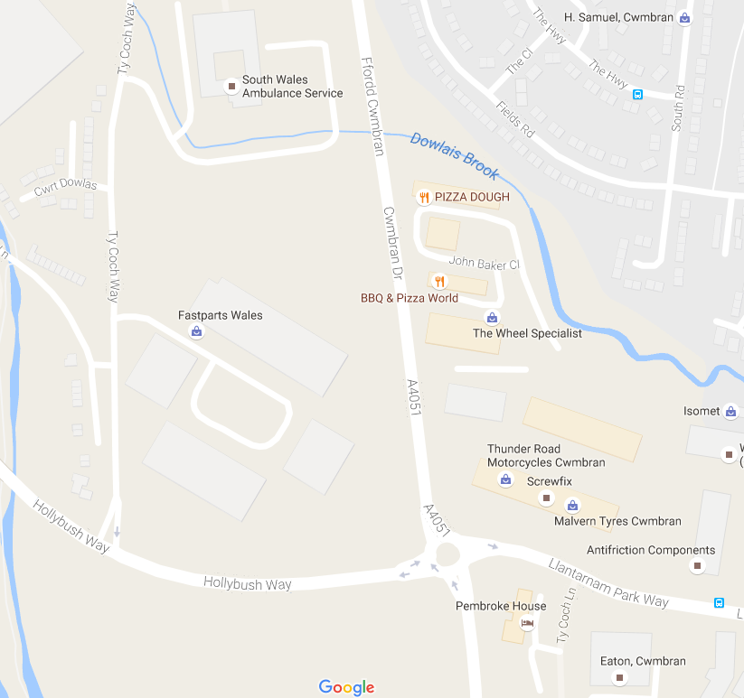

Aims of the Scenario

- The aim of investigative interviewing is to obtain accurate and reliable accounts from victims, witnesses or suspects about matters under police investigation.
- Investigators must act fairly when questioning victims, witnesses or suspects. Vulnerable people must be treated with particular consideration at all times.
- Investigative interviewing should be approached with an investigative mind-set. Accounts obtained from the person who is being interviewed should always be tested against what the interviewer already knows or what can reasonably be established.
- When conducting an interview, investigators are free to ask a wide range of questions in order to obtain material which may assist an investigation.
- Investigators should recognise the positive impact of an early admission in the context of the criminal justice system.
- Investigators are not bound to accept the first answer given. Questioning is not unfair merely because it is persistent.
- Even when the right of silence is exercised by a suspect, investigators have a responsibility to put questions to them.

Outcome of the Scenario

- Aim: To Provide interviewers with the competence to prepare and plan interviews with suspects.
- Objectives
- Assess information gathered about suspect(s)
- Assess the type and current condition of the suspect to inform the approach to the interview in accordance with legal requirements.
- Establish the correct interview approach utilising the engage and explain phase aide memoir
- Identify the nature of the allegation and identify investigative important information
- Produce a written interview plan that takes account of the suspect assessment , the needs of the investigation and legal requirements
- Select and set up the necessary interview location, resources and personnel.

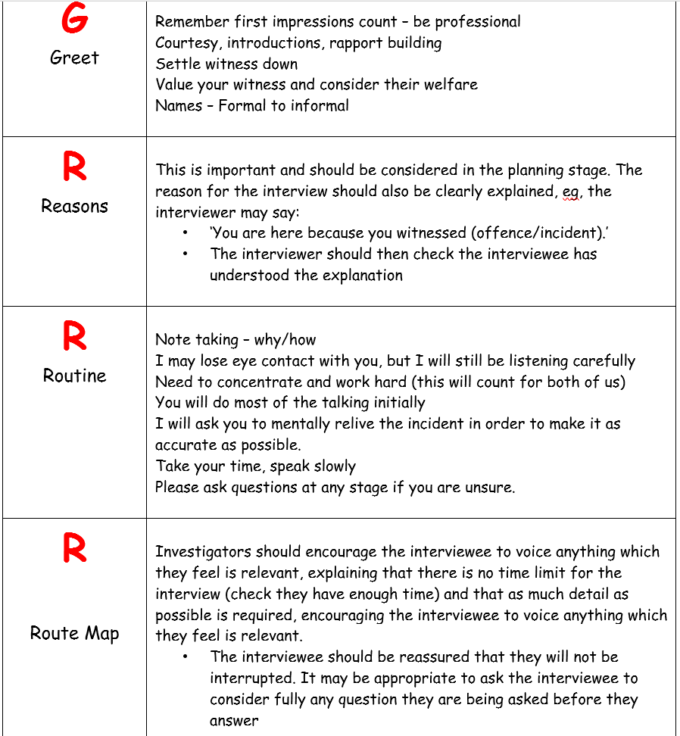

Section 39 of the Criminal Justice Act 1988
Provides that the offences of 'common assault' and 'battery', that were once provided by the common law, are now summary offences.
39(1) Common assault and battery shall be summary offences (penalty - see below).
39(2) Subsection (1) is subject to section 1 of the Assaults on Emergency Workers (Offences) Act 2018 (which makes provision for increased sentencing powers for offences of common assault and battery committed against an emergency worker acting in the exercise of functions as such a worker).
Notes
(i)This section creates two separate statutory offences, common assault and battery.
(ii) Assault - an assault is any intentional or reckless act which causes a person to apprehend immediate unlawful force or personal violence.
(iii) Battery - a battery is any intentional or reckless infliction of unlawful force or personal violence. Consequently, a battery may include an assault.
(iv) Although the word 'assault' is popularly used in a broad sense to mean some form of physical contact between the perpetrator and the victim, such interpretation is not correct in law. It is important to distinguish between the two offences, especially when laying an information. The inclusion of both offences in the same charge is bad for duplicity: where there is actual as well as apprehended unlawful violence the appropriate wording in the information is 'assault by beating'.
(v) In certain circumstances, either of the offences may be included in an indictment (see section 40 of this Act). For the purposes of joining a summary offence of assault to an indictment, the term 'assault' includes the offence of battery.
(vi) The threat of physical contact or the actual physical contact as the case may be, requires a mental element which is an intention, or recklessness.
(vii) Battery can be committed indirectly. For example, a woman holding her baby is hit by her boyfriend and drops the baby on the floor. The boyfriend commits assault by battery directly on the mother, and indirectly on the baby; the mother acting as a medium for the battery on the baby (see Haystead v DPP 2000).
(viii) If a common assault under this section is racially or religiously aggravated, you should consider the more serious version of this offence under section 29 of the Crime and Disorder Act 1998.
(ix) There are a number of defences to assault.
(x) From 13th November 2018, aggravated versions of the offences in this section apply, if the common assault or battery is committed against an emergency worker, as per subsection (2), above.

