Programme: BSc Health and Social Care
Module: Living with Care: The Older Person
Module code: BMHP6009
Lecturer: Laila Surani
Student Name: Sevzhihan Hasanova
Student Number: 2020999

Assessment 1 Written assignment (Report)
The impact of loneliness and social isolation on the elderly population on the UK and USA.

Table of content
1- Introduction
2- Comparison between two countries
3- Recommendations
4- Conclusion
5- Reference list

1-Introduction
This comparative report focuses primarily on the United States of America and the United Kingdom as its key points of comparison.
During my research, I will analyse what it means to be an elderly person in a number of different countries, with a special emphasis on the United Kingdom and the United States of America. In addition, I will talk about certain demographic statistics that are associated to ages, as well as how these figures have changed over the course of the past several years. In addition, there is a discussion of the fundamental ideas that underlie feelings of loneliness and isolation, as well as an analysis of the symptoms that are linked to feelings of loneliness, and an investigation into the effects that these emotions can have on elderly people who reside in assisted living facilities or other environments that are comparable to these kinds of settings. Legislation and policies that target or try to increase awareness of or restrict loneliness and isolation in older persons might be regarded to fall under this category. Legislation and policies that target or try to limit loneliness and isolation in younger adults could also be considered to fall under this category. Legislation and programmes that target or seek to decrease loneliness and isolation among younger individuals might also be considered as coming under this category. Additionally, comparisons between the local, national, and international provision of services for older people and the initiatives and policies that are already in place, as well as presentations of these analyses and comparisons that are as in-depth as they can possibly be. An investigation of the likely course of events regarding care for elderly people is now being carried out. This study will investigate, among other things, what changes might be made to programmes that are intended to tackle the problem of loneliness among the elderly and how technology may be used to enhance care for older persons who live alone. In closing, I will provide a few suggestions that people might implement into their day-to-day life to make them feel less lonely and isolated.
a) What it means to be elderly in the United Kingdom and the United States of America.
The term "elderly" usually refers to those who are quite old. The exact age at which a person is considered "elderly" depends on the nation's culture, setting, and circumstances. (NHS,2022).
The UK and US use "elderly" to refer to those 65 or older. Because many retire and start receiving social security at this age.
As in most countries, being an elderly person can bring a variety of challenges, including:
Health Concerns: Numerous physical and emotional health difficulties are related with ageing. Coronary heart disease, diabetes, arthritis, Alzheimer's, dementia, and other diseases are all too frequent. Quality healthcare for seniors is crucial.
Isolation: Retirement and losing acquaintances can cause social isolation in older adults. This may cause depression. However, many communities’ organisation now offers older people social activities and community involvement.
Concerns About Money Depending on their savings, pension, and other benefits, older individuals might worry about money. Many Americans depend on Social Security, while most Brits depend on a state pension.
Assistance and care: As people age, they may need additional help with daily tasks or medical care. The NHS and private care agencies in the UK provide this form of care. Private carers, Medicaid, and family members provide most elderly care in the US.
Discrimination Based on Age Ageism is the unfavourable stereotypes, prejudice, and mistreatment of older people. Many older people need living arrangement changes depending on their health and mobility. This may necessitate moving into a one-story dwelling, assisted living facility, or nursing home. Recreational time is something retired folks look forward to. Many community projects, groups, and activities target seniors. This includes gym classes, reading clubs, travel groups, and more, ageing is unique to each person and that many older people live busy, robust lives. As people live longer and healthier lives, social views about old age are changing.
b) Age-related population statistics and how these have changed over the past few years are presented here.
The world's population is getting older, which presents challenges related to loneliness and isolation.
The age-related population dynamics in the United Kingdom (UK) and the United States (USA) have both seen major alterations over the past several years. These movements have been driven by a variety of causes including birth rates, immigration, advancements in healthcare, and other factors.
Britain, often known as the UK:
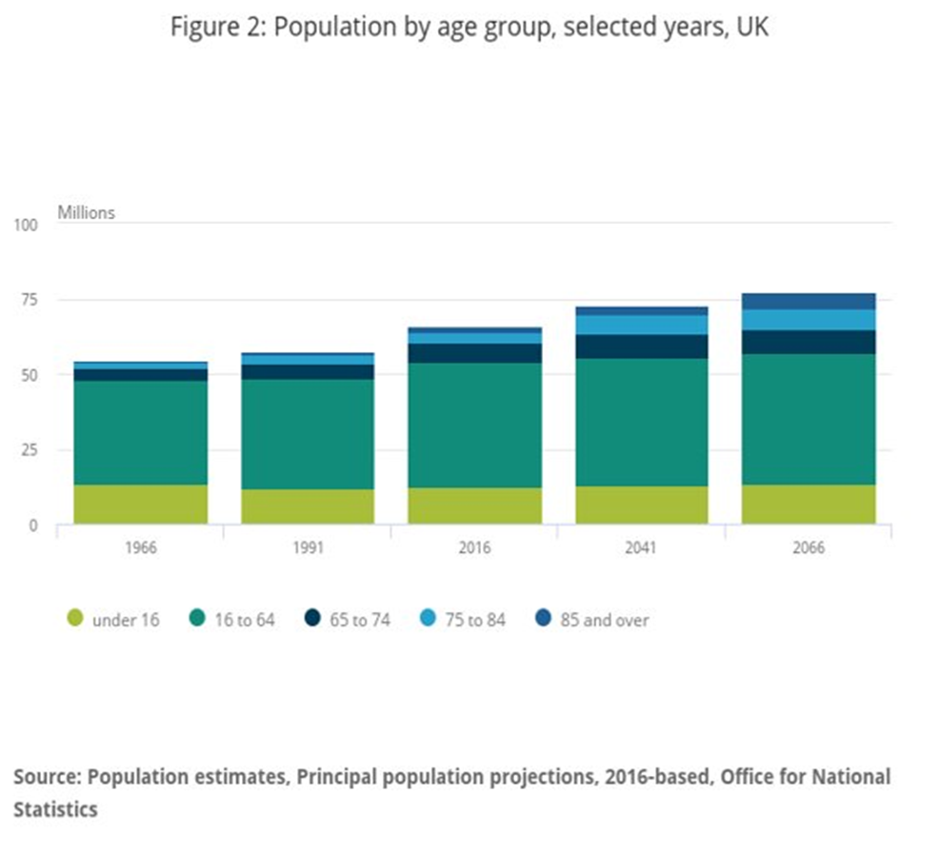The United Kingdom's population, like the populations of many other affluent countries, is getting older, and the number of senior individuals is growing. Around the turn of the 21st century, nearly one-fifth of the UK's population was at least 65 years old. This trend is anticipated to continue, with the percentage forecast to approach around one quarter by the year 2041. (Office for National Statistics, 2016)
Rates of Birth: The birth rate in the United Kingdom has been changing, although overall it has showed a reduction. The total fertility rate (TFR) was around 1.6 children per woman in the year 2020, which represented a decline from approximately 1.9 children per woman a decade earlier.
Life Expectancy: Over the course of the 20th century, the average lifespan increased gradually until it reached around 81 years. However, there were some worries about a modest standstill or fall in life expectancy in the years right before the year 2020. These worries were perhaps caused by factors such as austerity measures or seasonal flu. This statistic could also be subject to some transitory changes as a consequence of the influence of COVID-19.

The population of the United States of America (USA)
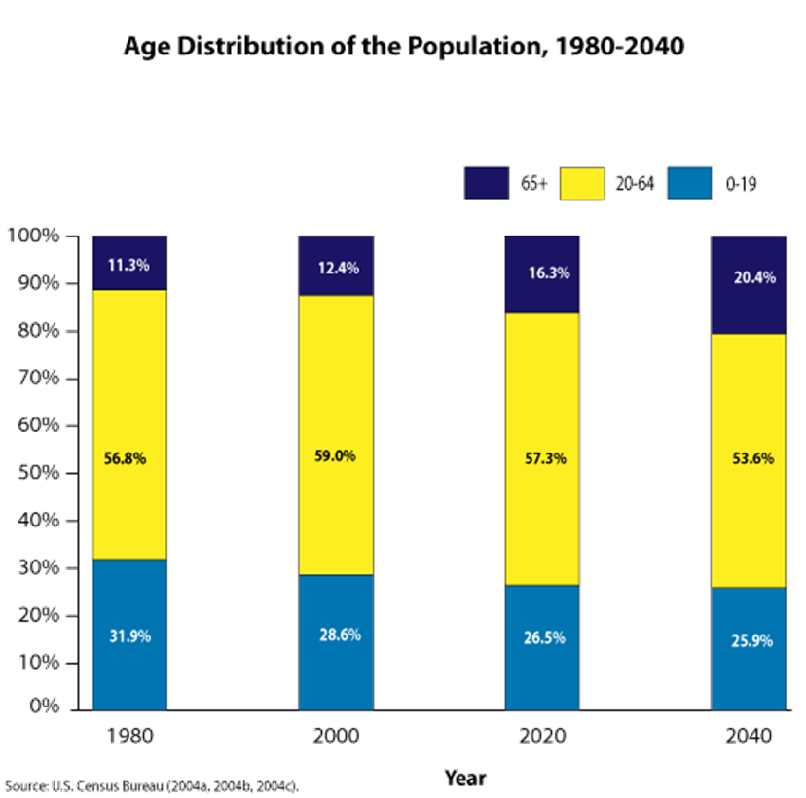
The population of the United States of America (USA) is getting older. By the year 2020, around 16.3% of the population in the United States will be 65 or older. This fraction has been gradually growing, and it is anticipated that it will approach about 20.4% by the year 2040.
Birth Rates: The birth rate in the United States has been on a downward trend for some years now. By the year 2020, the total fertility rate (TFR) had dropped to around 1.7 children per woman, which was one of the lowest rates ever recorded in the United States. This reduction, which has been ascribed to a number of variables, including economic conditions, later marriages, and individual decisions, is occurring.
Life Expectancy: Life expectancy in the United States had been increasing for decades but started to see a minor fall in the middle of the 2010s. This was mostly due to the opioid epidemic as well as other health-related concerns. The average life expectancy in the year 2020 was around 78 years. Again, it seems quite likely that the COVID-19 pandemic had a large influence on this statistic, albeit one that might be transient.
Age Structures That Vary It is very important to keep in mind that the age structure in the United States is not the same for people of different races and ethnicities. For example, the median age of people who are white and not of Hispanic origin is much older than the median age of those of Hispanic or Latino origin.
It is important to take into consideration, with regard to both nations, the possible short-term and long-term demographic implications that the COVID-19 pandemic may have. In a number of nations, particularly among the older population, there was an increase in the death rate. Concurrently, there were reports of falling birth rates, which were most likely caused by economic unpredictability in addition to other variables associated to the epidemic.
Also, since 1960, there has been a slowdown in the rate at which advances are being made to longevity, particularly for women. The decline in death rates among people in their later years has been a driving force behind these advances. There is a lot of uncertainty over the course that life expectancy will take in the future, but it might rise by a large amount. (Vaupel 2000) Others are of the opinion that fifty percent of all females born in this day and age will live to reach one hundred years old.
c) Discussion of key ideas of loneliness and isolation, as well as analysis of the concepts linked with loneliness.
Dr. John Cacioppo, a preeminent expert in the field of social neuroscience, is the author of a number of in-depth studies that investigate the influence that feeling lonely has on one's physical health as well as the biological roots of such emotions. (Cacioppo & Cacioppo, 2018). Because to his study, we now have substantial new insights into the dynamics of human isolation and the ways in which it influences many facets of well-being.
According to the Evolutionary Theory of Loneliness, (Cacioppo & Hawkley, 2009). The experiences of loneliness, despite the fact that they are distressing and difficult, have their origins in our evolutionary past. These emotions acted as a shield for our forefathers by encouraging them to get back in touch with the people in their community. However, the reasons why people feel lonely, and the repercussions of that feeling have gotten more nuanced in today's culture. When this is understood, it is possible to have more sympathy for those who experience feelings of isolation and to get insights about therapeutic and social treatments that may be used to address chronic loneliness.
Both feelings of loneliness and isolation, which are closely connected to one another but are not the same thing at all, can have a substantial negative influence on an individual's physical and mental health.
Experience of being isolated or missing company is what refer to as loneliness. Because it is not always about physical isolation but rather about the perceived quality and depth of social ties, it can be experienced even when one is surrounded by other people. This is because the focus is on the quality of social interactions. Even if are surrounded by a large number of people, it is still possible to have feelings of isolation if do not feel emotionally or socially connected to those around. The impacts of chronic loneliness and extended isolation are key topics of research both in the field of psychology and in the field of public health.
Chronic vs. short-term concerns Situational loneliness is a brief experience caused by specific circumstances, while chronic loneliness is a long-term feeling. Long-term alone can harm mental and physical health.
Social loneliness is the lack of a wider social network or community, whereas emotional loneliness is the absence of a strong emotional relationship or tie, such as with a best friend, lover, or family member. Both sorts of loneliness can harm mental and physical health.
However, isolation is the objective state of being physically alone or isolated from others. One might isolate oneself freely, such as by living alone or for personal reasons, or involuntarily, such as by illness, disability, or society.
The following are basic principles about being alone:
Physical vs. social isolation Physical isolation involves being geographically removed from others, whereas social isolation entails having no social connections, activities, or interactions.
Comparison of Voluntary and Involuntary Isolation Voluntary isolation is a conscious choice to seek alone, whereas involuntary isolation is enforced via quarantine or social exclusion.
Isolation and Health: Long-term social isolation can lead to heart disease, depression, cognitive decline, and early mortality.
Finally, despite their close link, loneliness and isolation are different. Someone might be physically alone without feeling lonely or surrounded by others and still feel lonely. However, social isolation and loneliness can have a particularly negative impact on an individual's well-being. Psychology and public health research have examined the detrimental impacts of persistent loneliness and isolation.
2- Comparison between two countries
d) The effects that feelings of loneliness and isolation can have on older people who live in an assisted living facility or another similar environment
Whether they live in the United Kingdom or the United States, older persons who experience feelings of loneliness and social isolation can have a significant impact on both their physical and mental health. These impacts can be even more prominent among elderly people who live in assisted living facilities or other surroundings with comparable characteristics, such as changes in living arrangements and decreasing levels of freedom, both of which can contribute to a sense of being isolated.
Healthcare Systems: The United Kingdom (UK) has a nationalised healthcare system that is provided by the National Health Service (NHS), which includes services for mental health. In spite of the existence of public insurance options like Medicare for people over 65, medical care in the United States is mostly provided by the private sector. The individual's insurance coverage as well as the resources available in the location in which they reside can have a significant impact on how easy it is for them to get mental health care.
The United Kingdom (UK) and the United States of America (USA) both place a high importance on individualism and independence, which can occasionally lead to elderly people experiencing feelings of isolation if they are unable to continue living alone. The way that society views people who are elderly and ageing can also play a role in the development of emotions of loneliness and isolation.
Care for the Elderly Policies and financing In both nations, the policies and financing that surround the care for the elderly may have a considerable influence on the experience that older persons have in assisted living facilities. Because of this, staffing ratios, the quality of care provided, and the resources available for social activities and mental health assistance may all suffer as a result.
Populations That Are Getting Older Both the United Kingdom, and the United States have populations that are getting older, which implies that an increasing number of people are expected to encounter these difficulties. Nevertheless, the particular demographics and requirements of these communities might differ from case to case.
Isolation and loneliness have a number of negative effects on people as they get older.
Physical Health Loneliness and social isolation, especially when they are chronic, have been related to a variety of physical health concerns, such as an increased risk of cardiovascular disease, high blood pressure, and a weaker immune system.
Isolation and loneliness may have a considerable negative influence on one's mental health, leading to an increased risk of illnesses such as dementia, depression, and anxiety. The mental health of elderly people is a significant issue in both the United Kingdom and the United States, particularly among those who are housed in assisted living communities. (Victor,2012)
Quality of Life: Loneliness and isolation have been shown to have a negative impact on the overall quality of life of older persons. This may be the result of decreased involvement in social activities, a reduction in the amount of time spent engaging in physical exercise, or a general sense of sadness or dissatisfaction.
Mortality: a number of studies have shown a connection between extended periods of social isolation and chronic loneliness, which is associated with an increased risk of death in older persons.
Both the United Kingdom and the United States have put measures into place to lessen the impact of these impacts. These include the provision of mental health services, the encouragement of family participation, and the promotion of social contact inside the institutions. However, the efficacy of these tactics can vary greatly based on a wide range of factors, such as the unique individual's life circumstances as well as the resources that are accessible in various institutions and communities.
e) Legislation and regulations now in effect in the United Kingdom and the United States that deal with, increase awareness of, or attempt to alleviate loneliness and isolation among the senior population
Loneliness and social isolation among the elderly are major concerns, and both the United Kingdom and the United States have developed a variety of laws and efforts to address these issues.
The United Kingdom: The Loneliness approach: In 2018, the UK Government introduced a ground-breaking approach to address loneliness. This strategy, titled "A Connected Society: A Strategy for Tackling Loneliness," provides a broad and long-term approach to creating more socially linked societies. The strategy outlines goals to expand social prescribing, which is the process through which doctors and other healthcare professionals refer patients to a variety of non-clinical services to enhance their health and well-being. (Department for Digital, Culture, Media & Sport, 2018).
Age UK: While not a legislative authority, Age UK is a large organisation that provides companionship, guidance, and assistance to elderly people who are lonely. They have affected public policy to guarantee that the elderly's needs are satisfied.
The Campaign to End Loneliness is a network of national, regional, and local organisations and people working together through community action, good practise, research, and policy to create the right conditions to reduce loneliness in later life in the United Kingdom (“Campaign to End Loneliness” 2019).
The United States: The Older Americans Act (OAA): This federal law provides funding for a variety of home and community-based services for those aged 60 and above, including food programmes, home care services, and carer assistance. These programmes can assist older individuals decrease social isolation by encouraging social engagement and providing necessary care. (Administration for Community Living,2016)
Policies to encourage Ageing in Place: A variety of federal, state, and municipal policies attempt to encourage ageing in place, which is the capacity of older persons to age in their own homes and communities. These policies can assist older persons maintain social ties and avoid the isolation that can sometimes accompany migration by funding home renovations, transportation, and community-based programmes.
The Supporting Grandparents Raising Grandchildren Act and the RAISE Family Carers Act: This legislation, enacted in 2018, aim to provide additional assistance to family carers, who play an important role in preventing loneliness among older individuals. (“Supporting Grandparents Raising Grandchildren | ACL Administration for Community Living”2019).
The Administration for Community Living (ACL) administers a number of programmes aimed at reducing loneliness and social isolation among older individuals. The "No Senior is Alone" project, for example, aims to raise public awareness and link older persons with services. (“About Community Living | ACL Administration for Community Living”2019).
Both the United Kingdom and the United States finance research on loneliness and social isolation in older individuals. For example, the National Institute on Ageing, which is part of the National Institutes of Health in the United States, funds a vigorous programme of study into social isolation and loneliness.
Furthermore, in the United States, state, local, and tribal governments, as well as local authorities and devolved administrations in the United Kingdom, may have their own programmes and projects. These might vary greatly, but they frequently include community-based programmes, social activities for older individuals, and carer assistance.
f) The possible future of care for older people; what changes could be made to schemes that try to help older people who are lonely in the UK and USA?
Elder care is always evolving to meet the needs of an ageing population. In the UK and US, there are several ways to improve elderly isolation:
Enhancing Social Prescribing Social prescribing, in which doctors refer patients to community services, might be improved. This may include suggesting social activities like joining local clubs, exercising together, or attending art or music therapy.
Improving Mental Health Service Funding and Access Mental health help for the elderly is becoming more accepted. Mental health services should be funded and accessible to meet this demand. Increased funding and greater access to these initiatives may reduce loneliness and mental health issues, especially for assisted living residents.
g) Future Prospects and Technological Interventions
Technology Enables Care and Social Interaction Elder care may benefit from technology. Video chat helps elders stay in touch with family and friends. Telemedicine also allows remote health consultations. Virtual reality and AI companions may potentially help reduce loneliness and promote social interaction. (“Intuition Robotics Tailors ElliQ to Help the Aged Overcome Isolation”2017).
Intergenerational initiatives: These initiatives bring individuals of different ages together and benefit both generations. Schools, community groups, and nursing homes can facilitate intergenerational interactions.
Community-Based Initiatives: Strengthening community links and neighbourhood engagement can help older adults overcome loneliness. Community volunteering, local activities, and neighbourhood support networks are options.
Health Care Carers and Professionals Instruction: persons that engage with elderly persons must know the indicators of loneliness and how to prevent it. This may need particular training or guidelines.
Improving Public Transportation: Seniors, especially rural ones, may feel isolated due to a lack of transportation options. Public transit improvements will assist. Enhancing public transit and providing mobility assistance can help elderly participate more in their communities.
Active Ageing: Encouraging older people to have a healthy lifestyle, including regular exercise, a balanced diet, and enough sleep, helps reduce loneliness. This can be done by encouraging older adult to exercise and obtain proper sleep. (Active Ageing,2002).
Public Policy Changes Ageing in place policies, affordable housing options, and improved funding for senior services help reduce social isolation and loneliness.
The most effective approaches will likely be a mix of many different methods, each tailored to certain groups and individuals. Because there is no silver bullet for elderly isolation, it is crucial to continue researching and implementing a variety of anti-loneliness measures.
3-Recommendation of improve the loneliness and the isolation
Multifaceted approaches are needed to combat loneliness and social isolation. The techniques depend on the person's position, age, and loneliness reasons. Several general suggestions:
Social Groups: Community Promote community and social involvement. Create or join support groups for similar interests or experiences. Some people find camaraderie in religious or spiritual groups.
Common Social Contact: Check in with family, friends, and neighbours regularly. Volunteering provides purpose and social connection. Pets may provide companionship, so consider adopting one if possible.
Support for Mental Health: Therapy and counselling can help with coping and underlying concerns. Some find group therapy helpful because they can connect with others who feel the same. Research indicates that exercise can minimise emotions of loneliness and melancholy. Group activities or fitness programmes can provide socialisation. Community sports leagues and walking clubs offer physical and social advantages. Use technology to keep connected, especially if mobility is an issue. Phone conversations, social media, and video calls can assist. Join hobby or interest forums online. Joining classes or workshops might help build new relationships. This might be for exercise, crafts, languages, or another passion. Group tours and travel can offer new experiences and social contacts if possible. Meeting new individuals on group excursions is possible.
Addressing Obstacles: Mobility might be difficult for seniors. Access to transit can make a big impact. Visual impairments like hearing loss can hamper social relationships. Good medical care and interventions assist. Community Initiatives: Local governments and organisations can contribute by providing programmes, workshops, or events. Create “buddy” or mentorship programmes where volunteers check on solitary people. When reframing attitude, it's important to focus on one's self-perception and thinking. Mindfulness, meditation, and writing aid self-reflection and positivity.
Reducing Comparisons: social media has led to people comparing their lives to others. Understand that these platforms promote highlights and may not reflect reality.
Promoting Intergenerational contacts: Activities that foster contacts between younger and older generations might be helpful. Programmes where college students live in older communities on discounted rent have proven potential.
It's important to recognise that loneliness and isolation are normal and experienced by many people. These sentiments may be handled and lessened by actively seeking relationships, support, and a proactive attitude.
4- Conclusion
In this report I investigates the problems encountered by the elderly in the UK and USA, highlighting both common and unique issues. The report highlights current developments in these nations' ageing populations and their significant implications. Loneliness theories and their value to older people are central to the findings. The investigation shows how loneliness and isolation affect elderly, especially in care institutions. The paper also reviews both nations' senior loneliness laws, identifying opportunities for improvement. It compares UK and US senior care services, highlighting strengths and weaknesses. The future of older adult loneliness programmes, with a focus on technology, is also considered. The report concludes with key recommendations to create a supportive environment for the elderly, emphasising the shared responsibility of both countries to ensure the emotional and physical well-being of their elderly citizens and encouraging collaboration and innovative approaches.
5- Reference list
2022. “Government’s Work on Tackling Loneliness.” GOV.UK, www.gov.uk/guidance/governments-work-on-tackling-loneliness.
“About Community Living | ACL Administration for Community Living.” Acl.gov, 2019, acl.gov/about-community-living. Accessed 1 May 2023.
Active Ageing. 2002.
Administration for Community Living. “Older Americans Act | ACL Administration for Community Living.” Acl.gov, 2016, acl.gov/about-acl/authorizing-statutes/older-americans-act. Accessed 4 May 2023.
Berkman, Lisa F., et al. Social Epidemiology. Google Books, Oxford University Press, 2014, books.google.co.uk/books?hl=en&lr=&id=qHpYCwAAQBAJ&oi=fnd&pg=PP1&ots=8boy8Bf1lp&sig=NrRBGQ9bJWLZEOiQI8mlH6VKMiY&redir_esc=y#v=onepage&q&f=false. Accessed 9 May 2023.
“Campaign to End Loneliness.” Campaign to End Loneliness, 9 Dec. 2019, www.campaigntoendloneliness.org/. Accessed 4 May 2023.
Department for Digital, Culture, Media & Sport. “A Connected Society: A Strategy for Tackling Loneliness.” GOV.UK, 14 Oct. 2018, www.gov.uk/government/publications/a-connected-society-a-strategy-for-tackling-loneliness. Accessed 6 June 2023.
“Intuition Robotics Tailors ElliQ to Help the Aged Overcome Isolation.” Robotics Business Review, 11 Jan. 2017, www.roboticsbusinessreview.com/health-medical/intuition-robotics-tailors-elliq-help-aged-overcome-isolation/. Accessed 4 May 2023.
National Academies of Sciences, Engineering. Social Isolation and Loneliness in Older Adults: Opportunities for the Health Care System. Nap.nationalacademies.org, National Academies Press, 27 Feb. 2020, nap.nationalacademies.org/catalog/25663/social-isolation-and-loneliness-in-older-adults-opportunities-for-the. Accessed 1 May 2023.
NHS England. “Improving Care for Older People.” England.nhs.uk, 2020, www.england.nhs.uk/ourwork/clinical-policy/older-people/improving-care-for-older-people/. Accessed 1 May 2023.
“PhD Student Research Suggests Care Home Residents Want More Time with Staff to Beat Loneliness | ENRICH.” Enrich.nihr.ac.uk, enrich.nihr.ac.uk/news/phd-student-research-suggests-care-home-residents-want-more-time/. Accessed 24 Apr. 2023.
“Reducing Loneliness | Programmes and Innovation.” Age UK, July 2017, www.ageuk.org.uk/our-impact/programmes/reducing-loneliness/. Accessed 16 Apr. 2023.
“Supporting Grandparents Raising Grandchildren | ACL Administration for Community Living.” Acl.gov, 2019, acl.gov/programs/support-caregivers/supporting-grandparents-raising-grandchildren-0. Accessed 1 Apr. 2023.
Urban Institute. “The US Population Is Aging.” Urban Institute, 12 Dec. 2019, www.urban.org/policy-centers/cross-center-initiatives/program-retirement-policy/projects/data-warehouse/what-future-holds/us-population-aging. Accessed 23 Apr. 2023.
US Census Bureau. “International Data Base (IDB).” Census.gov, 5 Dec. 2017, www.census.gov/programs-surveys/international-programs/about/idb.html. Accessed 6 May 2023.
Victor, Christina R. “Loneliness in Care Homes: A Neglected Area of Research?” Aging Health, vol. 8, no. 6, Dec. 2012, pp. 637–646, https://doi.org/10.2217/ahe.12.65.

