I confirm that I have not used any AI tools in the research or creation of this assignment. I confirm that I have not presented any AI generated materials as my own work. I confirm that I have copied of my drafts, notes, and other resources I have used, which I may be asked to provide in evidence.

As level five students we are required to complete 400 hours of placement activity, 200 of those hours should be face-to-face. For this year’s placement, I volunteered for Umbrella Cymru, a charity that focuses on advising and supporting LGBTQ+ people. Most of this work was completed online and I had a caseload of young people to work with. During my time there I helped them close inappropriate waitlist cases, supported young people and assessed them.
How I felt
In this placement I had a lot of self-doubt, I wanted to give young people the best advice and usually I did not have the knowledge to do this. As I did more sessions, I realised that it was okay to not have all the correct information at hand and to follow-up with the correct information later.
A lot of the young people I saw had accessed services in the past, and those services were not always helpful, therefore I told myself that I had to be the person that helped them. Therefore, I felt very frustrated and upset when I could not do so. I became too invested in helping young people which affected my own mental health. Later, when we had to start closing cases that did not belong on our waitlist, I found that I became less invested as my purpose was finding out whether another service would help them more. From then-on it was easier to take cases, and once I started assessing young people, I became less involved in their circumstances.
Advising and mentoring
Jeffs and Smith (2010, p.102) state that because youth workers are finding themselves in more ‘formal’ settings, “counselling, advocacy, advising and mentoring” are valued and are the poplar way for practitioners to work with “clients”. They also state that when a youth worker is young-person centred, advice can be beneficial. However, to avoid inappropriate advice, a youth worker must know the young person and their community well. At Umbrella Cymru, I only had six sessions to help young people, therefore it can be argued that I did not know them or their community well. While I did not know their area as a community, it can be argued that I do know their community as I know a lot about the LGBTQ+ community as my community profile focused on them.
It is also important to distinguish that youth workers are not counsellors; we utilise counselling skills but are not trained to be counsellors, as Jeffs and Smith (2010, p.42) state “...employing counselling skills was not the same as counselling”. If a young person was unsure of what Umbrella Cymru did, the first thing I told them was that we were not a counselling service.
Professional Development Plan (PDP)
In my PDP (pictured below) I aimed to create educational resources on transitioning, create personalised support plans, work with young people on a 1-2-1 basis, create sessions based on young people’s needs and educate other youth work organisations on LGBTQ+ identities.
I completed most of those aims, as I created personalised support plans for them, basing them off their individual needs and goals (e.g., a plan to come out to family) and utilised these plans during support sessions. I also worked with young people on a 1-2-1 basis, however, they could choose whether to have a parent/guardian present which some did.
While I did educate schools, residential care homes, and other services about the specific needs of the young people I was helping, I was not able to educate other youth work organisations and will therefore try and make that my aim for level 6.
I was also unable to create educational resources on transitioning but learnt to utilise current resources such as GenderKit (ND), which included most of what a transgender young person needs to know. However, I was able to create personalised resource packs if anyone wanted to know how to do specific things (e.g, change their name).
How did my work link to Youth Work theory?
Working with Umbrella Cymru, I was able to, “Build professional and working relationships with young people”, “Advocate with and on behalf of young people...”, “Access information with and for young people to inform decision making”, and “Assist young people to recognise, realise and defend their rights” (CLD Standards Council Scotland, 2019, YW09, YW10, YW13, YW14). My work was also accessible and inclusive which is one of the five aims of the Youth Work Strategy for Wales (2019). The work at Umbrella Cymru also worked towards the aims of the Wellbeing of Future generations Act (Welsh Government, 2015) as it works towards creating a healthier and resilient Wales.
In conclusion, my time at Umbrella Cymru has been very educational. I have learnt that this type of work would be too difficult for me, however, it has taught me skills that I will use throughout my career as a youth worker.

Reference list
CLD Standards Council Scotland (2019) National Occupational Standards for Youth Work
Gender Construction Kit (ND) GenderKit. Available at: Gender Construction Kit (Accessed 12th March 2025)
Jeffs and Smith (2010) Youth Work Practice. Hampshire: Palgrave Mcmillian
Welsh Government (2015) Wellbing of Future Generations Act. Available at Well-being of Future Generations (Wales) Act 2015: the essentials [HTML] | GOV.WALES (Accessed 29th March 2025)
Welsh Government (2019) Youth Work Strategy for Wales

Professional development plan

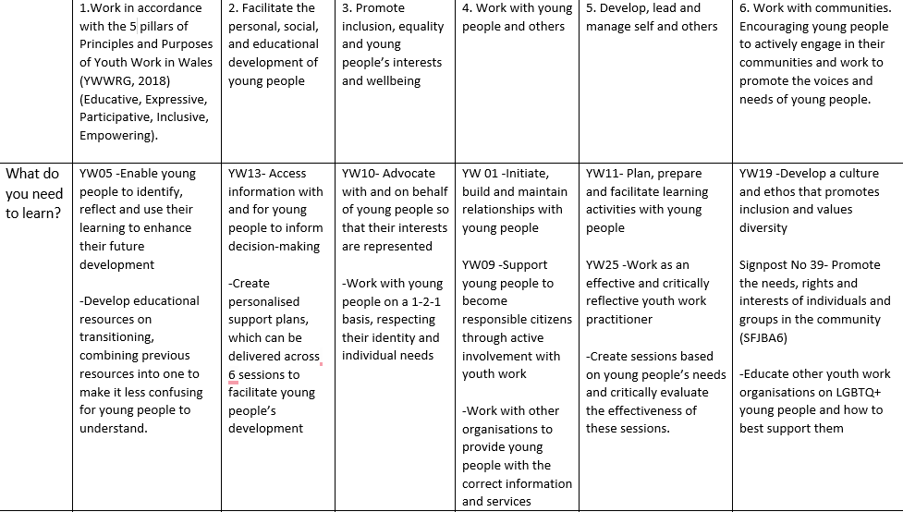

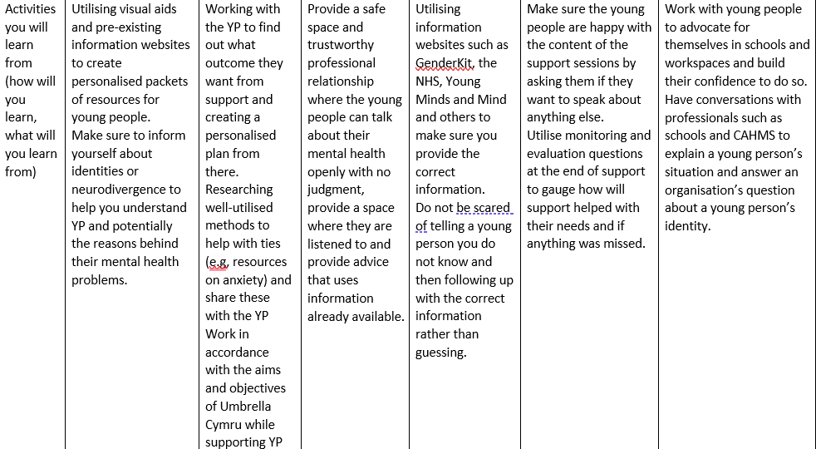

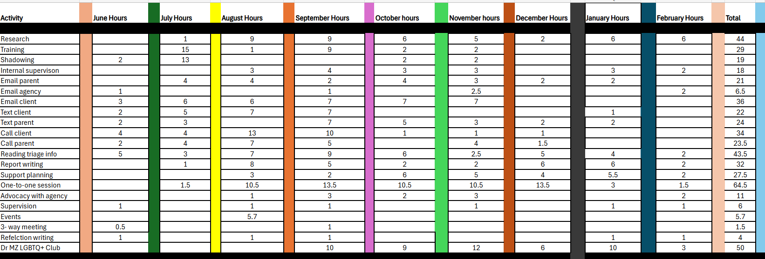
Hour Timetable

