
8
PLC Control – Developments & Functional Specifications

Control Technology

23/09/2024

Taylor Davies

Contents
Introduction 3
Task 1 3
1 Origins and Initial adoption 4
1.1 Development 4
1.2 Industrial Needs 4
2 Technological Advancements 4
2.1 Hardware Enhancements 5
2.2 Software Enhancements 5
2 Impact on Industrial Practice 6
3.1 Manufacturing Processes 6
3.2 Productivity 6
3.3 Industry Standards and Practices 6
Task 2 6
4 Essential Stages in Developing a Functional Design Specification 7
4.1 Requirement Analysis 7
4.2 System Design 7
4.3 Hardware Selection 7
4.4 Software Design 8
4.5 Implementation 100 words 8
4.6 Testing and Validation 100 words 8
4.7 Documentation and Review 100 words 9
5 Critical Factors in FDS Documentation 9
5.1 System Requirements 10
5.2 Hardware Selection Criteria 10
5.3 Software Design Considerations 10
5.4 Testing Procedures 10
5.5 Safety and Compliance 10
6 Evaluation of Real-World Examples and Case Studies 10
6.1 Case Study 11
6.2 Practices 11
6.3 Challenges 12
Conclusion 13
References 14

Table of Figures
Figure 1: The Modicon team with the 084 PLC 5
Figure 2: Basic Example of Ladder Diagram 9
Figure 3: Case Study - Scope 12
Figure 4: Hardware Selection 12
Figure 5: Operational Requirements 13
Figure 6: Input and Output (Safety) 13

Introduction

Industrial automation has advanced thanks in large part to the development of Programmable Logic Controllers (PLCs). This paper examines the history of PLCs, starting with their creation and early uptake.

The early PLC technological development was motivated by the demand for more dependable and efficient control systems in industrial environments. This section explores the innovative work that resulted in the development of the first PLCs and the industrial issues that made their adoption necessary.

PLC systems underwent substantial hardware and software transformations as technology advanced. Improvements in programming languages, user interfaces, and integration skills in addition to increases in processing speed, memory size, and networking possibilities.

PLCs have revolutionised production processes, increased productivity, and shaped industry standards, having a significant impact on industrial practices. This paper looks at how PLCs have automated and streamlined manufacturing processes to improve accuracy and efficiency.

Developing a Functional Design Specification (FDS) is a critical process in ensuring the successful implementation of complex systems. This document outlines the essential stages and critical factors involved in creating an effective FDS, providing a comprehensive guide for professionals in the field. This section delves into the critical factors that must be considered in FDS documentation, including system requirements, hardware selection criteria, software design considerations, testing procedures, and safety and compliance.

In addition to this, evaluating real-world examples and case studies helps in understanding best practices and usual challenges in FDS development. From this we can see if the research is true to real word practices.

Task One

Origins and Initial adoption

1.1 Development

A PLC also known as programmable logic controller may be used for a wide range of process control applications, with the growing demand for automation, a control system must be simple to program, adaptable, durable, strong, and economical. An overview of the use of programmable logic controllers (PLCs) in the current market is covered in this study (Kuphaldt, 2008) and (Alphonsus and Abdullah, 2016).

To replace relay controls, General Motors brought the first PLC into commercial production. The need for increased efficiency was brought about by increased rivalry and customer demands, therefore it was only reasonable to design a software-based system that could take the place of relays (Hanssen, 2015). General Motors is a U.S. manufacturer that Bedford Associates (Bedford, MA) submitted a Modular Digital Controller (Modicon) to. In 1968, General Motors introduced the first PLC. During that period, several companies presented computer-based plans, one of which relied on the Digital Equipment PDP-8. The world saw the introduction of PLCs into commercial production with the Modicon 084 (Olsson, 2005).

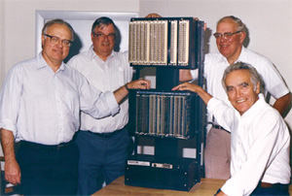
Figure 1: The Modicon team with the 084 PLC

1.2 Industrial Needs

The programmable logic controller was created in response to challenges faced by the automotive sector with the goal of replacing relay control panels. It has since grown to be a crucial piece of equipment for automating systems. As hardware and software components have been added to the initial concept over time, PLC has emerged as a leading industrial automation solution. A PLC can control various tasks through programming. Compared to a conventional relay, the programmable logic controller required significantly less wiring for circuit control, and it was easier to install and program. Other benefits of the PLC include high speed control, network compatibility, defect checking, and high reliability. One of the most adaptable and user-friendly pieces of equipment in an industrial setting is the PLC, which is always pursuing efficiency, making improvements, and expanding its uses within the industrial sector (da Fonseca and Pinto, 2019).

2 Technological Advancements

2.1 Hardware Enhancements

PLC systems have developed a tremendous amount over the years. They are the staple of many industrial processes. PLCs hardware has advanced over the years also.

In the late 1960s and early 1970s, the first generation of Programmable Logic Controllers (PLCs) were developed. The intricate and laborious relay-based control methods employed in industrial automation were intended to be replaced by these early PLCs. These PLCs were quite large and expensive in comparison to modern PLCs. They key benefit the PLC has is reliability and ease of programming (Romero and Theorin, 2013).

Major PLC manufacturers, such as Allen-Bradley, Siemens, and Mitsubishi, emerged in the 1970s and released their own programmable controller models. These producers started manufacturing PLCs with more memory and processing capacity, which allowed them to tackle more complicated jobs and support a wider range of applications (Kaminski, 2023).

As PLCs develop further over the years in the 1980s (second generation) and 1990s (third generation) programmable became more compact and efficient and more available within industrial processes. PLCs became functionally packed into smaller units and costs also became optimized. In addition to the hardware improvements during this period Ethernet and Modbus was introduced to allow for communications to other components/equipment. Finally, as emerging into the 20th century the HMI was being introduced to allow operators to monitor PLC systems and turn on and off functions (Process Solutions, 2020).

Fourth (2000s) and Fifth generation (2010s) PLC systems became even more powerful during the first decade of the 20th century. Systems became more compact with faster processors, more memory and the use of ethernet, Modbus and profinet became a staple way of communication (Automation Community, 2023)
As time progressed through the 2010s fifth generation PLCs started to support IoT (Internet of Things) and Cloud Connectivity. An example of this being used is at a manufacturing plant producing automotive parts using various machines controlled by PLCs (plctr, 2024).

The current generation PLC is developing on the improvements created from the 20th century. Systems are constantly developing, and technology is being used more effectively in a wider range of applications. This is all driven by the implementation of industry 4.0.

2.2 Software Enhancements

For PLC (programmable logic controller) systems to work better, perform better, and be easier to use, software improvements are essential. Over the years the PLC manufacturers have been making improvements to some key areas of PLC software. The main targets being improving the programming languages, Integrated development Environments, Communication protocols, user interface, data handling and security enhancements (Payne, 2014).

Other programming languages for industrial controllers were established under the IEC 61131-3 standard, but ladder diagram replied with innovations of its own and has demonstrated surprisingly strong longevity. Sequential function charts are preferable in several situations, especially in process control. Data manipulation is best done with structured text, although other IEC languages have advantages as well. However, ladder diagram continues to lead PLC programming languages by a significant margin (Payne, 2014).

PLC version control is a quickly developing field that is impacted by software development best practices and technology breakthroughs. PLC programs can now be accessed from anywhere thanks to centralised data management provided by cloud-based version control systems. It is especially helpful for remote work and international cooperation because it guarantees that all engineers can collaborate easily and obtain the most recent program upgrades. Scalability is another important benefit of cloud-based solutions. To accommodate expanding data and user needs, they can grow swiftly. In addition to this, by offering predictive and automated capabilities and automating mundane version control operations, AI and Machine Learning (ML) have the potential to revolutionise PLC version control and free up engineers to work on more complicated problems (plcbook, 2024).

Impact on Industrial Practice

PLCs, or programmable logic controllers, have revolutionised industrial processes by increasing automation, boosting productivity, and guaranteeing higher levels of precision across a range of operations.

3.1 Manufacturing Processes

PLC systems have revolutionized manufacturing by improving aspects of the processes. Automation has allowed companies to automate complex tasks that were previously done manually or with less efficient systems such as the old relay-based systems. Additionally, PLCs give the manufacturing environment more flexibility because they can program systems to make it simpler to adjust to new goods and procedures (Langmann and Stiller, 2019). Finally, they provide real time control that ensures the process is running smoothly and efficiently (Admin, 2024).

3.2 Productivity

Productivity has greatly increased since PLCs were introduced. Efficiency has really benefited from the introduction of PLC systems within the manufacturing industry. PLCs increase output by decreasing production time and effort by automating complicated and repetitive activities. Following on PLC’s have reduced the downtime within the industry as PLCs provide fault detection and diagnostic features that aid in promptly locating and fixing problems to reduce downtime (Plant Automation, 2023). Finally, automation guarantees process consistency, which lowers variability and raises the calibre of the final product (Admin, 2024).

3.3 Industry Standards and Practices

PLCs have also influenced industry standards and practices. Because of PLCs, industry standards like IEC 61131-3—which oversees establishing programming languages and practices—have been developed. Furthermore, PLCs facilitate regulatory compliance by offering precise and dependable process management, guaranteeing safety and quality standards (Langmann and Stiller, 2019).

Task Two

4 Essential Stages in Developing a Functional Design Specification

A functional design specification is a document that outlines the operation of a process or control system. The Functional Design Specification is devoid of extremely technical information. Instead, it explains how users will engage with the suggested system, how it will function, and what to anticipate in various operating scenarios (Crimmins, 2020).

Key components that fully comprehend the functionality of the system should be included in a FDS. You can make sure that the FDS clearly conveys the project scope and needs by using the following topics (ImperiumDynamics, 2023).

4.1 Requirement Analysis

The process of identifying user expectations for an application that must be developed or adjusted is called requirements analysis. It includes every task carried out to determine the needs of various stakeholders. Thus, requirements analysis refers to the process of examining, recording, verifying, and overseeing software or system requirements. This is the step where the scope of the project is outlined, and the objectives are defined (Reqtest, 2018).

4.2 System Design

During the system design the functional design specifications should cover the overall architecture of the system. The Design should include basic form of hardware and software required to control the system, this can include the type of logic, any digital displays such as HMI graphical Displays, operations and the inputs and outputs of the system (IDC Technologies, 2012).

A thorough and cohesive FDS offers many advantages, such as time savings of almost 50% of total time and resource and financial savings of roughly 25%. These advantages can only be attained if all parties have contributed to the application's design, development, testing, approval, and signing of the document that contains an ordered list of all functional and design criteria (Manning, 2006) and (IDC Technologies, 2012).

4.3 Hardware Selection

PLCs are vital components of many important automated processes. As a result, they must be carefully developed to guarantee that they function and perform as required; the requirements and limitations of the application must be taken into consideration when choosing the hardware and software components. The actual parts that comprise the PLC system are referred to as its hardware components. The CPU, memory, input/output (I/O) interfaces, communication interface, and programming device are the primary hardware components (jbaker, 2021).

There are some key factors to consider when selecting the hardware for the System. The PLC's CPU, which controls its processing power, is its brains. In terms of memory size, connectivity possibilities, and processing performance, different CPUs are not all created equal. It is also important to account for future scalability in case of expansions or adjustments (World, 2023).

In addition to this I/O modules oversee wiring the PLC to external components like switches, actuators, and sensors. Ascertain the kind and quantity of I/O points your system needs. Think about the voltage or current levels involved as well as whether digital or analogue inputs and outputs are required. Assess the module's interoperability with different field bus protocols as well, since this affects peripheral device connectivity (World, 2023).

Furthermore, it is important to consider the environment. PLC hardware components may be subjected to severe temperatures, humidity, dust, vibrations, and other demanding industrial conditions. Make sure the parts you've selected are built to survive these kinds of circumstances. Seek for robust solutions with increased working temperature ranges, superior dependability, and defence against environmental elements (World, 2023).

4.4 Software Design

Walters and Brylan state that multiple programming languages are available for most PLCs. They also stated the following definitions for the types of programming languages:

- Ladder Diagram (LD) - LD is a graphical language that was developed to mimic hard-wired relay logic.
- Structured Text - ST is a textual language that is like the BASIC programming language.
- Sequential Function Chart (SFC). SFC is a graphical language that resembles a flow chart.
- Functional Block Diagram (FBD) - Blocks in the graphical language FBD are connected to depict data flow. Logic functions, math functions, clocks, proportional-integral-derivative (PID) control, and other functions are examples of blocks

A ladder diagram is a language that is used a lot. While certain applications may find other languages easier to utilise, a ladder diagram can accomplish whatever that those other languages can. Example of Ladder Diagram is shown in Figure 2 (Walters and Bryla, 2016).

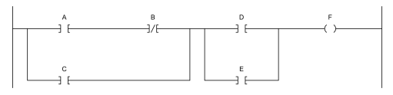
Figure 2: Basic Example of Ladder Diagram

4.5 Implementation

When writing the code, the programming language that was specified during the software design process should be used to write the code. Maintainability and scalability can be ensured by making it modular, following best practices, and having thorough documentation. It is also important to ensure it can be integrated with the hardware. Making sure the software and hardware—such as sensors, actuators, and PLCs—can communicate with each other efficiently is the task of this step. Configuring network settings, communication protocols, and resolving any compatibility problems may also fall under this category.

4.6 Testing and Validation

When testing and validating the unit it is important to specify the testing required. To ensure the system is evaluated and validated there are a number of different tests to consider. First unit testing should be considered. This entails testing separate system modules or components to make sure they operate properly when used separately. Usually automated, unit tests aid in the early detection of defects during the development phase.

Once that has been completed full system testing is complete. This phase of testing is extensive and involves testing the system. Functional, performance, and stress testing are all included to make sure the system satisfies all requirements.

Finally, validating the system against the original system requirements specified during the design stage. To make sure the system satisfies the basic requirements and goals established during the requirement analysis process; it is validated. User acceptability testing (UAT) may be used to confirm that the system functions as anticipated in real-world situations for stakeholders.

4.7 Documentation and Review

Thorough documentation is essential for upkeep and updates in the future. Documenting the hardware configurations, control logic, system design, and any modifications made during the implementation stage are all included in this. To make sure that the development process is in line with stakeholder expectations, reviews should be carried out on a regular basis. This covers code reviews, testing reviews, and design reviews. Stakeholder formal permissions obtained at significant milestones guarantee that the project continues course and achieves its goals.

5 Critical Factors in FDS Documentation

When completing the documentation for the FDS it is important that the documentation is devoid of technical information and is more friendly to project managers and less technical individuals.

5.1 System Requirements

The documentation needs to clearly define the functional and nonfunctional requirements of the PLC System. This covers the precise duties that the system must do, performance standards, and any limitations. To make sure the system lives up to the expectations of the stakeholders and end users, it must identify their demands. Finally, it must describe the processing power, input/output requirements, and any system integration (IDC Technologies, 2012).

5.2 Hardware Selection Criteria

The hardware documentation must show that the chosen hardware satisfies system requirements and is compatible with the current infrastructure. It is also important that the hardware selection can meet the PLC system's anticipated load, performance requirement and reliability. The documentation should also outline the hardware’s ability to be future proof to allow for expansion and improvements in the future.

5.3 Software Design Considerations

To document the software, it is important to ensure that the standards are being followed and what the standards are. employing standardised programming languages (e.g., Ladder Logic, Structured Text) as defined by IEC 61131-3. It is also important to outline the strategy of the software design for example designing the software in a modular fashion to facilitate maintenance and future updates. Finally, describe how the software is user friendly for the operators/end customers (Positive Engineering, 2023).

5.4 Testing Procedures

Outlining testing procedures is important as it helps the customers to understand that the system they are buying is validated and proven. It also helps different teams working on the project to understand what is required of them to complete the system. Acceptance testing is common as it preforms final testing with end users involved to confirm the system meets the requirements (Crimmins, 2020).

5.5 Safety and Compliance

One of the most important things to document within the FDS is safety and compliance. The system must adhere to all applicable industry norms and laws, including those pertaining to electrical codes, safety, and environmental effect. Furthermore, it is imperative to carry out comprehensive risk assessments in order to detect potential hazards and put in place suitable safety protocols. To make audits and inspections easier, keep thorough records of all safety features and compliance methods.

6 Evaluation of Real-World Examples and Case Studies

6.1 Case Study
The case study I have chosen to look at is a functional design specification from Oxford Instruments to update the design of legacy products to come in line with recent safety standards. The NGP (next generation plasma) range of tools will replace the existing legacy tools, however there will be an overlap period before the legacy tools are removed fully.

6.2 Practices

When looking at the best practices followed in comparison to the research, it is evident that the real-world example is in line with the steps defined in the research. In the example the scope and overview are concise but portrays the objectives and outcomes of the project, see figure x.

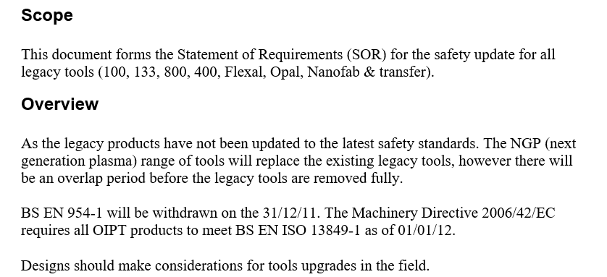
Figure 3: Case Study - Scope

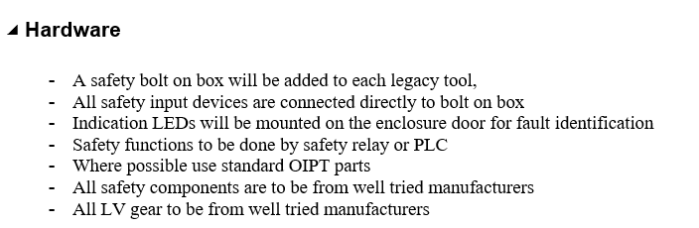
The example that has been accessible has been given quite a lot of freedom of choice hardware as it has allowed the engineer to state the hardware required but has not specified exact models or equipment, ideally in the functional design specification this would have been outlined to ensure that everyone understands the design is acceptable, see figure X for the hardware requirements.
Figure 4: Hardware Selection

The hardware was selected based on the specified operational requirements and then further from this the I/O requirements can also be specified. Specifying the I/O requirements is great for the non-technical stakeholders as it allows them to picture what the system will be capable of. The figures below show the operational requirements and the I/O functions.
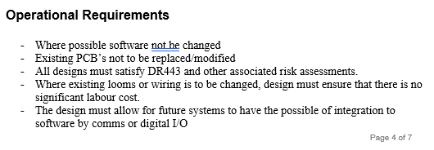
Figure 5: Operational Requirements
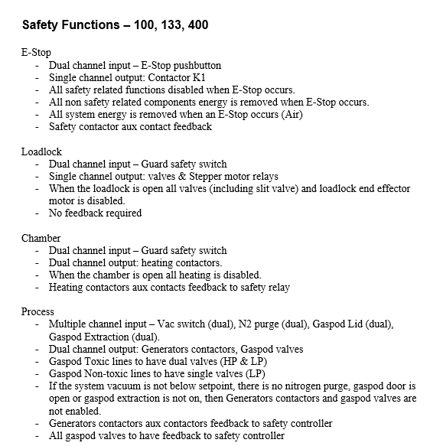
Figure 6: Input and Output (Safety)

6.3 Challenges

Even though the FDS has been completed and will benefit the stakeholders there are some challenges the engineering team could face. For example, as no hardware has been specified and agreed there could be a potential of integration issues such as the system not being able to integrate with other systems such as SCADA or MES systems (EIT, 2020).

Conclusion

In conclusion, the evolution of Programmable Logic Controllers (PLCs) has been pivotal in advancing industrial automation. From their inception, driven by the need for reliable and efficient control systems, PLCs have undergone significant technological transformations. These advancements in hardware and software have enhanced processing speeds, memory capacities, and integration capabilities, leading to more sophisticated and user-friendly systems.

The development of a Functional Design Specification (FDS) is crucial for the successful implementation of complex PLC systems. This document serves as a comprehensive guide, detailing essential stages and critical factors such as system requirements, hardware selection, software design, testing procedures, and compliance with safety standards. By evaluating real-world examples and case studies, professionals can gain valuable insights into best practices and common challenges in FDS development.

Overall, the continuous advancements in PLC technology and the meticulous development of FDS documents ensure that industrial automation systems remain robust, efficient, and adaptable to future needs. This paper underscores the importance of these elements in achieving successful and sustainable automation solutions.

References
Admin (2024). WHY PLC is used in Automation? | Efficiency, Precision. [online] iiPD. Available at: https://www.iipdglobal.com/blog/use-of-plc-in-automation/ [Accessed 19 Sep. 2024].

Alphonsus, E.R. and Abdullah, M.O. (2016). A review on the applications of programmable logic controllers (PLCs). Renewable and Sustainable Energy Reviews, [online] 60, pp.1185–1205. doi:https://doi.org/10.1016/j.rser.2016.01.025.

Automation Community (2023). History and Applications of PLC - Automation Community. [online] Available at: https://automationcommunity.com/history-and-applications-of-plc/ [Accessed 13 Sep. 2024].

Crimmins, D. (2020). What is a Functional Design Specification (FDS)? - RealPars. [online] Realpars.com. Available at: https://www.realpars.com/blog/fds [Accessed 17 Sep. 2024].

da Fonseca, R.H.H. and Pinto, F.R. (2019). The Importance of the Programmable Logic Controller ‘PLC ’In the Industry in the Automation Process.. The Importance of the Programmable Logic Controller ‘PLC ’In the Industry in the Automation Process., 6(11).

EIT (2020). Design of Industrial Automation Functional Specifications for PLCs, DCSs and SCADA Systems - Function Design Specifications (FDS) - Engineering Institute of Technology: Engineering Institute of Technology. [online] www.eit.edu.au. Available at:

https://www.eit.edu.au/resources/design-of-industrial-automation-functional-specifications-for-plcs-dcss-and-scada-systems-function-design-specifications-fds/ [Accessed 22 Sep. 2024].

Gozarian (n.d.). The Modicon Team with the 084 PLC. Gozarian.

Hanssen, D.H. (2015). Programmable Logic Controllers. [online] Google Books. Available at: https://books.google.co.uk/books?hl=en&lr=&id=My-PCgAAQBAJ&oi=fnd&pg=PP14&dq=History+of+programmable+logic+controller&ots=P93yg5EAmB&sig=EJ8pg7rH9W3edSzlVDXVg36o2Uw#v=onepage&q=History%20of%20programmable%20logic%20controller&f=false [Accessed 27 Aug. 2024].

IDC Technologies (2012). Design of Industrial Automation Functional Specifications for PLCs, DCSs and SCADA Systems. [online] Available at: https://idc-online.com/downloads/FC_IDCBookextract.pdf [Accessed 17 Sep. 2024].

ImperiumDynamics (2023). How to Write a Functional Design Document. [online] Imperiumdynamics.com. Available at: https://www.imperiumdynamics.com/blog/How-to-Write-a-Functional-Design-Document.html [Accessed 17 Sep. 2024].

jbaker (2021). A Guide to Designing/Selecting the Right PLC for Your Operation. [online] Turner Integrated Systems. Available at: https://www.turnerintegratedsystems.com/plc-design-selection-guide/ [Accessed 17 Sep. 2024].

Kaminski, J. (2023). The Evolution of PLCs in Industrial Automation: A 2,000-Year Journey. [online] MRO Electric Blog. Available at: https://www.mroelectric.com/blog/the-evolution-of-plcs-in-automation/ [Accessed 13 Sep. 2024].

Kuphaldt, T.R. (2008). Lessons in Industrial Instrumentation. Control.com.

Langmann and Stiller (2019). The PLC as a Smart Service in Industry 4.0 Production Systems. Applied Sciences, 9(18), p.3815. doi:https://doi.org/10.3390/app9183815.

Manning, S. (2006). Functional Design Specification. [online] Scott Manning. Available at: https://scottmanning.com/content/functional-design-specification/ [Accessed 17 Sep. 2024].

Olsson, G. (2005). Programmable Logic Controllers. Handbook of Networked and Embedded Control Systems, pp.259–278. doi:https://doi.org/10.1007/0-8176-4404-0_11.

Payne, J. (2014). Future of the PLC. [online] Control Engineering. Available at: https://www.controleng.com/articles/future-of-the-plc/ [Accessed 19 Sep. 2024].

Plant Automation (2023). Role of PLC automation in plant optimization | Enhancing manufacturing efficiency with PLCs. [online] www.plantautomation-technology.com. Available at: https://www.plantautomation-technology.com/articles/the-impact-of-plc-automation-services-on-manufacturing [Accessed 19 Sep. 2024].

plcbook (2024). Understanding PLC Version Control: A Practical Guide - PLCBook. [online] PLCBook. Available at: https://plcbook.com/blog/plc-version-control/ [Accessed 19 Sep. 2024].

Positive Engineering (2023). Functional Design Specification (FDS) for Industrial Control System Software - Positive Engineering. [online] Positive Engineering. Available at: https://positiveengineering.com/functional-design-specification-fds-for-industrial-control-system-software/ [Accessed 19 Sep. 2024].

Process Solutions (2020). A Brief History of Programmable Logic Controllers (PLCs). [online] Process Solutions, Inc. Available at: https://processsolutions.com/a-brief-history-of-programmable-logic-controllers-plcs/ [Accessed 13 Sep. 2024].

Reqtest (2018). Requirements Analysis - Understanding the Process & Techniques. [online] Reqtest. Available at: https://reqtest.com/en/knowledgebase/requirements-analysis/ [Accessed 17 Sep. 2024].

Romero, V. and Theorin, A. (2013). History of Control History of PLC and DCS. [online] Available at: https://archive.control.lth.se/media/Education/DoctorateProgram/2012/HistoryOfControl/Vanessa_Alfred_report.pdf [Accessed 13 Sep. 2024].

Walters, E. and Bryla, E. (2016). Software Architecture and Framework for Programmable Logic Controllers: A Case Study and Suggestions for Research. Machines, 4(2), p.13. doi:https://doi.org/10.3390/machines4020013.

World, P. (2023). How to Choose the Right PLC Hardware Components for Your Automation System? [online] Blogspot.com. Available at: https://plcworldau.blogspot.com/2023/06/how-to-choose-right-plc-hardware.html [Accessed 17 Sep. 2024].

