Entrepreneurship

Student Name:
Student ID:

Contents
Introduction 3
Company Overview 3
Entrepreneur Overview 3
Theories relating to Entrepreneurship 4
Linkage between the Entrepreneurial Theory and Colonel Harland Sanders 5
Starting as an Entrepreneur 6
Nailing the Business Model Game 6
Effective and Efficient Supply Chain management 7
Continuing the Legacy 8
Conclusion 8
Reference 8

Introduction
Entrepreneurship is a way of taking up the responsibility of owning the self-success. A number of people tries to do that but only the best ones sustain in the long run. The main goal of these people might be different but they all live up to continue their dream venture. Kentucky Fried Chicken or KFC owner Colonel Harland Sanders was one of them. And he not only worked for his venture, but also made sure that it sustains. He used the core entrepreneurial activities to made sure that the organization right from the beginning have all kind of infrastructure to sustain in the long run. The company structure that he built is still the core of KFC. The use of proper supply chain management along with a very cost cutting business model, he made sure everything in hand so that the organization can expand as far as possible. In his lifetime, he physically and mentally gave all his efforts to ensure that.

Company Overview

Kentucky Fried Chicken, mainly known as KFC is the brand name used in the market. The branding of this company has used acronym to use as a brand name. The company does have their headquarter as their name mentions in Kentucky. It has around 22 thousand locations globally being the second largest fast-food chain the world. Now the parent company of this brand is Yum! Brands.
Figure 1 KFC Logo (KFC Website)

Entrepreneur Overview
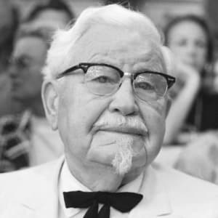
Colonel Harland Sanders is the man behind the entrepreneurship of KFC. He started by selling fried chicken from his roadside restaurant in a place named Corbin in Kentucky. The time was during the Great Depression when the economy was having a real hard time. But he was not really shy about understanding the potentiality of this business. He used his “11 herbs and spices” secret recipe to cook those amazing fried chickens. In a highly dominant market of hamburgers, he introduced fried chicken as a diversification to the market (Waweru, R.N., 2016). He was so good at his cooking that he was named as “Colonel Sander” after his fried chicken success. He did different kinds of job in his earlier days before starting KFC. And after the starting of KFC, he used to travel around to cook this recipe to different restaurants when he understood the potential market of franchising and went for it. Then at his old age he sold the company to other company to keep up the whole KFC evolution.
Figure 2 Colonel Harland Sanders (KFC Website)

Theories relating to Entrepreneurship
Entrepreneurship refers to the way of combining all the resources available in order to discover new products or services that has potentiality to sustain in the market. In other words, entrepreneurship is the way of starting a business with a risk in order to make money. There are different kinds of entrepreneurship available now. But all kinds of entrepreneurship can be characterized through a detailed way of theory (Devi, 2019). The theories of entrepreneurship can be discussed into thirteen different aspects even though merely one or two relates to the entrepreneurial thoughts of Colonel Harland Sanders. The theories are: innovation, need for achievement, status withdrawal, social change, social behaviour, leadership, model personality, systematic innovation, creation, psychological, sociological, economic, cultural. We will only be discussing the innovation theory, leadership theory and the economic theory and some other relevant ones.

Figure 3 Theories of Entrepreneurship (Tyas, E.H. and Naibaho, L., 2019)
The cultural theory was proposed by Thomas Cochran (1965) that the entrepreneurship came out of the cultural attribute of the entrepreneur comes within the cultural theory of entrepreneurship. Here, the whole operation of the venture is encouraged by the cultural aspect of the entrepreneur. The economic theory of entrepreneurship refers to the type of entrepreneurs who are moved by the economic aspect of their venture. The sociological theory of entrepreneurship is about how the social attributes, values and beliefs gets reflected to the entrepreneurship’s way of operation. And the psychological theory refers to the drive of the entrepreneur’s individual and mental situation meaning that the source of motivation. The innovation theory refers to the type of entrepreneurship where some innovation is made while progressing the venture.

Linkage between the Entrepreneurial Theory and Colonel Harland Sanders
Colonel Harland Sanders can be relatable to a number of theories based on what he did and how he did throughout his lifetime. Firstly, Colonel Harland Sanders was a man who actually has a background of working in different kinds of businesses and probably that’s how he generated his entrepreneurial mentality. And he was definitely a good cook that has been the Key to the start of KFC. This can be related to the cultural theory that he was well moved by his culture to start his entrepreneurial journey. Then comes his maturity in expanding the business that can is definitely relatable to the economic theory of entrepreneurship. He was pretty much fast in expanding his business (Mazzei et al., 2017). He started from scratch and then went on to go a long way from there. He was very much good at decision making, market research and positioning the customers that yet are applied to the current business of KFC. The Sociological and psychological theory of entrepreneurship might not have that much of a relation but the innovation theory might be coming at first in having relation to the entrepreneurial thoughtfulness of Colonel Harland Sanders. This is because, then the market was full of hamburgers (Aliouche, H. and Fernandez, D.B., 2017). And instead of selling that, he actually went for fried chicken and that too in an unconventional way called pressure cooking. This was because he wanted to get diversification to the market and was well successful in doing that. The understanding of its prosperity in franchising the business was well understood by him even in that early time. He physically started this franchising that went on to revolutionize the businesses. Some key entrepreneurial moves by Colonel Harland Sanders can clear out more of his understanding of the theoretical entrepreneurship:

Starting as an Entrepreneur
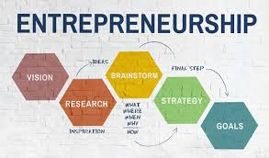
Colonel Harland Sanders started off as a pro entrepreneur. He had the vision of starting his business. But instead of directly diving into that he went for the market research. He could have gone for making hamburgers but he might have understood the market has been full of that (Devi, 2019). So, he came up with the strategy of diversifying the whole market with his special fried chicken. Then again, he did not opt for the conventional way of fried chicken, instead, he went for the pressure frying that lead him to a out of the taste scenario for his fried chicken with the secret recipe. So, in case of starting as an entrepreneur he was on point from the beginning.
Figure 4 Entrepreneurship Initials (Jadhav, 2018)

Nailing the Business Model Game
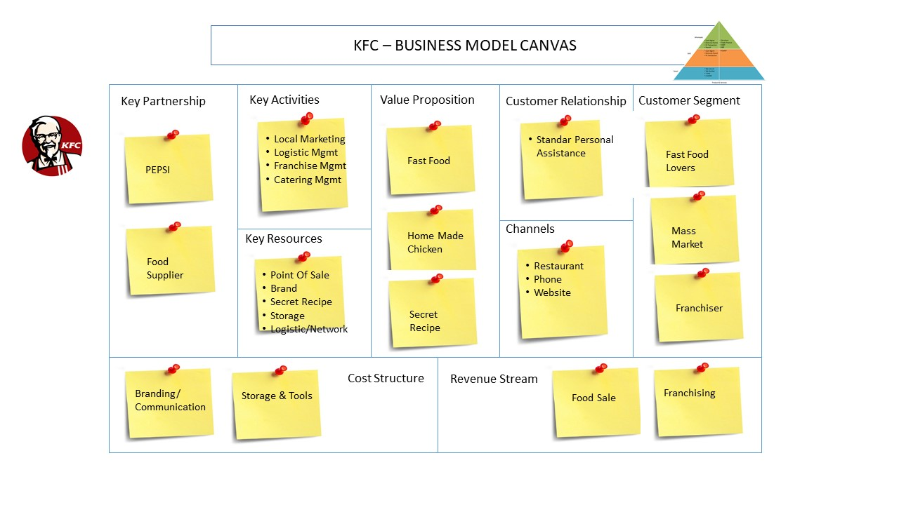
Figure 5 Business Model Game of KFC (Khanna, 2018)
The current business model used by KFC was used by Colonel Harland Sanders right from the beginning. After moving out from the restaurant, he very well managed to put this model in place while starting franchising (Achola, 2016). Using that model, the current business model of KFC stands right now. The use of this model has left them with a decreasing cost while quite a strong flow of revenue. Because in the franchising business, there is not much of an operation other than branding and proper supply chain management. Well, they nailed there in too.

Effective and Efficient Supply Chain management
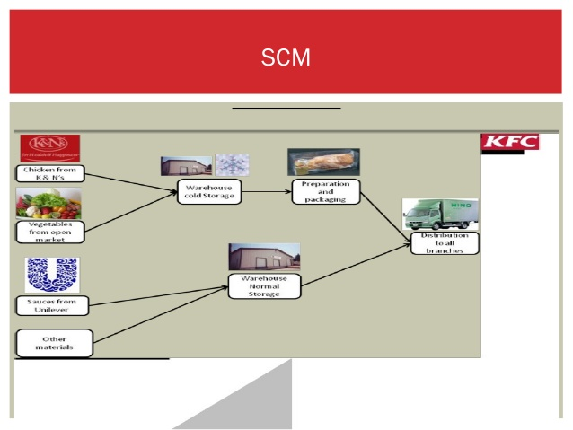
Supply Chain Management of KFC has been one of their key reason of being this much of a successful business. Their supply chain was right from the beginning spot on. And Colonel Harland Sanders was the one who have built this amazing kind of supply chain that actually helped them to grow this amazing kind of franchising business. This sort of franchising business was the key of their core business. This supply chain management now looks like this:
Figure 6 Supply Chain Management of KFC (Devi, 2019)
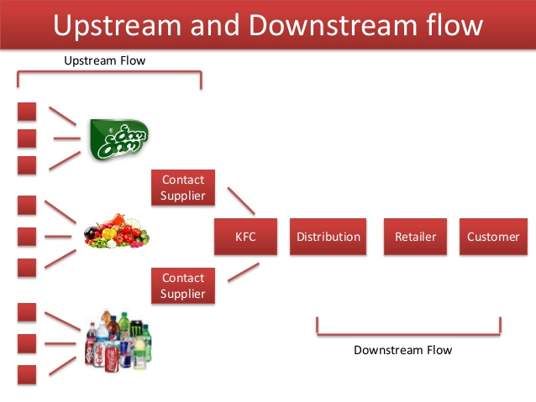
Figure 7 Current Supply Chain of KFC (Sukri, 2016)
Current Supply Chain of KFC looks like this. Almost identical to the actual one. Colonel Harland Sanders was the man behind this supply chain in that early days.

Continuing the Legacy
When Colonel Harland Sanders went on to his retirement, he wisely chooses the decision to make sure that his legacy goes on. He sold his business to Heublein in 1970 to continue this business to grow worldwide and that’s what they did.

Conclusion
Entrepreneurship is tougher than it looks and having a start-up might it easy but ensuring its sustainability for almost 100years. The whole goal of an entrepreneur is to make sure that the business sustains in the long run. And the founder of KFC, Colonel Harland Sanders did manage to do that in his lifetime. He started from absolute scratch and went on to go for the global expansion. The entrepreneurial mentality of him actually guided the whole company this far. The most amazing part was how he went on to expand a simple restaurant into a global franchising company. The whole story is not only amazing but also inspiring of how much dedication he put all through the process.

Reference
Achola, M.A., (2016). Franchising as a Market Entry Strategy by Kentucky Fried Chicken into Kenya. Unpublished MBA Thesis, University of Nairobi.
Aliouche, H. and Fernandez, D.B., (2017). Social Entrepreneurship and Franchising: A Panacea for Emerging Countries? The Case of Algeria. In Management and Governance of Networks (pp. 75-90). Springer, Cham.
Anand, D. and Yeung, D., (2018). Employee development and its effect on employee performance at KFC Restaurant Brands.
COJOCARI, P., (2019). Franchising–a successful form of entrepreneurship.
Devi, B.S., (2019). An Analysis of Loan operations and Financial Performance of Kerala Financial Corporation (KFC). Journal of the Gujarat Research Society, 21(2), pp.159-165.
Drăgușin, M., Sîrbu, M.O., Grosu, R.M. and Iosif, A.E., (2019). Synergies of Longevity/Silver Economy and Senior Entrepreneurship for a Sustainable Society. The Case of Romania. In Building Engagement for Sustainable Development (pp. 23-37). Springer Gabler, Wiesbaden.
Isdarmanto, I., (2016). The advantage collaboration program of Tourism Education based on Entrepreneurship in Culinary Products both Thailand and Indonesian countries. International Journal of Tourism and Hospitality Study, 1(1).
Jadhav, S., (2018). Food Ordering Mobile Applications–A new wave in Food Entrepreneurship. International Journal of Latest Technology in Engineering, Management & Applied Science (IJLTEMAS) Volume VII, Issue IV, pp.110-115.\
Keskin, M., (2018). THE INFLUENCE OF FRANCHISING ON THE DEVELOPMENT OF ENTREPRENEURSHIP–A PERSPECTIVE OF FRANCHISORS AND FRANCHISEES IN TURKEY. Zeszyty Naukowe Politechniki Częstochowskiej. Zarządzanie, (32), pp.180-191.
Khanna, T., (2018). Trust: Creating the Foundation for Entrepreneurship in Developing Countries. Berrett-Koehler Publishers.
Kong, J., Mei, Y., Pan, Y., He, X., Hong, T., Chen, Z., Lu, Y., Huang, G., Luo, H., Wu, T. and Hong, K., (2019), September. Difficulties Faced by College Students in Innovation and Entrepreneurship and Its Countermeasures. In The 4th International Conference on Economy, Judicature, Administration and Humanitarian Projects (JAHP (2019)). Atlantis Press.
Mazzei, M.J., Ketchen, D.J. and Shook, C.L., (2017). Understanding strategic entrepreneurship: a “theoretical toolbox” approach. International Entrepreneurship and Management Journal, 13(2), pp.631-663.
Meinarni, N.P.S. and Willdahlia, A.G., (2020), February. E-Commerce Regulation Analysis Related to Student Entrepreneurship Interest in STMIK STIKOM Indonesia. In 3rd International Conference on Learning Innovation and Quality Education (ICLIQE (2019)) (pp. 1232-1238). Atlantis Press.
Mianrcine, S. and Shaw, C., (2016). Running Head: MOTIVATIONS FOR ENTREPRENEURSHIP. In United States Association for Small Business and Entrepreneurship. Conference Proceedings (p. C1). United States Association for Small Business and Entrepreneurship.
Mkhwanazi, B.S.E., An investigation and problematisation of the Entrepreneurial Framework Conditions associated with entrepreneurship amongst Blac (Doctoral dissertation).
Osman, F.A., (2016). State-Owned Enterprise (SOE): The Role of SOE Entrepreneurship in Nation-Building Efforts, 1970-2014. Business & Economic History On-Line, 14.
Pratama, A.A.P.P., Halim, S. and Setiawan, D., (2019), August. Entrepreneurship Development through Tourism Villages in the Perspective of Defense Economic (Study Case: Penting Sari, Sleman, Yogyakarta). In 3rd International Conference on Accounting, Management and Economics (2018) (ICAME (2018)). Atlantis Press.
Qureshi, J.A., Qureshi, M.S. and Qureshi, M.A., (2018). Mitigating Risk of Failure by Expanding Family Entrepreneurship and Learning from International Franchising Experiences of Johnny Rockets: A Case Study in Pakistan. International Journal of Experiential Learning & Case Studies, 3(1), pp.110-127.
Rivo-López, E. and Villanueva-Villar, M., (2019). Family Offices: How Can They Help to Promote Entrepreneurship and Social Responsibility? In Handbook of Research on Entrepreneurial Leadership and Competitive Strategy in Family Business (pp. 399-416). IGI Global.
Simin, M.J. and Živkucin, S., (2018). ADVANTAGES OF FRANCHISE SYSTEM FOR DEVELOPMENT OF ENTREPRENEURSHIP. Knowledge International Journal, 28(1), pp.177-181.
Sukri, A.L., (2016). The boat is rocked–Employees’ grumbles: a decision dilemma.
Tyas, E.H. and Naibaho, L., (2019), November. The urgency of entrepreneurship learning in the industrial age of 4.0. In Journal of Physics: Conference Series (Vol. 1387, No. 1, p. 012032). IOP Publishing.
UniversityStudent, C., Socio-cultural factors affecting consumer behavior: A comparison of McDonalds& KFC in China and India.
Waweru, R.N., (2016). An Assessment of Customer Perspectives on Factors that have Influenced the Success of a MNC in the Kenyan Fast Food Industry: A case Study of KFC Vis-à-Vis Galito’s (Doctoral dissertation, United States International University-Africa).

