Assignment 1
Student-Alina Coman
(1919781)
International financial management
Lecturer - Isaiah Oino Module cod-LCBB6002

Contents
Introduction 2
The importance of International Financial Management 3
Challenges on International markets for Nestle 3
Dividend policies 4
Efficient Market Hypothesis 6
Investment Appraisal 6
Conclusion 7
References 8

Introduction
This report will analyse the company's market hypothesis, dividend policy and investor appraisal and a critical analysis of Nestle S.A will be presented.
Nestlé is the world's largest and most diverse food and beverage company based in Vevey, Switzerland, and employs approximately 276,000 people globally. Nestlé, as a global corporation, serves a wide range of consumer markets with a 44.9 per cent regional share of global sales, with the Americas as a leading market accounting for 26.6 billion Swiss francs, followed by Europe, the Middle East, and Africa (Statista Research Department, 2022). The company's market capitalization is at 336.79 billion market value, with net sales of 93.6 billion USD and a net profit of 16.9 billion CHF. Nestle is currently the second largest worldwide food and beverage industry with 43,476 billion revenues coming from beverage sector and market leader in 2019 with 93.1 billion revenues (Wunsch, 2022). The food and beverage industry has a high competition and Nestle competitors are listed on the figures bellow.
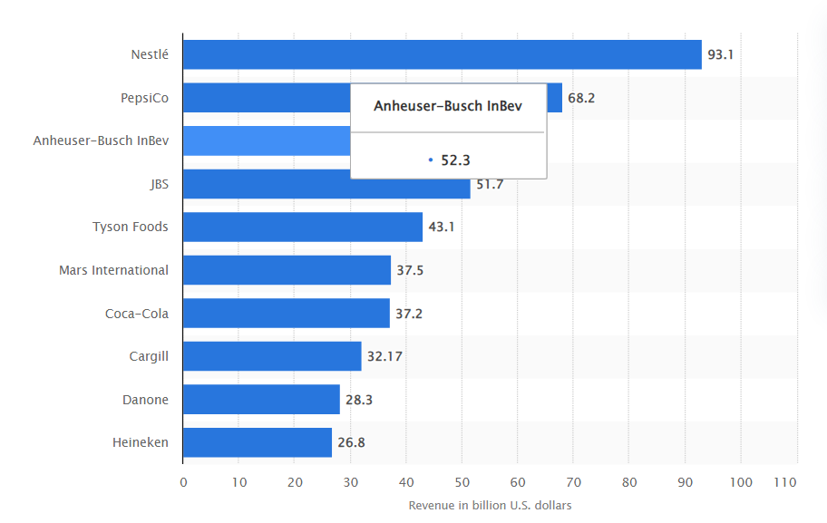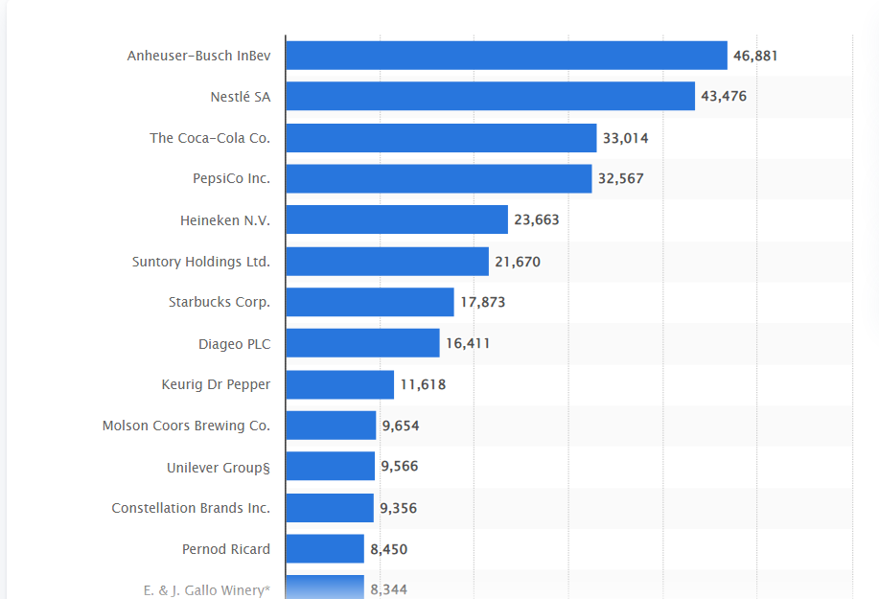
(Wunsch, 2022) (Ridder, 2022)
Nestlé owns and operates a diverse range of food and beverage brands. Nestlé Toll House, Gerber, and Nescafé are some of its most well-known brands. The powdered and liquid beverage categories account for most of the group's sales, followed by Pet Care products. In 2021, Nestle was the sixth largest confectionary company, divided into chocolate, sugar confectionary and biscuits. KitKat, Smarties, and Aero are a few of the confectionary brands owned by Nestle. The chocolate sector was the largest of these categories in 2021, with sales of more than 5.7 billion Swiss francs. (Wunsch, 2022). Nestle's most significant competitors in the food and beverage industry are Anheuser-Busch InBev, Coca Cola and PepsiCo, based on Statista research 2020 (Ridder, 2022).

The importance of International Financial Management
The world continues to develop, and globalisation is increasing accordingly. Every country depends on one another. Developed countries seek low-cost labour from developing countries while developing countries seek services and products. International finance is critical when multinational corporations (MNC) are trading deals between two countries to ensure no regulatory violations are present, and local government intervention ensures that both parties do not face competition (Hamdi, 2015). Multinational corporations are regional companies looking to expand internationally opening subsidiaries in different international markets. When MNC are trading their products or services internationally they face various risk as foreign exchange, market flaws, legal and political risks, and economical risks which can result in positive or negative challenges on international markets for any corporation worldwide (Bekaert, 2013). The advanced telecommunications and technology which improved accessibility and price fluctuation has driven the flames of globalisation even more. Financial developments like currency derivatives, global stock listings, multi-currency bonds, global mutual funds, and other global market instruments bring in more opportunities for multinational corporations. Therefore, the financial economics are responsible to deal with macroeconomic relationships and monetary transactions between two countries in a global corporate setting. Due to various national currencies, diverse opportunity sets, political contexts, and imperfect markets, every aspect of a business's operations impacts its financial performance, which implement the importance of financial managers and their decisions for the company financial wealth. (Arnold, 2013).

Challenges on International markets for Nestle
The international markets have significant impact on MNCs financial performance due to the foreign exchange, political risk factors, economic factors such as climate and inflation. The foreign exchange can affect the Multinational corporation financial performance because of the currency exchange rate fluctuation, which can result in a risk for the company financial health (Arnold, 2013). The exchange rate fluctuation can increase or decrease sales and company revenue.
The business economy is unpredictable due to various factor influencing the businesses profitability and cash flow activities. Therefore, multinational corporations adopt the Hedging strategy to protect the business loss in profit when trading in foreign exchange markets (Arnold, 2013). Nestle face the dollar depreciation after pandemic with loss in sales of 3.5 billion Swiss francs in foreign exchange market trade after exchange translation form dollar to Swiss francs. Due to this action, the firm apply the hedging strategies in foreign exchange by cutting of 3.5 billion cash flow in forwarded contracts (Karwal, 2021).
Nestle's overall risk score is 3.62 according to Global Data’s in-house risk methodology, indicating a high-risk profile. The operational and country risk pillars of the organisation have increased its overall risk profile. The financial risk scores have been significantly influenced by low liquidity and an excessive reliance on equity (GlobalData, 2022). The firm is most exposed to the food industry, then the non-alcoholic beverage industry with 66 percent of Nestle's income comes from food, and the remaining 14 percent coming from non-alcoholic drinks. The food and non-alcoholic beverage industries have low profit margins and limited growth expectations, giving the industry risk score of three on average (GlobalData, 2022).
As reported by the Nestle press release in June 2022, the foreign exchange rate decreases sales revenue by 1.5 percent (Nestle, 2021) , CHF 41.8 billion for the first half-year 2021 and 1.3 percent for full year 2021 resulting on a total 2.9 percent, however an increase of 3.3 percent in sales CHF81.7 billion (Nestle, 2022). However, the firm increases profit in the first quarter of the year 2022 by 5.4 percent due to the organic growth increasing sales by 7.6 internal growth and the foreign exchange rate 0.8 percent resulting in1.3 percent negative impact (Nestle, 2022).
The political risk is another crucial factor for MNCs because of its uncertainty. Operating in multinational markets, firms can lose control over ownership and benefits caused by any political emergency or unexpected changes. Enterprise can face extra cost in export/import, restricted in financial operations as investment return, the corporation freedom to operate in that country and standards and legislation for service or products (Madura, 2021). Nestlé employed a number of CPA methods that may have affected public health policy, research, and practise in ways that benefited the infant food sector. In order to prevent commercial interests from taking precedence over objectives related to public health, these findings might be utilised to better recognise and anticipate the effect of companies on health (Hacer Tanrikulu, 2020). The Brexit affected the food and beverage industry and therefore Nestle face challenges causing disruption foe the supply chain and return in investment. The firm increased stockpile in UK to prevent any shortage (Belger, 2019).

Dividend policies
The dividend policy is part of the company strategy to pay out dividend. There are four types of dividend policy such as regular, irregular, stable and no dividend policy (Madura, 2021). The most current information available as of August 2022 shows that Nestlé paid dividends of 2.94 USD per share during the previous 12 months to a dividend yield of 2.40 per cent at the stock's current price of USD 122.45. Nestle dividend policy is stable, as the firm is pay dividend once a year in April. The chart below present Nestle dividend payment history from 2007 to 2022 (Dividend Stock, 2022).
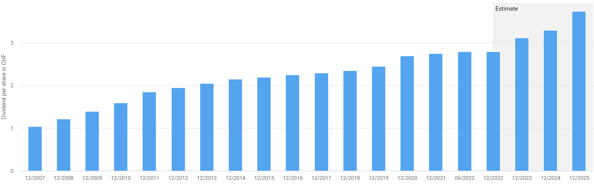
(Dividend Stock, 2022)
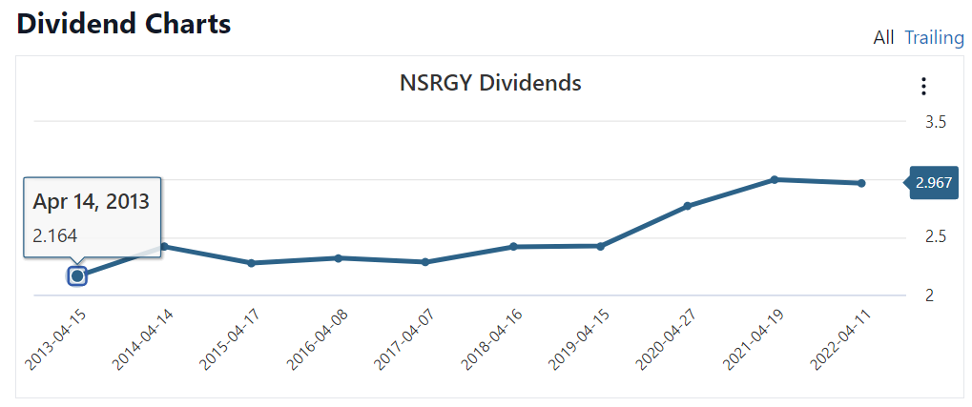
(Stock Analysis, 2022)
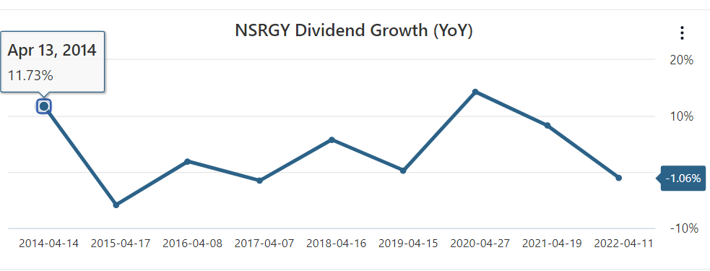
(Stock Analysis, 2022)
The corporation has maintained a stable dividend policy for the past 62 years, constantly increasing dividend per share. Between 2017 and 2021, the dividend pay-out is constantly increasing, as listed in the chart below (Nestle, 2021).
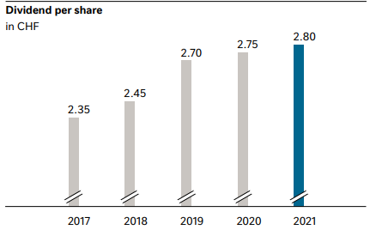
(Nestle, 2021)

Efficient Market Hypothesis
The Efficient Market Hypothesis (EMH) of market trading reflects the share price of a multinational corporation. The theory of EMH states that there is no consistent return when trading stock exchange, and the share price reflects all information. An efficient market is a market where there is no competition and share price is fairly traded, leaving no space for abnormal profit. However, some markets are inefficient where investors' strategies result in a risky one and beat the market price for an excess profit (Bekaert, 2013).
There are three forms of the efficient market that determine the market value week, semi-strong and strong. The week from the market states that the firm share price is affected by the past share price history based on technical analysis information, which investors take into account when making decisions. The semi-strong market theory is the most efficient in the stock exchange because of its ability to make a higher return. In other words, the investor can use information not available on the public markets to make a higher return profit. The strong market theory states that share price is accurate based on the theory that all information is available and there is no higher return for investors (Madura, 2021). The profitability score of Nestle is 61 points. The stock share value is overvalued by 17 per cent in New York stock exchange with current market price at USD100.69, and the market price valued is at USD122.05, (Alpha Spread, 2022) and London stock exchange the share price is at 116. 73, undervalued price. Based on the market share price fluctuation and demand London stock exchange is categorised as semi-strong market where information is absorbed rapidly resulting in share price volatility for Nestle.

Investment Appraisal
The Investment Appraisal is the company project for the future of the business and profitability. The financial managers are responsible of the company strategies that will enchase the business future profitability over the assets, cash flow, profitability, payback program and return in investment. The investment appraisal method called the discounted method, which benefit financial manager to make decision of wheatear the investment is profitable or not (Bekaert, 2013).
The underlying trading operating profit margin for Nestle decreases by 30 points in 2021, reported at 17.4 per cent and the operating profit decrease by 250 points, due to Wyeth business weakness. However, the earnings per share increased by 41.1 percent, respectively CHF 6.06 mainly coming from L’Oréal disposal. The firm is expecting increase in underlying profit and earning s per share approximately of 5 percent as the organic growth is in constant increase (Nestle, 2021).
For the quarter that ended in June 2022, Nestle's annualised return on invested capital (ROIC%) was 9.54 percent. The ROIC percentage for Nestle is 10.10%. Nestle's investments yield more returns than the expense to the business of raising the necessary funds for the investment. It is producing surplus returns. A company's value will rise as expansion accelerates if it anticipates continuing to provide positive surplus returns on new investments (Nestle, 2021).

Conclusion
The international financial management is the toll stand at any business success. The theory of International Finance provides a critical analysis of the international market trading and foreign exchange as well as import and export and, selling of good and services on international markets. All business face different challenges and risks when trading in foreign country, therefore, the knowledge of international finance can avoid risks of profit loss and cash flow disruption, moreover, the finance manager can help to build up a successful business by applying the relevant theory and methods available. The market trading is a fearless environment where the foreign exchange is the key to the profit. Depending on the market form and efficiency, the financial manager has to secure the profitability of a business and its market position. The higher the profit the higher the demand for its product and service and more chances for investment and growth resulting into a excellent application of the International finance.

References
Alpha Spread. (2022). Instrict value. Retrieved from Alpha Sprea: https://www.alphaspread.com/security/otc/nsrgf/summary
Arnold, G. (2013). Essentials of corporate financial management. Harlow, England : Pearson.
Bekaert, G. J. (2013). International financial management. Harlow : $b Pearson, $c 2013.: Harlow : $b Pearson, $c 2013.
Belger, T. (2019, August 13). Nestle warns Brexit means 'major challenges' for Britain's food and drink industry. Retrieved from Yahoo Finance: https://uk.finance.yahoo.com/news/nestle-warns-brexit-means-major-challenges-for-britains-food-and-drink-industry-230100800.html
Dividend Stock. (2022). Nestle Dividend. Retrieved from Dividend Stock, Global Dividend Growth: https://dividendstocks.cash/dividend-profile/Nestl%C3%A9-Dividend
GlobalData. (2022). Nestle SA – Risk Profile. Retrieved from GlobalData: https://www.globaldata.com/data-insights/consumer-food/nestle-sa-risk-profile/
Hacer Tanrikulu, D. N. (2020). Corporate political activity of the baby food industry: the example of Nestlé in the United States of America. International Breastfeeding Journal, 15-22.
Hamdi, F. (2015, June 11). The Impact of Globalization in the Developing Countries. Retrieved from LinkdeIn: The Impact of Globalization in the Developing Countries
Karwal, A. (2021, July 6). Unilever, Nestle cut hedges before emerging market FX rebound. Retrieved from EuroFinance: https://www.eurofinance.com/news/consumer-goods-giants-bet-on-em-recovery-with-fx-hedge-reduction/
Madura, J. (2021). International financial management. Australia: Australia : Cengage, [2021] ©2021.
Nestle. (2021). Anual Report. Vevey: Nestle.
Nestle. (2021, July 29). Nestlé reports half-year results for 2021, raises full-year organic sales growth guidance. Retrieved from Nestle press release: https://www.nestle.com/media/pressreleases/allpressreleases/half-year-results-2021
Nestle. (2022, February 17). Nestle report full year 2021. Retrieved from Press release: https://www.nestle.com/media/pressreleases/allpressreleases/full-year-results-2021
Nestle. (2022, April 21). Nestlé reports three-month sales for 2022. Retrieved from Nestle Press release: https://www.nestle.com/sites/default/files/2022-04/three-month-sales-2022-press-release-en.pdf
Nestle report 2022. (2022, April 21). Nestlé reports three-month sales for 2022. Retrieved from Nestle Good food, Good life: https://www.nestle.com/media/pressreleases/allpressreleases/three-month-sales-2022
Ridder, M. (2022, MArch 24). Leading beverage companies worldwide in 2020, based on sales. Retrieved from Statista: https://www.statista.com/statistics/307963/leading-beverage-companies-worldwide-based-on-net-sales/
Statista Research Department. (2022, june 2). Nestlé - statistics & facts. Retrieved from Statista: https://www.statista.com/topics/1439/nestle/#topicHeader__wrapper
Stock Analysis. (2022, August 3). Nestle SA (NSRGY). Retrieved from Stock Analysis: https://stockanalysis.com/stocks/nsrgy/dividend/
Wunsch, N.-G. (2022, March 17). Nestlé's leading markets worldwide 2021, based on sales. Retrieved from Statista: https://www.statista.com/statistics/413407/nestle-s-leading-markets-worldwide-based-on-sales/
Wunsch, N.-G. (2022, March 16). Statista. Retrieved from EBIT of the Nestlé Group worldwide 2008-2021: https://www.statista.com/statistics/268888/ebit-of-the-nestle-group-worldwide/#:~:text=In%202021%2C%20the%20trading%20operating%20profit%20%28EBIT%29%20of,worldwide%20from%202008%20to%202021%20%28in%20million%20CHF%29

