NatWest Service Strategy report.
Submission date: 16/12/2022
Submission ID: 2105306
File name: Strategic Management final assignment – BMMB7013D.
Word count: 5340

Executive summary
Banking in the UK has undergone major changes with the advancement in technology and government initiatives to help increase competition. Banking is a highly regulated and competitive environment with very little product differentiation in retail banks.
NatWest will need to differentiate itself by offering superior service, this starts with creating a strategy to become the number one ranked bank for service in the retail banking sector. This will be achieved through thorough analysis of the environment it operates both macro and micro, then employing key frameworks such as porters value chain, the change kaleidoscope to help assist in developing the necessary actions that need to be taken to achieve the strategy.
The strategy will envelope corporate, business and functional business units, all leaders and managers will need to be deployed in order to achieve the strategy and become a customer centric organization. The organization will need to ensure that it has capacity and capability from leaders, and to ensure no power or political agendas endanger the process.
In house knowledge through tech development, use of AI and the training of staff will create sustainable competitive advantage, VRIO analysis will help embed this and use it as a guide to ensure the Strategy creates value long term. Realigning business units and reducing the number of siloed functions will improve knowledge sharing, improve agility and reduce costs.

Introduction
The National Westminster group plc (NatWest) is a large retail banking and finance group with branches across the whole of the UK, the major brands included are Royal bank of Scotland, Ulster bank and NatWest (NatWest, 2022). This report shall explore a new strategic initiative as tasked by NatWest to be the number one ranked bank in customer service within the local UK market.
The report will be broken into two section. Section 1 will introduce strategy and its importance, define the environment in which NatWest operates. The report will use various frameworks necessary for successful strategy implementation.
Section 2 will analyze NatWest’s strategy to become the number one ranked retail bank in service. The report will draw from frameworks and models from section 1 and apply them to analyze the strategy, this will allow for key findings and action plans required to successfully implement the strategy.

Table of Contents
NatWest Service Strategy report. 1
Executive summary 2
Introduction 3
Section 1 6
What is strategy? 6
Organizational Environment. 8
Macro-economic environment. 8
Political 8
Economics 8
Social 9
Technology 9
Ecological Environment 9
Legal 10
Micro Environment 10
Customers 10
Competitors 11
Strategic Partners 11
Porters Five forces. 11
Threat of new Entrants 12
Bargaining power of buyers 12
Threat of substitute products 13
Bargaining power of suppliers 13
Rivalry amongst competitors 13
Value of resources and capability 13
Porters Value Chain 15
Firm Infrastructure. 16
Human resource Management 16
Technology 17
Procurement 17
The change Kaleidoscope 17
Section 2 21
NatWest strategy analyzed 21
Scope of the strategy. 21
Human resources. 22
Procurement 23
Time 23
Preservation 24
Diversity. 24
Capability 25
Capacity 25
Readiness 25
Power 25
Conclusion 26
References 27

Section 1

What is strategy?
It is important to understand what strategy is in order to ensure that the business remains focused and has clear objectives to align decisions against. Alfred D Chandler defines strategy as the determination of goals and objectives of an organization, the actions taken to achieve them and the resources that are needed to achieve the goals (Whittington, 2020) .
Practically strategy is broken down into three levels, corporate, business and functional.
Corporate level Strategy is concerned with the overall direction of the organization, allocation of resources and ensuring that value is added to stakeholders. The NatWest group would design an overall strategy, divide resources amongst the brands and monitor the performance of each brand. NatWest’s corporate strategy is “We are a relationship bank for a digital world. Our strategy for growth delivers on our purpose and drives sustainable returns to shareholders through four strategic priorities: we will support our customers at every stage of their lives; we will be powered by innovation and partnerships as we accelerate our digital transformation; we will be simple to deal with; and we will allocate our capital in a way that delivers for customers and shareholders.” NatWest 2022.
The business level strategy is concerned with the ensuring each business makes decisions based on the corporate strategy and creates plans to create competitive advantage within the market it operates.(Whittington, 2020). In NatWest this would entail specific divisions and sub groups such as NatWest retail bank, which offers financial services to individuals.
Functional strategy is the operational level where business level strategy is implemented, ensuring that the everyday business activities are being actioned in a way that achieves both business and corporate strategy.
The new strategy of becoming the number one ranked service provider will fall under the umbrella of functional level strategy, and will be part of the larger business and organizational strategy. Why is this strategy so important?
Great customer service strategy has a huge impact on an organization to attract and retain customers, it improves revenue, margins and lowers costs, (Goodman, J.A., 2009). All of these benefits fall within the scope of corporate, business and functional strategies. NatWest has performed poorly in customer service, ranking 10th in overall banking and online and mobile banking services, not making the top 17 in overdraft services, (Ipsos ,2022). This indicates that NatWest is losing out on the ability to generate income, retain and gain new customers.

Organizational Environment.

Macro-economic environment.
The report will use well known PESTEL Framework to analyse the macro environment, highlighting a few will allow us to make strategic choices further in this report. It is important to note that the PESTEL framework has very little logic underpinning the framework for predicting strategic outcomes it is still very important to understand the environment in which an organisation operates (Lynch, R.L, 2018).

Political
Political unrest across the globe can create market volatility that will effect interest rates and inflation on a domestic level, it also effects how customers view and interact with businesses, (Jobber, D, 2019). The Ukraine war and subsequent restrictions imposed on Russian imports have led to high fuel prices, inflation pressures and rising costs.

Economics
The health of the economy plays a very important role in how much disposable income customers have and what type of products they purchase (Jobber, D, 2019). It also has a direct impact on the costs of NatWest products as most lending products are linked to the lending rates they can obtain from the central bank. Another indicator is the Gini coefficient which indicates the available spending power of the population. The higher the score the higher the spending power of the total population. The UK Gini coefficient has been declining indicating that the majority of the population has less disposable income (ONS, 2021).
NatWest have been very cognisant and have taken steps to offer free financial health checks for its customers and advising them on various ways to improve customer financial decisions.

Social
Socially the UK has a very diversified population consisting of multiple ethnicities and social classes(gov.uk, 2018). This is becoming an ever more important aspect of the PESTEL framework as society evolves and changes, with cultural shifts and subset of people each having unique desires and views on the world (Jobber, D, 2019). The recent death of Floyd brought about a global desire of many people to see more equality and representation of black people in organisations, this is just one example of hundreds that demand attention from marketers.
NatWest reacted to the black lives matter movement positively displaying diversity and inclusion in communication. NatWest also held fundraising in response to Ukraine war giving customers an easy way to make an impact.

Technology
Technology is now at the forefront of many organisations, giving access to data to make analytical decisions and the ability to communicate with customers in many different ways. It give business the opportunity to create value by understanding consumer on much more personalised level (Amar, J, 2020).

Ecological Environment
The global climate change have been a huge issue for all countries and business globally in the last number of years. Customers are demanding that corporations step up to help combat climate change.
NatWest offer green mortgages, a carbon footprint feature in their app which allows their customers to track their own carbon footprint. NatWest has taken this issue seriously.

Legal
Laws governing the way in which an organisation can conduct itself (Jobber, D, 2019). The legal framework in the UK has big implications for the banking industry, how companies use data, target customers, what products they sell. It is very important that NatWest strictly adheres to all rules and regulation to avoid not only fines but also the trust of its customers.
NatWest ensure everything they do is legally compliant and are forthcoming in admitting fault. NatWest admitted to failures resulting in a money laundering breach that cost them 264 million pounds (NatWest, 2022). NatWest demonstrated integrity and openness which is crucial as customers need to trust the people managing their money. They have since introduced much tighter measures of control to ensure data is safe and any suspicious activity gets flagged and reported.

Micro Environment
The micro environment consists of internal stakeholders that could have influence on operational performance that can be perceived and controlled to some extent (Fahy, J 2019). In the case of NatWest these include customers, competitors and strategic partners. We will use this analysis to assist strategic marketing decisions.

Customers
NatWest has a broad customer base encompassing all age groups, ethnicities and races and businesses. The challenge is to connect to all these different groups in a meaningful way to create sustained value.

Competitors
Competitors are becoming an increasing problem for an industry that has until recently being considered an oligopoly. Technology and government initiatives have allowed for a variety of financial services organisations to enter the market at a much lower cost than would have been possible traditionally. Sterling bank is an example of this, starting in 2010 they now have over 2 million customer in the UK (Statista, 2021).

Strategic Partners
NatWest have numerous strategic partners such as advertising agencies, technological service providers, staff agencies etc. These need to be carefully managed to ensure that they are the correct partners to assist in achieving the organisational goals and that their business culture is in alignment with NatWest.

Porters Five forces.
Porters five forces framework is a useful tool to define the industry in which you operate and identify areas in which the organisation can focus strategy to improve the position within the industry. (Whittington, R, 2020).

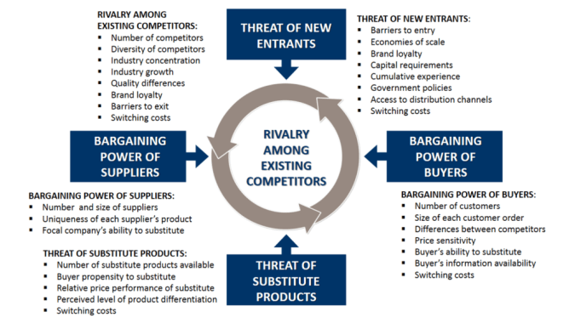

Never before has it been more important for NatWest to review the industry in which it operates as the environment is changing constantly.

Threat of new Entrants
Traditionally banking in the UK has been almost an oligopoly with a few players dominating the market, however with the advent of technology and supported by government initiatives there have been many new players entering the market, the likes of Monzo, Sterling and Revolut particularly aggressive.

Bargaining power of buyers
Buyers have medium bargaining power empowered by the ability to switch between accounts with no costs, competitors generally have very little product difference although there has been some movement to differentiate through partnerships such as Barclays offering free apple subscriptions, as most products are similar thus the defining factor on competitive advantage comes through service and the customer journey.

Threat of substitute products
This threat is quite low as banking is highly regulated and competition is strong so most core products have very similar functionalities, cost and benefits.

Bargaining power of suppliers
Suppliers bargaining power is generally low due to the high regulation from government to protect the consumers. This is obviously dependant on the specific products that need supplied, some legacy systems are controlled by companies and cannot easily be substituted but this is rapidly changing as banks move over to more modern systems that allow for advanced integration.

Rivalry amongst competitors
NatWest operates in a highly competitive industry. There are a number of areas in which NatWest can focus strategy to improve its competitive advantage. NatWest could use its relationship with regulators to make it harder for competitors to compete, focus on technology to improve product offerings and service thereby creating a competitive advantage and differentiating from other competitors.

Value of resources and capability
The VRIO (valuable, rare, inimitability, organisation) analysis is designed to assess the nature of the resources available in contrast to competitors in order to ensure that strategies employed create value to consumers and create competitive advantage (Whittington, 2020).
Value relates to the perceived or actual value customers get, are the products designed to suit the needs of the consumer and are competitors offering better value products? How can the organisation create value better than the competitors? This is particularly difficult as shown above, there are limited ways to create value, predominantly through service and the customer journey.(Whittington, 2020).
Rarity is the analysis of resources and how rare they are in relation to competitors. Does the organisation possess capital that others do not for example, unique technologies that are difficult to replicate. NatWest possess experience that new competitors cannot replicate easily, trust is another area where banks can differentiate themselves, careful analysis of staff is required to determine if the knowledge and skills it possesses are unique and defining.(Whittington, 2020).
Inimitability is the understanding how difficult it would be for competitors to replicate the resources the organisation has at its disposal. NatWest has inherent data collected from customers that would be very difficult to acquire for competitors, a good strategy would leverage this unique data to create competitive advantage (Whittington, 2020).
Organisation refers to the structure of the organisation and how it’s setup to support the organisational strategies and utilise resources effectively. NatWest need to be particularly aware of this and do a deep analysis in order to ensure that the organisation is setup in the best possible way. NatWest is a large organisation and thus would be less agile than new tech start-ups at adapting to changing technologies and environments (Whittington, 2020).
The below infographic shows how the above feed into competitive advantage and could be utilised to assist in developing and focusing strategy. The ultimate goal is to ensure that organisations achieve all four to achieve sustained competitive advantage (Whittington, 2020).

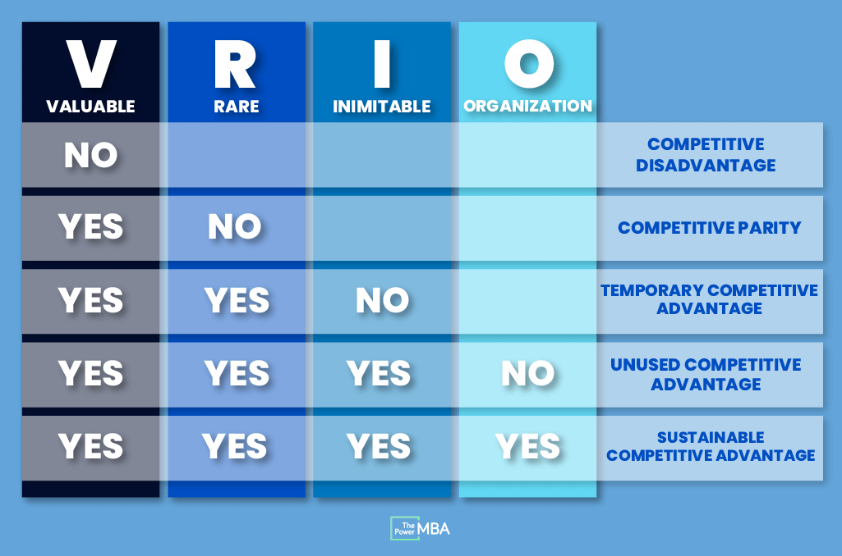
Source: https://www.thepowermba.com/en/b 1

Porters Value Chain
Porter’s Value chain shows how an organization can create competitive advantage by analyzing the structure and functions of the organization (Whittington, R, 2020) .
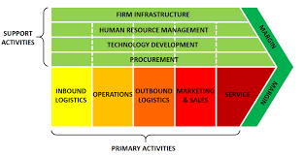
Source: (Whittington, R, 2020) 1
Porters value chain clearly shows that service is a primary activity that is required to achieve improved margins and create competitive advantage. NatWest’s omni channel strategy will need to be supported by every support activity in order to be successful.

Firm Infrastructure.
Organizations need to ensure that the structure of the firms is setup correctly to support strategies and functions in a way that maximizes resources. This is particularly relevant today as large organizations need to be more adaptable than ever, this means removing business units out of siloes and have a more collaborative structure that supports each other (Bollard, A, 2017). NatWest need to ensure that it’s operation enhance value, currently it’s call centers are siloed into different divisions creating a complicated and frustrating customer journey.

Human resource Management
The function of human resources is to manage the talent within the organization. This is one of the most fundamental roles in organizations today. Human resources needs to be involved at every level of the strategy development to ensure that they have the right capabilities to support the strategy. No easy task as the UK is currently experiencing a huge skills shortage with job vacancies at a record high in February 2022 (Office for National statics, March 2022), additional data by shows that demand for tech jobs has risen by 66% since third quarter 2020 to third quarter of 2021 whilst applicants for those positions have fallen by 41% (Broadbean Technologies, 2021).

Technology
Does the company have the right technology to support the organization and the customer journey. An imperative question in today’s ever changing landscape, with new technologies being developed daily and customers increasingly using them to interact with the company. There is a broad range of technologies that will affect NatWest and how it competes and adds value such as training technologies, according to Groysberg (2010) having employees trained internally with organisational goals in mind leads to competitive advantages that are difficult to replace with talent management strategies that focus on portability, this links back to the VRIO analysis to create sustained competitive advantage.

Procurement
This focuses on achieving the best possible inputs for the organisation to maximise output, for NatWest this could be the advertising agency selected or technology partners. NatWest needs to thoroughly analyse supplier capabilities and how they impact its ability to achieve its strategy.

The change Kaleidoscope

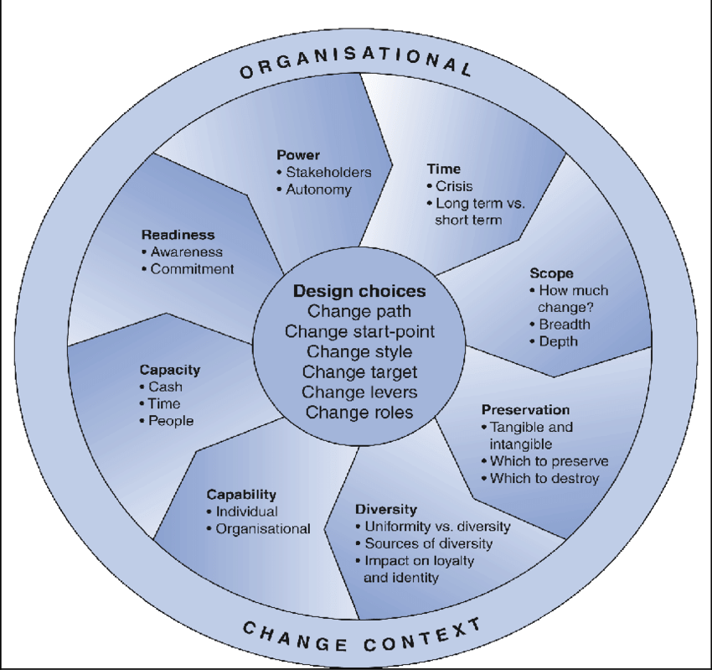
Source: Balogun, J, 2016 1

The change Kaleidoscope is a very valuable tool in developing a strategy and implementing strategies. Its creates a framework that highlights what is needed for the strategy to be successfully implemented. It’s important to note that it is not a fixed framework like many others and is designed to be used continuously as the organization develops and the environment in which the organization changes, it is in short design designed to be agile and respond to the ever changing landscape in which business operates (Bogun, J, 2016).
Time refers to the urgency required for implementation, it is very important to answer this question as it will affect resource allocation and create urgency for solutions and action. The covid pandemic of 2019 created a number of urgent strategies that were required for businesses to remain viable over the tumultuous period. Organizations that were agile enough survived and even thrived, time periods were very short and had to be prioritized (Whittington, 2020).
Scope refers to how wide spread the change is needed within an organization, is the strategy limited to one department or the entire organization? This impacts time frames and resources required to implement the strategy. An example would be a cultural change of empowering diversity in the work place which would encompass the entire organization or a change in advertising strategy that would be limited to the marketing department (Whittington, 2020)..
Preservation deal with what systems and strategies should be held onto in the change. It is important to understand that some functions still provide value or competitive advantage. NatWest have to embrace technology and to engage with a large portion of its consumers, however there are many older customers who do not interact with technology and want to deal with people in branches, how valuable is this to NatWest, should the strategy involve closing down branches or keep them open and use the space for something else in order to preserve the value for certain segments of customers (Whittington, 2020).
Diversity considers the ability for an organization to implement change in a way that gets buy in from all cultures and sub cultures in an organization. Do different departments or employees value the change in the same way, can one strategy connect to them all or are different methods required to engage with all the staff (Whittington, 2020).
Capability refers to the ability of leaders and employees to implement the change. Do they have the necessary skills and motivation to implement a new technology throughout an organization, employees may need to have the skills developed to use the new systems, managers may not have the necessary skills to get employees engaged and open to implementing the new strategies. The skills and capability also depend on the type of change or strategy being implemented. One manager might be capable at getting quick results but might not be able keep employees engaged over a long term period (Whittington, 2020).
Capacity refers to the amount of resources that can be committed to the change strategy. A company with limited resources might want a full IT infrastructure with 6 months but only have the resources to achieve the desired change within 2 years. Resources not only refer to financial means but time resources as well. Can the organization afford time off for employees to receive all the required training in a short space of time? Another aspect of capacity is trust. Do the employees trust the change, do they believe that management are capable of steering the organization to success (Whittington, 2020).
Readiness is all about how the employees and management will react to the change, are they ready for it. The communication needs to be effective in order for there to be understanding that the change is necessary and is in the benefit of all stakeholders (Whittington, 2020).
Power refers to the internal and external stakeholders that may have the ability to impact the change strategy. This needs to be carefully examined in order for the change to be accepted by the targeted recipients. An example of this would be for a Union to impact the need for changes to working conditions or shifts that are better suited to creating value for the customer or a board to disagree with the CEO and block proposals (Whittington, 2020).

Section 2

NatWest strategy analyzed
The report has established the need for the strategy in section 1 of this report and the many factors that influence strategy and the implementation. The question remains how do NatWest achieve their strategy, what the strategy looks like practically and does the strategy fit within the organization and environment.
In order to achieve the strategy of being the number one in customer service NatWest need a detailed omni strategy plan in order to ensure that customer journey is smooth, simple and effective (Amar, j et al, 2019). The channels required consist of branch, call centers, websites, social media and mobile platform, all these channels need to be consistent in their approach and offer a holistic view of the brand to create a seamless customer journey (Manser Payne, E, 2017).
Using the change kaleidoscope as a base an then tying in the other frameworks we will start to see the strategy formulation come together.

Scope of the strategy.
The NatWest strategy to become the number one ranked in service in the banking industry will encompass the entire organization. In order for the organization to achieve the strategy all support elements as highlighted from Porters value chain will be need to buy in to the strategy.
Organizational structure will be addressed to ensure that they support the business fully and integrate functions necessary. Units of the business will need to be less siloed and more collaborative. This will reduce costs, create shared knowledge and feed a culture of customer first culture that is needed (Amar, J, 2020)

Human resources.
Arguably one the most important functions for the strategy of becoming the best ranked service bank. HR will be required to assist in assessing the skills that are required, it is important to take a wholistic approach to job analysis, not just focusing on the tasks and responsibilities involved in the role but to include additional competencies and values that will be required to ensure that the future goals of the organization are met (Platts, 2018). Creating training and learning paths can greatly improve performance and understanding for staff and their impact on the organization. HR will be paramount to the organizational restructuring to ensure that cross functionalities engage and complement the different business units. Using call centers as not only a cost center but rather a talent pool could be utilized to create more customer centric staff who understand the customer needs and how to create value (Amar, J, 2020). This would also create better data and more meaningful engagement with customers in the short term. Promoting internally also demonstrates to potential external candidates that career growth opportunities exist within the organization (Torrington D, 2020).
Technology development will play major role in increasing customer service. NatWest currently incorporate chat bots into their apps and websites to improve efficiency in answering queries and connect to customers in a way that suits them, however they need to be better and more fluid and should ensure that customers get the assistance they need by offering quick solutions and if not they should be directing the customer directly to an agent who can assist rather than by looping them back and forth asking for more detailed information, what should be a quick and helpful tool can become an a source of anxiety and frustration for customers who are constantly directed to the chat bot. Incorporating AI solutions to call center staff can assist in providing more meaningful conversations and better data being collected, these range from empathy driven tools to assist in establishing emotional states to providing insights on what the customer needs (Amar, J, 2020). The technology development team will have to work closely with HR to develop training on skills shortages that are being recorded by data and vice versa on what the customers want will be directed by HR to improve customer products and engagement.

Procurement
The procurement department will work with both HR and technology to determine what skills and services need to be facilitated through external suppliers, procurement will work with HR and technology to determine if the suppliers have the right capabilities.

Time
Although an immediate improvement is required and this is a top priority for NatWest the goal is a five year goal and thus resources should be allocated accordingly. The challenge with the longer term is to ensure that fatigue doesn’t set in. The strategy implementation should include sort term wins by monitoring performance against Net promoter(NPS) scores, these scores can provide valuable wins for the employees servicing customers (Whittington, 2020). Managers and seniors will be looking to see improvement in financial performance, although this can take some time to show significant improvement and should also be benchmarked against industry growth and the environment in which it operates (Whittington, 2020). Retrition rates and new client growth and complaints monitoring will also give valuable performance benchmarks that could provide short term wins.

Preservation
Due to the nature of banking this is going to be a more difficult decision that normal. Legacy systems need to be maintained to preserve customer data and system integration that has been used for decades. Technology will need to eventually disregard this however practically this process would take years, technology teams should have a framework to do this and have a fixed time frame in order to do this. Branches are expensive and with less foot traffic are increasingly becoming difficult to justify however NatWest need to provide alternatives to ensure that customers who need face to face support can get it. the additional value of having branches is the marketing and presence they represent within the communities, thus it is worth analyzing if the premises could be used to facilitate some business functions allowing for them to be remained open.

Diversity.
NatWest has a large workforce that is diverse due to the size and types of roles it has, employees come from many different backgrounds. In additional there has been purposeful recruitment to ensure that NatWest is representative of the communities it represents. This could create challenges for the strategy to be implemented however NatWest has been undergoing change for quite some time in a number of areas and are familiar with the staff that require attention and how to engage with different sub cultures in the organisation.

Capability
NatWest has undergone many changes as it adapts to the changing technological landscape. The organization is agile and is well prepared to deal with change and new strategies being implemented. Leadership have displayed their abilities through the Covid pandemic and prior when shifting to a more digitally focused bank.

Capacity
NatWest is a large organization and has weathered recent events well showing strong financial performance. Careful planning is needed so as to ensure that this remains following the aftermath of covid, the war on Ukraine and the impact that will have on its customers and their ability to service debt, a main driver of NatWest financial performance. Time capacity shouldn’t be an issue as the organization is well staffed and has proven this during recent changes as mentioned previously.

Readiness
This could potentially be an area that creates some barriers to the strategy being implemented. Staff need to have the correct information and be included in the plan to ensure that they are engaged and enthusiastic. Staff need to be aware of the implications and opportunities this strategy will have. This should be implemented from the outset so that when the time comes for individual involvement there should be fewer objections to the change (Whittington, 2020).

Power
In the Pestel analysis we looked at government regulations and legal implications. The strategy and the implementation of strategies need to adhere strictly to any laws and regulations. Active engagement on any stumbling blocks could prevent any issues further down the line and also create valuable engagement and trust between the stakeholders. Political movement within the organization should be carefully considered to ensure that no agendas are at play to derail a very important strategic position. NatWest doesn’t appear to have any major internal issues but it is always prudent to ensure that the strategy will be implemented correctly without any power plays affecting implementation (Whittington, 2020).

Conclusion
“Personalization – and the empathy and connections that go with it are more critical than ever” (Amar, J, 2020). NatWest have real improvement to make if they wish to be successful at implementing a strategy to become the number one ranked service industry. The report has shown that the external environment has a major impact on the decisions, their operating environment is increasingly competitive. In order to create sustained competitive advantage the organization will need to invest in its service capabilities and develop internal skills that cannot be replicated easily providing a rare and valuable resource. Careful attention to the way in which the organization is structured to reduce costs and become more agile, improving staff knowledge and training, transforming the call center previously viewed as a cost center to becoming a valuable resource of customer led talent pool. The kaleidoscope framework should be used to assess the strategy on an ongoing basis to pick up and improve on any issues and implementation as required.

References
Amar J, Raabe J, Roggenhofer S (2019) Customer first: personalizing the customer-care journey. McKinsey & Company, New York
Amar, J et al. (2020) The vision for 2025: Hyperpersonalized care and ‘care of one. McKInsey. https://www.mckinsey.com/capabilities/operations/our-insights/the-vision-for-2025-hyperpersonalized-care-and-care-of-one
Anastasiu, L., Gavriş, O. and Maier, D. (2020) ‘Is Human Capital Ready for Change? A Strategic Approach Adapting Porter’s Five Forces to Human Resources’, Sustainability (Basel, Switzerland), 12(6), p. 2300–. Available at: https://doi.org/10.3390/su12062300.
Baye, M.R. and Prince, J. (2017) Managerial economics and business strategy. Ninth edition. New York, NY: McGraw-Hill Education.
Beard, D.W. and Dess, G.G., 1981. Corporate-level strategy, business-level strategy, and firm performance. Academy of management Journal, 24(4), pp.663-688.
Fahy, J. and Jobber, D. (2019) Foundations of marketing. Sixth edition. London: McGraw-Hill Education.
Goodman, J.A. (2009) Strategic customer service managing the customer experience to increase positive word of mouth, build loyalty, and maximize profits. New York: AMACOM.
Ipsos (2022), Personal Banking service – Great Britain. https://www.ipsos.com/en-uk/personal-banking-service-quality-great-britain-february-2022#online
Jobber, D. and Ellis-Chadwick, F. (2019) Principles and practice of marketing. Ninth edition. Maidenhead: McGraw-Hill Higher Education.
Lee, S.M. and Lee, D., 2020. “Untact”: a new customer service strategy in the digital age. Service Business, 14(1), pp.1-22.
Lynch, R.L. (2006) Corporate strategy. Fourth edition. Harlow, England: Financial Times/Prentice Hall.
Lynch, R.L. (2018) Strategic management. Eighth edition. Harlow, England: Pearson Education Limited.
Magretta, J. (2012) Understanding Michael Porter the essential guide to competition and strategy. Boston, Mass: Harvard Business Review P.
Manser Payne, E., Peltier, J.W. and Barger, V.A. (2017) ‘Omni-channel marketing, integrated marketing communications and consumer engagement: A research agenda’, Journal of research in interactive marketing, 11(2), pp. 185–197. Available at: https://doi.org/10.1108/JRIM-08-2016-0091.
Naylor, J. (2004) Management. Second edition. Harlow, England: FT Prentice Hall.
Whittington, R. et al. (2020) Exploring strategy : text and cases. Twelfth Edition. Harlow: Pearson.

