

Student Name : Vajra Chaitanya pondugula
Student id: 2418439

"Business Management in Project Expansion"
Table of Contents
1
1.Introduction 3
2. Fundamental Principles of Project Management 4
3. SWOT and PESTLE Analysis 5
3.1 SWOT Analysis 5
3.2 PESTLE Analysis 8
4. Organisational Structure and Technology Integration 10
5. Challenges of Moving to New Premises and Leadership Approaches 12
Conclusion 13
References 14

1.Introduction
Innocent Drinks, founded in 1998 by Richard Reed, Adam Balon, and Jon Wright, has grown from a modest startup to become Europe's leading smoothie brand (Fast Track 100, 2012). The company's mission has always been to provide natural, healthy beverages while upholding a strong commitment to sustainability and ethical business practices (Rubin, 2010).
Initially self-funded, Innocent's first significant investment came from Maurice Pinto, who contributed £250,000 to help launch the business (Wikipedia, 2025). This early funding helped Innocent expand rapidly, diversifying its product line and extending its market presence across Europe. By 2016, the company had achieved remarkable success, reporting sales of £247.4 million, partly due to the launch of new products such as coconut water and vegetable smoothies (Wikipedia, 2025).
A major turning point for Innocent came in 2009 when The Coca-Cola Company acquired a minority stake in the business (Wikipedia, 2025). Over the years, Coca-Cola’s investment increased, and by 2013, Coca-Cola owned over 90% of Innocent Drinks, while the original founders retained a small minority stake (Wikipedia, 2025). Despite this shift in ownership, Innocent has continued to prioritize sustainability and social responsibility. The company donates 10% of its profits to charity, primarily through the Innocent Foundation, which supports agricultural projects in regions where the company sources its fruit (Innocent website, 2012).
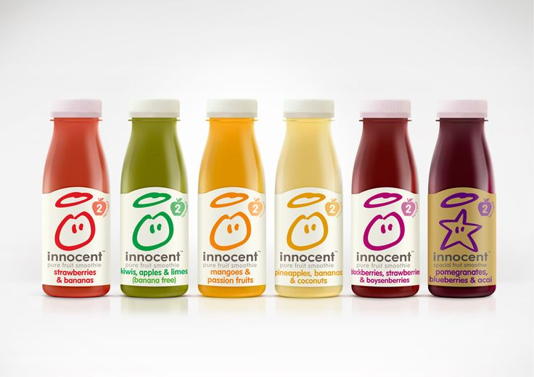
Innocent’s success has been recognized through numerous accolades, including the World Juice Award for Best New Product in 2011 and the Marketing Week Effectiveness Award for New Product of the Year in 2010 (Innocent website, 2012). Additionally, by 2011, one in four UK households purchased an Innocent product, further cementing the brand's market dominance (BuyEssay, 2025).
However, like many companies, Innocent faced challenges during the global financial crisis. In 2009, the company experienced a decline in revenue and even posted a loss (Wikipedia, 2025). Despite these setbacks, Innocent has managed to recover, adapting to shifting consumer preferences and evolving market conditions.
As of 2025, Innocent Drinks remains committed to innovation and expansion while balancing its growth objectives with its core values of sustainability and ethical business practices (Wikipedia, 2025). The company’s journey, from a small startup to a major player in the beverage industry, serves as an inspiring example of entrepreneurial success and responsible business management.

2. Fundamental Principles of Project Management
Project management is essential to ensure that complex projects are completed efficiently, on time, and within budget. For Innocent Drinks, applying key project management principles is vital as the company undertakes its relocation and expansion into new facilities and products. These principles help manage the complexities associated with growth while maintaining the company’s commitment to sustainability and quality. The key project management principles that Innocent Drinks must apply are scope management, time management, cost management, quality management, risk management, and communication management.
Scope Management
Scope management is the first step in any project to define its boundaries and objectives. For Innocent Drinks, this includes clearly defining the new facility's requirements, the products to be introduced, and any supply chain adjustments needed to meet the new demand. Defining the scope helps avoid scope creep, ensuring that only necessary tasks are performed without unnecessary expansions or delays (Kerzner, 2017). Clearly defined objectives allow Innocent to stay focused on the essential elements of the project.
Time Management
Time management is crucial for the successful completion of a project, particularly in relocation and expansion projects. Innocent Drinks must create a comprehensive timeline for key stages such as site selection, facility design, construction, and training. Tools like Gantt charts or project management software can help track progress and adjust timelines as needed (Turner, 2014). Proper time management ensures that deadlines are met, which is essential for minimizing operational disruptions during the transition.
Cost Management
Cost management is a critical element of any project, especially when dealing with large-scale expansions. Innocent Drinks needs to carefully estimate and track costs associated with relocating and expanding its product line. This includes budgeting for new facilities, equipment, logistics, and additional workforce needs. By establishing a clear budget and monitoring costs, the company can avoid financial strain and ensure the project stays within its allocated resources (Kerzner, 2017).
Quality Management
Innocent Drinks is known for its high-quality, natural products, and maintaining this quality is crucial during expansion. Quality management involves implementing regular checks, training staff, and auditing suppliers to ensure that the company’s product standards are met consistently. This is essential to maintaining consumer trust and ensuring the brand's reputation is not compromised (Turner, 2014).
Risk Management
Risk management helps identify potential challenges that could derail the project, such as financial issues, supply chain disruptions, or delays in construction. By identifying risks early and preparing contingency plans, Innocent can mitigate the negative impacts of unexpected events (Kerzner, 2017). This proactive approach ensures that risks are managed, minimizing the chance of project delays or cost overruns.
Communication Management
Clear communication is essential for any project’s success. Innocent must establish effective communication channels between all stakeholders—suppliers, distributors, and internal teams. Regular updates, meetings, and collaborative platforms ensure that everyone involved is informed, reducing misunderstandings and improving project outcomes (Turner, 2014).
Project Management Frameworks
To manage the expansion and relocation, Innocent Drinks can apply project management frameworks like PRINCE2 and Agile. PRINCE2 is particularly effective for managing the structured phases of the relocation, while Agile is better suited for managing the flexibility required during product development and market testing (Project Management Institute, 2017).
By applying these principles, Innocent Drinks can successfully manage its relocation and expansion while ensuring that its core values of sustainability, quality, and ethical practices remain intact.

3. SWOT and PESTLE Analysis

3.1 SWOT Analysis
A SWOT analysis helps evaluate the internal and external factors that could influence the success of a project or business. For Innocent Drinks, this analysis provides valuable insight into how the company can leverage its strengths, address its weaknesses, seize opportunities, and counteract potential threats as it moves forward with its expansion plans.
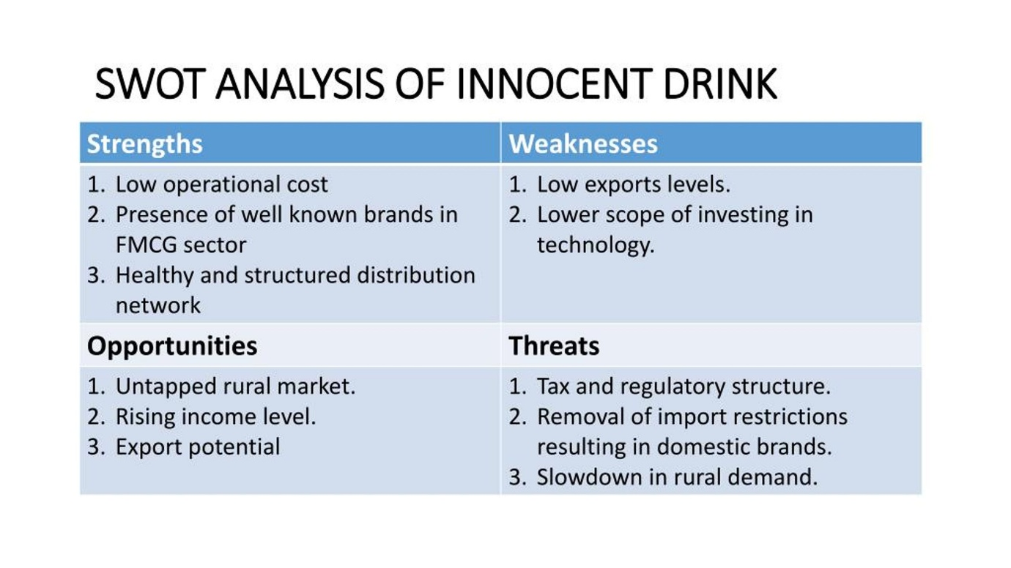
Strengths
Innocent Drinks has several key strengths that have helped it establish itself as a leader in the healthy beverage market. One of the company’s biggest strengths is its brand reputation. Innocent has built a strong brand image centered around health, sustainability, and high-quality products, which resonates well with consumers who prioritize these values. Their commitment to using natural ingredients and offering transparent product labeling has fostered customer loyalty (Innocent Drinks, 2025).
Another strength is sustainable sourcing. Innocent Drinks sources its ingredients from farmers who adhere to sustainable farming practices, particularly in the fruit industry. This ethical approach is not only aligned with the company’s mission but also appeals to increasingly environmentally-conscious consumers (Innocent Drinks, 2025).
The company also has strong relationships with suppliers. Over the years, Innocent has established long-term relationships with farmers and suppliers in the UK and Europe, ensuring a reliable and steady supply of high-quality ingredients. These relationships can be a significant advantage, particularly when scaling operations to meet the growing demand for Innocent products (Turner, 2014).
Weaknesses
However, Innocent Drinks faces some weaknesses that could affect its ability to scale efficiently. One of the major challenges is supply chain inefficiencies. As the company expands, it may struggle to maintain the same level of operational efficiency and communication within its supply chain. Missed deliveries and quality issues, as observed during periods of rapid growth, point to a lack of coordination and effective systems (Kerzner, 2017). These inefficiencies could disrupt operations and lead to delays or subpar product quality.
Innocent also has a dependency on external suppliers. While the company has built strong relationships with its suppliers, this reliance on external sources for raw materials can expose Innocent to risks like price fluctuations, quality issues, and delays in supply. As the company moves forward with its expansion, managing these external dependencies will become even more critical (Kerzner, 2017).
Opportunities
There are significant opportunities for Innocent Drinks as the market for healthy drinks continues to grow. Consumers are increasingly choosing beverages that are natural, organic, and nutritious, creating a larger market for Innocent’s products. The rising awareness of health issues, such as obesity and lifestyle diseases, is pushing more people toward healthier alternatives like smoothies and vegetable juices (Turner, 2014).
Another opportunity for Innocent is its expansion into new supermarkets. As demand for healthy drinks grows, new supermarkets are eager to stock products that align with consumer preferences. By partnering with these supermarkets, Innocent can reach new customers and increase its market share, especially in regions where it currently has limited presence (Project Management Institute, 2017).
Threats
Despite its strengths, Innocent Drinks faces several threats. Competition in the healthy drinks market is fierce, with many new brands entering the market and established players, like PepsiCo and Coca-Cola, introducing their own health-focused beverages. This increasing competition could impact Innocent's market share and pricing strategies (Kerzner, 2017).
Another threat is supply chain disruptions. As Innocent continues to expand, any disruption to the supply of raw materials—due to weather events, trade restrictions, or supplier issues—could cause delays in production or even result in stock shortages (Turner, 2014). This risk is heightened by the company’s reliance on external suppliers.
Lastly, the increasing cost of raw materials presents a challenge. As demand for organic and sustainable ingredients rises, the cost of sourcing these materials may increase, affecting profit margins. Innocent will need to carefully manage these cost pressures to maintain competitive pricing while safeguarding product quality (Project Management Institute, 2017).
Capitalizing on Strengths and Mitigating Weaknesses
To capitalize on its strengths, Innocent Drinks should continue to emphasize its brand reputation and sustainability efforts in its marketing strategies, reinforcing its position as a leader in healthy, ethical products. Strengthening its supply chain through improved technology and better communication systems can help mitigate inefficiencies and ensure smoother operations as the company scales (Kerzner, 2017). Additionally, Innocent can explore diversifying its supplier base to reduce dependency on external suppliers and secure more stable sourcing options (Turner, 2014).
By leveraging its strengths in sustainability and supplier relationships, Innocent can position itself as an even more attractive choice for environmentally conscious consumers, ensuring continued success in the expanding market.

3.2 PESTLE Analysis
A PESTLE analysis helps identify the external factors that can influence a business’s operations and success. For Innocent Drinks, the company must consider the political, economic, social, technological, legal, and environmental factors that may impact its operations as it expands and grows. Understanding these factors will enable Innocent to navigate challenges and seize opportunities to succeed in a competitive market.
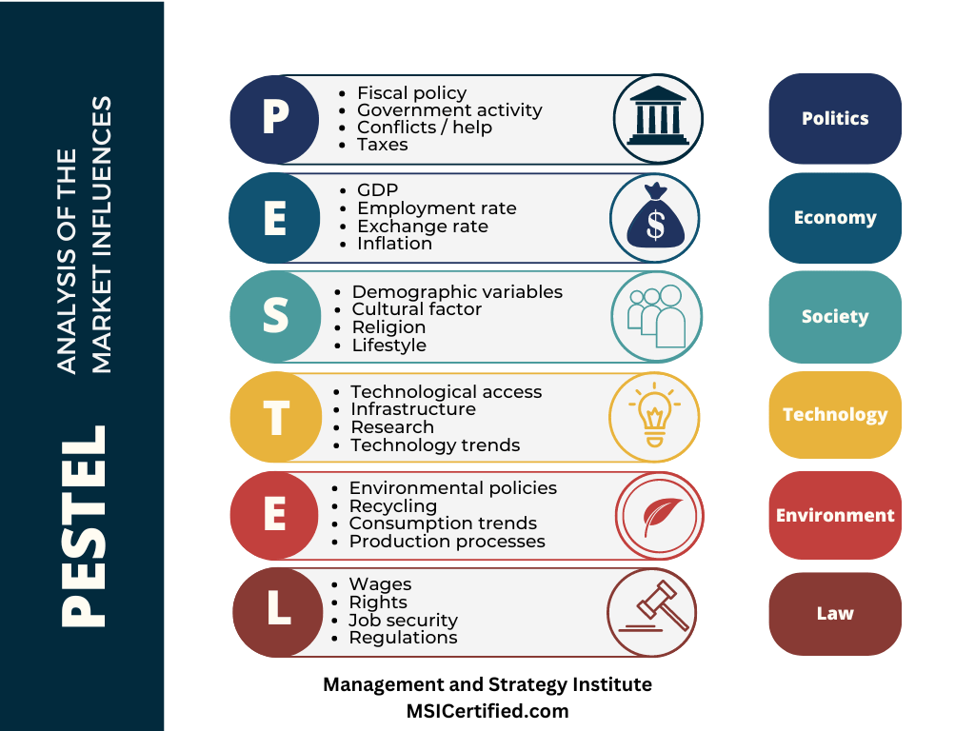
Political – Brexit Impact and Food Regulations
Brexit has introduced new challenges for UK-based companies like Innocent Drinks, particularly when it comes to importing raw materials and navigating new trade regulations. Since Innocent sources a significant portion of its fruit and ingredients from Europe, changes in tariffs, customs procedures, and trade agreements could increase costs or cause delays in the supply chain (Project Management Institute, 2017). To mitigate this risk, Innocent could consider diversifying its supplier base or building closer relationships with local farmers to reduce dependence on European suppliers.
Moreover, the food regulations in both the UK and Europe can significantly affect the way Innocent operates. The company must adhere to strict regulations around food safety, labeling, and advertising standards. As the regulatory environment around food continues to evolve, Innocent must stay updated on the latest laws to avoid penalties or reputational damage (Turner, 2014).
Economic – Inflation and Government Grants for Sustainability
Economic factors, including inflation and the cost of living, can have a direct impact on consumer spending power. If inflation rises, consumers may prioritize lower-cost products, which could affect the demand for premium-priced products like Innocent Drinks (Kerzner, 2017). To navigate this, Innocent could focus on maintaining competitive pricing while ensuring its premium offerings remain attractive to health-conscious consumers.
On a more positive note, the UK government and EU have grants for sustainability initiatives that Innocent could take advantage of. These grants encourage businesses to invest in sustainable practices, such as renewable energy, waste reduction, and sustainable sourcing. Innocent could apply for these funds to support its sustainability goals, which would also enhance its brand image as an environmentally responsible company (Project Management Institute, 2017).
Social – Increasing Health Consciousness and Demand for Plant-based Products
One of the most significant social trends driving Innocent Drinks’ success is the growing awareness of health and wellness. Consumers are becoming more conscious about the foods and beverages they consume, leading to a surge in demand for healthy, natural, and organic products. As part of this trend, plant-based products are increasingly popular, as people shift away from animal-based products due to health, ethical, and environmental reasons (Turner, 2014). Innocent can leverage this shift by expanding its plant-based product offerings and marketing them effectively to health-conscious consumers.
Technological – AI for Demand Forecasting and Blockchain for Transparency
Technological advancements can help Innocent optimize its operations. AI-powered demand forecasting can enable the company to predict customer preferences and product demand more accurately, reducing waste and ensuring better stock management (Kerzner, 2017). Additionally, implementing blockchain technology for supply chain transparency would enhance consumer trust by providing a verifiable record of where ingredients are sourced, the conditions under which they were grown, and their journey through the supply chain (Project Management Institute, 2017). This transparency is particularly important for consumers who prioritize sustainability and ethical sourcing.
Legal – Food Safety and Advertising Regulations
Innocent Drinks must comply with various food safety and advertising regulations to avoid legal issues and protect its brand reputation. The company needs to ensure that its products meet safety standards and that its marketing claims are accurate and truthful. Regulations in this area are constantly evolving, so Innocent must remain vigilant to ensure compliance, especially when introducing new products or entering new markets (Turner, 2014).
Environmental – Carbon Footprint and Sustainable Packaging
Environmental factors are increasingly important to consumers, and Innocent Drinks has a significant opportunity to lead in this area. The company has already made strides in reducing its carbon footprint through sustainable sourcing and production methods. However, with rising consumer concern over climate change, Innocent can further improve by investing in renewable energy sources for its production facilities and reducing energy consumption (Kerzner, 2017).
Sustainable packaging is another area where Innocent can make a difference. With growing awareness about plastic waste, consumers expect companies to adopt environmentally friendly packaging options. Innocent could invest in biodegradable or recyclable packaging materials, further aligning with its sustainability goals and appealing to eco-conscious consumers (Project Management Institute, 2017).
How Innocent Drinks Can Navigate These External Factors
To succeed, Innocent Drinks must adapt to these external factors. By diversifying its supply chain to manage Brexit-related challenges and leveraging sustainability grants to enhance its green initiatives, Innocent can mitigate risks and bolster its sustainability efforts. The company can also capitalize on social trends by expanding its plant-based product range and leveraging technology to optimize operations and supply chain transparency. Finally, staying compliant with legal regulations and continuing to reduce its environmental impact will further strengthen Innocent’s position as a leading brand in the healthy drinks sector.

4. Organisational Structure and Technology Integration
As Innocent Drinks continues to expand, it faces several operational challenges, particularly in its supply chain and logistics management. To ensure long-term scalability and improved efficiency, it is crucial for the company to adapt its organisational structure and incorporate modern technology. This section explores the current operational challenges, proposes necessary structural changes, and discusses how technology can streamline operations.
Current Challenges
A key challenge for Innocent Drinks is the lack of clear roles and responsibilities within the supply chain and logistics management. As the company grows, the complexity of managing the flow of goods—from raw material sourcing to product delivery—becomes more challenging. With an expanding product line and growing customer base, defining roles and responsibilities is essential for ensuring smooth operations.
Another challenge is poor communication between internal teams and external suppliers. Miscommunication leads to delays in deliveries and inconsistent product quality, affecting the company’s ability to meet deadlines and maintain standards. Furthermore, the absence of integrated technology tools complicates tracking, forecasting, and inventory management. Without a unified system, Innocent struggles with demand forecasting, which hinders its ability to efficiently manage stock levels.
Proposed Changes to Organisational Structure
To overcome these challenges, Innocent Drinks needs to implement strategic changes in its organisational structure:
- Supply Chain Management Team
The company should establish a Supply Chain Management Team responsible for overseeing procurement, supplier relationships, and logistics coordination. This centralised team will ensure smoother operations by reducing inefficiencies and improving communication between suppliers, transportation providers, and internal teams.
- Technology and Innovation Department
To support digital transformation, a Technology and Innovation Department should be created. This department would be responsible for integrating and optimising technological tools within the business, particularly in supply chain management. This dedicated team will help Innocent stay ahead of technological trends and use digital tools to drive efficiency.
- Defining Leadership Roles for Better Decision-Making
Clear leadership roles must be defined across various departments. Appointing supply chain managers, logistics heads, and technology officers will provide clear accountability and help streamline decision-making. Strong leadership will also improve alignment with business goals and ensure faster problem-solving.
Technology Integration to Improve Efficiency
Technology plays a vital role in improving operational efficiency and communication across departments:
- ERP Systems for Supply Chain Tracking
Implementing an Enterprise Resource Planning (ERP) system would allow Innocent to track raw materials, production processes, and inventory in real-time. This would increase visibility into the supply chain, allowing the company to quickly identify and resolve bottlenecks, improve decision-making, and reduce errors.
- Cloud-Based Communication Tools for Supplier Coordination
Cloud-based tools like Slack or Microsoft Teams could be used to improve communication between Innocent and its suppliers. These platforms provide real-time, secure communication, ensuring that updates, delays, or issues are immediately addressed.
- Data Analytics for Inventory Management and Sales Forecasting
Data analytics tools would help Innocent optimise inventory management and forecast demand. With advanced analytics, the company can predict trends and adjust stock levels accordingly, reducing the risk of overstocking or stockouts.
By restructuring its organisation and adopting technology, Innocent Drinks can overcome its current challenges and enhance its operational efficiency. The establishment of a Supply Chain Management Team will improve coordination, while technology integration will streamline processes, reduce costs, and increase scalability. Ultimately, these changes will support Innocent’s growth, helping it to maintain quality standards and remain competitive in the healthy drinks market.

5. Challenges of Moving to New Premises and Leadership Approaches
When Innocent Drinks decides to relocate to new premises, it will face several logistical challenges, particularly regarding funding, supply chain disruptions, and ensuring that its sustainability commitments are maintained. Alongside these challenges, different leadership styles will significantly influence the success of the transition, both in the short term and in the company’s long-term growth.
Key Logistical Challenges
- Securing Funding for Expansion One of the most critical challenges Innocent will face is securing the necessary funding to finance the move to new premises. This expansion involves not just the cost of physical relocation but also investments in infrastructure, technology, equipment, and workforce. The company will need to assess financing options, which could include loans, grants, or reinvesting profits. Managing financial risk and ensuring that the funding does not strain the company’s cash flow is essential for a smooth transition.
- Disruptions in Supply Chain and Production During the Move Another major logistical issue is the potential disruption to the supply chain and production operations during the relocation. Moving to a larger facility may involve temporarily halting production or dealing with delays in sourcing raw materials. Innocent must ensure that the transition causes minimal disruption to supply chains, keeping suppliers informed and managing the inventory to avoid shortages. It may also require re-evaluating transportation routes, lead times, and suppliers to avoid production bottlenecks.
- Ensuring Sustainability Commitments Are Upheld Innocent has a strong commitment to sustainability, which must be maintained during the move. This could include managing waste, reducing energy consumption, and ensuring that the new facility adheres to the company’s environmental standards. The company may need to invest in eco-friendly equipment and sustainable building practices to ensure that the new premises align with its environmental values. Failing to uphold these sustainability commitments could negatively impact Innocent’s brand reputation.
Leadership Styles and Their Impact
Effective leadership is crucial for navigating these challenges and ensuring that the company successfully transitions to its new premises.
- Transformational Leadership A transformational leadership style could drive innovation and motivate employees throughout the move. Transformational leaders are focused on inspiring their teams with a compelling vision, encouraging creativity, and fostering an environment of continuous improvement. During the relocation, this style could help motivate employees to adapt to new systems and structures while aligning them with the company’s long-term goals. It would encourage collaboration and innovation to solve any emerging challenges during the transition.
- Transactional Leadership On the other hand, transactional leadership focuses on efficiency, productivity, and maintaining order through clear rules and procedures. This leadership style could be essential for managing the day-to-day operations during the move, ensuring that tasks are completed on time and that employees meet established goals. In the context of a large-scale move, transactional leaders can ensure that the logistics of the transition are managed precisely, minimizing delays or disruptions in production and supply chains.
- Servant Leadership Servant leadership focuses on fostering a collaborative work environment where leaders prioritize the needs of their employees and work to empower them. This leadership style could help foster a sense of community within the company, ensuring that employees feel supported and valued during the stressful transition process. Servant leaders would encourage open communication, provide support for employee well-being, and create a culture of trust, which is essential for maintaining morale during significant organisational changes.
Best Leadership Approach for a Smooth Transition
The most effective leadership approach for Innocent’s move would likely be a combination of these styles. Transformational leadership would help employees embrace change and remain motivated throughout the transition. Transactional leadership would ensure that logistical tasks, deadlines, and operational objectives are met efficiently, while servant leadership would foster a supportive, collaborative atmosphere that encourages employee engagement.
By blending these leadership approaches, Innocent Drinks can tackle the logistical challenges of the move while maintaining productivity, sustainability, and employee morale. This combination of leadership will help the company manage the transition smoothly and position it for long-term success as it continues to grow and expand.

Conclusion
Innocent Drinks is well-positioned for expansion, with a strong brand reputation and a growing market for healthy beverages. However, the company faces challenges in supply chain management, operational inefficiencies, and maintaining sustainability commitments during the move. The feasibility of expansion is high, but careful planning and execution will be crucial to success. To facilitate a smooth transition, it’s recommended that Innocent implement digital solutions like ERP systems and cloud-based communication tools to improve supply chain visibility and forecasting. Additionally, restructuring the organisation by creating dedicated teams for supply chain management and technology innovation will help streamline operations and enhance decision-making. A transformational leadership approach will be key to motivating employees, fostering innovation, and ensuring that the company adapts effectively to new processes. Ultimately, Innocent’s commitment to sustainability and its focus on innovation will be essential in maintaining its competitive edge and ensuring long-term success in the evolving healthy drinks market. By focusing on technology integration, organisational restructuring, and strong leadership, Innocent can navigate its expansion challenges and position itself for continued growth while staying true to its core values of sustainability and quality.

References
- Fast Track 100, 2012. Innocent Drinks. [online] Available at: https://www.fasttrack.co.uk/
- Kerzner, H., 2017. Project Management: A Systems Approach to Planning, Scheduling, and Controlling. 12th ed. Hoboken: John Wiley & Sons, Inc.
- Rubin, L., 2010. Innocent Drinks: The Business Model That Sells Healthy Smoothies. [online] Available at: https://www.theguardian.com
- Turner, J.R., 2014. The Handbook of Project-based Management. 4th ed. New York: McGraw-Hill.
- Wikipedia, 2025. Innocent Drinks. [online] Available at: https://en.wikipedia.org/wiki/Innocent_Drinks
- Innocent Drinks, 2012. About Us. [online] Available at: https://www.innocentdrinks.co.uk/a-bit-about-us
- Project Management Institute, 2017. A Guide to the Project Management Body of Knowledge (PMBOK® Guide). 6th ed. Newtown Square: Project Management Institute.
- BuyEssay, 2025. Innocent Drinks Company Report. [online] Available at: https://buyessay.co.uk/samples/marketing/innocent-drinks-company-report
- UK Essays, 2025. Innocent Drinks Was Formed: Management Essay. [online] Available at: https://www.ukessays.com/essays/management/innocent-drinks-was-formed-management-essay.php
- Innocent Drinks, 2012. Innocent Foundation: Our Charitable Contributions. [online] Available at: https://www.innocentdrinks.co.uk/innocent-foundation
- Business Insider, 2015. How Innocent Drinks Became the UK's Most Popular Smoothie Brand. [online] Available at: https://www.businessinsider.com/innocent-drinks-uk-most-popular-brand-2015
- Clarke, R., 2010. Managing the Project Lifecycle. London: Routledge.
- Cohn, M., 2010. Succeeding with Agile: Software Development Using Scrum. Boston: Addison-Wesley.
- MindTools, 2025. PRINCE2 Project Management Methodology. [online] Available at: https://www.mindtools.com/pages/article/newPPM_60.htm
- Kotter, J.P., 2012. Leading Change. Boston: Harvard Business Review Press.
- MacDonald, P., 2016. The Impact of Leadership Styles on Organizational Change. Journal of Leadership and Organizational Studies, 23(1), pp. 10-22.
- Cook, J., 2018. The Role of Technology in Modern Supply Chain Management. Journal of Supply Chain Management, 32(3), pp. 12-18.
- Houghton Mifflin Harcourt, 2020. The Supply Chain Revolution: Innovative Sourcing and Operations Strategies for the New Economy. Boston: Houghton Mifflin Harcourt.
- Shapiro, J., 2015. Business Strategies for Growth: How Innocent Drinks Innovates for Success. London: Kogan Page.

