BSc - Applied Computing
10/7/2026

Data Warehousing and Data Mining ACCB 6026
Component 1 Report





Saidi Segirinya (2320521)
University of wales trinity saint david (UWTSD) – Institute of Inner-city LEArning (IICL) birmingham

Lecturer: Dr Md Abrar Jahin Almazi Bipon

Abstract
This report addresses the strategic decision-making challenges faced by the National Health Service (NHS) England due to fragmented operational data across complex care systems. It proposes the implementation of a comprehensive enterprise data warehousing solution to shift from transactional operational systems (OLTP) to a unified analytical architecture. An Extract, Transform, Load (ETL) pipeline is recommended to securely integrate diverse clinical, financial, workforce, and quality data into a centralised enterprise data warehouse, ensuring uninterrupted operations at the frontline. The proposed structural design includes dimensional modelling with a constellation of conformed star schemas covering Patient Activity, Workforce Utilisation, Financial Performance, and Quality Performance. Role-specific data marts will deliver integrated data to support executive, operational, clinical, and financial oversight. The report concludes that this architecture, underpinned by strict data governance and standardisation, will significantly simplify reporting and provide NHS leadership with a reliable foundation for improving patient outcomes, enhancing operational efficiency, and optimising resource planning.

Contents
Abstract 3
1) Introduction 5
This report explores how a data warehousing solution can assist the senior leadership of NHS England. It provides a comparison between online transaction processing (OLTP) and data warehousing, explains the underlying structure and processes involved, suggests the use of data marts, designs easy-to-understand star schemas, and discusses important aspects of data management and governance. 5
2) Task 1.1 — OLTP vs Data Warehouse 5
3) Task 1.2 — Data Warehouse Architecture & ETL 6
4. Task 1.3 — Data Marts for Management Decision-Making 8
5) Task 1.4 — OLTP Normalisation vs Dimensional Modelling 9
6) Task 2.1 — Source System Identification 11
7) Task 2.2 — Star Schema Design 12
8) Task 2.3 — Data Marts and Schema 18
9) Task 2.4 — ETL Plan 19
10) Task 2.5 — Data Quality & Governance 21
11) Conclusion 21
References 22

1) Introduction
The National Health Service (NHS) England operates in multiple areas, providing a variety of services, leading to the collection of different types of information about patients, healthcare, staff, operations, finances, and the quality of care. Because the system is so complex and draws data from many sources, leaders need a clear, comprehensive understanding of the organisation to make well-informed decisions.
Local operational systems are crucial for day-to-day activities, but the way data is currently organised can make it difficult to see the bigger picture. This lack of clarity can result in delays in patient care, added strain on hospital beds and staff, backlogs in scheduled procedures, difficulties in managing costs, and challenges in tracking quality and performance goals.

This report explores how a data warehousing solution can assist the senior leadership of NHS England. It provides a comparison between online transaction processing (OLTP) and data warehousing, explains the underlying structure and processes involved, suggests the use of data marts, designs easy-to-understand star schemas, and discusses important aspects of data management and governance.

2) Task 1.1 — OLTP vs Data Warehouse
Online Transaction Processing (OLTP) systems are designed to support routine day-to-day operations by quickly and accurately recording transactions [1]. As highlighted in recent literature addressing write-heavy workloads, these systems excel at managing the rapid data entry required for live operations [5]. In the context of NHS England, these transactions include patient registration, appointment booking, admissions and discharges, staffing updates, and financial entries.
A data warehouse serves a different purpose than an operational system, a foundational principle established across data warehousing implementations [4]. While operational systems (OLTP) focus on managing daily transactions, a data warehouse is tailored for analysis [3]. It involves integrating data from various sources, storing historical information, conducting trend analysis, and generating reports that aid in management decisions and comparisons across different regions [3]. As noted in research comparing holistic data management approaches, the main difference between OLTP and a data warehouse lies in their intended uses: OLTP supports daily operations, while a data warehouse facilitates strategic insights [7].
OLTP systems are designed for operational needs, managing current, detailed records and executing fast, routine transactions [8]. In contrast, whether built on traditional or cloud-based architectures, a data warehouse provides an integrated historical view and is utilised for complex queries that support decision-making [10], [11]. This key distinction emphasises that OLTP focuses on immediate tasks, whereas a data warehouse is built for long-term analysis and a deeper understanding of data trends [9]. For NHS England, recognising these differences is crucial because leadership decisions depend on identifying patterns that individual operational systems may not reveal.

3) Task 1.2 — Data Warehouse Architecture & ETL
A practical data warehouse architecture for NHS England would effectively separate operational systems from analytical reporting through a well-structured integration process. This arrangement involves various components, starting with the source systems that provide data, followed by a staging area where data is prepared. Next comes the Extract, Transform, Load (ETL) process, leading to the enterprise warehouse that stores the data, and finally the data marts that serve specific reporting needs, complemented by dashboards and reports for easy access to insights.
The data warehouse would gather information from multiple internal NHS systems, each capturing a different aspect of operations. For instance, the Electronic Patient Record (EPR) and Patient Administration System (PAS) handle patient and administrative data, while clinical systems manage treatments and diagnostics. Additionally, workforce systems capture staffing details, finance systems track budgets and costs, and quality systems monitor outcomes, incidents, and patient satisfaction.
Before data enters the warehouse, it needs to go through a staging area where it can be safely prepared. This stage involves checking the format of the data, identifying any missing values, resolving duplicates, and matching codes to ensure consistency. Importantly, this process keeps the extraction of data separate from live systems, minimising any potential disruptions to ongoing operations.
ETL stands for Extract, Transform and Load. In the NHS England data warehouse, ETL would be the process of copying data from existing operational systems, cleaning and standardising it, then loading it into warehouse fact and dimension tables for analysis. ETL should not replace frontline systems such as EPR, PAS, workforce or finance systems. Instead, it takes controlled extracts from them so daily healthcare operations can continue without disruption.
Importantly, this approach does not require any frontline systems to be replaced or disrupted. The existing source systems will remain operational, and data extracts can be scheduled to run at convenient times. When generating reports, queries will be directed to the warehouse instead of live operational systems, significantly reducing the strain on those systems that are vital for patient care and administrative tasks.
Once integrated, the data warehouse offers leaders a comprehensive and reliable view of operational performance across the NHS. This consolidated perspective includes insights into bed utilisation, waiting times, workforce pressures, spending, and the monitoring of outcomes and quality, all of which are crucial for informed decision-making and strategic planning.
The architecture, as illustrated in Figure 1 below, shows a clear data pipeline for NHS England. It starts with clinical, operational, and administrative data collected in a staging area. This data is cleaned, validated, and standardised through ETL (Extract, Transform, Load) before being stored in a central enterprise data warehouse. From there, data marts provide customised views for specific areas like elective care, urgent care, workforce management, finance, and population health, while dashboards present key metrics for leaders and operational teams.
The main advantage for NHS England is consistency. A governed data flow minimises duplication, improves data quality, enhances reporting safety, and gives decision-makers a clearer, near-real-time view of performance and outcomes.
This architecture is not just a technical framework; it is vital for helping leaders connect clinical performance, staffing, costs, and patient outcomes into a cohesive decision-making picture.

NHS Healthcare Pipeline Block Diagram
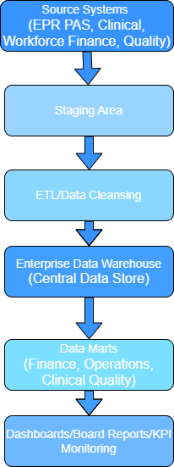
Figure 1.

4. Task 1.3 — Data Marts for Management Decision-Making
A data mart is a focused subset of the wider enterprise data warehouse designed to support a specific decision area or leadership role. It draws from the same core, integrated data but presents it in a way that is tailored to the needs of a particular audience. By narrowing the scope, a data mart reduces complexity, provides quicker access to relevant measures, and ensures leaders see the information most aligned to their responsibilities without navigating the full warehouse.
The Chief Executive would require a system-wide performance mart focused on operational visibility and strategic oversight. This view would bring together waiting-time trends, elective backlog levels, bed occupancy, regional variation in performance, and indicators of patient flow bottlenecks. It would allow the CEO to compare performance across NHS regions and service settings, identify emerging pressures, and assess whether improvement initiatives are having the intended impact. The emphasis is on cross-system insight and long-term trends that support strategic decision-making.
The Finance Director would need a mart centred on financial control, efficiency, and resource use. This would include budget-versus-actual reporting, cost per treatment or episode, tariff income, overtime and agency spend, and financial variance by region or service line. Such a mart supports decisions about cost containment, investment prioritisation, and productivity improvement. It enables finance leaders to quickly understand where resources are being used effectively and where corrective action may be required.
The Medical Director would require a clinical quality mart that links activity with outcomes and safety indicators. This would include readmissions, mortality indicators, patient safety incidents, theatre utilisation, clinical outcomes, and, where appropriate, patient satisfaction measures. The purpose is to support decisions about clinical governance, quality improvement, and patient safety. It provides a consolidated view of how clinical activity translates into outcomes and where risks or variation may exist.
These marts should not be isolated silos, but tailored views built from one integrated warehouse. Shared dimensions and consistent definitions ensure that all leaders are working from the same “single version of truth,” even though their decision needs differ. This approach delivers faster reporting, clearer accountability, and avoids the common pitfall of departments debating conflicting numbers rather than acting on them. A data mart is only effective when its measures are based on agreed definitions. Without this, insight becomes fragmented, and trust in the data erodes.

5) Task 1.4 — OLTP Normalisation vs Dimensional Modelling
Transactional systems commonly use normalised structures to minimise duplication and preserve data integrity during frequent updates [8]. Studies investigating normalisation models confirm that this highly structured approach ensures stability when handling repeated operational choices [6]. In practice, this means information is spread across many linked tables, each holding a very specific piece of data [4]. This design is excellent for ensuring accurate patient records, efficient appointment booking, and reliable updates to operational systems [5].
However, because the data is highly fragmented, it is not ideal for complex reporting or strategic analysis. Executives often find that answering seemingly simple questions requires navigating multiple interconnected tables, making analysis slow and resource-intensive [7]. By contrast, guided by established frameworks like the Kimball methodology, data warehouses use dimensional models because they are designed for analysis rather than day-to-day transaction processing [12], [13]. In a dimensional model, a central fact table stores measurable events such as admissions, procedures, or waiting-time milestones while surrounding dimension tables hold descriptive categories like patient demographics, hospital sites, diagnoses, or time periods [1]. This structure is far easier to query, supports rapid aggregation, and is purpose-built for management reporting, trend analysis, and performance oversight [3].
Recent proceedings from the IEEE International Conference on Healthcare Informatics and the IEEE Journal of Biomedical and Health Informatics validate the application of these data warehouse architectures directly within clinical and medical computing systems [14], [15]. For NHS England, a patient activity star schema could support analysis of admissions, procedures, waiting times and cost across different contexts [17]. The central FactPatientActivity table would capture activity counts, timestamps, and cost measures. Surrounding dimensions would include Time, Patient, Location, Diagnosis, Procedure, Service, and Staff/Consultant. Together, these create a clear, intuitive model that reflects how leaders think about operational performance.
This modelling approach, illustrated in Figure 2 below, allows leaders to analyse the same activity from multiple perspectives without navigating a highly complex operational database structure [16]. It enables reporting by month, hospital, region, diagnosis, service type, or pathway cost, giving senior teams a consistent and reliable foundation for decision-making. Neither model is inherently “better” overall, as the OLTP design is suited for frontline operations while the dimensional design is tailored for analytics and reporting [7], [9].

NHS England Patient Activity Star Schema
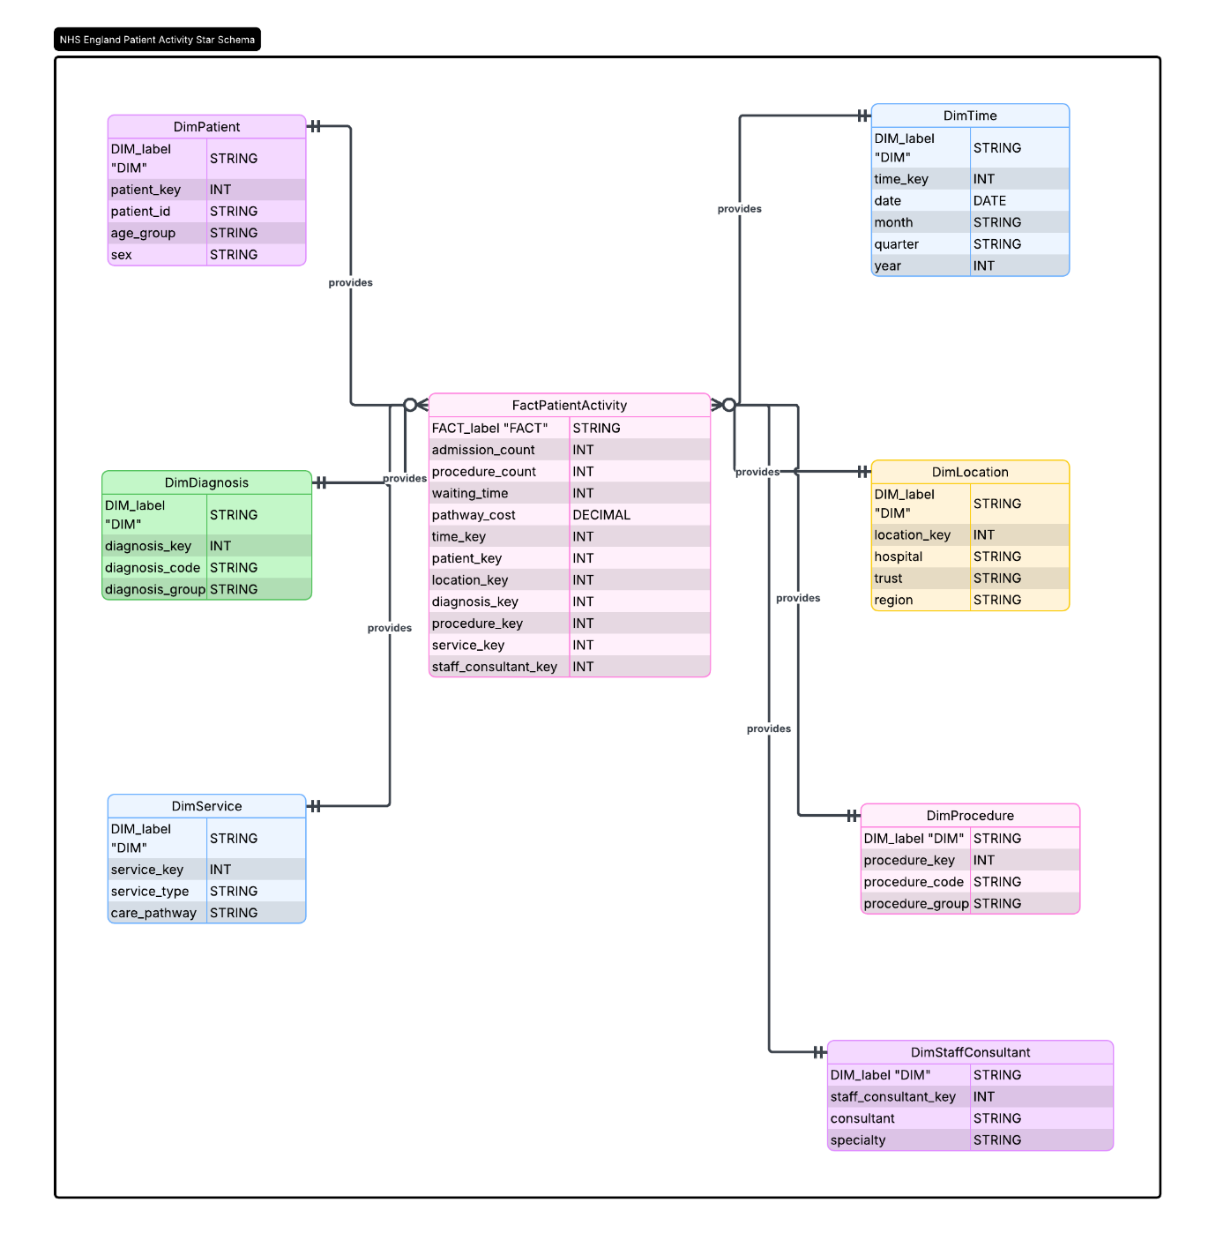
Figure 2.

6) Task 2.1 — Source System Identification
The proposed warehouse would combine both internal operational systems and selected external reference datasets to create a complete analytical view. Bringing these sources together ensures that activity, cost, quality and workforce information can be interpreted consistently and compared against national standards.
Internal sources would include EPR systems for patient records and clinical details, PAS for admissions, discharges and appointments, and clinical and diagnostic systems capturing tests, procedures and treatment activity. Operational insight would come from bed and ward management systems, while workforce and rostering systems provide information on staff availability, overtime and sickness. Finance systems supply budgets, spend, tariffs and costs, and quality/performance systems contribute data on incidents, readmissions, outcomes and patient satisfaction.
External sources remain straightforward but essential. These include ICD-10 and other coding standards, national tariff and reference cost information, public health and demographic datasets, and national targets or regulatory reporting definitions. These external datasets ensure that activity is coded consistently, comparisons are meaningful, and reporting aligns with national expectations.
The key point is that external sources do not complicate the warehouse; they simply provide the standards and benchmarks needed to interpret NHS operational data reliably.

7) Task 2.2 — Star Schema Design
A well-structured warehouse design for NHS England should incorporate multiple conformed star schemas rather than relying on a single, large model. This approach acknowledges that different data types, namely operational, workforce, finance, and quality metrics, are inherently measured in distinct ways. Simultaneously, it enables leadership to perform meaningful comparisons across these areas through shared dimensions such as time, organisation, location, patient cohort, and service line. At the foundation of this design should be a core schema centred on Patient Activity. The primary fact table, referred to as FactPatientActivity, illustrated in Figure 3 below, would be organised around individual patient episodes or attendances, tailored to specific reporting needs. Key metrics captured would encompass admissions, discharges, length of stay, waiting days, procedures performed, associated costs, readmission flags, and pathway milestones. Conformed dimensions integral to this schema would include DimPatient, DimTime, DimLocation, DimService, DimDiagnosis, DimProcedure, DimStaffConsultant, and DimReferralSource. This structured star schema not only facilitates effective demand forecasting and management of elective backlogs but also enhances patient flow analysis and allows for comparative assessments of regional activity. Through this framework, NHS leaders can derive actionable insights that drive operational efficiency and improve the quality of patient care.
NHS FactPatientActivity Schema
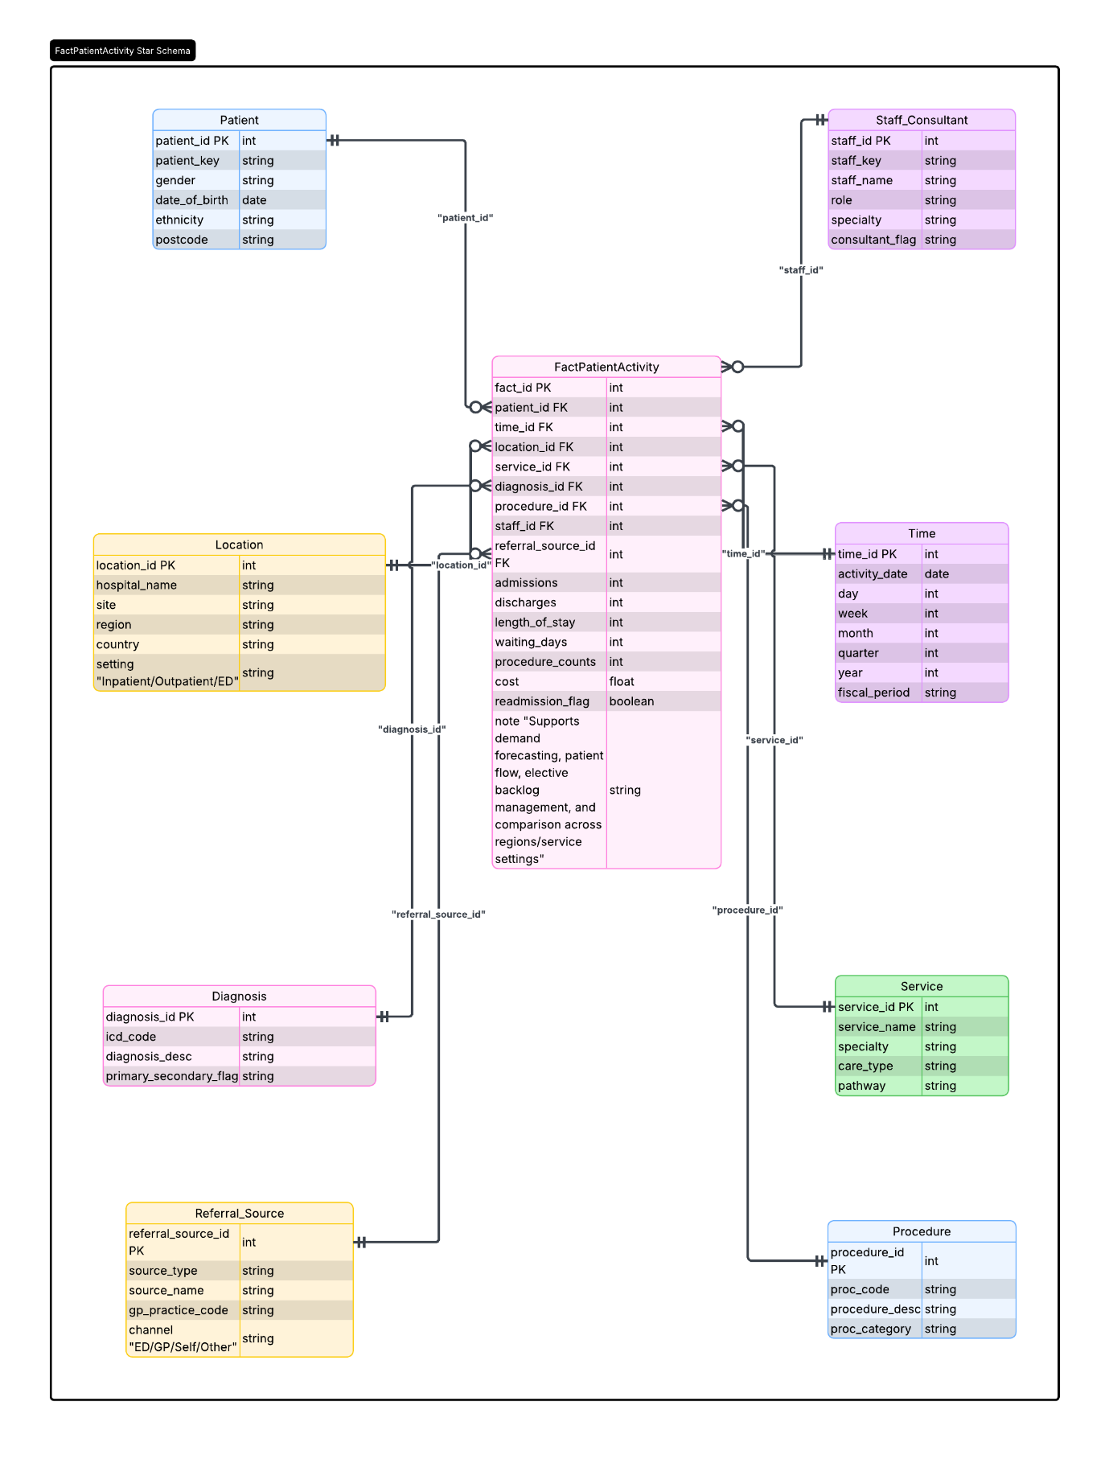
Figure 3.
A second star schema should represent Workforce Utilisation as shown in Figure 4 below. The central fact table, FactWorkforceUtilisation, will document individual staff shifts, roster periods, or contract periods, capturing metrics such as hours worked, overtime, sick days, agency usage, and shift counts. The dimensions will include DimStaff, DimRole, DimDepartment, DimTime, and DimLocation. This schema enables leadership to evaluate rota pressure, identify staffing shortages, monitor agency reliance, and analyse variations in workforce capacity across different sites and specialities.
NHS FactWorkforceUtilisation Schema
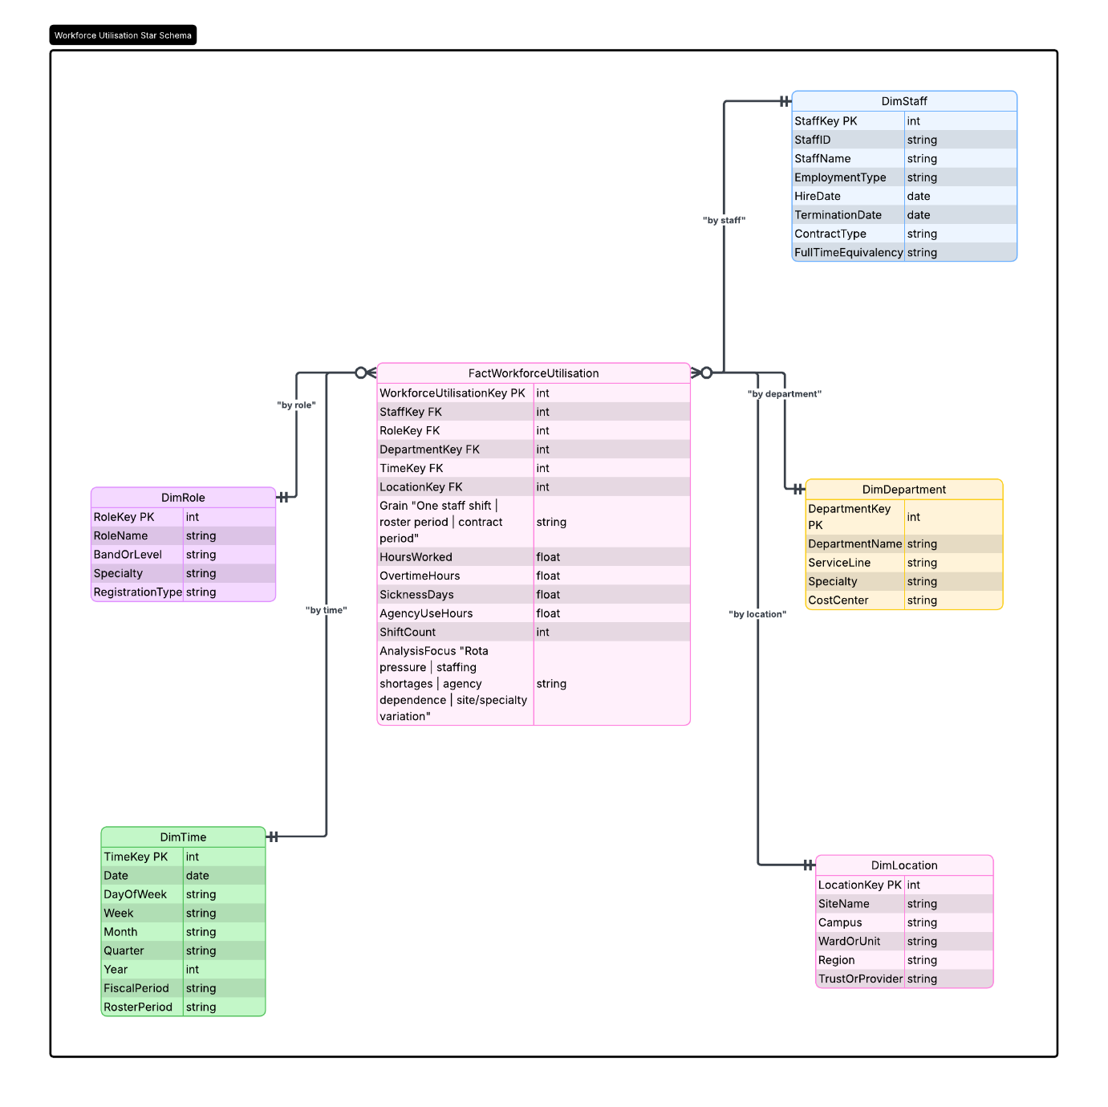
Figure 4.
A third star should focus on Finance Performance as illustrated in Figure 5 below. The FactFinancePerformance table will contain financial data at either a monthly or transactional level, with key metrics such as budget, actual spending, variance, tariff income, cost per episode, and staffing costs. The associated dimensions will include DimTime, DimOrganisation, DimLocation, DimService, DimCostCategory, and DimFundingSource. This structure supports budget control, service-line efficiency, trust-to-trust comparisons, and sustainability planning.
NHS FactFinancePerformance Schema
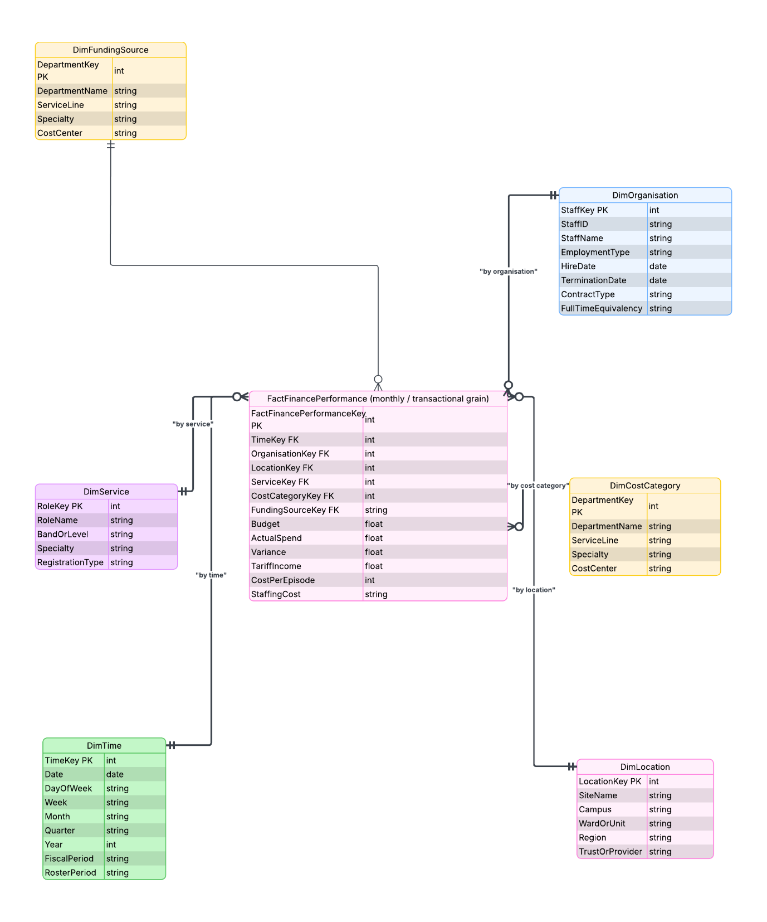
Figure 5.
A fourth star, as shown below in Figure 6, should represent Quality and Performance. The FactQualityUtilization should include metrics such as readmission rates, mortality indicators, incident counts, RTT breaches, waiting list measures, and satisfaction scores. The dimensions involved would be DimTime, DimLocation, DimStaff, DimDepartment, and DimLocation. This framework facilitates target tracking, quality monitoring, and outcome-based decision-making.
NHS FactQualityUtilisation Schema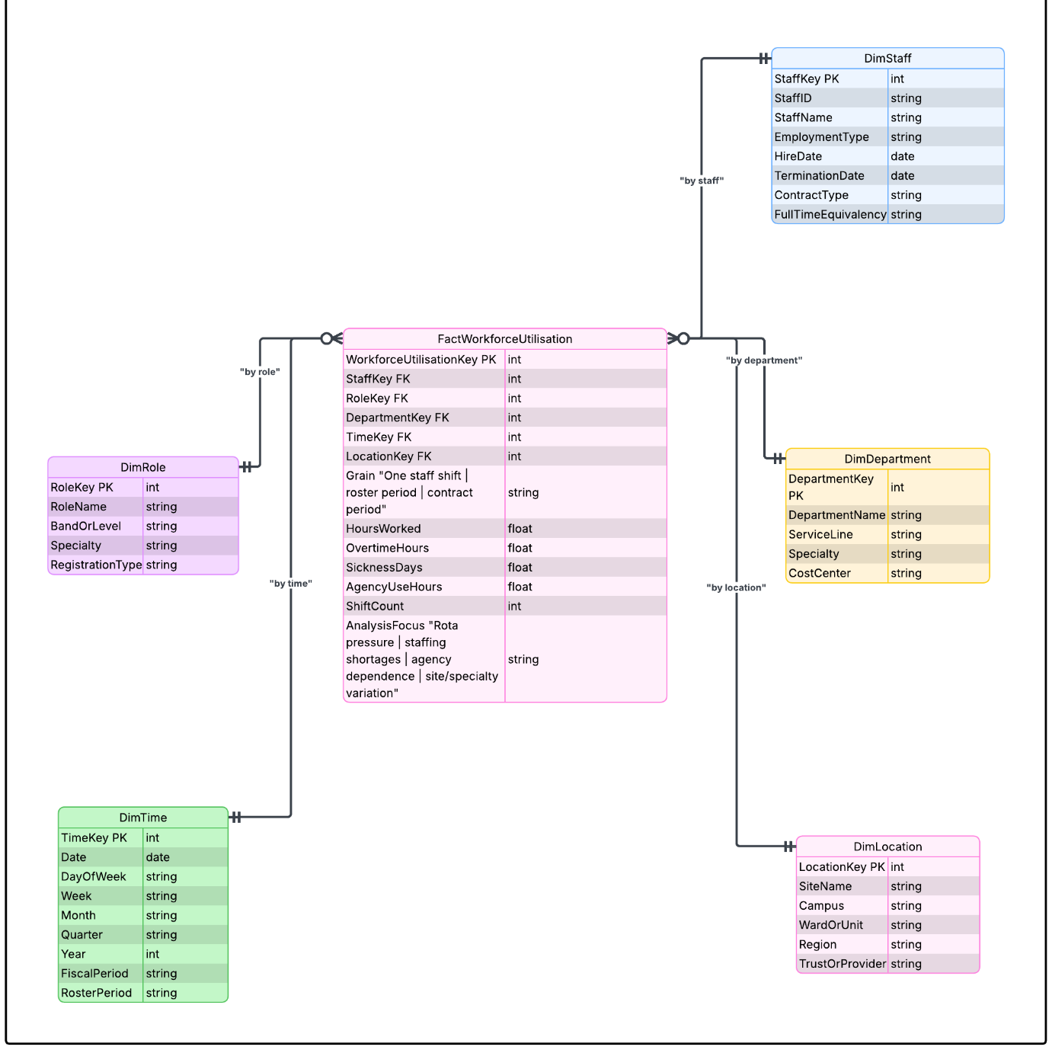
Figure 6.
To effectively support the warehouse, it is essential to include master data tables for key entities such as patients, staff, sites, and services. Additionally, metadata tables should be included for KPI definitions, service categories, diagnosis or procedure reference data, and business rules.
Aggregate tables should be created for efficient executive reporting, covering areas such as monthly occupancy, monthly RTT (Referral to Treatment) performance, monthly costs by service line, monthly readmission rates, and monthly staffing gaps.
For NHS England, this design strikes a clear balance: each star schema is simple enough for specific business areas, while the conformed dimensions ensure consistency throughout the system, as illustrated in Figure 7 below. This allows leaders to quickly answer local questions and compare performance across regions, trusts, and service types, using a single, trusted version of the truth.
Table version of the NHS Star Schema Design
Category | Main Table | What it supports
Facts | FactPatientActivity, FactWorkforceUtilisation, FactFinancePerformance, FactQualityPerformance | Core operational analysis across care delivery, staffing, finance and quality
Dimensions | DimTime, DimLocation, DimService, DimPatient, DimStaff, DimRole, DimDiagnosis, DimProcedure, DimReferralSource, DimCostCategory, DimFundingSource, DimPatientCohort, DimQualityMetric, DimIncidentType | Consistent reporting and comparison across regions, services and time
Master data | Patient, staff, site, service type | Trusted reference records for key NHS entities
Metadata | KPI definitions, business rules, diagnosis/procedure reference data, service categories | Shared meaning and standard definitions for reporting
Aggregates | Monthly occupancy, RTT rates, cost by service line, readmission rates, staffing gaps | Fast executive reporting and trend analysis
Figure 7

8) Task 2.3 — Data Marts and Schema
To make the NHS warehouse usable for different departments, its integrated data should be presented through focused data marts aligned to operational and management priorities. Each mart provides a simplified, role-specific view of the underlying warehouse, reducing complexity while keeping all teams aligned to the same definitions and measures.
An operations mart would combine patient activity and workforce utilisation data to support demand and capacity management. It would draw on facts such as admissions, discharges, length of stay, bed occupancy, delays, hours worked and staffing pressure. Shared dimensions time, location, service, staff and patient ensure that operational leaders can analyse flow, identify bottlenecks, and assess whether staffing levels match demand across wards, departments or regions.
A finance mart would primarily draw on the finance performance schema, supplemented by selected activity measures to support cost-per-episode and efficiency analysis. It would include budget, spend, variance, staffing cost and service-line financial performance, structured around dimensions such as time, location and service. This enables finance teams to monitor budget adherence, understand cost drivers, and compare financial efficiency across trusts or service lines.
A clinical quality mart would combine quality indicators with selected patient activity measures to support safety and outcome monitoring. It would include readmissions, incidents, mortality indicators, patient satisfaction and outcome metrics, linked to dimensions such as time, location, service and patient cohort. This helps clinical leaders track variation, identify risks, and intervene where quality or safety concerns emerge.
Although these marts serve different departments, they should share common dimensions so that performance can be compared consistently across time, service and geography. A mart only adds value if it reduces complexity without changing meaning; if each mart calculates KPIs differently, trust in the warehouse collapses and decision-making becomes fragmented.

9) Task 2.4 — ETL Plan
The ETL plan should align each major warehouse table with its source systems and necessary transformations as illustrated in Figure 8 below. Data will be extracted from NHS operational systems, including EPR, PAS, clinical, workforce, finance, and quality systems. Patient data from EPR/PAS will be validated, deduplicated, and standardised. Clinical data will utilise standard codes for mapping diagnoses, procedures, and services. Workforce data will be standardised for roles, departments, and records of shifts and sickness. Finance data will categorise costs, tariffs, and service lines for budget analysis. Quality data will encompass readmissions, mortality, incidents, and satisfaction measures. Clean data will load into various tables for reporting. This ETL process is crucial for turning inconsistent records into reliable management information, impacting insights on patient care and financial performance.
Compact ETL Plan Table
Warehouse Table | NHS source system | Main transformations
DimPatient | EPR, PAS | Validate NHS number, remove duplicates, standardise demographics, pseudonymise sensitive identifiers
DimStaff | Workforce, HR, rostering systems | Standardise role names, map staff to department and location
DimDiagnosis | Clinical systems | Standardise ICD-10 codes and diagnosis descriptions
DimProcedure | Clinical/procedure systems | Standardise procedure codes and categories
FactPatientActivity | EPR, PAS, clinical systems | Calculate length of stay, waiting days, readmission flags and treatment activity
FactWorkforceUtilisation | Rostering, HR, payroll systems | Calculate worked hours, overtime, sickness absence and agency usage
FactFinancePerformance | Finance systems, tariff data | Calculate budget variance, cost per episode and monthly expenditure
FactQualityPerformance | Quality, incident and outcome systems | Classify incidents, calculate readmission rates, mortality indicators and satisfaction measures
AggMonthlyOperationalPerformance | Patient, operational and workforce systems | Aggregate monthly admissions, occupancy, RTT breaches and staffing pressure
AggMonthlyFinancePerformance | Finance systems | Aggregate monthly budget, spend, variance and cost per episode
AggMonthlyQualityPerformance | Quality and outcome systems | Aggregate monthly readmissions, incidents, mortality and satisfaction scores
Figure 8.

10) Task 2.5 — Data Quality & Governance
Effective warehouse operations are vital for informed decision-making within NHS England. Strong data quality measures throughout the Extract, Transform, Load (ETL) process are essential to ensure accurate insights for clinical care and financial management.
To achieve reliable information, we must implement Master Data Management (MDM) to eliminate duplicate patient records and standardise clinical coding. Assigning data owners for different areas will establish accountability and help resolve discrepancies across departments.
Protecting patient confidentiality is equally important. Our data warehouse must comply with the NHS Data Security and Protection Toolkit (DSPT) and adhere to Caldicott Guardian principles. This includes strict access controls and data anonymisation to ensure staff access sensitive information only when necessary. Finally, clear data records will provide leadership with the transparency needed to trust our strategic insights.

11) Conclusion
NHS England’s fragmented operational systems hinder its ability to achieve a unified view of performance across services and regions. With patient activity, workforce information, financial data, and quality indicators stored separately, leaders find it challenging to identify pressures, risks, and opportunities, complicating strategic planning and response to challenges. A data warehouse, supported by robust ETL processes and role-specific data marts, offers a scalable solution by integrating core operational data into a consistent structure. This provides focused views tailored to the needs of executives, finance teams, operational managers, and clinical leaders, reducing complexity and aligning definitions. By merging patient, workforce, financial, and quality data, NHS England could enhance operational efficiency, resource planning, and patient care outcomes, allowing leaders to gain quicker insights and more confidence in decision-making. However, the effectiveness of the warehouse relies on strong data quality, governance, and thoughtful design; without these, even the best solutions cannot ensure reliable insights.

References
[1] | T. C. Hammergren and A. R. Simon, Data Warehousing for Dummies, 2nd ed. Wiley Publishing Inc, 2009, pp. 1–351.
[2] | J. Kraynak and D. Baum, Cloud Data Warehousing for Dummies, 2nd Snowflake Special Edition (Custom). For Dummies, 2019.
[3] | S. Ramesh, D. Delen, and E. Turban, Business Intelligence, Análise De Dados, Ciência De Dados E IA. Bookman Editora, 2025.
[4] | Rajiv Parida, Principles & Implementation of Datawarehousing. Firewall Media, 2008.
[5] | K.-S. Lee, M. An, and S.-W. Lee, “Addressing Write-Warm Pages in OLTP Workloads,” Journal of KIISE, vol. 50, no. 11, pp. 1002–1007, Nov. 2023, doi: 10.5626/jok.2023.50.11.1002.
[6] | A. Chernulich, “Modelling Reference Dependence for Repeated Choices: A Horse Race between Models of Normalisation,” Journal of Economic Psychology, vol. 87, p. 102429, Dec. 2021, doi: 10.1016/j.joep.2021.102429.
[7] | S. Rachapudi, “Holistic Data Management: Integrating OLTP and OLAP in Financial Systems,” International Journal of Science and Research (IJSR), vol. 13, no. 10, pp. 1115–1118, Oct. 2024, doi: 10.21275/sr241015110206.
[8] | X. Zhang, J. Lee, and W. W. Bin Goh, “An Investigation of How Normalisation and Local Modelling Techniques Confound Machine Learning Performance in a Mental Health Study,” SSRN Electronic Journal, 2022, doi: 10.2139/ssrn.4006226.
[9] | “Data Lake Vs. Data Warehouse: Choosing the Right Architecture,” International Journal of Artificial Intelligence, Data Science, and Machine Learning, vol. 4, 2023, doi: 10.63282/3050-9262.ijaidsml-v4i4p107.
[10] | D. Golec, I. Strugar, and D. Belak, “The Benefits of Enterprise Data Warehouse Implementation in Cloud Vs. On-premises,” ENTRENOVA - ENTerprise REsearch InNOVAtion, vol. 7, no. 1, pp. 66–74, Sept. 2021, doi: 10.54820/dmzs9230.
[11] | Robbia Gulnar, “Traditional Vs Cloud Data Warehouse – Comparative Analysis & Survey Paper,” Journal of Computing and Artificial Intelligence, vol. 1, no. 1, May 2023, doi: 10.69591/jcai.v1i1.10.
[12] | R. Kimball, “The Data Webhouse Toolkit: Building the Web‐enabled Data Warehouse,” Industrial Management & Data Systems, vol. 100, no. 8, pp. 406–408, Nov. 2000, doi: 10.1108/imds.2000.100.8.406.1.
[13] | A. Ratu, L. Kusneti, and A. Wijaya, “Prototype Data Warehouse Kantor Penilai Publik XYZ Dengan Metode Nine-Step Kimball,” Journal of Informatics and Business, vol. 1, no. 2, pp. 89–96, Dec. 2023, doi: 10.47233/jibs.v1i3.372.
[14] “IEEE Journal of Biomedical and Health Informatics,” IEEE Journal of Biomedical and Health Informatics, vol. 26, no. 5, pp. C2–C2, Sept. 2022, doi: 10.1109/JBHI.2022.3170118.
[15] 2024 IEEE 12th International Conference on Healthcare Informatics (ICHI). Piscataway, NJ: IEEE Computer Society, 2024.
[16] 2023 IEEE 22nd International Conference on Trust, Security and Privacy in Computing and Communications (TrustCom). Piscataway, NJ: IEEE Computer Society, 2023. doi: 10.1109/TrustCom60117.2023.
[17] Shen, “2022 IEEE 35th International Symposium on Computer-Based Medical Systems (CBMS) /,” Piscataway, NJ: IEEE, 2022. doi: 10.1109/CMBS55023.2022.

