

Task 1 – Reading Task Template
Upload your photo of your A3 in-class notes here:
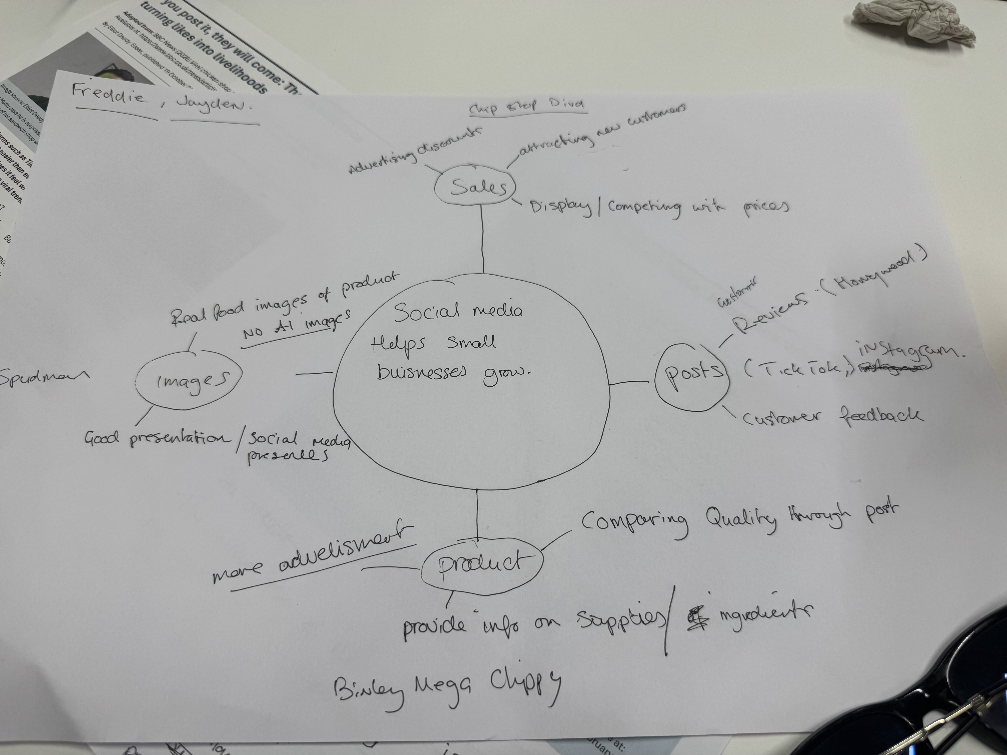

This is a screenshot of a brain tree.

1. Answer these questions using the sentence starters below

a. What is the main idea of the text?
The main idea is that social media posts can help small businesses grow.

b. What are two key points?
One key point is food presentation in posts. Real images of your product showing quality and good presentation.
Another key point is sales. You can increase profits and attract new customers by offering deals to customers through social media posts. Also you can post good customer reviews and feedback for other potential buyers to see.

c. What part of the text did you find most important? Why?
The most important part is understanding how much social media can help small businesses. This is because it will help me to break down information from social media posts and analyse it correctly.

d. Was anything unclear or difficult to understand?
No it was easy to understand.

e. How did your group help you understand the text better?
My group helped me by sharing opinions and suggestions.

3. One sentence reflection
I have found this course very satisfying so far and I hope this feeling continues.

Question: What did you find challenging about this task?
The hardest part was taking the time to word my sentences correctly.

