AI Declaration:
I acknowledge the use of [ChatGPT] (https://chatgpt.com/) on 16/02/2025 as a guide to structure my Sway Blogs. I used the following prompts:
- Give me a structure for a 1000 word blog focusing on development with the title: Growth vs. fixed mindset: The Impact on Emotional Development in Children.
- Give me a structure for a 1000 word blog focusing on development with the title: Is Unstructured Outdoor Play crucial for child Cognitive Development?

- Give me a structure for a 1000 word blog focusing on development with the title: The Impact of Stress on Development.

I can confirm that I have not presented any AI generated texts as my own work. I confirm I have copies of my drafts, notes, and other resources I used before, and after the use of AI tools which I may be asked to provide in evidence.

https://sway.cloud.microsoft/9CSNR047JEAzq8b2?ref=Link



Growth vs. Fixed Mindset: The Impact on Emotional Development in Children
What if we viewed children’s mistakes as opportunities to grow rather than failure? Emotional development crucial for a child’s well-being, influencing social interactions, and their ability to deal with adversity and resilience. According to the National Centre for Safe and Supportive Learning Environments, “strong emotional development leads to five main key skills: social and self-awareness, emotional regulation, responsible decision making, and relationship building”. All of which are vital developmental aspects of a child’s life. The notion of Growth and Fixed Mindsets were first introduced by Carol Dweck, these ideas provide insights into how children’s perceptions of their own abilities can impact their emotional development.
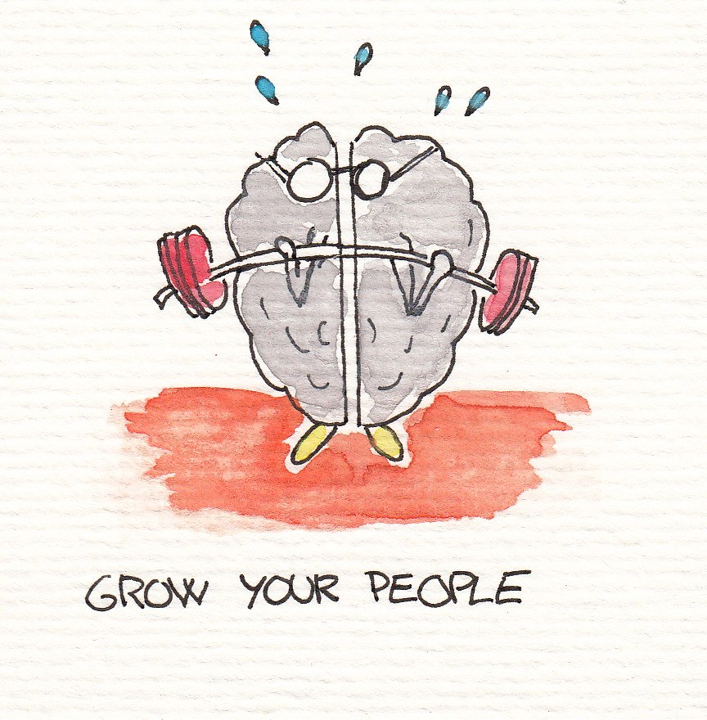
1 - Understanding Growth and Fixed Mindsets
The concept of a ‘growth mindset’ is highly valued, especially in academia. Children with a growth mindset are often believed to be more willing to improve. Subsequently, those with a fixed mindset, are limited by their self-belief. Yes, the growth mindset is generally seen as ‘good’ while the ‘fixed’ mindset is considered ‘bad’ but what exactly does this mean? Carol Dweck’s research shows that “individuals who believe their talents can be developed have a growth mindset” (Dweck, 2016), leading them to to putting more effort into learning. Whereas those with a fixed mindset, who believe intelligence is innate, often struggle with resilience and fear of failure. “Individuals with fixed mindsets believe intelligence is something we are born with” This means that when adversity hits, these individuals see this as a ‘fail’ and are “less likely to try something new in the future” (Lawrence, 2017).
The Impact on Emotional Development
The mindset in which a child adopts has a huge impact on their emotional development, especially when it comes to dealing with their emotions.

Resilience and Coping Mechanisms
We all have different ways with dealing with our emotions and situations around us, but how does this benefit/limit our emotional development? If a child has a growth mindset, they are more likely to develop greater emotional resilience. The environment in which we grow up tend to affect our emotional response. “When children are surrounded by supportive environments, they learn positive coping mechanisms” Yates and Shillington (2024), this supports their emotional wellbeing.

Self-Esteem and Motivation
As we have discussed; a child’s mindset has a significant impact on their emotional wellbeing, but mindset also influences self-esteem. “Having a growth mindset can help us try new things” (Sunflower Empowerment, 2023) this personal effort fosters positive self-image. I am sure this is evident in many of our lives. This makes me think about the phrase “do it scared” even if fear is holding back, change your mindset and just do it. I have tried this over the last couple of months and I feel I have now adopted a growth mindset
However, children with a fixed mindset are likely to create a sort of external validation; if they succeed, they are happy, if they fail, they feel ‘worthless’. This creates an intrinsic environment where they only focus on tasks, they know they can succeed in.
Theoretical Frameworks
There are many theoretical frameworks in child development which support the notion of growth and fixed mindsets.

Vygotsky’s Zone of Proximal Development Theory
“The idea of his theory is that children learn best when they are challenged” (Sprouts, 2021). A growth mindset aligns well with Vygotsky’s theory as it emphasises the importance of effort of the individual, as well as the right support. “As a child’s competence grows, their zone of proximal development also expands to encompass new challenges” (McLeod, 2024). When children are in their ZPD they can push themselves beyond their current capabilities, and thus, can develop new skills. On the other hand, a fixed mindset limits an individual’s ability to complete tasks in their ZPD as they are ‘too afraid of failure’, this can cause children to give up easily because of their “innate” fear of failure; limiting their opportunities for growth.

Eriksons Psychosocial Development Theory
Cherry (2024) discusses that “Erikson was interested in how social interaction and relationships played a role in the development and growth of human beings”. The outcome of each of these stages illustrates how an individual deals with adversity. A growth mindset is sought after in this sense, helping with the challenge, whereas a fixed mindset will likely hinder the development and may lead to feelings of discouragement or stress for the child.

Relevant Legislation and Its Impact
Various pieces of legislation and legal framework guid practitioners who work with children to ensure emotional development is nurtured. In the UK, the Individuals with Disabilities Education Act 2001 is a law which ensures all education practitioners “make reasonable adjustments to make sure disabled students are not discriminated against” (UK Government, date: unknown). With education that is tailored to a child’s individual emotional needs, they can grow, naturally, in a way that supports them. In these environments, where children are supported in developing resilience, a growth mindset comes naturally.
The Early Years Foundation Stage (EYFS) statutory framework also highlights the importance of emotional development in the early years of a child’s life. This framework outlines “the standard that school and childcare providers must meet for the learning, development and care of children from birth to 5” (UK Government, 2024). It ensures children are given opportunities to develop emotional resilience through play. Practitioners are encouraged to foster a growth mindset in children by providing positive reinforcement to celebrate children’s efforts.
Barriers and Challenges to Emotional Development
Whilst the growth mindset has numerous benefits, several barriers can hinder a child’s emotional development. Socioeconomic factors play a significant role in emotional development. “The impact of low socioeconomic status on emotional well-being is substantial” (NIH, 2020). Children who are brought up in these environments may develop a mixed mindset, believing that their circumstances limit their potential. Cultural factors may also influence emotional development
Cultural Factors may also influence emotional development. For many, the stereotypes of certain cultures may lead to individuals believing “they cannot succeed even with great effort” (NIH, 2023), this strains from them developing a fixed mindset because of the stereotypes.
Parental Attitudes play a huge role in children’s mindset in general. Parents are primary caregivers for their children, they “play an important role in shaping the children’s early lives and the development of their selfhood structure” (Kolburan et al., p.2), Parents who focus more on achievement than effort, accidentally reinforce a fixed mindset, even if this was not the aim.

The Role of Practitioners
Practitioners play a crucial role in a child’s emotional development. While not the child’s primary caregiver, their influence is significant. Teachers, for example, shape children’s mindsets; by creating a supportive learning environment they are single-handedly fostering an environment where a child can develop their mindset in a positive and rational way. According to Selby (2024) “teachers also provide emotional support, helping children understand and manage their feelings. This emotional intelligence is vital for personal growth and mental health”. I can relate to this personally. Growing up, I often struggled to understand my full potential, frequenting the phrase “I can’t”. I genuinely believed that my academic abilities were capped at a certain point. However, my teachers helped me recognise this as a ‘fixed mindset’ and encouraged me to adopt a ‘growth mindset’. Though challenging, their support helped me build self-belief and resilience. Over time, I have nearly eradicated the word ‘can’t’ from my vocabulary, embracing a more positive, growth mindset. This highlights the crucial role teachers play in both education and emotional development in children.
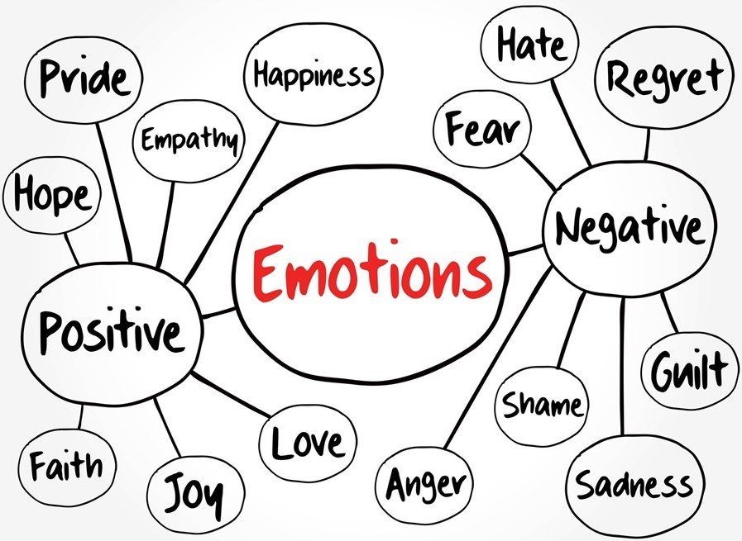
2 - In summary, understanding and nurturing a child’s emotional development through the lens of growth mindset is crucial in fostering resilience and a positive outlook. Practitioners, specifically teachers play a pivotal role in shaping these children’s mindsets but also emotional well-being and development.
References
Cherry, K, (2024) Eriksons Stages of Development. Available: https://www.verywellmind.com/erik-eriksons-stages-of-psychosocial-development-2795740#:~:text=Erikson%20was%20interested%20in%20how,context%20of%20a%20larger%20community (Accessed: 22 February 2025)

Kolburan, G., Comert, I.T., Narter, M. and Isozen, H. (2012) Parental attitude perception in adolescents by gender. Elsevier Ltd.

Lawrence, B. (2017) Resilience and the Growth Mindset. Available at: https://www.in-equilibrium.co.uk/resilience-and-the-growth-mindset/ (Accessed: 18 February 2025).

McLeod, S. (2024) Vygotsky’s Zone Of Proximal Development. Available at: https://www.simplypsychology.org/zone-of-proximal-development.html (Accessed: 22 February 2025)

Meinke, H. (2019) Understanding the Stages of Emotional Development in Children. Available at: https://www.rasmussen.edu/degrees/education/blog/stages-of-emotional-development/#:~:text=According%20to%20the%20National%20Center,decision%20making%20and%20relationship%20building (Accessed: 19 February 2025)

NIH. (2020) The affective neuroscience of socioeconomic status: implications for mental health. Available at: https://pmc.ncbi.nlm.nih.gov/articles/PMC7525591/#:~:text=Low%20socioeconomic%20status%20(SES)%20is,particularly%20mood%20and%20anxiety%20disorders.&text=Life's%20challenges%20weigh%20more%20heavily,emotional%20well%2Dbeing%20is%20substantial (Accessed: 14 February 2025)

Selby, J. (2024) The Vital Role of Teachers in Early Childhood Development. Available at: https://ooh-box.co.uk/blogs/news/the-vital-role-of-teachers-in-early-childhood-development#:~:text=Teachers%20also%20provide%20emotional%20support,personal%20growth%20and%20mental%20health.&text=Teachers%20empower%20children%20to%20become%20confident%20and%20independent%20learners (Accessed: 15 February 2025)

Sprouts. (2021) Vygotsky’s Theory of Cognitive Development in Social Relationships. Available at: https://www.youtube.com/watch?v=8I2hrSRbmHE (Accessed: 15 February 2025)

UK Government. (date: unknown) Disability rights. Available at: https://www.gov.uk/rights-disabled-person/education-rights#:~:text=An%20education%20provider%20has%20a,like%20specialist%20teachers%20or%20equipment (Accessed: 22 February 2025)

UK Government. (2014) Early years foundation stage (EYFS) statutory framework. Available at: https://www.gov.uk/government/publications/early-years-foundation-stage-framework--2 (Accessed: 17 February 2025)

Yates, J and Shillington, K. (2024) The upside of adversity: Children learn resilience from coping with difficulties. Available at: https://theconversation.com/the-upside-of-adversity-children-learn-resilience-from-coping-with-difficulties-241754#:~:text=and%20stress%20hormones.-,When%20children%20are%20surrounded%20by%20supportive%20environments%2C%20they%20can%20learn,should%20not%20always%20be%20avoided (Accessed: 15 February 2025)

Is Unstructured Outdoor Play crucial for child Cognitive Development?

Outdoor play…. simple right? The thought of outdoor play for children comes naturally to many parents, and practitioners. Yes, it is great to allow children some outdoor time in the day, but what are the cognitive benefits? Outdoor play helps children engage in activities which aid cognitive development. According to the Pilgrims School (2024) “playing with natural materials such as sand, water and sticks stimulates creativity and imagination”.
What is Unstructured Outdoor Play?
Unstructured play is defined by the Playground Centre (date: unknown) as “creative and improvised with no set goal and unlimited possibilities. It is a way in which children can express themselves through play. Outdoor play comes in two different forms: structured and unstructured. Both being central to a child’s wellbeing. According to Sundquist (2020) “when children engage in unstructured play, their play is motivated by their own desires and curiosity and guided by their own mental rules”. Outdoor play not only benefits children, but also adults. Sounds silly? Just think about the time where you were overwhelmed so decided to take a stroll in nature. Being in a natural environment benefits out mental and cognitive wellbeing. Just like children.
Creative play outlines the main types of outdoor play which include “games with rules such as football or netball” (outdoor PE lessons) “Social play: role playing with each other and physical play: should be encouraged by the likes of large areas of hill and grass”.
Cognitive Development in Children
Durrant (date: unknown) describes cognitive development as “the process of building up your toolkit, starting with basic skills (attention, memory and problem solving) …. upgrading tools, you already have”. These cognitive abilities are influenced by the experiences the child has and are developed by unstructured outdoor play. Cognitive development in children is especially important in early years as it refers to the notion of developing their ability to think, learn and problem solve.
How Unstructured Outdoor Play Affects Cognitive Development
Unstructured play offers many cognitive benefits that structured play simply cannot. For example, unstructured outdoor play enhances problem-solving and Critical Thinking. When outdoors, children may be faced with adversity that has to be overcome. They think of creative ways to navigate these challenges, further enhancing cognitive development.

The Role of Nature in Cognitive Development
We are all drawn to nature, there is a belief that “humans are genetically predisposed to be attracted to nature” – the Biophilia Hypothesis (Wilson, 1984). Humans. Love. Nature. It is in their innate disposition. This connection has been shown to benefit brain development, meaning when children play outdoors, in a natural setting, they benefit from the calming effects of nature. Mind and Mood (2019) state that “spending just 20 minutes connecting with nature can help lower stress hormone levels”. See, just being in a green space benefits our mental wellbeing and supports cognitive growth to help stimulate the brain and the body.

Link to Practitioner
Through unstructured outdoor play, children can be primary agents of their own development, however the work of practitioners is needed to help aid them. Practitioners such as parents, teachers and caregivers play a huge role in creating a safe environment to aid ‘unstructured outdoor play’. The Trespass Team (2021) highlights some ways in which parents can “keep their children safe” whilst outdoors, some of which include “dressing appropriately, finding safe places to play, being aware of your surroundings”. Unstructured or structured, it is up to practitioners to ensure children’s safety when participating in outdoor play.
Practitioners also play a part in supporting children’s cognitive development. Teachers, for example, should encourage children to make their own decisions (within reason of course, we do not want any injuries) allowing children to figure things out independently. Parents can foster an environment where creativity is the focus allowing for exploration.
Relevant Framework and Legislation
Unstructured outdoor play is being recognised by many as a crucial part of cognitive development in children. Various frameworks and legislation also encourage outdoor play as an essential part of early development.
The United Nations Convention on the Rights of the Child Article 31 (Holland, 2013) focuses on ensuring that all children have access to rest and leisure and to “engage in play and recreational activities”. This Act recognises children’s need for play and that is crucial for all development, especially cognitive development. The convention encourages independent learning and problem solving. All of which are key aspects of unstructured outdoor play.

The Playwork Principles
This is a framework that guides practitioners working in children’s play, more specifically outdoor play. Some of the key points of this frameworks, highlighted by Play Wales (2005) include “the impulse to play is innate” and “play is intrinsically motivated”. In line with these principles, unstructured outdoor play encourages children to make their own decisions and engage in critical thinking, which all supports their cognitive development.

3 - In conclusion, unstructured play is much more than just a little fun activity for children; it is a crucial part of their cognitive development. Through a means of ‘free play’, their creativity flows and children can shape their ability to think critically and engage with the world around them. Practitioners play a vital role in creating environments that encourage these natural learning opportunities. Let’s continue to embrace the outdoors, with children by our side, watching them thrive through the power of play.
References
Creative play. (date: unknown) Different Types of Outdoor Play. Available at: https://creativeplayuk.com/42555-2/ (Accessed: 19 February 2025)
Durrant, Sam. (date: unknown) Understanding cognitive development: Different stages and Piaget’s theory. Available at: https://www.bbc.co.uk/tiny-happy-people/articles/zwq7ywx#zh8wnk7 (Accessed: 16 February 2025)
Holland, Sally. (2013) Making rights a reality for all children in Wales. Available at: https://www.childcomwales.org.uk/wp-content/uploads/2018/04/Play-FINAL.pdf (Accessed: 19 February 2025)
Mind and Mood. (2019) A 20-minute nature break relieves stress. Available at: https://www.health.harvard.edu/mind-and-mood/a-20-minute-nature-break-relieves-stress (Accessed: 23 February 2025)
Pilgrims School. (2024) The Role of Outdoor Play in Cognitive Development for Early Years. Available at: https://www.pilgrims-school.info/the-role-of-outdoor-play-in-cognitive-development-for-early-years/#:~:text=Playing%20with%20natural%20materials%20such,unpredictable%20environments%20and%20overcome%20challenges (Accessed: 20 February 2025)
Playground centre. (date: unknown) Unstructured vs structured play. Available at: https://www.playgroundcentre.com/unstructured-vs-structured-play/#:~:text=What%20is%20unstructured%20play%3F,set%20goal%20and%20unlimited%20possibilities (Accessed: 18 February 2025)
Play Wales. (2005) The Playwork Principles. Available at: https://play.wales/wp-content/uploads/2023/04/The-Playwork-Principles-2023.pdf (Accessed: 15 February 2025)
Sundquist, K. (2020) What Is Unstructured Play? Available at: https://letgrow.org/unstructured-play/ (Accessed: 20 February 2025)
Trespass Team. (2021) Outdoor Safety Tips with Kids. Available at: https://www.trespass.com/advice/outdoor-safety-tips-with-kids/ (Accessed: 18 February 2025)
Wilson, E.O. (1984) Biophilia. Available at: https://www.terramai.com/blog/understanding-biophilia-hypothesis/#:~:text=The%20biophilia%20hypothesis%20is%20the,%2C%20Biophilia%2C%20published%20in%201984 (Accessed: 16 February 2025)

The Impact of Stress on Social Development

Did you know that chronic stress can impact how children interact with others? Stress is an inevitable part of life. We tend to think of older people, those who are at university for example, when we think of balancing an education and social life, but this is also a huge part of childhood. Pedersen (2022) discusses that “stress can occur anytime a child is required to adapt to something new”.
Understanding Stress and Social Development
In today’s busy life, stress has become an inevitable part of daily life. Stress can strain from academic pressure to personal challenges. Unfortunately, it is a natural response (for many) to difficult situations and can have a profound impact on an individuals mental and social well-being. According to mind (2022) there are two types of stress: “acute and chronic” acute stress happens over a short period of time and “might be very intense” whereas chronic stress is long lasting and “keeps coming back”. Both types can play a huge role not only in self-concept but also can influence behaviour and the way individuals navigate social situations and can affect meaningful relationships. Chronic stress especially can interfere with an individual’s ability to develop healthy social behaviours.

How Stress Affects Children’s Social Development
Stress can have a massive impact on emotional regulation. According to Kinner et al. (2014) “the capacity to regulate emotions is particularly important during and after the encounter of a stressor”. Our ability to deal with stress in a positive way for emotional regulation is key for our well-being. If we have a lack of positive emotional regulation this could create difficulty in building relationships. Children under stress especially may struggle with forming positive relationships due to many things.
“The time around puberty seems to be essential for the acquisition of those social skills needed to adapt to unfamiliar conspecifics in a non-stressful and non-aggressive way” (Sachser et al. 1998, p.894).

Peer Stress and Social Stress
Peer pressure is something we all go through in life but is especially apparent in childhood-adolescent, specifically in school. Peer pressure can cause things such as bullying, “the effects of such behaviours can decrease self-confidence and may distance people from family members” (Freud, 2020). These behaviours can cause immense stress, hindering an individual’s ability to communicate feelings affectively and may make individuals feel anxious and less confident. Peer pressure however does not always have to be a negative thing. Scripps (2024) states that “positive peer pressure can help teens develop the coping skills necessary for adulthood…. and avoid risky behaviours”. Understanding both outcomes of peer pressure is important in supporting social development.
Impact on Social Confidence
Chronic stress from peers can erode confidence, making it harder to engage socially. Another impact of stress is that individuals “may end up having difficulty negotiating smooth interpersonal relationships with others” (mentalhealth, 2024), this obviously makes it extremely difficult to engage socially.

4 - The Role of Practitioners
Stress is such a significant part of so many lives and practitioners such as teachers, parents and social workers play a crucial role in supporting individuals affected by stress. Practitioners such as therapists and social workers are usually where an individual goes if they are feeling overwhelmingly stressed, because of this they must know what strategies to put in place and what is causing such significant discomfort. Teachers also play a significant role in supporting students who are stressed. They can create a supportive classroom environment to promote positive social interaction. I am sure all had a favourite teacher in Primary school, I know I sure did. She was genuinely my favourite part of school (apart from all the learning I did…) and created a comfortable environment for me to express my honest feelings. I remember being specifically stressed about going into junior school, but she calmed me right down, gave me a hot chocolate, and told me it was going to be okay. This little gesture enabled me to regulate my thoughts and realise it was all okay. Teachers are such a monumental part of social development in schools.
Relevant Legislation and legal Framework
The Children Act 1989 “centres on the idea children are best cared for within their own families and every effort should be made to support that” (Elvin, A et al., 2019). This Act emphasises the importance of identifying stressors and overcoming these, minimising the negative impact of stress on their social development.

5 - In summary, stress plays a significant role in shaping social development, especially influencing how people interact with each other and engage with the communities.
References
Elvin, A,. Evans, K., Feuchtwang, A., Jones, R., Thoburn, J., and Willow, C,. (2019) The Children Act 1988: 30 Years On. Available at: https://www.cypnow.co.uk/content/features/the-children-act-1989-30-years-on/#:~:text=The%201989%20Act%20centres%20on,should%20be%20taken%20into%20account (Accessed: 16 February 2025)
Freud, A. (2020) Peer Pressure. Available at: https://www.mentallyhealthyschools.org.uk/factors-that-impact-mental-health/school-based-risk-factors/peer-pressure/#:~:text=Negative%20peer%20pressure%20is%20often,from%20family%20members%20and%20friends (Accessed: 22 February 2025)
Mentalhealth (2024) Stress & Interpersonal Dynamics. Available at: https://www.mentalhealth.com/library/stress-interpersonal-dynamics#:~:text=They%20may%20end%20up%20having,forms%20of%20social%20support%20available (Accessed: 20 February 2025)
Mind. (2022) What is stress? Available at: https://www.mind.org.uk/information-support/types-of-mental-health-problems/stress/what-is-stress/ (Accessed: 15 February 2025)
Pedersen, T (2022) How Does Stress Affect Child Development? Available at: https://psychcentral.com/stress/how-stress-affects-children-how-to-manage-it (Accessed: 13 February 2025)
Kinner, V.L., Het, S. and Wolf, O.T (2014) Emotion regulation: exploring the impact of stress and sex. Germany: Department of Cognitive Psychology.
Scripps. (2024) How Does Peer Pressure Affect a Teens Social Development. Available at : https://www.scripps.org/news_items/4648-how-does-peer-pressure-affect-a-teen-s-social-development#:~:text=Positive%20peer%20pressure%20can%20help,lead%20teens%20in%20bad%20directions (Accessed 23 February 2025)
Sachser, N., Durschlag. And Hirzel, D. (1998) Social Relationships and The Management of Stress. Germany: Elsevier.

