
2023/4
Williams Brett
Tata Steel UK

Process Safety Training Aid Project


Independent Project

Module Code: ACCA6020

Student id: 2215656

Project Supervisor : Dr Stephen Mosey

Electrical & Electronic Engineering Lvl 6

Contents

Introduction 2
Project Design 7
Resources and Planning 8
Glossary 9
Reading List 10

Independent Project Proposal

Process Safety Training Aid & Simulator

Introduction
The project I have selected is going to be based around a bespoke teaching aid and human machine interface (HMI) which will replicate one of the three gas holders on site, the gas holder model will be used to gain a level of understanding and awareness of ‘Process Safety’ predominantly aimed towards team leaders, supervisors and control room operators who are all continuously making on the spot decisions and adjustments to various control systems.
An automated simulation will be investigated and formulated using best practice to ensure conformity with current BS-EN-61508 International Functional Safety Standards for Electronic Control Systems.

Background
The Control Room operator
A pair of control room operators sit in a gas safe room in the centre of the steelmaking site working as part of a 5 shift rota, 24hrs a day, 365 days of the year monitoring and balancing continuous production. Ensuring the plant is balanced and running to within its safe operating limits is a major concern as the assets become old and unreliable. There are multiple remote operating screens simulating the associated process functions, some are graphically illustrated (see fig 1 below) with multiple alarms to prompt operator response. As parts of the plant are well over 70 years old, not everything in the control room is automatic, there are many important decisions made daily that can affect the business’ top line and can result in unplanned incidents.
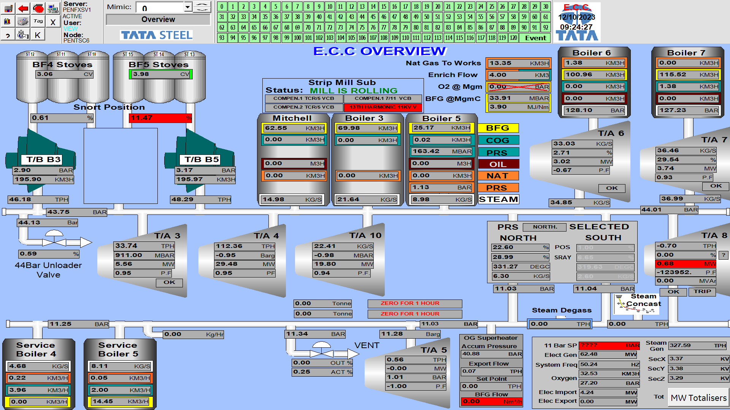
Energy Control Centre asset Overview iFix page (Fig 1)

On-site gasses
Multiple gas imports on to site include Nitrogen, Oxygen, Natural Gas, and large quantities of bi-product gases are produced onsite, these include Blast Furnace Gas (BFG),Coke oven gas (COG) and Basic Oxygen Steelmaking Gas (BOSG). It is the control room operators job to utilise these on-site gases to reduce the natural gas import costs to the business as well as the use of the gases as fuels to produce steam which is used for electrical generation off setting import requirements and their spiralling associated energy costs.
[1]

What is Process Safety?
From my research, the IChemE Safety Centre states that the most common definition of process safety is from the Centre of Chemical Process Safety (CCPS).
They have defined the following 'a disciplined framework for managing the integrity of hazardous operating systems and processes by applying GOOD DESIGN PRINCIPLES, ENGINEERING AND OPERATING PRACTICES. It deals with the prevention and control of incidents that have the potential to release hazardous materials or energy. Such incidents can cause toxic effects, fire or explosion and could ultimately result in serious injuries, property damage, lost production and environmental impacts’,
[2]
We tend to term these incidents on site as Major Accident Hazards or MAH’s or ‘Top Events’.

How did we get here?
Buncefield Dec 10th 2005
An oil Storage depot in Hertfordshire, the largest of its kind in the United Kingdom loses control while filling storage its tanks with liquid fuel. The emergency alarm was activated by an operator and this activated water pumps and also ignited the fuel vapour from the overspilling petroleum causing a huge explosion that could be seen from miles away.
Design
By design the level switch had no back up or voting system and a only a gauge was present on the tank, both were found to be faulty following a lack of suitable maintenance and functional testing.
The bund wall which was designed to hold the entire contents of the liquid storage vessel failed to contain the highly combustible fuel vapours which flowed over the bund wall and into the surrounding area, finding an ignition source. A huge fire ball explosion of ignited fuel and vapour caused the plastic seals between the bund wall sections to melt which caused and uncontrolled release of the remaining liquid fuel.
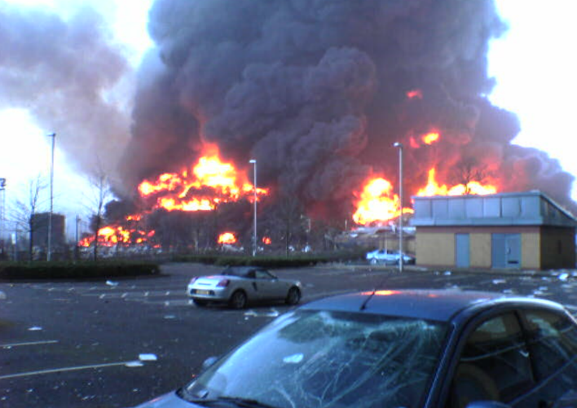
Outcome
Luckily no one was hurt and the outcome of the thorough investigation by the Crown Prosecution Services was to award a £10M Fine, It was here the 3 standard Buncefield questions was founded.
The following three questions are now known worldwide as the basis of process safety and are highly recommended by the Health and Safety Executive HSE.

HSE supported Buncefield questions
- Do we know what can go wrong
- Do we know what barriers are in place to prevent this from happening
- Are the barriers effective and working properly
[3]

Risk
Risk is the LIKELIHOOD of a hazard causing harm
Hazard is something that has the POTENTIAL to harm

Learning from past events
Corus Port Talbot Nov 2001 – 3 steelworkers killed when water penetrated No 5 Blast Furnace Shell casing causing a catastrophic release of molten Iron onto the working party who were situated below the cast house floor area.
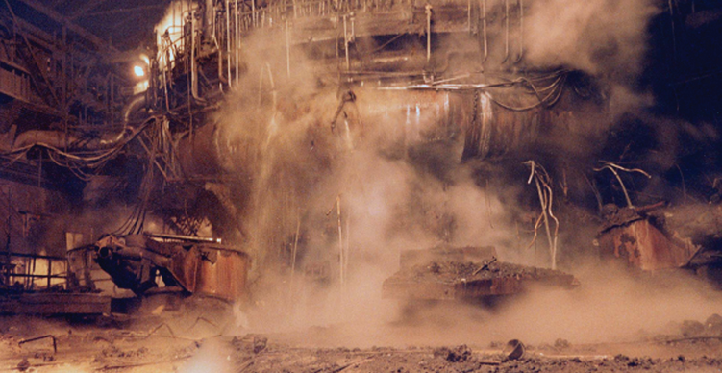
Cast house floor shortly after the incident (fig 2)
[4]

April 2019- 2 workers burned after a torpedo spills molten iron onto a waterlogged area causing an explosion with substantial damage to assets and surrounding infrastructure. Internal roads were closed indefinitely and whole departments moved to alternative areas.
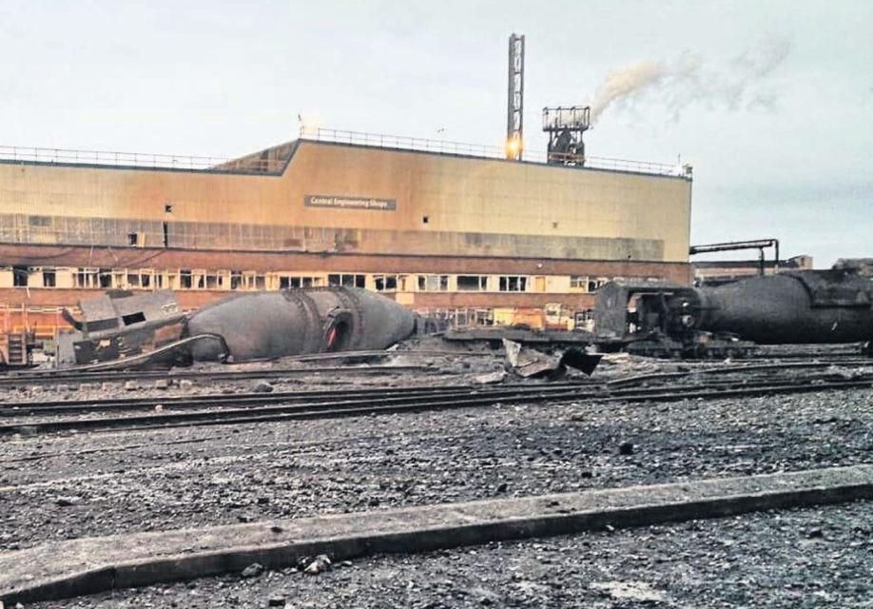
Torpedo explosion in front of Central engineering Workshops (fig 4)
[5]

Sept 2021- Turbo Alternator no9- A 20MW alternator over speeds in seconds causing harm to 3 workers in the turbine hall and catastrophically explodes after mechanical failure of steam valves followed by an incorrect decision made by leaders, this resulted in the alternator becoming disconnected from the 11kV network, which was holding it at a controlled synchronisation speed.

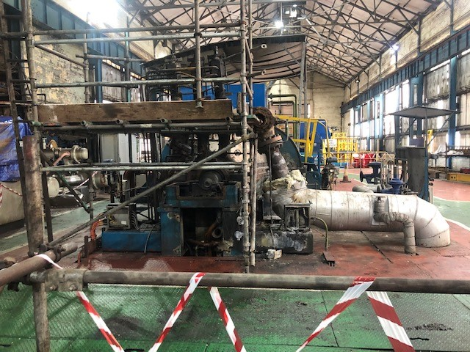
TA9-Turbine Hall shortly after the incident in 2021 (fig 3)

HSE- recommendations
As can be seen within the previous document from the investigation of the Blast Furnace 5 incident, it states:-
“The principal methods that are available to determine the likelihood and potential consequences of plant failure are; Fault Tree Analysis (FTA), Hazard and Operability Studies (HAZOPS), Failure Modes and Effects Analysis (FMEA) and Layers of Protection Analysis (LoPA)”
[4]
HSE Summary
A process deviation in a node under a common heading of More Flow or Less flow when studying the potential hazards of operability of a blast furnace may have concluded a back up water supply or more thorough maintenance was required to the cooling section of the shell to prevent a MAH.

Project purpose.
The purpose of the training aid will be to produce a scaled working example of one of Port Talbot steel manufacturing sites gas holders. Building it to replicate one of the control room operators known assets will hopefully engage the team and help bridge the process safety awareness gap that we have presently on site. This was clearly mentioned in a 2022 report by the CA who investigate our MAH’s. The report stated “The purpose of this inspection was to verify the progress made against the 3-year rolling Process Safety improvement plan set out in 2020 by Tata”
[6]

Incorrect control or imbalances between consumers and the production of the onsite gasses as a biproduct to steelmaking can erode our process safety barriers.
A Lack of understanding of our barriers and their effectiveness could quickly lead to Process Safety incident or Major Accident Hazard (MAH)

Automation/Simulation
For the purpose of this project and to remove the RISK of a human making an incorrect decision, it would be of great benefit to simulate the gas holder process and its stability of control, through an automated process simulation illustration on a Human Machine Interface (HMI). I will investigate this early in the project as it will involve a lot of programming and graphical representation which will have to be self-taught and the hardware could prove extremely difficult to obtain due to its expense.
An automated simulation of a gas holder as a safe and controllable example where the users can adjust parameters to see the imbalances in the system will help bridge awareness gaps and ascertain a healthy understanding of the process and what could go wrong.

Project Design
Overview of awareness
Currently there are no training aids available to utilise on site and the understanding of Process Safety is very much in its infancy stage. The ability to utilise a gas holder training aid within a workshop learning environment will increase the Process Safety awareness. coupled with an E-learning package and site improvements will significantly help improve the overall understanding. The training aid will play a fundamental part of the training.
Other improvements that could support the training aid are:-
- Employees on-site should have an awareness of Process Safety, this could be included during induction.
- All equipment on site must be clearly identified as process safety critical equipment (PSCE) and maintained accordingly, examples will be provided.
- Design an E-learning package, Process Safety level 5 (site wide employees)
- Process safety training (Process Safety level 4) Team leaders/Control room operators, Training aid based.
- Update all onsite HaZops to identify the ‘TOP EVENTS’ on-site that could result in a MAH.
- Splitting each ‘Top Event’ down into its separate components, identifying it as a Bowtie/LoPA clearly showing the barriers in place, separate from this project but will also be supporting in the development of Process Safety awareness on site.
I believe that improvements can be made in all of the areas above and once implemented, jointly they should reduce the likelihood of a MAH happening on the Port Talbot site.

Measurable Outcomes
- Data reporting of Process Safety incidents via shift reports will be the key PS awareness indicator, with a better understanding of process safety, this could arm the workforce with the ability to quickly identify failed barriers that could lead to a MAH if not addressed.
- Compare best practice or as designed asset example to present day process, what’s changed ?
- Identifying all PSCE equipment, focus maintenance budgets and reduce probability of failure on demand. Reducing likelihood of unplanned events.
- Sample labelling of PSCE (eliminating identity mistakes and human errors)
- Develop operating manual.
- Simulation software program and HMI illustration.

Deliverables
- Attempts will be made to deliver a prototype training aid replicating the Basic Oxygen Steelmaking Gas (BOSG) holder and its inherent safe by design control.
- A simulated copy of the plant to prove full automation is possible, this reduces human factors and their ability to cause unwanted disturbances or MAH’s. Whilst Allen-Bradley is the preferred OEM for control systems I will look at the alternative options if required.
- Produce a Slideshow to support the training aid and its function.
- Produce a written operating manual for the system
- Provide information to help support E-learning package on Process Safety
- Compare SAP notification data to ascertain improvements in reporting issues on equipment failure and maintenance on critical plant (shift reports)
- PSCE tagging for quick and reliable onsite information, reduce human error.
- Update/help develop accurate piping identification drawing for the asset.

Once the training aid is fully assembled and tested. Awareness training will be developed and planned with the Process Safety team and interested parties.

Process Safety Workshop Feedback
Feedback from operators and team members that attend the Process Safety workshop will maintain alignment with the Process Safety understanding to ensure the correct pace and depth is maintained to maximise the interaction from the team.
This can also be proven by additional assessments as part of the workshop, direct feedback by the operators can be assessed by the Process Safety Team. Any alterations will be addressed following the 1st workshop.

Training Aid P+ID
A single line drawing of the training aid replicating a gas holder (using water for ease of illustration for this project). Will be provided as part of this project. All equipment will be correctly described and tagged to comply with current legislation using PSCE tagging information.
A detailed explanation of the diagram will be covered in the operating manual which will be developed to form part of the final project.

Resources and Planning
Resources
With the business fully committed in a ‘Drive to Save’ initiative, this project will be developed at a minimal cost throughout, I will attempt to source all the hardware required for building the training aid, including its simulation, control and development of the Training aid build by either using used or donated hardware. Keeping the overall spend to a minimum.

Budgets and Bursaries
There is no supporting budget allocated to this project, any outlay in costs will have to be to be self-funded.
I intend to investigate a bursary through the University that may be able to support a small amount of funding. This will be possible after I have listed a clear bill of materials that are required to ascertain the whole project cost.

Project Plan Oct 2023
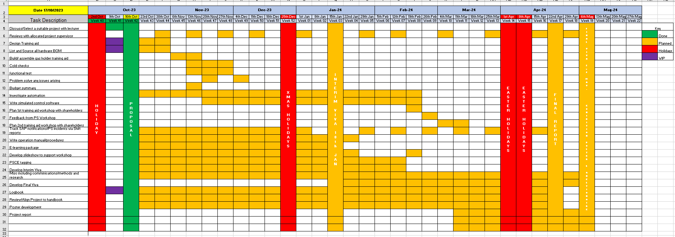

Limitations and Legalities.
Due to the recent announcement within Tata steel on decarbonisation and the potential effect of the reduction of its steel manufacturing assets, it is unknown what overall effects within the business could affect the project. A manning reduction is expected but details are unknown at this moment in time. This could reduce the amount of specialist support available, it may also affect my roles and responsibilities. I will therefore factor this into the project plan if/when any updates arise in the meantime I will allow extra time wherever possible.

Glossary
BFG | BLAST FURNACE GAS
P&ID | PIPING AND INSTRUMENTATION DIAGRAM
CA | COMPETANT AUTHORITY
LoPA | LAYER OF PROTECTION ANALYSIS
BOSG | BASIC OXYGEN STEELMAKING GAS
MAH | MAJOR ACCIDENT HAZARD
HAZOP | HAZARD AND OPERABILITY ANALYSIS
HSE | HEALTH & SAFETY EXECUTIVE
COMAH | CONTROL OF MAJOR ACCIDENT HAZARDS
COG | COKE OVEN GAS
HMI | HUMAN MACHINE INTERFACE
PSCE | PROCESS SAFETY CRITICAL EQUIPMENT

Reading List

[1] | “Tata steel Port Talbot,” 2022. [Online]. Available: https://www.tatasteeleurope.com/construction/sustainability/performance-at-our-sites/port-talbot.
[2] | IChemE safety centre, “Process Safety and the ISC,” June 2014. [Online]. Available: https://www.icheme.org/media/1584/final-common-language-revised-6-6-14.pdf.
[3] | “Buncefield Response,” 11 dec 2005. [Online]. Available: https://www.hse.gov.uk/comah/buncefield/.
[4] | J. H. a. S. Curry, “SYMPOSIUM SERIES NO. 156,” 2011. [Online]. Available: https://www.icheme.org/media/9293/xxii-paper-83.pdf.
[5] | Evening Post, “We though we were being bombed,” 27 April 2019. [Online]. Available: https://www.pressreader.com/uk/south-wales-evening-post/20190427/282003263838638.
[6] | Rhiannon Thomas, CEng MIChemE DipNEBOSH, “COMAH report,” CA Organisation, Unit & Team: HSE, CEMHD 6B, Cardiff, 2022.

