The purpose of this study is to assess the correlation between knife crime and young people in deprived areas of the UK, and to evaluate the responses to which, from the UK government. The three key objectives in place to aid in concluding the study are to analyse historical trends and the impact of covid on knife crime, identify whether young people are more vulnerable to knife crime and to assess the success of UK government strategies and responses currently in place to tackle knife crime, all three objectives are to be addressed. The purpose of the primary research being undertaken is to the address gaps identified while conducting the literature review, as primary research is not limited to what is currently found in existing literature (Driscoll, 2011). For example, a significant finding in chapter two was the absence of existing literature in relation to older generations regarding knife crime for comparative purposes to that of younger people. The use of primary research also allows for the opportunity to ask open questions in order to gather qualitative data based on opinions and relationships that are not fully assessed with the quantitative data provided in existing literature (Cypress, 2015). For example, for objective one, primary research will gather public perceptions regarding people’s feelings of safety or fear of knife crime over time and how their confidence in the police has been affected. As for objective two, primary research can allow for age specific analysis in relation to vulnerability and likelihood of knife carrying to deduce whether young people are in fact more vulnerable. Finally, primary research can provide relevant and specific data for objective three in the form of general public viewpoints surrounding how the government tackle knife crime and provides opportunity for them to suggest their own ideas.
The framework for this methodology is based on the research onion, of which explains the numerous considerations that must be acknowledged when developing a research methodology in the form of 6 layers, these are the research philosophy, research approach, research strategy, choices, time horizon and techniques and procedures (Saunders et al, 2016).
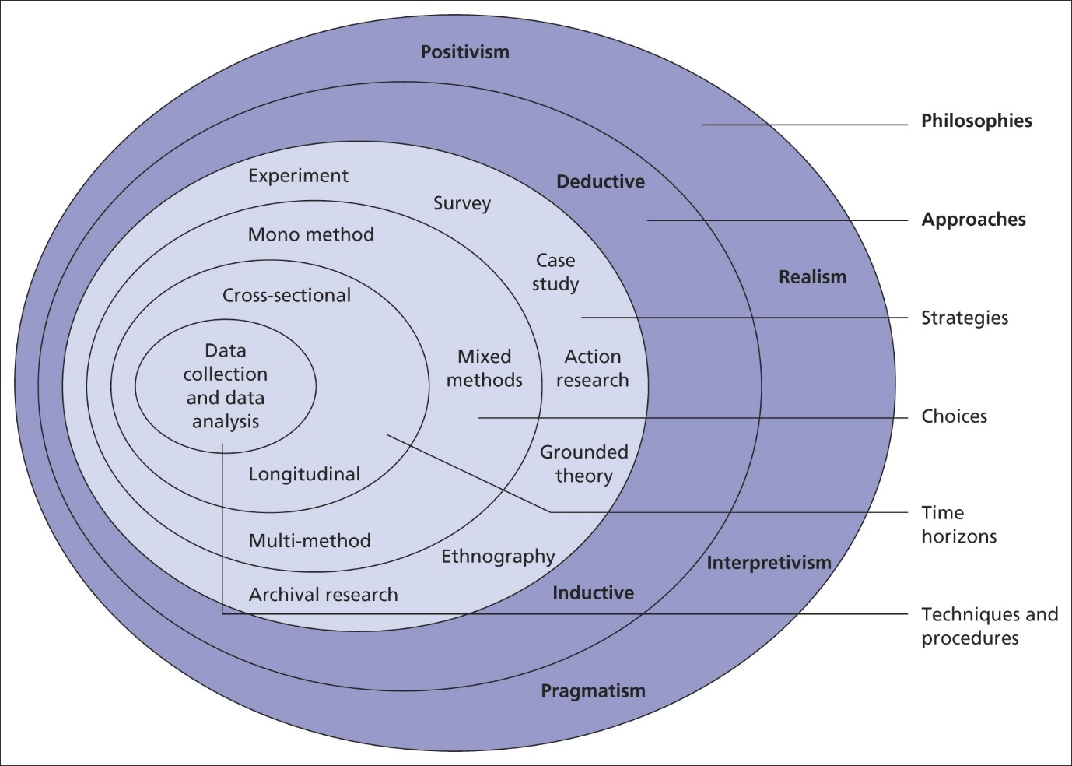

Research Philosophy
The research philosophy is the set of beliefs and assumptions that develop knowledge in relation to research (Saunders et al, 2009), this is often taken in the form of ontology and epistemology. Ontology being the branch of philosophy that is concerned with what is real (Smith, 2012) while epistemology questions what makes knowledge valid and how it can be obtained (Al-Ababneh, 2020). As for this research, both branches of philosophy have been adopted. Ontology during secondary research, where an understanding has been developed through the conducting of research into existing literature and epistemology when gathering primary data to validate information extracted from the literature and to address any identified gaps in existing research. The gathering of qualitative data through the use of open questions based on perspectives, means the positivism approach to philosophy is disregarded while an interpretivism approach is utilised to consider the differing views held by members of the public regarding knife crime and attitudes towards the police, as interpretivism considers the differing views of individuals in oppose to a generalised understanding (Alharahsheh and Pius, 2020).
Research approach
The research approach refers to the manner in which research is gathered and takes one of two forms, these are the inductive approach and the deductive approach. Soiferman (2010) acknowledges that inductive research begins specifically to the topic and moves towards a more general understanding, whereas deductive leads with general data and moves towards specific data throughout. Therefore the inductive approach to research is concerned with generating new theories based on data collected, whereas the deductive approach is founded on an already existing theory. Due to the nature of this research, aspects of both research approaches are to be utilised. The primary approach to the research is to be inductive as a conclusion is to be made through the analysis of the research findings, the inductive approach is also to be utilised of the purpose of addressing gaps in the current literature, of which were identified through the conducting of secondary research, as new theories and understandings are to be developed. Although, aspects of the deductive approach are displayed when primary research is based on supporting data found in existing literature, as existing theories are being tested by the primary research. In addition to this, both quantitative and qualitative data are to be gathered, while inductive research is generally associated with qualitative data and deductive research with quantitative (Newman, 2000), meaning that a mixed approach is appropriate to this study as it provides all the necessary data needed in order to conclude.
Research strategy
The main approach being used in this project is the survey approach, of which is the collection of data from a sample of people of which have been asked a series of questions (Ponto, 2015). The survey approach is of great use to this study as it provides important data regarding the attitudes, beliefs and knowledge of the general public of which can be assessed to conclude (Story and Tate, 2019). The survey in question will gather public perceptions regarding knife crime and the government’s responses to identify if the general public are satisfied with how knife crime is currently being controlled and assess whether people are fearful of knife crime in their area. The survey approach also allows for the gathering of demographic data regarding age and area of residence, of which is of great use to the study as this can be analysed for comparative purposes. Differing responses from older and younger groups of people can be assessed to identify whether younger people are more vulnerable to knife crime and area of residence is important to investigate differences in levels of deprivation in relation to knife crime. Other approaches to be considered include the grounded theory approach, which involves the use of systematic guidelines to collect and analyse data in order to create new theories (Charmaz, 2014), as it allows for the development of new theories regarding the reasoning for the recent increase in knife crime to be expressed. The other approach that is beneficial to this study is ethnology, which focuses on the differing characteristics of individuals over time. This is important for this study as it involves an emphasis on differing characteristics based on age and socioeconomic class as an explanation for knife crime. Therefore, analysing data collected from a range of individuals with differing characteristics will allow for correlations and relationships between characteristics and knife crime to be identified and analysed effectively.
Choices
Due to the importance of both quantitative and qualitative data in relation to this study, a mixed approach to data collection is required, this is because it allows for the collection of both types of data. To achieve, the use of a questionnaire, consisting of 20 quantitative and qualitative orientated questions is to be utilised. A questionnaire is best suited to this study as it allows for a substantial amount of data to be collected in a short period of time (Kent, 2020)
Time Horizon
As there is no time dimension for the survey, the cross-sectional approach to research is to be used as data is collected at a given point in time (Kesmodel, 2018) This is beneficial to the study as it allows for relevant data regarding the current situation, meaning that data collected is up to date and reliable. Longitudinal studies consist of gathering data over prolonged periods of time for comparative purposes over time (Caruana et al, 2015). Though, due to the nature of this study and time frame available, this method of data collection is unnecessary.
Techniques and procedures
As it has already been established that the type of research being conducted is primary in order to gather both qualitative and quantitative data, the use of a questionnaire is best suited to this study. This is because it allows for the gathering of specific data, that may not be as accessible through other means of research (Dewaele, 2018). This method of research is also effective for gathering data as it is easily accessible for recipients due to the use of online platforms, in which the survey will be shared too. This in turns allows for the opportunity to reach an appropriate audience and therefore obtain adequate responses. The use of an online questionnaire also rules out geographical restrictions and allows for anonymous responses that can be stored appropriately to minimise ethical risks (Nayak and Narakyan, 2019). As for the participants, participation will be optional and chosen at random and in order to access participants, the survey will be posted to online social media platforms, giving potential participants the option to complete the survey or decline participation. The use of online platforms to access participants is more reliable than the use of paper-based surveys as it decreases the likelihood of participants not receiving the survey (Rada and Dominguez-Alvarez, 2014). As for the sample size, The questionnaire aims to gather approximately 100 responses, as this will allow for enough data to analyse appropriately and limit the risk of the quality of the data being compromised.
The questionnaire is being developed via Microsoft Forms, a software that records responses and categorises results automatically. To further analyse the results, two key methods are to be used. The first of which is statistical analysis, in order to identify trends over time in relation to public perception of safety and the impact of Covid-19 on knife crime (Ali and Bhaskar, 2018). The other method of analysis is content analysis, in order to assess the differing responses given by age category to develop an understanding as to whether young people are more fearful or vulnerable to knife crime and to identify if the public are confident in the government to tackle knife crime.
Limitations
It is important to address any limitations that may be faced during data collection. Firstly, the likelihood of gathering responses from a range of demographics, to ensure this is the case, the questionnaire is to be posted to a wide range of social media platforms that are catered to both younger and older generations to encourage members of the public of all ages to participate. In addition to this, there is always a risk of careless responses of which can impact the quality of data (Meade and Craig, 2012). In order to reduce the impact of this, it is important to achieve a reasonable number of responses to minimise the effects from minority careless responses on data as a whole. This also highlights the issue of not getting enough responses. Therefore, developing the questionnaire in advance will allow for a reasonable amount of time to gather data effectively. The consideration of such limitations means that it is likely that the data collected will be reliable and beneficial to the study.
References:
Al-Ababneh, M. (2020). Linking ontology, epistemology and research methodology. Science & Philosophy, 8(1), pp.75-91.
Alharahsheh, H.H. and Pius, A. (2020). A review of key paradigms: Positivism VS interpretivism. Global Academic Journal of Humanities and Social Sciences, 2(3), pp.39-43.
Ali, Z. and Bhaskar, Sb. (2018). Basic statistical tools in research and data analysis. Indian Journal of Anaesthesia. 60(9), p.662.

Caruana, E.J., Roman, M., Hernández-Sánchez, J. and Solli, P. (2015). Longitudinal studies. Journal of thoracic disease, 7(11), p.E537.
Charmaz, K.(2014). Constructing grounded theory. sage.
Cypress, B.S. (2015). Qualitative research: the “what,”“why,”“who,” and “how”!. Dimensions of Critical Care Nursing, 34(6), pp.356-361.
Dewaele, J.M. (2018). Online questionnaires. The Palgrave handbook of applied linguistics research methodology, pp.269-286.
Driscoll, D.L. (2011). Introduction to primary research: Observations, surveys, and interviews. Writing spaces: Readings on writing, 2(2011), pp.153-174.
Kent, R. (2020). Data construction and data analysis for survey research. Bloomsbury Publishing.
Kesmodel, U.S.,(2018). Cross‐sectional studies–what are they good for?. Acta obstetricia et gynecologica Scandinavica, 97(4), pp.388-393.
‌Meade, A.W. and Craig, S.B. (2012). Identifying careless responses in survey data. Psychological methods, 17(3), p.437.
Nayak, M.S.D.P. and Narayan, K.A. (2019). Strengths and weaknesses of online surveys. technology, 6(7), pp.0837-2405053138.
Newman, I. (2000). A Conceptualization of Mixed Methods: A Need for Inductive/Deductive Approach to Conducting Research.
Ponto, J. (2015). Understanding and evaluating survey research. Journal of the advanced practitioner in oncology, 6(2), p.168.
Rada, V.D.D. and Domínguez-Álvarez, J.A. (2014). Response quality of self-administered questionnaires: A comparison between paper and web questionnaires. Social Science Computer Review, 32(2), pp.256-269.
‌Saunders, M., Lewis, P. and Thornhill, A. (2009). Understanding Research Philosophies and Approaches. ResearchGate. Available at: https://www.researchgate.net/publication/309102603_Understanding_research_philosophies_and_approaches. (Accessed 20th January)

Saunders, M., Lewis, P. and Thornhill, A. (2016). Research Methods for Business Students. 7th ed. Harlow, Essex, England: Pearson Education Limited.
‌Smith, B. (2012). Ontology. In The furniture of the world (pp. 47-68). Brill.
Soiferman, L.K. (2010). Compare and Contrast Inductive and Deductive Research Approaches. Online Submission.
Story, D.A. and Tait, A.R. (2019). Survey research. Anesthesiology, 130(2), pp.192-202.

