A Case Study of UK’s Hafod

Table of Contents
Introduction 3
Background 4
Imagery and Cultural Impact 4
Approaches to Development 5
Behavioural Change and Challenges 7
Analysis and Recommendations 8
Conclusions 9

Introduction
Hafod is a community area in the City and County of Swansea, located approximately two miles north of Swansea city centre. With a population of exceeding 12,500, Hafod has been a mix of local authority and privately owned housing. The community has faced significant development and expansion during the 20th century (Hafod Community Centre, 2023). It was the time when Swansea started to grow into an industrial centre. Furthermore, in the 20th century, the growth and evolution of areas like Hafod was significant within the broader context of UK’s social history. Likewise, South Wales became a key hub to support UK with its natural resources when its heavy industries like steel, mining and manufacturing drove UK’s economy in the early-to-mid 1900s. Hence, it undoubtedly shaped the expansion of communities like Hafod to offer housing and services to the developing and increasing workforce (Hafod Community Centre, 2023). However, there has been a sufficient decline of these traditional industries and had major impacts on areas like Hafod from 20th century onward. Likewise, community decline and deprivation grew over time and the reason was with limited employment. Even today, some parts of Hafod fall within some of the highest rates of poverty and unemployment in Swansea.
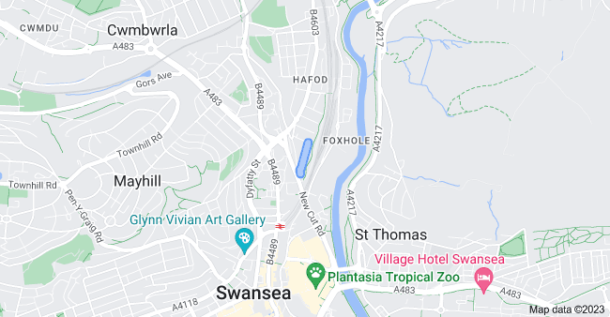
(Fig 1: Google Map)

Background
As a rural area on the outskirts of Swansea, Hafod has its origins, with cottage industries like farming and weaving dominating for much of its early history. However, during the 19th and 20th century, as heavy industries took hold, Hafod was dramatically transformed by Swansea's economic boom (Hafod, 2023). Similarly, the population grew rapidly as migrants from the different ethnic groups started to come in Hafod and the reason was Hafod was able to offer industrial jobs. Hence, the given pattern resulted in dense housing development across Hafod's landscape. In addition, it also impacted community health because of the increase in industrialisation and population burst (Lǎozǐ, 2023). Moreover, coal and steel production resulted in heavy pollution that eventually caused respiratory illnesses. Therefore, such diseases became common, while cramped, low-quality housing facilitated the spread of infectious diseases like tuberculosis. In addition, from early 20th century, compromised healthcare services also plagued Hafod. However, the creation of the National Health Service in 1948 was a landmark event for enabling improved community health and access to care (Lǎozǐ, 2023). From the later 1900s, council funding also targeted upgrades to housing conditions, public amenities and recreational spaces across Hafod. This likely supported community wellbeing (Hafod, 2013). Yet from the 1970s, Swansea's industrial decline brought economic depression and social issues to Hafod, negatively impacting public health once again. Recovering from this remains an ongoing challenge. Developing health and social care services to meet Hafod's contemporary needs is vital.

Imagery and Cultural Impact
The town of Hafod in Wales is deeply rooted in the country's industrial history. As a result, it has a separate working-class identity and culture. Likewise, images of its rows of terraced houses, factories, and smokestacks practically define Hafod. So, when Wales' steel and smelting industries thrived in the early 1900s, Hafod was a prime example of a Welsh industrial town (Hafod, 2013). In addition, at that time, familiar scenes emerged of cobblestone streets, corner shops, pubs and chapels that dignified the hard yet lively daily lives in such working-class areas. Even today, these nostalgic images connect people to the community's culture. However, equally striking are the darker images of poverty, illness, and poor living conditions common in densely populated neighbourhoods (Hafod, 2013).
Over time, filthy alleys, photos of smoggy skies, and needy children exposed Wales' hidden hardships to greater British society. Likewise, images of miners washing off work grime stimulated periodic urges for labour reforms and better living standards across struggling towns. Beyond just imagery, Hafod has long symbolised issues around industrial collapse, joblessness and urban deprivation in Wales (Lǎozǐ, 2023). After the 1970s, when de-industrialisation overwhelmed communities like Hafod seen social upheaval and identity crisis, which eventually sent shockwaves through Welsh society (Phillips et al. 2019). In result, Hafod developed a key symbol of the economic devastation. As a result of this, uncertainty faced by many towns. Likewise, via drawing extensive attention to these struggles, Hafod focused regeneration efforts. However, countering the legacy of systemic exclusion and powerlessness has been a continuous national obstacle that is proving out to be devastating for the overall development of Hafod, also echoed in (Tomlinson, 2021). Yet, Hafod holds an important place in the nation's cultural psyche via layered visual motifs and strong ties to Wales' archetypal working class. Its imagery and societal role have been in a position from where it can reflect Wales' complex relationship with industry, prosperity and identity (Lǎozǐ, 2023).

Approaches to Development
Hafod has been facing numerous strategic approaches to enhance the community growth over recent decades and being a compromised area, it is in the dire need of revitalisation. Likewise, since industrial decline, to uplift Hafod’s pity condition, efforts have been made significantly and majority of those efforts have been successfully targeted the economic, social and environmental enhancements. However, effecting real change has proved an ongoing challenge.
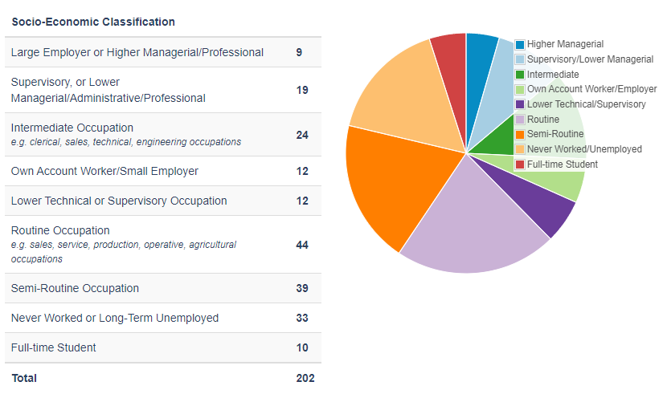
(Fig 2: Socio-Economic Classification Source: Hafod, 2013)
As illustrated in fig 2, more than 10% of the working class of Hafod is working as intermediate occupation. While talking about economic shift, there has been a core focus on the development of the local business, and significantly encouraging investment to sites in Hafod that have been dilapidated from some time now. Likewise, it will allow the policy makers of Hafod to enhance the skills and employability, so that the development and competitiveness within the community can be improved, also supported in (Manzoor et al. 2019).
Moreover, taking Swansea Council’s Priority Areas as an example, they have applied customised application around potential financial incentives. The idea of this porgramme is to encourage companies to open branches and revamp properties in Hafod (Kuckertz et al. 2020). With new retail openings, some successes have emerged like convenience stores helping in countering limited shopping access. However, other contributory factors in the form of crime, compromised infrastructure and limited custom are known for limiting the transformational business growth (Kuckertz et al. 2020).
Furthermore, when it comes to the economic, social priorities have incorporated community services via developing public amenities and mitigating crime and antisocial behaviour. In addition, customised messaging via community forums has aimed at behavioural change around littering, graffiti and other issues degrading communal areas. Furthermore, developing community participation in painting over unwanted graffiti has developed local buy-in to tackle the issue (Gokhale et al. 2020). In addition, progress has occurred too, with new youth clubs and upgraded public spaces enhancing perceptions around community pride and unity that feedback back into further participation. However, ingrained socioeconomic challenges contribute to continuing sabotage and disorder that hamper lasting change (Gokhale et al. 2020).
Whereas in the case of environment, improving Hafod’s physical landscape has been followed via different initiatives. Although the initiatives are mainly targeting housing, greenspaces and general urban infrastructure, still they have possessed the sufficient level of potential in reviving the true image and poster of Hafod’s environment (Liu et al. 2021). Likewise, in the context of Hafod, grant schemes have also been introduced and their core focus is on initiating home improvements, which eventually offer positive gesture to reinforce community participation in uplifting their surrounds.

Behavioural Change and Challenges
To effect positive behavioural change in Hafod regarding issues such as littering, vandalism, and antisocial behaviour, it is important to apply strategic interventions based on key concepts in community psychology. It is crucial to carefully personalised plan that will connect the community with local norms and attitudes and the aim will be to dismantle problematic behavioural patterns that have been developed amongst the people amid compromised conditions in Hafod mainly in the form of littering, vandalism, and antisocial behaviour (Adams et al. 2019). However, achieving substantive change also requires countering or mitigating the broader socioeconomic challenges that motivate these issues in deprived areas like Hafod. As a result of this, successful planning is required to be fundamentally resonating with the internalised motivations and identities within Hafod to bring about lasting behavioural shifts. Likewise, instead of simply reprimanding fines, it will be suitable and attractive way to craft explicit correlations between limiting or controlling waste and developing community pride (Ceccato et al. 2023).
In response to this, personalied communication channels are required to be developed via schools and public events that creatively incentivise recycling participation, which will eventually play their part in solidifying social responsibility. Furthermore, organizing school competitions for designing anti-litter posters have the potential in encouragin activism while incorporating civic developing (Moqadam et al. 2022). Furthermore, the management or community responsible for the overall development in the context of Hafod can also develop fun community with the name of "cleanathons" with prizes, which will allow them to promote pro-environmental behaviours as a collective activity.
Likewise, campaigns that illustrates actual savings through behavioural changes in the shape of home insulation, have the potential to offer self-interest to drive change. Furthermore, theoretical frameworks such as communal efficacy, participation, and modelling will also offer guidance for behavioural change strategies (Heap, 2021). Therefore, there is a need to engage youth of Hafod in community art projects to decorate litter bins that stimulates activism while visually showcasing desired waste behaviours. In addition, incorporation of colourful paintings and slogans authored by young residents can engrave messaging via creative participation. Sports events that involve residents in area clean-ups will also develop broader participation and allow positive peer modelling within community subgroups (Heap, 2021).

Analysis and Recommendations
From the analysis, it has been found that poor areas like Hafod need integrated plans across money, social, and environmental topics to develop and grow in a sustainable way. While strategies have tried targeting these topics, ongoing issues that have been covered around social and economic hurdles make real development almost impossible to achieve. As a result of this, poverty and limited or controlled power is required be ensured throughout the community. Therefore, when it comes to money, helping local businesses and jobs will increase the demand and will eventually enhance the existing skills of the people, transport, buildings and market reach. Bhati, (2023), shops opening in Hafod have struggled with high crime and few customers; therefore, the survival rate of these initiative have always been an issue. Brahim, (2021) articulated that combining financial help with better transport, safety efforts and advice for small businesses play an essential role in shaping the growth and development of the businesses. Additionally, Ajayi et al. (2020) confirm that plans to shift work beyond declining industries need widely available retraining programs. So, more participation subsidies, flexible course types and business team-ups possess the sufficient level of potential to play their role in the overall development of Hafod’s workforce transition into growing areas like healthcare, education, and construction sector.
Socially, evidence affirms that community involvement, leadership and capability all are required to apply and then execute top-down plans for turnaround. Hotra, (2022), resident-led projects have the potential to improve Hafod’s environment. Furthermore, there is also a need to build local buy-in and guardianship around cared-for public spaces. As a result of this, developing these community development efforts will be playing an essential role when it comes to boost accessible youth services so positive gesture reaches those most prone to lack of power. Also, facilitating community voice in planning processes cements participatory priorities (Moqadam et al. 2022).
Environmentally, it has been dignified that landscape upgrades are required to be strategically coordinated between parties when spanning public and private spaces. As a result of this, entire Hafod’s schemes are supposed to be responsible in enhancing housing, greenspaces, amenities and infrastructure in a coordinated area-based way can assist (Moqadam et al. 2022). Furthermore, there is also a need of developing visions for local parks with council recovery efforts for drainage systems creates beneficial lift.

Conclusions
The following analysis of the Hafod community dignifies that economically compromised areas in the UK require coordinated policy efforts spanning economic development, social service programs and environmental upgrades in order to achieve genuine revitalisation. Furthermore, while targeted strategies across these domains have endeavoured to develop growth in Hafod, issues around deep-set socioeconomic disadvantage have persisted, constraining sustainable change. The implications of this for health and social care are profound. Hence, from the analysis, it has been found that chronic poverty and compromised economic opportunity fundamentally damage public health and social outcomes at the community level. Likewise, mental and physical health suffer through the stigma and stress of unemployment, poor diet, substance abuse, crime and loss of communal identity. Hence, it establishes deprivation while also heightening demands for pushed public services.

References
Adams, J., Millie, A., Culbertson, L., Craske, N., Hartlebury, J., Team, D. I., ... & from kind Academics, G. F. (2019). An investigation of everyday morality and anti-social behaviour (Doctoral dissertation, Edge Hill University).
Ajayi, A. O., & Atanda, C. (2020). Evaluation of Crime and Safety in Lagos Metropolitan Parks. UNIOSUN Journal of Engineering and Environmental Sciences, 2(2), 78-86.
Bhati, A. (2023). Tourism research and tackling vandalism: Shifting the approach. Tourism and Hospitality Research, 23(2), 275-281.
Brahim, M. I. (2021). Reducing vandalism in elevators: the use of visual cues to nudge an altruistic behavior (Doctoral dissertation).
Ceccato, V., Parishwad, O., & Levine, N. (2023). Defecation, littering and other acts of public disturbance in pandemic times–A study of a Scandinavian city. Cities, 141, 104456.
Gokhale, P., & Kulkarni, P. M. (2020, December). Creating high-performance work system in technology startups. In International Conference on Information Systems and Management Science (pp. 1-10). Cham: Springer International Publishing.
Hafod Community Centre. (2023). Retrieved from https://www.swansea.gov.uk/hafodcommunitycentre
Hafod, Swansea (Abertawe) - area information, map, walks and more. (2023). Retrieved from https://getoutside.ordnancesurvey.co.uk/local/hafod-swansea-abertawe
Hafod. (2013). Retrieved from https://ididitthisway.wordpress.com/swansea-old-picture-photos/18th-century/hafod/
Hafod. (2013). Retrieved from https://ididitthisway.wordpress.com/swansea-old-picture-photos/18th-century/hafod/
Heap, V. (2021). Exploring the effects of long-term anti-social behaviour victimisation. International Review of Victimology, 27(2), 227-242.
Hotra, B. (2022). Updating the Cal Poly Construction Management Community Partners List.
Kuckertz, A., Brändle, L., Gaudig, A., Hinderer, S., Reyes, C. A. M., Prochotta, A., ... & Berger, E. S. (2020). Startups in times of crisis–A rapid response to the COVID-19 pandemic. Journal of Business Venturing Insights, 13, e00169.
Lǎozǐ. (2023). Hafod. Retrieved from https://mapcarta.com/N266323060
Liu, O. Y., & Russo, A. (2021). Assessing the contribution of urban green spaces in green infrastructure strategy planning for urban ecosystem conditions and services. Sustainable Cities and Society, 68, 102772.
Manzoor, F., Wei, L., Asif, M., Haq, M. Z. U., & Rehman, H. U. (2019). The contribution of sustainable tourism to economic growth and employment in Pakistan. International journal of environmental research and public health, 16(19), 3785.
Moqadam, S., & Nubani, L. (2022). The impact of spatial changes of Shiraz’s historic district on perceived anti-social behavior. Sustainability, 14(14), 8446.
Phillips, J., Wright, V., & Tomlinson, J. (2019). Deindustrialization, the Linwood car plant and Scotland’s political divergence from England in the 1960s and 1970s. Twentieth Century British History, 30(3), 399-423.
Tomlinson, J. (2021). Deindustrialisation and ‘Thatcherism’: Moral economy and unintended consequences. Contemporary British History, 35(4), 620-642.

